Since we were two groups that got merged together, there were differences in the way we implemented things. In the “Java project used” folder that’s inside the “android” folder, you can find the project folder and the jar file that I imported to android studio. That java project folder has no javadoc comments because it is not the main java project for our group. However, the main java project and the android do have javadocs.

For my android application to work, I had to modify some models of the java project. My Menu class looks like how it is shown in figure 1. Since we were asked to keep track of *weekly* schedules, I created in the model a DayOfTheWeek class has a string for the name of the day of the week and start and end times which serve to represent an employee’s schedule for a specific day of the week. My Employee class has 3 attributes and one of them, “schedule” is not added in the arguments of the constructor. I made it so when an employee get’s created, his schedule get’s automatically initiated to a list of 7 DayOfTheWeek objects, which all have the default values for start and end times.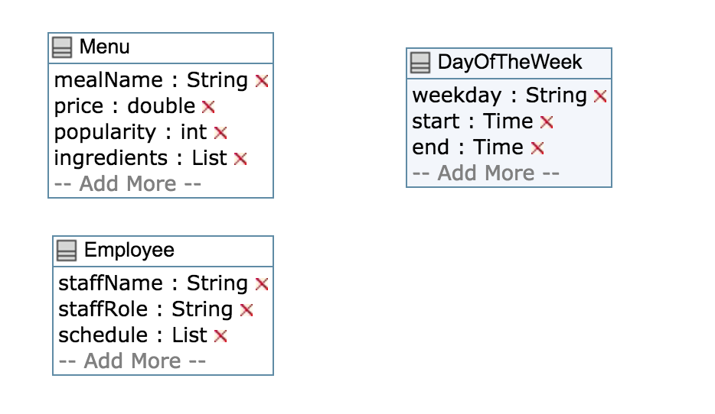

Fig.1 Modified and added classes of the model

I also had to add to the controller 3 methods that my android application needed. You can see below in Fig.2 a description of those 2 added methods.

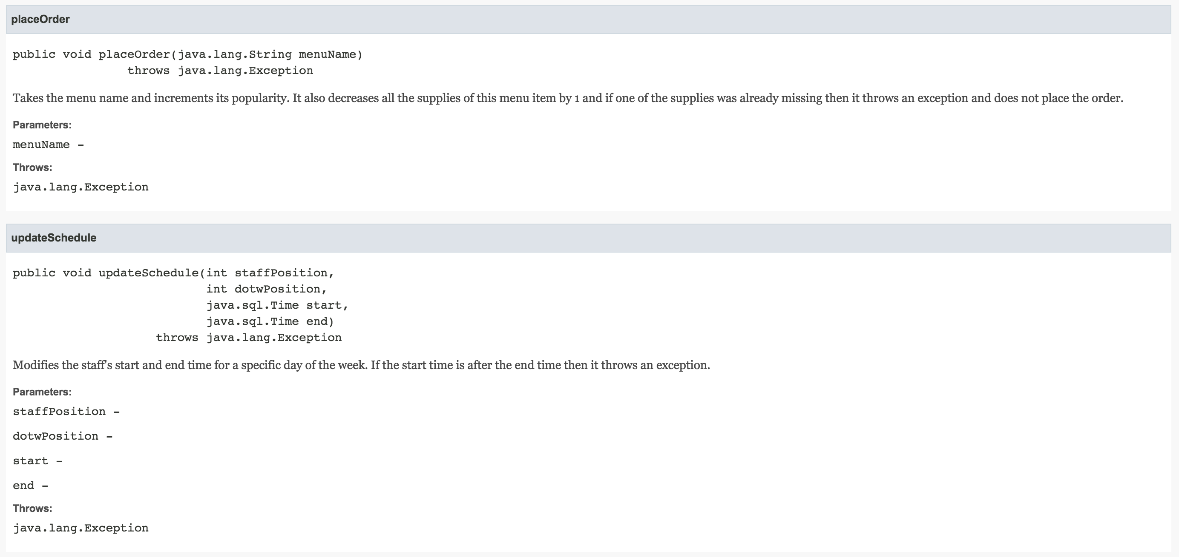

Fig.2 Javadoc of added methods in the controller