**Final Project Design Document**

**Purpose:**

The web page I will design will be my ePortfolio for the Masters in Educational Foundations – Instructional Technology program. The purpose of my ePortfolio is twofold: (1) to be the summative assessment portfolio to assess my competencies with the International Society for Technology in Education (ISTE) NETS-C standards as well as what I have learned in the program, and (2) to be a website future employers, students in the Instructional Technology program, and anyone interested in learning more about my skills and this Master’s program at The University of Akron. The goal of my ePortfolio is to showcase what I have learned through reflection and artifacts from my coursework and field experiences.

**Needs Assessment:**

To determine the need for this website, I used the Instructional Technology Master’s Program Handbook from the College of Education; the Instructional Technology Springboard site, the Alignment Document, the ePortfolio Instruction document, and the ePortfolio Rubric. I also viewed several examples of ePortfolios of students who graduated from this program as ePortfolios of students of students that were given as examples on our class Springboard site. Just to broaden my perspective, I also viewed some ePortfolios of students in other disciplines from other universities that I found online.

These sources provided me with a framework and the knowledge of what I need to include in my ePortfolio website: artifacts and reflections from coursework and field experience and how they align with the ISTE NETS-C standards for technology in education.

**Audience:**

The audience for my ePortfolio will be those assessing my proficiency in aligning with the NETS-C standards and how well I have learned the content of the program. After my graduation from the program, my audience will be future employers, students in the Instructional Technology program who want an example of an ePortfolio, and anyone interested in learning more about this program.

**Content/Subject and its fit with web site goals:**

Those who visit my ePortfolio webpage will find:

* Home page with my photo, introductory paragraph, voice introduction, tabs, and links
* Contact information (my email address) at the bottom of every page
* Link to U Akron website at the bottom of every page
* Artifacts from coursework to demonstrate proficiency in the NETS-C standards
* Field experience artifacts and reflections
* My resume
* Philosophy of Instructional Technology
* Educational Philosophy
* Navigational tabs as follows:
  + Home
  + Leadership
  + Teaching and Learning
  + Instructional Design
  + Multimedia Development
  + Professional Development
  + Resume

**Presentation of information:**

The home page will have a banner photo across the top related to the use of technology in education. There will the title of the website, as well as navigation tabs. On the page will be a photo of me, with a brief introduction of my schooling and why I chose this Master’s degree, and contact information. From this home page, viewers will be able to go to each of the other six pages (there will be seven across the top: Home, Leadership, Teaching and Learning, Instructional Design, Multimedia Development, and Professional Development, and Resume). Each page will contain a description of that area, then two columns, one with a “Course Artifacts” heading and the other with a “Field Experience Artifacts” heading. Since viewers will be able to go back to any page through the top navigation bar, at the bottom of each page (or midway and at the bottom on long pages) will be a “Return to Top” button. I will use new banner pictures on each webpage, and photos and visuals throughout the website.

I want my website to be visually pleasing, easy to navigate, with each page having the same layout, color scheme, and design for consistency. The navigation bar and tabs will be visible on each page, and visitors will be able to go from one webpage to another without having to go back to the homepage first. I also want my ePortfolio site to be personable, yet well-executed to be professional. I want viewers to feel connected and interested in all this program has taught me and all that can be accomplished with technology in education.

**Rationale for organization:**

The homepage will have an interesting and artistic photo related to Technology in Education at the top of the page that stretches across the page. The links bar will be below the photo and title of the page, and these links will appear on all pages. The homepage will also contain my picture, an audio introduction, my contact information, a welcome paragraph to the site, and links to The University of Akron and ISTE. The links bar will have the following categories: Home, Leadership, Teaching and Learning, Instructional Design, Multimedia Development, Professional Development, and Resume.

The Leadership, Teaching and Learning, Instructional Design, Multimedia Development, and Professional Development pages will have two sections, the first being “Coursework Artifacts” and the second being “Experiences in the Field.” Each section will have a clear heading so the viewer knows they are in the Course Artifacts section or the Field Experience section. Each artifact will contain a link to other pages that contain information about that artifact or field experience and its reflection. All documents will be uploaded/linked as pdf files.

**Media, acquisition or development, and rationale for using:**

The media will include all of my audio and visual artifacts. The homepage will include a photo of me (as well as the large artistic photo related to technology in education that is visually inviting to the viewer). It will also include an audio introduction that the viewer can click on. The font will be a sans serif font that is suitable for all operating systems and servers, such as Verdana. Headings will be in a script or serif font to add visual interest and design.

**Color scheme and rationale:**

The color scheme will be beige, blue, and white, with a clean and fresh look, using these colors as a palette:

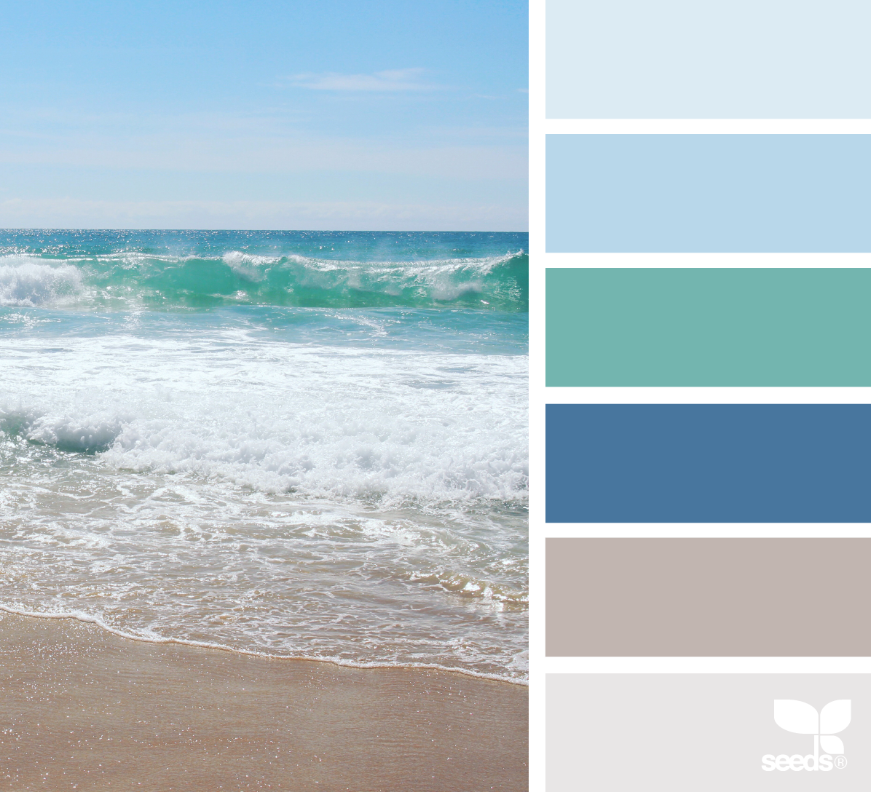 Picture source is [here](http://www.design-seeds.com/category/nature-made/) (near the bottom of the photo group).

I plan to find a free template online that best embodies the visual goals I have for my website, but it may mean some compromise on what I envision.

**Outline of web site organization:**

Homepage

* Large artistic and related photo
* Picture of me
* Audio introduction
* Welcome text with purpose of site
* A quote
* Contact email link (will be on every page)
* Link to The University of Akron website (will be on every page)
* Date of most recent revision
* Navigation bar with tabs
  + Home (see description above of what will be on the page)
  + Leadership
    - * Technology Plan Evaluation
      * Grant Writing Project
      * Two Field Experience artifacts and reflections
      * Links to other pages
      * Contact email link
      * UA website link
      * Links to other pages (through Navigation bar at top of every page):
        + Home
        + Leadership
    - Teaching and Learning
    - Instructional Design
    - Multimedia Development
    - Professional Development
    - Resume
  + Teaching and Learning
    - Wiki Reflections
      * Integrating Project
      * Paper and Lesson Plan
      * Online Learning Project
      * Online Learning Paper
      * Main Project or Paper from Educational Psychology
      * Main Project or Paper from Techniques of Research
      * At least 2 field experience artifacts and reflections
      * Links to other pages (through Navigation bar at top of every page):
        + Home
        + Leadership
    - Teaching and Learning
    - Instructional Design
    - Multimedia Development
    - Professional Development
    - Resume
* Instructional Design
  + - * Instructional Design Project
      * Instructional Design Paper
      * Design Document (from Multimedia/Hypermedia class)
      * At least 2 field experience artifacts and reflections
      * Links to other pages (through Navigation bar at top of every page):
        + Home
        + Leadership
    - Teaching and Learning
    - Instructional Design
    - Multimedia Development
    - Professional Development
    - Resume
    - Multimedia Development
      * Mini Projects from Multimedia/Hypermedia class
      * Final Website (from Multimedia/Hypermedia class)
      * Online Learning Project
      * Web-based Learning Systems Project
      * At least 2 field experience artifacts and reflections
      * Links to other pages (through Navigation bar at top of every page):
        + Home
        + Leadership
    - Teaching and Learning
    - Instructional Design
    - Multimedia Development
    - Professional Development
    - Resume
* Professional Development
  + - * Pre-Admission Competencies Verification
      * Teaching and Technology Philosophy Paper
      * Wiki Reflection
      * Two field experience artifacts and reflections
      * Links to other pages (through Navigation bar at top of every page):
        + Home
        + Leadership
    - Teaching and Learning
    - Instructional Design
    - Multimedia Development
    - Professional Development
    - Resume
  + Resume
    - PDF document of my resume
      * Links to other pages (through Navigation bar at top of every page):
        + Home
        + Leadership
    - Teaching and Learning
    - Instructional Design
    - Multimedia Development
    - Professional Development
    - Resume