 

**Placement Empowerment Program**

***Cloud Computing and DevOps Centre***

60 Days of DevOps Challenge

***Day 1: Linux Basics - Commands, File System & Permissions***

***Name: MONISHA J R Department: CSE***



This Proof of Concept (PoC) demonstrates the Linux Basics - Commands, File System & Permissions.

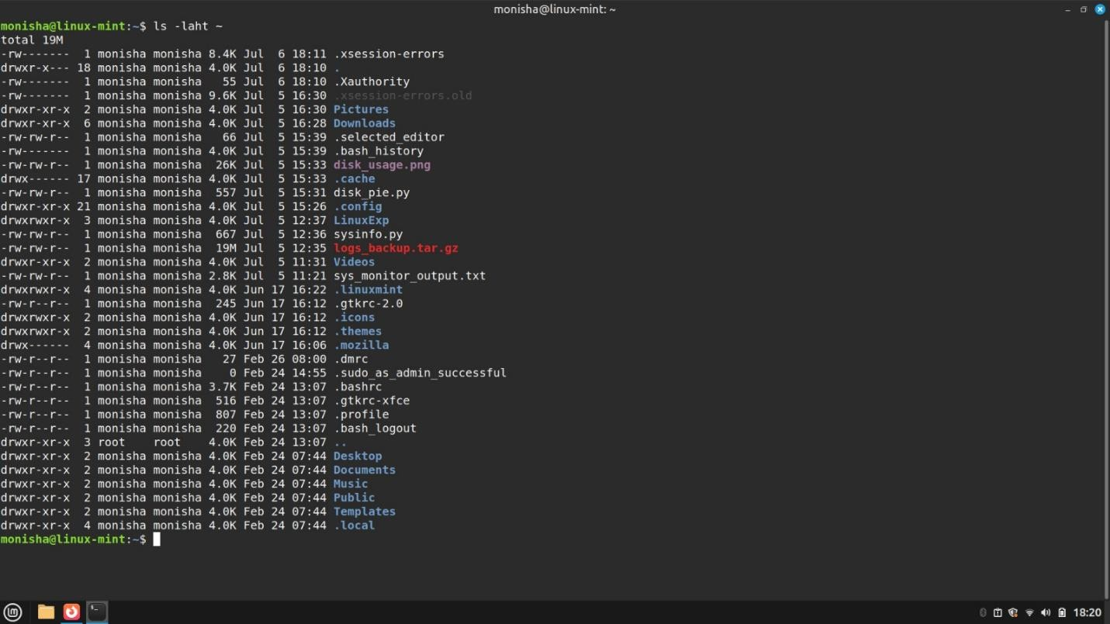**Challenge 1**: List all files (including hidden ones) in your home directory and sort them by modification time.

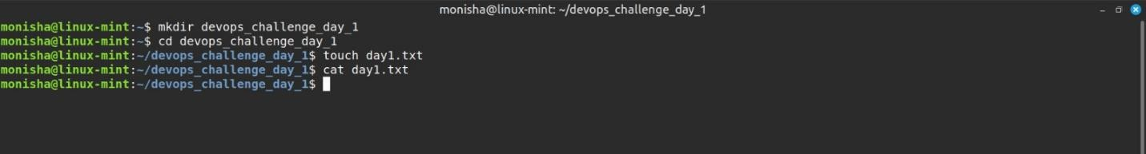**Challenge 2**: Create a directory named devops_challenge_day_1, navigate into it, and create an empty file named day1.txt.

**Challenge 3:** Change the permissions of day1.txt to allow only the owner to read and write, but no permissions for others.

Using *chmod 600 day1.txt*

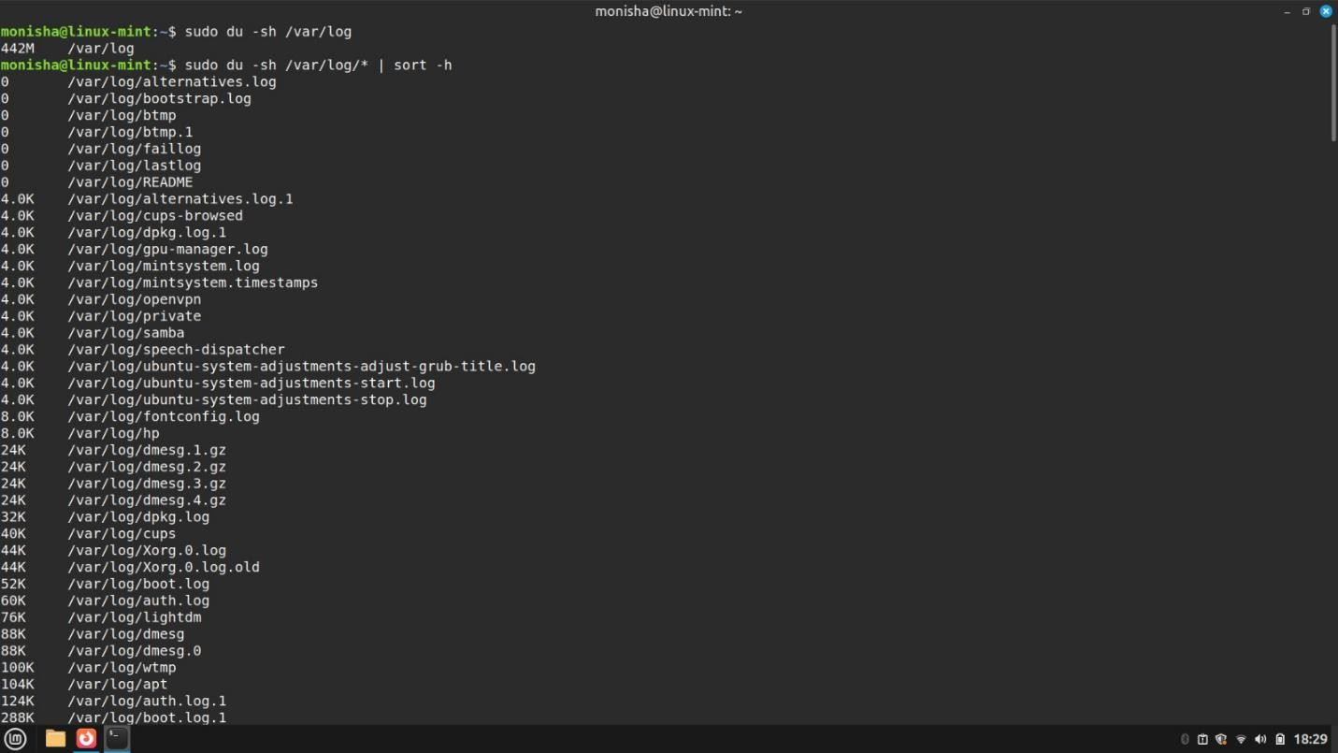

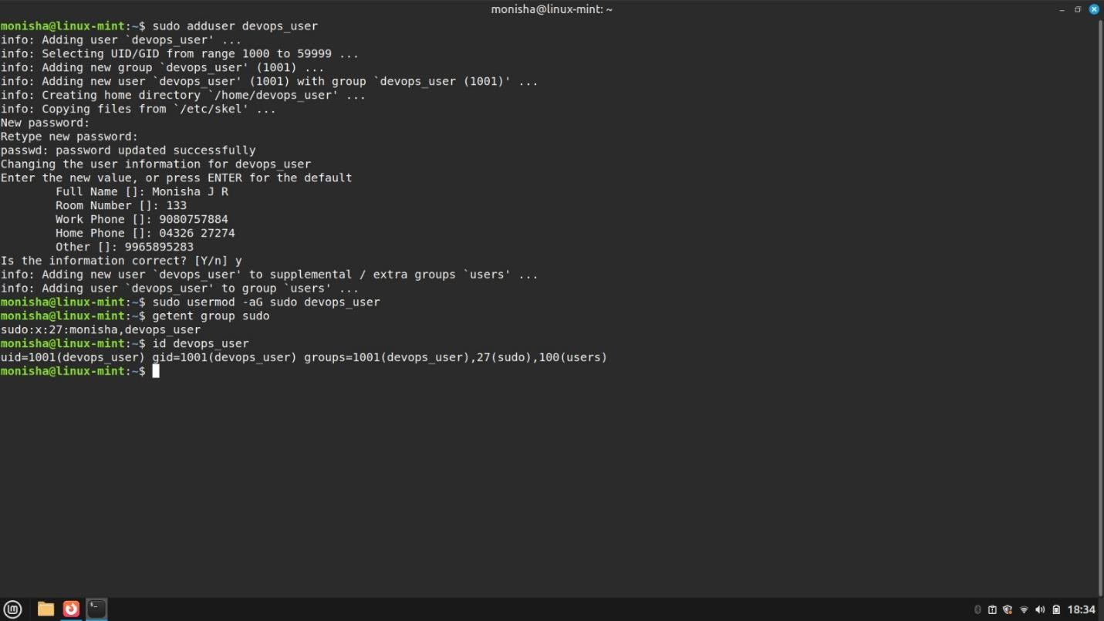**Challenge 4**: Find all files in /etc that were modified in the last 7 days.

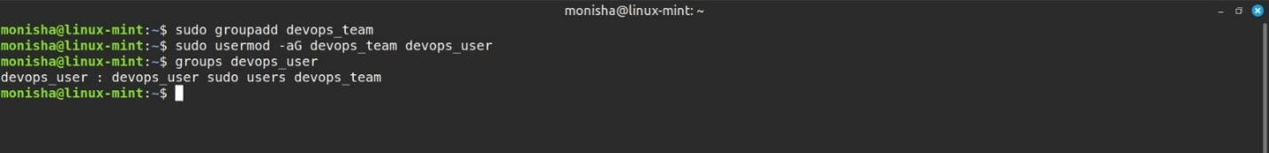**Challenge 5**: Write a one-liner command to find the most frequently used command in your shell history.

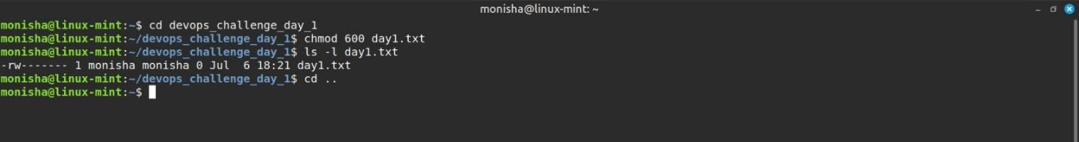**Challenge 6**: Change the permissions of day1.txt to allow only the owner to read and write, but no permissions for others.

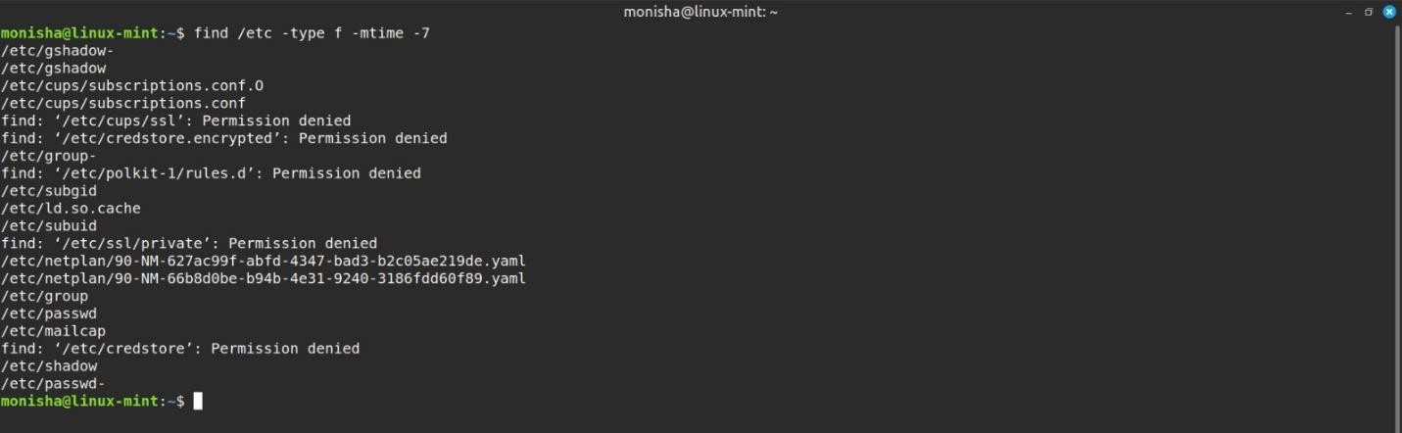**Challenge 7**: Find all files in /etc that were modified in the last 7 days.

**Challenge 8**: Write a one-liner command to find the most frequently used command in your shell history.