Refactoring Molecular Clustering Workflow using Snakemake

1. Introduction
This project implements a modular and reproducible pipeline for identifying natural substitutes for synthetic compounds. By using molecular descriptors and fingerprints, we want to cluster compounds and analyze their similarities. The workflow is arranged using Snakemake[1], a workflow management system that ensures scalability, reproducibility, and efficient execution.

2. Role of Snakemake in the Project
Snakemake is used as the backbone of this project, offering:​
- Modularity: Each analytical step is encapsulated in a separate rule, developing clarity and simplicity of maintenance.​
- Parallelization: Tasks like feature extraction and fingerprint generation are parallelized across data chunks, optimizing resource utilization.​
- Reproducibility: Snakemake tracks file dependencies, ensuring that only outdated or missing outputs are regenerated.​
- Visualization: The workflow's structure is visualized using Directed Acyclic Graphs (DAGs), aiding in understanding and debugging.​
For more on Snakemake's capabilities, refer to the official documentation [1].

2. Workflow Design and Parallelization
The workflow supports parallel execution of feature extraction and fingerprint generation across data chunks using Snakemake's wildcard and resource management features. Dependencies are automatically managed, and only changed parts are recomputed.
The DAG of the workflow is visualized in `dag.png`.

3. Snakemake Workflow Structure
Each rule represents a step:
- `load_data`: Merge natural and synthetic SMILES
- `clean_chunk`: Clean individual chunks
- `featurize_chunk`: Compute descriptors
- `fingerprint_chunk`: Compute fingerprints
- `merge_features` / `merge_fingerprints`: Combine CSVs
- `run_analysis`: Complete clustering and visualization

4. Clustering and Results

- HAC clustering used with UMAP for dimension reduction.
- Mixed clusters (natural + synthetic) identified and visualized.
- Natural substitutes reported if their Tanimoto similarity >= 0.8 with matched synthetic counterparts.

5. Challenges
Data Chunking
Challenge: Effective processing of large datasets.
Solution: The dataset is divided into chunks, allowing parallel execution of data cleaning, feature extraction, and fingerprint generation. This approach reduces computation time and memory.
Rule Dependency Management
Challenge: Proper ordering of Snakemake rule execution.
Solution: Snakemake's automatic dependency management ensures a rule is executed only after its prerequisites have been met. Proper ordering is ensured by declaring explicit input and output files for all rules.
Reproducibility
Challenge: Having consistent results across different runs and environments.
Solution: By specifying exact versions of libraries and tools in a requirements.txt file and making use of Snakemake's configuration capabilities, the workflow is reproducible.

6. DAG Visualization
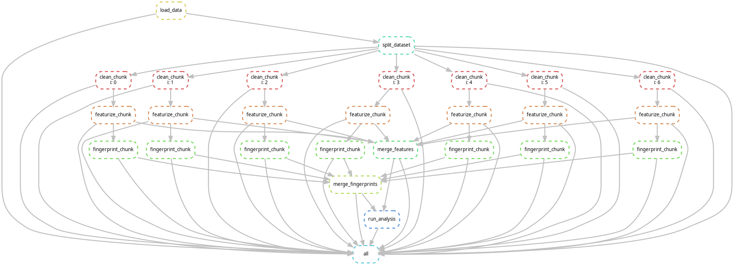

References
[1] https://snakemake.readthedocs.io/en/stable/
[2] Chat GPT: as editor of context and also solving code’s errors

