|  |  |  |
| --- | --- | --- |
|  | **Rochester Institute of Technology**  **Golisano College of Computing and Information Sciences**  **School of Interactive Games and Media**  **2145 Golisano Hall – (585) 475-7680** |  |

**Data Structures & Algorithms for Games & Simulation II**

**IGME 309, 2015 Fall**

**E05: Translations**

You have starting code through ReEngine, you may use your own solution if you want to, but the translation of starting code is entirely your responsibility. Startup code is available at: <https://github.com/labigm/ReEngApplication> under the **E05_Translations** project. It will generate this:

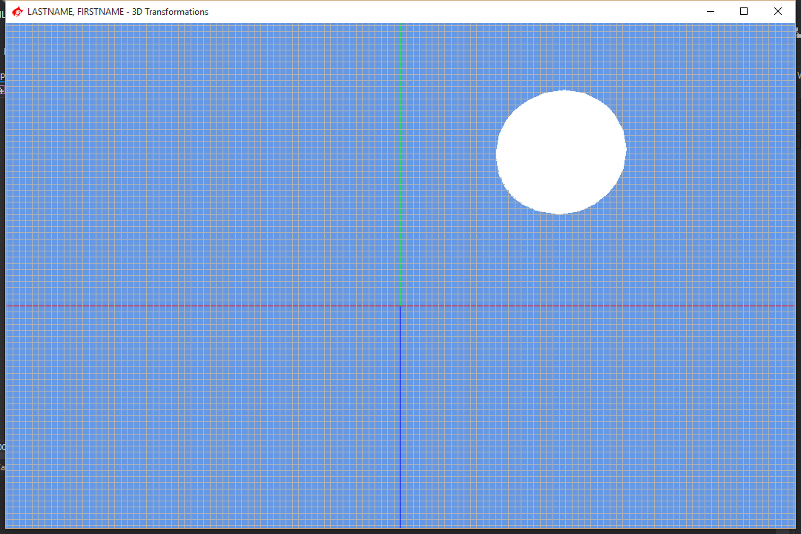

The goal of this in-class exercise is to get practice generating shapes and performing translations on them under a common coordinate system.

Using the provided code replicate the image show below:

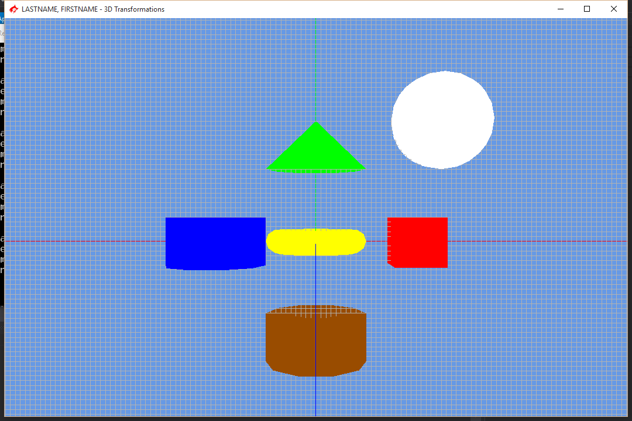

All shapes has a radius of 1 and are one unit in size, you can use other colors if you want.

Show this to the professor or TA and submit to the dropbox labeled E05 Translations.

Remember to delete the Z_Delete file, the .SDF folder and the projects you are not using for this solution.