SIMATS ENGINEERING
ASSESSMENT TOOL 3

COURSE NAME: INTERNET PROGRAMMING
COURSE CODE: CSA43

COURSE OUTCOME COVERED

CO-1: Develop well-structured, standards-compliant web pages using HTML/XHTML and XML, and apply Internet protocols and HTTP communication mechanisms for web content delivery. (L2)

Assessment Tool : Case Study

Weightage: 10%

QUESTIONS: Total Marks: 10

Scenario: Web Development Standards Implementation
A startup is developing a modern web application. During development, the team encounters multiple issues related to HTML elements, HTTP methods, XML syntax, and web communication protocols.
The following observations are made:
- The team needs to embed a promotional video on the homepage.
- A registration form must securely send user data to the server.
- The navigation menu must follow semantic HTML standards.
- XML configuration files are being used but contain syntax errors.
- The application must communicate over the correct web protocol.

Data Snippets Provided
Snippet 1: Video Embedding Options
A. <media src="video.mp4"></media>
B. <video src="video.mp4" controls></video>
C. <movie src="video.mp4"></movie>
D. <vid src="video.mp4"></vid>
Snippet 2: Form Submission Methods
A. GET
B. POST
C. PUT
D. DELETE
Snippet 3: Navigation Elements
A. <div>
B. <nav>
C. <section>
D. <header>
Snippet 4: XML Syntax
A. <note><to>User</to><from>Admin</from>
B. <note><to>User</to><from>Admin</from></note>
C. <note><to>User</from></note>
D. <note to="User"></note
Snippet 5: Web Communication Protocols
A. FTP
B. HTTP
C. SMTP
D. SNMP

Questions:
- Select the correct HTML tag for video embedding and justify your answer.
Correct Answer: Option B — <video src="video.mp4" controls></video>
The HTML5 <video> tag is used to embed video content directly into a web page. The src attribute specifies the video file location, while the controls attribute displays playback controls such as play, pause, volume, and fullscreen. It is a standard HTML element supported by modern web browsers.
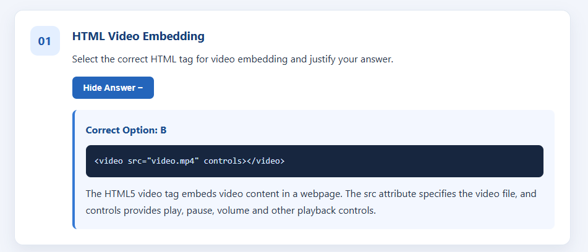

- Identify the appropriate HTTP method for form submission and explain why.
Correct Answer: Option B — POST
The POST method is appropriate for submitting registration form data to a server. It sends the submitted data in the HTTP request body rather than placing it in the URL. This is suitable for user registration and other data-submission operations. However, POST alone does not guarantee security; HTTPS should be used to encrypt the data during transmission.
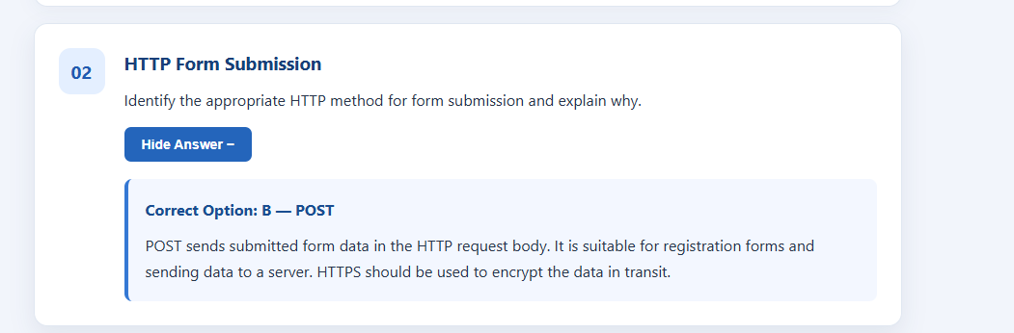

- Choose the proper semantic element for navigation and justify its usage.
Correct Answer: Option B — <nav>
The <nav> element is a semantic HTML element used to define a section containing major navigation links. It helps browsers, search engines, and assistive technologies understand the structure of a web page. Using <nav> instead of a generic <div> improves accessibility and makes the HTML code more meaningful and maintainable.
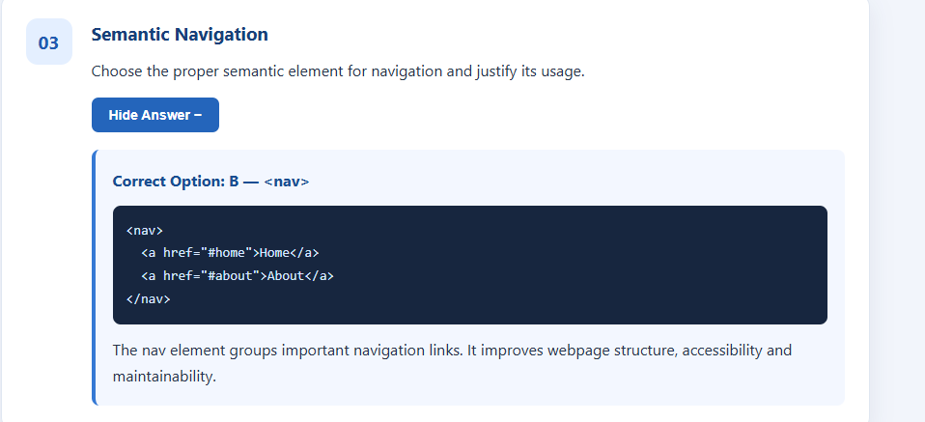

- Identify the correct XML syntax and explain the error in other options.

Correct Answer: Option B

<note>
<to>User</to>
<from>Admin</from>
</note>Option B is correct because every opening tag has a matching closing tag, and the document contains a single root element, <note>.
- Option A: Incorrect because the <note> root element is not closed.
- Option B: Correct because all elements are properly opened and closed.
- Option C: Incorrect because the <to> element is opened but incorrectly closed with </from>.
- Option D: Incorrect because the closing angle bracket > is missing from the closing tag </note>.
XML requires properly nested elements, matching opening and closing tags, and exactly one root element.
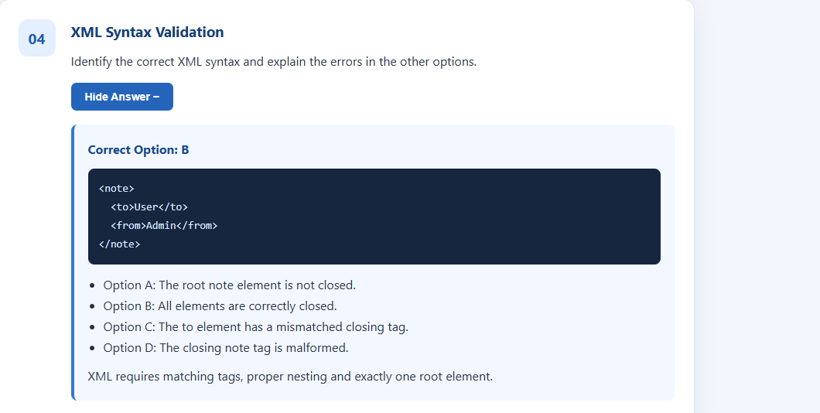

- Choose the correct protocol for web communication and justify your choice.
Correct Answer: Option B — HTTP
HTTP (Hypertext Transfer Protocol) is the application-layer protocol used for communication between web browsers and web servers. It allows clients to request web pages and other resources, while servers send responses containing the requested content. HTTPS is the secure version of HTTP and uses encryption through TLS to protect data during transmission. Therefore, HTTPS is recommended for modern web applications, especially those handling registration and personal information.
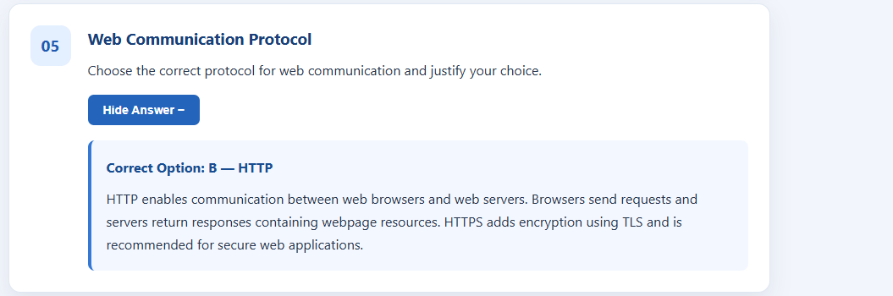

Code of Conduct:

I ____________________ (Name / Reg No) certify that this submission is my original work and that I have adhered to the guidelines specified for this assessment.
I understand that any violation of academic integrity rules will result in disciplinary action.

Signature of the student:

RUBRICS FOR CALCULATION:

Criteria | Weightage | Level 4 – Exemplary | Level 3 – Proficient | Level 2 – Developing | Level 1 – Beginning
Understanding of Case | 25 | Thorough understanding; clearly identifies all key issues | Good understanding with most issues identified | Basic understanding; some issues missed | Poor understanding; problem not identified correctly
Application of Concepts | 25 | Effectively applies relevant concepts to analyze the case deeply | Applies appropriate concepts with minor gaps | Limited application of concepts | Fails to apply relevant concepts
Analysis | 20 | In-depth analysis with strong reasoning and insights | Good analysis with logical reasoning | Basic analysis with limited depth | Weak or no analysis; lacks reasoning
Solution Design | 20 | Innovative, feasible solutions with strong justification | Logical solutions with adequate justification | Basic solutions with weak justification | Incorrect or no solution provided
Clarity | 10 | Clear, well-structured, and easy to understand | Organized and understandable presentation | Limited clarity and structure | Poor clarity; difficult to understand

