ShopBridge

# Overview

* ShopBridge is an E-Commerce site to manage the products.
* It’s a single page application developed by Angular, Angular Material, CSS, Bootstrap, Http services for front end, Jasmine Karma for unit testing and node js express for sample database.
* User can view, add, modify, and delete items from the cart.
* Routing is implemented to navigate easily without refresh of application.
* Unit testing is done with 97% code coverage.
* Form Validations are done with user friendly messages.
* Exception Handling is taken care of.

# Home Page

* The landing page of ShopBridge which has navigation bar to navigate between View Items, Add Item, Delete Item, Modify Item.
* Default path or wrong path redirects to home page.

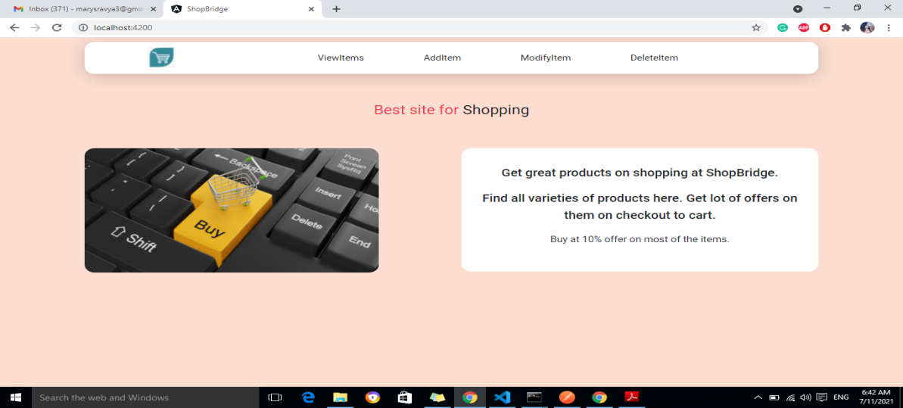

# View Items Page

* It enables to view all the items present in the cart. It includes name, cost and description of each product.
* Total Cost of all the products in the cart can also be seen.
* Pagination is included to cut down data into pages.
* ViewItems link is highlighted on navigation bar.

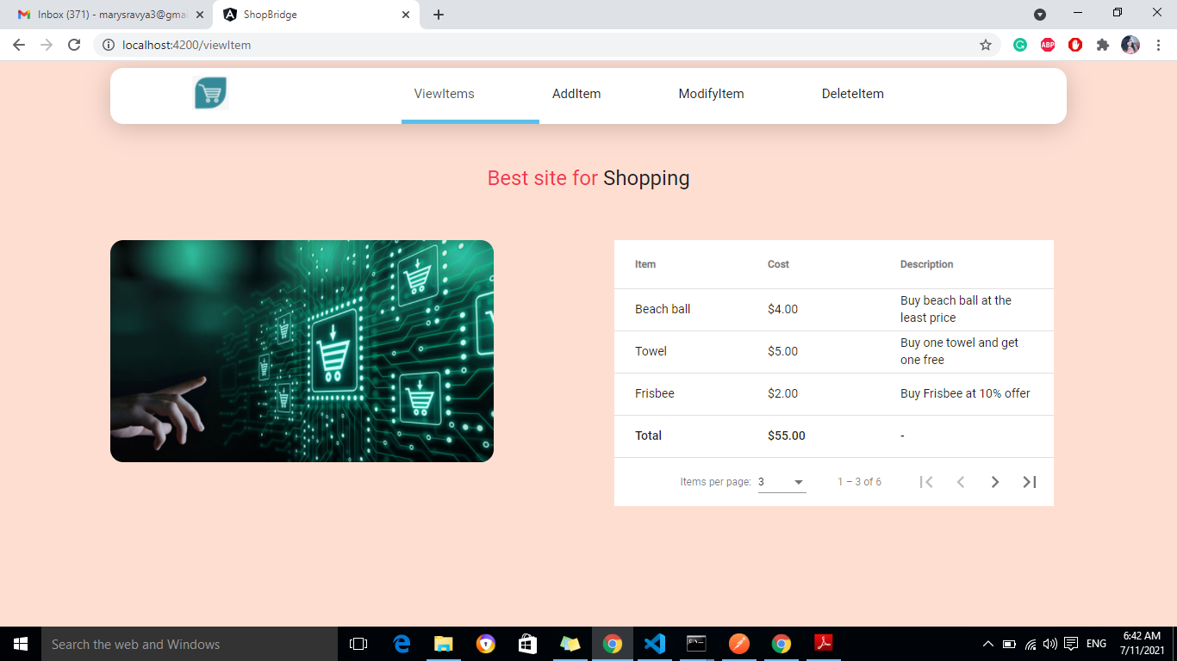

# Add Item

* Angular reactive form is used to add items to the cart.
* Name, Cost, Description are the fields to be entered.
* Respective field validations are done.
* On submit, success or error message is shown.
* Submit button is disabled if the form is invalid.

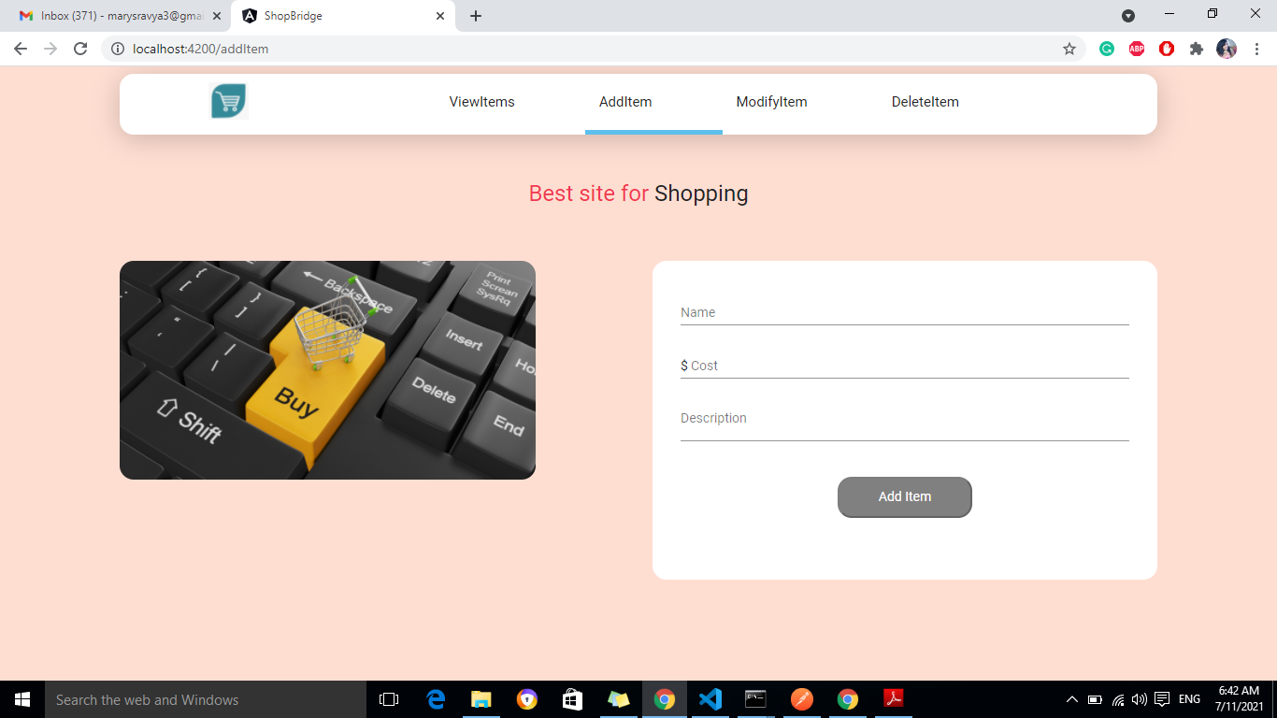

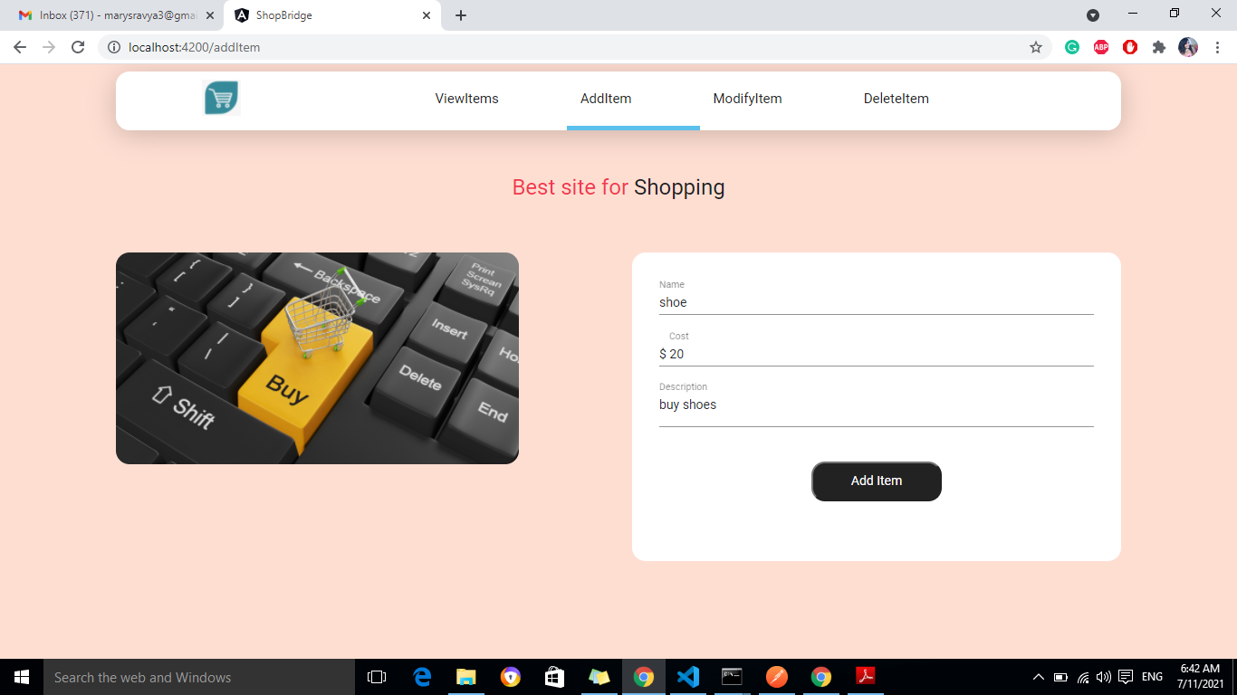

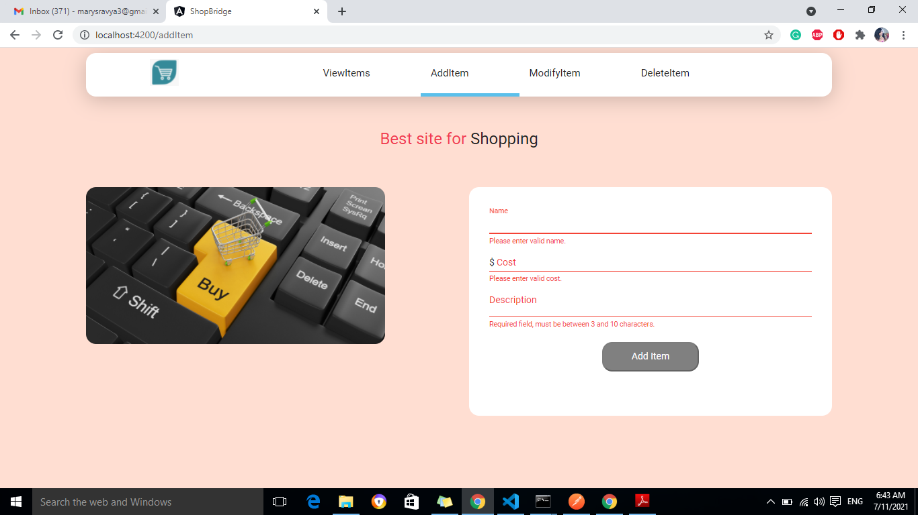

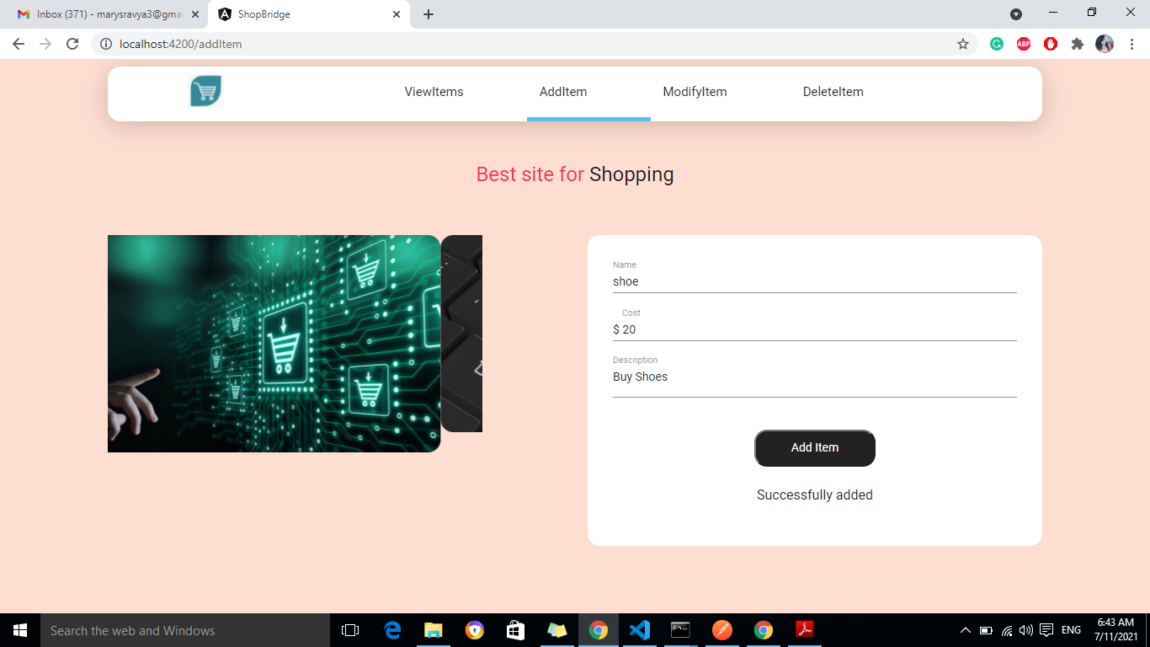

# Modify Item

* User can select a product name from Name dropdown.
* The other fields are auto selected after the name is chosen.
* Can modify any of the fields and submit.

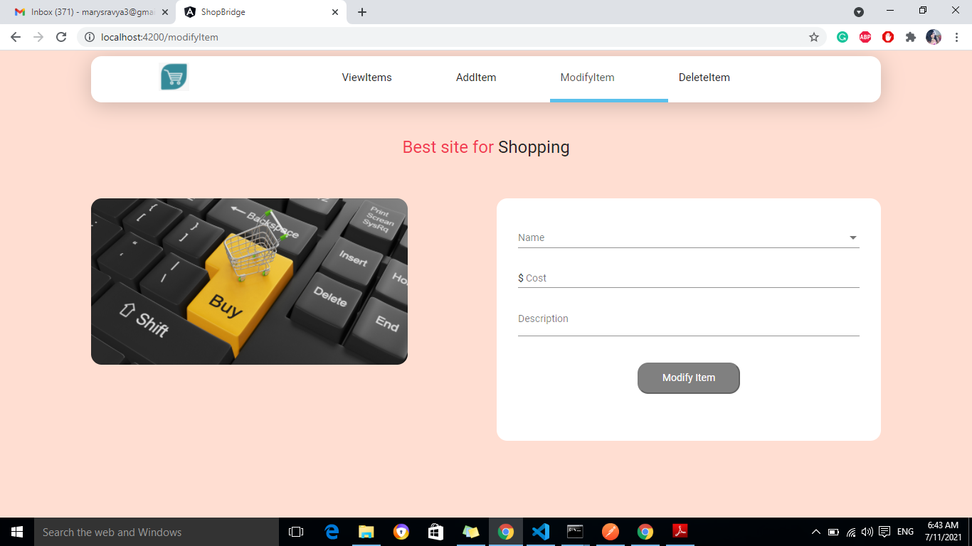

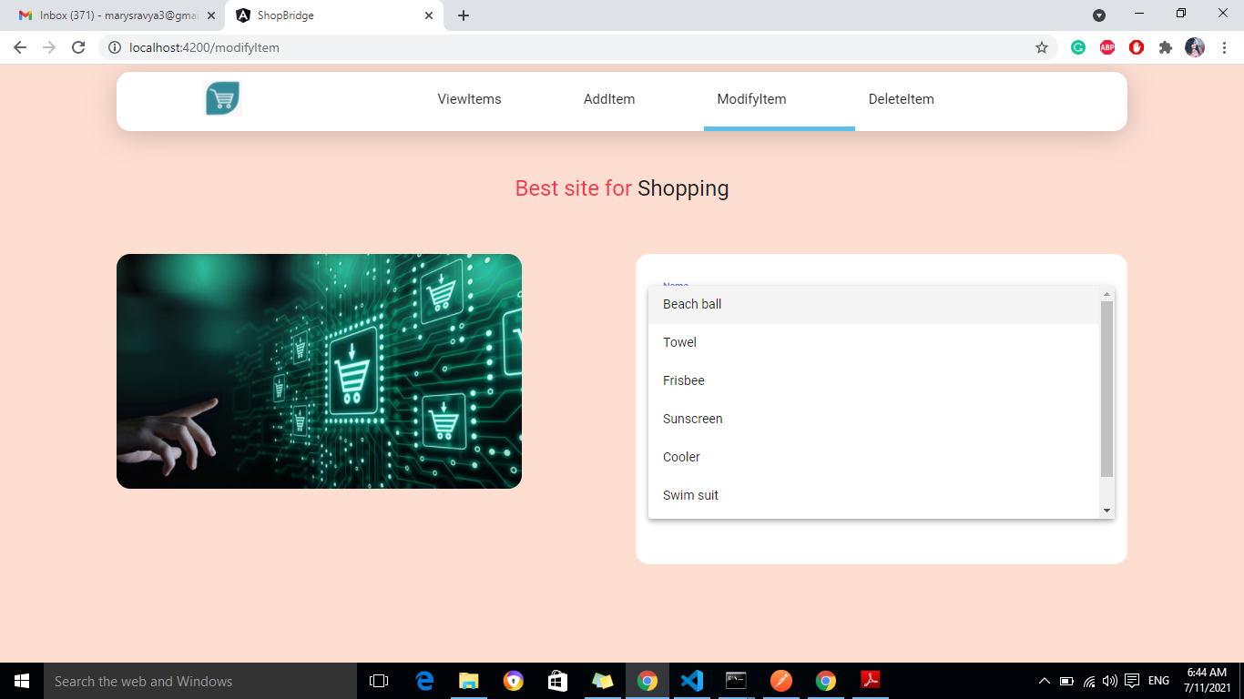

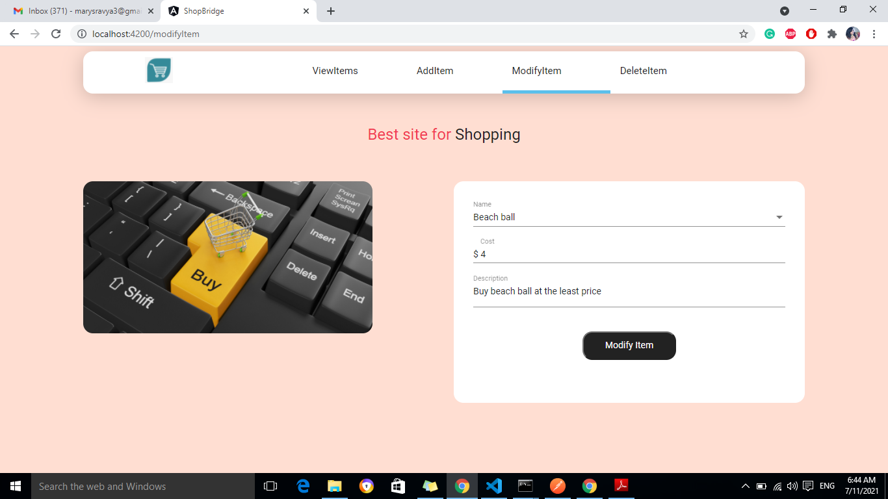

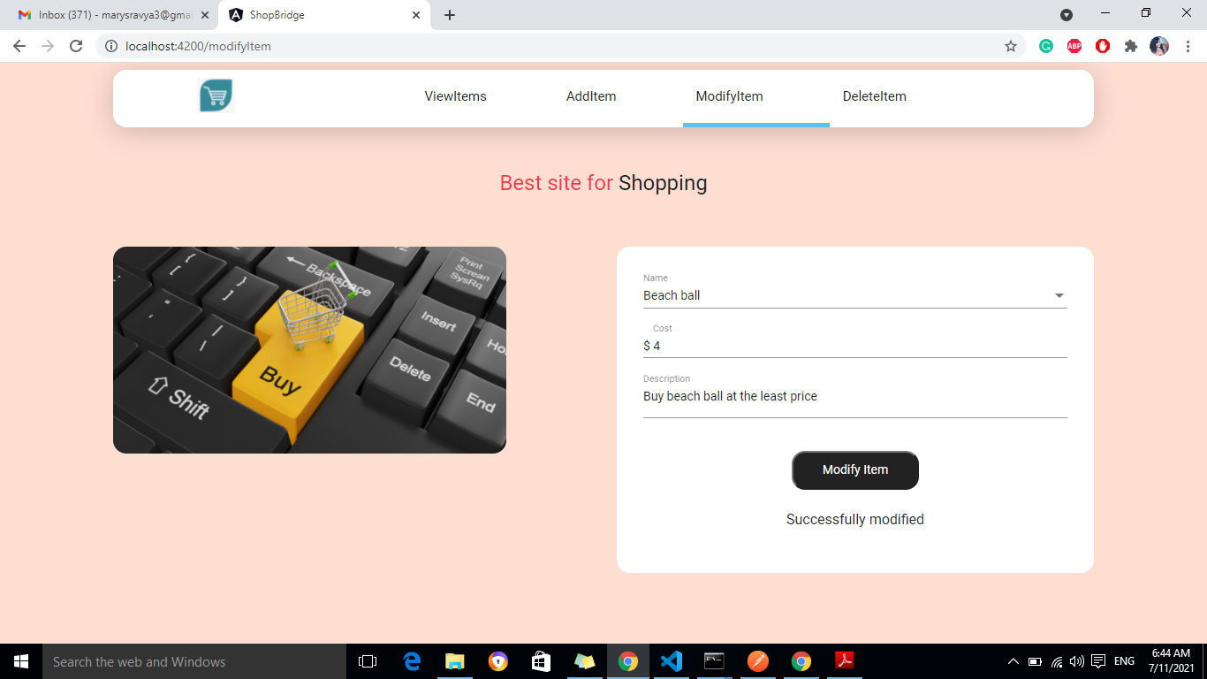

# Delete Item

* User can select a product by choosing the name from the dropdown and click on Delete button.

