PorciTrack

Professional User Manual

System Version 1.0.0 | Official Operations Manual Prepared for: Farm Administrators & Field Personnel

© 2026 PorciTrack. All rights reserved.

PorciTrack — Professional User Manual

System Version: 1.0.0 | Document Type: Official Operations Manual
Prepared for: Farm Administrators & Field Personnel

Table of Contents
- [System Overview](#1-system-overview)

- [User Roles & Access Control](#2-user-roles--access-control)
- [Getting Started: Registration & Login](#3-getting-started-registration--login)
- [Administrator Portal](#4-administrator-portal)

- 4.1 Farm Dashboard
- 4.2 Pen Management
- 4.3 Swine Registry & Health
- 4.4 Task Deployment
- 4.5 Inventory Management
- 4.6 QR Label Generator
- 4.7 Reports
- 4.8 System Settings
  - [Field Worker Portal](#5-field-worker-portal)

- 5.1 Worker Dashboard
- 5.2 Task Board
- 5.3 Swine Details & Daily Assessment
- 5.4 Emergency Flagging
- 5.5 Weekly Reports
  - [Data Definitions & Field Reference](#6-data-definitions--field-reference)
  - [System Automation & Business Logic](#7-system-automation--business-logic)
  - [Troubleshooting & FAQ](#8-troubleshooting--faq)

System Overview

PorciTrack is an enterprise-grade, web-based livestock management platform built specifically for modern piggery operations. It provides end-to-end visibility over animal health, feed inventory, workforce accountability, and regional biosecurity threats.

Core Capabilities

Capability | Description
Livestock Registry | Individual pig tracking from registration to sale/disposal
Biosecurity Intelligence | AI-powered regional disease risk scoring per pen
Offline-First PWA | Field workers can operate without internet connectivity
Real-Time Alerts | Critical medical emergencies escalate instantly to admins
Inventory Control | Feed, medicine, and sanitation stock tracking
Task Management | Protocol deployment with progress tracking
QR Traceability | Unique QR labels for each pen and animal

      - Technology Stack
Backend: Laravel 12 / PHP 8.4
Frontend: Blade Templates, Vanilla CSS, JavaScript (ES6+)
Database: MySQL / MariaDB
Key Libraries: SweetAlert2, Boxicons, jsPDF

User Roles & Access Control

PorciTrack uses Role-Based Access Control (RBAC) with two primary roles.

Role Comparison

Feature | Administrator | Farm Worker
Farm Dashboard | ✅ | ✅ (simplified view)
Pen CRUD (Create/Edit/Delete) | ✅ | ❌
Register/Edit/Delete Animals | ✅ | ❌
View Assigned Pigs & Pens | ✅ | ✅
Daily Health Assessment | ❌ | ✅
Task Deployment | ✅ | ❌
Task Completion | ❌ | ✅
Inventory Management | ✅ | ❌
QR Label Generation | ✅ | ❌
Weekly Reports (submit) | ❌ | ✅
Weekly Reports (view all) | ✅ | ❌
System Settings | ✅ | ❌
Emergency Alert (send) | ❌ | ✅ (via health log)
Emergency Alert (receive) | ✅ | ❌

      - Routing Logic
Upon login, the system automatically redirects each user to their appropriate portal:
Administrators → /admin/dashboard
Farm Workers → /worker/dashboard

Getting Started: Registration & Login

Accessing the System
Navigate to the PorciTrack URL in any modern web browser (Chrome, Edge, Firefox recommended).
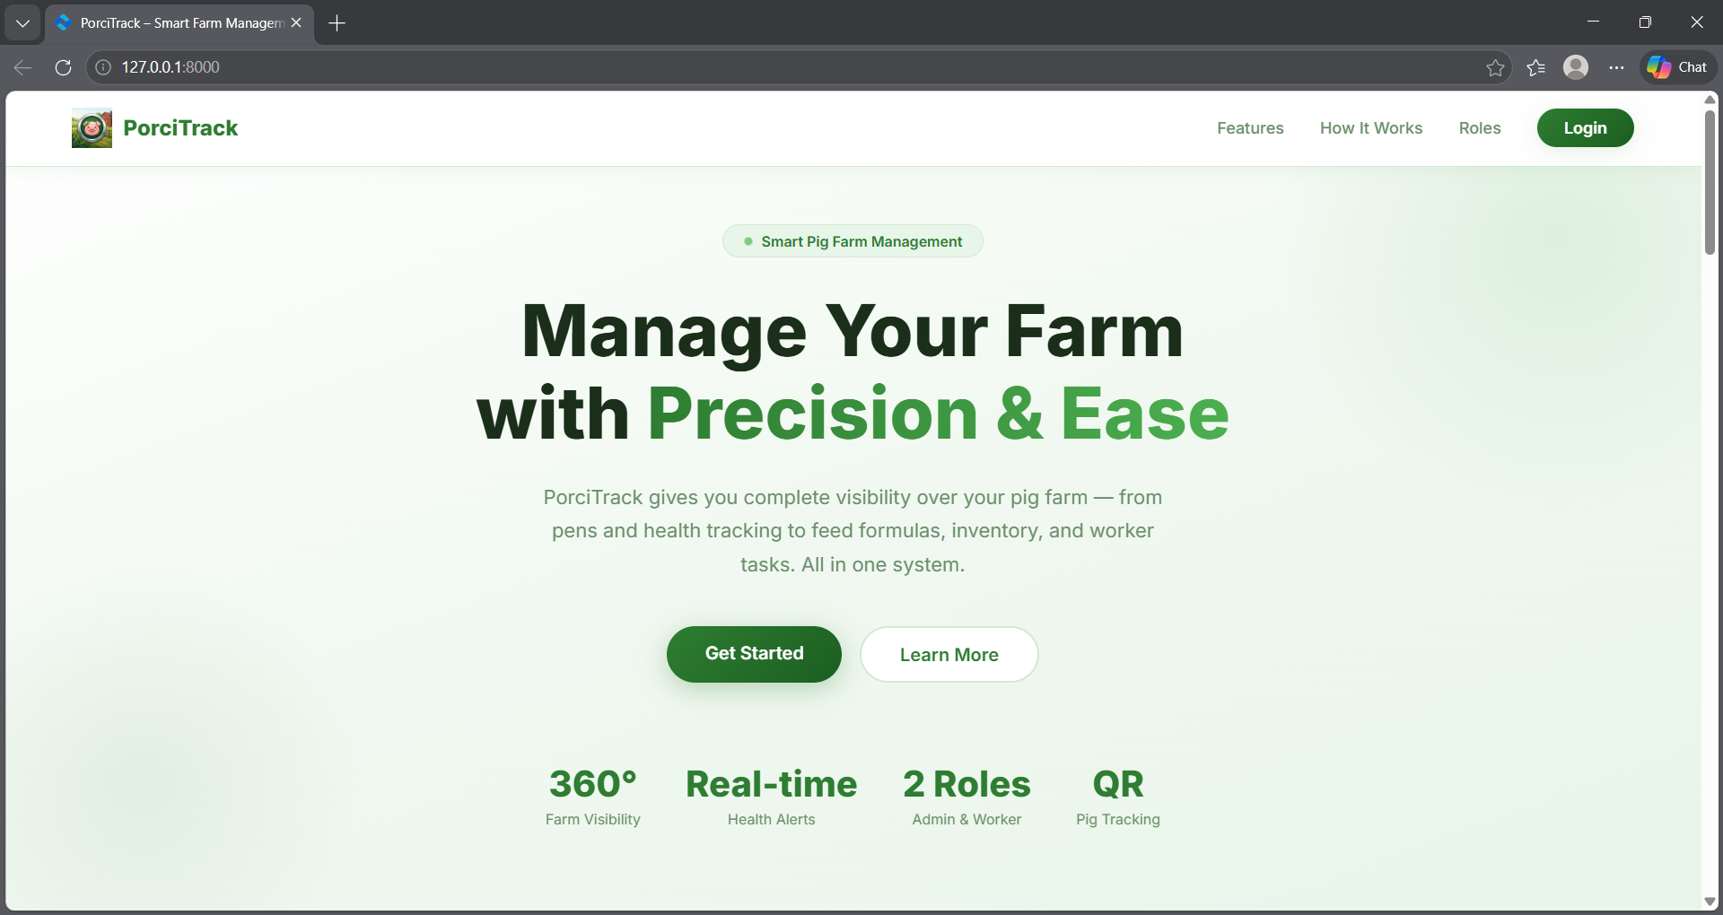

Creating an Account
New users may register via the Create Account form.

Steps:
- Click "Get Started" or "Create Account" on the landing page.
- Fill in the following required fields:

- Full Name — Your complete legal name.
- Email Address — A valid, unique email address for login.
- Role — Select either admin or farm_worker from the dropdown.
- Profile Photo (optional) — Upload a profile image.
- Password — Minimum 8 characters.
- Confirm Password — Must match the password field exactly.
  - Click "Sign Up" to submit.
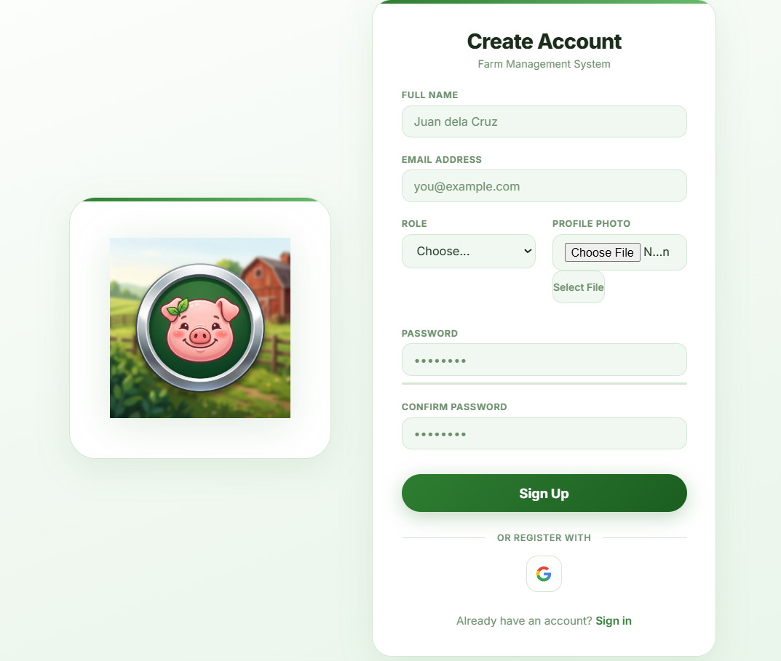
  - Alternatively, use "Sign in with Google" for OAuth-based registration

Important: A user's role determines their entire portal experience. Ensure the correct role is selected before submitting.

Logging In
- Navigate to the login page via the "Login" button on the landing page.
- Enter your registered Email Address and Password.
- Click "Sign In".
- Use "Forgot Password?" if you cannot recall your credentials.

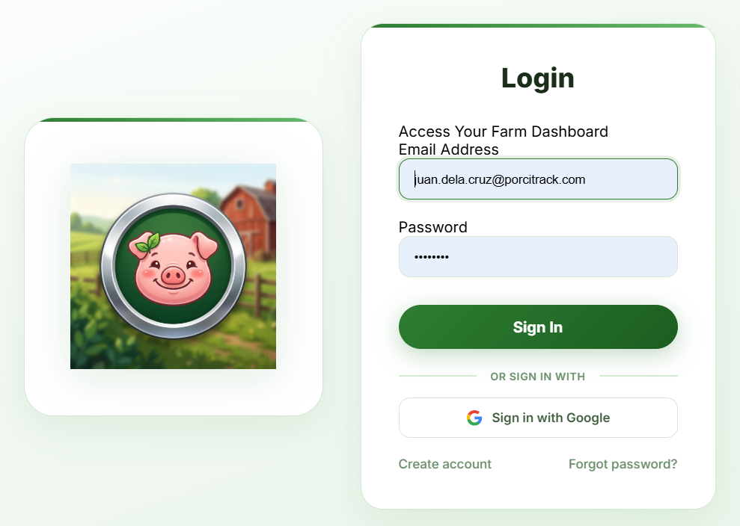

Administrator Portal

Farm Dashboard

The Admin Dashboard is the primary control center. It loads automatically upon admin login at /admin/dashboard .
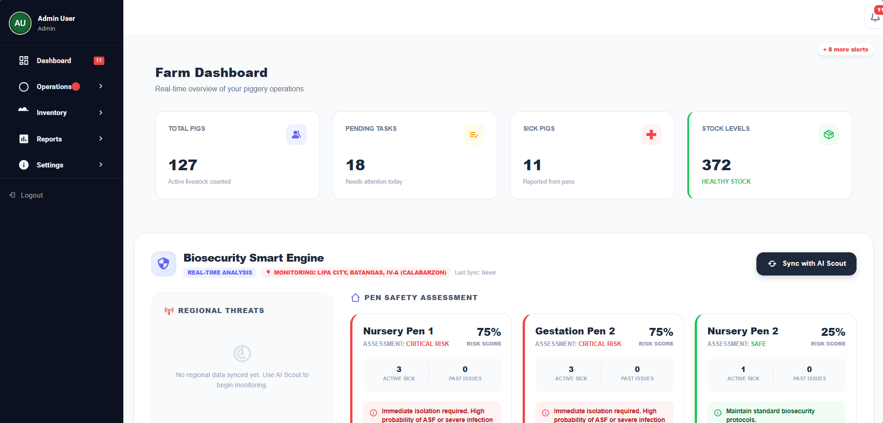

        - Summary Stat Cards

Four cards at the top of the dashboard provide at-a-glance farm metrics:

Card | What It Shows | Data Source
Total Pigs | Count of all active pigs (excludes Sold/Disposed) | pigs table
Pending Tasks | Count of tasks with status = pending | tasks table
Sick Pigs | Count of pigs with healthstatus  = Sick | pigs table
Stock Levels | Net available inventory (Total Delivered − Total Consumed) | feeddeliveries ,  feed_consumptions tables

        - Biosecurity Smart Engine

The Biosecurity Smart Engine is an AI-powered risk assessment tool that calculates a
Risk Score (0–100) for each pen based on two inputs:

          - Regional Disease Data — Active diseases synced from the AI Scout (via Gemini API).
- A High -level regional disease adds +15 to the base risk.
- A Medium -level regional disease adds +5 to the base risk.
1. Pen Health Data — Active sick animals and historical medical activity logs.

- Each active sick animal adds +25 to the pen's score.
- Each historical medical activity adds +5 to the pen's score.

Risk Thresholds:

Score Range | Status | Recommended Action
0 – 39 | ✅ Safe | Maintain standard biosecurity protocols.
40 – 74 | ⚠ Elevated Risk | Increase sanitation frequency. Monitor closely.
75 – 100 | 🔴 Critical Risk | Immediate isolation required. High probability of infection spread.

To refresh the regional disease data, click the "Sync with AI Scout" button.

        - Real-Time Worker Alerts

The dashboard automatically polls the API endpoint /admin/api/unacknowledged- alerts every few seconds. When a field worker logs a critical medical emergency, the admin receives:

An auditory notification sound.

A pop-up alert showing the exact Pig Tag and Pen Location.
The alert persists until the administrator clicks "Acknowledge".

Pen Management

Navigate to: Operations → Pens & Pigs
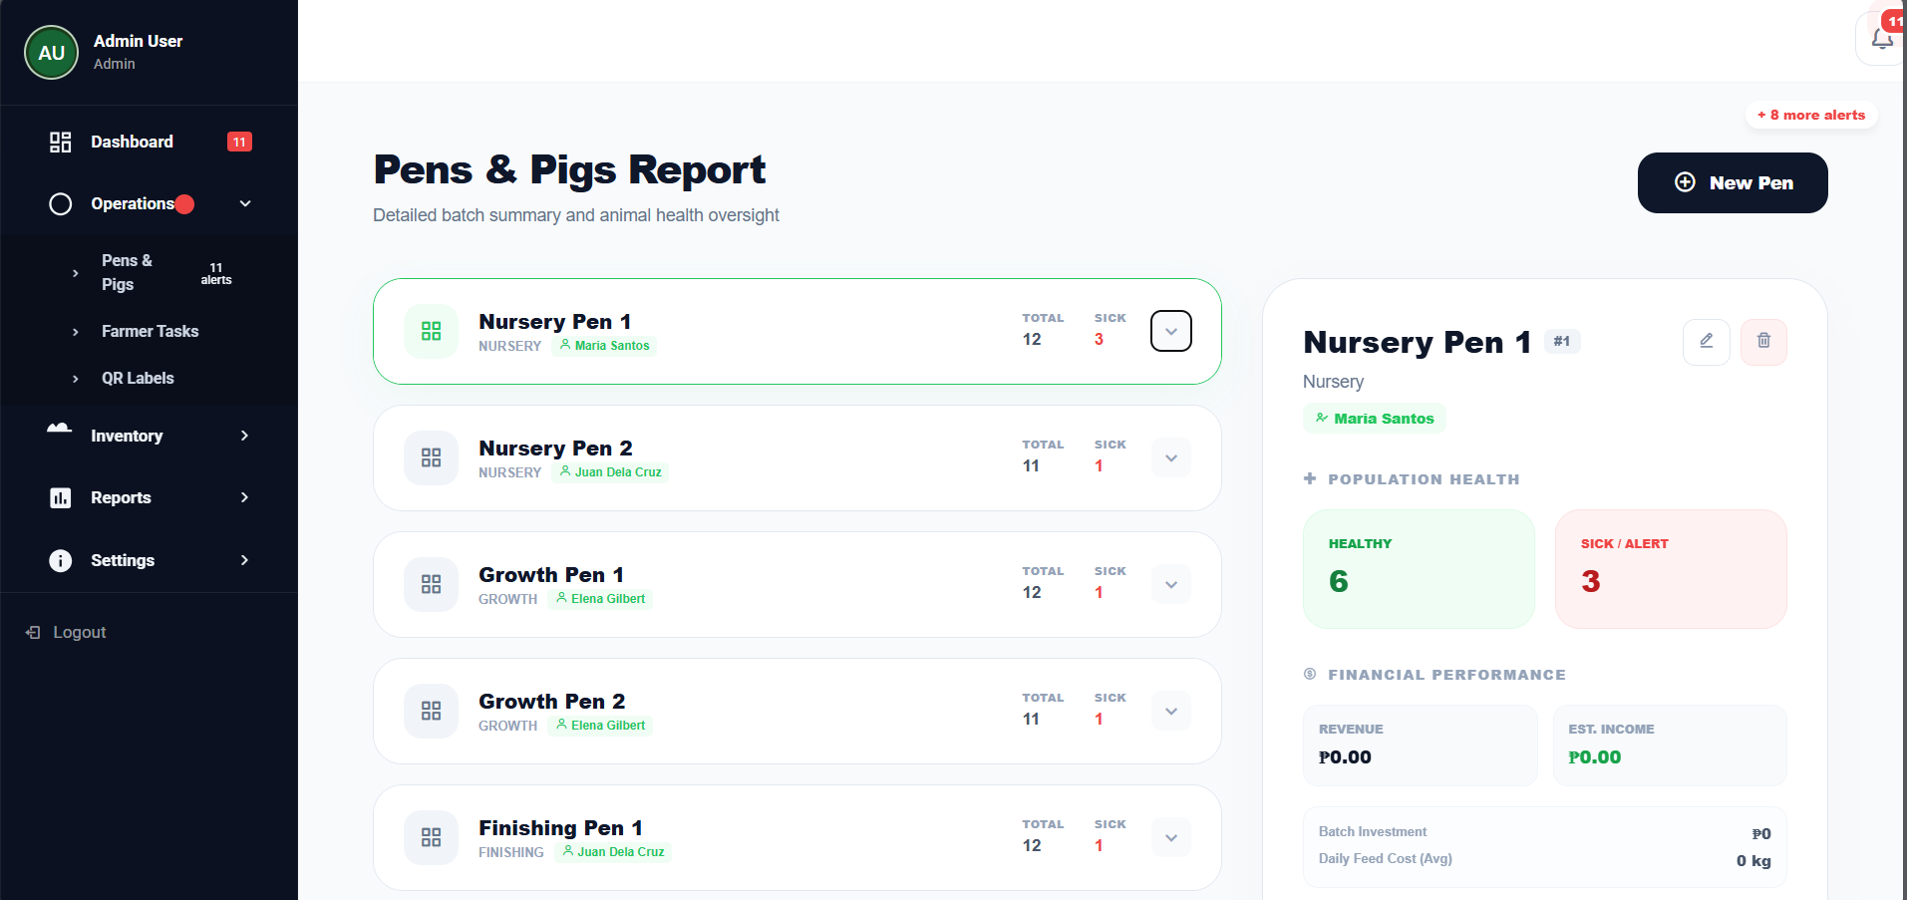

This page is the central hub for managing all physical pens on the farm. Each pen card shows the pen name, assigned section, assigned personnel, total pig count, and sick pig count.

        - Creating a New Pen

          - Click the "+ New Pen" button in the top-right corner.
          - The Create New Pen modal will appear. Fill in:

- Pen Identifier / Name (required) — e.g., "Pen Alpha-1". This name drives the auto- generated Ear Tag prefix.
- Auto-Generated Code — Read-only. Automatically derived from the pen name.
- Section / Classification — e.g., "Nursery", "Fattening", "Gestation".
- Assigned Personnel — Select a registered Farm Worker from the dropdown.
- Initial Pig Count — Number of pigs to pre-populate in the pen upon creation. The system will auto-generate unique Ear Tag IDs for each.
- Batch Investment (₱) — The total cost of purchasing/acquiring the initial batch.

- Avg Start Weight (KG) — Average starting weight of animals in the batch.
- Target Weight (KG) — The target market weight for the batch.
- Start Date / End Date — The operational date range for this batch.

- Click "Confirm" to save.
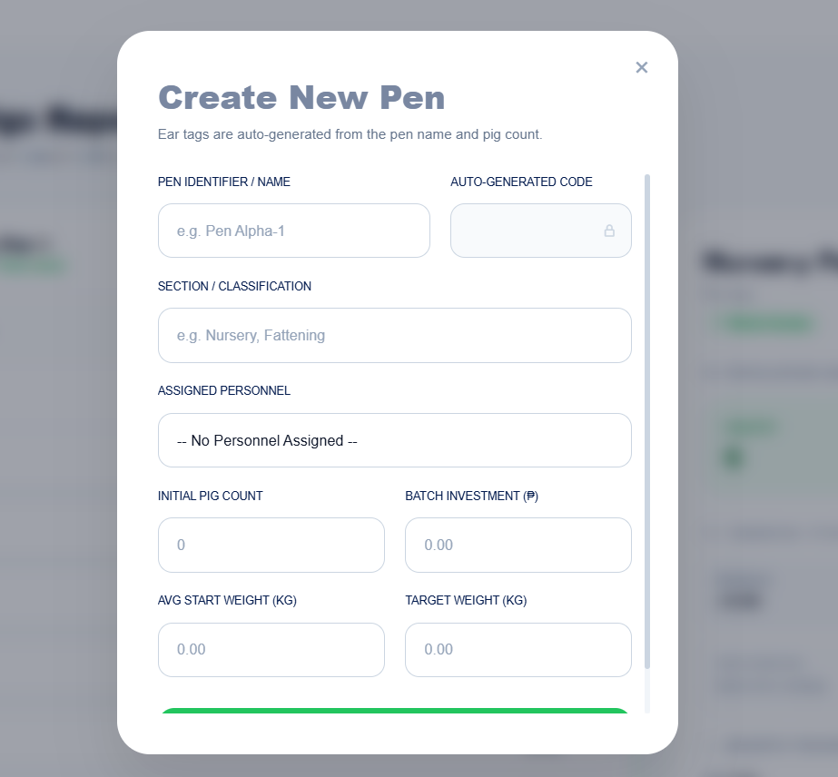

Note: Ear Tags are auto-generated using the pen name prefix and a sequential counter (e.g., Pen "Alpha" generates tags ALPHA-001 , ALPHA-002 ). The system guarantees uniqueness across all pens.

        - Viewing Pen Details

Click on any pen card to expand it and view the individual pigs list on the left and the
Pen Detail Panel on the right.

The Pen Detail Panel shows:
Population Health — Count of Healthy vs. Sick/Alert animals.
Financial Performance — Revenue from sold pigs, Estimated Income (Revenue − Batch Investment), Daily Feed Cost Average.
Growth Progress — Average weight vs. target weight.

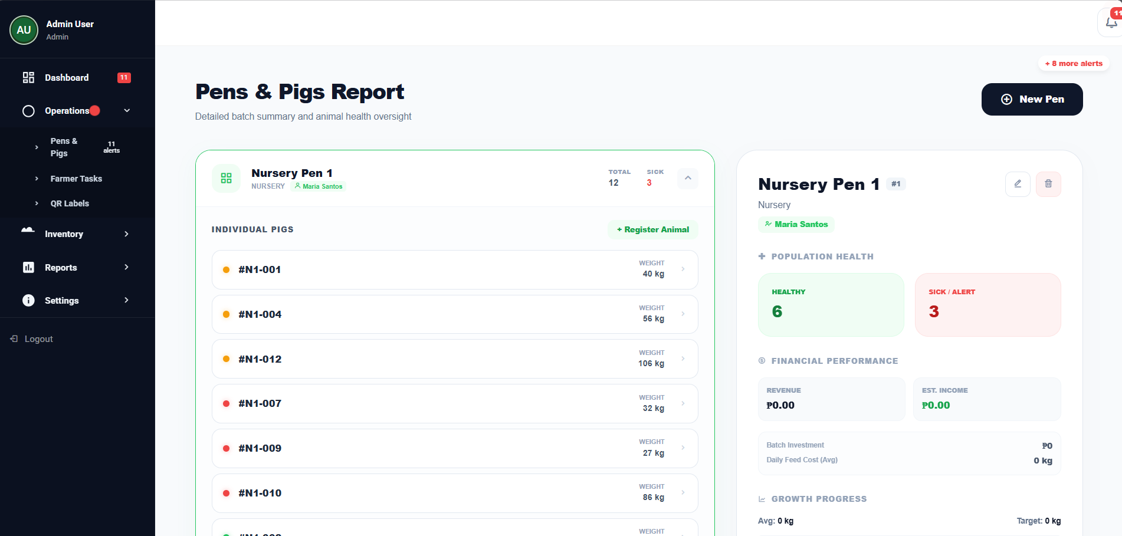

        - Editing & Deleting a Pen
Edit: Click the ✏ (pencil) icon on the Pen Detail Panel to update pen information. Delete: Click the 🗑 (trash) icon. Note: Deleting a pen is permanent and will cascade to related records.

        - Generating a Pen Report

At the bottom of the Pen Detail Panel, click "Generate & View Report". A modal will open with a complete batch summary including economic metrics, health status breakdown, and activity logs. A PDF can be downloaded directly from this modal.

Swine Registry & Health

        - Registering a New Animal

From within an expanded pen, click "+ Register Animal".

The Register Individual Animal modal provides two options:
New Registration — Register a brand-new animal. The Ear Tag is auto-generated and system-protected (cannot be manually changed).
Transfer Existing — Move a pig that is already registered in the system into this pen.
For a New Registration, fill in:

Initial Weight (KG)
Health Status — Defaults to "Healthy".
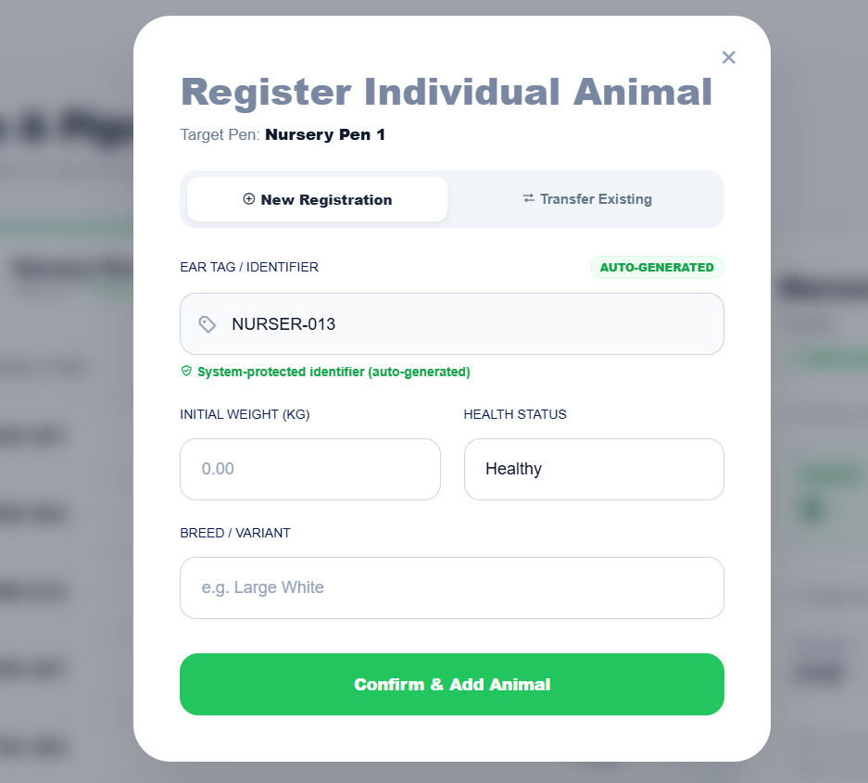
Breed / Variant — e.g., "Large White", "Duroc", "Landrace". Click "Confirm & Add Animal" to save.

        - Viewing an Individual Animal's Record

Click on any animal's tag (e.g., #A10-0010 ) in the pig list to open its Individual Record Modal.

This modal displays:
Header Card (dark): Ear Tag ID, Health Status badge (Sick/Healthy), Pen assignment, Breed.
Vitals: Current Weight (KG), Age (in weeks), BCS Score (1–5 scale).
Feeding & Mixture: Feeding Activity level, Target Market Weight, AI-recommended feed mixture formula.
Activities Tab: A chronological log of all health checks, medical events, and task completions.
Worker Tasks Tab: Pending tasks assigned to workers for this specific animal.
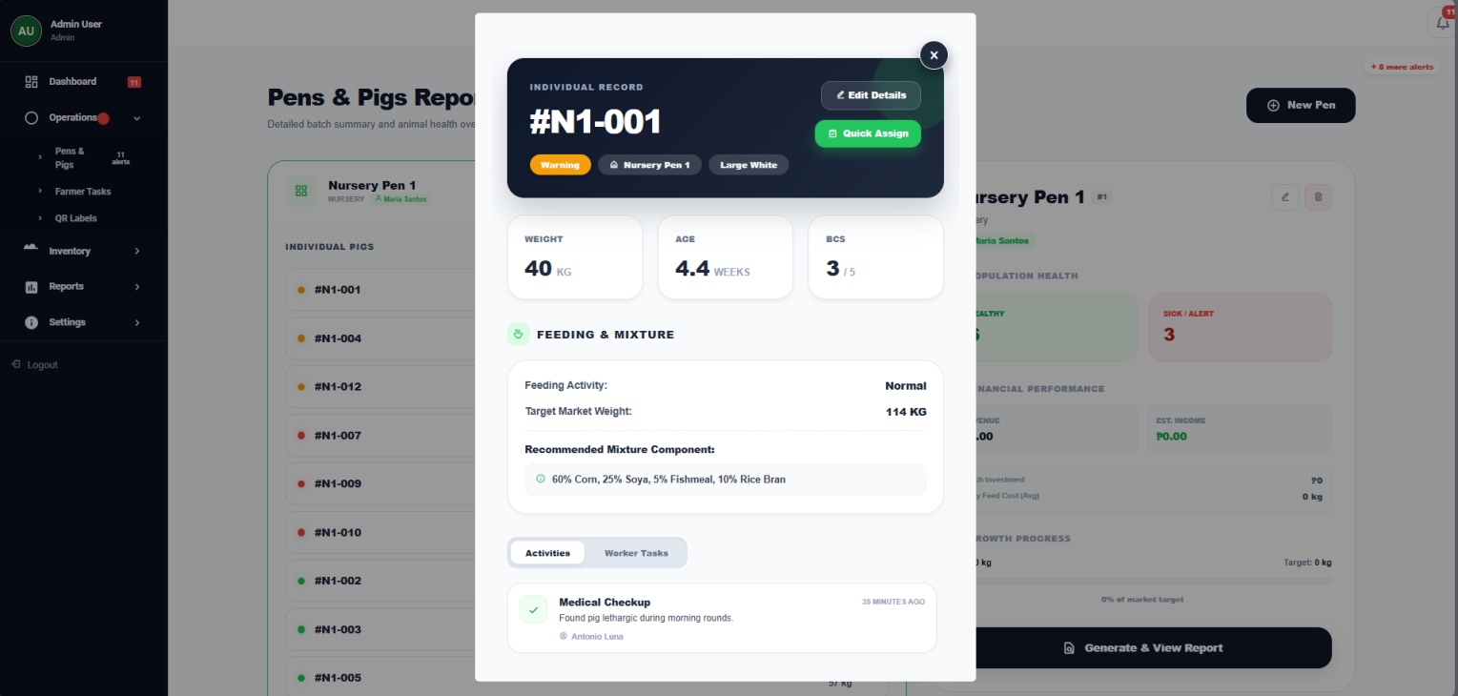

Two action buttons are available in the modal header:
"Edit Details" — Opens the editable record form.
"Quick Assign" — Opens the Assign Monitoring Task modal to deploy a worker task for this specific pig.
        - Editing an Animal's Record

Click "Edit Details" in the Individual Record Modal. The form allows modification of:

Weight, Birth Date, BCS Score
Feeding Activity (Active / Normal / Poor)

Target Market Weight
Admin Remarks / Clinical Notes

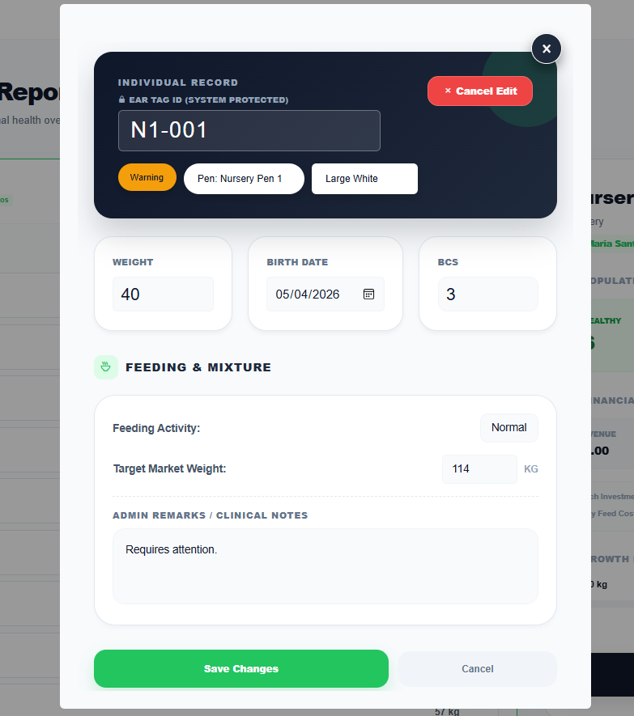
Click "Save Changes" to update, or "Cancel" to discard

        - Pig Lifecycle: Sell or Dispose

From an animal's record, administrators can permanently change a pig's lifecycle status to Sold or Disposed. This removes the animal from all active counts but preserves its historical data for financial reporting.

Task Deployment

Navigate to: Operations → Farmer Tasks
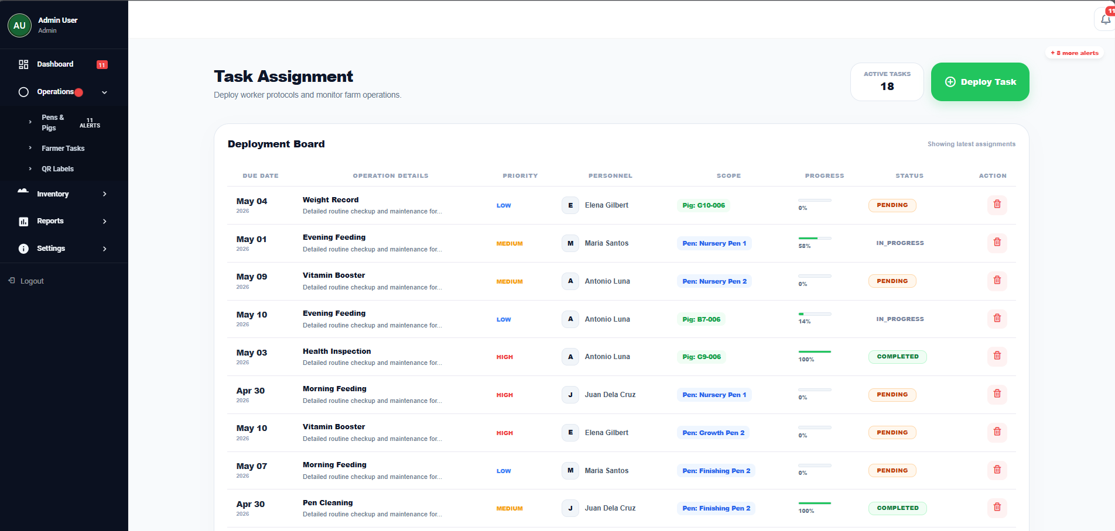

The Deployment Board displays all assigned tasks with their due date, assigned worker, target scope (pen or individual pig), progress bar, and current status.

        - Deploying a New Task

Click "Deploy Task" to open the New Assignment modal.

Fill in the following fields:
Task Objective (required) — A short title for the task (e.g., "Health Inspection").

Protocol Details — Specific instructions for the worker (e.g., "Check for swollen joints and skin redness.").
Assign Personnel (required) — Select a Farm Worker from the dropdown.
Target Pen — Select a specific pen or "General" for farm-wide tasks.
Target Pig (Optional) — Narrow the task down to a single animal.
Deployment Deadline (required) — The due date for task completion.
Task Priority — Low / Medium / High / Critical.

Click "Deploy Task" to save. Workers receive the task on their mobile dashboard instantly.
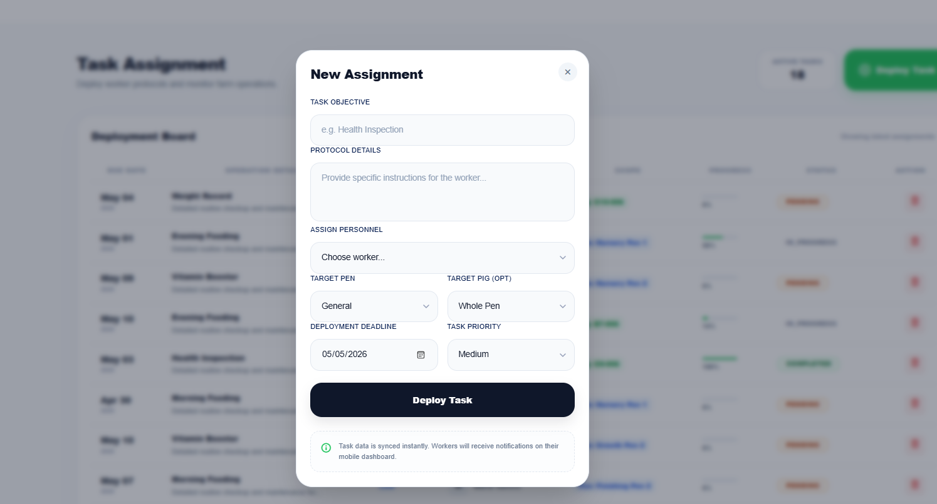

Important: Tasks with High, Urgent, or Critical priority cannot be partially saved. Workers must mark them as 100% complete in a single submission.

        - Quick Assign (from a Pig Record)

When viewing an individual animal's record, click "Quick Assign" to open the Assign Monitoring Task modal. This pre-fills the pig and pen context automatically.

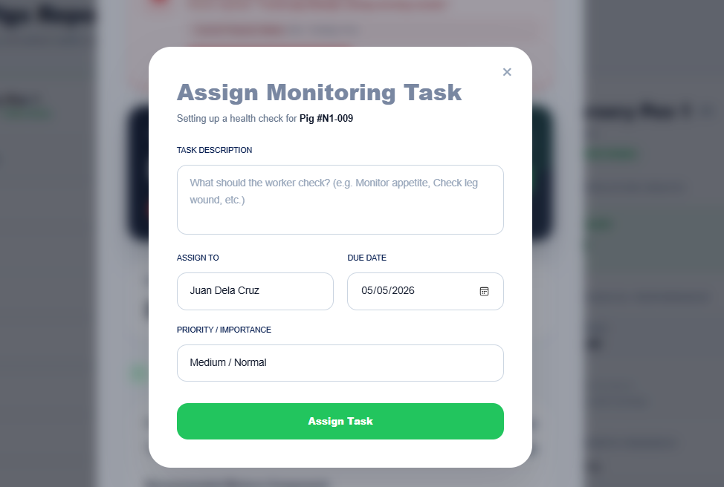

        - Deleting a Task
Click the 🗑 icon in the task row's Action column. Only administrators can delete tasks.

Inventory Management

Navigate to: Inventory → Master Stocks

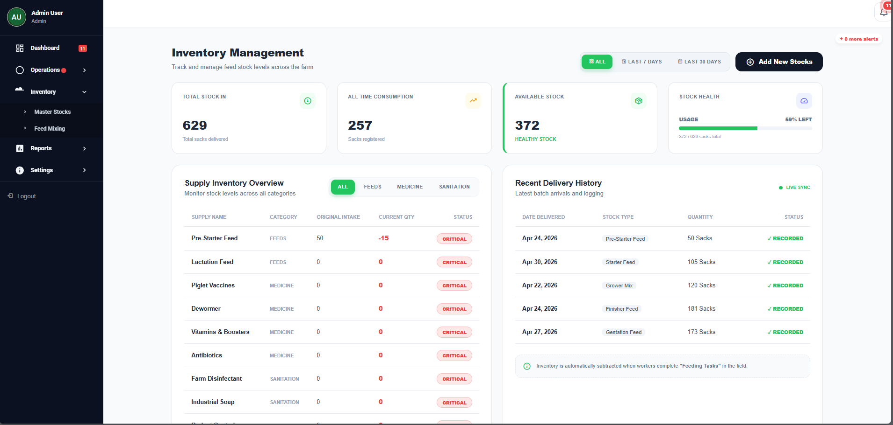

PorciTrack tracks three categories of farm supplies:

Category | Items Tracked
Feeds | Pre-Starter Feed, Starter Feed, Grower Mix, Finisher Feed, Gestation Feed, Lactation Feed
Medicine | Piglet Vaccines, Dewormer, Vitamins & Boosters, Antibiotics
Sanitation | Farm Disinfectant, Industrial Soap, Rodent Control

Each supply item shows:
Original Intake — Total quantity ever delivered.
Current Qty — Available stock (Delivered − Consumed).
Status — CRITICAL (≤10 sacks), MODERATE (≤25 sacks), or HEALTHY (>25 sacks).
        - Recording a New Delivery

Click "Add New Stocks" and fill in:

Delivery Date
Supply Type (from the dropdown)
Quantity (in sacks/units)

Click "Save" to record. Inventory is updated immediately.

        - Filtering the View

Use the filter tabs (All / Last 7 Days / Last 30 Days) and category buttons (All / Feeds
/ Medicine / Sanitation) to narrow the inventory view.

QR Label Generator

Navigate to: Operations → QR Labels

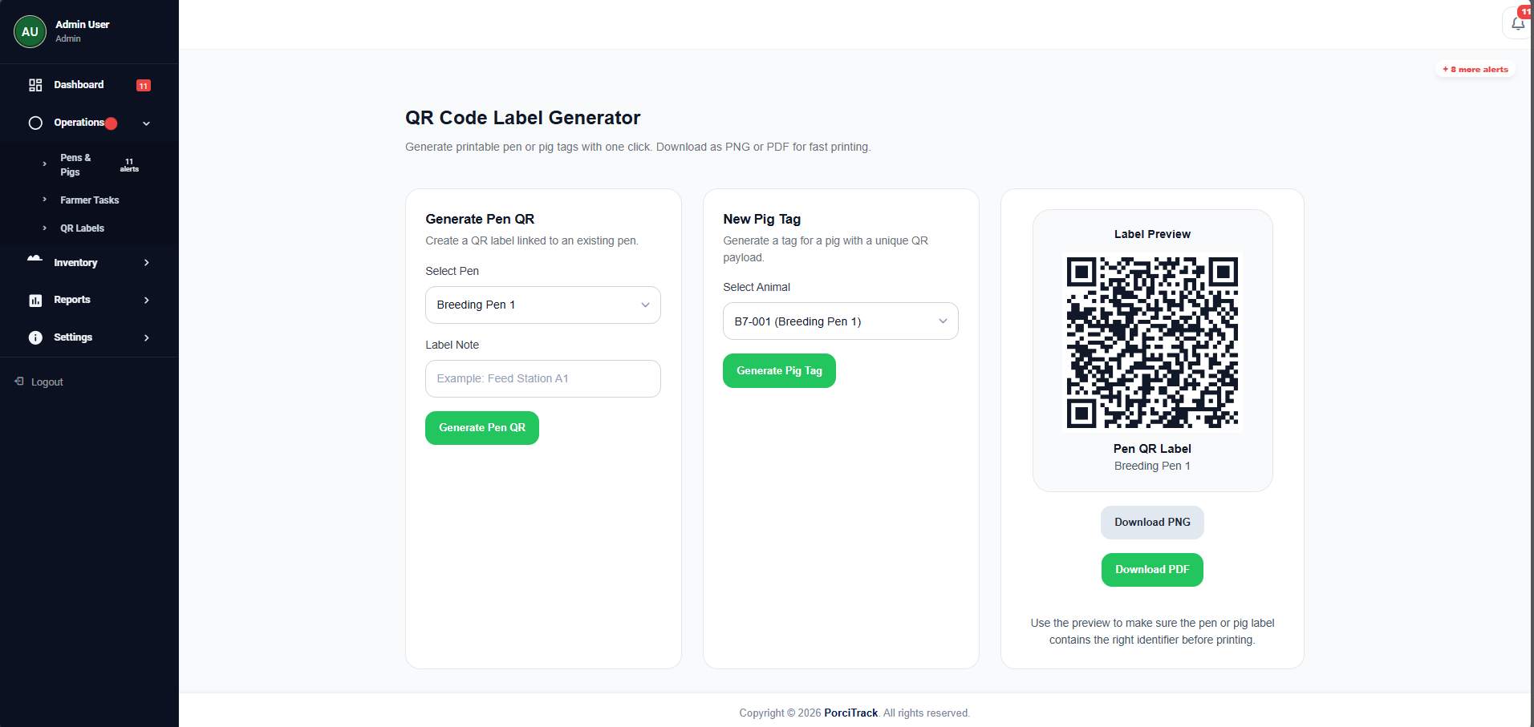
This tool generates printable identification labels for physical tagging.

        - Generating a Pen QR Code

          - Under "Generate Pen QR", select a pen from the "Select Pen" dropdown.
          - Optionally add a Label Note (e.g., "Feed Station A1").
          - Click "Generate Pen QR".
          - A preview appears on the right. Click "Download PNG" or "Download PDF" to save.
        - Generating an Individual Pig QR Tag

          - Under "New Pig Tag", select an animal from the "Select Animal" dropdown.
          - Click "Generate Pig Tag".

          - Download as PNG or PDF for printing and physical attachment to the animal's ear tag.
When a Field Worker scans a Pig QR code with their mobile device, the system calls
/api/health/pig/{tag} and loads the pig's complete data record instantly.

Reports

Navigate to: Reports → Weekly Reports

The Reports module allows administrators to review weekly activity reports submitted by farm workers. The view shows all registered workers and whether they have submitted a report for the current week.

System Settings

Navigate to: Settings

Administrators can configure farm-wide settings including the farm's geographic location (used by the Biosecurity Smart Engine to retrieve regional disease data from the AI Scout).

Field Worker Portal

The Worker Portal is a mobile-optimized Progressive Web App (PWA). Workers can install it on their smartphone's home screen and access it fully offline.

Worker Dashboard

Upon login, workers are directed to /worker/dashboard .

The dashboard shows:
Active Tasks — Number of pending tasks assigned to this worker.
Total Animals — Total active pigs on the farm.
Alerts — Number of sick pigs currently flagged.
Feed Stock — Net available feed inventory (in kg).
Pens Overview — A list of all pens, their animal count, sick count, average weight, and status.
Recent Activity — The last 5 animal-level activity logs.
Regional Alerts — Active regional disease warnings relevant to the farm's location.

Task Board

Navigate to: Tasks (bottom navigation bar)

Workers see two sections:
- Pending Tasks — All active tasks assigned to them, sorted oldest-first (First In, First Out).
- Recently Completed — The last 5 tasks marked as done.

        - Completing a Task

For each pending task, workers can:
Update the progress percentage using a slider (0–100%). Click "Mark Complete" to finalize the task at 100%.
When a task is completed, the system automatically logs a PigActivity record for the relevant pig(s) or pen. If the task title or description contains medical keywords
( vaccine , medical , sick , deworm , treatment , vet , etc.), the activity is classified as type "Medical"; otherwise, it is classified as "Care".

Swine Details & Daily Assessment

Navigate to: Swine Details (from the bottom navigation bar or main menu)

This is the core field operations page. Workers see only the pens that are assigned to them by the administrator.
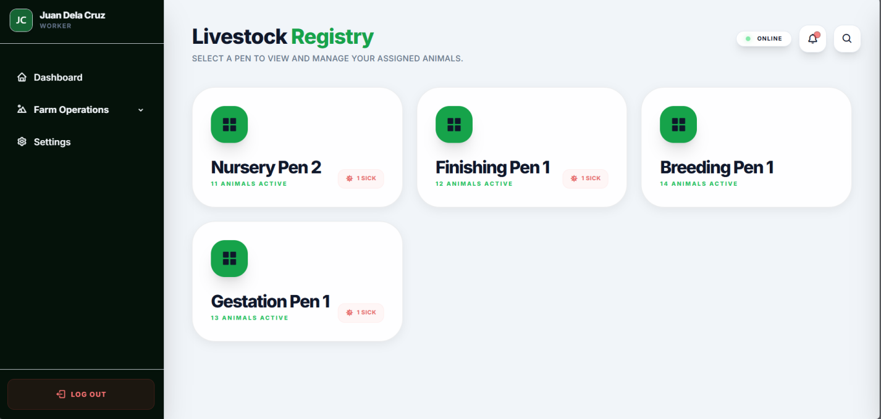

        - Daily Progress Tracker

At the top of the page:
Total Pigs — Count of active pigs in assigned pens.
Checked Today — Number of pigs the worker has assessed today.
Progress % — (Checked Today / Total Pigs) * 100 .

        - Performing a Daily Health Assessment

Tap on any pig from the list to open its Assessment Card.

Fill in the following fields:

Field | Description
Symptom / Health Status | Select "Healthy" or describe observed symptoms (e.g., "Minor Cough").
Body Condition Score (BCS) | Score from 1 (emaciated) to 5 (obese).
Feeding Behavior | Active / Normal / Poor.
Weight (KG) (optional) | Current measured weight. Updates the pig's record.
Physical Checks | Checklist of observable conditions (skin, posture, eyes, etc.).
Water Intake | Normal / Low / Refusing.
Notes | Free-text clinical observations.

Tap "Save Assessment" to submit. The system will:
          - Create a PigHealthReport record.
          - Update the pig's health_status to Healthy or Sick .
          - Create a PigActivity log entry.
          - If the status changed from Healthy to Sick, automatically increment the pen's
sickpigs counter and decrement healthy pigs .
          - If the pig was marked Sick, a iscriticalalert = true flag is set, triggering an immediate notification to the Administrator Dashboard.

Emergency Flagging

An emergency is triggered automatically when a worker submits a health assessment with a Sick symptom. There is no separate button — the assessment itself generates the critical alert.

What happens on the admin side:
- The admin dashboard polls the /admin/api/unacknowledged-alerts endpoint in real time.
- The alert appears with the Pig's Ear Tag, Pen name, and the reported symptom.
- The administrator must click "Acknowledge" to dismiss the alert from the HUD.

Weekly Reports

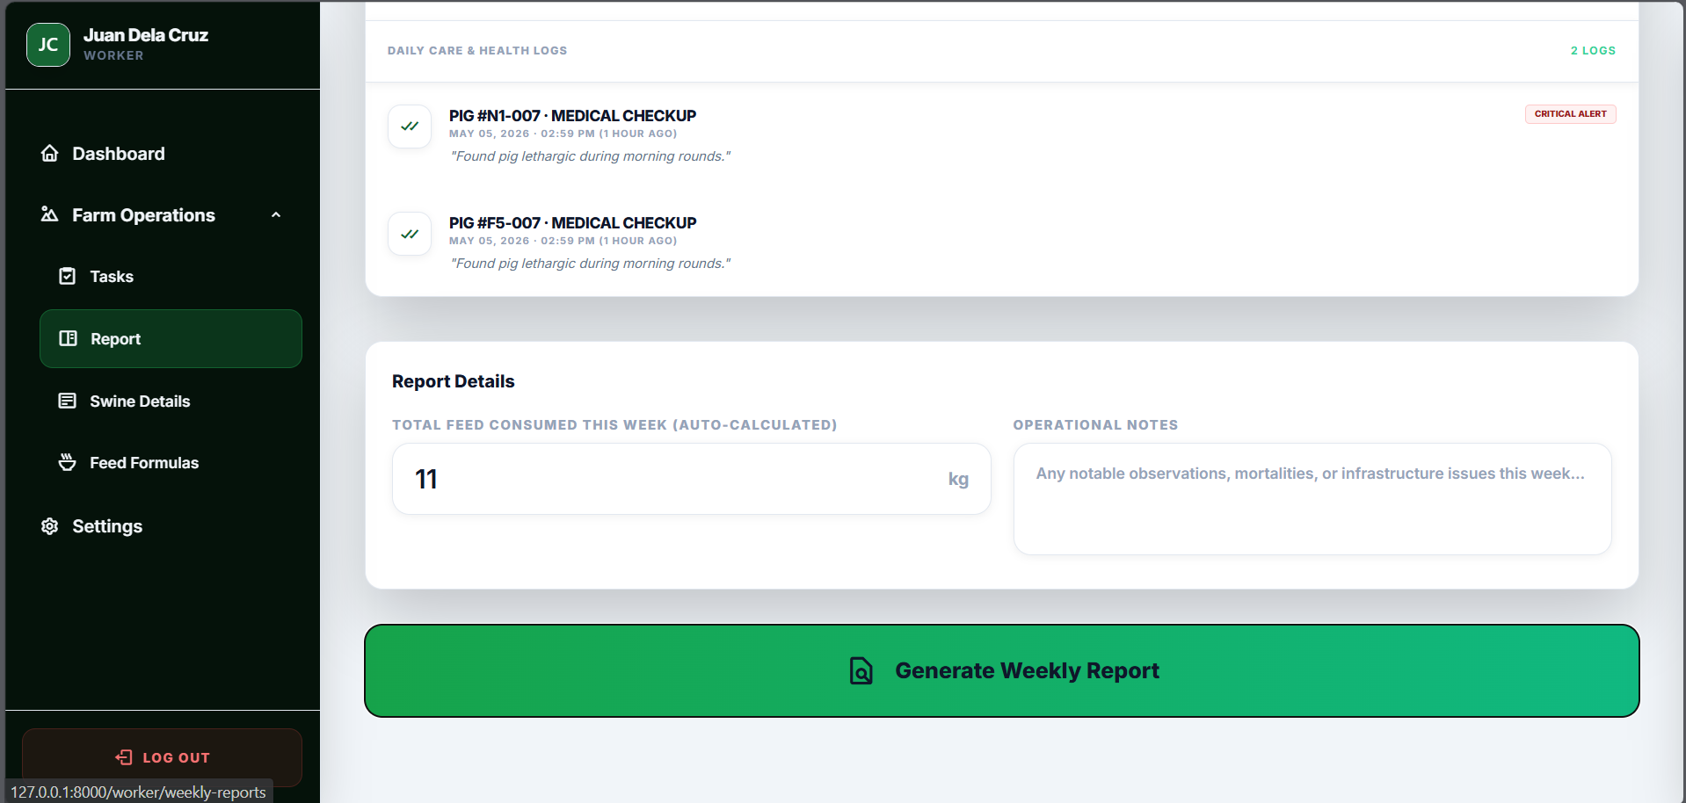

Navigate to: Reports (worker portal)

Workers submit a structured weekly report containing:
Details / Narrative — Free-text summary of the week's activities.
Total Pigs, Sick Pigs, Avg Weight — Auto-populated from farm data.
Feed Consumed — Feed consumption figure for the reporting week.

Click "Submit Report" to finalize. Only one report per worker per week is allowed. Subsequent submissions will update the existing report ( updateOrCreate logic).

Data Definitions & Field Reference

      - Health Status Values

Value | Meaning
Healthy | Animal shows no symptoms of illness.
Sick | Animal is symptomatic. Triggers critical alert to admin.
Warning | Animal shows mild symptoms, under observation.
Recovering | Previously sick animal improving after treatment.

      - Pig Lifecycle Status Values

Value | Meaning | Included in Active Count
Active | Normal operational status | ✅
Sold | Animal has been sold and removed from active production | ❌
Disposed | Animal died or was culled | ❌

      - Task Priority Levels

Priority | Behavior
Low / Medium | Workers may save partial progress.
High / Urgent /  Critical | Workers must submit at 100% completion. Partial saves are rejected.

      - BCS (Body Condition Score) Scale

Score | Condition
1 | Emaciated — Severe malnutrition. Immediate intervention required.
2 | Thin — Below optimal. Increase feed ration.
3 | Ideal — Optimal condition for production.
4 | Fat — Slightly over-conditioned. Reduce feed.
5 | Obese — Significant health risk. Dietary management needed.

      - Inventory Stock Status Thresholds

Status | Condition
🔴 CRITICAL | Available stock ≤ 10 units. Immediate restock required.
🟡 MODERATE | Available stock ≤ 25 units. Plan restocking within the week.
🟢 HEALTHY | Available stock > 25 units. No action needed.

System Automation & Business Logic

Understanding PorciTrack's automated behaviors prevents confusion and data inconsistencies.

Trigger | Automated Action
Worker submits health assessment with Sick status | iscriticalalert flag set → Admin HUD notified
Worker completes a task | PigActivity record auto-created for all affected pigs
Task keyword matches medical terms | Activity type auto-set to Medical ; otherwise  Care
Pig status changes Healthy → Sick | pen.sickpigs incremented;  pen.healthy pigs decremented
Pig status changes Sick → Healthy | pen.sickpigs decremented;  pen.healthy pigs incremented
Worker completes a feeding task | FeedConsumption record created; inventory deducted automatically
New pen created with Pig Count > 0 | System auto-generates unique Ear Tag IDs for all pigs
Offline data (PWA) reconnects | Local queue syncs to server via /worker/sync- logs endpoint

Troubleshooting & FAQ

Problem | Likely Cause | Solution
Data not syncing after field work | Device was offline. Queue not yet flushed. | Open the Worker Portal on a Wi- Fi connection and wait for auto- sync.
Admin not receiving emergency alert | Browser tab is inactive or muted. | Keep the Admin Dashboard tab open and active. Ensure device audio is not muted.
QR code scan returns "Pig Not Found" | Pig was sold/disposed, or QR is for a different environment. | Verify the pig is still active. Regenerate QR from the QR Labels page.
Task progress save rejected | Task priority is High/Urgent/Critical. | Partial saves are disabled for priority tasks. Worker must complete and submit at 100%.
"No Personnel Assigned" in pen dropdown | No users with farm_worker  role are registered. | Register at least one Farm Worker account first via the registration page.
Biosecurity score not updating | Regional disease data is stale. | Click "Sync with AI Scout" on the Admin Dashboard to refresh.
Worker cannot see any pigs | Pens are not assigned to that worker. | In Pen Management, edit each pen and set Assigned
Personnel to the correct worker.

Document compiled based on PorciTrack source code analysis. For technical support, contact the development team.

© 2026 PorciTrack. All rights reserved.

