**Practical work 02**

1. As computers don't understand any letters, characters and numbers except 0 and 1, we need to tell them how to interpret this digital information (ones and zeros) into characters (letters, numbers and symbols). To do this we assign specific numeric value to each character. This is called character encoding.
2. A byte order mark (BOM) is a special character from the Unicode standard that is placed at the beginning of a text file or stream. It is used to indicate byte order, confirm that text is Unicode encoded, and indicate which Unicode character encoding is being used. This allows the values to be correctly interpreted into symbols.

The main difference between UTF-8 with a BOM and UTF-8 without a BOM is that the BOM occupies three bytes at the beginning of the file, which can cause problems with some programs that do not expect or handle the BOM correctly.

1. ASCII art is an image making technique (or graphic design technique) in which ASCII characters are used to create various images. It arose due to the lack of graphics capabilities on early computers and printers.

**Example**

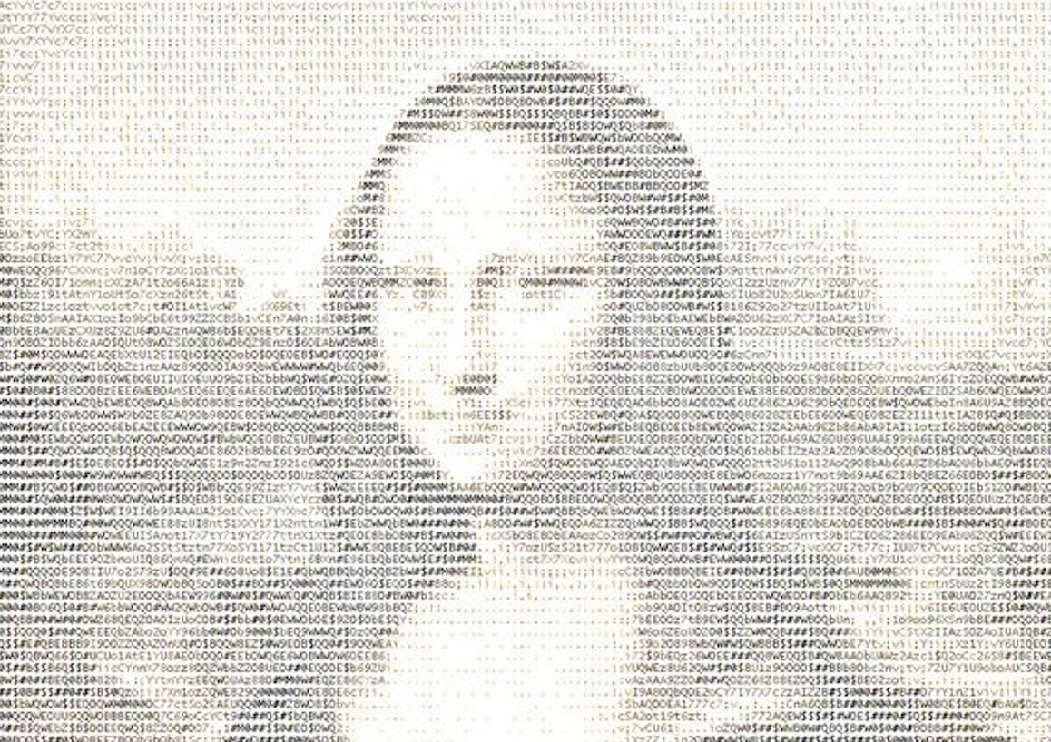

1. HTML entities are the reserved characters that are used in the HTML document. There are entity names and entity numbers. They are used to display characters which are reserved in HTML (so browser might mix them with tags) or characters which we usually don't have on our standard keyboard.
2. The <pre> tag in HTML is used to define the block of preformatted text. This helps to save all spaces, tabs, line breaks and other formatting which is usually ignored by browsers. The <code> tag is used to display content as a part of computer code which means that monospace font style will be used for it.