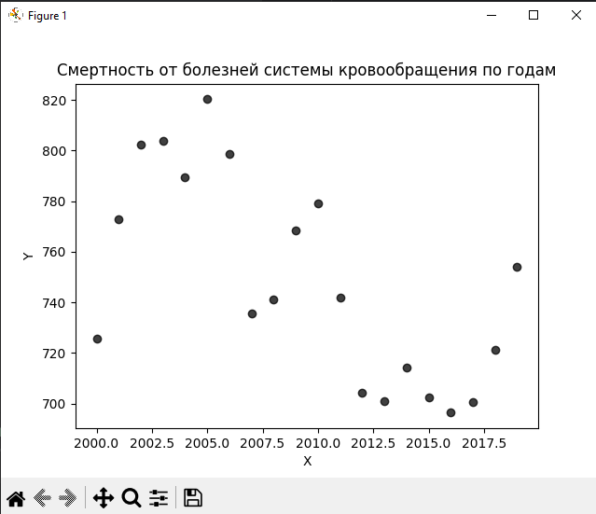

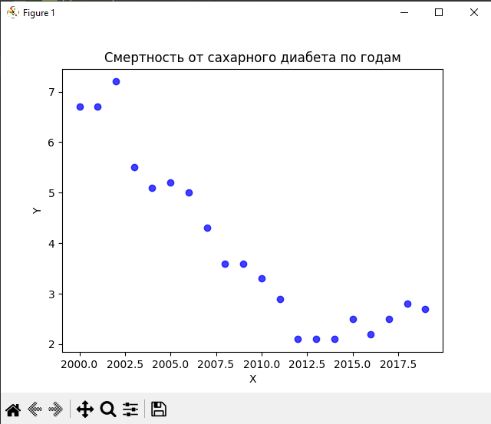

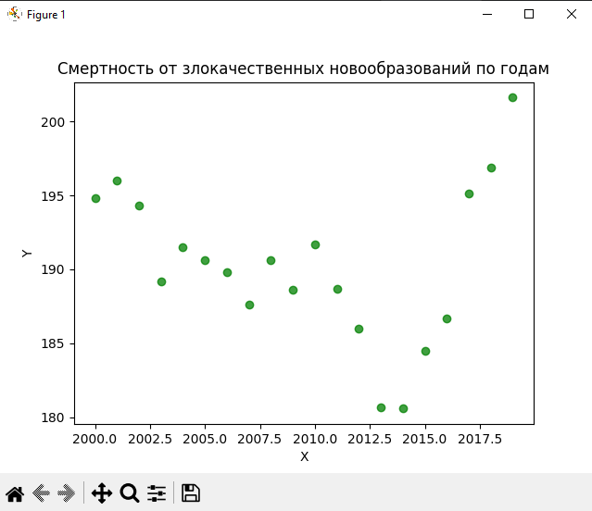

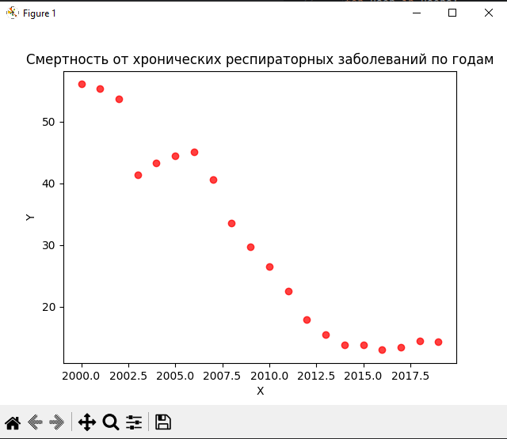

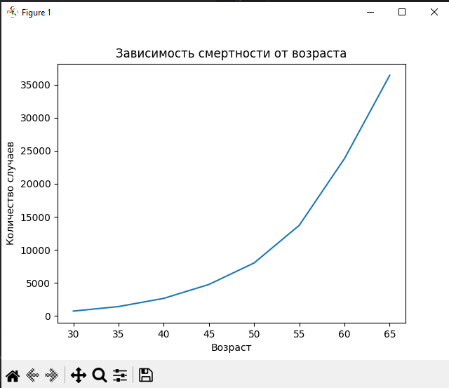

X=pd.read_csv("d:\\data_science_24\lab3\data3.csv")

year;disease;gender;age;region;value

count 1440

unique 1440

top 2000;Смертность от болезней системы кровообращ...

freq 1

('2000', 725.5, 6.7, 194.8, 56.1)

('2001', 772.9, 6.7, 196, 55.4)

('2002', 802.5, 7.2, 194.3, 53.7)

('2003', 804, 5.5, 189.2, 41.4)

('2004', 789.4, 5.1, 191.5, 43.3)

('2005', 820.3, 5.2, 190.6, 44.5)

('2006', 798.8, 5, 189.8, 45.1)

('2007', 735.5, 4.3, 187.6, 40.6)

('2008', 741.2, 3.6, 190.6, 33.6)

('2009', 768.5, 3.6, 188.6, 29.7)

('2010', 779.2, 3.3, 191.7, 26.5)

('2011', 742, 2.9, 188.7, 22.5)

('2012', 704.4, 2.1, 186, 17.9)

('2013', 701.1, 2.1, 180.7, 15.5)

('2014', 714.1, 2.1, 180.6, 13.8)

('2015', 702.4, 2.5, 184.5, 13.8)

('2016', 696.4, 2.2, 186.7, 13)

('2017', 700.6, 2.5, 195.1, 13.4)

('2018', 721.4, 2.8, 196.9, 14.4)

('2019', 753.9, 2.7, 201.6, 14.3)

(30, 722.6)

(35, 1410.4)

(40, 2649.8)

(45, 4757.5)

(50, 8015.6)

(55, 13720.4)

(60, 23821.1)

(65, 36425.1)