Source Data Mapping Approach to CDMV5.4
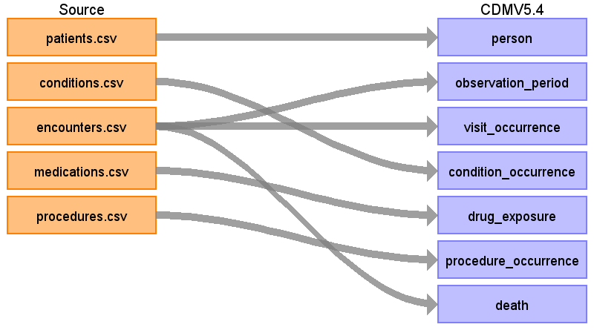
Table name: person
Reading from patients.csv
One row per patient. Names, SSN, address and other identifiers are not carried over.
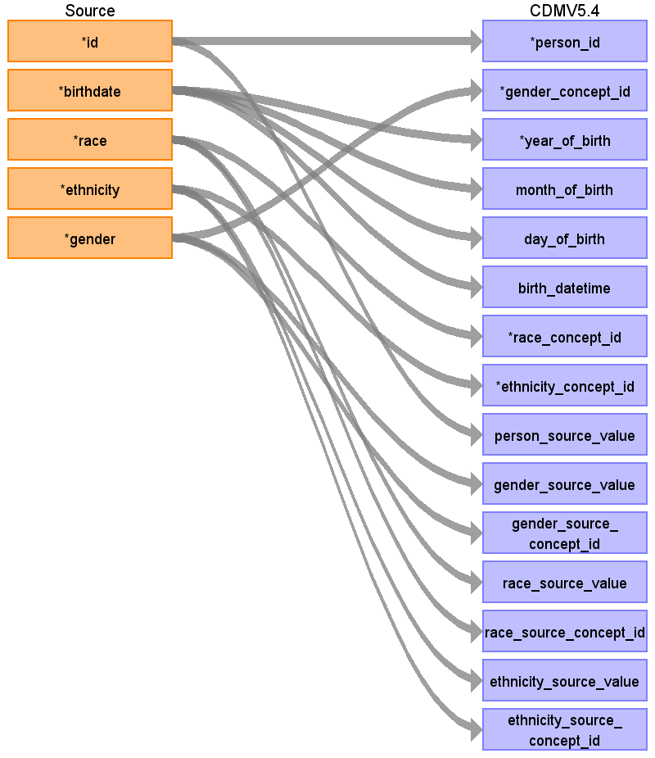
Destination Field | Source Field | Logic | Comment
person_id | id | Generated whole number per patient
gender_concept_id | gender | M → 8507, F → 8532.
year_of_birth | birthdate | Year part of birthdate.
month_of_birth | birthdate | Month part of birthdate.
day_of_birth | birthdate | Day part of birthdate.
birth_datetime | birthdate | Birthdate at midnight (no time recorded).
race_concept_id | race | white → 8527, black → 8516, asian → 8515, anything else → 0.
ethnicity_concept_id | ethnicity | hispanic → 38003563, anything else → 0.
location_id
provider_id
care_site_id
person_source_value | id
gender_source_value | gender
gender_source_concept_id | gender | Set to 0.
race_source_value | race
race_source_concept_id | race | Set to 0.
ethnicity_source_value | ethnicity
ethnicity_source_concept_id | ethnicity | Set to 0.
Table name: observation_period
Reading from encounters.csv
One period per patient, from their first encounter to their last.
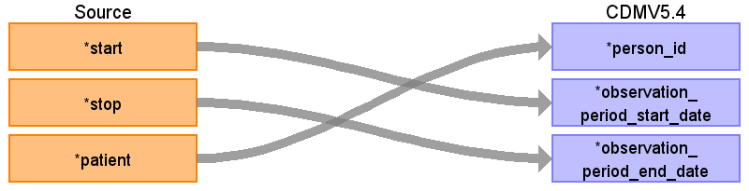
Destination Field | Source Field | Logic | Comment
observation_period_id
person_id | patient
observation_period_start_date | start | Earliest encounter start per patient.
observation_period_end_date | stop | Latest encounter stop per patient.
period_type_concept_id
Table name: visit_occurrence
Reading from encounters.csv
Encounter class → visit type: inpatient 9201, outpatient/ambulatory/wellness 9202, emergency/urgent care 9203. Inpatient stays less than a day apart are merged.
Destination Field | Source Field | Logic | Comment
visit_occurrence_id
person_id
visit_concept_id
visit_start_date
visit_start_datetime
visit_end_date
visit_end_datetime
visit_type_concept_id
provider_id
care_site_id
visit_source_value
visit_source_concept_id
admitted_from_concept_id
admitted_from_source_value
discharged_to_concept_id
discharged_to_source_value
preceding_visit_occurrence_id
Table name: visit_detail
Table name: condition_occurrence
Reading from conditions.csv
SNOMED codes mapped to standard condition concepts. ICD-10 codes (about 3%, including other cancers) need checking after loading.
Destination Field | Source Field | Logic | Comment
condition_occurrence_id
person_id
condition_concept_id
condition_start_date
condition_start_datetime
condition_end_date
condition_end_datetime
condition_type_concept_id
condition_status_concept_id
stop_reason
provider_id
visit_occurrence_id
visit_detail_id
condition_source_value
condition_source_concept_id
condition_status_source_value
Table name: drug_exposure
Reading from medications.csv
RxNorm codes mapped to standard drug concepts. If there’s no stop date, end date = start date.
Destination Field | Source Field | Logic | Comment
drug_exposure_id
person_id
drug_concept_id
drug_exposure_start_date
drug_exposure_start_datetime
drug_exposure_end_date
drug_exposure_end_datetime
verbatim_end_date
drug_type_concept_id
stop_reason
refills
quantity
days_supply
sig
route_concept_id
lot_number
provider_id
visit_occurrence_id
visit_detail_id
drug_source_value
drug_source_concept_id
route_source_value
dose_unit_source_value
Table name: procedure_occurrence
Reading from procedures.csv
SNOMED codes mapped to standard procedure concepts.
Destination Field | Source Field | Logic | Comment
procedure_occurrence_id
person_id
procedure_concept_id
procedure_date
procedure_datetime
procedure_end_date
procedure_end_datetime
procedure_type_concept_id
modifier_concept_id
quantity
provider_id
visit_occurrence_id
visit_detail_id
procedure_source_value
procedure_source_concept_id
modifier_source_value
Table name: device_exposure
Table name: measurement
Table name: observation
Table name: death
Reading from encounters.csv
Only encounters with code 308646001 (Death certification).
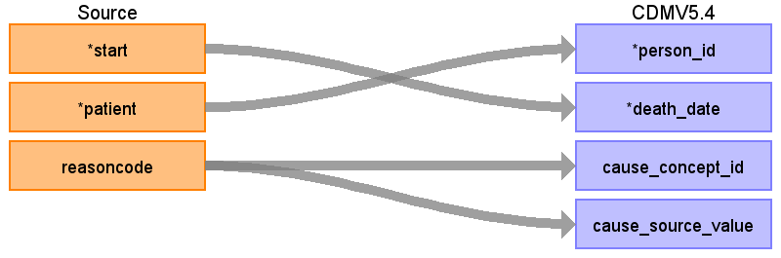
Destination Field | Source Field | Logic | Comment
person_id | patient
death_date | start | Start date of the Death certification encounter (a few days after DEATHDATE).
death_datetime
death_type_concept_id
cause_concept_id | reasoncode | Reason code mapped to a standard SNOMED condition concept.
cause_source_value | reasoncode
cause_source_concept_id
Table name: note
Table name: note_nlp
Table name: specimen
Table name: fact_relationship
Table name: location
Table name: care_site
Table name: provider
Table name: payer_plan_period
Table name: cost
Table name: drug_era
Table name: dose_era
Table name: condition_era
Table name: episode
Table name: episode_event
Table name: metadata
Table name: cdm_source
Table name: cohort
Table name: cohort_definition
Appendix: source tables
Table: patients.csv
Field | Type | Most freq. value | Comment
id | VARCHAR
birthdate | DATE | 1939-10-05
deathdate | DATE
ssn | VARCHAR
drivers | VARCHAR
passport | VARCHAR
prefix | VARCHAR | Mr.
first | VARCHAR
middle | VARCHAR
last | VARCHAR | D'Amore443
suffix | VARCHAR
maiden | VARCHAR
marital | VARCHAR | M
race | VARCHAR | white
ethnicity | VARCHAR | nonhispanic
gender | VARCHAR | M
birthplace | VARCHAR | Boston Massachusetts US
address | VARCHAR
city | VARCHAR | Boston
state | VARCHAR | Massachusetts
county | VARCHAR | Middlesex County
fips | INT | 25009
zip | INT | 00000
lat | REAL
lon | REAL
healthcare_expenses | REAL
healthcare_coverage | REAL
income | INT | 31371
Table: allergies.csv
Field | Type | Most freq. value | Comment
start | DATE | 1965-03-03
stop | EMPTY
patient | VARCHAR | 5f1d2f30-7204-e996-95aa-b94dc380a09e
encounter | VARCHAR | 933ad8d1-b305-3633-b9af-8520477902a7
code | INT | 419199007
system | VARCHAR | Unknown
description | VARCHAR | Allergy to substance (finding)
type | VARCHAR | allergy
category | VARCHAR | environment
reaction1 | INT
description1 | VARCHAR
severity1 | VARCHAR
reaction2 | INT
description2 | VARCHAR
severity2 | VARCHAR
Table: careplans.csv
Field | Type | Most freq. value | Comment
id | VARCHAR
start | DATE | 1967-12-14
stop | DATE
patient | VARCHAR | be8a37a5-3ad9-11a1-be2a-8caf19fe45e5
encounter | VARCHAR
code | INT | 182964004
description | VARCHAR | Terminal care
reasoncode | INT
reasondescription | VARCHAR
Table: claims.csv
Field | Type | Most freq. value | Comment
id | VARCHAR
patientid | VARCHAR | 34497261-7808-a621-5786-698cc1455038
providerid | VARCHAR | 0ab9f3b1-e09f-3c14-8397-614594e3e063
primarypatientinsuranceid | VARCHAR | a735bf55-83e9-331a-899d-a82a60b9f60c
secondarypatientinsuranceid | VARCHAR
departmentid | INT | 3
patientdepartmentid | INT | 3
diagnosis1 | VARCHAR | 424132000
diagnosis2 | VARCHAR
diagnosis3 | VARCHAR
diagnosis4 | INT
diagnosis5 | INT
diagnosis6 | INT
diagnosis7 | INT
diagnosis8 | INT
referringproviderid | EMPTY
appointmentid | VARCHAR | 7d1be644-55c4-c423-6b3d-b88e2c328f8b
currentillnessdate | VARCHAR | 2019-03-07T02:06:22Z
servicedate | VARCHAR | 2003-12-05T06:55:34Z
supervisingproviderid | VARCHAR | 0ab9f3b1-e09f-3c14-8397-614594e3e063
status1 | VARCHAR | CLOSED
status2 | VARCHAR | CLOSED
statusp | VARCHAR | CLOSED
outstanding1 | REAL | 0
outstanding2 | REAL | 0
outstandingp | REAL | 0
lastbilleddate1 | VARCHAR | 2004-01-07T14:41:34Z
lastbilleddate2 | VARCHAR
lastbilleddatep | VARCHAR | 2004-01-07T14:41:34Z
healthcareclaimtypeid1 | INT | 2
healthcareclaimtypeid2 | INT | 0
Table: claims_transactions.csv
Field | Type | Most freq. value | Comment
id | VARCHAR
claimid | VARCHAR | 1697b269-f7ef-44c7-44e8-f76af9206218
chargeid | INT
patientid | VARCHAR | 7c0aa832-2b0e-d4b4-d4c4-7f3482a043d0
type | VARCHAR | PAYMENT
amount | REAL
method | VARCHAR
fromdate | VARCHAR | 1986-12-02T19:07:22Z
todate | VARCHAR | 1970-01-01T00:00:00Z
placeofservice | VARCHAR | 7b20d1c4-c56b-3647-801c-5e4e13679073
procedurecode | VARCHAR | 1736854
modifier1 | EMPTY
modifier2 | EMPTY
diagnosisref1 | INT | 1
diagnosisref2 | INT
diagnosisref3 | INT
diagnosisref4 | INT
units | INT | 1
departmentid | INT | 3
notes | VARCHAR | Cisplatin 50 MG Injection
unitamount | REAL | 0.00
transferoutid | INT
transfertype | VARCHAR
payments | REAL | 0.00
adjustments | REAL | 0.00
transfers | REAL
outstanding | REAL | 0.00
appointmentid | VARCHAR | 01ca787d-8d30-bf7d-e0ef-ca2115e3ba6a
linenote | EMPTY
patientinsuranceid | VARCHAR | 7c0aa832-2b0e-d4b4-d4c4-7f3482a043d0
feescheduleid | INT | 1
providerid | VARCHAR | 1dc88f92-a9b9-3f89-a673-82b1ee4cfed6
supervisingproviderid | VARCHAR | 1dc88f92-a9b9-3f89-a673-82b1ee4cfed6
Table: conditions.csv
Field | Type | Most freq. value | Comment
start | DATE | 1957-11-28
stop | DATE
patient | VARCHAR | e2f255b2-790f-010f-aedf-78c8b05f8e73
encounter | VARCHAR | d7430b8b-d45c-7800-0477-2432b93ba2ea
system | VARCHAR | SNOMED-CT
code | VARCHAR | 314529007
description | VARCHAR | Medication review due (situation)
Table: devices.csv
Field | Type | Most freq. value | Comment
start | VARCHAR | 2004-10-07T09:00:06Z
stop | VARCHAR
patient | VARCHAR | 106a46ad-5b89-6238-70c8-d8d6355ab4dc
encounter | VARCHAR
code | INT | 91537007
description | VARCHAR | Hospital bed device (physical object)
udi | VARCHAR
Table: encounters.csv
Field | Type | Most freq. value | Comment
id | VARCHAR
start | VARCHAR | 1957-11-28T09:00:06Z
stop | VARCHAR | 2026-10-26T18:38:23Z
patient | VARCHAR | 34497261-7808-a621-5786-698cc1455038
organization | VARCHAR | 171254da-957c-304a-b3fc-51a2d3ebee43
provider | VARCHAR | 0ab9f3b1-e09f-3c14-8397-614594e3e063
payer | VARCHAR | a735bf55-83e9-331a-899d-a82a60b9f60c
encounterclass | VARCHAR | ambulatory
code | INT | 185347001
description | VARCHAR | Encounter for problem
base_encounter_cost | REAL | 85.55
total_claim_cost | REAL | 535.87
payer_coverage | REAL | 0.00
reasoncode | INT
reasondescription | VARCHAR
Table: imaging_studies.csv
Field | Type | Most freq. value | Comment
id | VARCHAR | bd857fb0-a8f3-b8b4-e7da-d85928d1f733
date | VARCHAR | 2026-05-26T11:00:01Z
patient | VARCHAR | ba2c8839-0204-b6ef-2b6e-8d32c7339a24
encounter | VARCHAR | 978d7b79-dfbc-b7c8-b024-2a1be8b9f2b9
series_uid | VARCHAR | 1.2.840.99999999.1.26104723.1779793201033
bodysite_code | INT | 51185008
bodysite_description | VARCHAR | Thoracic structure (body structure)
modality_code | VARCHAR | CT
modality_description | VARCHAR | Computed Tomography
instance_uid | VARCHAR
sop_code | VARCHAR | 1.2.840.10008.5.1.4.1.1.2
sop_description | VARCHAR | CT Image Storage
procedure_code | INT | 16335031000119103
Table: immunizations.csv
Field | Type | Most freq. value | Comment
date | VARCHAR | 2006-01-05T09:00:06Z
patient | VARCHAR | 09946b90-c2b8-36ba-3913-ff425ff7703a
encounter | VARCHAR
code | INT | 140
description | VARCHAR | Influenza seasonal injectable preservative free
base_cost | REAL | 136.00
Table: medications.csv
Field | Type | Most freq. value | Comment
start | VARCHAR | 2018-07-24T03:30:19Z
stop | VARCHAR
patient | VARCHAR | 36a22c13-ce7a-fe85-af82-3df64a384ba7
payer | VARCHAR | a735bf55-83e9-331a-899d-a82a60b9f60c
encounter | VARCHAR | 7d1be644-55c4-c423-6b3d-b88e2c328f8b
code | INT | 1736854
description | VARCHAR | Cisplatin 50 MG Injection
base_cost | REAL | 203.84
payer_coverage | REAL | 203.84
dispenses | INT | 1
totalcost | REAL | 203.84
reasoncode | INT | 424132000
reasondescription | VARCHAR | Non-small cell carcinoma of lung TNM stage 1 (disorder)
Table: observations.csv
Field | Type | Most freq. value | Comment
date | VARCHAR | 2006-09-28T09:00:06Z
patient | VARCHAR | 60f0067f-cd35-77b4-20aa-9acc5910809c
encounter | VARCHAR | 74972eb6-1dbc-6b44-bd71-6bc7d4f6bbef
category | VARCHAR | laboratory
code | VARCHAR | 72514-3
description | VARCHAR | Pain severity - 0-10 verbal numeric rating [Score] - Reported
value | VARCHAR | No
units | VARCHAR | {nominal}
type | VARCHAR | numeric
Table: organizations.csv
Field | Type | Most freq. value | Comment
id | VARCHAR
name | VARCHAR | BOSTON HEALTH CARE FOR THE HOMELESS PROGRAM INC
address | VARCHAR | 800 WASHINGTON ST
city | VARCHAR | WORCESTER
state | VARCHAR | MA
zip | INT
lat | REAL | 42.2212188
lon | REAL | -71.1522766
phone | VARCHAR | 800-865-3384
revenue | REAL | 0.0
utilization | INT | 7
Table: payer_transitions.csv
Field | Type | Most freq. value | Comment
patient | VARCHAR | 5cebe8fb-cb5c-c435-4a76-9c926fe174bc
memberid | VARCHAR
start_date | VARCHAR | 2016-10-06T09:00:06Z
end_date | VARCHAR | 2016-10-06T09:00:06Z
payer | VARCHAR | a735bf55-83e9-331a-899d-a82a60b9f60c
secondary_payer | VARCHAR
plan_ownership | VARCHAR | Self
owner_name | VARCHAR
Table: payers.csv
Field | Type | Most freq. value | Comment
id | VARCHAR
name | VARCHAR
ownership | VARCHAR | PRIVATE
address | EMPTY
city | EMPTY
state_headquartered | EMPTY
zip | EMPTY
phone | EMPTY
amount_covered | REAL
amount_uncovered | REAL
revenue | REAL
covered_encounters | INT
uncovered_encounters | INT | 0
covered_medications | INT
uncovered_medications | INT | 0
covered_procedures | INT
uncovered_procedures | INT | 0
covered_immunizations | INT
uncovered_immunizations | INT | 0
unique_customers | INT
qols_avg | REAL
member_months | INT
Table: procedures.csv
Field | Type | Most freq. value | Comment
start | VARCHAR | 2014-10-09T09:00:06Z
stop | VARCHAR | 2014-10-09T09:15:06Z
patient | VARCHAR | 34497261-7808-a621-5786-698cc1455038
encounter | VARCHAR | 2dc6e903-1388-e606-0141-9ee8934d552a
system | VARCHAR | SNOMED-CT
code | VARCHAR | 703423002
description | VARCHAR | Combined chemotherapy and radiation therapy (procedure)
base_cost | REAL | 431.40
reasoncode | INT
reasondescription | VARCHAR
Table: providers.csv
Field | Type | Most freq. value | Comment
id | VARCHAR
organization | VARCHAR
name | VARCHAR
gender | VARCHAR | F
speciality | VARCHAR | GENERAL PRACTICE
address | VARCHAR | 800 WASHINGTON ST
city | VARCHAR | WORCESTER
state | VARCHAR | MA
zip | INT
lat | REAL | 42.2212188
lon | REAL | -71.1522766
encounters | INT | 7
procedures | INT | 0
Table: supplies.csv
Field | Type | Most freq. value | Comment
date | DATE | 1991-10-17
patient | VARCHAR | 157eebb5-197b-9101-a0b1-d928e6b38d71
encounter | VARCHAR | c1b3d80d-1bf9-1f8f-157c-902e9d525a72
code | INT | 337388004
description | VARCHAR | Blood glucose testing strips (physical object)
quantity | INT | 1

