RVIZ2 Opening Commands:

cd ~/sdaadof_ws
colcon build
source install/setup.bash
ros2 launch urdf_tutorial display.launch.py model:=/home/maryam-mahmood/sdaadof_ws/src/daadbot_desc/urdf/daadbot.urdf.xacro

Opening manually:
- ros2 run robot_state_publisher robot_state_publisher --ros-args -p robot_description:="$(xacro /home/maryam-mahmood/sdaadof_ws/src/daadbot_desc/urdf/daadbot.urdf.xacro)"
- ros2 run joint_state_publisher_gui joint_state_publisher_gui
- ros2 run rviz2 rviz2

cd ~/sdaadof_ws
colcon build
source install/setup.bash
ros2 launch daadbot_desc display.launch.py

cd ~/sdaadof_ws
colcon build
source install/setup.bash
ros2 launch daadbot_desc gazebo.launch.py

Controller Test Commands:
__________________________________________________________________________
cd ~/sdaadof_ws
colcon build
source install/setup.bash
ros2 launch daadbot_desc gazebo.launch.py

cd ~/sdaadof_ws
colcon build
source install/setup.bash
ros2 launch daadbot_controller controller.launch.py

cd ~/sdaadof_ws
colcon build
source install/setup.bash
ros2 topic pub /gripper_controller/commands std_msgs/msg/Float64MultiArray "layout:
dim: []
data_offset: 0
data: [-1]"
__________________________________________________________________________

____________________________________________________________________________

ros2 topic pubarm_controller/commanands std_msgs/msg/Float64MultiArray "layout:
dim: []
data_offset: 0
data: [0, 0, 0, 0, 0, 0, 0]"

ros2 topic pub /arm_controller/commands std_msgs/msg/Float64MultiArray "layout:
dim: []
data_offset: 0
data: [0.1, -0.2, 0.2, 0.3, -0.5, 0.1, 0.2]"
____________________________________________________________________________

TF:
cd ~/sdaadof_ws
colcon build
source install/setup.bash
ros2 launch daadbot_desc display.launch.py
___________________________________________________________________________
ros2 topic echo /tf
___________________________________________________________________________
ros2 run tf2_ros tf2_echo Link_1 Link_2
___________________________________________________________________________
ros2 run tf2_tools view_frames
evince frames_2025-02-08_15.50.08.pdf
___________________________________________________________________________

Moveit2
___________________________________________________________________________
cd ~/sdaadof_ws
colcon build
source install/setup.bash
ros2 launch daadbot_desc gazebo.launch.py

cd ~/sdaadof_ws
colcon build
source install/setup.bash
ros2 launch daadbot_controller controller.launch.py

cd ~/sdaadof_ws
colcon build
source install/setup.bash
ros2 launch daadbot_moveit moveit.launch.py

cd ~/sdaadof_ws
colcon build
source install/setup.bash
ros2 launch daadbot_desc gazebo.launch.py

cd ~/sdaadof_ws
colcon build
source install/setup.bash
ros2 launch daadbot_controller controller.launch.py

cd ~/sdaadof_ws
colcon build
source install/setup.bash
ros2 launch daadbot_moveit moveit.launch.py

cd ~/sdaadof_ws
colcon build
source install/setup.bash
ros2 launch daadbot_posegen mp_interface.launch.py

ros2 launch daadbot_handpose wpose_mv_interface.launch.py

cd ~/sdaadof_ws
colcon build
source install/setup.bash
ros2 action send_goal /multi_task_server daadbot_msgs/action/DaadbotTaskServer "task_id: 1"

daadbot_handpose
Uses task IDs to bring manipulator to a hand pose in base frame. (IK)

daadbot_posegen
Uses task IDs to bring manipulator to a set of joint angles. (FK)

moveit_pose:
Brings manipulator to a hand pose in world frame without task IDs. (IK)

Without Task IDs and launch file:

cd ~/daadbot_ws
colcon build
source install/setup.bash
ros2 launch daadbot_desc gazebo.launch.py

cd ~/daadbot_ws
colcon build
source install/setup.bash
ros2 launch daadbot_controller controller.launch.py

cd ~/daadbot_ws
colcon build
source install/setup.bash
ros2 launch daadbot_moveit moveit.launch.py

cd ~/daadbot_ws
colcon build
source install/setup.bash
ros2 run moveit_pose hand_pose_node

cd ~/sdaadof_ws
colcon build
source install/setup.bash
ros2 run some_examples_cpp lifecycle_node_ex

ros2 lifecycle nodes
ros2 lifecycle get /my_lifecycle_node
ros2 lifecycle set /my_lifecycle_node configure
ros2 lifecycle set /my_lifecycle_node activate
ros2 lifecycle list /my_lifecycle_node

source ~/mediapipe_pose/bin/activate
cd ~/sdaadof_ws
colcon build
source install/setup.bash
ros2 run some_examples_py mpipe

source ~/mediapipe_pose/bin/activate
cd ~/daadbot_ws
colcon build
source install/setup.bash
ros2 run some_examples_py mpipe

export PYTHONPATH=$HOME/mediapipe_pose/lib/python3.12/site-packages:$PYTHONPATH

ros2 launch daadbot_desc gazebo_effort.launch.py
ros2 launch daadbot_controller effort_controller.launch.py
ros2 launch daadbot_moveit moveit_effort.launch.py

ros2 launch daadbot_desc gazebo_vel.launch.py
ros2 launch daadbot_controller vel_controller.launch.py
ros2 launch daadbot_moveit moveit_vel.launch.py

ros2 launch daadbot_posegen input_moveit.launch.py

cd ~/daadbot_ws
colcon build
source install/setup.bash
ros2 launch daadbot_desc gazebo.launch.py

cd ~/daadbot_ws
colcon build
source install/setup.bash
ros2 launch daadbot_controller controller.launch.py

cd ~/daadbot_ws
colcon build
source install/setup.bash
ros2 launch daadbot_moveit moveit.launch.py

cd ~/daadbot_ws
colcon build
source install/setup.bash
ros2 launch daadbot_desc gazebo_vel.launch.py

cd ~/daadbot_ws
colcon build
source install/setup.bash
ros2 launch daadbot_controller vel_controller.launch.py

cd ~/daadbot_ws
colcon build
source install/setup.bash
ros2 launch daadbot_moveit moveit_vel.launch.py

/home/maryammahmood/Downloads/final_7dof_urdf_9oct2024/meshes

ros2 launch daadbot_bringup sim_robot.launch.py

cd ~/ndaadbot_ws
colcon build
source install/setup.bash
ros2 launch daadbot_desc gazebo_table_vel.launch.py

cd ~/ndaadbot_ws
colcon build
source install/setup.bash
ros2 launch daadbot_controller vel_controller_table.launch.py

cd ~/ndaadbot_ws
colcon build
source install/setup.bash
ros2 launch daadbot_moveit moveit_table.launch.py

cd ~/ndaadbot_ws
colcon build
source install/setup.bash
ros2 run daadbot_moveit trajectory_plotter.py

ros2 launch daadbot_bringup sim_robot_table.launch.py
ros2 launch daadbot_bringup real_robot_table.launch.py

cd ~/ndaadbot_ws
colcon build
source install/setup.bash
ros2 launch daadbot_bringup sim_robot_table.launch.py

cd ~/ndaadbot_ws
colcon build
source install/setup.bash
ros2 launch daadbot_bringup real_robot_table.launch.py

cd ~/mdaadbot_ws
colcon build
source install/setup.bash
ros2 launch daadbot_desc gazebo_ntable_vel.launch.py

cd ~/mdaadbot_ws
colcon build
source install/setup.bash
ros2 launch daadbot_controller vel_controller_table.launch.py

cd ~/daadbot_ws
colcon build
source install/setup.bash
ros2 launch daadbot_desc gazebo_table_vel.launch.py

cd ~/daadbot_ws
colcon build
source install/setup.bash
ros2 launch daadbot_controller vel_controller_table.launch.py

cd ~/daadbot_ws
colcon build
source install/setup.bash
ros2 launch daadbot_moveit moveit_table.launch.py

cd ~/.mujoco/mujoco-3.3.2/bin
./simulate

cd ~/xdaadbot_ws
colcon build
source install/setup.bash
ros2 launch daadbot_desc gazebo_table_vel.launch.py

cd ~/xdaadbot_ws
colcon build
source install/setup.bash
ros2 launch daadbot_controller vel_controller_table.launch.py

cd ~/xdaadbot_ws
colcon build
source install/setup.bash
ros2 launch daadbot_moveit moveit_table.launch.py

cd ~/xdaadbot_ws
colcon build
source install/setup.bash
ros2 launch daadbot_bringup real_robot_table.launch.py

cd ~/xdaadbot_ws
colcon build
source install/setup.bash
ros2 launch daadbot_bringup sim_robot_table.launch.py

cd ~/xdaadbot_ws
colcon build
source install/setup.bash
ros2 launch daadbot_desc gazebo_table_effort.launch.py

cd ~/xdaadbot_ws
colcon build
source install/setup.bash
ros2 launch daadbot_controller effort_controller_table.launch.py

cd ~/mujoco_ws
colcon build
source install/setup.bash
ros2 launch mujoco_demo_robot cart_effort.launch.py

cd ~/mujoco_ws
colcon build
source install/setup.bash
ros2 run mujoco_ros2_control_demos example_effort

cd ~/mujoco2_ws
colcon build
source install/setup.bash
ros2 launch kuka_velocity_control mujoco.py

cd ~/zdaadbot_ws
colcon build
source install/setup.bash
ros2 launch mujoco_demo_robot daadbot.launch.py

source ~/dartpy_env/bin/activate
python3 /home/maryam-mahmood/dartcode.py

xdg-open /opt/ros/jazzy/opt/gz_sim_vendor/share/gz/gz-sim8/worlds

xdg-open /usr/share/ignition/ignition-gazebo6/worlds/

gz sim sensors.sdf
gz topic -e -t /world/sensors/model/force_torque_demo/joint/joint_01/sensor/force_torque/forcetorque

gz sim /home/maryam-mahmood/custom_gz_worlds/force_torque_demo.sdf

gz topic -e -t /world/empty/model/daadbot/joint/joint_1/sensor/ft_sensor_joint_1/forcetorque

cd ~/udaadbot_ws
colcon build
source install/setup.bash
ros2 launch daadbot_bringup real_robot_table.launch.py

zdaadbot – For mujoco integration.
udaadbot - with new hardware interface.
xdaadbot – with gazebo plugin for force-torque. (only joint_1 for now.)

Humble:
ros2 launch realsense2_camera rs_launch.py pointcloud.enable:=true
rviz2
pointcloud from depth/color/points topic.

python /home/maryammahmood/Documents/IK_URDF/inertia_trimesh

source ~/pin_env/bin/activate
python /home/maryammahmood/Documents/IK_URDF/rob_dyn.py

cd ~/ws_moveit2
source install/setup.bash
ros2 launch moveit_servo servo_example.launch.py

cd ~/ws_moveit2
source install/setup.bash
ros2 service call /servo_node/start_servo std_srvs/srv/Trigger {}

cd ~/ws_moveit2
source install/setup.bash
ros2 run moveit2_tutorials servo_keyboard_input

cd ~/ws_moveit2
source install/setup.bash
ros2 launch moveit2_tutorials servo_cpp_interface_demo.launch.py

cd ~/ros2_control_demos
source install/setup.bash
ros2 launch ros2_control_demo_example_7 r6bot_controller.launch.py

cd ~/ros2_control_demos
source install/setup.bash
ros2 launch ros2_control_demo_example_7 send_trajectory.launch.py

cd ~/xdaadbot_ws
colcon build
source install/setup.bash
ros2 launch daadbot_desc cam_bot.launch.py

cd ~/xdaadbot_ws
colcon build
source install/setup.bash
ros2 launch daadbot_bringup sim_robot_table.launch.py

ros2 run tf2_ros static_transform_publisher --x 0.04 --y -0.05 --z 0.114463048454132 --roll 1.5707963267949 --pitch 0 --yaw 0 --frame-id Link_1 --child-frame-id daadbot/joint_2/tcp_fts_sensor_joint_2

ros2 run tf2_ros tf2_echo Link_1 daadbot/joint_2/tcp_fts_sensor_joint_2

source install/setup.bash
ros2 topic echo /daadbot/z_torques

export DART_DATA_LOCAL_PATH=/home/maryammahmood/dart/data/
python3 /home/maryammahmood/dart/kr5_sim.py
python3 /home/maryammahmood/dart/new_code.py

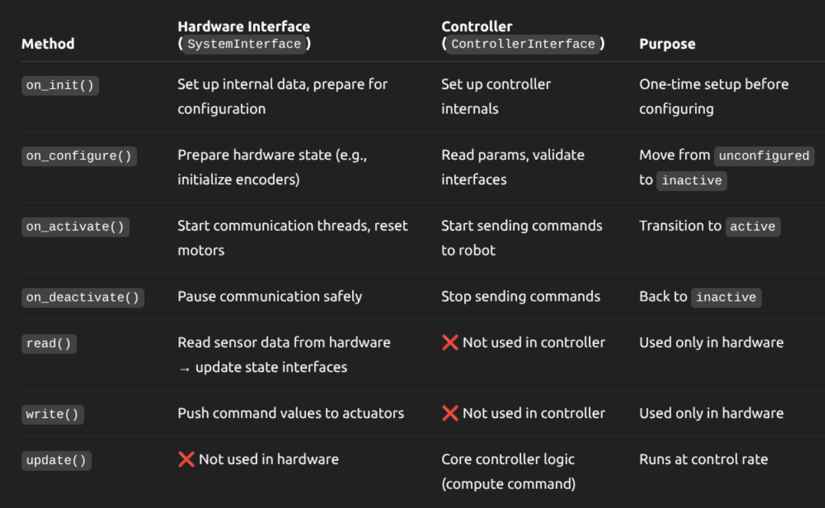

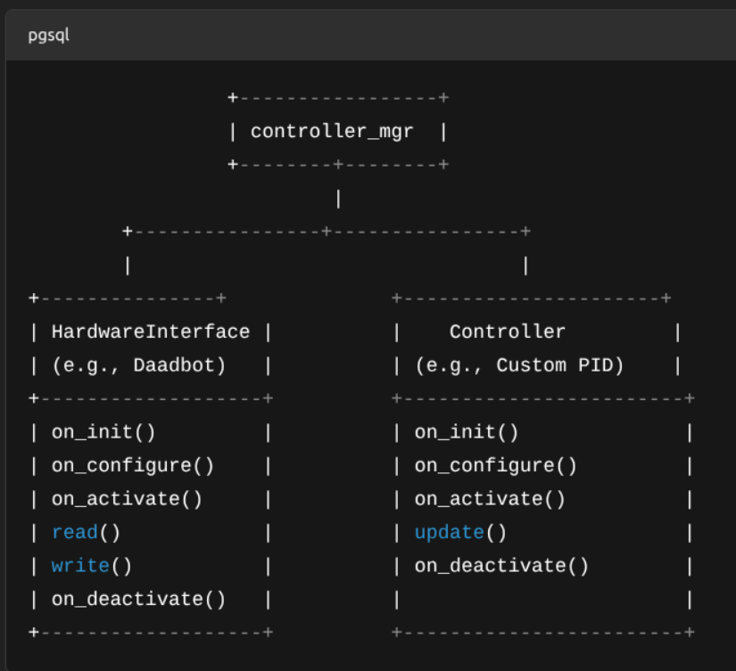

source ~/rerun_env/bin/activate
python /home/maryammahmood/rerun_code.py

conda activate mujmpc_env && cd ~/mujocoMPC/mujoco_mpc/build/bin && ./mjpc

conda activate env_isaaclab
python /home/maryammahmood/gpu_training_inf/vae_gpu.py
conda activate env_isaaclab
python /home/maryammahmood/gpu_training_inf/vae_transformer.py

cd /home/maryammahmood/mujocoMPC/mujoco_mpc/build/bin
./mjpc

conda activate mujmpc_env && cd ~/mujocoMPC/mujoco_mpc/build/bin && ./mjpc

cd ~/mujocoMPC/mujoco_mpc/build/bin && ./mjpc

cd ~/xdaadbot_ws
colcon build
source install/setup.bash
ros2 launch daadbot_bringup sim_robot_table.launch.py

cd ~/xdaadbot_ws
colcon build
source install/setup.bash
ros2 run some_examples_py tf_visualizer

cd ~/xdaadbot_ws
colcon build
source install/setup.bash
ros2 run moveit_pose hand_pose_node

In the git-controlled version.
____________________________________________________________________________
ros2 launch reach_ros start.launch.py robot_description_file:=/home/daad-pc1/xdaadbot_ws/src/daadbot_desc/urdf/urdf_table_vel/daadbot.urdf.xacro robot_description_semantic_file:=/home/daad-pc1/xdaadbot_ws/src/daadbot_moveit/config/daadbot_table.srdf robot_description_kinematics_file:=/home/daad-pc1/xdaadbot_ws/src/daadbot_moveit/config/kinematics.yaml robot_description_joint_limits_file:=/home/daad-pc1/xdaadbot_ws/src/daadbot_moveit/config/joint_limits.yaml config_file:=/home/daad-pc1/reach_ws/src/reach_ros2/config/reach_study.yaml config_name:=daadbot_study results_dir:=/home/daad-pc1/reach_ws/src/reach_ros2/config/results

ros2 launch reach_ros setup.launch.py robot_description_file:=/home/daad-pc1/xdaadbot_ws/src/daadbot_desc/urdf/urdf_table_vel/daadbot.urdf.xacro robot_description_semantic_file:=/home/daad-pc1/xdaadbot_ws/src/daadbot_moveit/config/daadbot_table.srdf use_rviz:=True

source ~/reach_ws/install/setup.bash
source ~/xdaadbot_ws/install/setup.bash
____________________________________________________________________________
cd ~/xdaadbot_ws
colcon build
source install/setup.bash
ros2 launch daadbot_bringup sim_robot_table_ws.launch.py

export PYTHONPATH=/home/maryammahmood/anaconda3/envs/vision_ml/lib/python3.10/site-packages:$PYTHONPATH

source install/setup.bash
ros2 run some_examples_py mpipe

cd ~/xdaadbot_ws
colcon build
source install/setup.bash
ros2 launch daadbot_bringup sim_robot_inverted_pos.launch.py

ros2 launch urdf_tutorial display.launch.py model:='/home/maryammahmood/panda_description/urdf/panda.urdf'

cd ~/xdaadbot_ws
colcon build
source install/setup.bash
ros2 launch daadbot_bringup sim_robot_inverted_forw_torque.launch.py

ros2 launch daadbot_bringup sim_robot_inverted_forw_torque.launch.py transparent_top:=true

source install/setup.bash
ros2 run some_examples_py main_node

source install/setup.bash
ros2 run some_examples_py main_controller

conda activate pinocchio_robotics
source install/setup.bash
ros2 run some_examples_py ctc_controller

ros2 topic echo /effort_controller/commands
ros2 topic echo /joint_states

conda activate pinocchio_robotics
source install/setup.bash
ros2 run some_examples_py collect_data

cd ~/xdaadbot_ws/src/some_examples_py/some_examples_py/
python3 train_dynamics.py

Conversion from xacro to urdf

ros2 run xacro xacro /home/maryammahmood/xdaadbot_ws/src/daadbot_desc/urdf/urdf_inverted_torque/daadbot.urdf.xacro > /home/maryammahmood/xdaadbot_ws/src/daadbot_desc/urdf/urdf_inverted_torque/daadbot.urdf

ros2 run xacro xacro /home/maryammahmood/xdaadbot_ws/src/daadbot_desc/urdf/2_link_urdf/2link_robot.urdf.xacro > /home/maryammahmood/xdaadbot_ws/src/daadbot_desc/urdf/2_link_urdf/2link_robot.urdf

cd ~/xdaadbot_ws
colcon build
conda activate pinocchio_robotics
source install/setup.bash
ros2 run some_examples_py collect_data

ros2 run some_examples_py quantile_error

nominal u – circular
collect data (model selection) on a specific trajectory only.
quantile
feedback linearization necessary?
IK joint angles constraint
conformally robust on manipulator (literature)
PINNs

Excellent hardware demo
Excellent physics engine demo
Dr. Ali Murtaza’s videos on paper – same format.

- Translation: [0.005, 0.217, 0.388]
- Rotation: in Quaternion (xyzw) [-0.000, 1.000, 0.002, 0.000]
- Rotation: in RPY (radian) [3.138, 0.000, -3.142]
- Rotation: in RPY (degree) [179.817, 0.000, -180.000]
- Matrix:
-1.000 -0.000 0.000 0.005
-0.000 1.000 0.003 0.217
-0.000 0.003 -1.000 0.388
0.000 0.000 0.000 1.000

- Translation: [-0.038, -0.003, 0.433]
- Rotation: in Quaternion (xyzw) [0.709, -0.705, -0.007, 0.007]
- Rotation: in RPY (radian) [3.122, 0.000, -1.566]
- Rotation: in RPY (degree) [178.899, 0.009, -89.712]
- Matrix:
0.005 -1.000 -0.019 -0.038
-1.000 -0.005 0.000 -0.003
-0.000 0.019 -1.000 0.433
0.000 0.000 0.000 1.000

- Translation: [-0.354, -0.264, 0.563]
- Rotation: in Quaternion (xyzw) [0.838, -0.439, -0.144, 0.290]
- Rotation: in RPY (radian) [2.482, -0.013, -0.961]
- Rotation: in RPY (degree) [142.202, -0.769, -55.088]
- Matrix:
0.572 -0.653 -0.497 -0.354
-0.820 -0.445 -0.359 -0.264
0.013 0.613 -0.790 0.563
0.000 0.000 0.000 1.000

m
ros2 run tf2_ros tf2_echo world endeffector

height: z=0.563 (from world frame 0,0,0)
xy plane radius: 0.195 m

conda activate pinocchio_robotics
python3 ~/xdaadbot_ws/src/some_examples_py/some_examples_py/CRCLF_CRCBF_traj/calculate_quantile.py

cd ~/xdaadbot_ws
colcon build
source install/setup.bash
ros2 launch daadbot_bringup sim_2_link_forw_torque.launch.py

source install/setup.bash
ros2 run some_examples_py pinocchio_main_node_2_link

source install/setup.bash
ros2 run some_examples_py main_2_link

Stabalization instead of tracking
cbf on pendulum
model learning

Pendulum testing (test the same thing on pendulum instead of 2 DOF)
Test the learned model to see if it’s learned perfectly (too perfect model not required)
7 DOF full testing

Don’t wait till the end of the week

Experiment to see what kind of noise and model performance could be suitable to showcase CR’s benefit in tracking performance

Test on a stablization problem

What had I done:
- I had learned a model for 2 dof dynamics.
- CR didn’t have much performance difference for tracking (CLF) atleast visibly. [CR version more tightly followed trajectory and faster V(x) convergence]. The level of noise in dynamics model which made visible trajectory violations possible, had both CR and regular versions performing bad and reacting to noise.

Targets for next week:
- Pendulum testing (test the same thing on pendulum instead of 2 DOF)
- Test the learned model to see if it’s learned perfectly (too perfect model not required)
- 7 DOF full testing

/usr/local/MATLAB/R2022b/bin/matlab
/usr/local/MATLAB/R2025b/bin/matlab

source install/setup.bash
ros2 run some_examples_py cr_main_2_link

ros2 run tf2_ros tf2_echo base_link end_effector

At time 19.573000000
- Translation: [-0.546, -0.010, 0.511]
- Rotation: in Quaternion (xyzw) [0.500, -0.500, -0.500, 0.500]
- Rotation: in RPY (radian) [1.571, 0.000, -1.571]
- Rotation: in RPY (degree) [90.000, 0.005, -90.000]
- Matrix:
-0.000 -0.000 -1.000 -0.546
-1.000 -0.000 0.000 -0.010
-0.000 1.000 -0.000 0.511
0.000 0.000 0.000 1.000

- Translation: [-0.546, 0.332, 0.758]
- Rotation: in Quaternion (xyzw) [0.698, -0.112, -0.698, 0.112]
- Rotation: in RPY (radian) [1.571, 1.252, -1.571]
- Rotation: in RPY (degree) [90.001, 71.748, -90.000]
- Matrix:
0.000 -0.000 -1.000 -0.546
-0.313 -0.950 0.000 0.332
-0.950 0.313 -0.000 0.758
0.000 0.000 0.000 1.000

- Translation: [-0.546, -0.352, 0.758]
- Rotation: in Quaternion (xyzw) [0.112, -0.698, -0.112, 0.698]
- Rotation: in RPY (radian) [1.571, -1.252, -1.571]
- Rotation: in RPY (degree) [90.001, -71.748, -90.001]
- Matrix:
-0.000 0.000 -1.000 -0.546
-0.313 0.950 0.000 -0.352
0.950 0.313 -0.000 0.758
0.000 0.000 0.000 1.000

- Translation: [-0.546, 0.332, 0.758]
- Translation: [-0.546, -0.352, 0.758]

0.867-0.511

- Saturation on mu and Tau (especially test on limits)
  - Test the tracking performance on limits of torque
- 7 dof full
- Test with the timings (Hz and ms to know how much I can do with the current motor capacity?
- Learned model for dynamics instead of uncertain
- urdf

I had increased the quantile and decreased the clf tracking parameters and the pd controller gains. Which played the role of acting as a stiffer clf tracking controller. All that acts on errors is model free part of controller (clf tracking and error based lyapunov function – error dynamics) vs the model based part that is dictated by the feedback linearization.
As our goal is to have a data driven model and showcase that using a quantile is more beneficial to overcome the errors in the learned model errors, so it makes more sense to focus more on the non-error portion of the clf than the error based

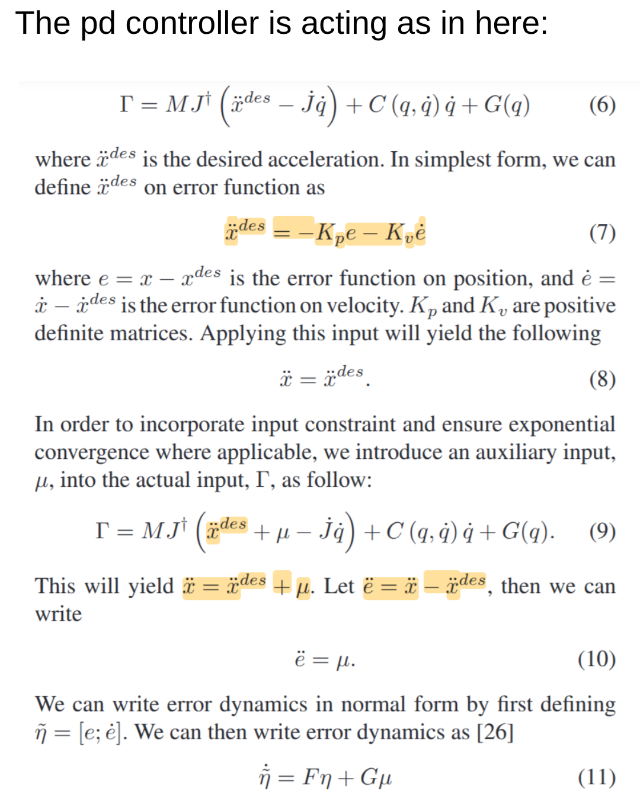

1. Get the minimum gains which would work reasonably good for the non-noisy model (original dynamics)
2. Get a noisy model and see how gains perform for that model – it should perform worse
3. Now use quantile and compare the robustness effects

Only FBL – use mu in the code to be zero
If non-robust clf – use quantile = 0

ros2 run some_examples_py quantile_data_7_dof

I did try the more emphasis on the model based control instead of the model free (error dynamics) and I got the problem better than before, but with a very high quantile. I wasn’t able to trian a model properly, tried different approaches – first joint space version but the task space version doesn’t work. I am unable to identify the issue as I was more busy experimenting with different stuff. And didn’t record anything. Lagrangian

- Quantile plot properly with pdf and cdf way of viewing things
- Use original quantile from data instead of the self-modified version and see how can I cause a noticeable difference there
- Train the model, identify the issues. Please have properly quantified reasons for failure this time
- Have the 7 dof working with the quantile smoothly video

