RVIZ2 Opening Commands:

cd ~/sdaadof_ws
colcon build
source install/setup.bash
ros2 launch urdf_tutorial display.launch.py model:=/home/maryam-mahmood/sdaadof_ws/src/daadbot_desc/urdf/daadbot.urdf.xacro

Opening manually:
- ros2 run robot_state_publisher robot_state_publisher --ros-args -p robot_description:="$(xacro /home/maryam-mahmood/sdaadof_ws/src/daadbot_desc/urdf/daadbot.urdf.xacro)"
- ros2 run joint_state_publisher_gui joint_state_publisher_gui
- ros2 run rviz2 rviz2

cd ~/sdaadof_ws
colcon build
source install/setup.bash
ros2 launch daadbot_desc display.launch.py

cd ~/sdaadof_ws
colcon build
source install/setup.bash
ros2 launch daadbot_desc gazebo.launch.py

Controller Test Commands:
__________________________________________________________________________
cd ~/sdaadof_ws
colcon build
source install/setup.bash
ros2 launch daadbot_desc gazebo.launch.py

cd ~/sdaadof_ws
colcon build
source install/setup.bash
ros2 launch daadbot_controller controller.launch.py

cd ~/sdaadof_ws
colcon build
source install/setup.bash
ros2 topic pub /gripper_controller/commands std_msgs/msg/Float64MultiArray "layout:
dim: []
data_offset: 0
data: [-1]"
__________________________________________________________________________

____________________________________________________________________________

ros2 topic pubarm_controller/commanands std_msgs/msg/Float64MultiArray "layout:
dim: []
data_offset: 0
data: [0, 0, 0, 0, 0, 0, 0]"

ros2 topic pub /arm_controller/commands std_msgs/msg/Float64MultiArray "layout:
dim: []
data_offset: 0
data: [0.1, -0.2, 0.2, 0.3, -0.5, 0.1, 0.2]"
____________________________________________________________________________

TF:
cd ~/sdaadof_ws
colcon build
source install/setup.bash
ros2 launch daadbot_desc display.launch.py
___________________________________________________________________________
ros2 topic echo /tf
___________________________________________________________________________
ros2 run tf2_ros tf2_echo Link_1 Link_2
___________________________________________________________________________
ros2 run tf2_tools view_frames
evince frames_2025-02-08_15.50.08.pdf
___________________________________________________________________________

Moveit2
___________________________________________________________________________
cd ~/sdaadof_ws
colcon build
source install/setup.bash
ros2 launch daadbot_desc gazebo.launch.py

cd ~/sdaadof_ws
colcon build
source install/setup.bash
ros2 launch daadbot_controller controller.launch.py

cd ~/sdaadof_ws
colcon build
source install/setup.bash
ros2 launch daadbot_moveit moveit.launch.py

cd ~/sdaadof_ws
colcon build
source install/setup.bash
ros2 launch daadbot_desc gazebo.launch.py

cd ~/sdaadof_ws
colcon build
source install/setup.bash
ros2 launch daadbot_controller controller.launch.py

cd ~/sdaadof_ws
colcon build
source install/setup.bash
ros2 launch daadbot_moveit moveit.launch.py

cd ~/sdaadof_ws
colcon build
source install/setup.bash
ros2 launch daadbot_posegen mp_interface.launch.py

ros2 launch daadbot_handpose wpose_mv_interface.launch.py

cd ~/sdaadof_ws
colcon build
source install/setup.bash
ros2 action send_goal /multi_task_server daadbot_msgs/action/DaadbotTaskServer "task_id: 1"

daadbot_handpose
Uses task IDs to bring manipulator to a hand pose in base frame. (IK)

daadbot_posegen
Uses task IDs to bring manipulator to a set of joint angles. (FK)

moveit_pose:
Brings manipulator to a hand pose in world frame without task IDs. (IK)

Without Task IDs and launch file:

cd ~/daadbot_ws
colcon build
source install/setup.bash
ros2 launch daadbot_desc gazebo.launch.py

cd ~/daadbot_ws
colcon build
source install/setup.bash
ros2 launch daadbot_controller controller.launch.py

cd ~/daadbot_ws
colcon build
source install/setup.bash
ros2 launch daadbot_moveit moveit.launch.py

cd ~/daadbot_ws
colcon build
source install/setup.bash
ros2 run moveit_pose hand_pose_node

cd ~/sdaadof_ws
colcon build
source install/setup.bash
ros2 run some_examples_cpp lifecycle_node_ex

ros2 lifecycle nodes
ros2 lifecycle get /my_lifecycle_node
ros2 lifecycle set /my_lifecycle_node configure
ros2 lifecycle set /my_lifecycle_node activate
ros2 lifecycle list /my_lifecycle_node

source ~/mediapipe_pose/bin/activate
cd ~/sdaadof_ws
colcon build
source install/setup.bash
ros2 run some_examples_py mpipe

source ~/mediapipe_pose/bin/activate
cd ~/daadbot_ws
colcon build
source install/setup.bash
ros2 run some_examples_py mpipe

export PYTHONPATH=$HOME/mediapipe_pose/lib/python3.12/site-packages:$PYTHONPATH

ros2 launch daadbot_desc gazebo_effort.launch.py
ros2 launch daadbot_controller effort_controller.launch.py
ros2 launch daadbot_moveit moveit_effort.launch.py

ros2 launch daadbot_desc gazebo_vel.launch.py
ros2 launch daadbot_controller vel_controller.launch.py
ros2 launch daadbot_moveit moveit_vel.launch.py

ros2 launch daadbot_posegen input_moveit.launch.py

cd ~/daadbot_ws
colcon build
source install/setup.bash
ros2 launch daadbot_desc gazebo.launch.py

cd ~/daadbot_ws
colcon build
source install/setup.bash
ros2 launch daadbot_controller controller.launch.py

cd ~/daadbot_ws
colcon build
source install/setup.bash
ros2 launch daadbot_moveit moveit.launch.py

cd ~/daadbot_ws
colcon build
source install/setup.bash
ros2 launch daadbot_desc gazebo_vel.launch.py

cd ~/daadbot_ws
colcon build
source install/setup.bash
ros2 launch daadbot_controller vel_controller.launch.py

cd ~/daadbot_ws
colcon build
source install/setup.bash
ros2 launch daadbot_moveit moveit_vel.launch.py

/home/maryammahmood/Downloads/final_7dof_urdf_9oct2024/meshes

ros2 launch daadbot_bringup sim_robot.launch.py

cd ~/ndaadbot_ws
colcon build
source install/setup.bash
ros2 launch daadbot_desc gazebo_table_vel.launch.py

cd ~/ndaadbot_ws
colcon build
source install/setup.bash
ros2 launch daadbot_controller vel_controller_table.launch.py

cd ~/ndaadbot_ws
colcon build
source install/setup.bash
ros2 launch daadbot_moveit moveit_table.launch.py

cd ~/ndaadbot_ws
colcon build
source install/setup.bash
ros2 run daadbot_moveit trajectory_plotter.py

ros2 launch daadbot_bringup sim_robot_table.launch.py
ros2 launch daadbot_bringup real_robot_table.launch.py

cd ~/ndaadbot_ws
colcon build
source install/setup.bash
ros2 launch daadbot_bringup sim_robot_table.launch.py

cd ~/ndaadbot_ws
colcon build
source install/setup.bash
ros2 launch daadbot_bringup real_robot_table.launch.py

cd ~/mdaadbot_ws
colcon build
source install/setup.bash
ros2 launch daadbot_desc gazebo_ntable_vel.launch.py

cd ~/mdaadbot_ws
colcon build
source install/setup.bash
ros2 launch daadbot_controller vel_controller_table.launch.py

cd ~/daadbot_ws
colcon build
source install/setup.bash
ros2 launch daadbot_desc gazebo_table_vel.launch.py

cd ~/daadbot_ws
colcon build
source install/setup.bash
ros2 launch daadbot_controller vel_controller_table.launch.py

cd ~/daadbot_ws
colcon build
source install/setup.bash
ros2 launch daadbot_moveit moveit_table.launch.py

cd ~/.mujoco/mujoco-3.3.2/bin
./simulate

cd ~/xdaadbot_ws
colcon build
source install/setup.bash
ros2 launch daadbot_desc gazebo_table_vel.launch.py

cd ~/xdaadbot_ws
colcon build
source install/setup.bash
ros2 launch daadbot_controller vel_controller_table.launch.py

cd ~/xdaadbot_ws
colcon build
source install/setup.bash
ros2 launch daadbot_moveit moveit_table.launch.py

cd ~/xdaadbot_ws
colcon build
source install/setup.bash
ros2 launch daadbot_bringup real_robot_table.launch.py

cd ~/xdaadbot_ws
colcon build
source install/setup.bash
ros2 launch daadbot_bringup sim_robot_table.launch.py

cd ~/xdaadbot_ws
colcon build
source install/setup.bash
ros2 launch daadbot_desc gazebo_table_effort.launch.py

cd ~/xdaadbot_ws
colcon build
source install/setup.bash
ros2 launch daadbot_controller effort_controller_table.launch.py

cd ~/mujoco_ws
colcon build
source install/setup.bash
ros2 launch mujoco_demo_robot cart_effort.launch.py

cd ~/mujoco_ws
colcon build
source install/setup.bash
ros2 run mujoco_ros2_control_demos example_effort

cd ~/mujoco2_ws
colcon build
source install/setup.bash
ros2 launch kuka_velocity_control mujoco.py

cd ~/zdaadbot_ws
colcon build
source install/setup.bash
ros2 launch mujoco_demo_robot daadbot.launch.py

source ~/dartpy_env/bin/activate
python3 /home/maryam-mahmood/dartcode.py

xdg-open /opt/ros/jazzy/opt/gz_sim_vendor/share/gz/gz-sim8/worlds

xdg-open /usr/share/ignition/ignition-gazebo6/worlds/

gz sim sensors.sdf
gz topic -e -t /world/sensors/model/force_torque_demo/joint/joint_01/sensor/force_torque/forcetorque

gz sim /home/maryam-mahmood/custom_gz_worlds/force_torque_demo.sdf

gz topic -e -t /world/empty/model/daadbot/joint/joint_1/sensor/ft_sensor_joint_1/forcetorque

cd ~/udaadbot_ws
colcon build
source install/setup.bash
ros2 launch daadbot_bringup real_robot_table.launch.py

zdaadbot – For mujoco integration.
udaadbot - with new hardware interface.
xdaadbot – with gazebo plugin for force-torque. (only joint_1 for now.)

Humble:
ros2 launch realsense2_camera rs_launch.py pointcloud.enable:=true
rviz2
pointcloud from depth/color/points topic.

python /home/maryammahmood/Documents/IK_URDF/inertia_trimesh

source ~/pin_env/bin/activate
python /home/maryammahmood/Documents/IK_URDF/rob_dyn.py

cd ~/ws_moveit2
source install/setup.bash
ros2 launch moveit_servo servo_example.launch.py

cd ~/ws_moveit2
source install/setup.bash
ros2 service call /servo_node/start_servo std_srvs/srv/Trigger {}

cd ~/ws_moveit2
source install/setup.bash
ros2 run moveit2_tutorials servo_keyboard_input

cd ~/ws_moveit2
source install/setup.bash
ros2 launch moveit2_tutorials servo_cpp_interface_demo.launch.py

cd ~/ros2_control_demos
source install/setup.bash
ros2 launch ros2_control_demo_example_7 r6bot_controller.launch.py

cd ~/ros2_control_demos
source install/setup.bash
ros2 launch ros2_control_demo_example_7 send_trajectory.launch.py

cd ~/xdaadbot_ws
colcon build
source install/setup.bash
ros2 launch daadbot_desc cam_bot.launch.py

cd ~/xdaadbot_ws
colcon build
source install/setup.bash
ros2 launch daadbot_bringup sim_robot_table.launch.py

ros2 run tf2_ros static_transform_publisher --x 0.04 --y -0.05 --z 0.114463048454132 --roll 1.5707963267949 --pitch 0 --yaw 0 --frame-id Link_1 --child-frame-id daadbot/joint_2/tcp_fts_sensor_joint_2

ros2 run tf2_ros tf2_echo Link_1 daadbot/joint_2/tcp_fts_sensor_joint_2

source install/setup.bash
ros2 topic echo /daadbot/z_torques

export DART_DATA_LOCAL_PATH=/home/maryammahmood/dart/data/
python3 /home/maryammahmood/dart/kr5_sim.py
python3 /home/maryammahmood/dart/new_code.py

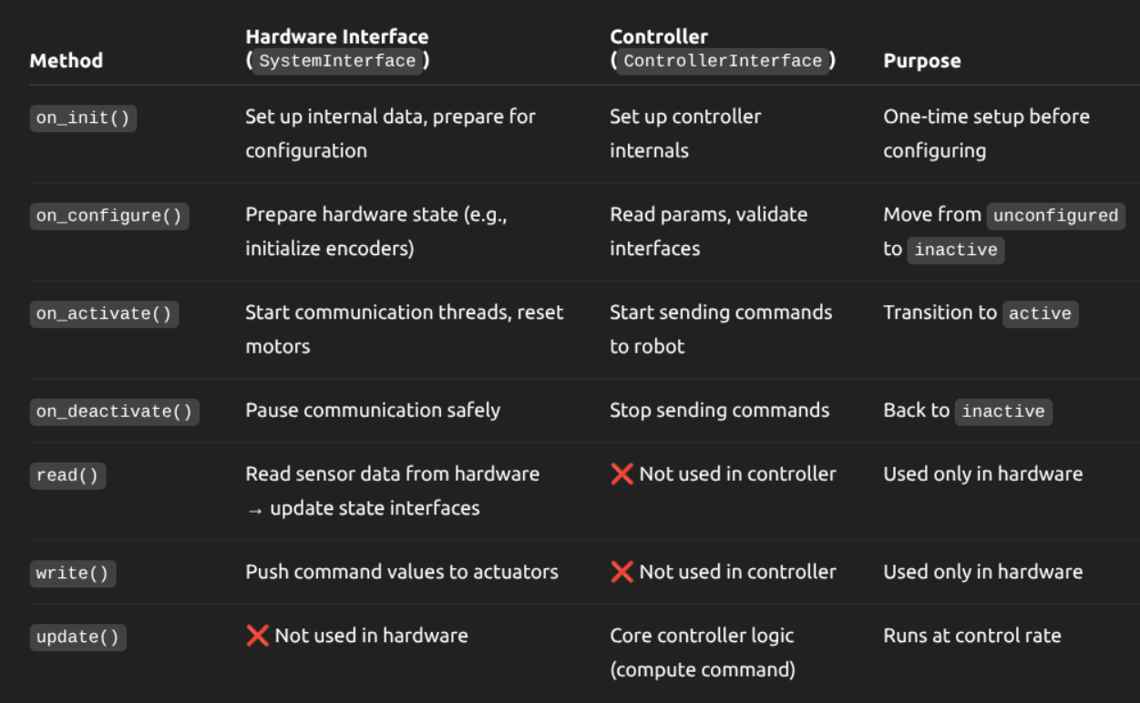

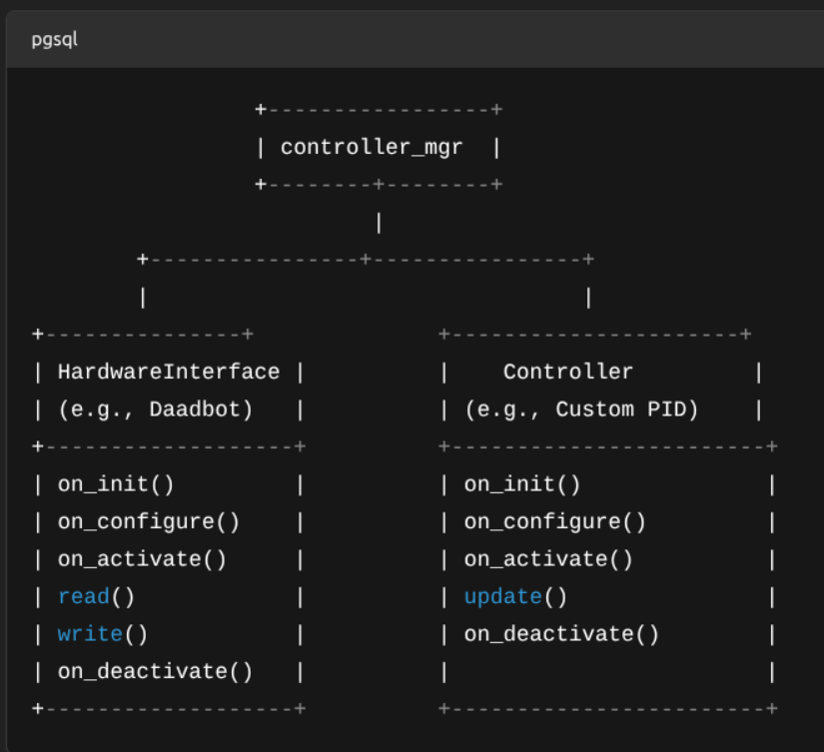

source ~/rerun_env/bin/activate
python /home/maryammahmood/rerun_code.py

conda activate mujmpc_env && cd ~/mujocoMPC/mujoco_mpc/build/bin && ./mjpc

conda activate env_isaaclab
python /home/maryammahmood/gpu_training_inf/vae_gpu.py
conda activate env_isaaclab
python /home/maryammahmood/gpu_training_inf/vae_transformer.py

cd /home/maryammahmood/mujocoMPC/mujoco_mpc/build/bin
./mjpc

conda activate mujmpc_env && cd ~/mujocoMPC/mujoco_mpc/build/bin && ./mjpc

cd ~/mujocoMPC/mujoco_mpc/build/bin && ./mjpc

cd ~/xdaadbot_ws
colcon build
source install/setup.bash
ros2 launch daadbot_bringup sim_robot_table.launch.py

cd ~/xdaadbot_ws
colcon build
source install/setup.bash
ros2 run some_examples_py tf_visualizer

cd ~/xdaadbot_ws
colcon build
source install/setup.bash
ros2 run moveit_pose hand_pose_node

In the git-controlled version.
cd ~/xdaadbot_ws
colcon build
source install/setup.bash
ros2 launch daadbot_bringup sim_robot_table_ws.launch.py

export PYTHONPATH=/home/maryammahmood/anaconda3/envs/vision_ml/lib/python3.10/site-packages:$PYTHONPATH

source install/setup.bash
ros2 run some_examples_py mpipe

cd ~/xdaadbot_ws
colcon build
source install/setup.bash
ros2 launch daadbot_bringup sim_robot_inverted_pos.launch.py

ros2 launch urdf_tutorial display.launch.py model:='/home/maryammahmood/panda_description/urdf/panda.urdf'

cd ~/xdaadbot_ws
colcon build
source install/setup.bash
ros2 launch daadbot_bringup sim_robot_inverted_forw_torque.launch.py

ros2 launch daadbot_bringup sim_robot_inverted_forw_torque.launch.py transparent_top:=true

source install/setup.bash
ros2 run some_examples_py main_node

source install/setup.bash
ros2 run some_examples_py main_controller

conda activate pinocchio_robotics
source install/setup.bash
ros2 run some_examples_py ctc_controller

ros2 topic echo /effort_controller/commands
ros2 topic echo /joint_states

conda activate pinocchio_robotics
source install/setup.bash
ros2 run some_examples_py collect_data

cd ~/xdaadbot_ws/src/some_examples_py/some_examples_py/
python3 train_dynamics.py

Conversion from xacro to urdf

ros2 run xacro xacro /home/maryammahmood/xdaadbot_ws/src/daadbot_desc/urdf/urdf_inverted_torque/daadbot.urdf.xacro > /home/maryammahmood/xdaadbot_ws/src/daadbot_desc/urdf/urdf_inverted_torque/daadbot.urdf

cd ~/xdaadbot_ws
colcon build
conda activate pinocchio_robotics
source install/setup.bash
ros2 run some_examples_py collect_data

ros2 run some_examples_py quantile_error

nominal u – circular
collect data (model selection) on a specific trajectory only.
quantile
feedback linearization necessary?
IK joint angles constraint
conformally robust on manipulator (literature)
PINNs

Excellent hardware demo
Excellent physics engine demo
Dr. Ali Murtaza’s videos on paper – same format.

- Translation: [0.005, 0.217, 0.388]
- Rotation: in Quaternion (xyzw) [-0.000, 1.000, 0.002, 0.000]
- Rotation: in RPY (radian) [3.138, 0.000, -3.142]
- Rotation: in RPY (degree) [179.817, 0.000, -180.000]
- Matrix:
-1.000 -0.000 0.000 0.005
-0.000 1.000 0.003 0.217
-0.000 0.003 -1.000 0.388
0.000 0.000 0.000 1.000

- Translation: [-0.038, -0.003, 0.433]
- Rotation: in Quaternion (xyzw) [0.709, -0.705, -0.007, 0.007]
- Rotation: in RPY (radian) [3.122, 0.000, -1.566]
- Rotation: in RPY (degree) [178.899, 0.009, -89.712]
- Matrix:
0.005 -1.000 -0.019 -0.038
-1.000 -0.005 0.000 -0.003
-0.000 0.019 -1.000 0.433
0.000 0.000 0.000 1.000

- Translation: [-0.354, -0.264, 0.563]
- Rotation: in Quaternion (xyzw) [0.838, -0.439, -0.144, 0.290]
- Rotation: in RPY (radian) [2.482, -0.013, -0.961]
- Rotation: in RPY (degree) [142.202, -0.769, -55.088]
- Matrix:
0.572 -0.653 -0.497 -0.354
-0.820 -0.445 -0.359 -0.264
0.013 0.613 -0.790 0.563
0.000 0.000 0.000 1.000

m
ros2 run tf2_ros tf2_echo world endeffector

height: z=0.563 (from world frame 0,0,0)
xy plane radius: 0.195 m

conda activate pinocchio_robotics
python3 ~/xdaadbot_ws/src/some_examples_py/some_examples_py/CRCLF_CRCBF_traj/calculate_quantile.py

