LAB 03

Submitted by: Maryam Shabbir
Submitted to : Sir. Mubashir Ubaidullah
Registration no : SP23-BSE-012
Subject : Visual Programming


COMSATS University Islamabad
Campus Vehari

Activity 1:
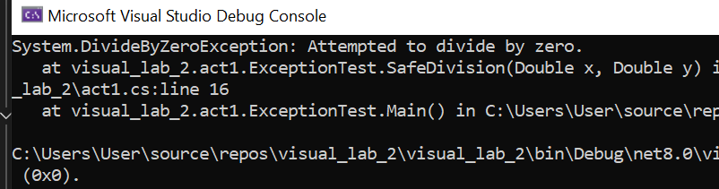
Activity 2:
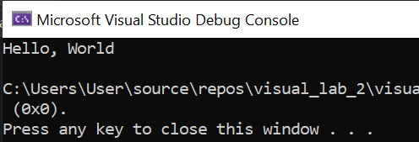
Activity 4:

Activity 5:
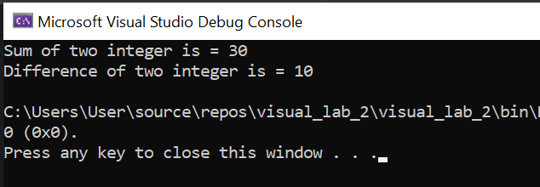
TASK 1:
Program :
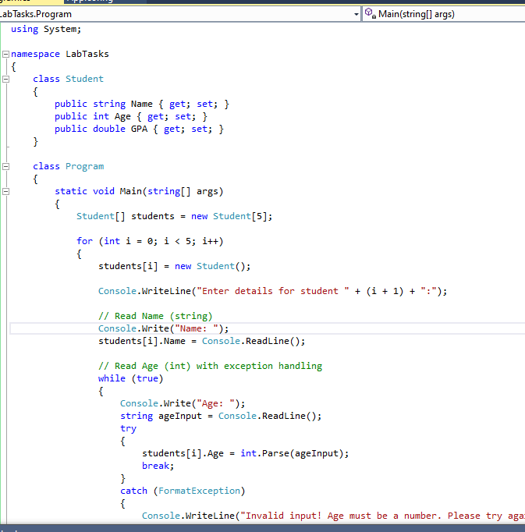
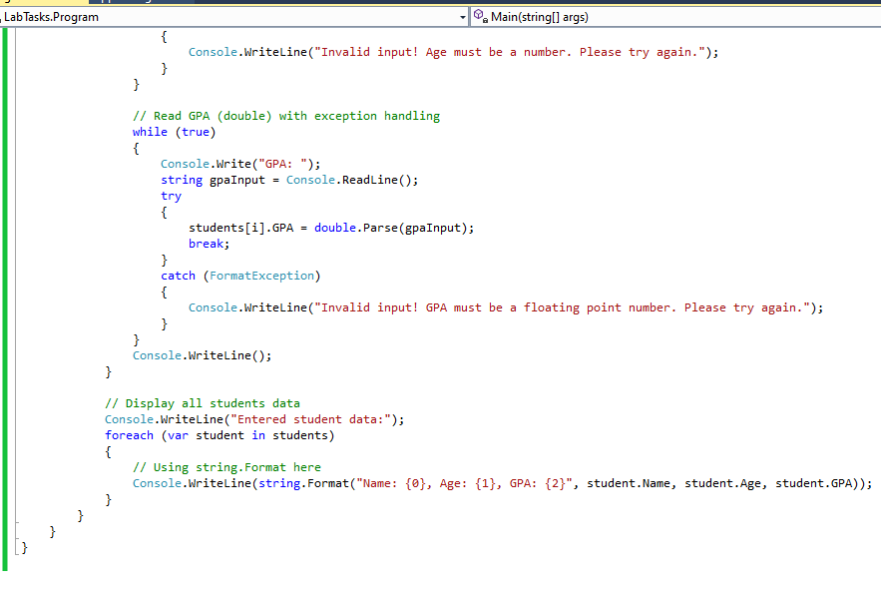
Output:
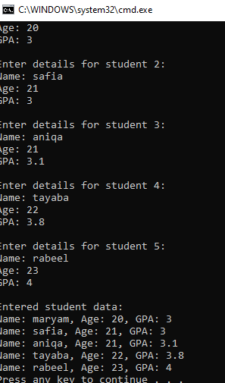
TASK 2:
Program:
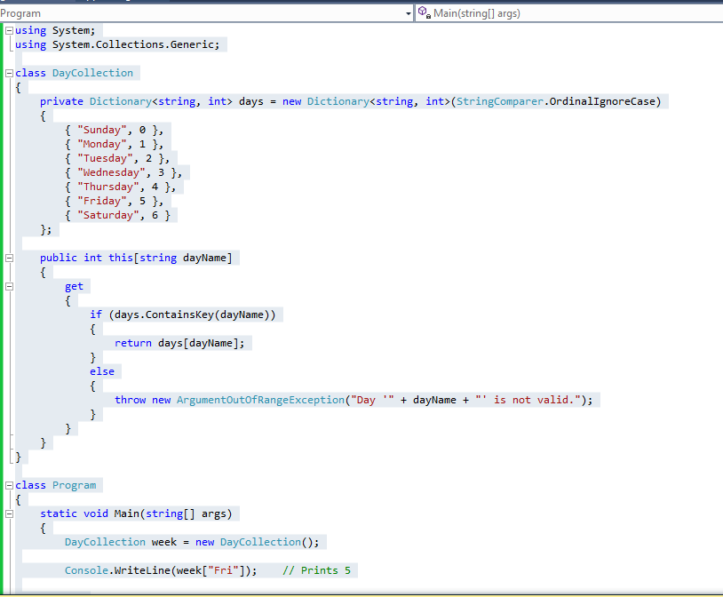
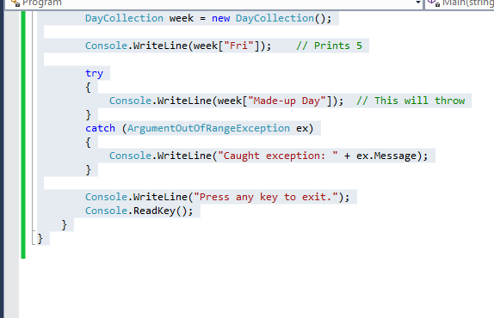
Output :
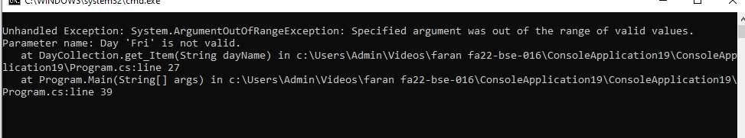

TASK 4 :
Program :
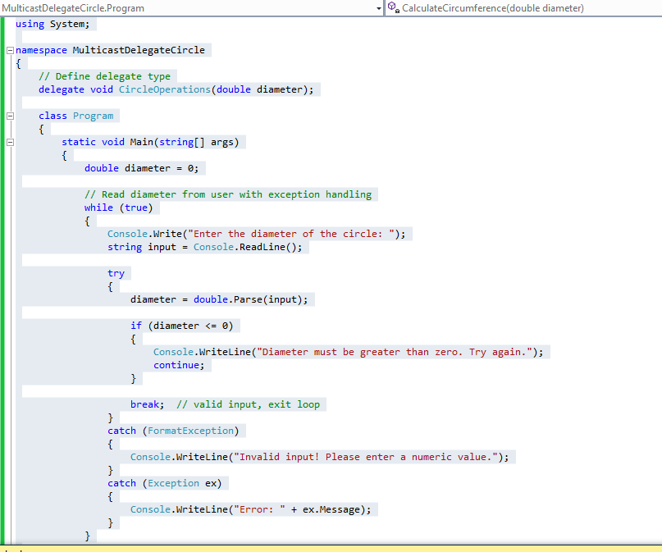
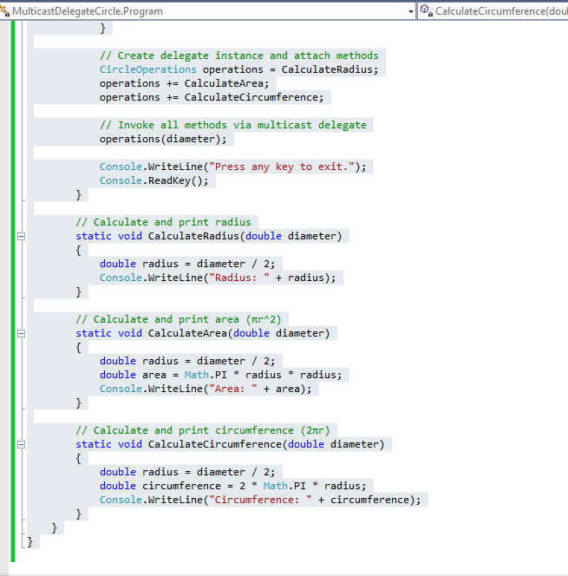
Output :
