

**Punjab University College of Information and Technology**

**Submitted by:**

Mariam Shehzadi

**Roll no:**

MCSF19A039

**Submitted to:**

Professor Haq Nawaz

**Date:**

March 16, 2021

**Screens of Andriod Studio**

**Screen 01 ( MyApplication1):**

* Try to make the simple screen
* use Constraint Layout
* use background pic
* use Two text view

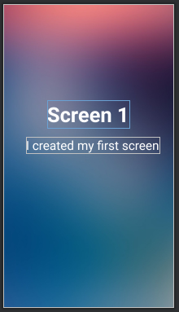

**Screen 02:**

* Try to make the login page .
* use Linear layout inside Constraint layout
* use four Edit text
* use a button
* use a Text view
* use circular image view

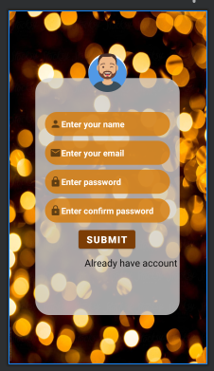

**Screen 03:**

* Try to make the frontend of simple calculator
* use Constraint layout
* use two edit text
* use 18 buttons.

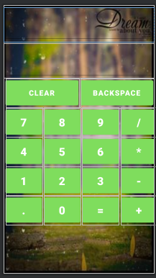

**ClassTodo :**

* use to activities as main activity and activity_main2
* In main activity there is a background pic
* Use one button
* And in activity_main2 ,there is a background pic
* And use two buttons.
* Apply implementation code of all buttons
* The button that is in main activity is used to move to the activity_main2
* And the buttons in activity_main2, named as website and call
* Website button is used to open the website
* And call button is used call the number

