TASK 1
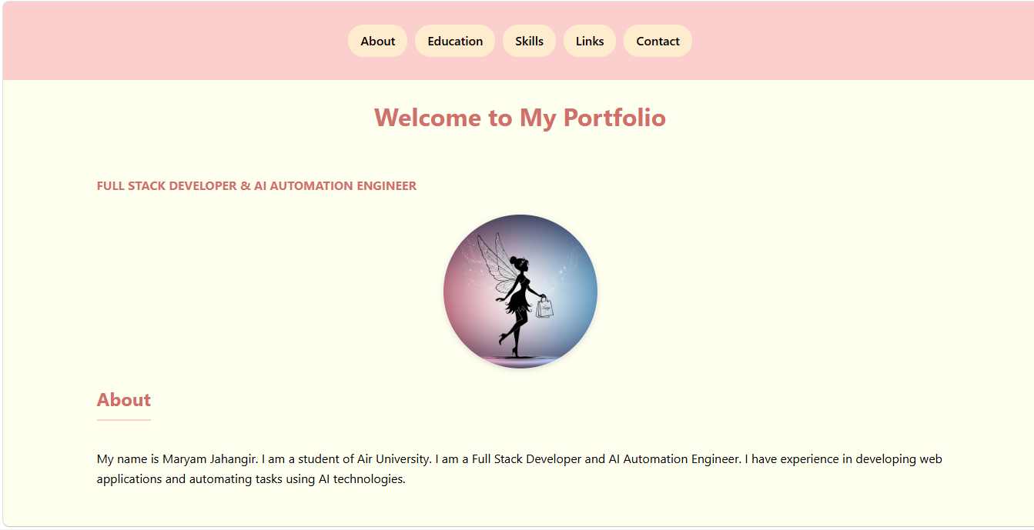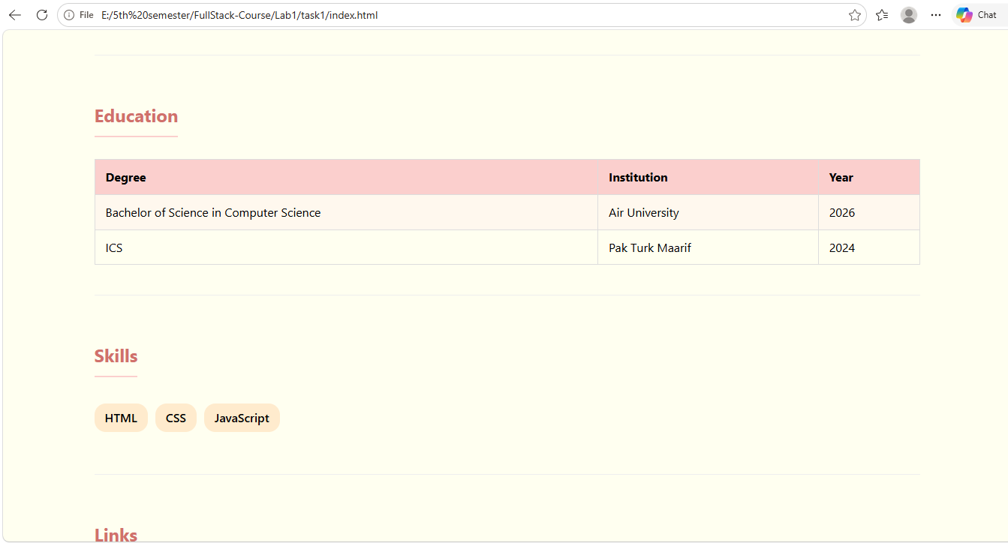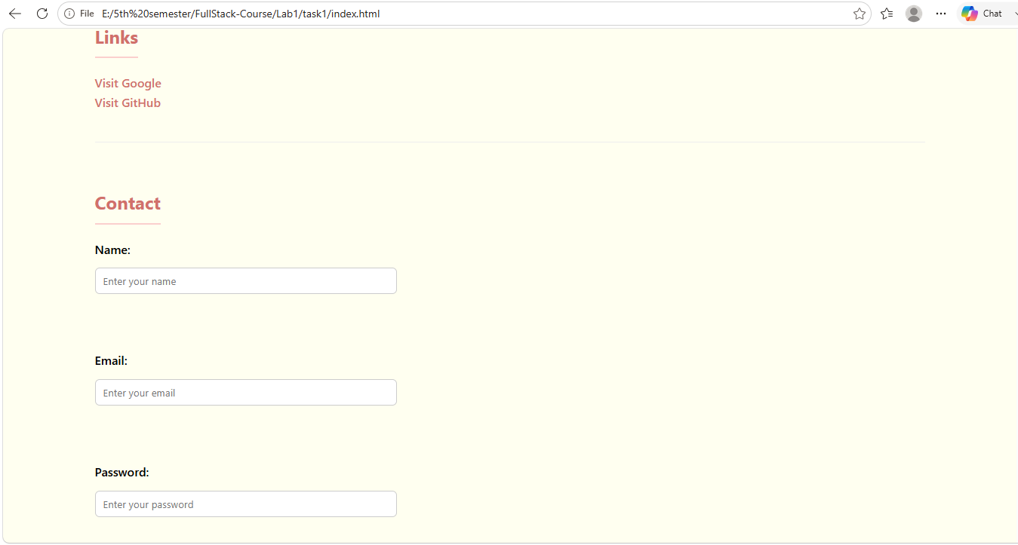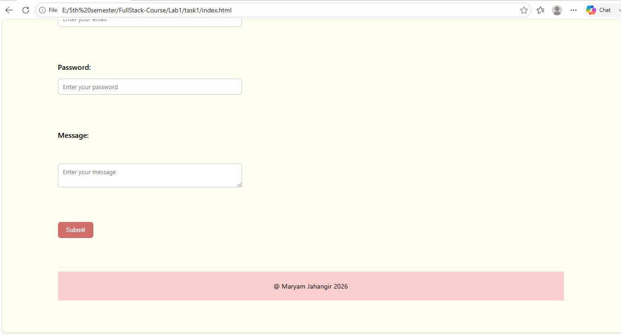
TASK 2
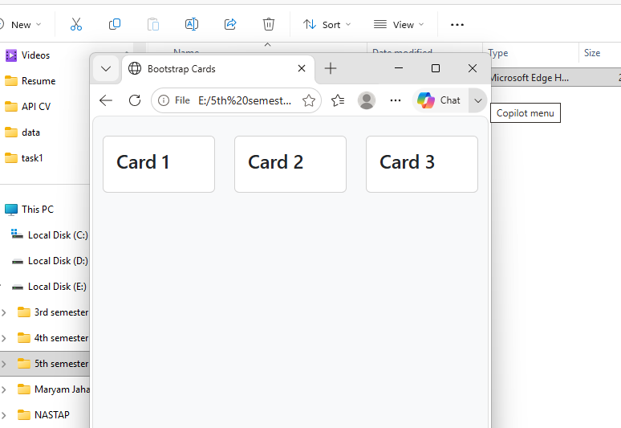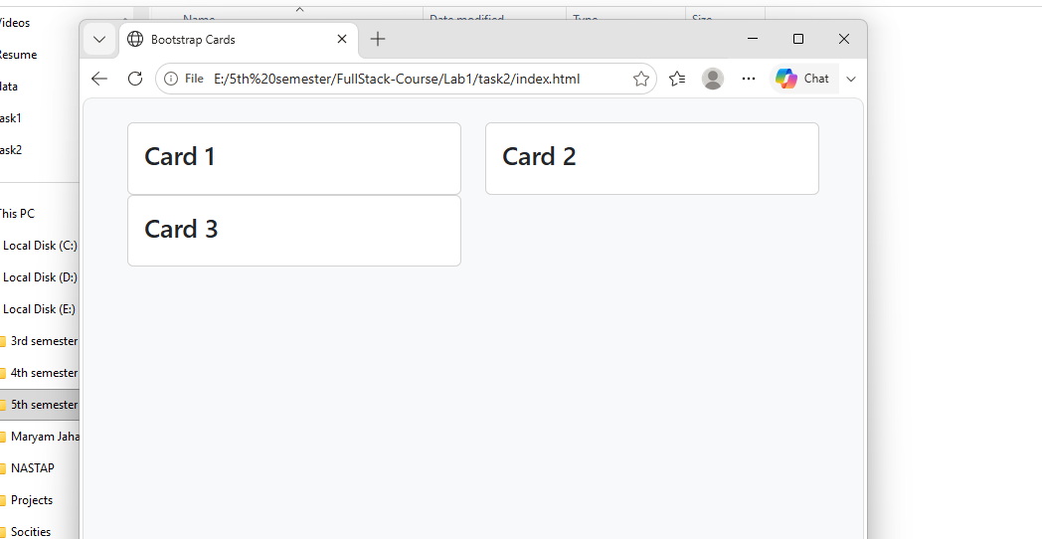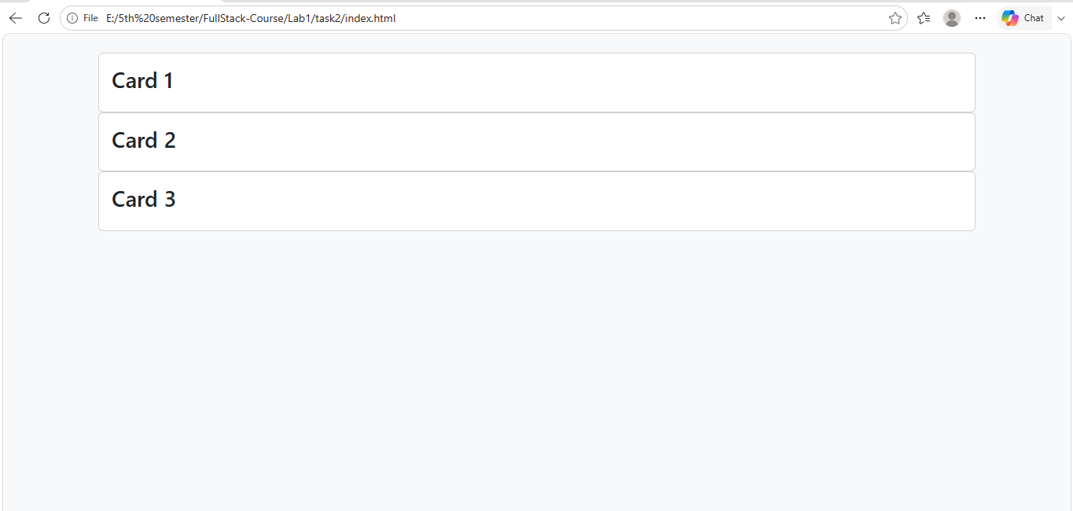

- Now my concepts related to the grid system and breaking points are more clear.
- Three cards inside a Bootstrap container and row.
- For each card, classes col-4 col-md-6 col-lg-12.
- On small screens: col-4 is applied, so each card takes 4 out of 12 columns. This means all three cards can fit in the same row because 4 + 4 + 4 = 12.
- On medium screens: col-md-6 is applied, so each card takes 6 out of 12 columns. Therefore, only two cards fit in one row, as 6+6 = 12 and the third card moves to the next row.
- On large screens: col-lg-12 is applied, so each card takes the full 12 columns. Therefore, all three cards appear one below another, with each card taking the full row width.
- Used Bootstrap's predefined card and card-body classes to create the cards without writing custom CSS for their basic structure.
- bg-light for the light background and py-4 for vertical padding.

HOME TASK
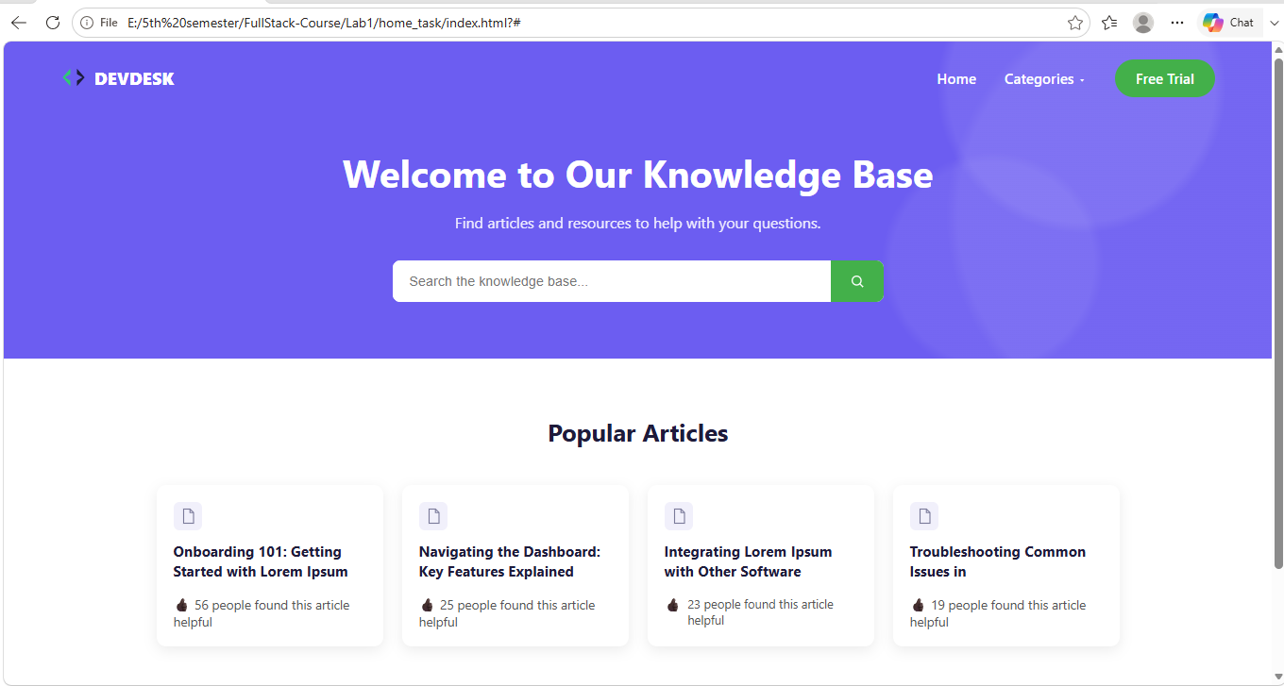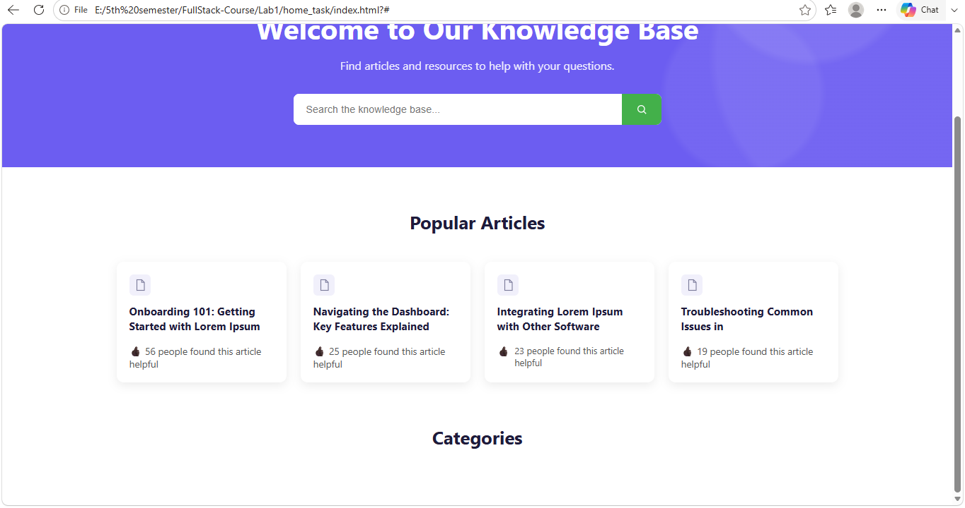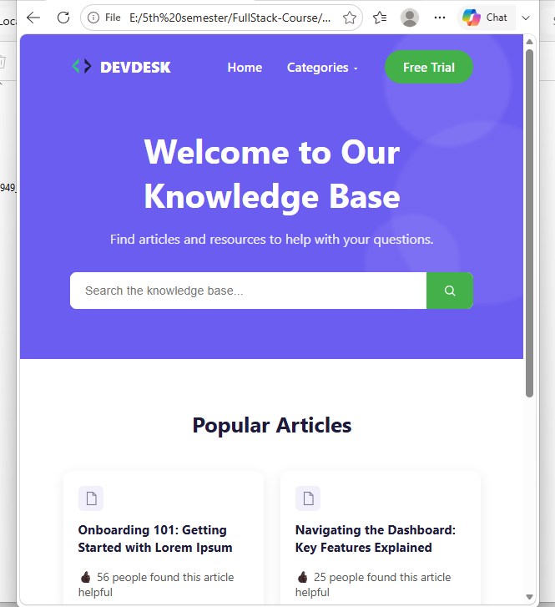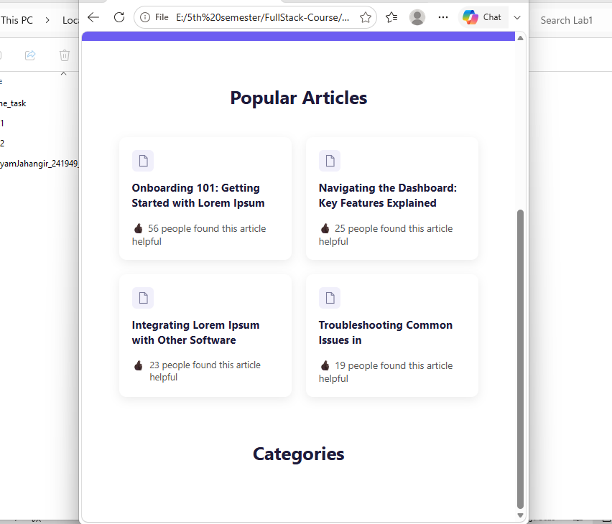

- In the navbar, I used Flexbox with justify-content: space-between to place the logo on one side and navigation links on the other.
- The hero section uses a purple background with multiple radial-gradient() effects to create the background design.
- The search bar using Flexbox, where the input takes the available space using flex: 1.
- For the Popular Articles section, I created four separate article cards and arranged them using display: flex, gap, and flex-wrap.
- Each article card has an icon, heading, and helpful count. I used box-shadow, border-radius, and padding to improve the card design.
- SVG elements for the DevDesk logo, search icon, and document icons instead of using image files.
- The Free Trial button and search button were styled separately using background colors, padding, and border-radius.
- max-width and margin: 0 auto to keep the content centered and prevent it from becoming too wide.

