**Overview:**

I developed and deployed a **Retrieval-Augmented Generation (RAG) based chatbot** that allows users to upload multiple PDF documents and ask questions about their contents. The chatbot uses **semantic search powered by sentence-transformers** to extract relevant chunks from the documents and then sends them to a **Groq-hosted LLaMA 3 language model** for generating accurate and context-aware answers.

The application features a **Gradio-based user interface** where users can:

* Upload multiple PDFs
* Ask natural language questions
* Receive intelligent answers based on the uploaded content

**Enhancements Added:**

* Replaced TF-IDF with **sentence-transformers** for accurate semantic search and better answer relevance.
* 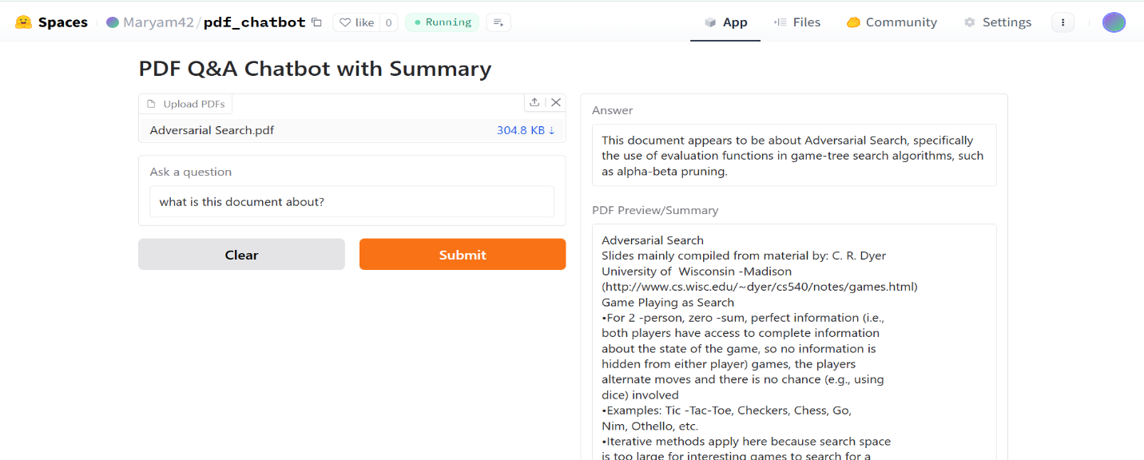**Added PDF preview** and summary before allowing users to ask questions.

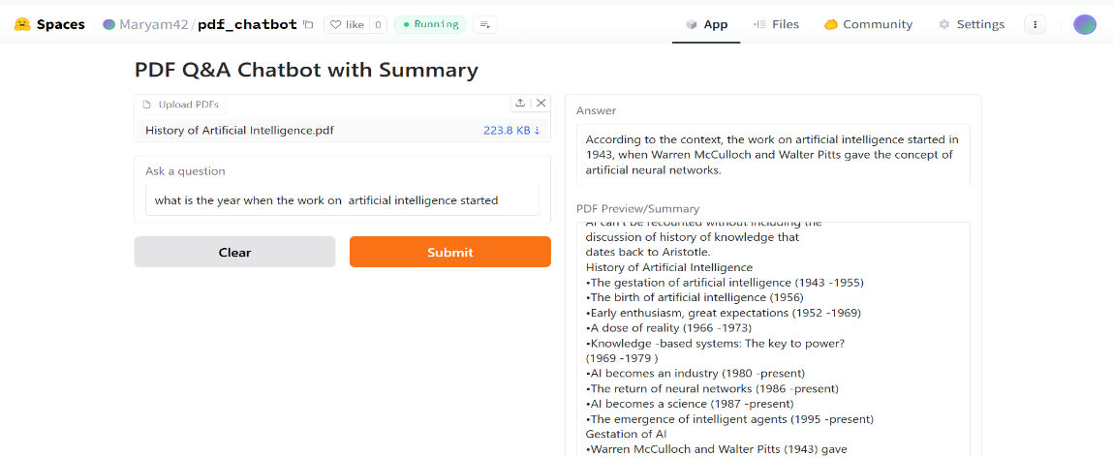

Screenshot 2:

**Challenges faced:**

* API key not detected due to naming mismatch
* Groq API returned 503 errors during testing
* Interface didn't show results initially