Adnan Jelani BUIC

CSL 114 Introduction to Information & Communication Technology Lab
Lab 6 Journal
Introduction to Git, GitHub and GitHub Desktop

Table of Contents
Lab Tasks 1
Task 1: Creating Your First Repository 1
Task 2: Making Changes and Commits 2
2A - Edit the README 2
2B - Making a Commit 2
2C - Publishing to GitHub 2
2D - Making More Commits 2
Task 3: Working with Branches 2
3A - Creating a Branch 3
3B - Making Changes on a Branch 3
3C - Merging the Branch 3
Task 4: Fork, Clone, and Create a Pull Request 4
4A: Fork the Repo 4
4B: Clone Your Fork 4
4C: Edit and Commit 4
4D: Create a Pull Request 4
Assessment Questions 5
Lab Deliverables (submission guideline) 5

Lab Tasks
Add screenshots step by step.

Task 1: Creating Your First Repository

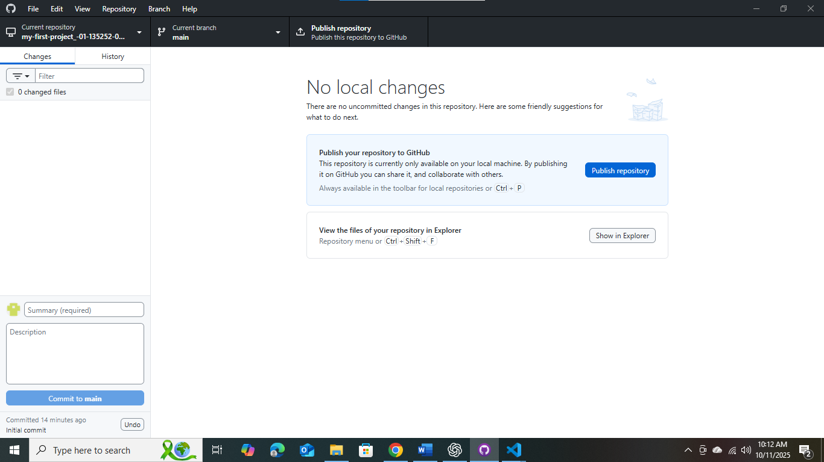

Task 2: Making Changes and Commits

2A - Edit the README
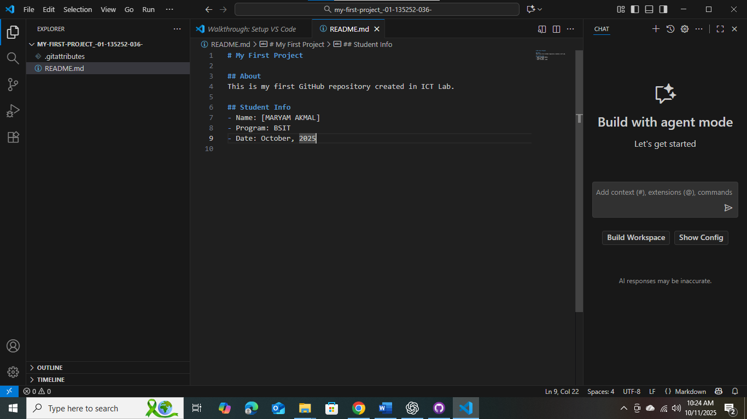

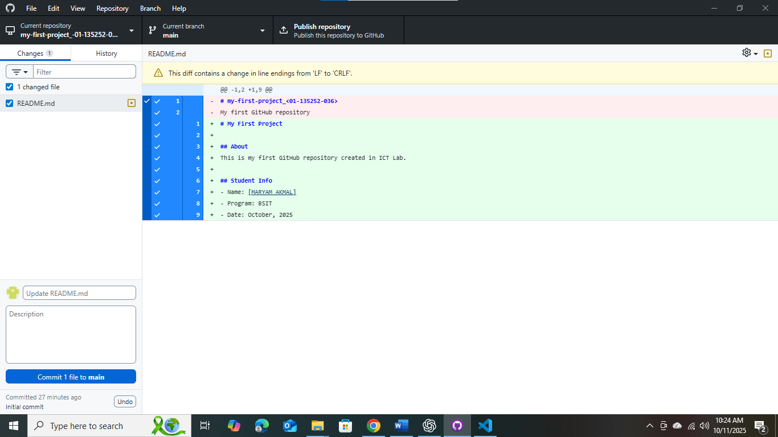

2B - Making a Commit
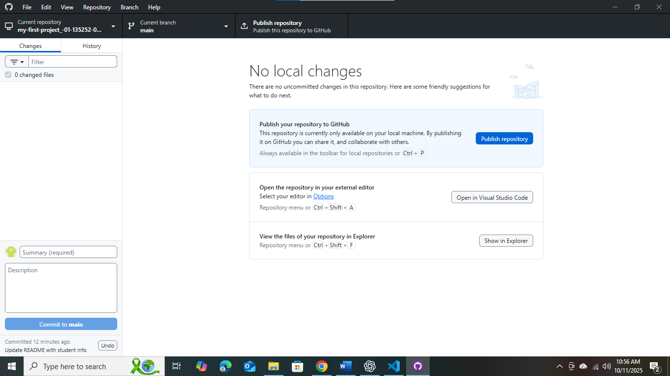

2C - Publishing to GitHub
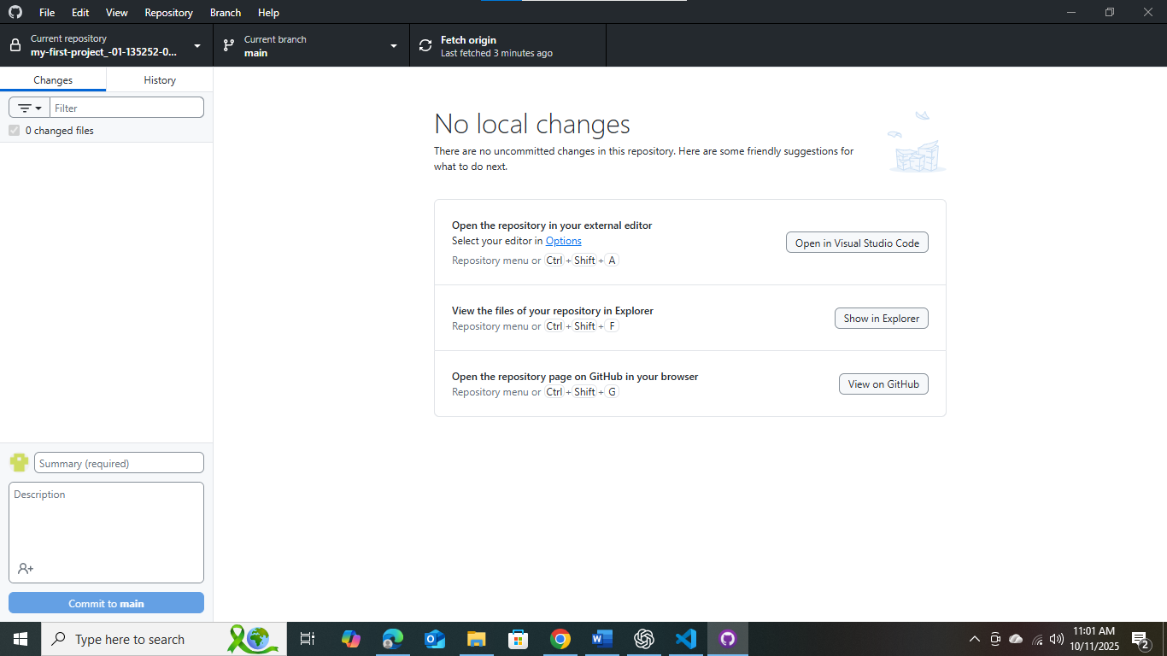

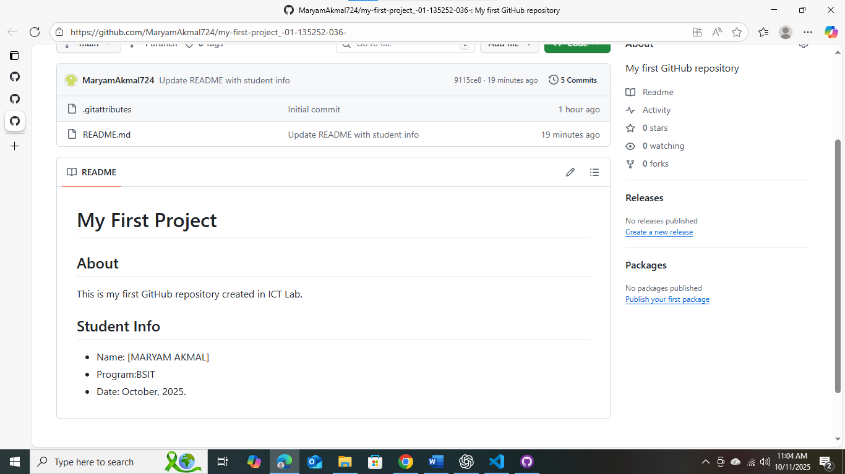

2D - Making More Commits

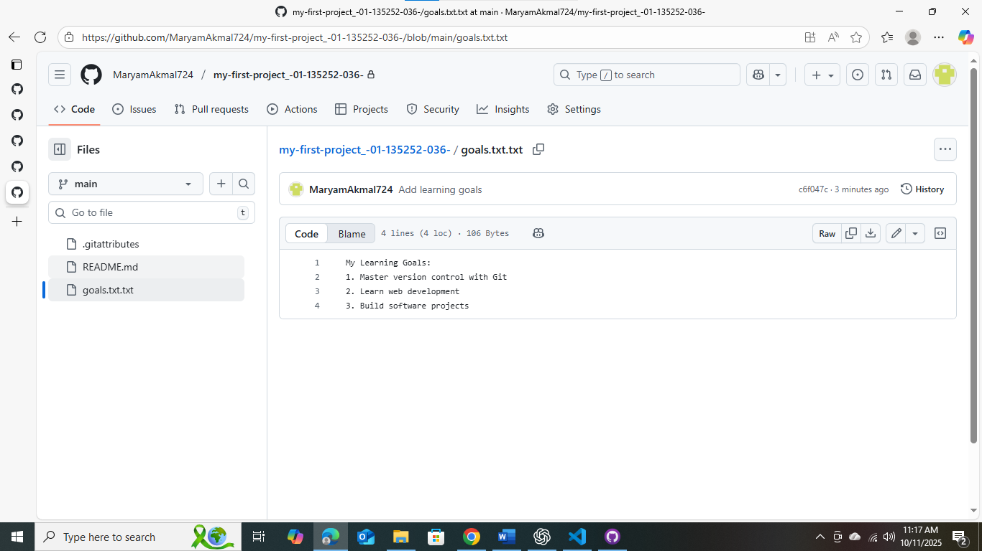

Task 3: Working with Branches

3A - Creating a Branch
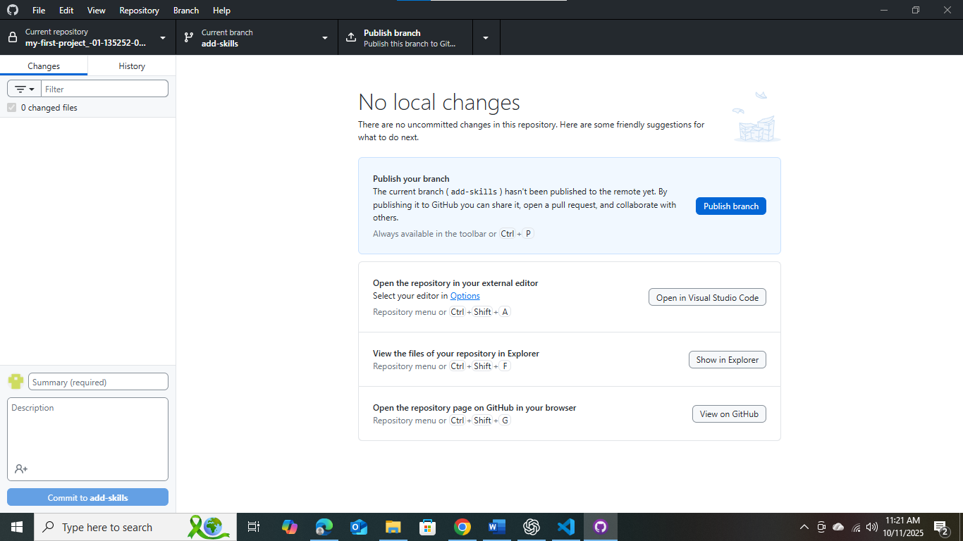

3B - Making Changes on a Branch
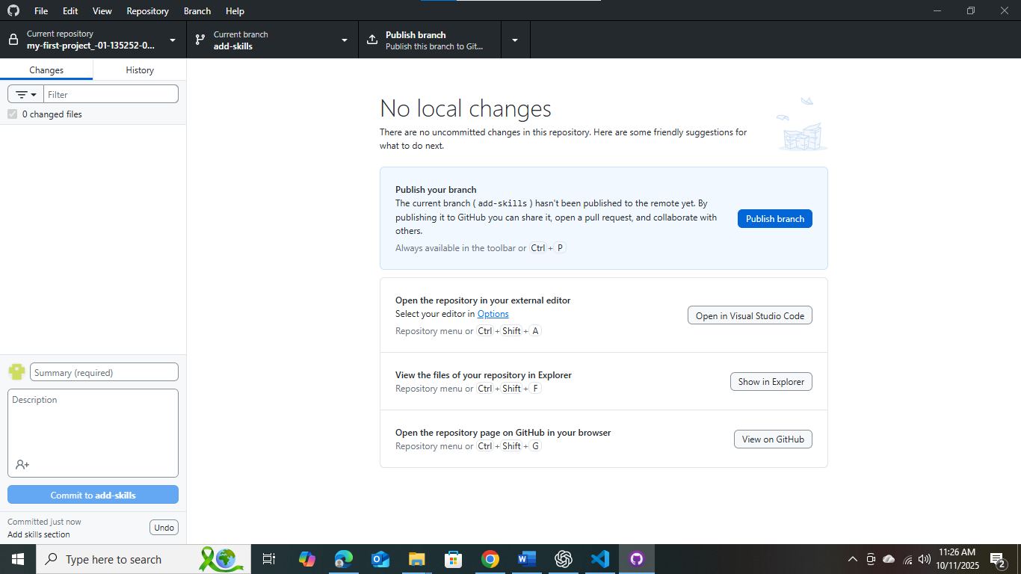

3C - Merging the Branch

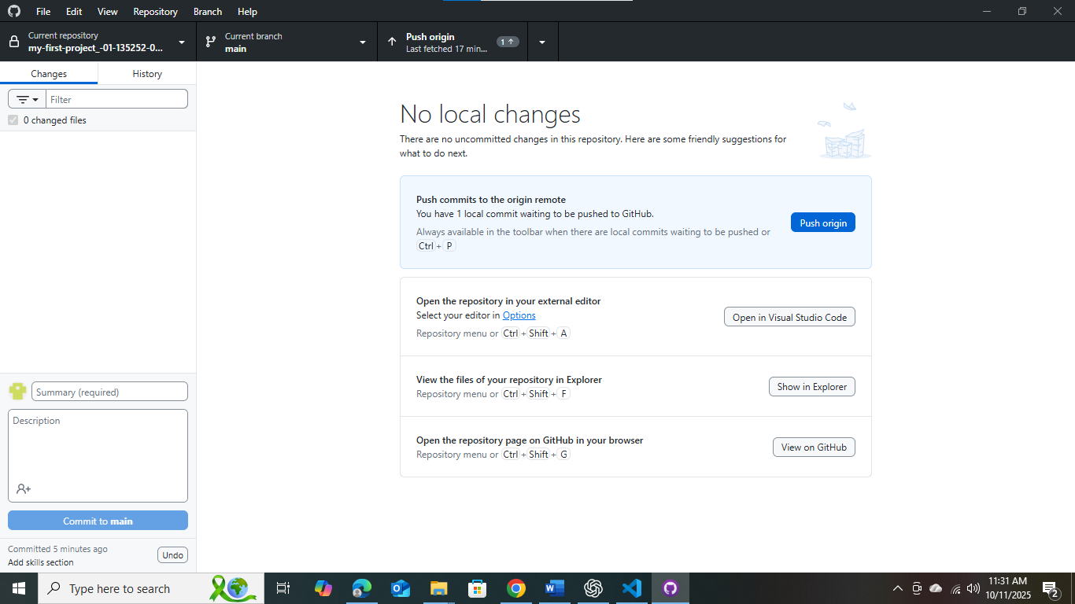

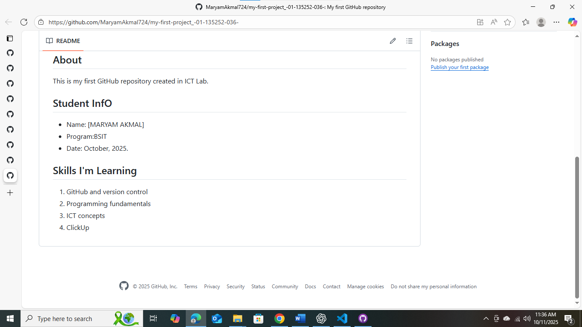

Task 4: Fork, Clone, and Create a Pull Request

4A: Fork the Repo
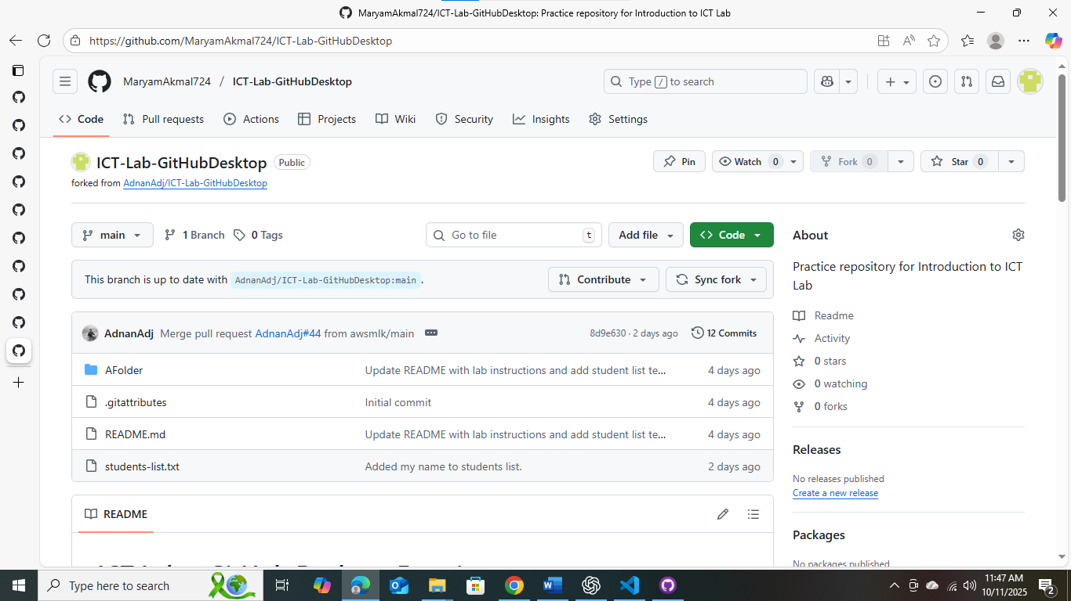

4B: Clone Your Fork
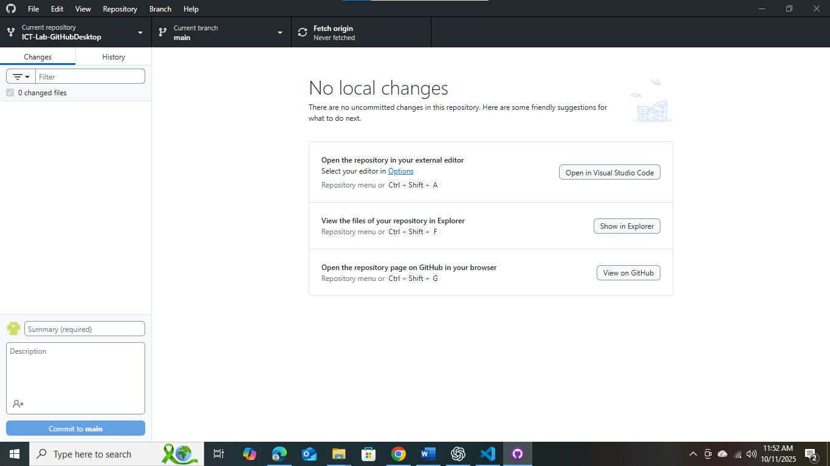

4C: Edit and Commit
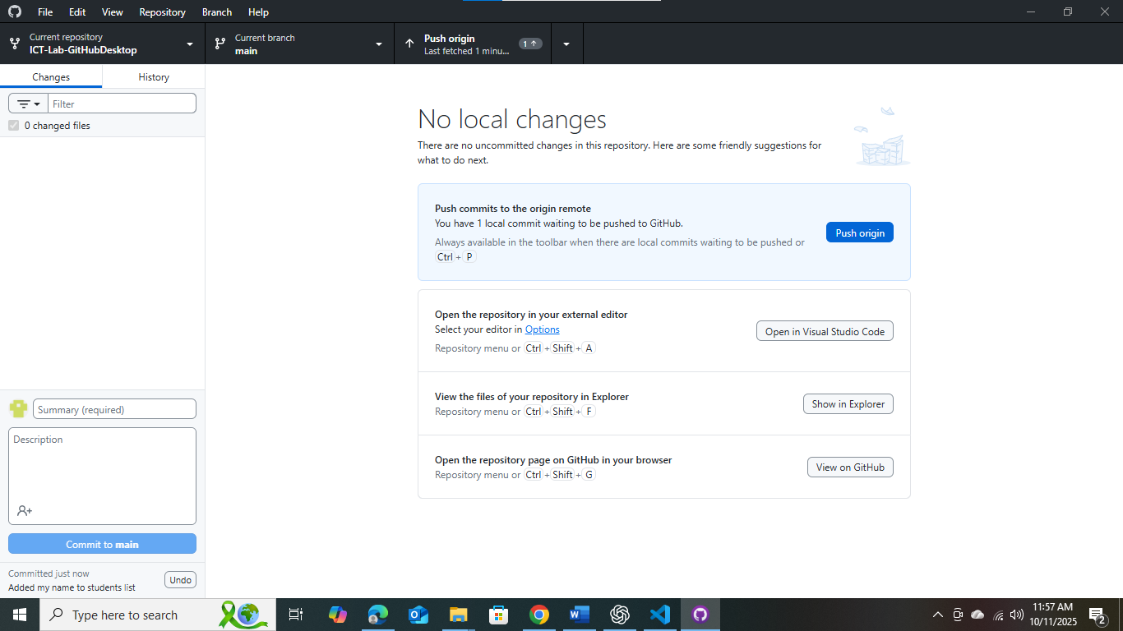

4D: Create a Pull Request

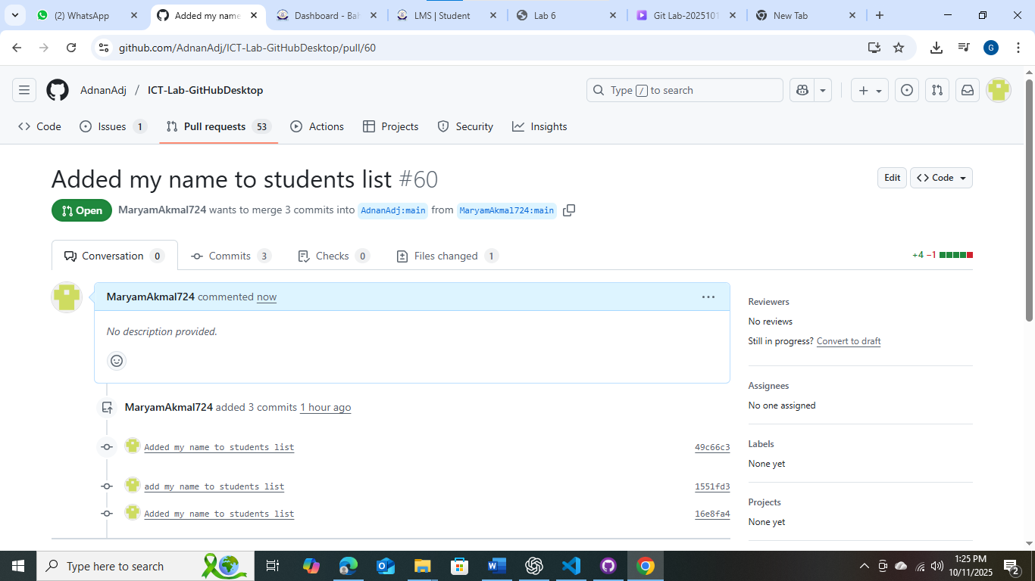

Assessment Questions
- What is a commit?
A saved snapshot of your project after a change.

- What's the difference between a local repository and one on GitHub?
Local is on your PC, GitHub repo is online version.

- Why would you use a branch?
To work on new features without breaking main project.
- What does "push" mean?
Upload local commits to GitHub online.

- What is the purpose of a commit message?
Describe what was changed in that commit.

GITHUB LINK:
https://github.com/MaryamAkmal724

Lab Deliverables (submission guideline)

By the end of this lab, you are required to submit the following:

- MS WORD Lab journal file
Get it from assignments and rename it to YourRollNumber_journal_6.docx

- Your Github profile should have all of the tasks completed.

