Adnan Jelani BUIC

CSL 114 Introduction to Information & Communication Technology Lab
Lab 7 Journal
Github Collaboration

Table of Contents
Lab Deliverables (submission guideline) 1
Lab Task 2
Assessment Questions 3

Lab Deliverables (submission guideline)

By the end of this lab, you are required to submit the following:

- MS WORD Lab journal file
Get it from assignments and rename it to YourRollNumber_journal_7.docx
Add the following:
- Repository Link (Group Leader’s repo)
- Screenshot showing all three folders visible on GitHub
- Screenshot of each member’s HTML profile page in the browser
- Screenshot of GitHub Desktop showing the commit message
- Take a screenshot of your created issue.

- Your Github profile should have all of the tasks completed.

Lab Task
Add screenshots step by step with proper headings.

Fork aur Clone:

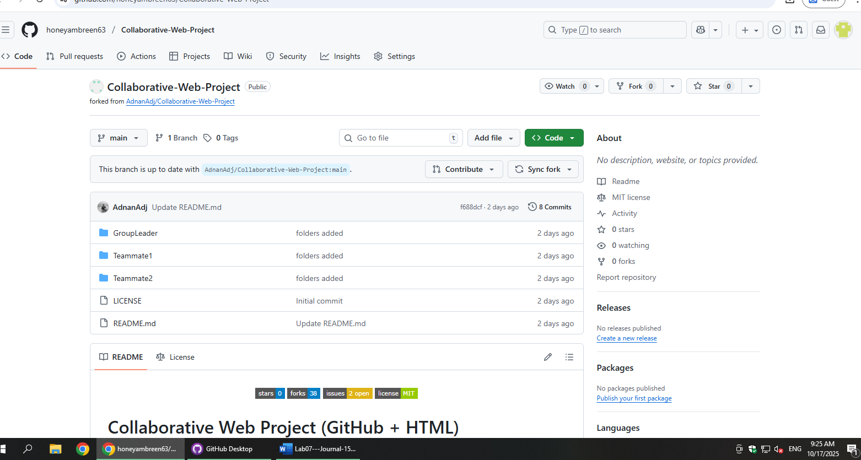

LINK:
https://github.com/honeyambreen63/Collaborative-Web-Project

EDIT HTML FILE:
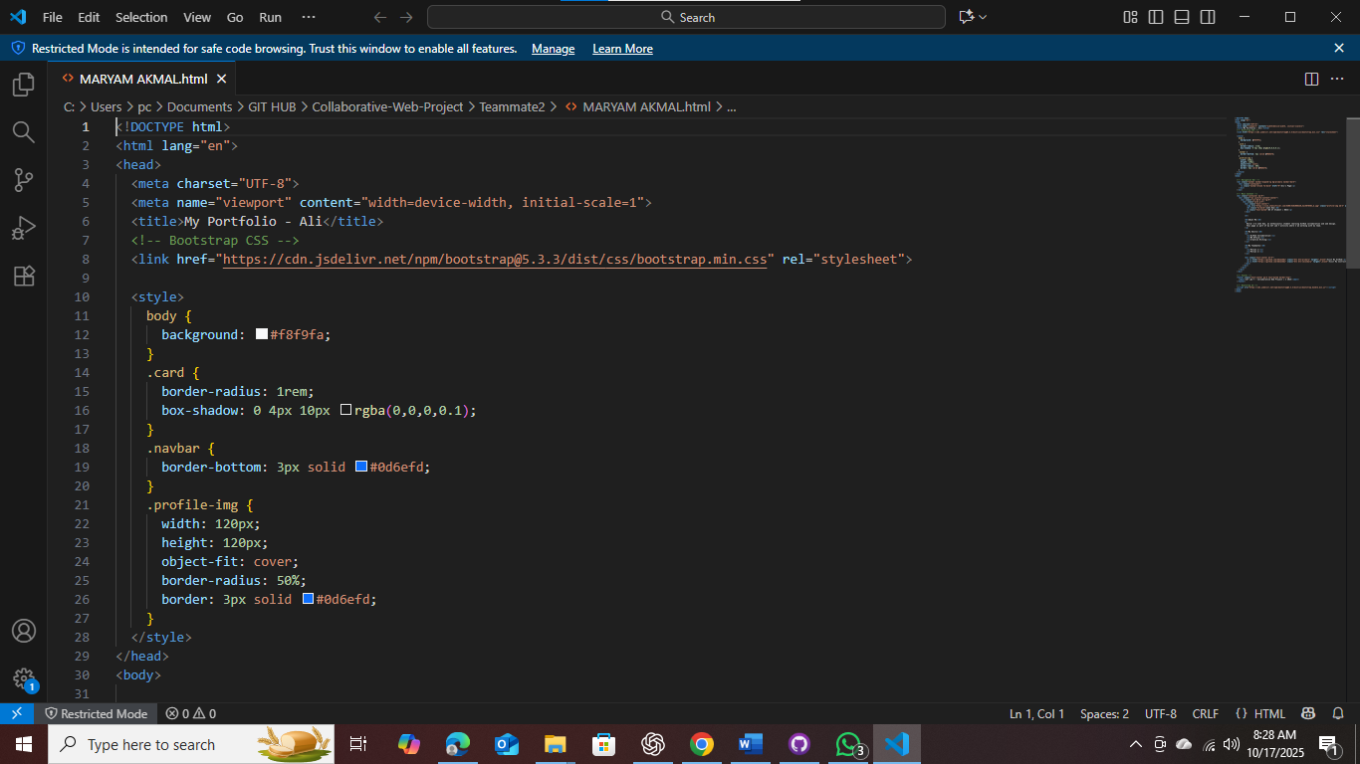

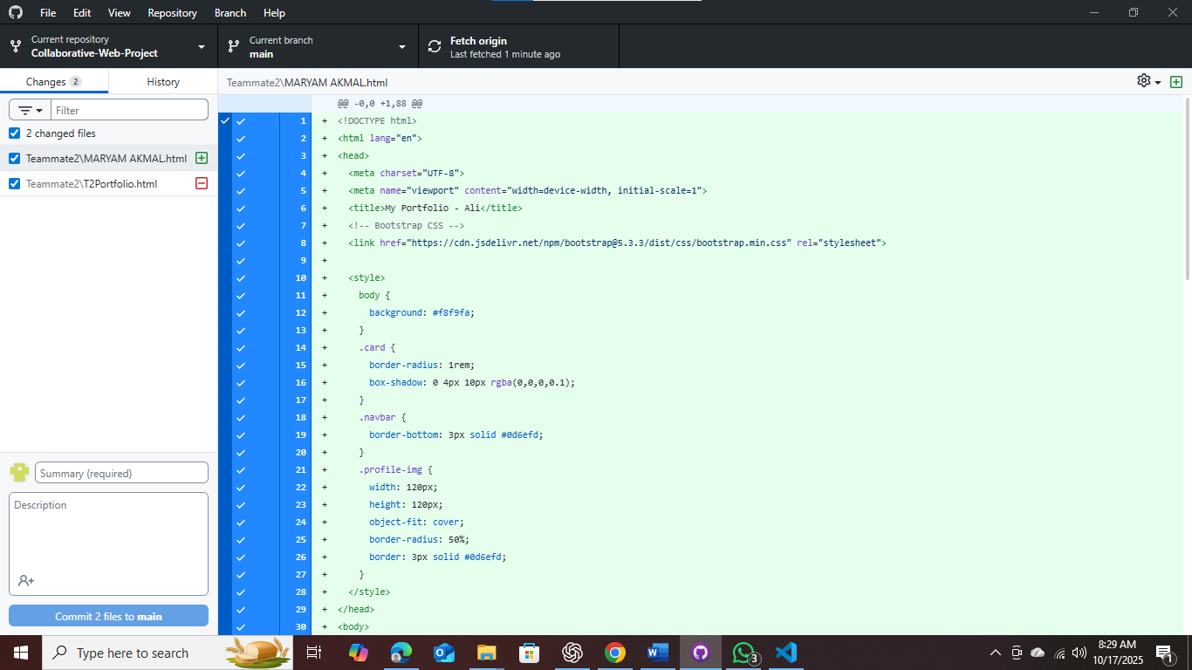
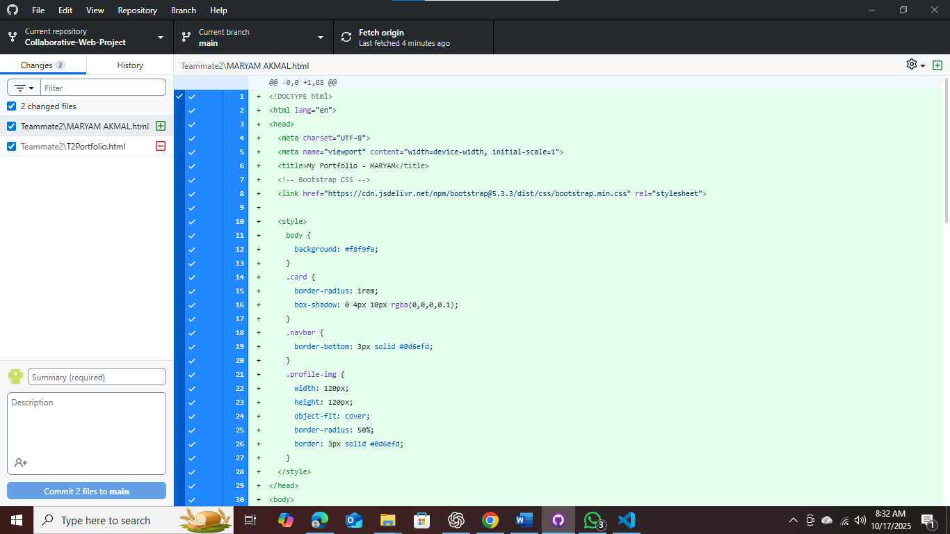

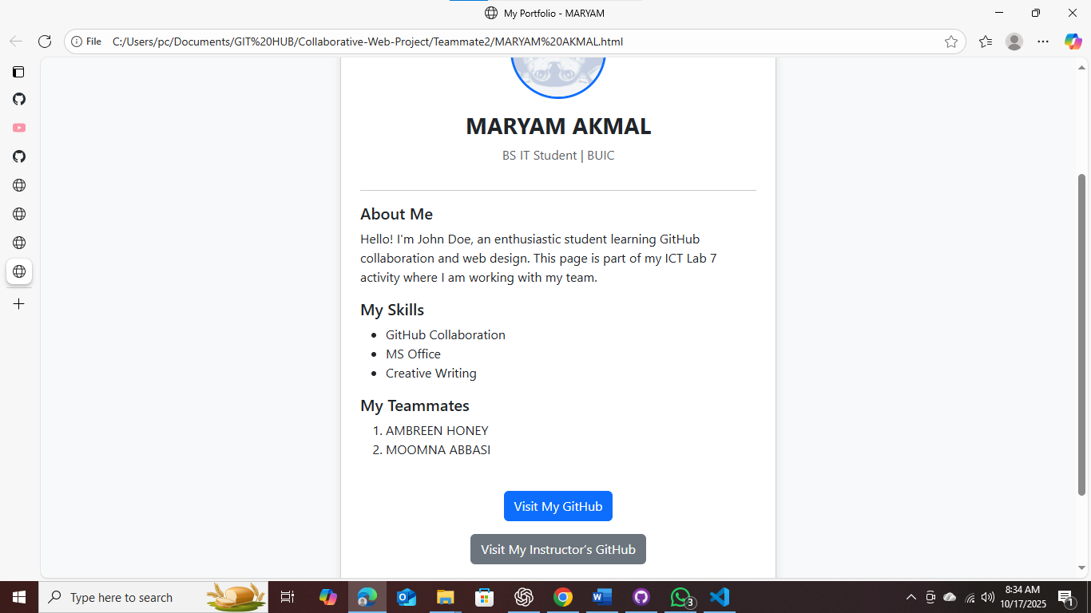

ADDED PROFILE PAGE: 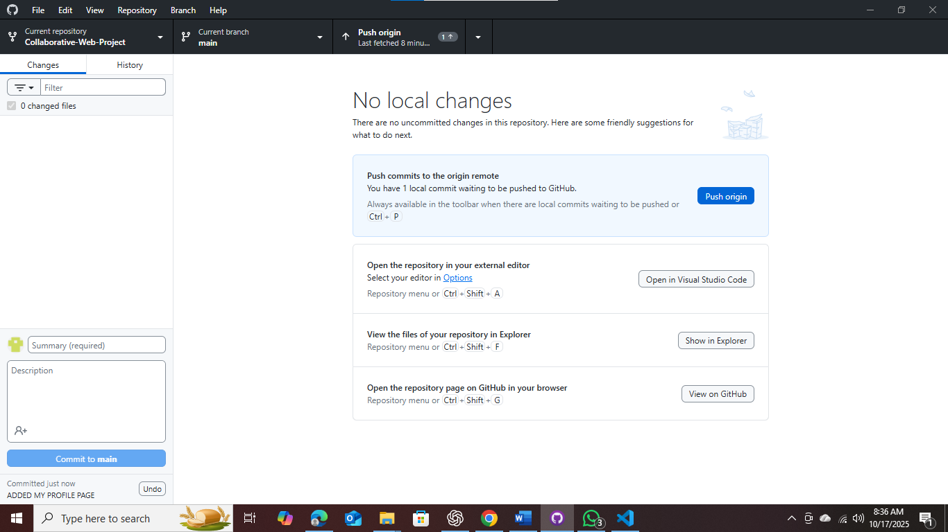

READ ME FILE:

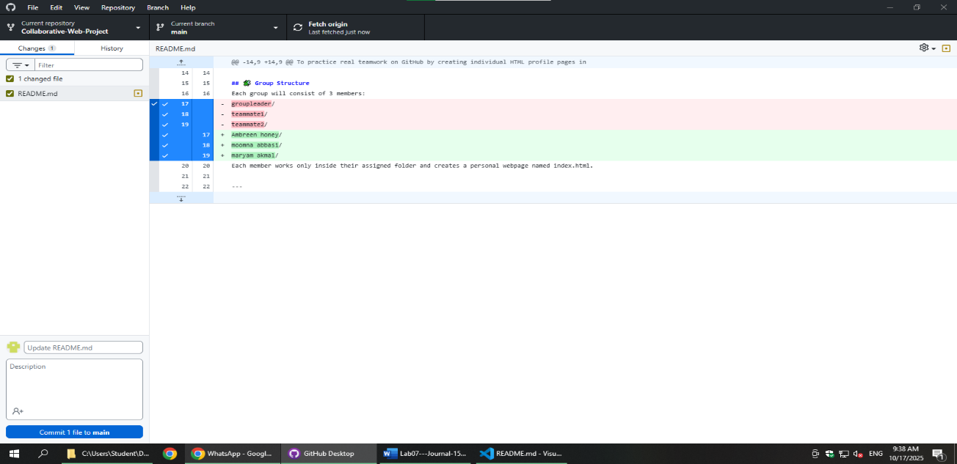
ISSUE CREATE COMMENT :
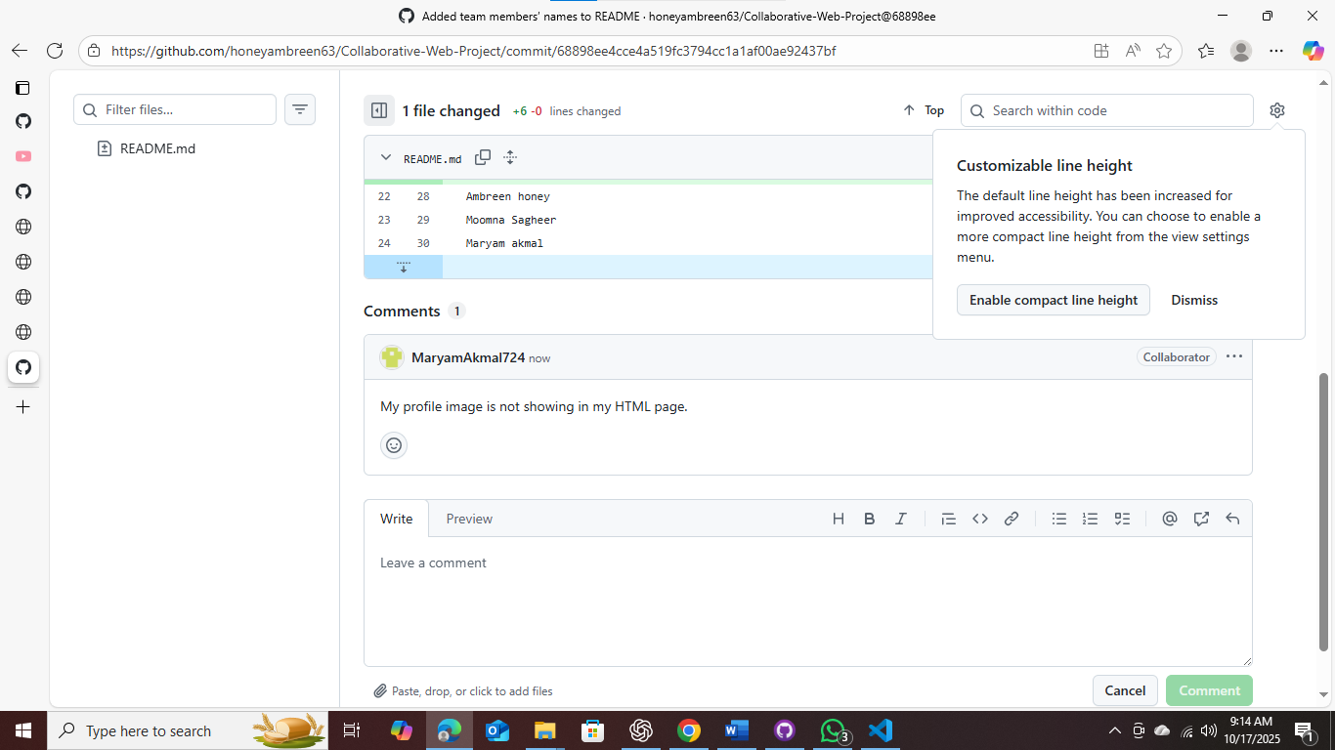

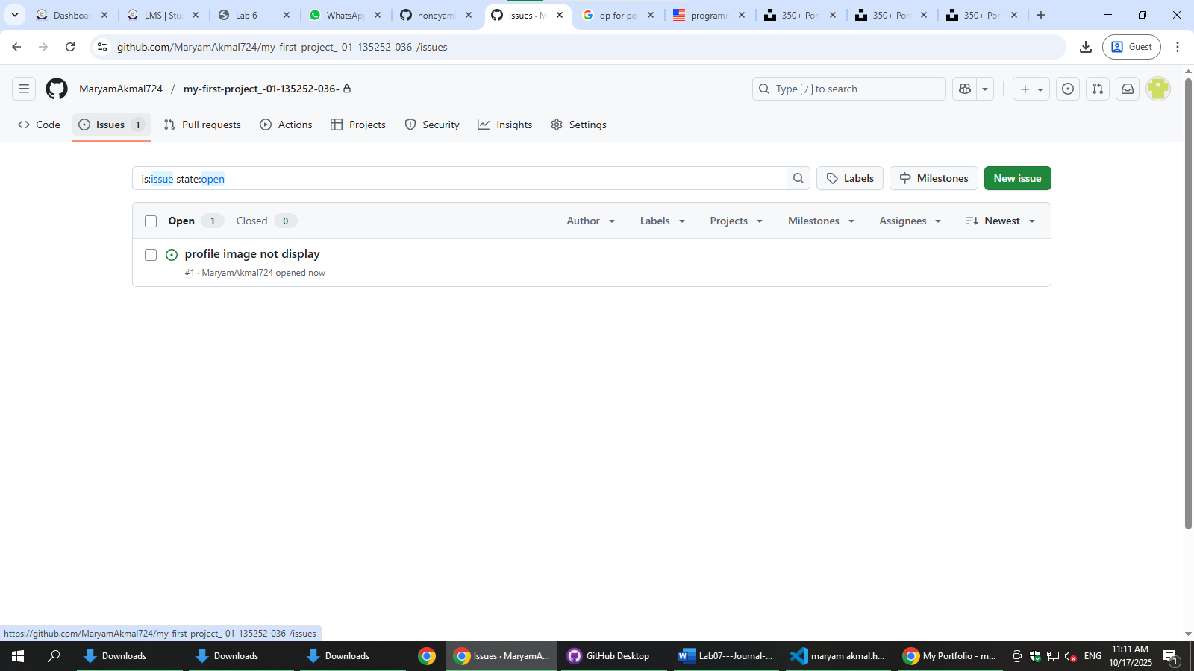
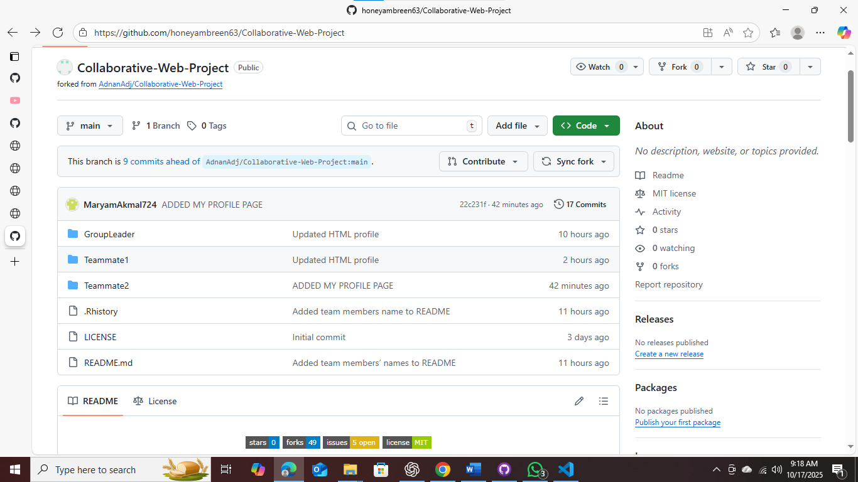

Assessment Questions
- What are the main steps to add your work to GitHub after editing your HTML profile page?
ANSWER: I open GitHub Desktop, write a commit message, click Commit to main, and then click Push origin to upload my HTML work to GitHub.

- How do you ensure your local repository is up-to-date with your teammates’ changes?

ANSWER: I click Fetch origin and then Pull origin so my files get updated and I get the latest work from my teammates.

