

Lab Assignment 1:

Fa20-BCS-009

Maryam Amjad

BCS 7A

Microprocessor And Assembly Language

28/Sep/2023

Submitted To: Mr Fayaz

Code: 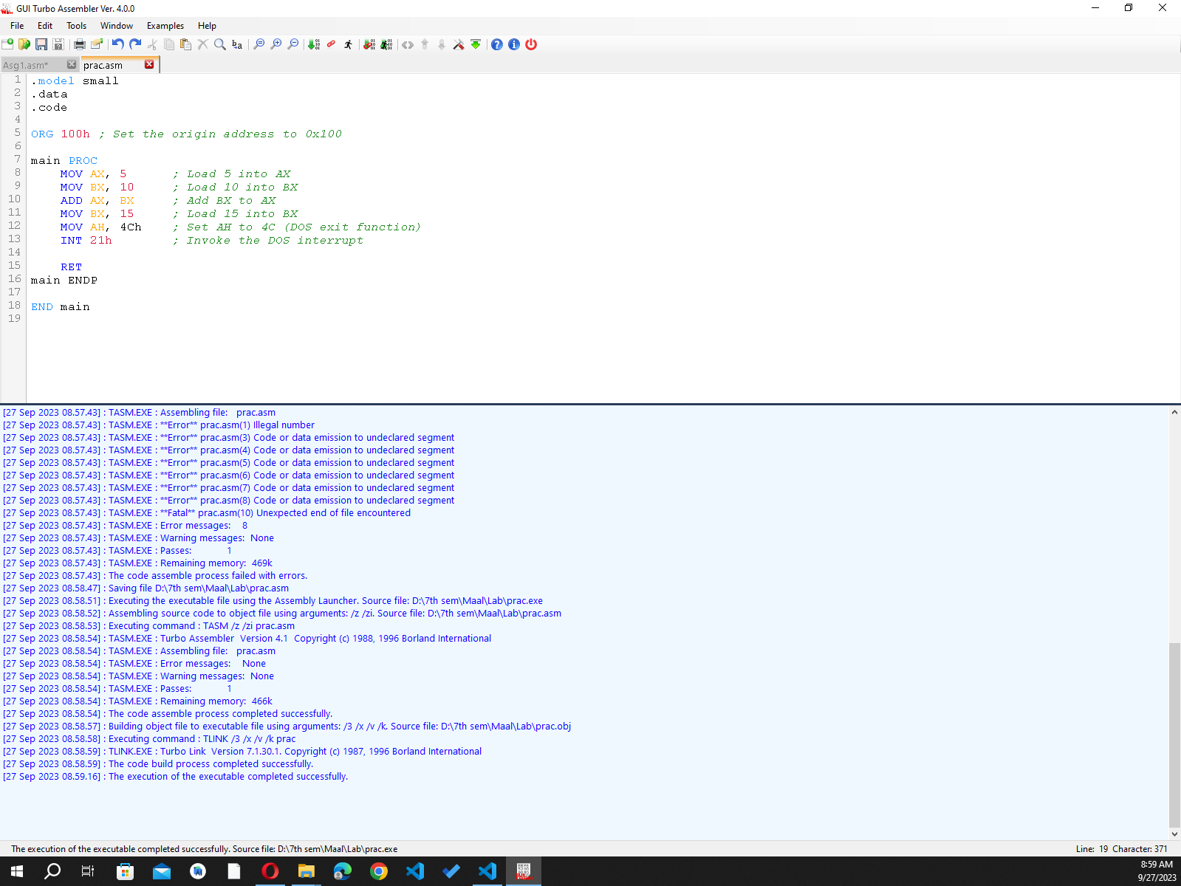

Output :

