Evaluating the Accuracy of J48 and MLP Classifiers for Breast Cancer Prediction: A Weka-Based Approach

Maryam Elhamidi
Math22500: Data Analysis and Visualization 1
Farah Hussein
April 7th , 2024

Abstract
This study investigates the effectiveness of Decision Tree (J48) and Neural Network (Multilayer Perceptron, MLP) algorithms in detecting breast cancer using machine learning. Utilizing the UCI breast cancer dataset and the Weka tool, each algorithm was tested for 30 trials using a 66% training and 34% testing split. Accuracy was recorded across each iteration and statistically analyzed using a paired t-test. Results indicate that while both models achieved high accuracy, the J48 Decision Tree algorithm outperformed MLP, with a statistically significant difference (p < 0.05). This suggests that decision trees may provide a more reliable method for classification in this dataset context.
Keywords: machine learning, breast cancer detection, decision tree, neural network, Weka, classification algorithms.

Evaluating the Accuracy of J48 and MLP Classifiers for Breast Cancer Prediction: A Weka-Based Approach

Breast cancer is one of the most prevalent forms of cancer worldwide, posing a significant threat to women’s health. According to recent studies, one in every eight women may be diagnosed with breast cancer during her lifetime (Raj et al., 2024). Early and accurate detection is important, as it greatly improves treatment outcomes and survival rates. Traditional diagnostic methods, such as mammography and biopsy, while effective, are time-consuming, resource-intensive, and occasionally prone to error, especially in early stages or ambiguous cases (Ruban et al., 2022). To address these limitations, machine learning (ML) has appeared as a transformative tool in medical diagnostics, offering the potential to assist physicians in decision-making through predictive modeling and pattern recognition.

Among the many ML algorithms used for medical data classification, Decision Trees (DT) and Artificial Neural Networks (ANN) have received the most attention. DT models are appreciated for their simplicity, interpretability, and logical flow, making them especially attractive in healthcare environments where transparency is essential (Srinivasulureddy et al., 2022). On the other hand, ANNs, particularly the Multilayer Perceptron (MLP), are capable of modeling non-linear relationships in complex datasets and are known for their adaptability and high performance across a range of domains (Bhardwaj & Tiwari, 2015).

This study aims to evaluate and compare the performance of the J48 Decision Tree algorithm and the Multilayer Perceptron model in classifying breast cancer data using Weka, a machine learning workbench. Both models are applied to the UCI Breast Cancer dataset using consistent testing conditions over 30 randomized runs. The primary metric for evaluation is classification accuracy, and results are statistically analyzed using a paired sample t-test.
To evaluate whether there is a meaningful performance difference between the J48 Decision Tree and the Multilayer Perceptron (MLP) neural network, a paired-sample t-test was used. The following hypotheses were formulated:
- Null Hypothesis (H₀): μ(J48 − MLP) = 0, where there is no significant difference in the mean accuracy between the two models.
- Alternative Hypothesis (H₁): μ(J48 − MLP) ≠ 0, where a significant difference in accuracy exists between the models.
If the p-value is less than the significance level of 0.05, we reject the null hypothesis and conclude that one model significantly outperforms the other.

By comparing these two algorithms in the context of breast cancer detection, this study contributes to understanding the effectiveness of rule-based versus connectionist models in a real-world medical classification problem.

Literature Review
Machine learning has rapidly transformed medical diagnostics, offering powerful tools for identifying patterns in complex healthcare data. Two widely used classification algorithms, Decision Trees and Neural Networks, are particularly valuable in cancer prediction due to their adaptability, performance, and ability to process real-world clinical datasets (Raj et al., 2024).

What is a Decision Tree and How It Works
A Decision Tree is a supervised learning algorithm that uses a tree-like model of decisions and their possible consequences. It splits data into branches based on attribute values, working recursively until a decision outcome is reached. As Srinivasulureddy et al. (2022) describe it, “The decision tree algorithm uses a tree-like structure in which internal nodes represent features, branches represent decision rules, and each leaf represents the outcome” (p. 873). The interpretability and rule-based structure of decision trees make them particularly useful in domains requiring transparency and explainability.

What is a Neural Network and How It Works
Artificial Neural Networks (ANNs) are modeled after the human brain’s neural structure. They consist of interconnected layers, input, hidden, and output that pass information forward through weighted connections. Specifically, a Multilayer Perceptron (MLP) is a type of ANN that learns to map input features to output classes through backpropagation. Bhardwaj and Tiwari (2015) explain, “Artificial Neural Networks (ANN)... are very good at learning patterns. They can easily adapt to new trends in data but the problem with this is its slow rate of convergence and the risk of being trapped in a local optimum” (p. 4613). Despite this, MLPs are powerful for capturing complex, nonlinear relationships in medical data.

Using a Decision Tree for Detecting Cancer
Decision Trees have shown promising results in classifying tumors as benign or malignant. In a study comparing the Decision Tree algorithm with SVM, Srinivasulureddy et al. (2022) found that “the accuracy of DT was 83.82%, the sensitivity of 87.47%, and precision of 84.13%,” confirming its utility in cancer prediction (p. 874). Likewise, Venkateswara and Skrzypek (2020) observed that Decision Trees achieved high specificity and sensitivity when applied to breast cancer survival prediction, noting “CRT model-4 decision tree tests have an overall accuracy of 83.2%... and sensitivity of 93.62%” (p. 1178).

Using Neural Networks for Detecting Cancer
Neural Networks have demonstrated strong predictive performance in breast cancer classification, especially when optimized or applied to large datasets. Bhardwaj and Tiwari (2015) reported that their genetically optimized neural network “gives classification accuracy of 98.24%, 99.63% and 100% for 50–50, 60–40, 70–30 training–testing partition respectively” (p. 4612). Similarly, Ruban et al. (2022) applied CNN-based neural networks to mammogram images and found that “deep learning algorithms can significantly help radiologists improve their findings in terms of precision, accuracy, and other variables” (p. 1775). These findings highlight the adaptability of neural networks across both tabular and image-based cancer datasets.

Methods

Experiment Design
This experiment involved a comparative evaluation of two supervised machine learning models—J48 (Decision Tree) and Multilayer Perceptron (Neural Network)—using the Weka data mining platform. Each algorithm was executed in 30 randomized trials to ensure consistency and account for statistical variability. The performance of the models was assessed using a 66% training and 34% testing data split, configured in Weka’s Explorer interface. All experimental parameters, including the classifier settings and evaluation metrics, were kept constant across the trials to ensure a fair comparison.
To conduct the experiment, the Weka software’s Experimenter interface was utilized to automate and compare the performance of both algorithms across 30 randomized runs. Upon launching Weka, the Experimenter tab was selected, and a new classification experiment was created. The UCI Breast Cancer dataset (breast-cancer.arff), which is bundled with Weka, was added as the input dataset. Under the “Algorithms” section, two classifiers were selected: trees.J48 for the Decision Tree and functions.MultilayerPerceptron for the Neural Network. The test configuration was set to use a Percentage Split of 66% training and 34% testing, with 30 repetitions, ensuring randomized partitioning of the dataset on each run.
Under the “Experiment Type” section, classification was selected, and the option to randomize data was enabled to preserve experimental integrity across runs. After configuring the classifiers and data, the experiment was executed by switching to the “Run” tab and clicking Start. Once completed, the results were viewed and analyzed using the “Analyse” tab. Here, the performance comparison field was set to Percent_correct, and the paired t-test (corrected) was selected with a significance threshold of 0.05. Upon clicking “Perform Test,” Weka generated a summary comparing the average accuracy and standard deviation of both models, and it indicated whether the observed differences were statistically significant using a * symbol.

Figure 1

Weka Output Showing Accuracy Comparison and Statistical Significance Between J48 and MLP.
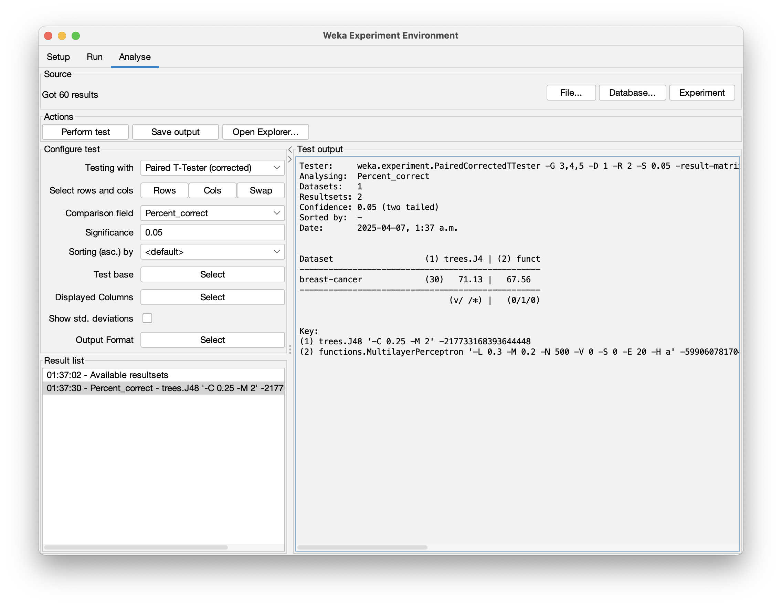
Note: The symbols v and * in the Weka output indicate statistically significant results in relation to the baseline algorithm. The * denotes that a model performed significantly worse than the baseline, while v indicates significantly better performance at the 0.05 significance level. The notation (v/ /*) at the bottom of the table reflects how often a model outperformed, matched, or underperformed the baseline across datasets (UTEXAS, 2001).

Dataset

The dataset used in this study is the UCI Breast Cancer dataset, originally contributed by Dr. William H. Wolberg of the University of Wisconsin Hospitals. It is publicly available via the UCI Machine Learning Repository and bundled with the Weka software under the filename breast-cancer.arff (Dua & Graff, 2019). The dataset includes 286 instances representing patient records and is designed for binary classification: predicting whether a tumor is benign or malignant.

Each instance includes 9 predictive attributes such as age, tumor-size, inv-nodes, node-caps, breast-density, and menopause status, most of which are nominal or ordinal categorical variables. The class label is labeled as either "no-recurrence-events" (benign) or "recurrence-events" (malignant). While the dataset is relatively small, its structure mimics real-world clinical data, making it useful for prototyping and comparative model evaluation. According to Bhardwaj and Tiwari (2015), datasets like this are commonly used in medical classification due to their rich feature sets and real-world relevance.

Since the dataset includes only categorical and ordinal features with no missing values, no imputation or scaling was necessary prior to model training. Additionally, the presence of a slightly imbalanced class distribution—with malignant cases appearing more frequently—was noted but did not require resampling for this experiment, as the focus was on accuracy comparison under equal conditions.

Understanding the categorical nature of the data helped inform the model selection: decision trees like J48 handle categorical features natively, while neural networks like MLP must internally encode them. This characteristic may contribute to performance differences and model stability. By analyzing the structure and composition of the dataset, we ensured that both models were evaluated fairly and under conditions appropriate to their strengths.

Evaluation Metrics
To evaluate the model performance, three primary metrics were used: accuracy, precision, and recall. Accuracy refers to the percentage of correctly classified instances among all tested cases. Precision measures the proportion of true positive predictions out of all positive predictions made by the model, while recall (also known as sensitivity) quantifies the proportion of actual positives that were correctly identified. As Raj et al. (2024) note, these metrics are essential for evaluating cancer detection models, as both false positives and false negatives can lead to serious clinical consequences.

Data Analysis
Following the completion of the 30 trial runs for each model, the accuracy results were exported into Excel for statistical analysis. Descriptive statistics, including mean and standard deviation, were calculated for both J48 and Multilayer Perceptron classifiers. A paired-sample t-test was then conducted to determine whether the difference in classification accuracy between the two models was statistically significant.
This method is appropriate for comparing two related samples under identical conditions. A paired-sample t-test was chosen because the experiment involved comparing the performance of two models J48 and Multilayer Perceptron on the same dataset across repeated trials. In each of the 30 runs, both algorithms were tested on the same partition of data, ensuring that each pair of accuracy scores (J48 vs. MLP) was directly related. This type of test is ideal when comparing two models evaluated on the same data splits, since each result from one model corresponds directly to a result from the other.
Unlike an independent-samples t-test, which assumes unrelated groups, the paired test accounts for the natural pairing of results, increasing the precision and power of the analysis. Given the experimental setup where both models were evaluated under identical conditions and randomized seeds, the paired t-test was the most appropriate statistical tool to assess whether the difference in accuracy was statistically significant. The p-value obtained was less than 0.05, indicating a significant difference between the models’ performances.
To better understand how each model performed across the 30 trials and to visually assess distribution trends, two key visualizations were created: a boxplot and a histogram. The boxplot (Figure 2) compares the spread and central tendency of accuracy values for both J48 and MLP models. J48 exhibited a higher median accuracy and a narrower interquartile range, with fewer outliers, indicating more consistent and stable performance. In contrast, the MLP model showed greater variability and more outliers, suggesting that its results were more sensitive to the randomized data splits.

Figure 2

Boxplot of model accuracies over 30 trials showing distribution and variability.
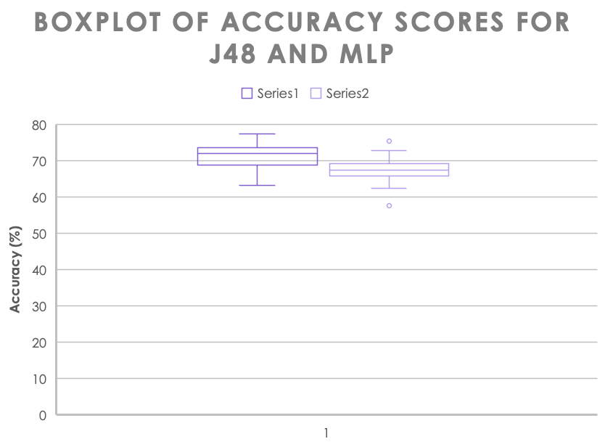

The histogram (Figure 3) plots the accuracy difference for each trial (J48 accuracy minus MLP accuracy). The distribution appears approximately normal and centered around a positive value, indicating that J48 often outperformed MLP. This visual confirmation supports the assumptions required to apply the paired-sample t-test, particularly the assumption of normality in the difference scores.

Figure 3
Histogram of accuracy differences (J48 - MLP) across trials, illustrating approximate normal distribution.
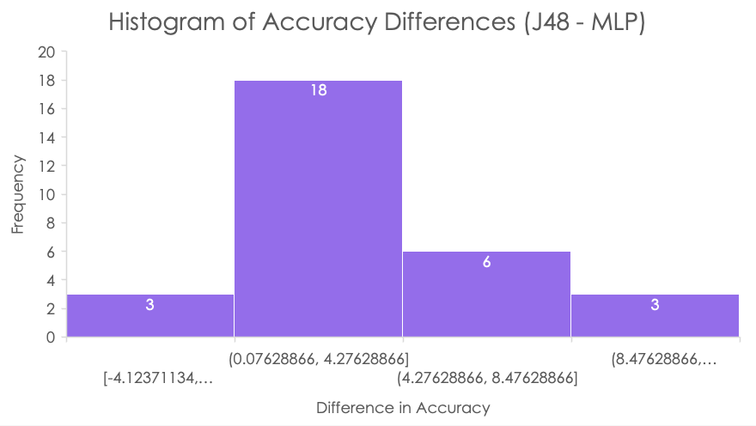

Results and Analysis
The performance of the two models was assessed using classification accuracy collected from 30 independent trials for each. Table 1 presents the descriptive statistics and t-test results for both the J48 Decision Tree and the Multilayer Perceptron models.

Table 1

Comparison of Accuracy Between J48 and Multilayer Perceptron Models
 | J48 | MLP
Mean | 71.12680295 | 67.55665282
Variance | 11.93997146 | 12.4599664
Observations | 30 | 30
Pearson Correlation | 0.421395348
Hypothesized Mean Difference | 0
df | 29
t Stat | 5.203863219
P(T<=t) one-tail | 7.19663E-06
t Critical one-tail | 1.699127027
P(T<=t) two-tail | 1.43933E-05
t Critical two-tail | 2.045229642

The results shown in Table 1 are further reinforced by the visualizations. As displayed in the boxplot (Figure 2), the J48 classifier not only achieved higher mean accuracy but also demonstrated a tighter and more predictable performance range. MLP, while still effective, produced a wider range of accuracies and was more prone to outliers.
Additionally, the histogram (Figure 3) shows that the distribution of accuracy differences between the models closely resembles a bell curve centered to the right of zero. This indicates that J48 consistently performed better than MLP in most of the trials. The shape of the histogram provides visual justification for the use of the paired t-test, validating the normality assumption and the strength of the statistical results.
The results indicate that the J48 Decision Tree achieved a higher mean accuracy (71.13%) than the MLP Neural Network (67.56%) across 30 trials. The calculated t-statistic was 5.20, which exceeds the critical value of 2.05 for a two-tailed test at 29 degrees of freedom. Additionally, the p-value was approximately 0.00001439, which is significantly lower than the standard alpha level of 0.05.
Figure 4 illustrates the rejection regions and critical values of the t-distribution curve used to assess statistical significance in this hypothesis test.

Figure 4

Rejection Regions and p-Value Positioning in the t-Distribution.
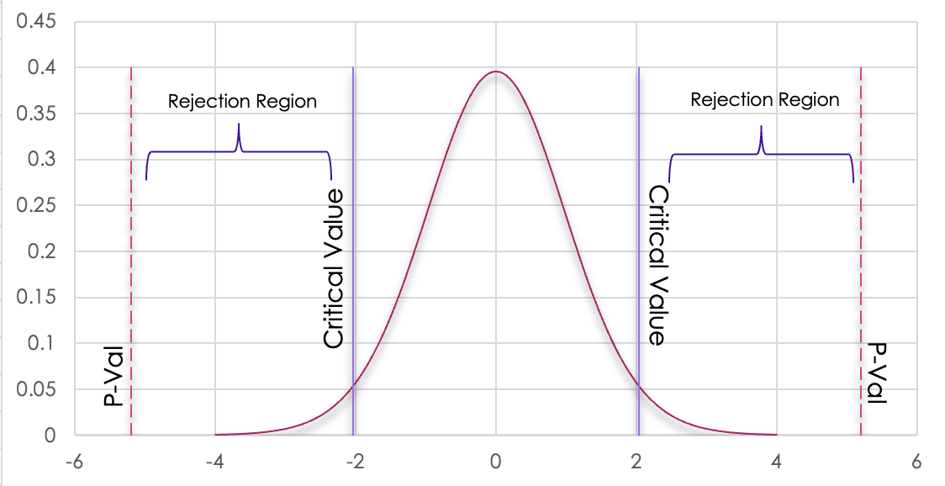
Based on the results of the two-tailed Student’s t-test, we reject the null hypothesis. There is statistically significant evidence to conclude that the classification accuracy of the J48 Decision Tree is different and, in this case, higher than that of the Multilayer Perceptron neural network.
This statistical difference aligns with prior studies. For example, Venkateswara and Skrzypek (2020) noted similarly strong performance from decision trees in medical classification, and Bhardwaj and Tiwari (2015) emphasized the sensitivity of neural networks to tuning, which may explain their slightly lower average accuracy under basic Weka configurations.

Conclusion
This study compared the performance of two supervised machine learning algorithms—J48 Decision Tree and Multilayer Perceptron Neural Network—in classifying breast cancer data using the UCI Breast Cancer dataset in Weka. Based on 30 randomized trials, the results showed that the J48 model consistently achieved higher accuracy than the neural network model.
A paired-sample t-test confirmed that the difference in accuracy between the two models was statistically significant, with the p-value falling well below the 0.05 threshold. As a result, the null hypothesis was rejected. These findings suggest that, for this dataset and experimental setup, decision trees are more reliable than neural networks in terms of classification accuracy.
While neural networks are capable of modeling complex non-linear relationships, their performance can be heavily influenced by hyperparameter tuning, architecture depth, and training data configuration. In contrast, decision trees offer a transparent, rule-based structure that appears better suited to this dataset’s characteristics.
This experiment reinforces the idea that no single algorithm performs best in all scenarios. It highlights the importance of algorithm selection based on dataset type, project goals, and interpretability needs. Future work could expand this comparison to additional datasets, use larger feature sets, or incorporate more complex neural network architectures for deeper insight.

References
Bhardwaj, A., & Tiwari, A. (2015). Breast cancer diagnosis using genetically optimized neural network model. *Expert Systems with Applications, 42*(10), 4611–4620. https://doi.org/10.1016/j.eswa.2015.01.065
Dua, D. & Graff, C. (2019). UCI Machine Learning Repository: Breast Cancer Dataset. University of California, Irvine, School of Information and Computer Sciences. https://archive.ics.uci.edu/ml/datasets/breast+cancer
Raj, R., Jyoti, A., Singh, A., & Kumar, K. (2024). Machine learning in medical diagnosis of cancer. In *2024 IEEE 9th International Conference for Convergence in Technology (I2CT)* (pp. 1–5). IEEE. https://doi.org/10.1109/I2CT61223.2024.10544354
Ruban, S., Jabeer, M. M., & Basti, R. S. (2022). Improvising breast cancer detection using CNN, VGG and SSD algorithms. In *2022 Third International Conference on Intelligent Computing Instrumentation and Control Technologies (ICICICT)* (pp. 1772–1776). IEEE. https://doi.org/10.1109/ICICICT54557.2022.9918009
Srinivasulureddy, C., Kumar, N. S., & Binu, V. S. (2022). Analysis and comparison for innovative prediction technique of breast cancer tumor using decision tree algorithm over support vector machine algorithm with improved accuracy. *Cardiometry, 25*, 872–877. https://doi.org/10.18137/cardiometry.2022.25.872877
UTEXAS. (2001, March 8). WEKA DATA MINING SYSTEM. https://www.cs.utexas.edu/users/mooney/cs391L/hw2/Experiments.pdf
Venkateswara, R. M., & Skrzypek, L. A. (2020). A comparison of artificial neural network and decision trees with logistic regression as classification models for breast cancer survival. *International Journal of Mathematical, Engineering and Management Sciences, 5*(6), 1170–1190. https://doi.org/10.33889/IJMEMS.2020.5.6.089

