2.4 GHz Microstrip Patch Antenna

System response: reflection coefficient

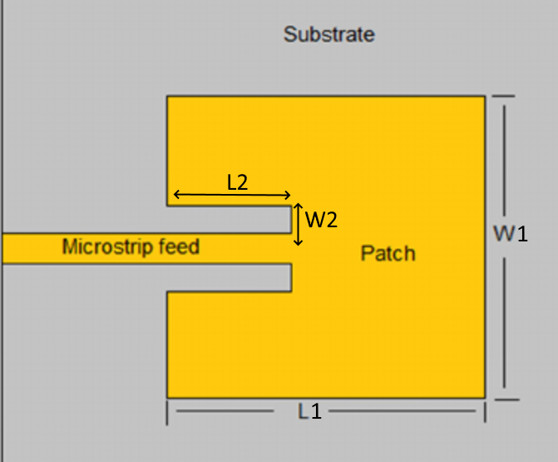Target antenna impedance = 50 ohm

Target center frequency = 2.4 +- 0.05 GHz

**Feasible region problem:**

f1 <arg min(S11) < f2

f1 = 2.35 GHz

f2 = 2.45 GHz

Layout:

number of polygons = 2

number of vertices = 12

Parameters:

W1: patch width

L1: patch length

W2: feed insertion gap

L2: feed insertion length

h_ox: substrate height

e_ox: substrate relative permittivity

loss tangent= 0.003

conductor material: perfect electric conductor

-----Parameter ranges-----

|  |  |  |  |  |  |
| --- | --- | --- | --- | --- | --- |
|  |  | For sparser sampling | | For denser sampling | |
|  | Initial design | Lower bound | Upper bound | Lower bound | Upper bound |
| W1 | 35 mm | 32 mm | 38 mm | 23 mm | 38 mm |
| L1 | 30.5 mm | 27.5 mm | 33.5 mm | 15.5 mm | 33.5 mm |
| W2 | 2.9 mm | 2.2 mm | 3.6 mm | 2.2 mm | 3.6 mm |
| L2 | 8.7 mm | 8.2 mm | 9.2 mm | 8.2 mm | 9.2 mm |
| h_ox | 1.5 mm | 1mm | 2.0 mm | 1.0mm | 3.0 mm |
| e_ox | 4.3 | 2 | 5 | 2 | 7 |

-----Simulation setup-----

solver = Momentum Microwave

start frequency = 2 GHz

stop frequency = 4 GHz

sweep type = Linear

number of points = 101

200 |s11| samples:

