Double folded stub microstrip stopband filter

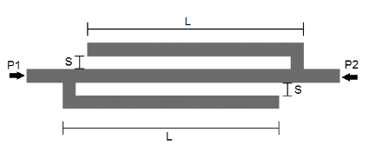System response: S21

Target stop-band width = 7.5 GHz

Target center frequency = 14 +- 0.5 GHz

**Feasible region problem:**

BW > 7 GHz

13.5 < f0 < 14.5 GHz

Layout:

number of polygons = 5

number of vertices = 20

Parameters:

L = stub length - S

S = line-stub gap

h_ox = 0.127 mm: substrate height

e_ox = 9.9: substrate relative permittivity

loss tangent= 0

conductor material: perfect electric conductor

-----Parameter ranges-----

|  |  |  |  |  |  |
| --- | --- | --- | --- | --- | --- |
|  |  | Old ranges | | New ranges | |
|  | Initial design | Lower bound | Upper bound | Lower bound | Upper bound |
| L | 2.195 mm | 1.98 mm | 2.38 mm | 2 mm | 2.5 mm |
| S | 0.122 mm | 0.081 mm | 0.161 mm | 0.1 mm | 0.2 mm |
| E_ox | 9.9 | 9.6 | 11 | 9.5 | 11 |
| H_ox | 0.127 mm | 0.110 mm | 0.150 mm | 0.100 mm | 0.150 mm |

-----Simulation setup-----

solver = Momentum Microwave

start frequency = 5 GHz

stop frequency = 25 GHz

sweep type = Linear

number of points = 101

# SOURCE*: Variability analysis of multiport systems via polynomial-chaos expansion* (D. Spina et al.)

Simulation result for 144 uniform samples:

35 in the feasible region (24%)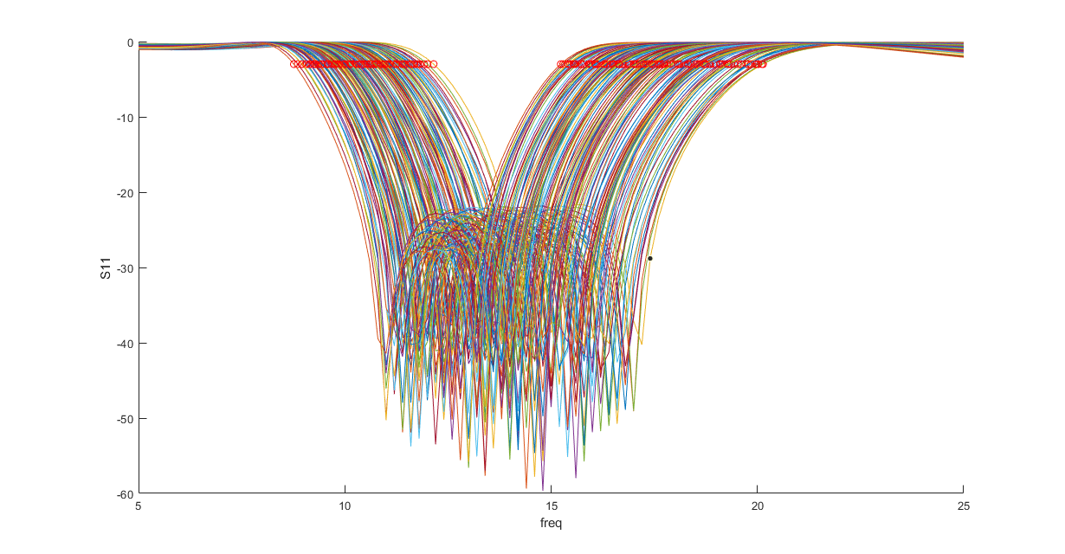

Figure 1: all samples

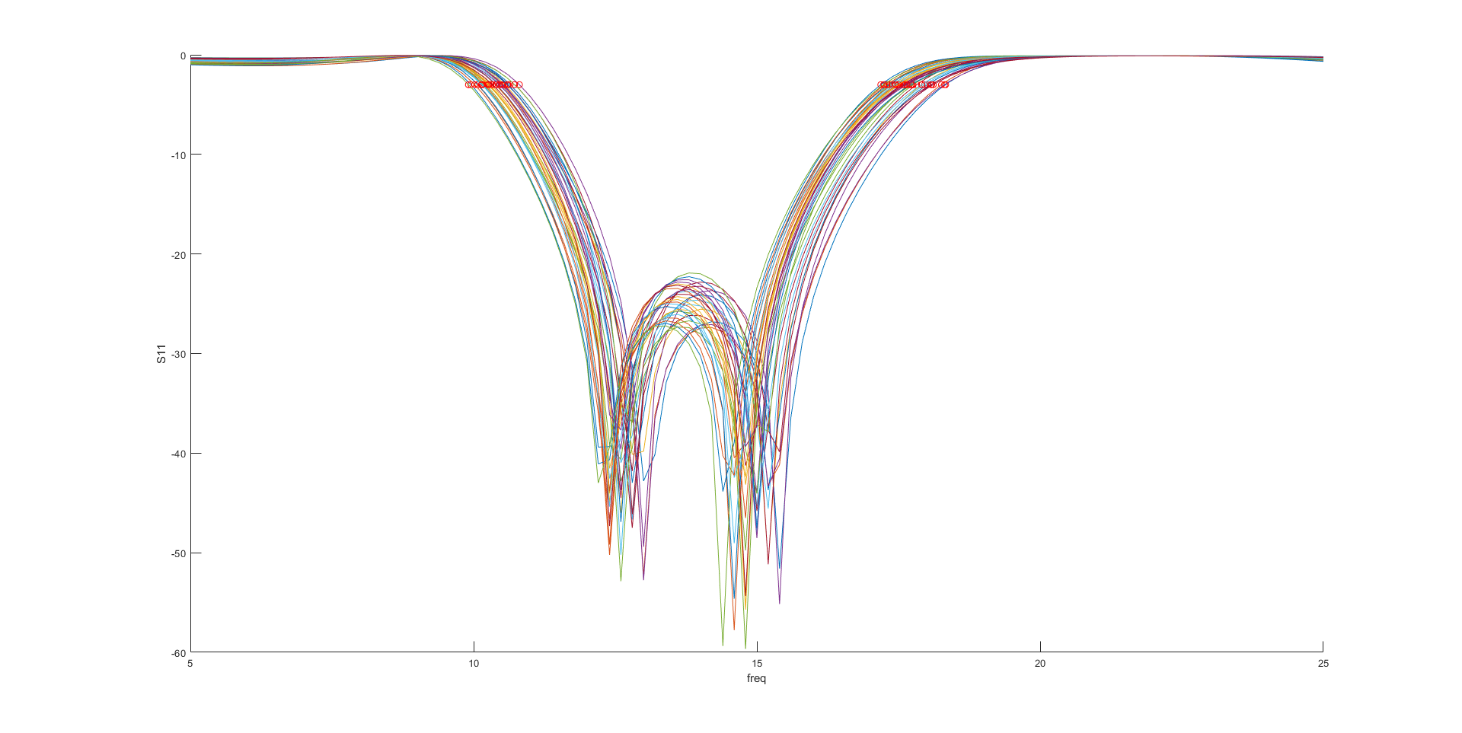

Figure 2: samples in feasible region