Band-stop Microstrip Stub Filter

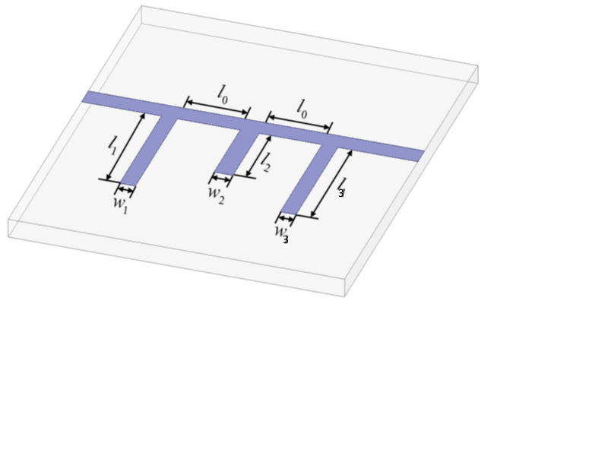System response: S11 (Re + jIm)

Objectives:

* |S11|<= 0.4 in 7.2 GHz<=f<=10.2 GHz
* |S11|>= 0.94 in 7.2 GHz<=f<=10.2 GHz
* |S11|<= 0.4 in 7.2 GHz<=f<=10.2 GHz

**Parameters**:

L0 : stub spacing

L1 : stub1 length

L2 : stub2 length

L3=L1 : stub3 length

W0 = 0.635 mm : line width

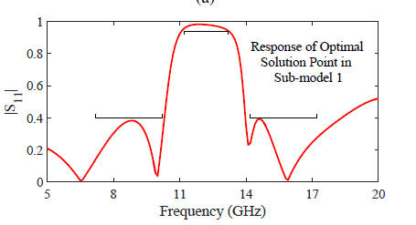W1 = 0.10523 mm : stub1 width

W2 = 0.2097 mm : stub2 width

W3 = W1 : stub3 width

h_ox = 0.635 mm : substrate height

e_ox = 9.4 : substrate relative permittivity

loss tangent= ?

conductor material: perfect electric conductor

|  |  |  |  |  |  |
| --- | --- | --- | --- | --- | --- |
|  |  | For sparser sampling | |  |  |
|  | Initial design | Lower bound | Upper bound | Test sample 1 | Test sample 2 |
| L0 | mm | 2 mm | 5.2 mm | 5.15 mm | 3.405 mm |
| L1 | mm | 2.2 mm | 5.4 mm | 4.95 mm | 4.075 mm |
| L2 | mm | 1.8 mm | 5 mm | 2.765 mm | 2.985 mm |

-----**Parameter** **ranges**----

-----Simulation setup-----

solver = Momentum Microwave

start frequency = 5 GHz

stop frequency = 20 GHz

sweep type = Linear

number of points = 151

# EXPERIMENTS LOG

1. BAYESIAN OPTIMIZATION:
   * d = 5 mm, w =0.625 mm
   * OBJECTIVE:
     + E1 = sum(abs(s21 + 0dB) , 1 < f < 3 GHz
     + E2 = sum(abs(s21 + 40 dB) , 4 < f < 7 GHz
     + E3 = sum(abs(s21 + 0dB) , 7 < f < 10 GHz
     + Find min(E1 + E2 + E3)
   * Acquisition: EI

|  |  |  |  |
| --- | --- | --- | --- |
| Parameter | Lower bound | Upper bound | Results |
| L1 | -10 mm | 10 mm | 5.273 mm |
| L2 | -10 mm | 10 mm | 4.22 mm |
| L3 | -10 mm | 10 mm | 6.36 mm |
| L4 | -10 mm | 10 mm | 7.34 mm |

1. CONSTRAINED BAYESIAN OPTIMIZATION:
   * d = 5 mm, w =0.625 mm
   * OBJECTIVE:
     + E1 = sum(abs(s21 + 0dB) , 1 < f < 3 GHz
     + E2 = sum(abs(s21 + 40 dB) , 4 < f < 7 GHz
     + E3 = sum(abs(s21 + 0dB) , 7 < f < 10 GHz
     + Find min(E1 + E2 + E3)
   * CONSTRAINT:
     + min (|L1| + |L2| + |L3|+ |L4|)
   * Acquisition: EI * POF

|  |  |  |  |
| --- | --- | --- | --- |
| Parameter | Lower bound | Upper bound | Results |
| L1 | -10 mm | 10 mm | -4.69 mm |
| L2 | -10 mm | 10 mm | -5.79 mm |
| L3 | -10 mm | 10 mm | 7.2 mm |
| L4 | -10 mm | 10 mm | -4.15 mm |