**Car Rental System**

**Software Requirements Specification**

**Functional Requirements:**

* **Customer’s View:**

1. The system shall allow the customer to register their account.
2. The system shall allow the customer to login with their registered account.
3. The system will allow the user to view the available cars and its details.
4. The system shall allow the user to book a car for the desired period.
5. The system will display the amount the user needs to pay for the rented car.

* **Administrator View:**

1. The system shall allow the administrator to login with their account.
2. The system shall allow the administrator to insert new car details.
3. The system shall allow the administrator to update the existing cars information.
4. The system shall allow the administrator to accept or delete customer bookings.

**Non-Functional Requirements:**

* The system will be in working condition at all times.
* The system will provide security by allowing the user to login with their correct details. In case of incorrect login, the system will give an error message and will ask the user to enter their correct credentials.
* The system will provide efficient service to the customers.
* The system will be robust.
* The system will be safe as it will not allow the user to change the car details and only administrator will have this privilege.

**Diagrams:**

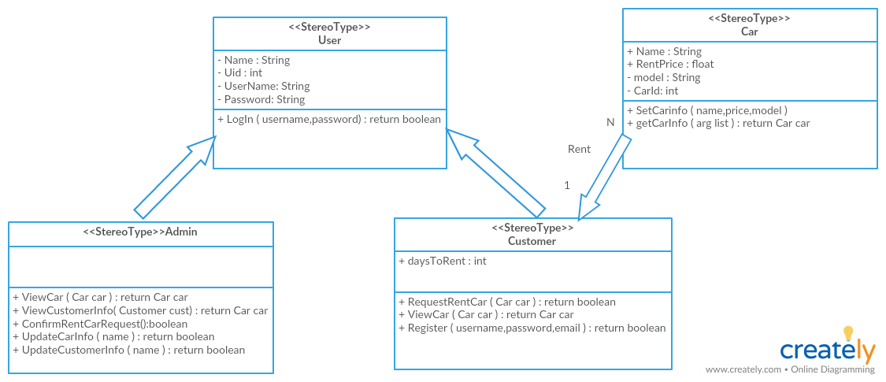

**Work Division:**

|  |  |  |
| --- | --- | --- |
| **Name** | **Work Completed** | **Parts** |
| **Maryam Adnan** | * Database and SRS Diagrams * User Interface for Main Page * Complete Functionality of the Main Page | * Part1 * Part2 * Part 3 |
| **Maryam Hasnain** | * Database, Connection * User Interface for Main Page * Complete Functionality of the Main Page | * Part1 * Part2 * Part 3 |
| **Usman Haider** | * SRS * Login and Registration * Administrator page | * Part1 * Part2 * Part3 |

**Link to GitHub:**

https://github.com/MaryamHasnain11/CarRentalSystem.git