**Link to GitHub:** https://github.com/MaryamHasnain11/Lab5.git

1. **Graph No. 1:**

**Code:**

barplot(mtcars$mpg,mtcars$hp, col='blue', xlab='mpg', ylab='hp', main='mpg')

**Output:**

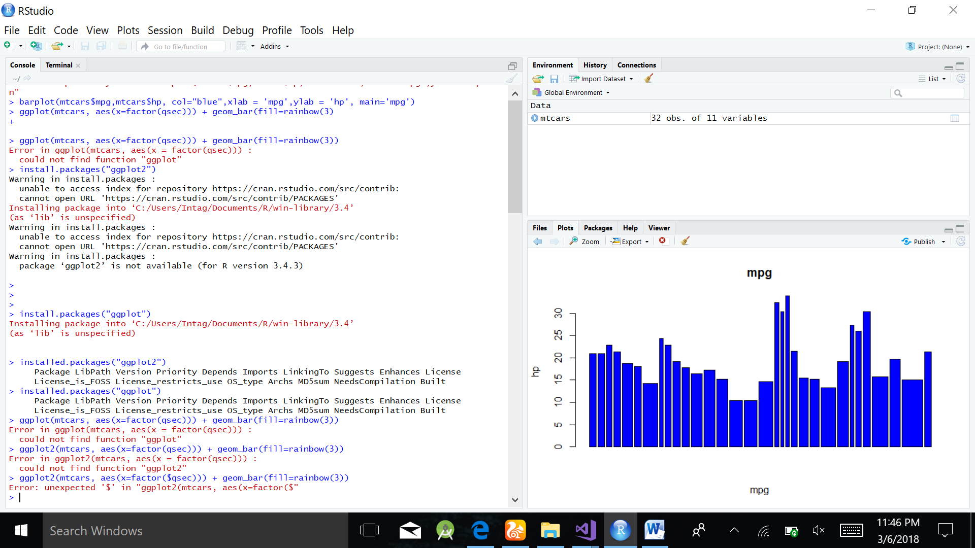

2**. Graph No. 2:**

**Code:**

plot(mtcars$mpg,mtcars$disp)

**Output:**

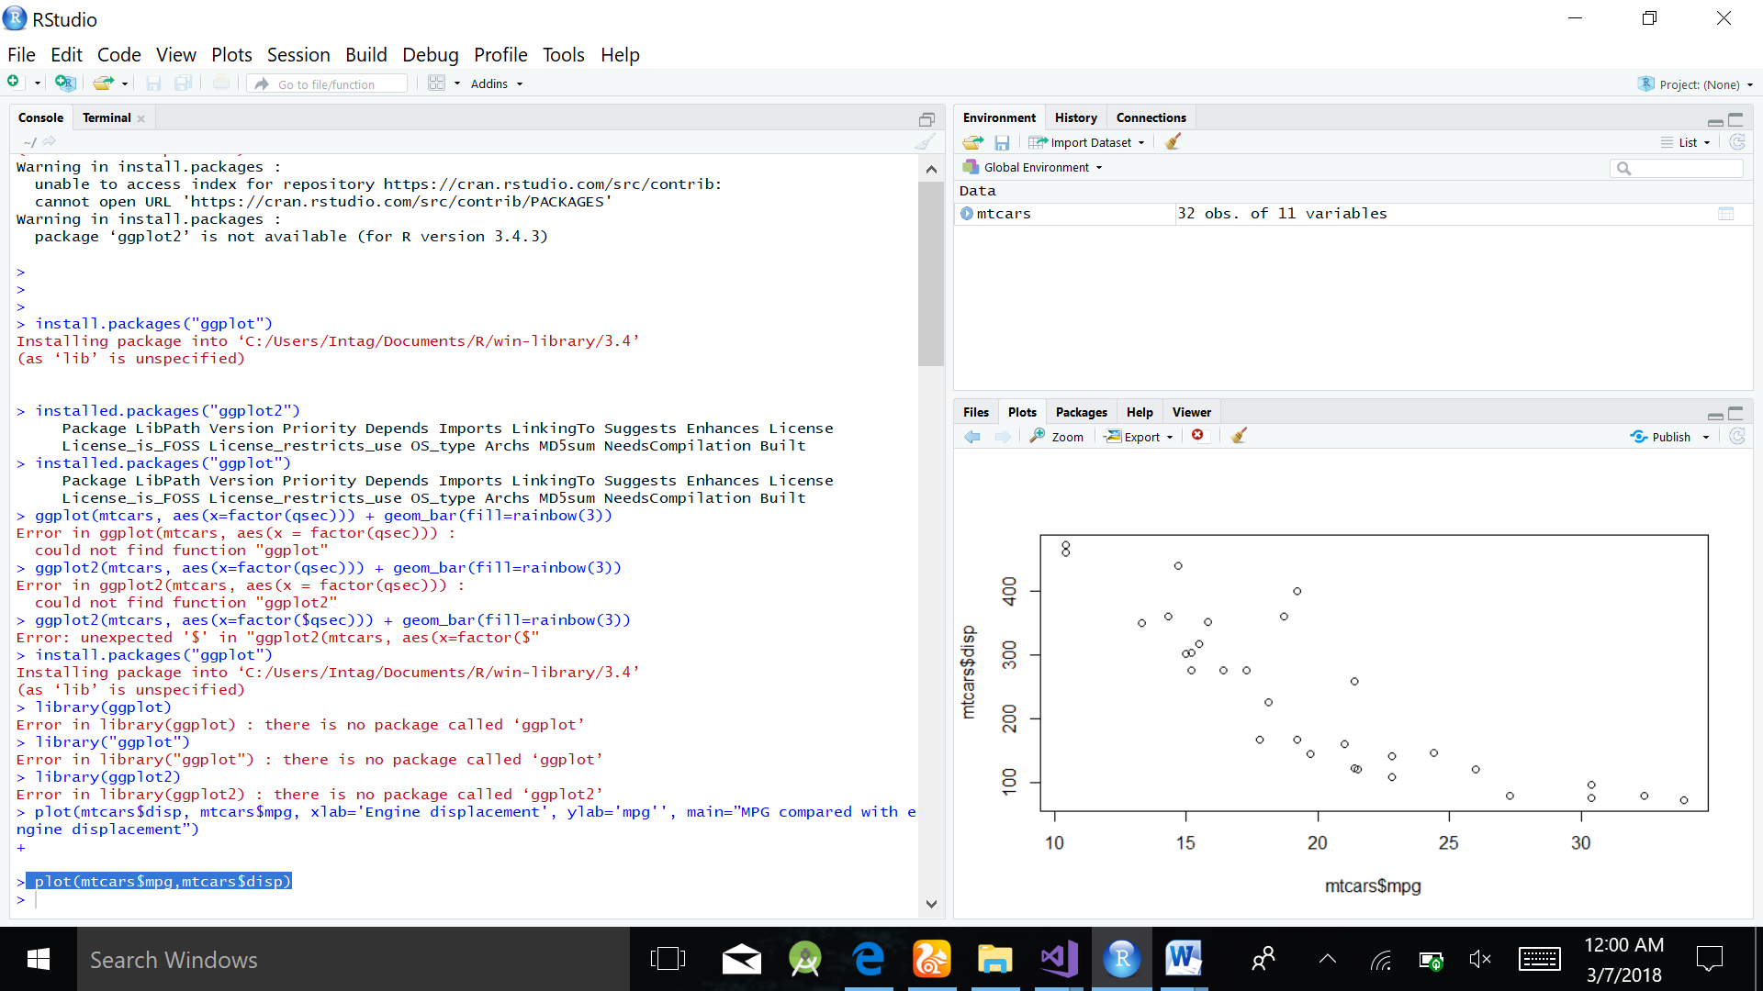

**Graph No. 3:**

**Code:**

barplot(mtcars$wt,mtcars$hp, col='black', xlab='wt', ylab='hp', main='wt')

**Output:**

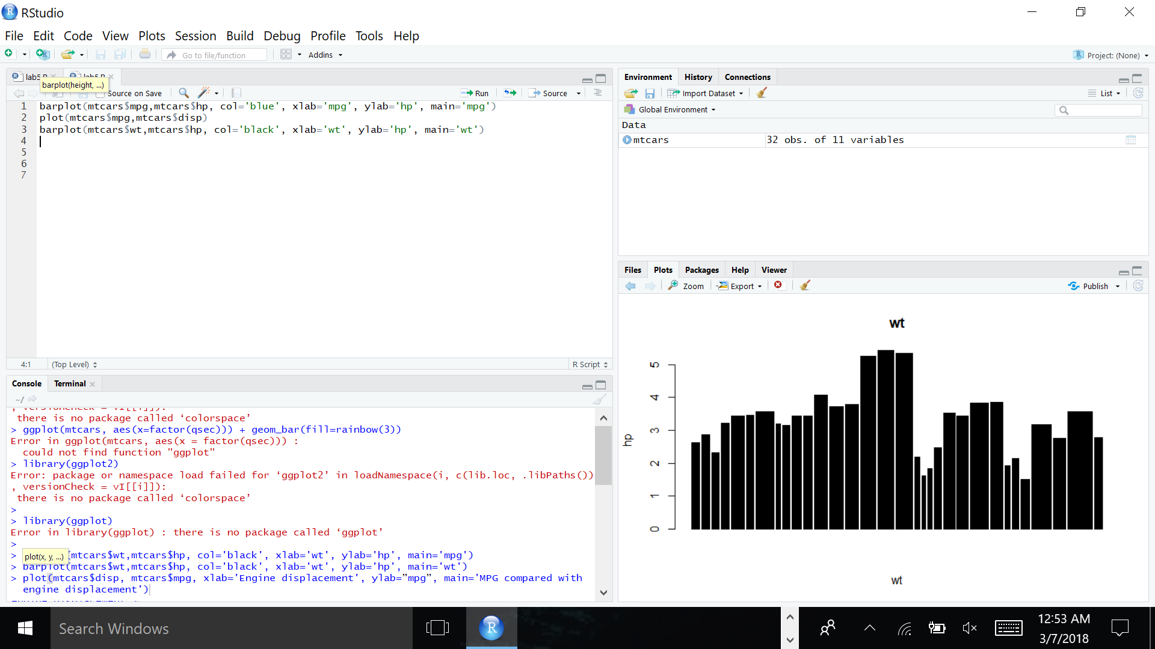

**Graph No. 4:**

**Code:**

hist(mtcars$gear,col="red",main="Histogram for gears",xlab="Number of gears",ylab="Number of cars")

**Output:**

