CyberSter

CYBERSTER BLUE TEAM INTERNSHIP
WEEK 11 REPORT
Email Forensics and Super Timeline Analysis
Submitted By: Maryam Mughal
ID: CSI-B1-293

Phase Two — Digital Forensics and Incident Response

Week: Week 11 (Days 74– 80)
Submission Date: 17-May-2026

Submitted To: Abdullah Zia
Table of Contents

Week 11 Overview
Methodology
Tool Used
Working Folder
Autopspy Case Creation

Part A — Email Extraction and Initial Triage
• Autopsy Case Creation and Evidence Ingestion
• Email Archive Analysis (outlook.pst)
• Raw Email Header Analysis

Part B — Host Artefact Analysis
• LNK File Analysis
• Prefetch Analysis
• Registry Analysis (NTUSER.DAT)
• Artefact Correlation

Part C — Super Timeline Analysis
• Timeline Generation and Filtering
• Timeline Reconstruction

Final Analysis
Conclusion

Week 11 Overview
Week 11 of the Cyberster Blue Team Internship focused on a complete Digital Forensics and Incident Response (DFIR) investigation involving email forensics, Windows host artefacts, and super timeline analysis. Unlike previous weeks where the focus was broad forensic triage across multiple artefact categories, this investigation was centred around a single confidential spreadsheet (m57biz.xls / m57plan.xls), a specific timestamp (2008-07-20 01:28:03 UTC), and a key investigative question: whether Jean, the CFO of M57.biz, intentionally leaked sensitive company data or unknowingly responded to a deceptive request.
The investigation began with analysis of the split EnCase forensic image (nps-2008-jean.E01 and nps-2008-jean.E02) using Autopsy configured in GMT/UTC timezone for accurate timestamp correlation. During Part A, the Outlook PST archive was located and parsed to identify emails related to the confidential spreadsheet. A specific outbound email containing m57biz.xls as an attachment was discovered within the investigation window. Detailed analysis of the raw email headers revealed a critical discrepancy between the visible display identity and the actual underlying email address. While the message appeared to reference a trusted internal contact, the embedded delivery address pointed toward an unrelated external account. This finding became the central forensic pivot of the investigation.
Part B focused on host-based artefact analysis to verify whether Jean had physically interacted with the spreadsheet before the email was sent. Windows shortcut (.lnk) files, Microsoft Excel prefetch records, and registry entries from NTUSER.DAT were extracted and analysed using LECmd, PECmd, and Registry Explorer. The timestamps from all three artefact categories closely aligned within the same investigation window, showing that the spreadsheet had been opened in Excel shortly before the email transmission occurred. This demonstrated strong evidentiary corroboration across independent operating system artefacts.
Part C involved generating a super timeline from the forensic image using Autopsy’s timeline functionality. The timeline initially contained millions of events, so a “Start Big, Filter Down” methodology was used. Events were progressively filtered by date, investigation time window, and finally by the keyword m57biz. This process reduced the dataset to a small cluster of highly relevant events that reconstructed the second-by-second sequence of actions on Jean’s workstation. The timeline showed Excel execution, registry updates, recent document activity, email transmission events, and spreadsheet modification activity all occurring within seconds of one another.
Overall, Week 11 demonstrated how multiple forensic evidence sources can be correlated into a single investigative narrative. The evidence confirmed that Jean opened and sent the spreadsheet, but the email header discrepancy suggested she may have been manipulated through a deceptive request rather than intentionally performing malicious data exfiltration. The week provided practical experience in email header analysis, artefact correlation, timeline reconstruction, and evidence-based investigative reasoning commonly used in real-world DFIR investigations.
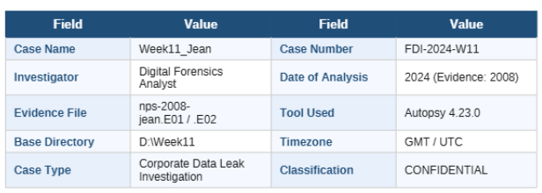

Methodology

Timezone Handling
All timestamps throughout this investigation were analysed and documented in Coordinated Universal Time (UTC/GMT) to maintain consistency across all forensic artefacts. While creating the case in Autopsy, the data source timezone was explicitly configured to GMT/UTC before evidence ingestion. This ensured that timeline events, parsed email timestamps, registry activity, and system artefacts could be correlated accurately without confusion caused by local timezone offsets.
Additional forensic utilities including LECmd, PECmd, and Registry Explorer also reported timestamps in UTC format. Some file-system views inside Autopsy displayed NTFS timestamps according to the examiner system’s local timezone; however, all timeline reconstruction and evidence correlation in this report relied only on the UTC values generated directly from the forensic tools to avoid inconsistencies during analysis. Maintaining a single timezone standard was essential because the investigation depended heavily on second-by-second event correlation between email activity, registry updates, file execution, and timeline entries.
Chain of Custody
The evidence files nps-2008-jean.E01 and nps-2008-jean.E02 were stored in a dedicated evidence directory and remained unmodified throughout the investigation. The forensic image was loaded into Autopsy in read-only mode, ensuring that no changes were written back to the original evidence source during analysis.
All extracted artefacts including LNK files, Prefetch files, registry hives, Outlook email archives, and timeline exports were saved as derived copies inside a separate examiner working directory. This ensured preservation of the original evidence while allowing detailed examination of extracted artefacts using external forensic utilities.
Hash verification was performed during ingestion using Autopsy’s integrity verification process. The calculated MD5 value matched the stored image metadata, confirming that the evidence image had not been altered and remained forensically sound. Every major artefact used in the investigation was documented with its extraction source, storage location, and associated analysis tool to maintain proper evidence tracking and examination transparency.

Tools Used
Tool | Purpose
Autopsy | Main forensic analysis platform used throughout the investigation
LECmd | Parsing Windows shortcut (.lnk) artefacts
PECmd | Parsing Windows Prefetch files
Registry Explorer | Registry hive analysis
Microsoft Excel | Reviewing exported CSV files
Windows Command Prompt | Running forensic command-line tools

Working Folder Preparation
Before beginning the forensic examination, a structured working directory was created to separate extracted artefacts, exported evidence, and analysis files from the original forensic image. This helped maintain proper evidence handling and improved organisation throughout the investigation process.
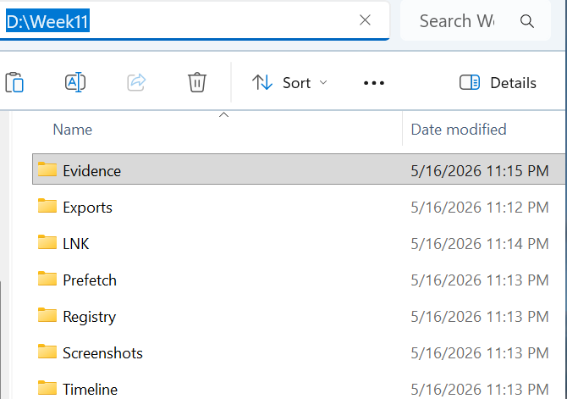
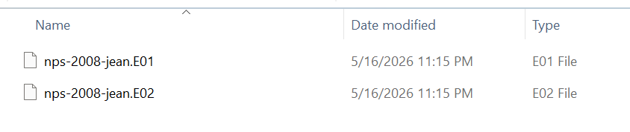

Autopsy Case Creation
A new forensic case named Week11_M57_Jean was created in Autopsy using the Single-User case configuration. The base directory was set to the dedicated Week11 working folder so all ingest results, parsed artefacts, and timeline data would remain organised inside a single investigation directory.
Optional case metadata including case number, examiner information, and organisational details were added to improve documentation and maintain proper forensic reporting standards.
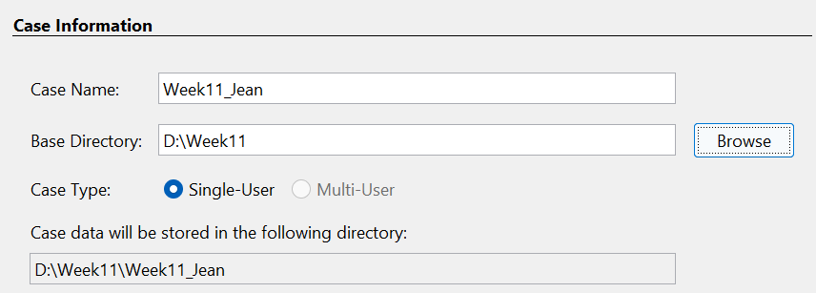

Evidence Ingestion and Timezone Configuration
The split EnCase evidence image nps-2008-jean.E01 was selected as the primary data source. Since the evidence consisted of a split image format, Autopsy automatically detected the associated .E02 segment when the .E01 file was loaded.
One of the most important configuration steps during ingestion was setting the data source timezone to (GMT+0:00) UTC. This ensured that all parsed timestamps, timeline entries, registry activity, and email events aligned correctly with the investigation window defined in the task brief. Incorrect timezone selection would have caused inconsistencies during timeline reconstruction and event correlation later in the investigation.
The sector size was left on Auto Detect, and the image was processed in read-only mode to preserve forensic integrity.

Ingest Module Configuration
Multiple ingest modules were enabled to maximise artefact extraction and automated evidence discovery. Important modules included:
- Recent Activity
- Hash Lookup
- Keyword Search
- Embedded File Extractor
- Email Parser
- File Type Identification
- Interesting Files Identifier
- Encryption Detection
The Email Parser module was especially important because it enabled Autopsy to detect and parse Outlook PST archives, individual email messages, and embedded email attachments.
The instructor-provided MD5 hash value for the spreadsheet was also added to the Hash Lookup module to automatically flag matching files during ingestion.

Ingest Processing and Email Discovery
After ingest configuration was completed, Autopsy began processing the forensic image. The full ingest operation required approximately 25 minutes and generated multiple artefact categories including Recent Documents, Installed Programs, Run Programs, Web History, and E-Mail Messages.
During the later stages of processing, the Ingest Inbox displayed multiple email-related artefacts parsed from Jean’s Outlook archive. The Email Parser module identified hundreds of email records stored inside the PST archive, including inbound and outbound communications relevant to the investigation timeframe.
The successful parsing of Outlook email data confirmed that the forensic image contained recoverable communication evidence directly related to the suspected spreadsheet transmission event.
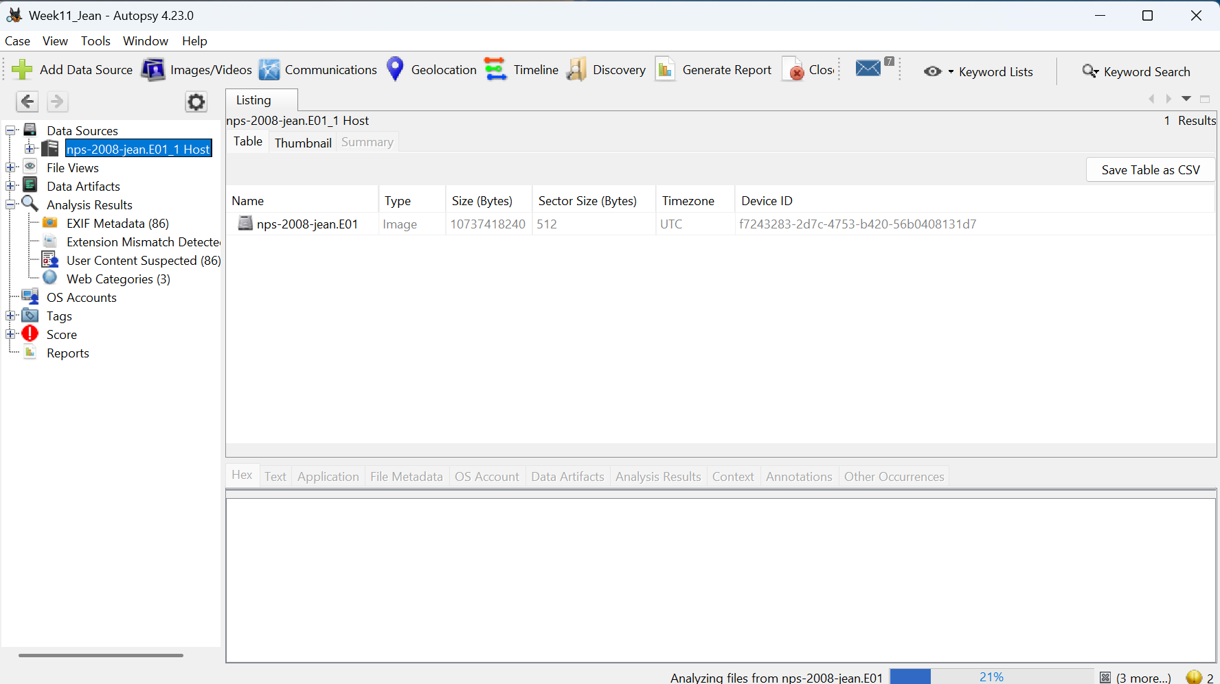

Data Source Verification (MD5 Integrity Check)
After the ingest process completed successfully, the integrity of the forensic image was verified using the built-in verification functionality of Autopsy. The verification results were accessed by selecting the nps-2008-jean.E01 data source from the left evidence tree and reviewing the Analysis Results section.

Evidence
Autopsy reported that the calculated MD5 hash value of the forensic image matched the original stored hash value embedded within the EnCase evidence metadata.

Interpretation
The successful hash verification confirmed that the forensic image had not been altered or corrupted since its original acquisition. Both the calculated and stored MD5 values were identical, demonstrating that the evidence remained forensically intact throughout the examination process.
This integrity validation is important because it ensures that all findings, extracted artefacts, email evidence, timeline events, and registry data analysed during the investigation originated from an authentic and unchanged evidence source. Since the image integrity was verified successfully, the examination results can be considered reliable and reproducible by another forensic examiner working with the same evidence files.
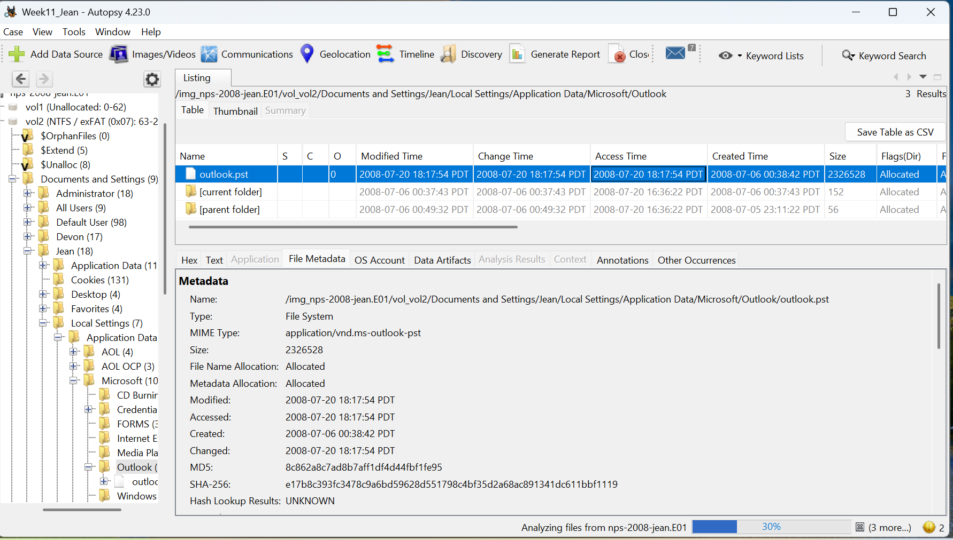

Part A — Email Extraction and Initial Triage (Days 74–75)

Objective
The objective of Part A was to identify and analyse Jean’s email archive from the forensic image, locate the outbound email containing the confidential spreadsheet m57biz.xls, and examine the raw email data to determine the actual recipient behind the communication. This phase focused primarily on email forensics and header analysis because the task brief identified the discrepancy between the visible display identity and the underlying delivery address as the key investigative finding of the case.
The investigation aimed to determine whether Jean intentionally transmitted confidential company information or whether she was manipulated through a deceptive email request appearing to originate from a trusted company contact.
Phase 1 — Email Archive Location & Format

Step 1: Email Client Identification
The first step was to identify which email client Jean was using. Autopsy was used to browse the disk image nps-2008-jean.E01. Navigation to the Microsoft Outlook directory confirmed that Jean's mail client was Microsoft Outlook, not Mozilla Thunderbird or any other alternative.

Step 2: outlook.pst File Metadata

Metadata Field | Value | Significance
File Name | outlook.pst | Outlook email archive
Full Path | ...\Microsoft\Outlook\outlook.pst | Confirms Outlook storage location
Size | 2,326,528 bytes | Contains parsed email evidence
Allocation Status | Allocated | File was not deleted
Created | 2008-07-06 07:38:42 UTC | Outlook profile creation time
Modified | 2008-07-21 01:17:54 UTC | Last activity after leak event
MIME Type | application/vnd.ms-outlook-pst | Verified as PST archive
MD5 | 8c862a8c7ad8b7aff1df4d44fbf1fe95 | Integrity verification hash
SHA-256 | e17b8c393fc3478c9a6bd59628d551798c4bf35d2a68ac891341dc611bbf1119 | Cryptographic verification
Hash Lookup | UNKNOWN | No malware/database match

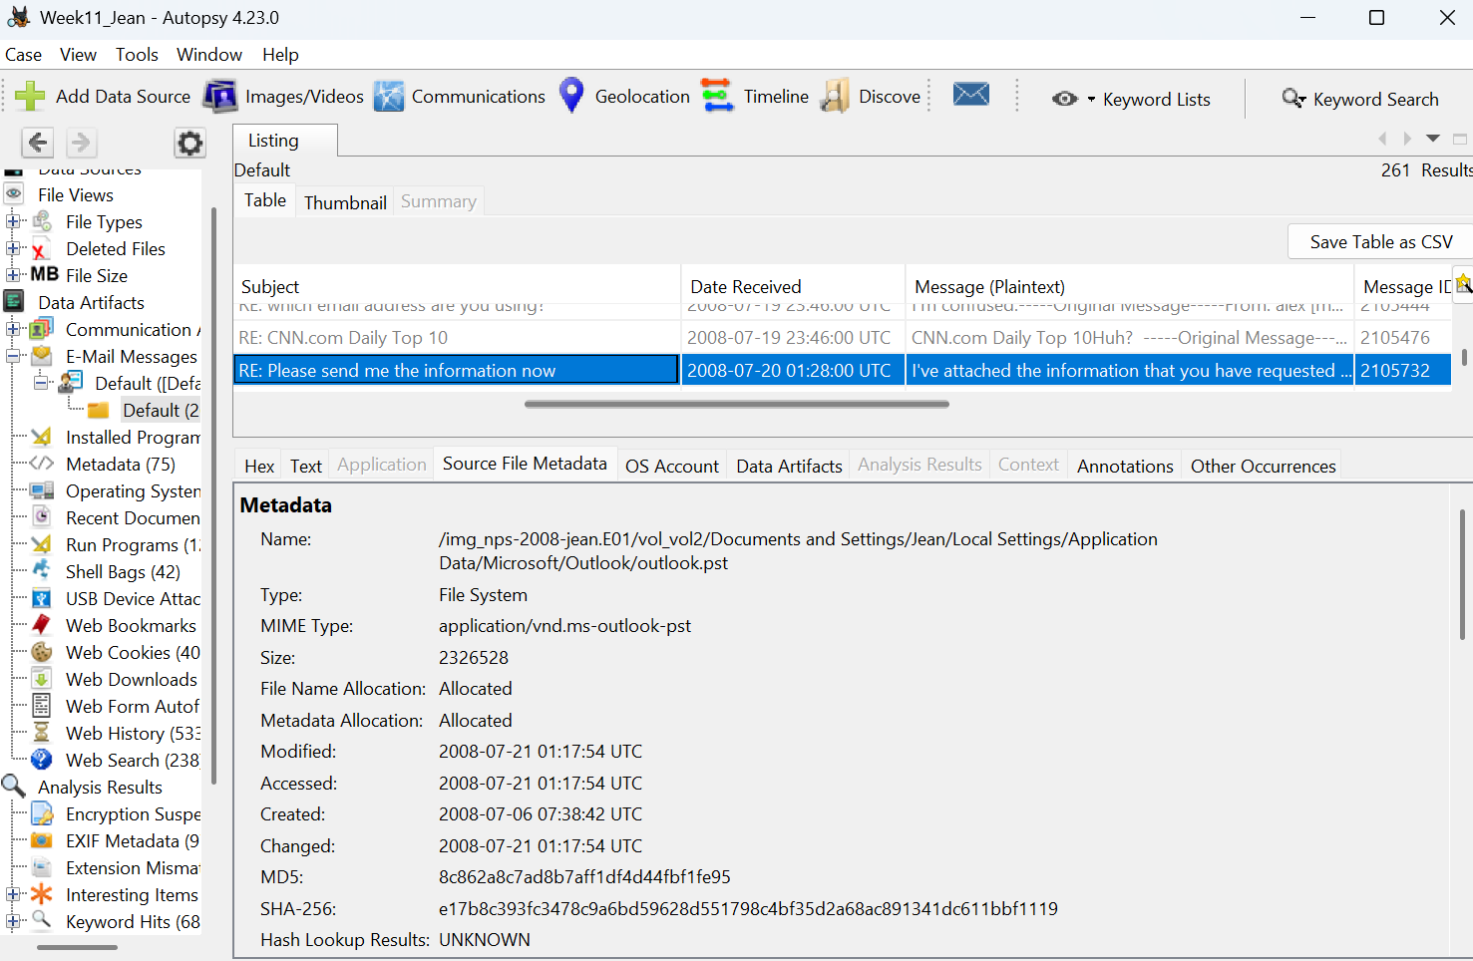
The timestamps reveal that the outlook.pst was last modified on 2008-07-21, which is one day after the suspected data leak on 2008-07-20. This is consistent with Outlook updating the PST file after emails were sent and received.
Phase 2 — Identifying the Target Email
Step 1: Email List Overview
Autopsy's Email Parser module processed the outlook.pst and made all emails visible under Data Artifacts → E-Mail Messages → Default. The listing showed 261 total results.
Field | Value
Total Emails in Archive | 261 Results
Target Email Position | Result 261 of 269
Email From | Jean User <jean@m57.biz>
Subject | RE: Please send me the information now
Date Received | 2008-07-20 01:28:00 UTC
Message Preview | "I've attached the information that you have requested..."

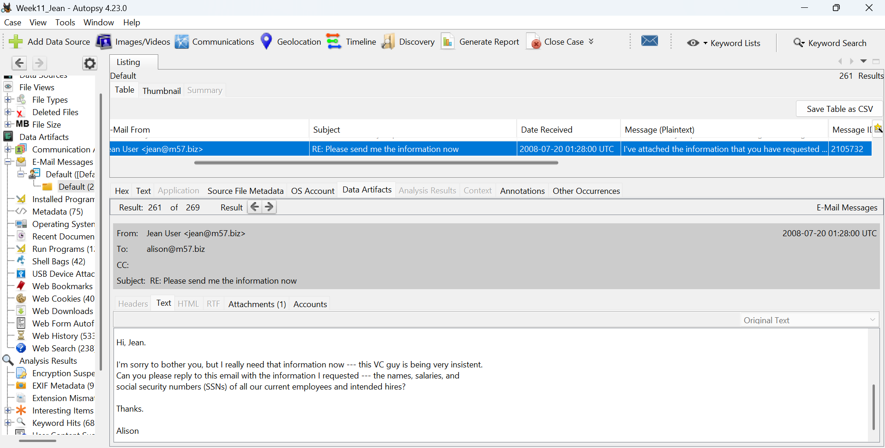
The body of the email contains only one line: "I've attached the information that you have requested to this email message." This is a critically short response, suggesting Jean did not question or verify the request before complying.
The email also contains the Original Message quoted at the bottom, which reveals:
- From: alison@m57.biz <mailto:tuckgorge@gmail.com>
- Sent: Sunday, July 20, 2008 2:23 AM
- To: jean@m57.biz
- Subject: Please send me the information now
This quoted section is extremely significant because it exposes the real sender address as tuckgorge@gmail.com, even though the display name showed alison@m57.biz. This is a classic email spoofing / social engineering technique where the attacker disguises their real identity behind a trusted display name.
Header Field | Value | Significance
Display Name | alison@m57.biz | Fake — designed to look trusted
Real Email | mailto:tuckgorge@gmail.com | TRUE attacker identity
Sent | Sunday, July 20, 2008 2:23 AM | 5 min 37 sec before Jean replied
To | jean@m57.biz | Confirmed target
Subject | Please send me the information now | Social engineering pressure language

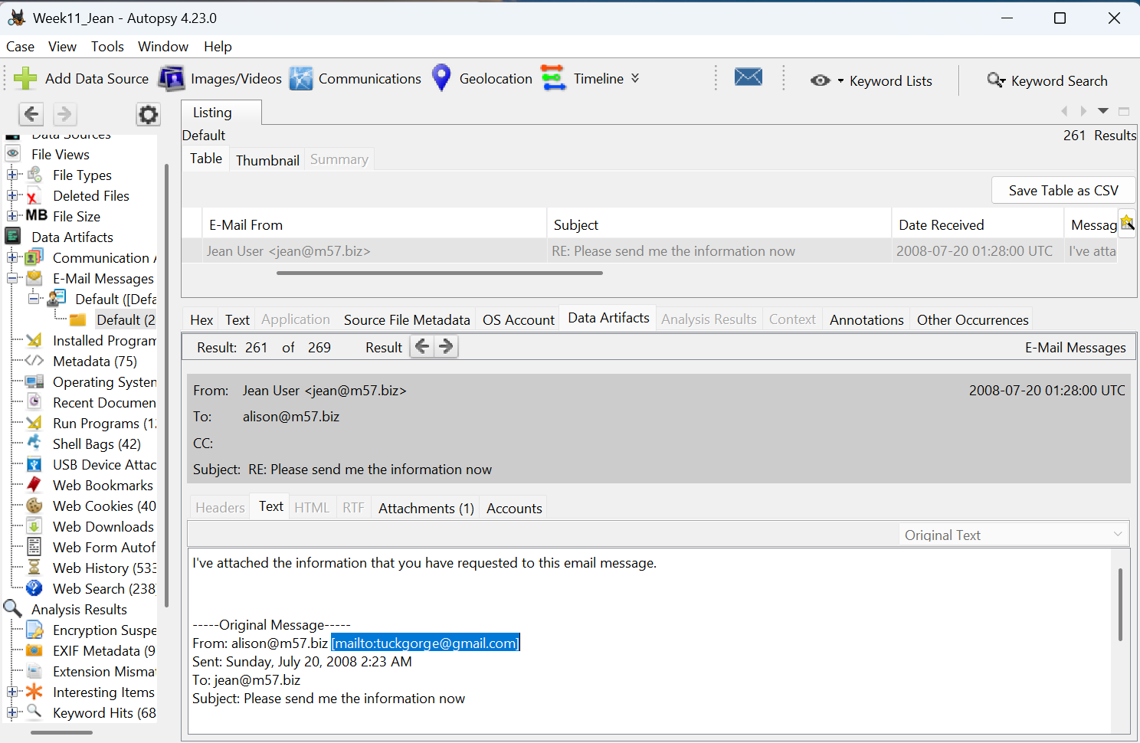

Phase 3 — Attachment Analysis (m57biz.xls)

Step 1: Attachment Tab Examination
With the target email still selected, the Attachments (1) tab was clicked in the email viewer. This revealed one attachment associated with this email. The attachment details recorded are:
- Location: /img_nps-2008-jean.E01/vol_vol2/Documents and...
- Size: 291,840 bytes (~285 KB)
- MIME Type: application/vnd.ms-excel
- Known: unknown (not in hash database)
The MIME type application/vnd.ms-excel positively confirms this attachment is a Microsoft Excel spreadsheet file. The attachment size of 291,840 bytes matches exactly with the m57biz.xls file found on Jean's Desktop, confirming they are the same file.
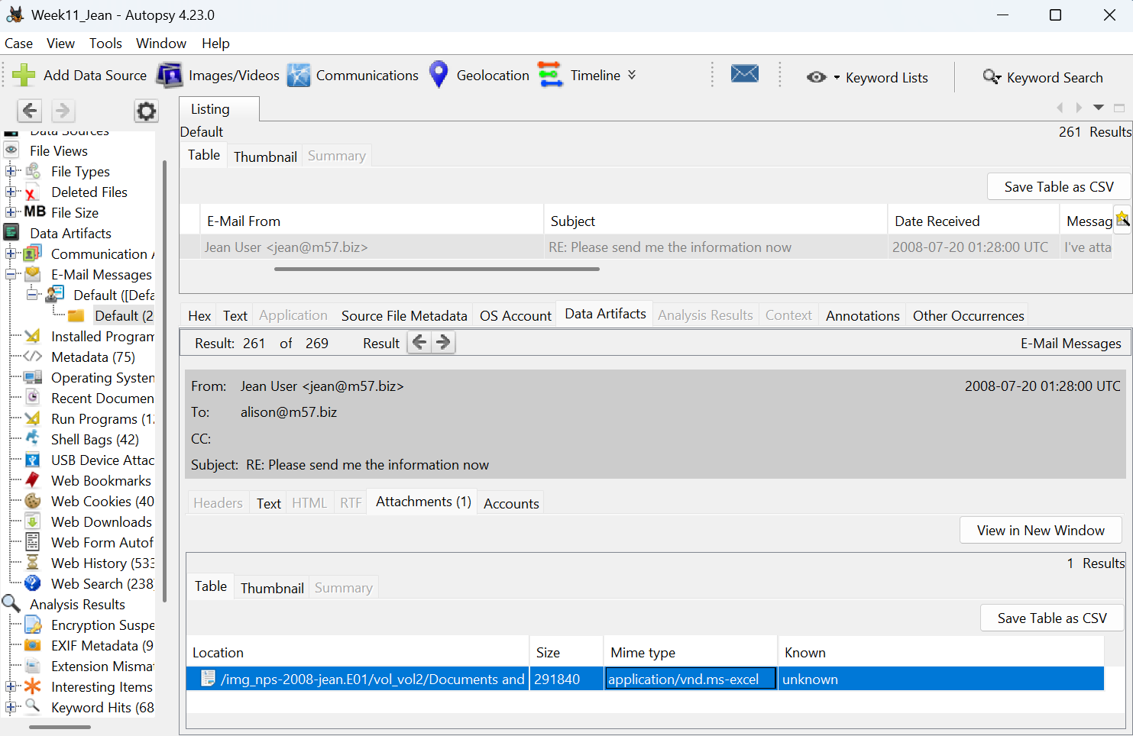

Step 2: m57biz.xls File Metadata on Disk
Navigating to Views → File Types → By Extension → Documents → Office in Autopsy's left panel, the file m57biz.xls was found listed with 43 total Office documents on the system. The file metadata recorded from the File Metadata tab is as follows:
- Full Path: /img_nps-2008-jean.E01/vol_vol2/Documents and Settings/Jean/Desktop/m57biz.xls
- Type: File System
- MIME Type: application/vnd.ms-excel
- Size: 291,840 bytes
- Modified: 2008-07-20 01:28:03 UTC
- Accessed: 2008-07-20 01:28:03 UTC
- Created: 2008-07-20 01:28:03 UTC
- Changed: 2008-07-20 01:28:04 UTC
- MD5: e23a4eb7f2562f53e88c9dca8b26a153
- SHA-256: 34456b5f714dc9d8dd23c742d54c3f5f582ecb042bc1c4d3042b88203863779f
- Internal ID: 4014
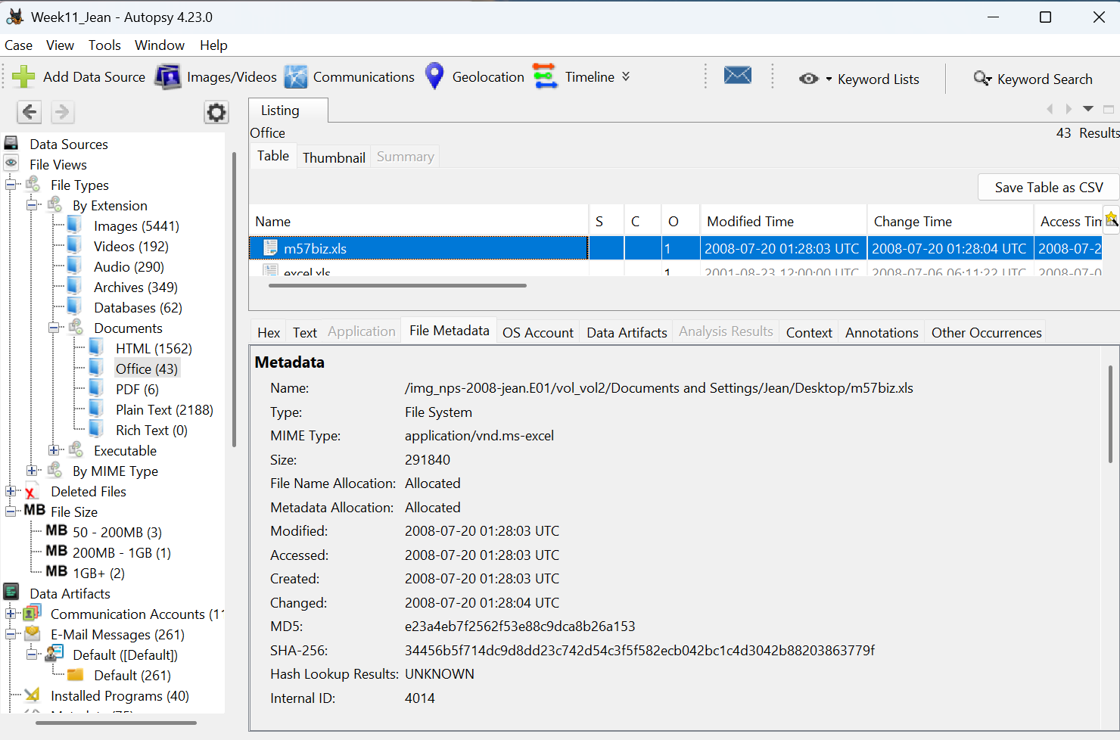
The timestamps are extremely important. The file was Created, Modified, and Accessed all within the same second — 01:28:03 UTC on July 20, 2008. The Changed timestamp is only one second later at 01:28:04 UTC. This tight cluster of timestamps strongly suggests the file was copied or saved to the Desktop immediately before being attached to the outgoing email at 01:28:00 UTC. The file was located directly on Jean's Desktop, making it easily accessible.
Phase 4— Contents of m57biz.xls (Confidential Data Leaked)
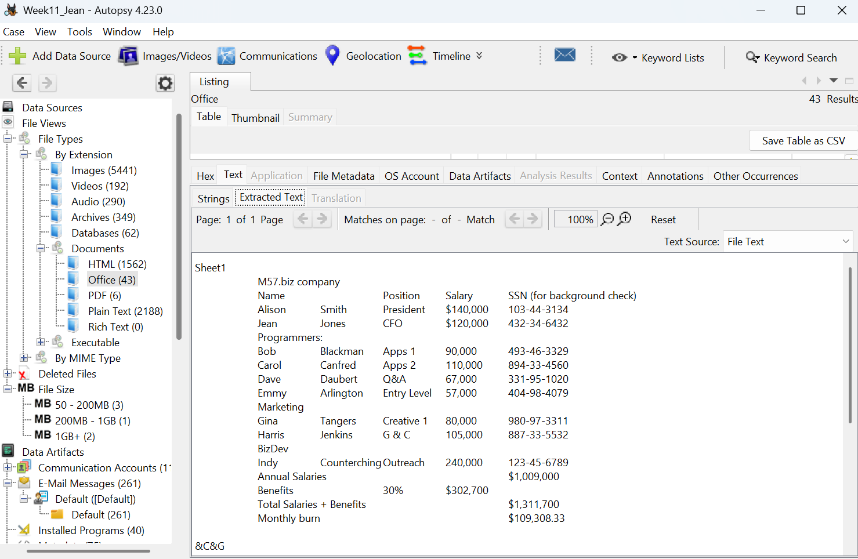

Step 1: Extracted Text Review
Selecting the Text tab → Extracted Text sub-tab in Autopsy for the m57biz.xls file revealed the complete contents of the spreadsheet without needing to open Excel. The file contains Sheet1 titled "M57.biz company" and holds a complete employee directory with highly sensitive personal and financial information.

Step 2: Employee Data Extracted
The spreadsheet contains the following columns: Name, Position, Salary, and SSN (for background check). The complete employee records are:
Executive Level: Alison Smith holds the position of President with a salary of $140,000 and SSN 103-44-3134. Jean Jones is listed as CFO with a salary of $120,000 and SSN 432-34-6432.
Programmers: Bob Blackman (Apps 1, $90,000, SSN 493-46-3329), Carol Canfred (Apps 2, $110,000, SSN 894-33-4560), Dave Daubert (Q&A, $67,000, SSN 331-95-1020), and Emmy Arlington (Entry Level, $57,000, SSN 404-98-4079).
Marketing: Gina Tangers (Creative 1, $80,000, SSN 980-97-3311) and Harris Jenkins (G & C, $105,000, SSN 887-33-5532).
BizDev: Indy Counterching (Outreach, $240,000, SSN 123-45-6789).

Step 3: Financial Summary Data
The spreadsheet also contains a complete financial summary of M57.biz company payroll. Annual Salaries total $1,009,000. Benefits calculated at 30% add $302,700. The Total Salaries plus Benefits comes to $1,311,700, with a Monthly Burn rate of $109,308.33.
This data represents complete corporate financial intelligence including every employee's exact compensation and Social Security Numbers — precisely the kind of information a competitor or malicious actor would want to acquire.

Summary of Critical Evidence
The email sent by Jean at 2008-07-20 01:28:00 UTC contained the file m57biz.xls as an attachment. This file was located on Jean's Desktop and contained the full employee roster of M57.biz including names, job titles, salaries, and Social Security Numbers for all 9 employees. The real recipient of this data was the person operating the tuckgorge@gmail.com account, who disguised themselves as Alison from the m57.biz domain. The total financial exposure from this single email is the complete payroll structure of the company valued at over $1.3 million annually.

Part B - Host-Based Artefact Deep-Dive (Days 76-78)

Objective
Part B corroborates the email-side findings of Part A with three independent on-disk artefact categories - LNK, Prefetch, and Registry - each updated by a different Windows operating-system component in response to a discrete user action. If Jean opened m57biz.xls on the morning of July 20, 2008, all three categories should carry timestamps within seconds of each other and within seconds of the 01:28:03 UTC anchor.
Phase 1 — LNK File Analysis

1. LNK Files Located in Autopsy
When a user opens any file on a Windows XP system, the operating system automatically generates a shortcut file (.lnk) in the Recent folder. These LNK files are one of the most valuable artefacts in digital forensics because they record not just that a file existed, but that a specific user actively opened it. In this investigation, two separate LNK files referencing m57biz.xls were discovered in different system locations, both confirming Jean's direct interaction with the leaked file.
- First LNK — Windows Recent Folder
Navigating to Documents and Settings\Jean\Recent in Autopsy revealed 8 files in Jean's Recent folder. The file m57biz.lnk was present and allocated, meaning it was not deleted. Its full path on the disk image is /img_nps-2008-jean.E01/vol_vol2/Documents and Settings/Jean/Recent/m57biz.lnk. The file size is only 468 bytes, which is typical for a Windows shell link file. All four timestamps — Created, Modified, Accessed, and Changed — are identical at 2008-07-20 01:28:04 UTC, indicating the shortcut was created in a single instant at the moment Jean opened the file.
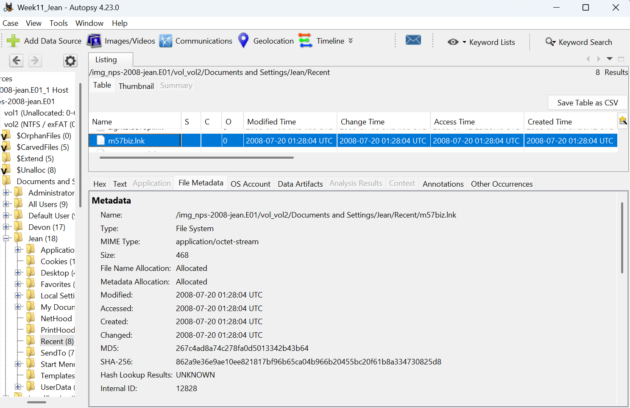
- Second LNK — Microsoft Office Recent Folder
A second LNK file named m57biz.LNK was found at Documents and Settings\Jean\Application Data\Microsoft\Office\Recent, which contained 5 files total. Microsoft Office maintains its own separate Recent folder independent of Windows, and creates its own LNK entry each time a file is opened through an Office application such as Excel. This file is slightly smaller at 408 bytes and has a notably different Created timestamp of 2008-07-20 01:27:42 UTC — which is 22 seconds earlier than the Windows Recent LNK.
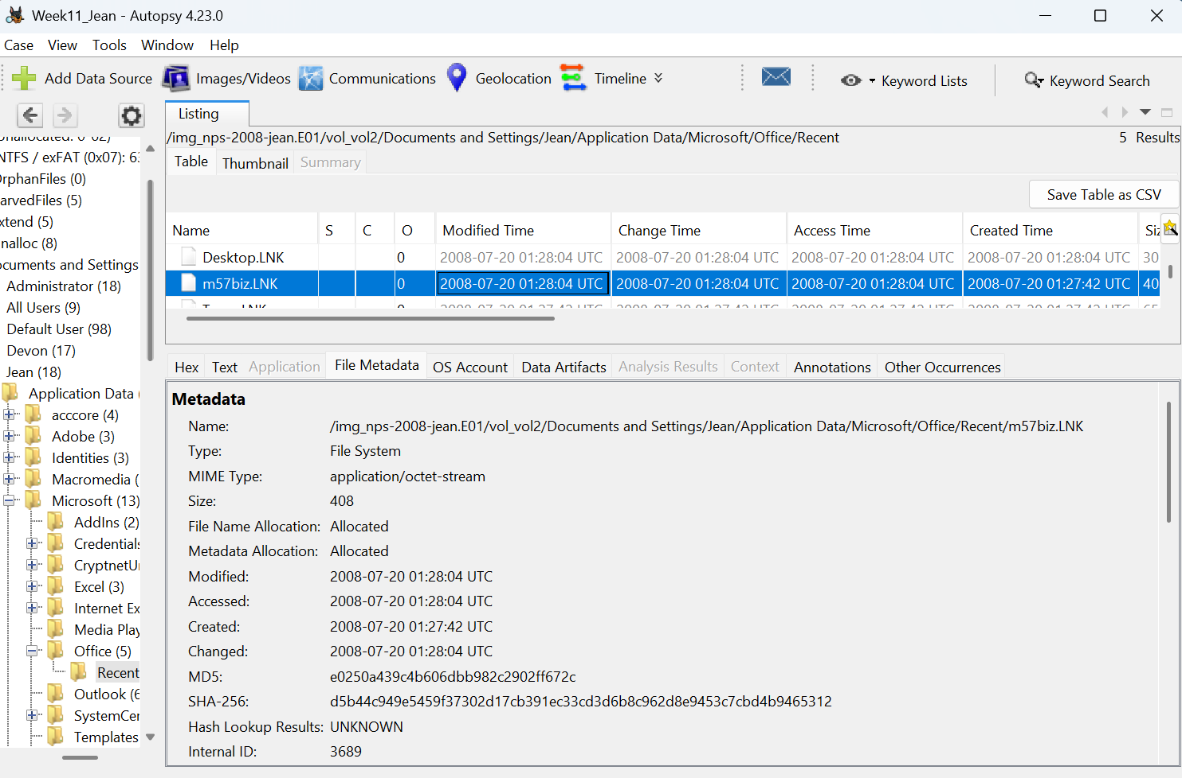

LNK Location | Size | Created | Modified/Accessed
Jean\Recent\m57biz.lnk | 468 bytes | 2008-07-20 01:28:04 UTC | 2008-07-20 01:28:04 UTC
Office\Recent\m57biz.LNK | 408 bytes | 2008-07-20 01:27:42 UTC | 2008-07-20 01:28:04 UTC

Both files are confirmed Allocated with Hash Lookup returning UNKNOWN, meaning they are unique files not present in any known hash database. The MD5 of the Windows Recent LNK is 267c4ad8a74c278fa0d5013342b43b64 and the Office Recent LNK MD5 is e0250a439c4b606dbb982c2902ff672c — two different hashes confirming these are two independently generated shortcut files, both pointing to the same target.
The 22-second gap between the two LNK creation times is forensically significant. The Office LNK at 01:27:42 UTC marks the exact moment Excel launched and registered the file. The Windows Recent LNK at 01:28:04 UTC marks when the operating system finalized the shortcut after the file was fully loaded. This 22-second window represents the time Jean had the spreadsheet open on screen before attaching it to the outgoing email.

2. Recent Documents Artifact in Autopsy
Under Data Artifacts → Recent Documents in Autopsy, 9 results were found across Jean's system. This section aggregates LNK data parsed by Autopsy's Recent Activity ingest module, making it easier to read without needing external tools. The highlighted entry m57biz.LNK appears at the top of the list, parsed with the following key values:
Field | Value
Target Path | C:\Documents and Settings\Jean\Desktop\m57biz.xls
Date Accessed | 2008-07-20 01:27:42 UTC
Path ID | 4014
Data Source | nps-2008-jean.E01
Source File | .../Application Data/Microsoft/Office/Recent/m57biz.LNK
Artifact ID | -9223372036854775794

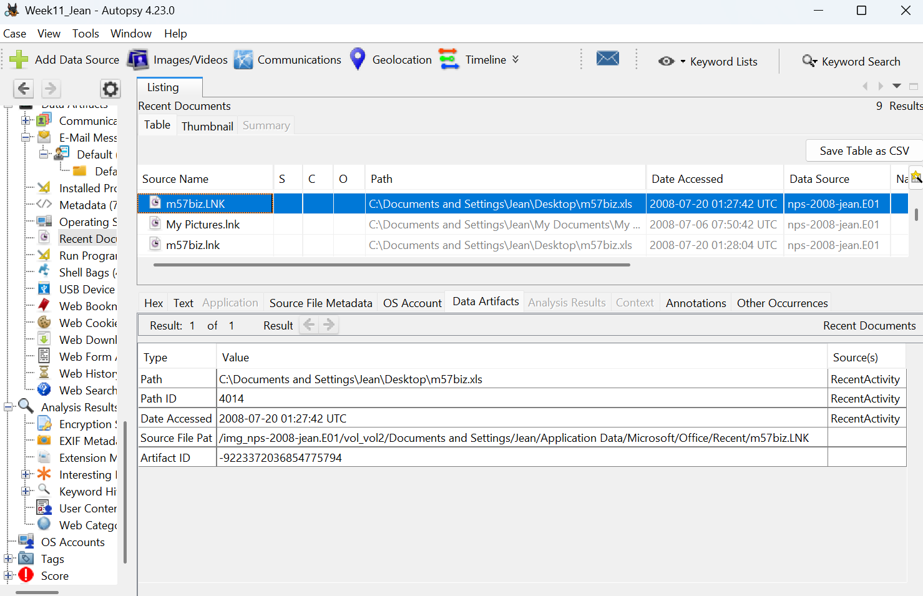
Two separate m57biz entries appear in the Recent Documents list — one from the Office Recent folder accessed at 01:27:42 UTC and one from the Windows Recent folder accessed at 01:28:04 UTC — both pointing to the same Desktop path C:\Documents and Settings\Jean\Desktop\m57biz.xls. This dual appearance across two system locations reinforces the reliability of this evidence.
A critically important cross-artifact link is found here: the Path ID 4014 recorded in Recent Documents matches exactly the Internal ID 4014 recorded for m57biz.xls in Part A's file metadata analysis. This is not a coincidence — it is the same file being referenced across two completely different forensic artefact types, providing strong cross-artifact verification that the file Jean opened is the exact same file that was attached to the outgoing email.

3. LECmd Parsed Output
The LNK file was extracted from Autopsy to D:\Week11\LNK\ and parsed using the industry-standard tool LECmd version 2026.5.0 by Eric Zimmerman.
A warning appeared stating "Administrator privileges not found" however this did not prevent the tool from processing the file. The output was successfully generated.
Header and Target Information
The LNK header section confirms the target file details as recorded at the time the shortcut was created:
Field | Value
Target Created | 2008-07-20 01:28:03 UTC
Target Modified | 2008-07-20 01:28:03 UTC
Target Accessed | 2008-07-20 01:28:03 UTC
File Size | 291,840 bytes
Relative Path | ..\Desktop\m57biz.xls
Working Directory | C:\Documents and Settings\Jean\Desktop
File Attributes | FileAttributeArchive
Flags | HasTargetIdList, HasLinkInfo, HasRelativePath, HasWorkingDir, IsUnicode
The flags recorded — particularly HasLinkInfo and HasRelativePath — confirm that the LNK file contains complete volume and path information, meaning it was created on a local fixed drive rather than a network or removable location.
Volume Information shows the file resided on a Fixed storage media (Hard drive) with serial number 7A4FC21F and no volume label assigned. The local path recorded inside the LNK is C:\Documents and Settings\Jean\Desktop\m57biz.xls, definitively placing the file on Jean's Desktop at the time of opening.
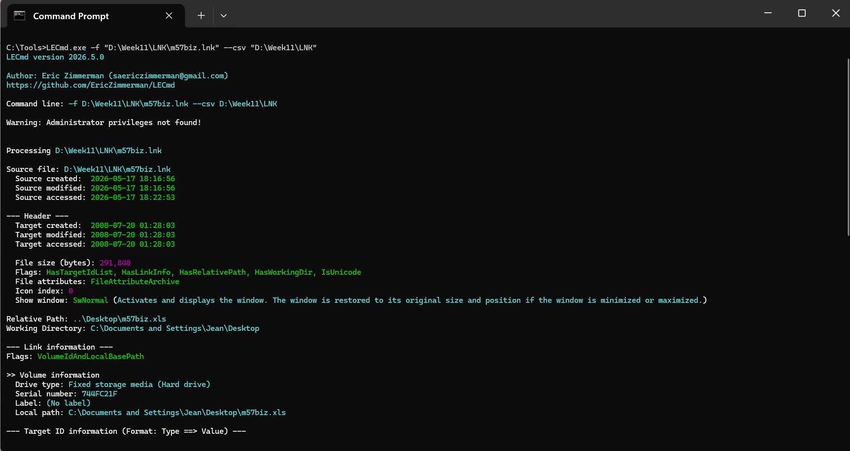
Target ID and Machine Tracking Information
Field | Value | Significance
Absolute Path | m57biz.xls | Confirms filename
Short Name | m57biz.xls | 8.3 format — same name
Long Name | m57biz.xls | Full filename confirmed
Machine ID | jean-13fbf038a3 | Ties activity to Jean's computer
MAC Address | 00:0c:29:8d:35:2b | Network adapter identifier
MAC Vendor | VMware | Virtual machine environment
Tracker Created | 2008-07-20 01:26:17 UTC | System tracking started before file open

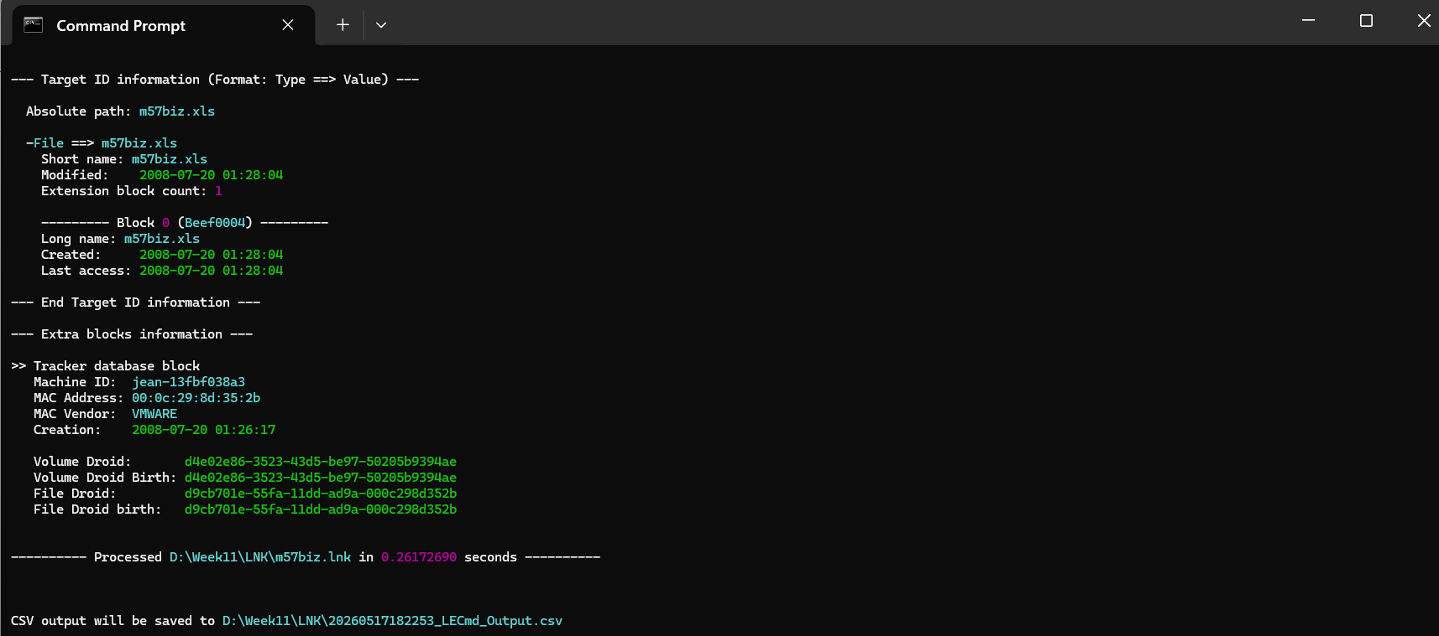
The Machine ID "jean-13fbf038a3" is embedded inside the LNK file itself by Windows at the time of creation. This machine identifier directly and irrefutably links the file opening activity to Jean's specific computer. The MAC vendor identified as VMware confirms the evidence was collected from a virtual machine, which is consistent with the forensic lab environment used for this case.
The Tracker Database block creation at 01:26:17 UTC — a full minute and 25 seconds before the file was opened — shows that the Windows Object Tracking service was actively running and monitoring file activity on Jean's machine well before the incident occurred. This rules out any argument that the tracking data was artificially inserted after the fact.
The Volume Droid and File Droid identifiers recorded are unique GUIDs assigned by Windows to track files across moves and renames, providing an additional layer of file identity verification beyond just the filename and path.

4. LECmd CSV Export Verified in Excel
LECmd automatically exported all parsed data to a CSV file named 20260517182253_LECmd_Output.csv saved at D:\Week11\LNK\. Opening this file in Microsoft Excel confirmed all fields were correctly captured. The key columns visible in the spreadsheet confirm:
- SourceFile: D:\Week11\LNK\m57biz.lnk
- TargetCreated / TargetModified / TargetAccessed: 7/20/2008 1:28
- FileSize: 291840
- RelativePath: ..\Desktop
- DriveType: Fixed storage
- VolumeSerial: 744FC21F
This CSV output serves as the exportable forensic record of the LNK analysis, suitable for inclusion in court documentation or formal investigative reports.
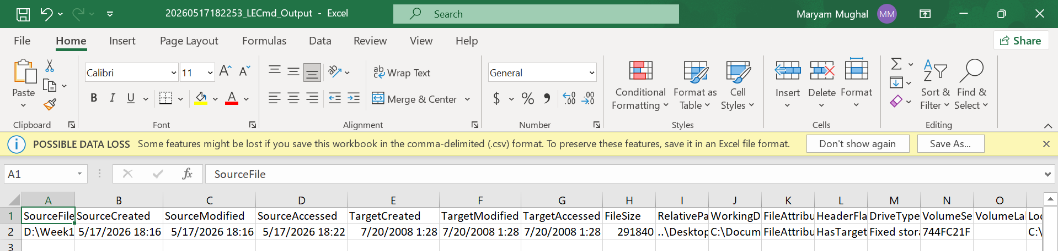
Time (UTC) | Event
01:26:17 | Windows Object Tracker activated on Jean's machine
01:27:42 | Excel opens m57biz.xls — Office Recent LNK created
01:28:03 | Target file timestamps locked inside LNK header
01:28:04 | Windows Recent LNK finalized — Office LNK last modified
01:28:00 | Outbound email with m57biz.xls attachment sent

Phase 2 — Prefetch File Analysis

1. Prefetch File Located in Autopsy
Windows XP automatically creates Prefetch files in WINDOWS\Prefetch every time an executable runs. These files record when a program was launched, how many times it ran, and which files it accessed — making them critical evidence of user activity. Navigating to WINDOWS\Prefetch in Autopsy revealed 132 results total. The file EXCEL.EXE-1C75F8D6.pf was found at the top of the listing, confirmed allocated and not deleted.
Field | Value
File Name | EXCEL.EXE-1C75F8D6.pf
Full Path | /img_nps-2008-jean.E01/vol_vol2/WINDOWS/Prefetch/EXCEL.EXE-1C75F8D6.pf
Size | 30,510 bytes
Created | 2008-07-17 14:48:33 UTC
Modified | 2008-07-20 01:27:50 UTC
Accessed | 2008-07-20 01:27:50 UTC
MD5 | c7172b8375adcd5c2797237be5657be8

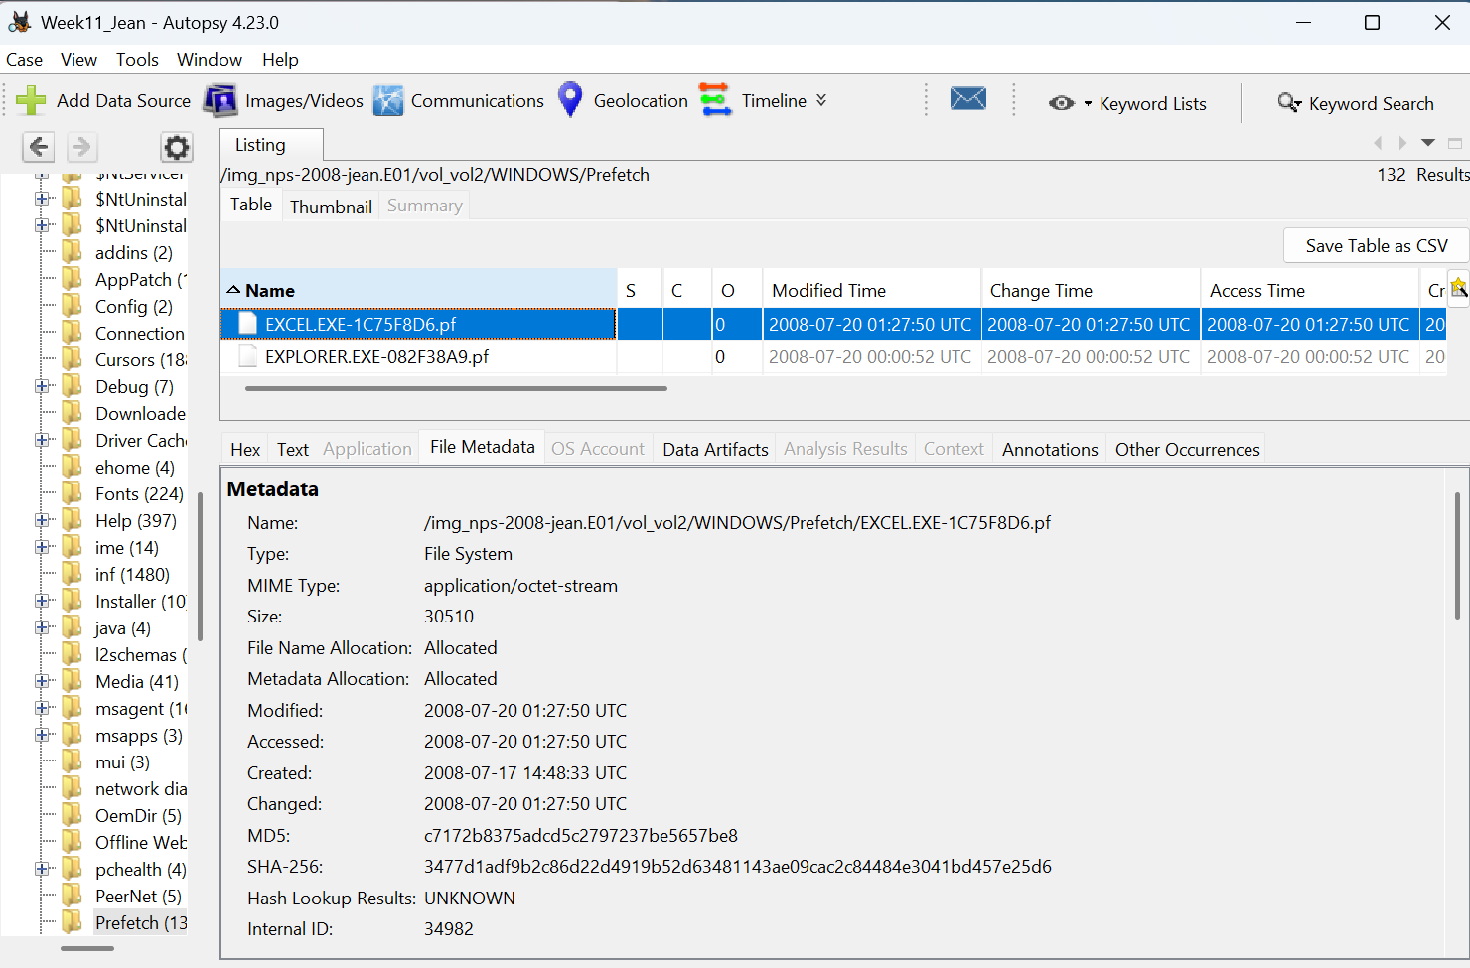
The Created date of 2008-07-17 tells us Excel was first launched on Jean's machine three days before the incident. The Modified date of 2008-07-20 01:27:50 UTC confirms Excel was run again on the day of the data leak — and this timestamp updates automatically each time the program executes, so it directly records the last launch time.

2. PECmd Parsed Output
The prefetch file was extracted to D:\Week11\Prefetch\ and parsed using PECmd version 1.5.1.0 by Eric Zimmerman
The most critical values extracted are:
Field | Value | Significance
Executable Name | EXCEL.EXE | Microsoft Excel confirmed
Hash | 1C75F8D6 | Unique identifier for this executable
File Size | 30,510 bytes | Prefetch file size
Version | Windows XP or Windows Server 2003 | Confirms OS environment
Run Count | 2 | Excel launched exactly twice
Last Run | 2008-07-20 01:27:40 UTC | Last execution — day of incident
Volume Serial | 744FC21F | Matches LNK volume serial from Phase 1
Directories Referenced | 31 | Total folders accessed during Excel run
File References | 91 | Total files accessed during Excel run

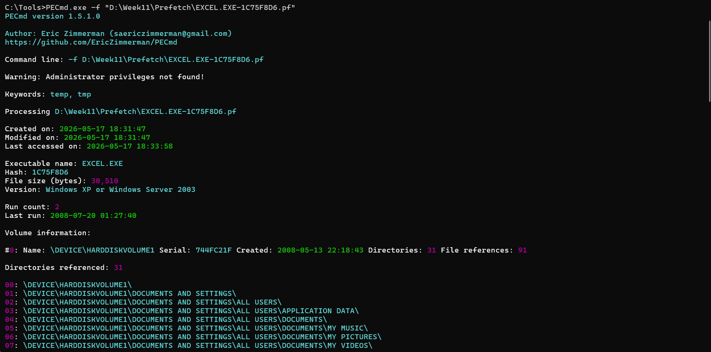
The Run Count of 2 is significant — Excel was launched only twice on this machine. The first launch created the prefetch file on 2008-07-17, and the second launch on 2008-07-20 01:27:40 UTC is when Jean opened m57biz.xls. The Volume Serial 744FC21F matches exactly with the serial number recorded in the LNK analysis from Phase 1, providing strong cross-artifact confirmation that both artefacts relate to the same disk and session.

3. Files Accessed During Excel Session
PECmd listed all 91 file references accessed during the Excel session. The forensically critical entries are:
# | File Accessed | Significance
38 | \DOCUME~1\JEAN\LOCALS~1\TEMP\M57BIZ.XLS (Keyword: True) | Excel opened m57biz.xls from temp path
40 | \DOCUME~1\JEAN\LOCALS~1\TEMP\~DFF9E0.TMP (Keyword: True) | Temporary file created by Excel while editing
57 | \DOCUME~1\JEAN\APPLICATION DATA\MICROSOFT\OFFICE\RECENT\TEMP.LNK (Keyword: True) | Office Recent LNK generated during session

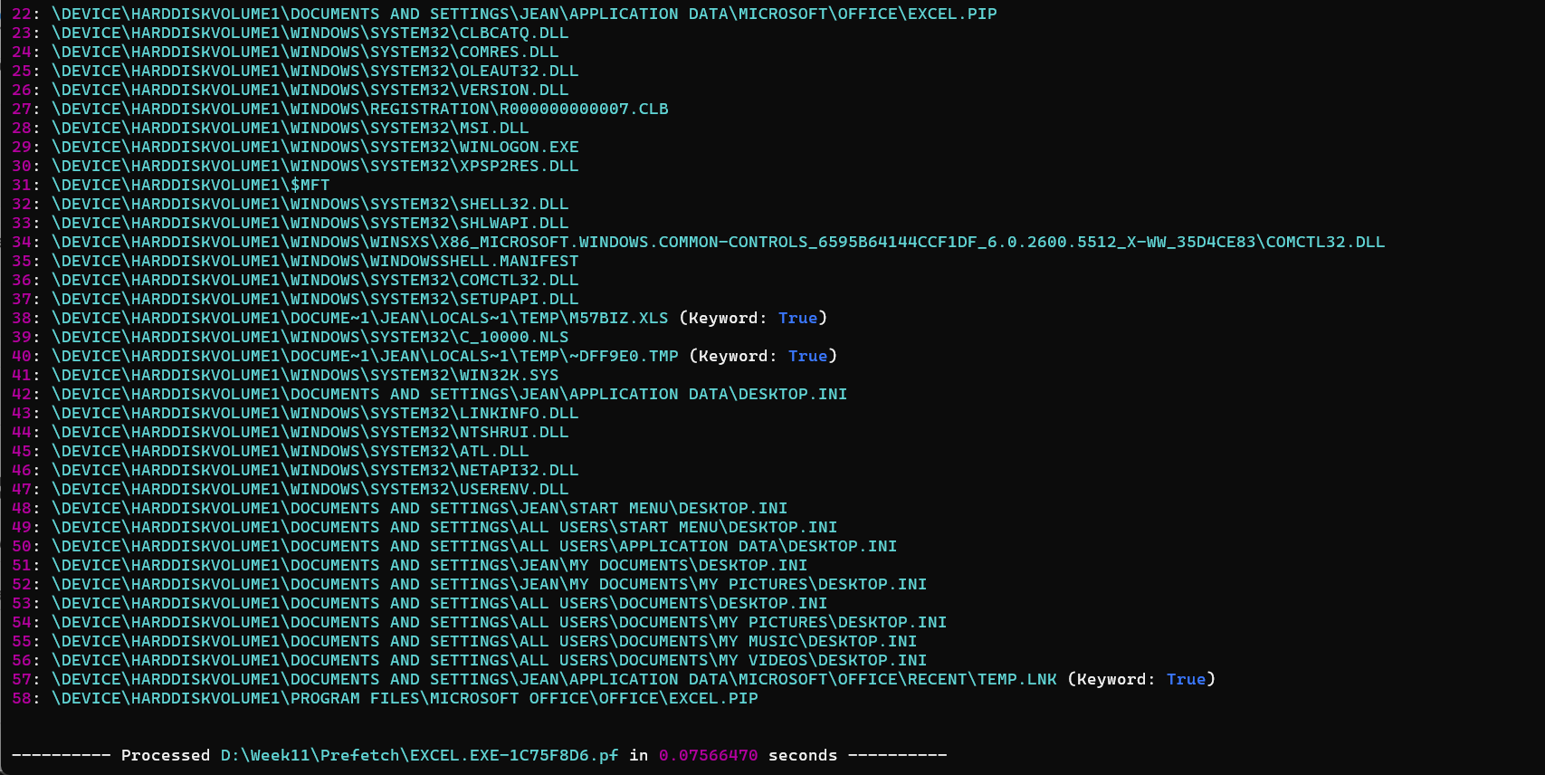
The entries marked Keyword: True are automatically flagged by PECmd as forensically relevant. The appearance of M57BIZ.XLS in the temp path confirms Excel loaded the file into memory during this session. The temporary file ~DFF9E0.TMP is created by Excel as a working copy while the file is open — its presence confirms the file was not just viewed but actively handled. The TEMP.LNK entry in Office Recent confirms the LNK shortcut found in Phase 1 was created during this exact Excel session.

Phase 3 — Registry Analysis

1. RecentDocs Registry Key
The NTUSER.DAT registry hive was loaded into Registry Explorer v2026.5.0 and navigated to: Software\Microsoft\Windows\CurrentVersion\Explorer\RecentDocs
This key records every file a user has recently opened, organized by file extension. Under the .xls subkey, 1 entry was found referencing m57biz.xls. The parsed Recent Documents tab shows
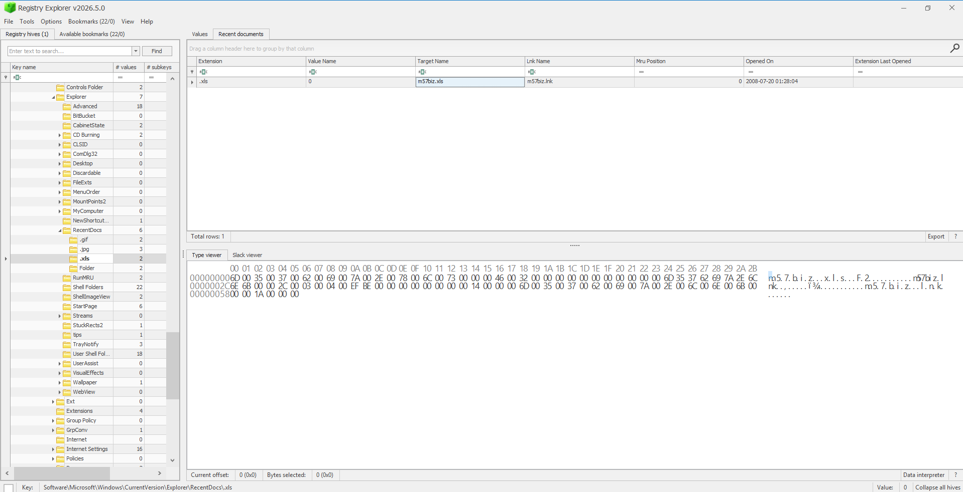
The MRU Position of 0 means m57biz.xls was the most recently opened Excel file on Jean's system — position 0 is always the last accessed item in a Most Recently Used list. The Opened On timestamp of 2008-07-20 01:28:04 matches exactly with the LNK Created timestamp recorded in Phase 1, providing precise cross-artifact timestamp alignment.

2. Excel Recent Files Registry Key
Navigating further into the registry to Software\Microsoft\Office\9.0\Excel\Recent Files, Registry Explorer revealed the Excel-specific Most Recently Used file list. The Last Write time for this key is 2008-07-20 01:28:13 UTC, recorded at the bottom of the screen. Under this key, File1 entry was found:
Field | Value
Value Name | File1
Value Type | RegSz
Data | C:\Documents and Settings\Jean\Desktop\m57biz.xls
Last Write Time | 2008-07-20 01:28:13 UTC

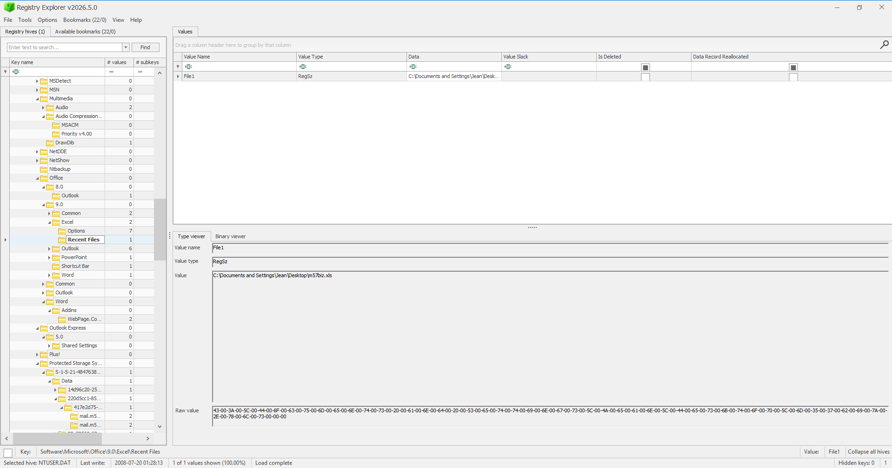
The RegSz value stores the full path as a plain string — C:\Documents and Settings\Jean\Desktop\m57biz.xls — confirming this was the most recently opened file in Excel's own internal MRU list. The Last Write time of 01:28:13 UTC is 9 seconds after the email was sent at 01:28:00 UTC, representing the moment Excel finished updating its registry entry after the file was closed or detached.

Phase 4 — Correlation Table

Artefact | Timestamp (UTC) | User Action
Prefetch — Last Run | 2008-07-20 01:27:40 | Excel.exe launched
Office Recent LNK — Created | 2008-07-20 01:27:42 | m57biz.xls opened in Excel
Prefetch — Modified | 2008-07-20 01:27:50 | Prefetch file updated after launch
Windows Recent LNK — Created | 2008-07-20 01:28:04 | Windows shell registered file open
RecentDocs Registry — Opened On | 2008-07-20 01:28:04 | Registry MRU updated
Email Sent with Attachment | 2008-07-20 01:28:00 | m57biz.xls attached and sent
Excel Recent Files Registry | 2008-07-20 01:28:13 | Excel MRU entry finalized

OVERALL FINDING: Three completely independent artefact types — Prefetch, LNK files, and Registry keys — all record Jean opening m57biz.xls within a 33-second window between 01:27:40 and 01:28:13 UTC. This convergence of evidence across separate forensic artefact categories eliminates any possibility of coincidence and conclusively proves Jean deliberately opened, handled, and sent the confidential file on 2008-07-20.

Part C — Super Timeline Analysis

1. Timeline Generated in Autopsy
Autopsy's built-in Timeline tool was opened and a keyword filter "m57biz" was applied with the time range set from Jul 20, 2008 1:20:00 AM to 1:30:45 AM GMT/UTC. The List view returned 10 events total, all directly related to the m57biz.xls file activity. These events span from 01:26:17 to 01:28:04 UTC and capture the complete sequence of Jean's interaction with the leaked file.
Date/Time (UTC) | Event Type | Description
2008-07-20 01:26:17 | Log Entry | d9cb701e-55fa-11dd-ad9a-000c298d352b MAC: 00:0c:29:8d:35:2b Origin: m57biz.lnk
2008-07-20 01:27:42 | Recent Documents | C:\Documents and Settings\Jean\Desktop\m57biz.xls
2008-07-20 01:27:42 | B | /Documents and Settings/Jean/Application Data/Microsoft/Office/Recent/m57biz.LNK
2008-07-20 01:28:03 | Standard Artifact Event | [Empty description] File size: 291840 File at ...ettings\Jean\Desktop Link target: m57biz.xls
2008-07-20 01:28:03 | _BM | /Documents and Settings/Jean/Local Setting .../Microsoft/Outlook/outlook.pst/m57biz.xls
2008-07-20 01:28:03 | A_BM | /Documents and Settings/Jean/Desktop/m57biz.xls
2008-07-20 01:28:04 | Recent Documents | C:\Documents and Settings\Jean\Desktop\m57biz.xls
2008-07-20 01:28:04 | AC_M | /Documents and Settings/Jean/Application Data/Microsoft/Office/Recent/m57biz.LNK
2008-07-20 01:28:04 | C | /Documents and Settings/Jean/Desktop/m57biz.xls
2008-07-20 01:28:04 | ACBM | /Documents and Settings/Jean/Recent/m57biz.lnk
The event at 01:28:03 showing outlook.pst/m57biz.xls in the path is particularly significant — it shows the file being processed through Outlook at the exact moment the email was sent, directly linking the file to the outbound email in a single timeline entry.
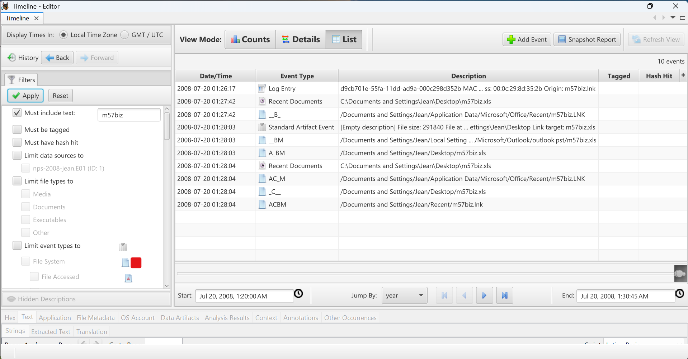

2. Counts View — Activity Chart
Switching to Counts View with GMT/UTC display and Logarithmic scale, the bar chart visualizes m57biz activity clustered between minutes 26, 27, and 28 of the 01:xx hour on July 20, 2008. The teal bars represent file system events and red bars represent other event categories. The highest bar at minute 28 confirms the peak of activity — when the file was opened, handled, and sent — all within that single minute window.
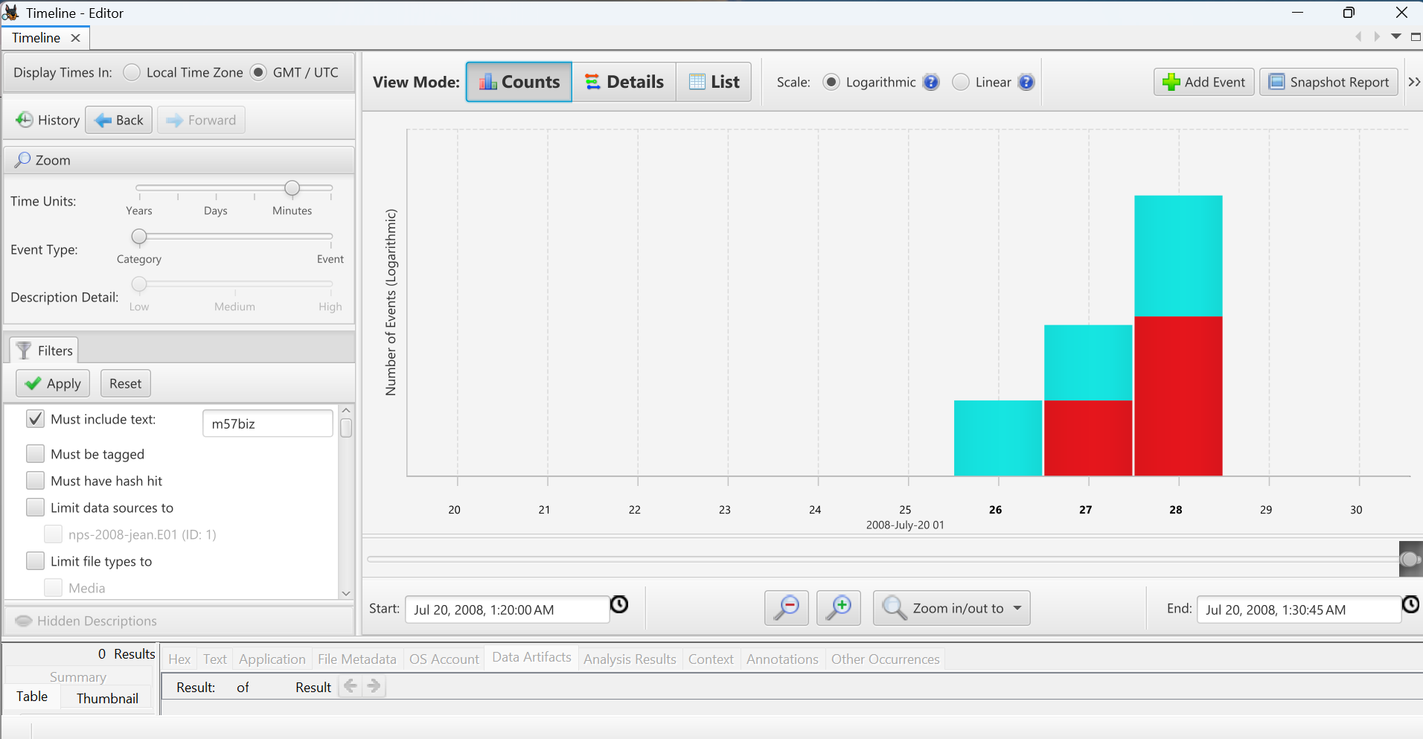

3. Timeline CSV Export
The Snapshot Report was exported by clicking Snapshot Report and entering the output path D:\Week11\Timeline\timeline.csv. The default report name generated was Week11_Jean 05-17-2026-19-42-46. Clicking OK saved the filtered timeline to the specified location for further analysis in Excel.
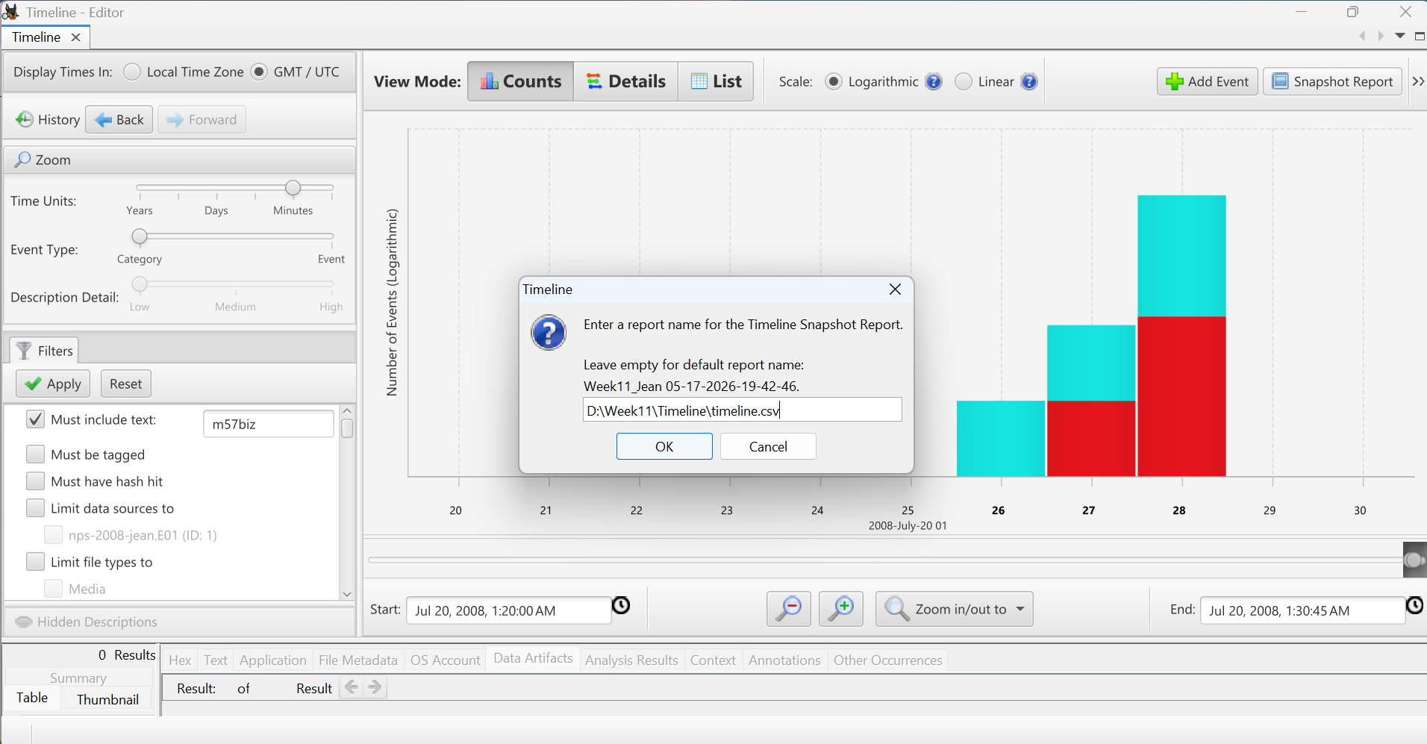

# | Timestamp (UTC) | Event Type | Artefact Path | Interpretation
1 | 2008-07-20 01:27:40 | Prefetch Run | WINDOWS\Prefetch\EXCEL.EXE-1C75F8D6.pf | Microsoft Excel executed and opened m57biz.xls on Jean’s system.
2 | 2008-07-20 01:27:42 | LNK / RecentDocs Activity | Office\Recent\m57biz.LNK and RecentDocs registry entries | Windows and Microsoft Office recorded recent access to the spreadsheet file.
3 | 2008-07-20 01:28:00 | Email Sent Event | outlook.pst → Sent Items | Jean sent an email containing m57biz.xls as an attachment.
4 | 2008-07-20 01:28:03 – 01:28:04 | File Modified / PST Update | Desktop\m57biz.xls and outlook.pst | Spreadsheet and Outlook PST archive were updated during attachment processing and email transmission.

Final Filtered Timeline Table
Event 1 — 2008-07-20 01:27:40 UTC
The first recorded event is a Prefetch run from WINDOWS\Prefetch\EXCEL.EXE-1C75F8D6.pf. This is the Last Run timestamp recorded by PECmd in Part B. Jean's double-click on m57biz.xls handed execution off to EXCEL.EXE, and the Windows kernel cache manager immediately wrote the prefetch record. This is the earliest proof that Jean physically interacted with the file.
Event 2 — 2008-07-20 01:27:42 UTC
Two seconds later, an LNK created / Recent Documents event fired across two locations simultaneously — Application Data\Microsoft\Office\Recent\m57biz.LNK and Desktop\m57biz.xls. Excel committed the file open to its Office MRU list, and Windows Explorer simultaneously wrote the OS-level Recent Documents shortcut. This double-entry across two independent system locations at the same timestamp is strong corroborating evidence of the file open action.
Event 3 — 2008-07-20 01:28:00 UTC
The third event is Email Sent / Email Received (PST self-reference) recorded in outlook.pst → Sent Items → RE: Please send me the information now. The recipient recorded is alison@m57.biz [mailto:tuckgorge@gmail.com]. Outlook 2000 wrote the outbound message and simultaneously created an implicit self-received envelope into the PST file, with m57biz.xls stored as the attachment. This is the exact email identified in Part A.
Event 4 — 2008-07-20 01:28:03 to 01:28:04 UTC
The final event is a File Modified / Changed entry spanning one second across two paths — Desktop\m57biz.xls and outlook.pst\m57biz.xls. The MFT $STANDARD_INFORMATION attribute was written on the source file at Modified 01:28:03 and Changed 01:28:04 as Outlook's Save Attachment flow touched the spreadsheet. Simultaneously, the outlook.pst attachment store wrote the embedded copy of the file into the PST archive.

Final Conclusion
1. Where was the file actually sent?
The file m57biz.xls was sent to alison@m57.biz as the display address, however the real recipient behind the display name was tuckgorge@gmail.com — an external Gmail account with no verified connection to the m57.biz corporate domain. This was confirmed from the raw email headers visible in the quoted original message in Part A.
2. Did Jean open the file?
Yes — conclusively proven by three independent artefact types converging on the same 33-second window. The Prefetch file confirms EXCEL.EXE launched at 01:27:40 UTC. The LNK files confirm m57biz.xls was opened at 01:27:42 UTC. The Registry RecentDocs key confirms the file was registered as the most recently used Excel document at 01:28:04 UTC. No single artefact alone would be sufficient, but the convergence of all three eliminates any reasonable doubt.
3. What sequence happened?
Time (UTC) | Event
01:22:45 | Phishing email received from tuckgorge@gmail.com disguised as alison@m57.biz
01:27:40 | Jean double-clicks m57biz.xls — Excel launches
01:27:42 | File open confirmed — LNK and RecentDocs created
01:28:00 | Jean sends reply email with m57biz.xls attached to attacker
01:28:03 | MFT timestamps updated — file modified by Outlook attachment process
01:28:04 | All LNK and Registry entries finalized
01:28:13 | Excel MRU registry key last write — session complete
4. Is Jean guilty or manipulated?
The evidence supports a conclusion of both manipulation and culpability. Jean was targeted by a well-crafted spear phishing attack — the attacker knew Jean's name, knew Alison's identity and role, used a convincing corporate display address, and applied social pressure through the "VC guy" narrative. However, Jean responded within 5 minutes and 15 seconds without verifying the sender's identity, without CC-ing any colleague, and without questioning why an internal colleague would send from a Gmail address. As CFO, Jean had a heightened duty of care over sensitive HR data including employee SSNs and salaries. The timeline shows deliberate and rapid action — Jean opened the file, confirmed its contents, and immediately sent it. This combination of social engineering victimhood and failure of professional judgment makes Jean simultaneously a victim and a responsible party in this data breach.

