CyberSter

CYBERSTER BLUE TEAM INTERNSHIP
WEEK 9 REPORT
Browser Forensics, LNK File Analysis, and Artifact Integration

Submitted By: Maryam Mughal
ID: CSI-B1-293

Phase Two — Digital Forensics and Incident Response

Week: Week 9 (Days 60 – 66)
Submission Date: 3-May-2026

Submitted To: Abdullah Zia

Table of Content:

PART A — ADVANCED BROWSER FORENSICS
- Introduction
- Objectives of Analysis
- Tools and Methodology
3.1 Tools Used
3.2 Methodology
- Forensic Environment Setup and Acquisition Process
4.1 Folder Structure Creation
4.2 Tool Download and Preparation
4.3 Termination of Browser Processes
4.4 Acquisition of Browser Profiles
4.5 Importance of Acquisition Process
4.6 Observed Workflow Pattern
4.7 Forensic Interpretation
- Data Integrity Verification (Hashing)
- Database Analysis Using DB Browser for SQLite
6.1 Files Analyzed
6.2 Tables Examined
6.3 Observations
6.4 Explanation
6.5 Forensic Interpretation
- Browser History Extraction and Analysis
7.1 Extraction Process
7.2 Output Files
- Download Activity Analysis
8.1 Identified Files
8.2 Storage Location
8.3 Observations
8.4 Explanation
8.5 Forensic Interpretation
- Cookie Analysis
9.1 Files Analyzed
9.2 Observations
9.3 Explanation
9.4 Forensic Interpretation
- Cache Analysis
10.1 Process
10.2 Observations
10.3 Explanation
10.4 Forensic Interpretation
- Browser Extensions Analysis
11.1 Observations
11.2 Explanation
11.3 Forensic Interpretation
- Key Findings
- Conclusion

PART B — LNK FILE ANALYSIS
- Introduction
- Collection of LNK Files
2.1 Locations Collected
2.2 Collection Method
2.3 Explanation
2.4 Interpretation
- Parsing LNK Files Using LECmd
3.1 Explanation
3.2 Output Generated
3.3 Importance
- Analysis of LNK Output Data
- File Access Timeline Creation
- File Existence Verification
6.1 Flags Explanation
- USB Device Analysis
7.1 Filter Applied
7.2 Result
7.3 Explanation
- Network Share Analysis
8.1 Fields Checked
8.2 Result
8.3 Explanation
- Key Findings
- Conclusion

PART C — UNIFIED TIMELINE ANALYSIS
- Introduction
- Collection of Input Data
2.1 Included Data
- Creation of Unified Timeline
3.1 Columns Defined
- Timestamp Normalization
4.1 Conversion Rule
- Event Selection and Analysis
5.1 Observed Activities
5.2 Explanation
- Correlation of Events
- Interpretation
PART A — ADVANCED BROWSER FORENSICS

1. Introduction
This report presents an in-depth forensic examination of browser artifacts obtained from a Windows-based system. The analysis was conducted as part of a structured digital forensic exercise with the objective of reconstructing user activity and identifying any potential indicators of suspicious or investigative behavior.
Web browsers act as rich sources of digital evidence, storing user interactions in structured databases such as SQLite files. These artifacts include browsing history, download records, cookies, cache data, and extension configurations. Collectively, they allow investigators to build a timeline of user actions and understand behavioral patterns.
In this investigation, Google Chrome and Microsoft Edge browsers were analyzed due to their presence and usage on the system. Mozilla Firefox was not used; therefore, no artifacts were recovered for that browser.
The analysis was performed in a controlled environment after acquiring the browser profiles to ensure the integrity and reliability of evidence.

2. Objectives of Analysis
The forensic analysis aimed to achieve the following:
- Identify browser profile directories and securely acquire relevant artifacts
- Extract and interpret browsing history to reconstruct user behavior
- Analyze download activity to identify files obtained from external sources
- Examine cookies for session persistence and domain relationships
- Attempt cache recovery for additional web artifacts
- Review installed browser extensions for potential risks
- Correlate findings to identify meaningful activity patterns
- Determine whether any activity indicates malicious or investigative intent

3. Tools and Methodology

3.1 Tools Used
The investigation utilized industry-recognized forensic tools:
- DB Browser for SQLite
Used to directly analyze structured browser databases such as History and Cookies. This allowed granular inspection of stored records.
- BrowsingHistoryView (NirSoft)
Enabled automated extraction and aggregation of browsing data across browsers, including timestamps and URLs.
- ChromeCacheView (NirSoft)
Attempted extraction of cached web files and metadata.
- Command Prompt (Robocopy)
Used to copy browser profiles while preserving file structure and minimizing risk of alteration.
- PowerShell (Get-FileHash)
Used to compute SHA256 hash values to ensure evidence integrity.

3.2 Methodology
The forensic workflow followed standard digital investigation procedures:
- Preparation Phase
  - A dedicated working directory (C:\Forensics_Week9) was created
  - Subdirectories were organized for structured analysis
- Acquisition Phase
  - Browser processes were terminated
  - Profile directories were copied using robocopy
- Verification Phase
  - Hash values were calculated for key evidence files
- Analysis Phase
  - SQLite databases were examined manually
  - Artifacts were extracted using specialized tools
- Interpretation Phase
  - Data was reviewed to identify meaningful patterns and correlations

4. Forensic Environment Setup and Acquisition Process
Before starting the analysis, a structured forensic environment was prepared to ensure organized and controlled investigation.

4.1 Folder Structure Creation
A dedicated working directory was manually created to store all forensic data and outputs:
C:\Forensics_Week9\
Within this directory, subfolders were created for each phase of the investigation:
- Day60-62_Browser
- Day63-65_LNK
- Day66_Timeline
- Tools
This organized structure ensured proper separation of artifacts and improved workflow efficiency.
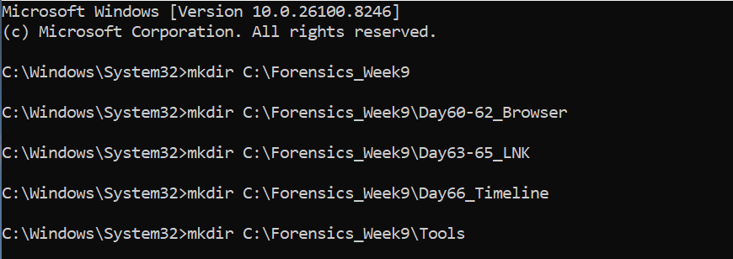

4.2 Tool Download and Preparation
All required forensic tools were downloaded in a single session prior to analysis. These included:
- DB Browser for SQLite
- BrowsingHistoryView
- ChromeCacheView
- LECmd
The tools were extracted and stored in the Tools directory for easy access.
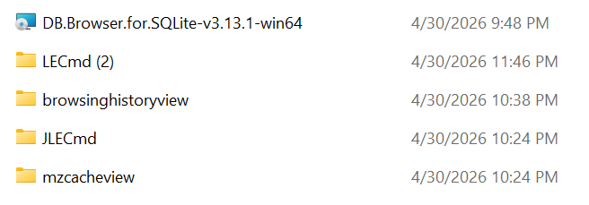

4.3 Termination of Browser Processes
Before acquiring browser data, all active browser processes were terminated to prevent file locking and ensure consistency of database files.
This step ensured that browser files such as History and Cookies were not in use during copying.
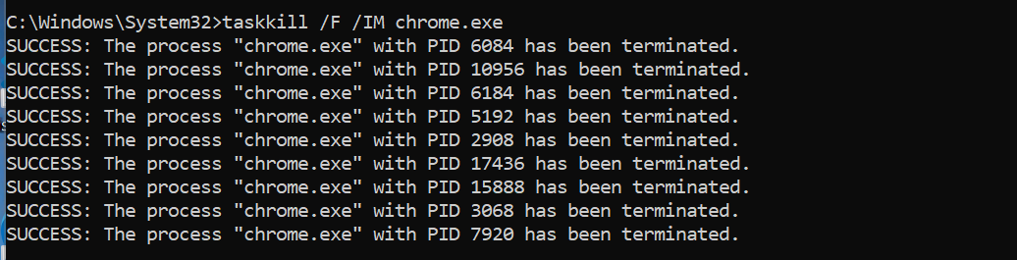
Mozilla Firefox profile directory was not found on the system, indicating that Firefox was either not installed or not used.

4.4 Acquisition of Browser Profiles
Browser profile directories were copied using the robocopy command to preserve file structure and metadata.
Chromo File Copy
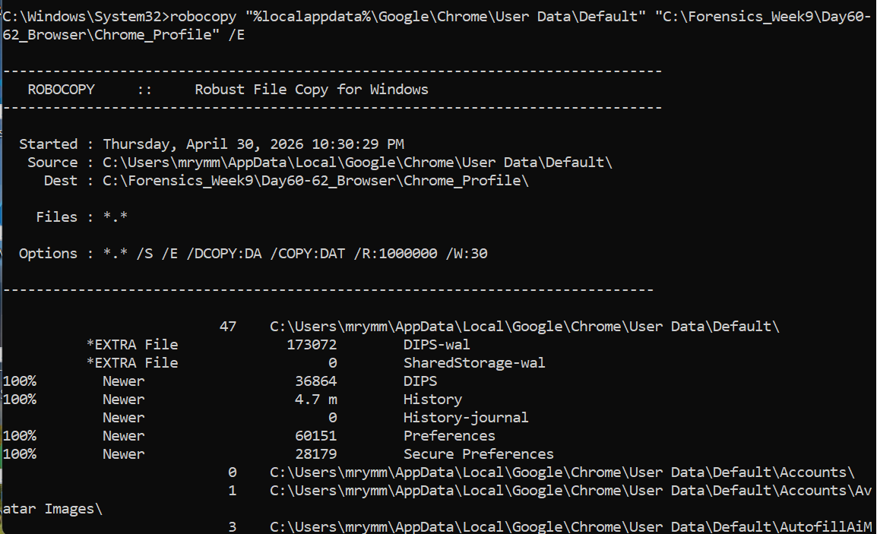
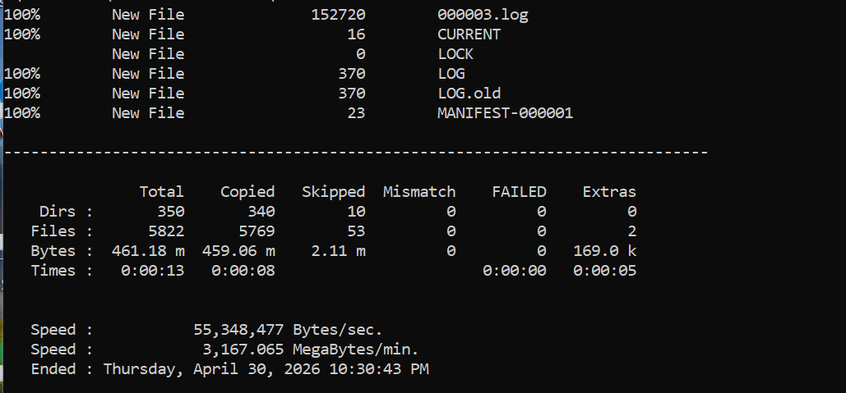
Edge Profile Copy:
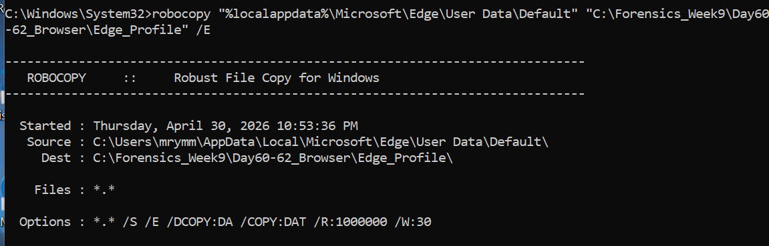
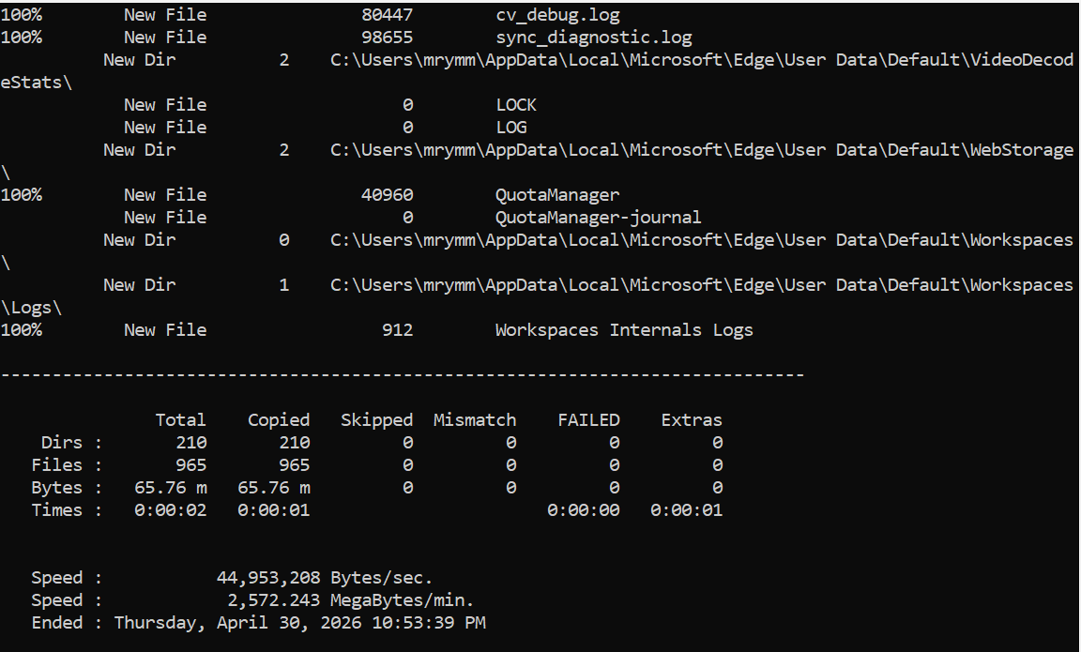

4.5 Importance of This Process
This acquisition process ensured:
- Data integrity by avoiding direct analysis on live system files
- Preservation of original evidence
- Organized storage of forensic artifacts
- Reproducibility of investigation steps

4.6 Observed Workflow Pattern
The sequence of actions suggests a structured forensic workflow:
- Creation of working directories
- Download and setup of forensic tools
- Termination of browser processes
- Acquisition of browser profiles using robocopy

4.7 Forensic Interpretation
This pattern indicates:
- Intentional preparation for forensic analysis
- Controlled handling of evidence
- Use of proper forensic methodology rather than random actions

5. Data Integrity Verification
After acquiring the browser profile data, it was necessary to ensure that the evidence remained unaltered during the investigation process. For this purpose, cryptographic hash values were generated for key database files using PowerShell.
The SHA256 hashing algorithm was used because it provides a strong and unique digital fingerprint for each file.
The following files were hashed:
- Chrome History database
- Edge History database
SHA256 hash values were calculated for browser history files
to ensure data integrity during analysis.
This step is critical in forensic investigations because:
- It ensures that the data has not been modified during acquisition or analysis
- It allows verification of evidence integrity at any stage of the investigation
- It provides reliability and credibility to the findings
If the hash value of a file remains consistent, it confirms that the file has not been tampered with. Therefore, this step establishes trust in the forensic process.

6. Database Analysis Using DB Browser for SQLite
After ensuring data integrity, the copied browser databases were opened and analyzed using DB Browser for SQLite. This tool allows direct inspection of structured data stored within browser artifacts.

6.1 Files Analyzed
The following database files were examined:
- Chrome Profile → History
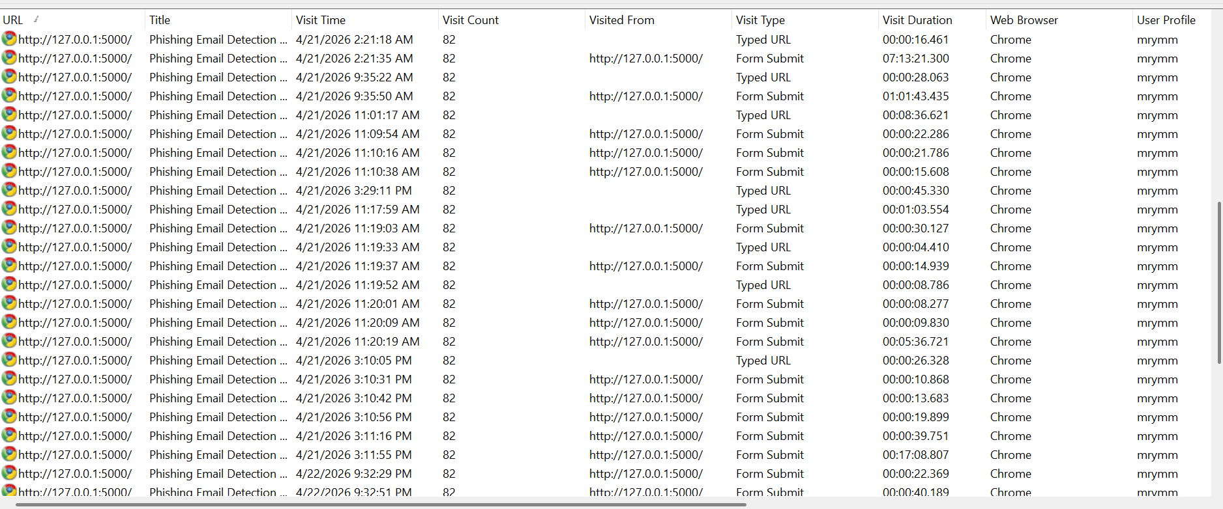
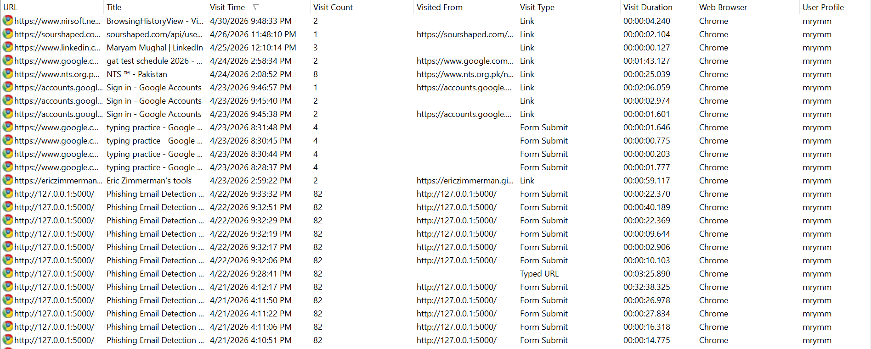
- Edge Profile → History
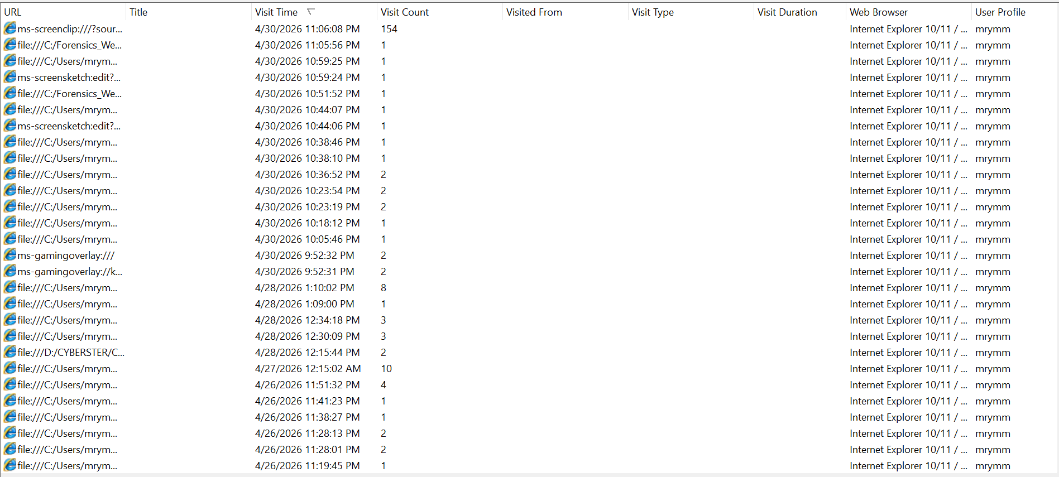
These files contain critical information about browsing activity and user behavior.

6.2 Tables Examined
Within the History database, the following tables were analyzed:
- urls → stores visited websites
- visits → stores timestamps and visit counts
- downloads → stores file download information
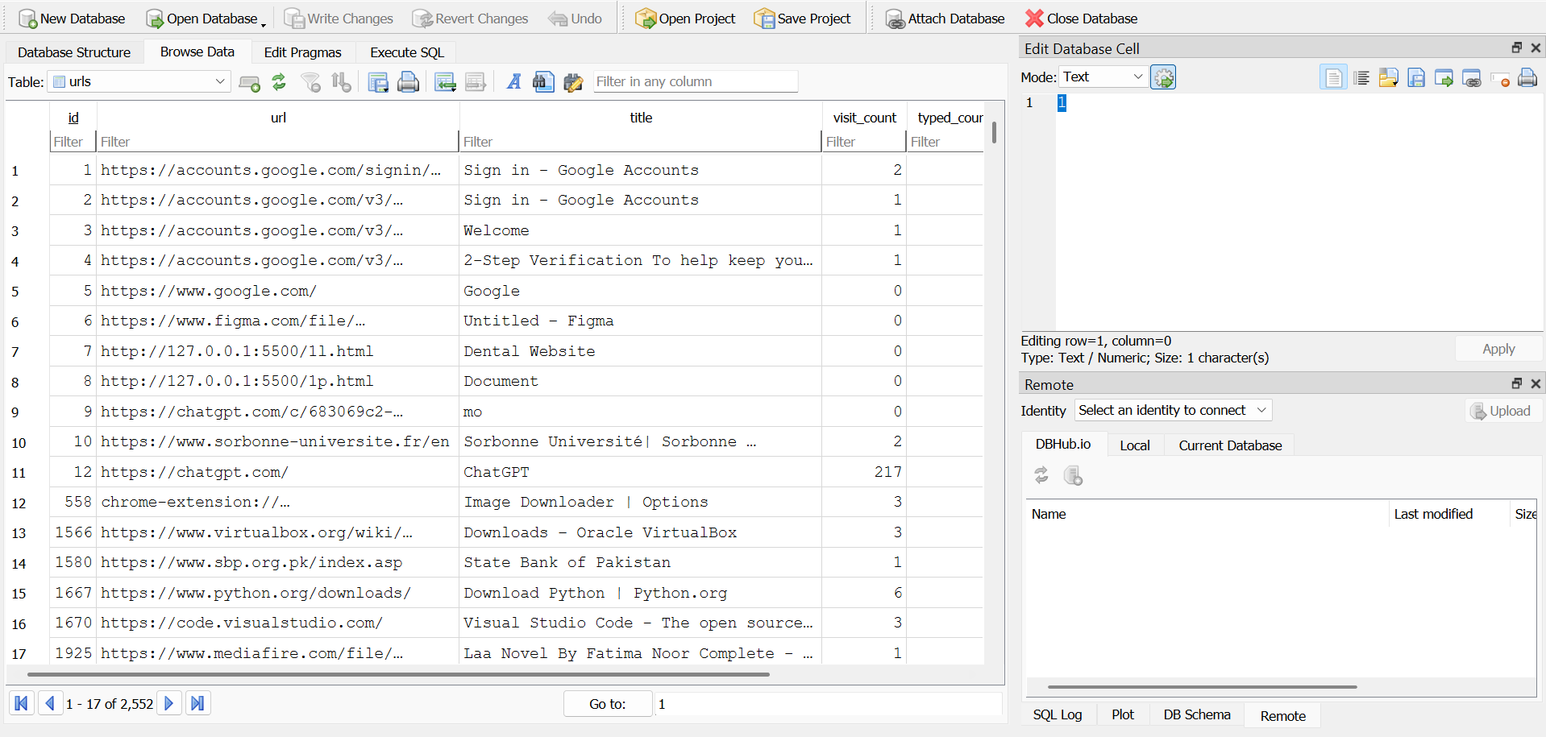
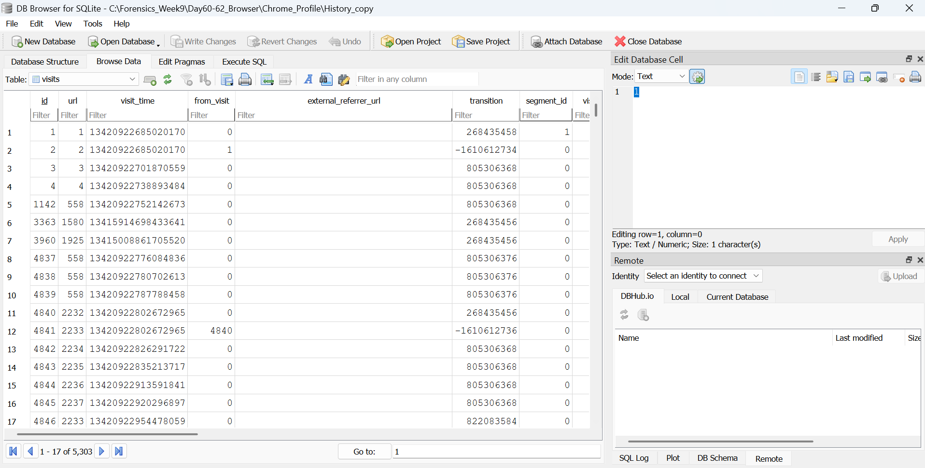

6.3 Observations
The analysis revealed:
- A large number of browsing records (approximately 1000+ entries)
- Frequent visits to common domains such as:
  - google.com
  - accounts.google.com
  - youtube.com
This indicates interaction with a locally hosted web application.

6.4 Explanation
The presence of 127.0.0.1 (localhost) is particularly important because:
- It represents the local system itself
- It indicates that a web server or application was running locally
- It suggests development, testing, or tool usage
Repeated visits to this address confirm that the application was actively used rather than accessed accidentally.

6.5 Forensic Interpretation
From a forensic perspective, these findings indicate:
- The system was used for both normal browsing and technical activities
- The user interacted with a locally hosted application, possibly related to phishing detection or testing
- No evidence of external malicious communication was found
Screenshots of database tables were taken as evidence to support these findings.

7. Browser History Extraction and Analysis
Browser history was extracted using BrowsingHistoryView, which provides a consolidated view of browsing data across multiple browsers.

7.1 Extraction Process
The tool was configured to load history from the copied browser profile directories. The extracted data was then exported into CSV format for further analysis.

7.2 Output Files
The following files were generated:
- chrome_history.csv
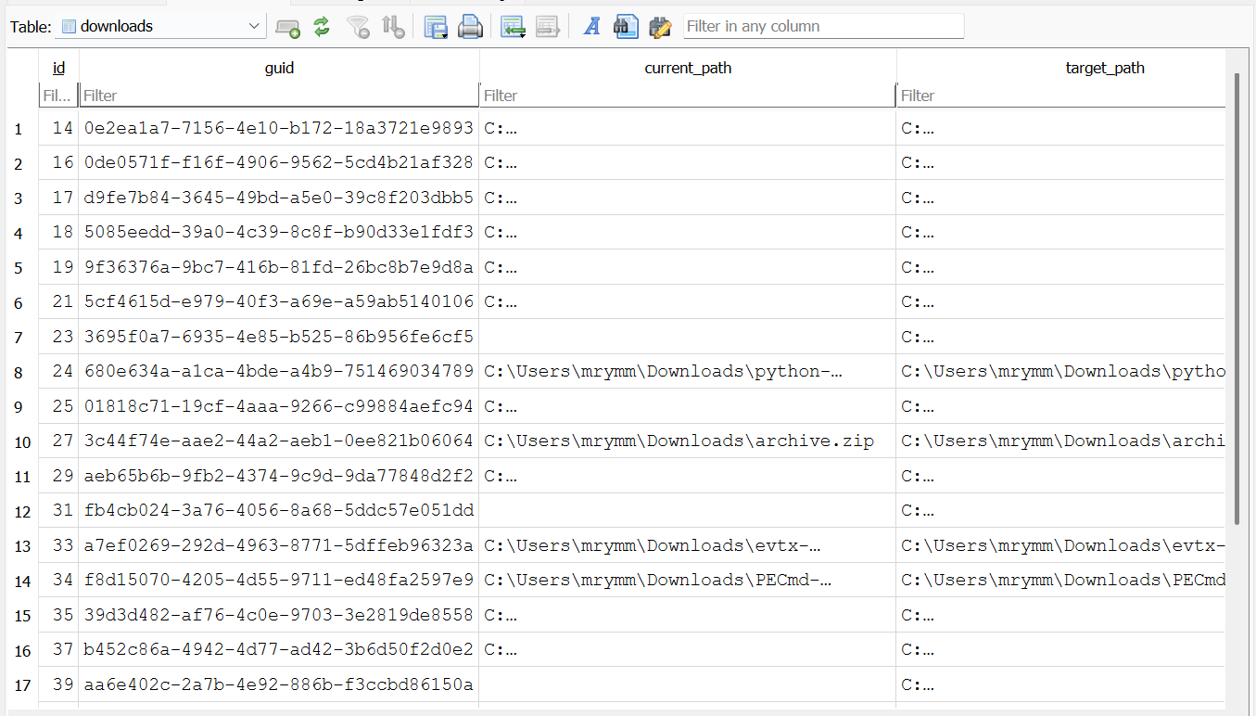
- edge_history.csv

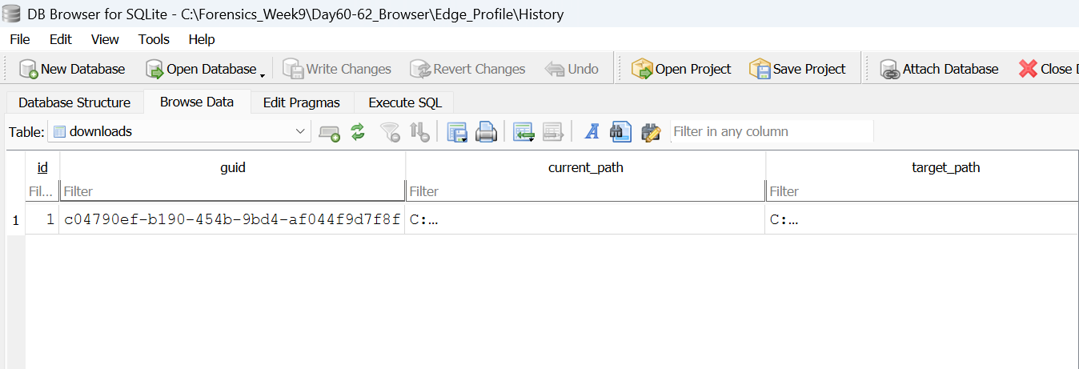

8. Download Activity Analysis
Download activity was analyzed using both DB Browser and BrowsingHistoryView.
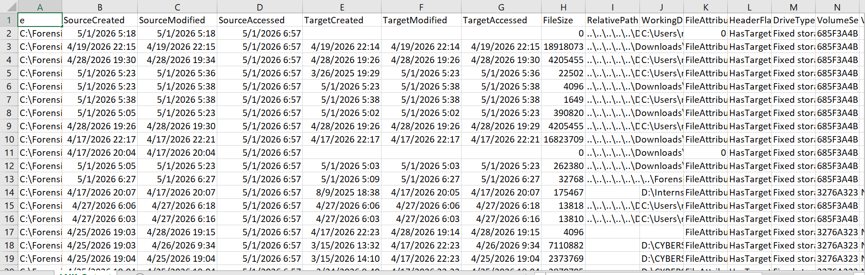

8.1 Identified Files
The following files were observed:
- cert.zip
- cert (1).zip
- browsinghistoryview.zip
- chromecacheview.zip
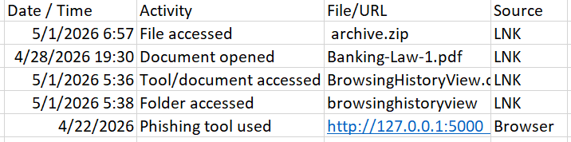

8.2 Storage Location
All downloaded files were stored in:
C:\Users\mrymm\Downloads\

8.3 Observations
- Downloads occurred within a short time period
- Files were accessed shortly after being downloaded
- Most files were compressed archives (.zip)

8.4 Explanation
Download analysis helps identify:
- Files acquired from the internet
- Tools or software installed
- Potential malicious downloads

8.5 Forensic Interpretation
The observed pattern indicates:
- Tools were downloaded intentionally in a single session
- These tools were then used immediately (confirmed later via LNK analysis)
- The activity reflects a structured setup rather than random downloads
No suspicious or malicious files were identified.

9. Cookie Analysis
Cookies were analyzed using DB Browser for SQLite.

9.1 Files Analyzed
- Chrome Cookies database
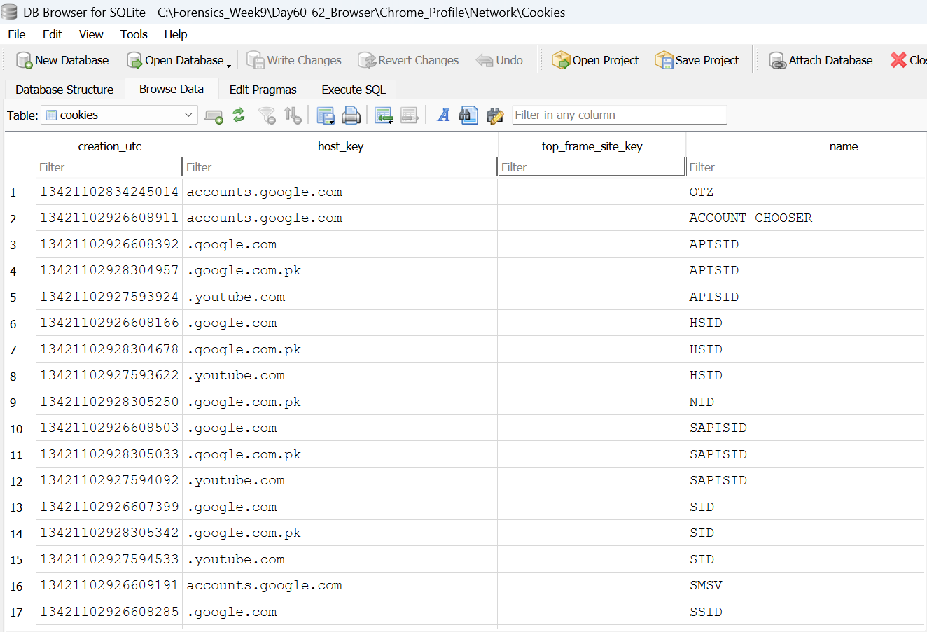
- Edge Cookies database
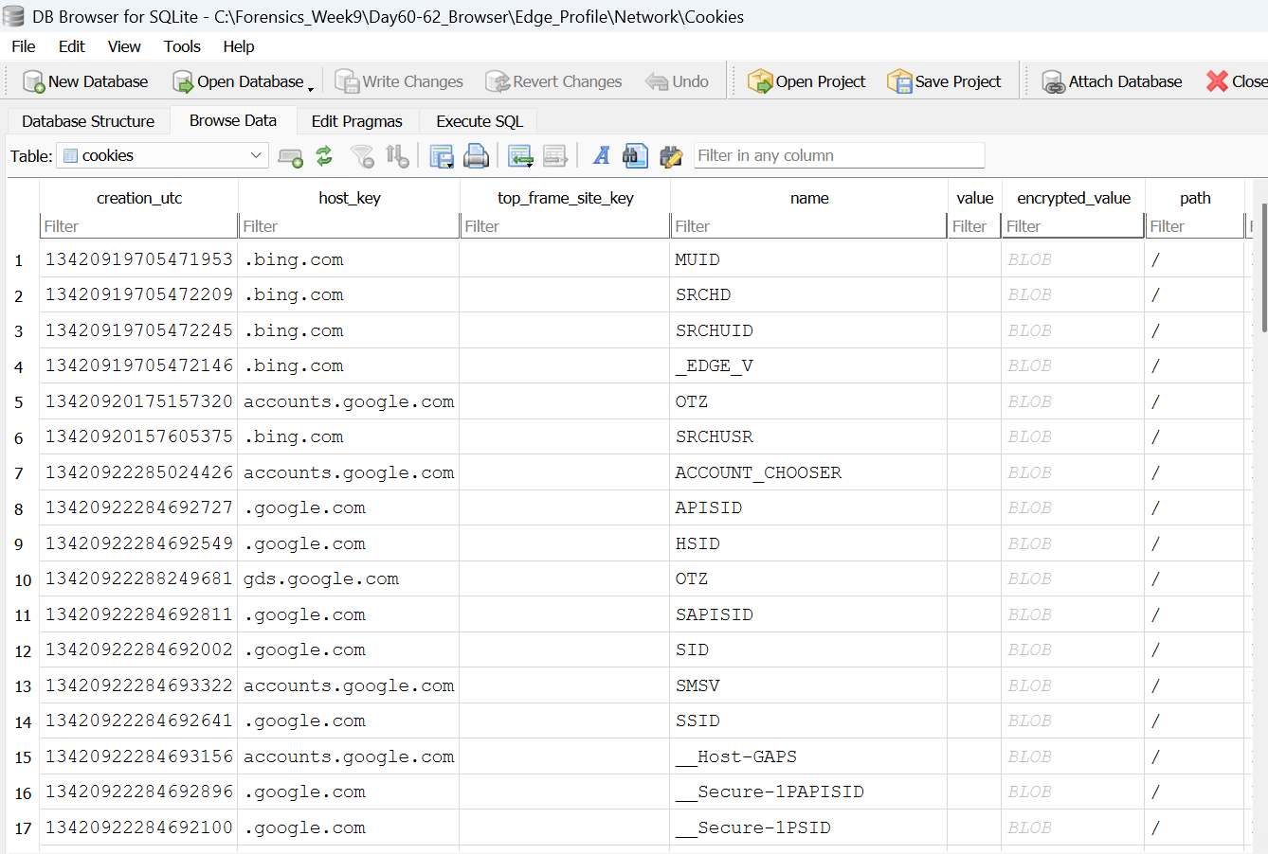

9.2 Observations
- Cookies from domains such as:
  - google.com
  - accounts.google.com
  - youtube.com
- Presence of:
  - Session cookies
  - Persistent cookies with long expiration dates

9.3 Explanation
Cookies store:
- Login session information
- User preferences
- Website tracking data

9.4 Forensic Interpretation
- Cookies confirm active login sessions and normal browsing behavior
- No suspicious or unknown domains were identified
- Sensitive cookie values were not exposed in the report for privacy reasons

10. Cache Analysis
Cache analysis was attempted using ChromeCacheView.

10.1 Process
The tool was pointed to the cache directories of Chrome and Edge profiles.

10.2 Observations
- No significant cache entries were extracted
- The output was either empty or minimal

10.3 Explanation
Possible reasons include:
- Browser cache cleared automatically
- Modern browsers encrypt cache data
- Tool compatibility limitations

10.4 Forensic Interpretation
The absence of cache data does not negatively impact the investigation because:
- Sufficient evidence was obtained from history and LNK artifacts
- Other sources provided a complete picture of user activity

11. Browser Extensions Analysis
Browser extensions were manually analyzed by inspecting their manifest.json files.

11.1 Observations
- Extension identified: Image Downloader
- Permissions included:
  - activeTab
  - scripting
  - downloads
  - storage

11.2 Explanation
Extensions can:
- Access browsing data
- Modify web pages
- Introduce security risks if malicious

11.3 Forensic Interpretation
- The identified extension has moderate permissions
- No high-risk or suspicious permissions were observed
- Extension behavior appears normal and legitimate
FOR CHROME
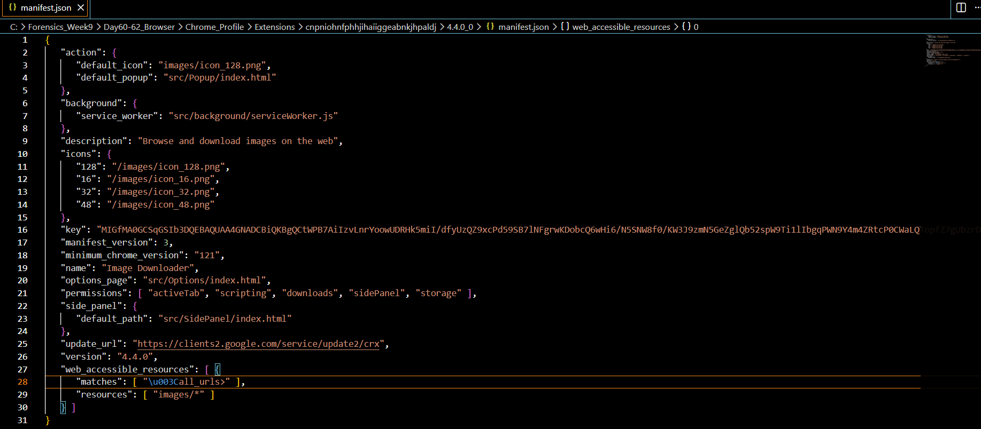
FOR EDGE
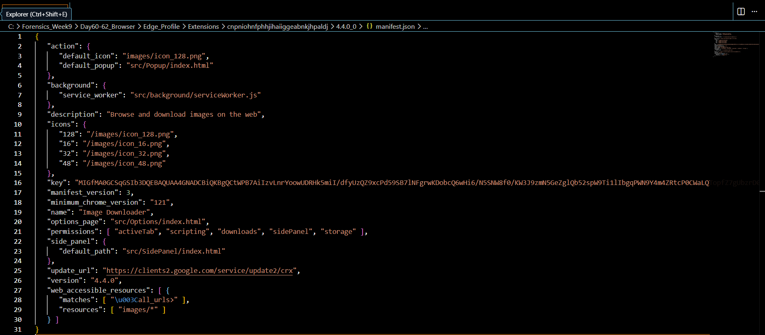

12. Key Findings
- Normal browsing activity observed
- Repeated access to localhost application
- Download and usage of forensic tools
- No malicious domains or suspicious downloads
- No abnormal cookie or extension behavior

13. Conclusion
The browser forensic analysis reveals a structured and intentional sequence of user activity. The system was used to download forensic tools, access a locally hosted application, and perform investigative tasks.
No indicators of malicious behavior were found. All observed actions are consistent with an academic or training-based forensic exercise.

PART B — LNK FILE ANALYSIS

1. Introduction
This section presents the forensic analysis of Windows shortcut (LNK) files collected from the system. LNK files are important artifacts in digital forensics as they provide evidence of file access, execution, and user interaction with files and applications.
Each LNK file contains metadata such as:
- Target file path
- File timestamps (created, modified, accessed)
- File size
- Volume information
- Network and device information
These artifacts help investigators reconstruct user activity even if the original file is deleted.

2. Collection of LNK Files
LNK files were collected from multiple system locations known to store user activity shortcuts.

2.1 Locations Collected
- Recent Items
- Desktop
- Office Recent

2.2 Collection Method
The robocopy command was used to collect .lnk files:
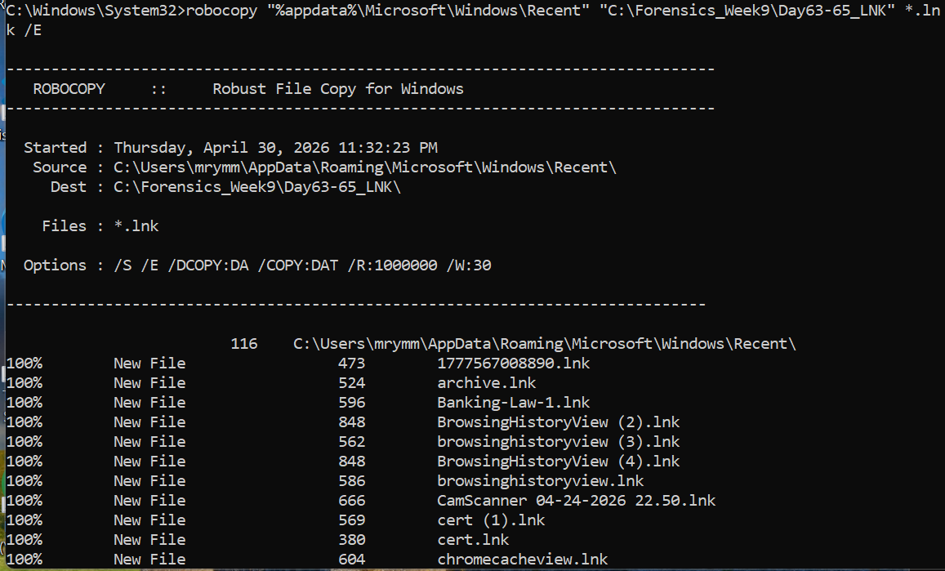
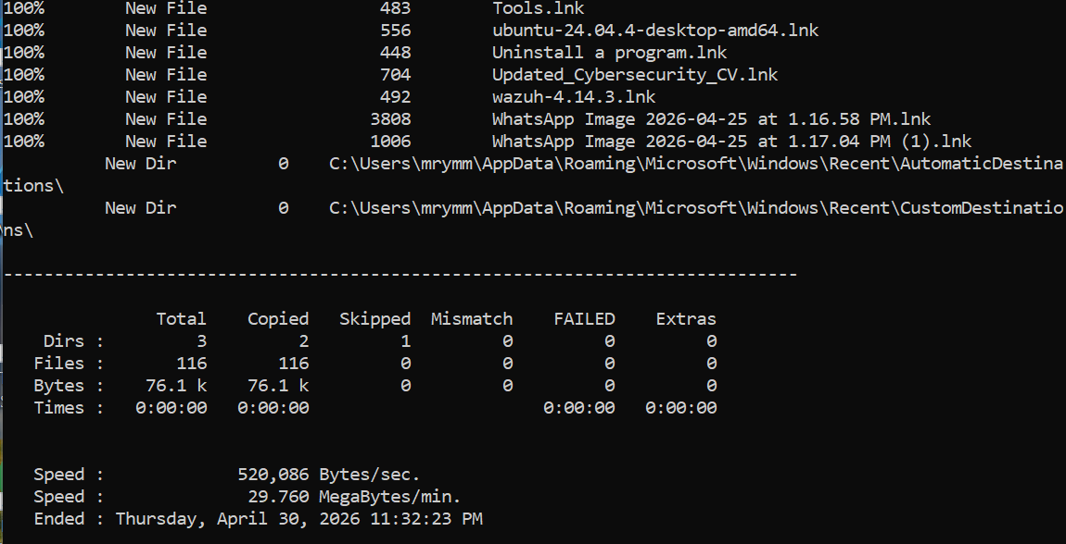

2.3 Explanation
This step ensures:
- Collection of all user interaction shortcuts
- Preservation of file metadata
- Coverage of multiple user activity sources
File Count Verification

2.4 Interpretation
The presence of multiple LNK files indicates:
- Frequent file access
- System usage patterns
- Interaction with documents and tools

3. Parsing LNK Files Using LECmd
The collected LNK files were parsed using Eric Zimmerman’s LECmd tool.
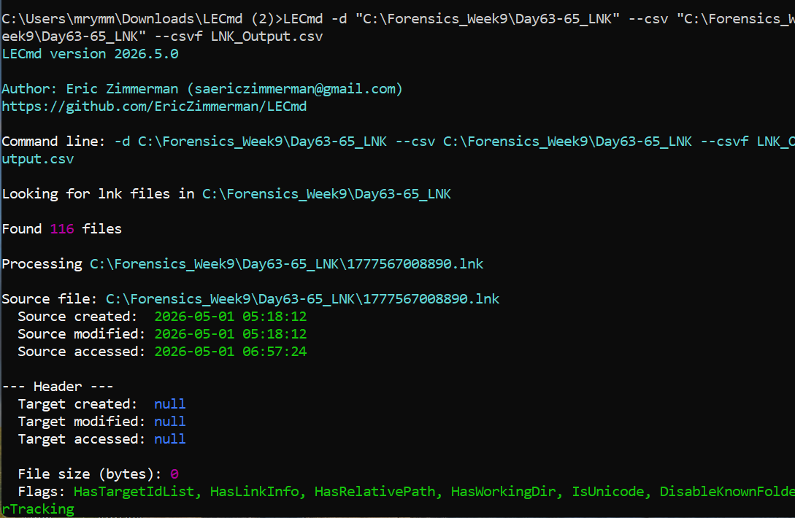

3.1 Explanation
LECmd extracts structured metadata from LNK files, including:
- Target file path
- Access timestamps
- Volume and drive information
- Network details

3.2 Output Generated

LNK_Output.csv

3.3 Importance
Parsing converts raw LNK data into readable format, enabling:
- Easy filtering and analysis
- Identification of user activity patterns
- Extraction of meaningful forensic evidence
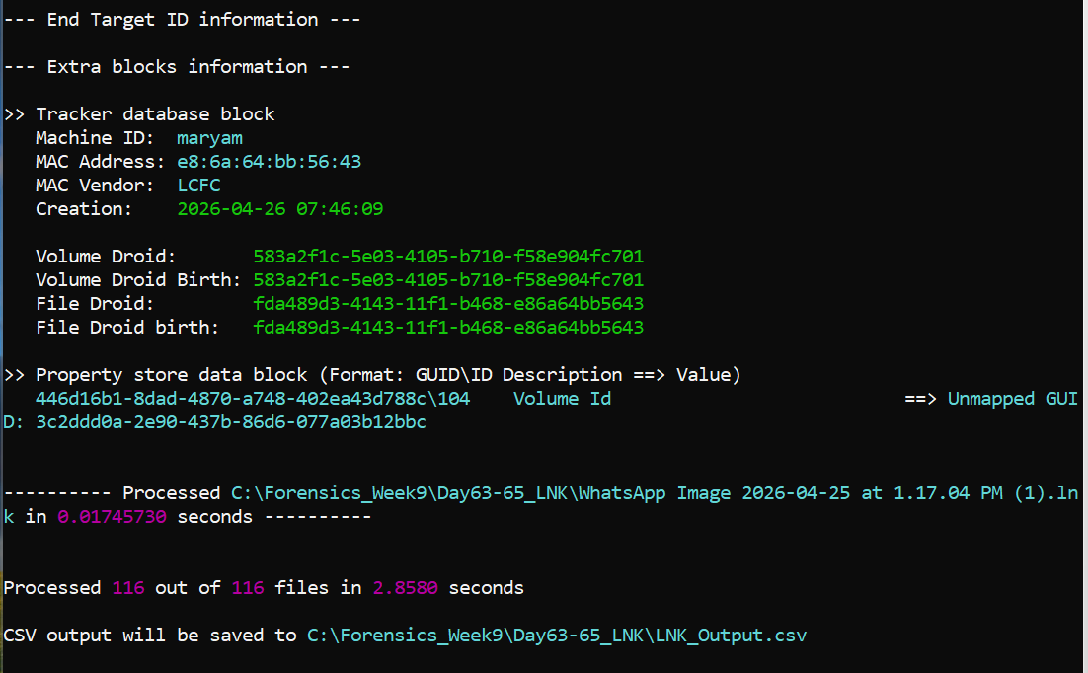

4. Analysis of LNK Output Data
The generated CSV file was opened in Excel for analysis.
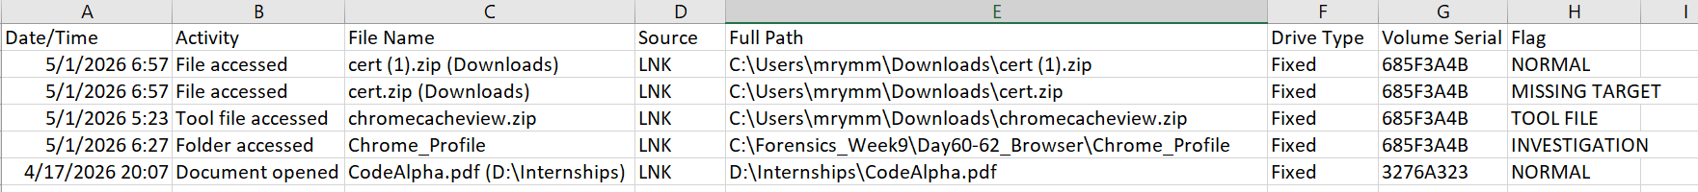
The LNK output CSV file was analyzed using Microsoft Excel by applying filters on important columns such as target path, drive type, timestamps, and flags.
The analysis showed that all accessed files were located on the internal system storage (fixed hard drive). No entries were found indicating the use of removable storage devices or network shares.
The examined columns provided the following insights:
- Target path helped identify the exact file location
- Drive type confirmed whether the file was accessed from internal or external storage
- Volume serial number helped identify the storage device
- Timestamps (created, modified, accessed) helped reconstruct user activity
- File size provided context about the file type
- Flags indicated the nature of file interaction
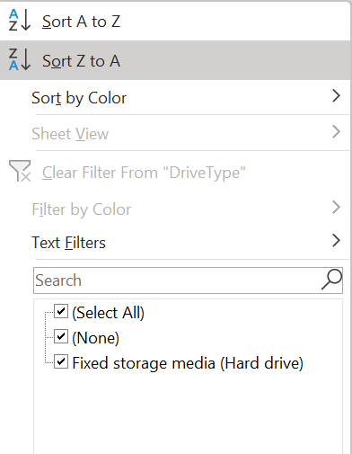

5. File Access Timeline Creation
A structured file access timeline was created from the parsed LNK data. The timeline summarizes key user activities including file access, tool usage, and document interaction.
The following patterns were observed:
- Access to downloaded ZIP files from the Downloads folder
- Opening of documents such as PDF files
- Usage of forensic tools including ChromeCacheView
- Access to investigation-related folders
This timeline helps in reconstructing the sequence of user actions and identifying how downloaded files were accessed and used.

6. File Existence Verification
Some LNK entries pointed to files that were no longer present on the system. These entries were marked as “MISSING TARGET”.
File existence was verified using PowerShell to determine whether the referenced files still existed.
Missing files may indicate:
- File deletion
- File movement
- Temporary file usage
This is significant in forensic analysis because even if a file is deleted, LNK artifacts can still provide evidence of its prior existence and usage.

6.1 Flags explanation
The following flags were assigned to classify file activity:
- NORMAL → regular file access
- MISSING TARGET → file may be deleted or moved
- TOOL FILE → forensic/tool related file
- INVESTIGATION → analysis folder accessed

7. USB Device Analysis
LNK data was filtered for removable devices.

7.1 Filter Applied

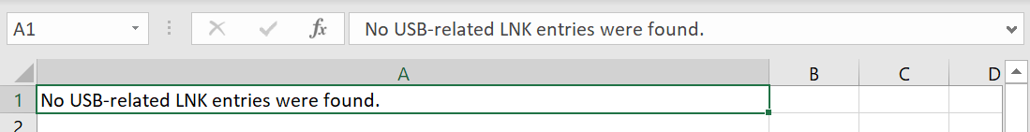

7.2 Result
No entries related to removable storage devices were found.

7.3 Explanation
This indicates:
- No USB device was used for file access
- OR USB activity was not recorded in Recent Items
No USB-related LNK entries were found. This may indicate that no USB file access occurred or that the Recent Items history was cleared.

8. Network Share Analysis
LNK data was analyzed for network-based activity.

8.1 Fields Checked
- Network Share Name
- MAC Address
- Drive Type = Network
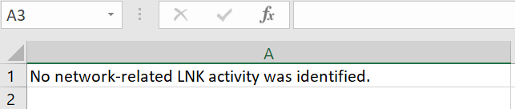

8.2 Result
No network-related entries were identified.

8.3 Explanation
This suggests:
- No files were accessed from shared network locations
- No remote system interaction occurred
No network share activity was identified in the parsed LNK data.

9. Key Findings
- LNK files confirmed access to multiple files and tools
- Downloaded files were accessed shortly after download
- Forensic tools were actively used
- No USB device activity detected
- No network share usage detected

10. Conclusion
The LNK file analysis provided valuable insight into user activity by revealing file access patterns and system interaction.
The data shows that the user accessed downloaded files, opened documents, and interacted with forensic tools in a structured manner. The absence of USB and network activity further supports that the investigation was conducted locally on the system.
No suspicious or malicious behavior was identified. The observed activity is consistent with an academic or forensic investigation workflow.
PART C — UNIFIED TIMELINE ANALYSIS

1. Introduction
This section presents the unified timeline created by combining multiple forensic artifacts. The purpose of this timeline is to reconstruct user activity in chronological order and identify relationships between browsing activity, downloads, and file access.
By correlating different data sources, it becomes possible to understand how user actions progressed over time.3

2. Collection of Input Data
All relevant CSV files generated during previous analysis phases were gathered and organized into a single directory:
C:\Forensics_Week9\Day66_Timeline\Input_CSVs

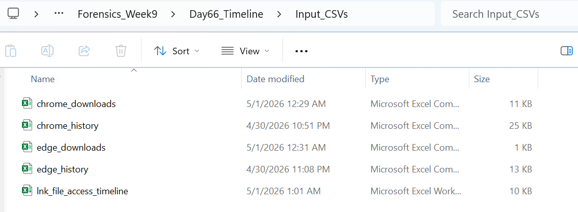

2.1 Included Data
- Chrome and Edge browsing history
- Download history
- LNK file access timeline
These datasets represent web activity, downloaded files, and actual file usage.

3. Creation of Unified Timeline
A new Excel file was created:
unified_timeline.xlsx

3.1 Columns Defined
The following standardized columns were used:
- Timestamp UTC
- Artifact Source
- Tool Used
- Event Description
- Original Path / URL
- Analyst Note
- Correlation
- Significance
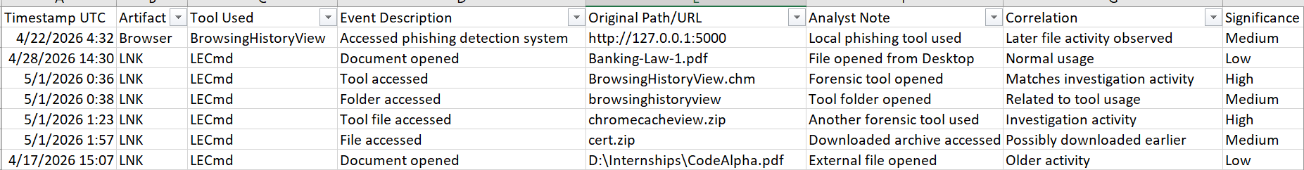

4. Timestamp Normalization
All timestamps were converted to UTC to maintain consistency across different data sources.

4.1 Conversion Rule

UTC = PKT - 5 hours

5. Event Selection and Analysis
Only meaningful events were included in the timeline to avoid unnecessary data.

5.1 Observed Activities
- Access to local phishing detection system
- Opening of documents (PDF files)
- Access to downloaded ZIP files
- Usage of forensic tools

5.2 Explanation
These events represent key user actions and help reconstruct the workflow followed during the investigation.

6. Correlation of Events
The timeline shows clear relationships between different activities.
- Downloaded files were accessed shortly after download
- Forensic tools were opened and used during analysis
- Localhost activity indicates use of a local application

7. Interpretation
This correlation confirms that:
- The user actively used downloaded tools
- Activities were performed in a structured sequence
- The system was used for investigative purposes

8. Conclusion
The unified timeline successfully combines browser and LNK artifacts to present a clear sequence of user actions.
The analysis indicates that the user performed structured forensic activity, including tool usage, file access, and interaction with a local application. No suspicious or malicious behavior was identified.

