CyberSter

CYBERSTER BLUE TEAM INTERNSHIP
WEEK 7 REPORT
Digital Forensics Foundations: Disk Imaging, File Systems, and Evidence Analysis

Submitted By: Maryam Mughal
ID: CSI-B1-293

Phase Two — Digital Forensics and Incident Response

Week: Week 7 (Days 43 – 52)
Submission Date: End of Day 52

Submitted To: Abdullah Zia

Table of Contents
- Introduction
- Objectives of the Lab
- Lab Environment
- Tools Used
- Day 46–47: Disk Imaging and Evidence Acquisition
- Hash Verification and Integrity Validation
- Mounting the Evidence Image
- Chain of Custody Documentation
- Day 48–49: Alternate Data Streams (ADS) Analysis
- Master File Table (MFT) Analysis
- Timestamp Experiment and Analysis
- Day 50–52: Autopsy Investigation and Digital Evidence Triage
- Deleted File Recovery
- Evidence Log
- Findings and Observations

1. Introduction
Digital forensics is a branch of cybersecurity that focuses on identifying, collecting, preserving, analyzing, and presenting digital evidence in a secure and legally acceptable manner. It is commonly used in cybercrime investigations, incident response, and recovery of deleted or hidden data from digital devices.
The purpose of this Week 7 lab was to gain practical experience with forensic investigation techniques using professional forensic tools. The tasks included creating a forensic image of a USB drive, verifying evidence integrity using hash values, analyzing NTFS artifacts, investigating Alternate Data Streams (ADS), examining Master File Table (MFT) records, and performing forensic analysis using Autopsy.
During the investigation, FTK Imager was used to create a forensic image in E01 format while maintaining evidence integrity through MD5 and SHA256 hashing. The image was later mounted in read-only mode using Arsenal Image Mounter to prevent accidental modification of evidence.
Additional analysis involved detecting hidden Alternate Data Streams, examining file metadata through MFT analysis, observing timestamp behavior, and recovering deleted files using Autopsy on Windows.
This lab provided practical understanding of evidence acquisition, evidence preservation, forensic analysis, and proper forensic documentation procedures used in real-world investigations.

2. Objectives of the Lab
The main objective of this forensic lab was to understand how digital evidence is collected, preserved, analyzed, and documented during a forensic investigation.
The specific objectives were:
- To create a forensic image of a USB device using FTK Imager.
- To verify evidence integrity using MD5 and SHA256 hashes.
- To understand the importance of read-only evidence handling.
- To study NTFS artifacts such as Alternate Data Streams (ADS) and MFT records.
- To analyze file timestamps and metadata.
- To recover deleted files from a forensic image.
- To perform forensic analysis using Autopsy on Windows.
- To maintain proper forensic documentation and chain of custody.
This lab helped improve practical knowledge of digital forensic investigation procedures and evidence handling techniques.

3. Lab Environment
The forensic investigation was performed in a controlled environment using Windows operating system and forensic analysis tools.
Component | Details
Operating System | Windows 10
Evidence Source | USB Flash Drive
File System | NTFS
Image Format | E01
Analysis Tools | FTK Imager, Arsenal Image Mounter, MFT Explorer, Autopsy
The USB drive contained multiple files including text documents, images, and PDF files. One file was intentionally deleted before imaging so that deleted file recovery could later be performed.
Unlike some forensic labs that use Kali Linux, this investigation was completed entirely on Windows, including the use of Autopsy for forensic analysis.
The forensic image was mounted in read-only mode to ensure the original evidence remained unchanged during analysis.

4. Tools Used
Several forensic tools were used during this lab to perform acquisition, analysis, and evidence examination.

4.1 FTK Imager
FTK Imager was used to create a forensic image of the USB drive in E01 format. The tool also generated MD5 and SHA256 hashes to verify evidence integrity.
Functions performed:
- Disk imaging
- Hash generation
- Image verification
- Evidence preview
- MFT export

4.2 Arsenal Image Mounter

Arsenal Image Mounter was used to safely mount the E01 forensic image in read-only mode. This allowed evidence analysis without modifying the original image.

4.3 MFT Explorer
MFT Explorer was used to analyze the exported Master File Table records from the NTFS file system.
The tool helped examine:
- File names
- File sizes
- MACB timestamps
- File metadata

4.4 Command Prompt (CMD)

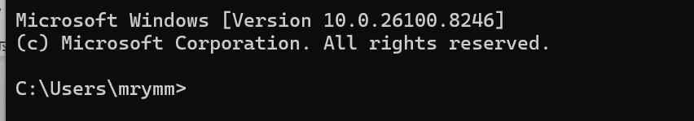
Windows Command Prompt was used to create and detect Alternate Data Streams (ADS) using commands.It was also used during timestamp experiments.

4.5 Autopsy

Autopsy was used on Windows to perform forensic analysis of the E01 image.
The tool was used for:
- File system analysis
- Deleted file recovery
- Timeline analysis
- Metadata extraction
- Thumbnail analysis
- Evidence triage
Autopsy helped organize and analyze evidence artifacts efficiently during the investigation.

5. Day 46–47: Disk Imaging and Evidence Acquisition

5.1 USB Preparation

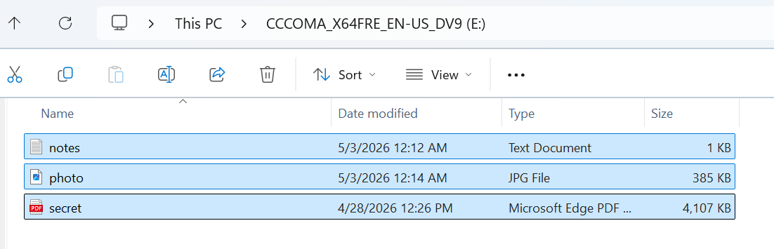
A USB flash drive was prepared as the evidence source. Multiple files including text files, images, and PDF documents were added to the USB device. One file was intentionally deleted to simulate a real-world forensic investigation scenario.
This setup allowed the forensic investigation to include both active and deleted data recovery.

5.2 Launching FTK Imager

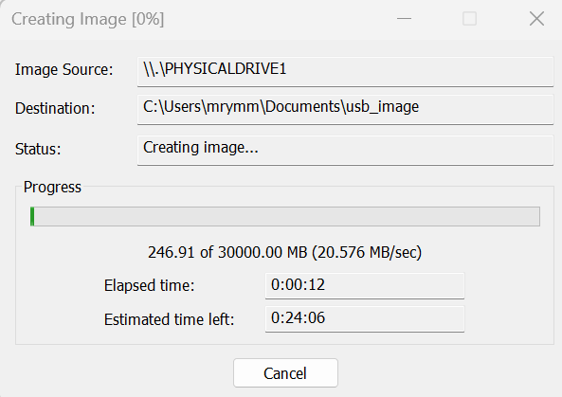
FTK Imager was launched with administrator privileges on the Windows system. Running forensic tools as administrator is important because access to physical drives requires elevated permissions.
The following option was selected:
File → Create Disk Image
The “Physical Drive” option was chosen because the task required acquisition of the actual USB device instead of logical partition imaging.

5.3 Selecting the Evidence Source
The connected USB flash drive was identified from the available physical drives and selected as the evidence source.
Proper care was taken to ensure the correct drive was selected in order to avoid imaging the wrong storage device.

5.4 Choosing the Image Format
The E01 image format was selected for forensic acquisition.
The E01 format is widely used in digital forensics because it supports:
- Compression
- Metadata storage
- Hash verification
- Segmentation
- Evidence integrity validation

5.5 Evidence Metadata
The following metadata was entered during image creation:
Field | Value
Case Number | 01
Examiner | Maryam
Description | USB Forensic Image
Metadata documentation is important because it provides identification and tracking information for digital evidence.

5.6 Hash Configuration

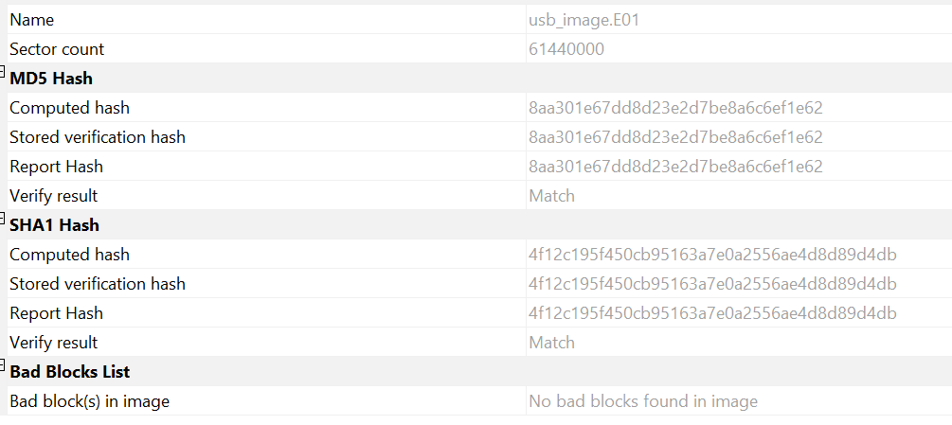
During imaging, both MD5 and SHA256 hash algorithms were enabled.
Hashing is critical in digital forensics because it verifies that the forensic image is identical to the original source.
The following hash algorithms were selected:
- MD5
- SHA256

5.7 Evidence Acquisition Process

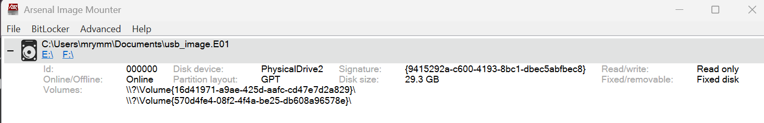
After configuration, the imaging process was started. FTK Imager created a complete forensic image of the USB drive.
The imaging process included:
- Reading the original evidence
- Creating an E01 forensic image
- Calculating source hashes
- Calculating image hashes
- Verifying image integrity
Once the acquisition completed successfully, FTK Imager displayed matching hash values.

6. Hash Verification and Integrity Validation
Hash verification is one of the most important concepts in digital forensics. A forensic image is considered forensically sound only if the source hash and image hash values match.
The following verification results were observed:
Hash Type | Source Value | Image Value | Status
MD5 | Matching | Matching | Verified
SHA256 | Matching | Matching | Verified
The matching hash values confirmed that:
- No data was altered during imaging.
- The evidence remained intact.
- The forensic image was an exact duplicate of the original USB device.
The verification statement recorded in the report was:
“MD5 (Source) = MD5 (Image) and SHA256 (Source) = SHA256 (Image). This confirms the forensic image is forensically sound and maintains evidence integrity.”
Screenshots were captured showing:
- MD5 hash values
- SHA256 hash values
- Source and image verification results

7. Mounting the Evidence Image

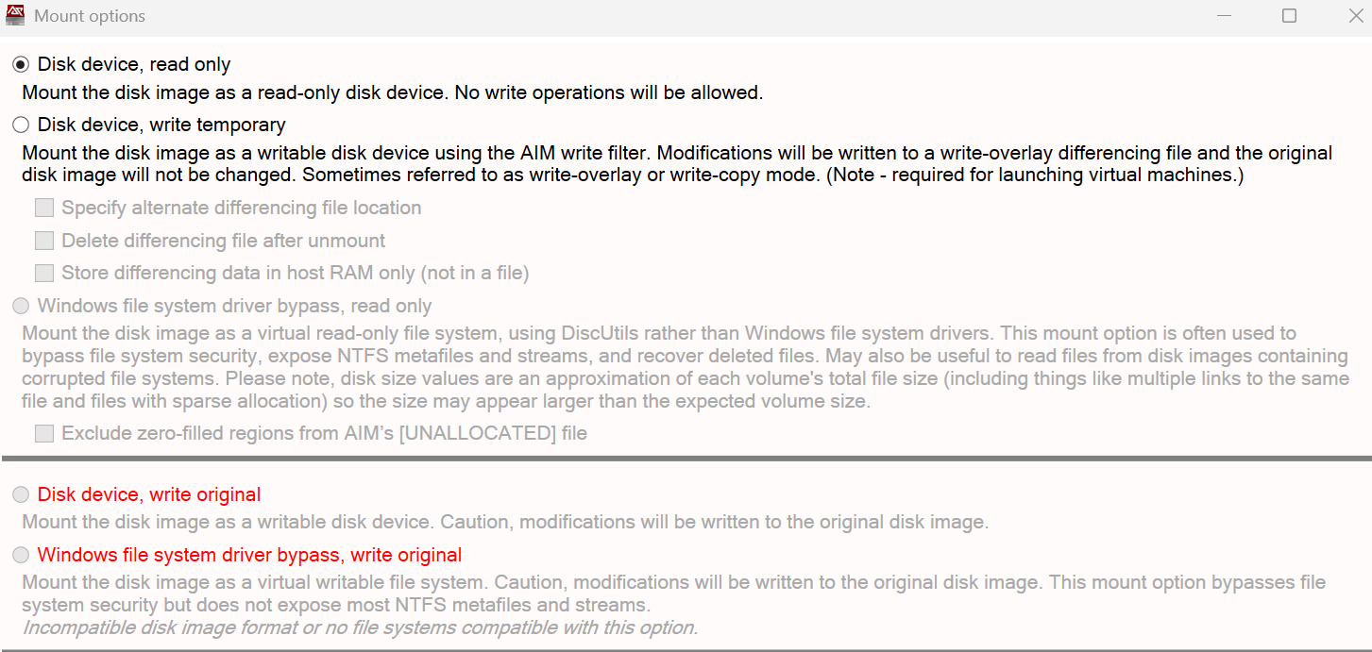
After acquisition, the forensic image was mounted using Arsenal Image Mounter.
The E01 image file was loaded into the application and mounted in read-only mode.
Read-only mode is extremely important because it prevents accidental modification of digital evidence during analysis.
The mounted image appeared as a separate drive in Windows File Explorer, allowing safe examination of files and folders.
A screenshot of the mounted forensic image was captured for documentation purposes.

8. Chain of Custody Documentation
Chain of custody is a formal process used to document how evidence is collected, transferred, stored, and analyzed.
Proper chain of custody ensures:
- Evidence authenticity
- Evidence integrity
- Legal admissibility
- Accountability
The following information was documented:

Field | Details
Evidence ID | USB-001
Date and Time | Recorded during acquisition
Examiner | Maryam
Tool Used | FTK Imager
Image Format | E01
Hash Algorithms | MD5 and SHA256
Storage Location | Evidence Folder
Maintaining proper documentation is critical in forensic investigations because it establishes trust and reliability of evidence handling.
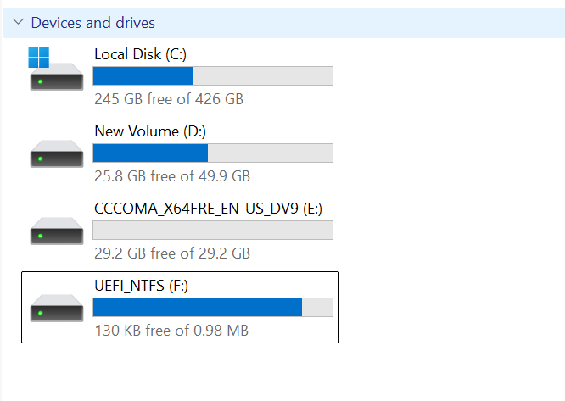
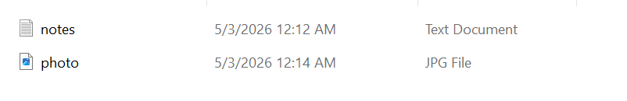
The image was mounted using Arsenal Image Mounter in read-only mode. Initially, the partition was not automatically detected, so the image was re-mounted with partition mounting enabled. The filesystem was successfully accessed and verified.

9. Day 48–49: Alternate Data Streams (ADS) Analysis

9.1 Introduction to Alternate Data Streams (ADS)
Alternate Data Streams (ADS) are a feature of the NTFS file system that allows additional hidden data to be attached to a file without changing the visible content of the original file. ADS can store hidden text, scripts, or other information that may not appear during normal file viewing.
In digital forensics, ADS analysis is important because attackers sometimes use hidden streams to conceal malicious files or sensitive data. Therefore, forensic investigators must examine NTFS streams carefully during investigations.

9.2 Creating an Alternate Data Stream

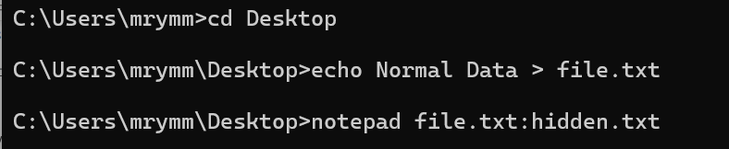
The ADS experiment was performed using Windows Command Prompt.
First, the working directory was changed to the Desktop using the following command:
cd Desktop
A hidden Alternate Data Stream was then created using the following command:
notepad file.txt:hidden.txt

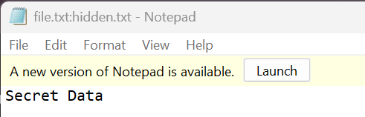
After executing the command, Notepad opened and the following text was added:
Secret Data
The file was saved and closed successfully.
This process created a hidden data stream attached to the main file file.txt.

9.3 Viewing the Normal File

The normal file was opened using:
notepad file.txt

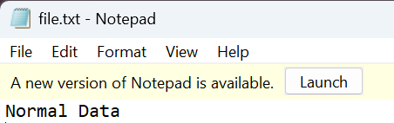
The hidden text was not visible inside the normal file.
This demonstrated that Alternate Data Streams can hide information without changing the visible contents of the original file.

9.4 Detecting Alternate Data Streams

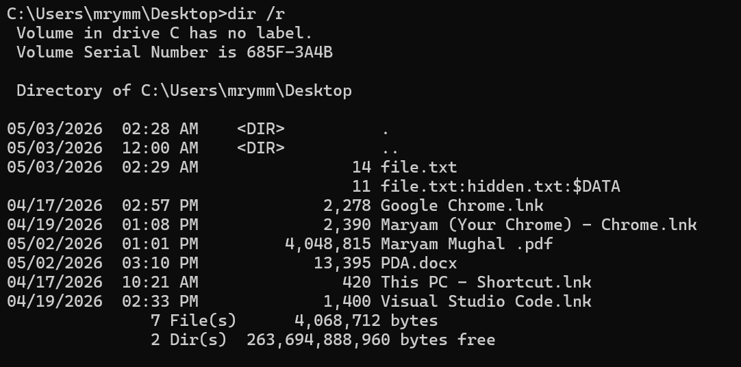
To detect hidden streams, the following command was executed:
dir /r
The /r option displays Alternate Data Streams associated with files in NTFS.
The output showed the hidden stream attached to file.txt, confirming the presence of hidden data.
The command successfully revealed the ADS that was invisible during normal file viewing.

9.5 ADS Investigation Findings
The ADS analysis demonstrated several important forensic concepts:
- Hidden data can exist inside NTFS files without appearing normally.
- Alternate Data Streams can be used to conceal information.
- Standard file viewing methods may not detect hidden streams.
- Forensic investigators must use specialized commands and tools to identify ADS activity.
This experiment also highlighted how attackers may misuse NTFS features to hide malicious content or evade detection.

9.7 Conclusion
The Alternate Data Streams experiment provided practical understanding of hidden NTFS data structures and their forensic significance. The investigation demonstrated how hidden information can exist within files without appearing during normal usage.
The analysis improved understanding of NTFS forensic artifacts and emphasized the importance of detailed forensic examination during digital investigations.
Alternate Data Streams (ADS) were created and analyzed using Windows NTFS. The hidden stream (file.txt:hidden.txt:$DATA) was not visible in normal file viewing but was successfully detected using the 'dir /r' command. The hidden content was accessed using Notepad, confirming the presence of concealed data.

10. Master File Table (MFT) Analysis

10.1 Introduction to MFT
The Master File Table (MFT) is one of the most important components of the NTFS file system. Every file and folder stored on an NTFS volume contains a corresponding record inside the MFT. These records store important metadata related to file activity and system operations.
The MFT contains information such as:
- File name
- File size
- File allocation status
- MACB timestamps
- Metadata attributes
- File system allocation details
MFT analysis is a critical part of digital forensic investigations because investigators use these records to analyze file activity, identify deleted files, and reconstruct system timelines.

10.2 Accessing the MFT File in Autopsy

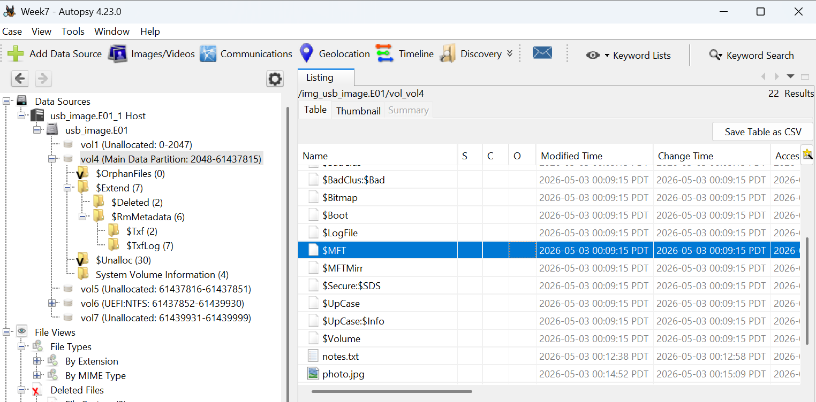
During the investigation, the forensic image file was loaded into Autopsy for analysis. Instead of exporting the $MFT file separately, Autopsy was used to directly analyze file system records, which internally rely on MFT structures.
The following steps were performed:
- The E01 forensic image was added as a data source in Autopsy.
- The NTFS partition was expanded from the data source tree.
- File system view was used to explore files and directories.
- Individual file records were examined to extract metadata and timestamps.
Autopsy automatically parses the MFT and presents file-level metadata, allowing investigators to analyze file activity without manually opening the raw $MFT file.

10.3 Analysis of MFT Metadata

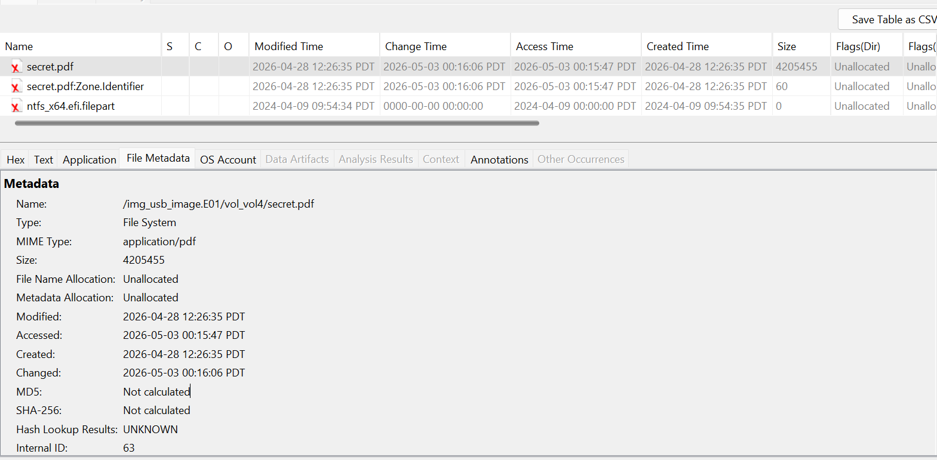
During the analysis, a deleted file named secret.pdf was identified within the forensic image.
The following metadata was extracted:
Attribute | Value
File Name | secret.pdf
File Type | PDF Document
Size | 4,205,455 bytes
File Name Allocation | Unallocated
Metadata Allocation | Unallocated
Path | /img_usb_image.E01/vol_vol4/secret.pdf
Key Observation:
- The file was marked as Unallocated, indicating that it had been deleted.
- Despite deletion, the file record was still present in the MFT.
- This confirms that deletion does not remove file data immediately.

10.4 MACB Timestamp Analysis
The timestamps associated with the deleted file were analyzed as follows:
Timestamp | Value | Interpretation
Created (B) | 2026-04-28 | File was originally created
Modified (M) | 2026-04-28 | Last content modification
Accessed (A) | 2026-05-03 | File accessed before deletion
Changed (C) | 2026-05-03 | Metadata updated (likely deletion)
Forensic Interpretation:
- The file was created and modified on April 28, 2026.
- On May 3, 2026, the file was accessed and then deleted.
- The Changed timestamp reflects metadata alteration, indicating deletion activity.
This demonstrates how MACB timestamps can be used to reconstruct user behavior and system activity.

10.5 Findings from MFT Analysis
The MFT analysis revealed several important forensic findings:
- Deleted file records remain available within the MFT.
- The file secret.pdf was successfully identified as a deleted artifact.
- File allocation status confirmed logical deletion.
- MACB timestamps enabled reconstruction of file lifecycle.
- Evidence showed that file deletion does not permanently remove data immediately.
Additionally, the deleted PDF file was successfully recovered, confirming the reliability of MFT-based forensic analysis.

10.6 Conclusion
The MFT analysis provided a detailed understanding of NTFS metadata and forensic artifacts. Using Autopsy, file-level metadata and timestamps were successfully analyzed without directly parsing the raw $MFT file.
The investigation demonstrated that:
- MFT retains critical metadata even after file deletion
- Deleted files can be identified and recovered
- MACB timestamps help reconstruct system activity timelines
This highlights the importance of MFT analysis in digital forensic investigations.

11. Timestamp Experiment and Analysis

11.1 Objective
The purpose of the timestamp experiment was to observe how different file operations affect NTFS timestamps.
This experiment helped in understanding how file metadata changes when files are created, copied, moved, opened, or modified.

11.2 Procedure

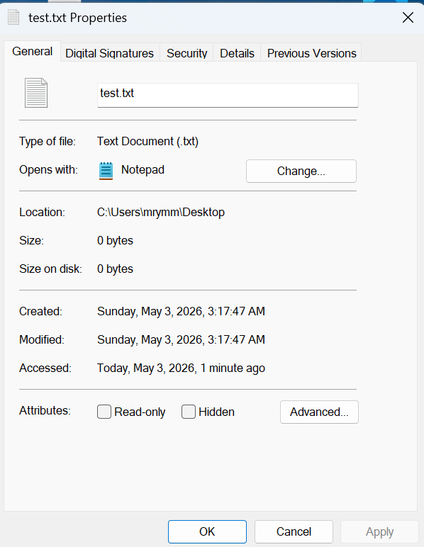
A file named test.txt was created on the Windows system.
The following actions were performed one by one:
- File creation
- File copy
- File move
- File open/access
- File modification
After each action, the file properties were checked to observe timestamp changes.

11.3 Timestamp Observation Table

Action | Modified | Accessed | Created
Create | Updated | Updated | Updated
Copy | Updated | Updated | Updated
Move | No Major Change | No Major Change | No Major Change
Open | No Change | Updated | No Change
Modify | Updated | Updated | No Change

11.4 Analysis of Results
The experiment showed that different actions affect timestamps differently.

File Creation

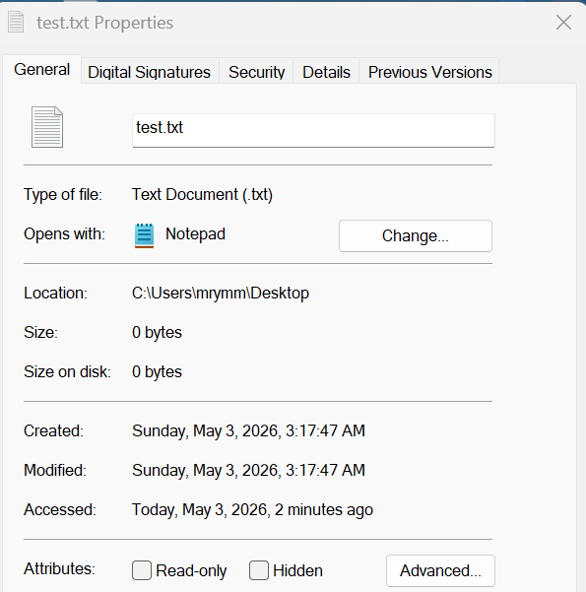
When the file was first created, all timestamps were updated because the file was newly generated.

File Copy

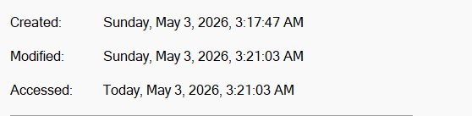
Copying the file created a new file instance, which generated new timestamps.

File Move

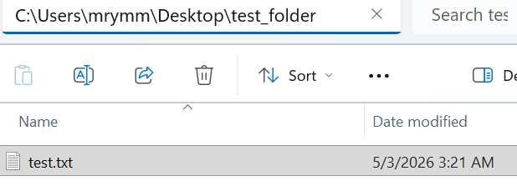
Moving the file within the same partition caused minimal timestamp changes because the file itself was not recreated.

File Open

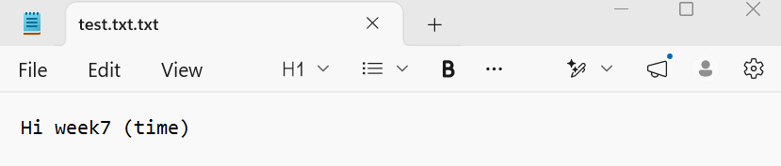

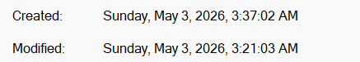

Opening the file updated the Accessed timestamp only.

File Modification
Editing the file updated the Modified timestamp and also changed the Accessed timestamp.

11.5 Importance in Digital Forensics
Timestamp analysis is very important during forensic investigations because timestamps help investigators:
- Reconstruct timelines
- Identify suspicious activity
- Track user behavior
- Determine when files were accessed or modified
Investigators often rely on timestamp analysis to understand how an incident occurred.
The timestamp experiment demonstrated how file system metadata changes with user actions. Opening a file updates access time, modifying changes both modified and accessed times, copying creates a new file with a new creation timestamp, while moving does not significantly alter timestamps.

12. Day 50–52: Autopsy Investigation and Digital Evidence Triage

12.1 Introduction to Autopsy
Autopsy is an open-source digital forensic investigation tool used for analyzing forensic images, recovering deleted files, examining metadata, and performing evidence triage.
In this lab, Autopsy was installed and used on Windows to investigate the E01 forensic image created earlier using FTK Imager.
The purpose of this investigation was to analyze the contents of the forensic image and identify useful forensic artifacts.

12.2 Creating a New Case

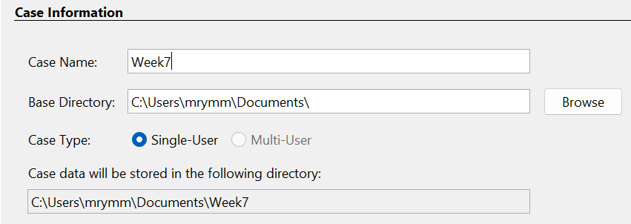
After launching Autopsy, a new forensic case was created.
The following information was entered:
Field | Details
Case Name | Week7
Examiner Name | Maryam
Description | USB Forensic Investigation
Creating a case helps organize evidence, reports, and investigation data properly.

12.3 Adding the Data Source

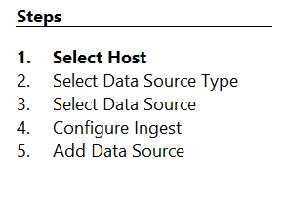
The previously created E01 forensic image was added as the data source.
The following steps were performed:
- Open Autopsy
- Create New Case
- Select “Add Data Source”
- Choose “Disk Image or VM File”
- Browse and select the E01 image
- Start processing
Autopsy successfully loaded the forensic image for analysis.

12.4 Hash Verification
During image loading, the forensic image hashes were verified and compared with the original FTK Imager hash values.
The hash values matched successfully, confirming that:
- The image was authentic.
- Evidence integrity was maintained.
- No modification occurred during analysis.
This step is very important in forensic investigations because investigators must always verify evidence integrity before analysis.

12.5 Modules Enabled
Several ingest modules were enabled during processing to automate forensic analysis.
The following modules were selected:
- File Type Identification
- Hash Lookup
- Keyword Search
- EXIF Metadata
- Recent Activity Analysis
- Thumbnail Generation
These modules helped extract useful evidence artifacts from the forensic image.

12.6 Evidence Processing and Analysis

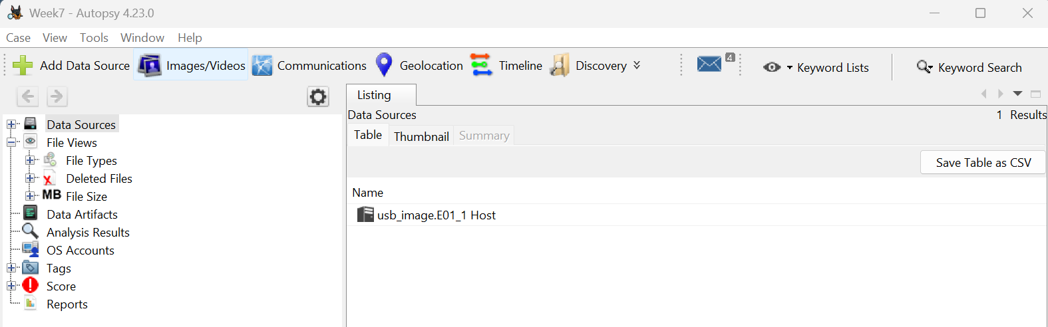
After enabling ingest modules, Autopsy processed the forensic image.
The tool analyzed:
- File systems
- Deleted files
- Metadata
- File signatures
- Images
- User activity artifacts
The processing phase took some time depending on the image size and enabled modules.

12.7 File Tree Analysis

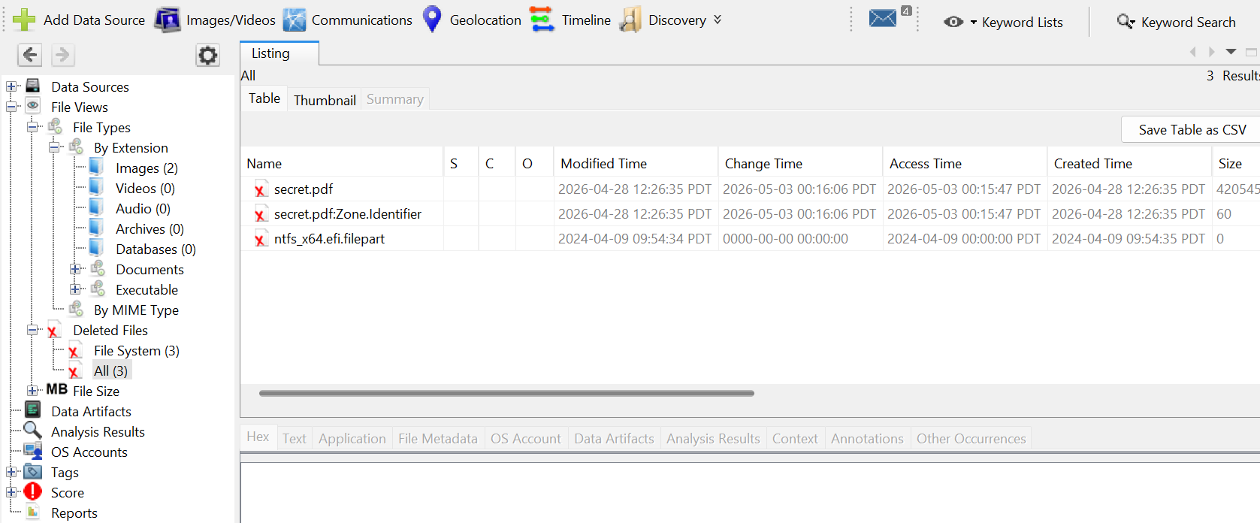
The File Tree section was used to examine files and folders stored inside the forensic image.
The investigation focused on:
- Suspicious file names
- Hidden files
- Deleted content
- User-created documents
The analysis helped identify important evidence files stored on the USB drive.

12.8 Timeline Analysis


Autopsy generated a timeline of file activities based on timestamps.
The timeline helped observe:
- File creation events
- File modification events
- File access activity
- Deleted file events
Timeline analysis is useful because investigators can reconstruct system activity and identify suspicious behavior patterns.
13. Deleted File Recovery
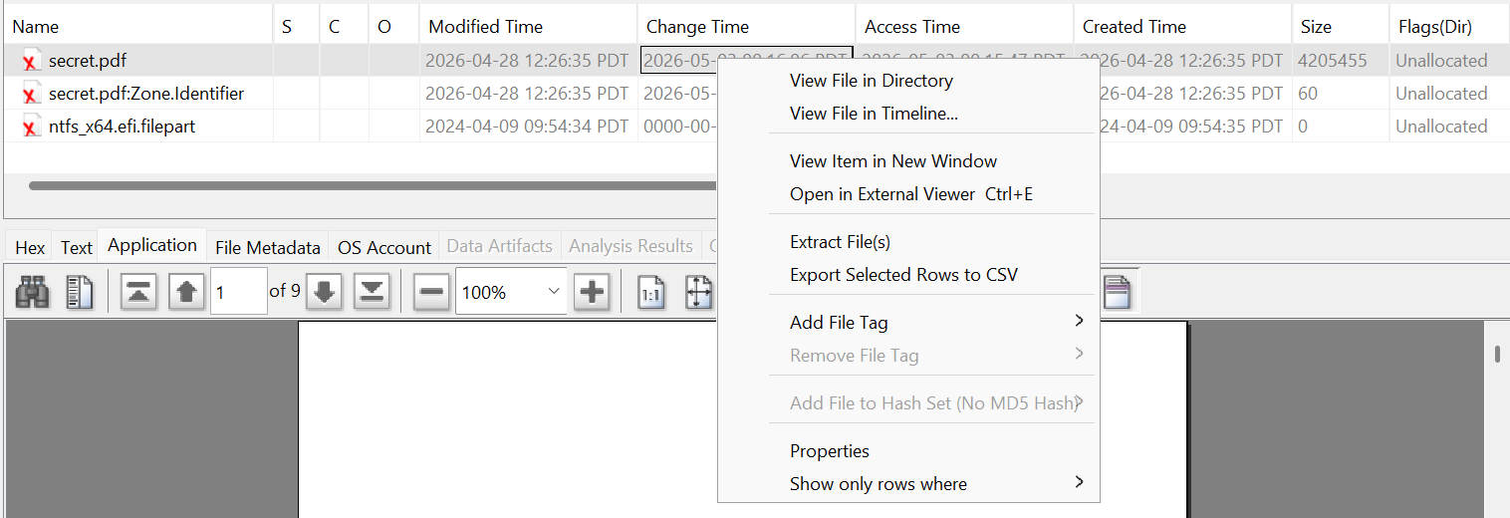
One of the most important parts of the investigation was deleted file recovery.
Autopsy successfully identified deleted files from the forensic image.
The deleted files were examined to determine:
- File names
- File paths
- File types
- File contents
This demonstrated that deleted files may still remain recoverable until overwritten by new data.
Screenshots of deleted file recovery were captured as investigation evidence.

13.1 Thumbnail and Media Analysis

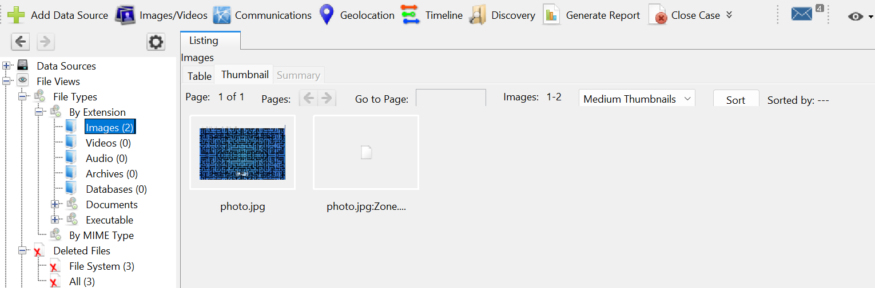
Autopsy automatically generated thumbnails for image files found in the forensic image.
This feature helped quickly preview image content without opening every file manually.
Thumbnail analysis is useful during forensic investigations because investigators can rapidly identify suspicious or hidden media files.
14. Evidence Log
The forensic investigation revealed several important findings:
- The forensic image was loaded successfully.
- Evidence integrity remained intact.
- Deleted files were recoverable.
- Metadata and timestamps were visible.
- File activity timelines were generated successfully.
- Hidden and deleted artifacts could be identified.
The investigation demonstrated how forensic tools help reconstruct digital activity from storage devices.


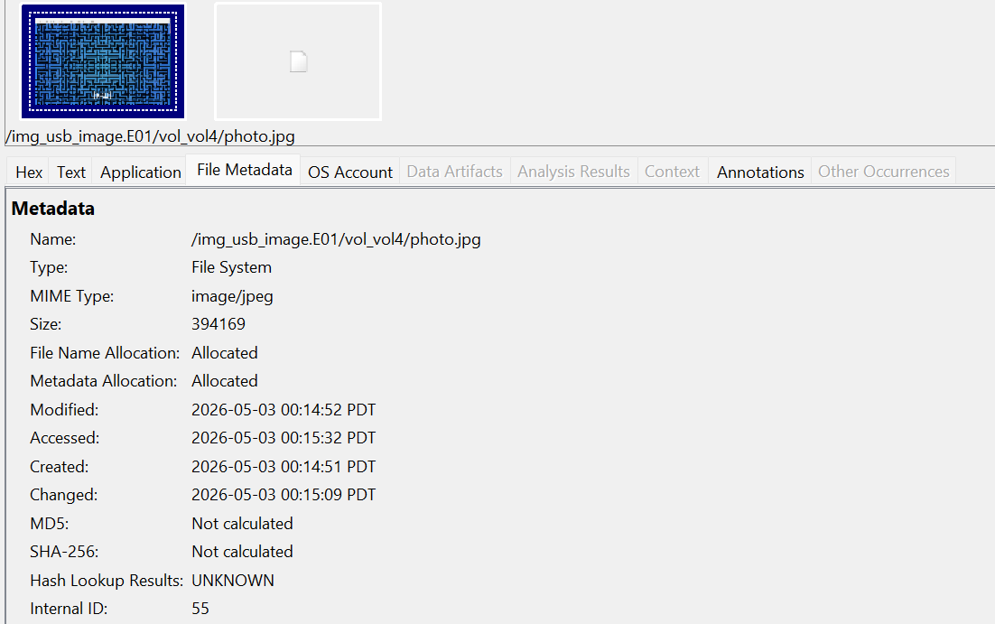

15. Findings and Observations
A deleted file named "secret.pdf" was identified during analysis. The file was located in unallocated space, as indicated by both file name and metadata allocation status being unallocated. This confirms that the file had been deleted but was still recoverable.

Timestamp analysis revealed that the file was originally created and modified on April 28, 2026. It was later accessed on May 3, 2026, followed by a metadata change shortly after, suggesting possible deletion or modification activity.

The file size (approximately 4.2 MB) indicates that it was a valid document and not an empty or corrupted file. This provides strong evidence of user interaction with the file prior to deletion.
This analysis demonstrates the importance of forensic tools in recovering deleted evidence and analyzing user behavior through file system metadata.

