CyberSter

CYBERSTER BLUE TEAM INTERNSHIP
WEEK 8 REPORT
Windows Artifact Analysis: Event Logs and Prefetch

Submitted By: Maryam Mughal
ID: CSI-B1-293

Phase Two — Digital Forensics and Incident Response

Week: Week 8 (Days 53 – 59)
Submission Date: 26-April-2026

Submitted To: Abdullah Zia

📑 TABLE OF CONTENTS

1. Introduction

2. Methodology Overview

3. Part A — Event Log Analysis (Days 53–55)

3.1 Overview of Event Log Analysis

3.2 Purpose of Event Log Analysis

3.3 Evidence Collection and Integrity

3.4 Importance of Windows Security Logs

3.5 Evidence Integrity and Hashing

3.6 Log Parsing and Data Preparation (EvtxECmd)

3.7 Key Event IDs and Their Significance

3.8 Human Activity Analysis (Event ID 4624)

3.9 Privilege Escalation Analysis (Event ID 4672)

3.10 System Noise Analysis (Logon Type 5)

3.11 Additional Observations and Indicators

4. Part B — Prefetch Analysis (Days 56–57)

4.1 Overview of Prefetch Analysis

4.2 Evidence Collection (Prefetch Copy Process)

4.3 Prefetch Parsing and Output (PECmd)

4.4 Analysis of Frequently Executed Programs

4.5 Suspicious Path Analysis

4.6 Download and Recent File Activity

4.7 Application Data and File Access Analysis

4.8 USB Device Analysis

4.9 Execution Timeline Analysis

4.10 Correlation with Event Logs

4.11 Key Findings from Prefetch Analysis

5. Part C — Cache, Thumbcache & Recycle Bin Analysis (Days 58–59)

5.1 Overview of User Activity Artifacts

5.2 Thumbcache Analysis

5.3 Browser Cache Analysis

5.4 Recycle Bin Analysis

5.5 Cross-Artifact Correlation

5.6 Key Findings from Part C

1. INTRODUCTION
This week focused on practical Windows digital forensics, where real system-generated artifacts were analyzed to understand user and system activity. Unlike theoretical learning, this task involved working on a live Windows machine, which provided realistic and meaningful forensic data.
Modern operating systems continuously generate logs and artifacts whenever a user interacts with the system. Activities such as logging in, running applications, browsing the internet, viewing images, or deleting files leave behind digital traces. These traces, known as forensic artifacts, are critical in reconstructing past events during an investigation.
In this task, three major categories of Windows artifacts were analyzed:
- Event Logs: Record authentication events, system activity, failed logins, and privilege usage
- Prefetch Files: Store evidence of executed programs along with execution details
- Cache & Thumbcache: Reveal user viewing activity and accessed content, even after deletion
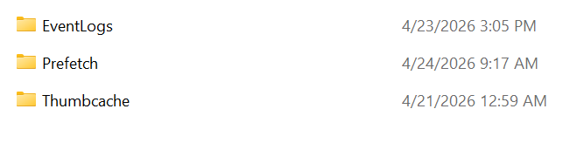
The main objective was not only to extract these artifacts but also to interpret and correlate them. In digital forensics, a single artifact rarely provides complete evidence. Instead, investigators must connect multiple data sources to build a clear and reliable picture of system activity.
Since the analysis was performed on a personal machine, it also helped in understanding normal user behavior (baseline). This is important because identifying abnormal or suspicious activity is only possible when normal patterns are clearly understood.

2. METHODOLOGY OVERVIEW
The investigation was conducted in a structured manner and divided into three main parts. Each part focused on a different type of forensic artifact, allowing detailed analysis and later correlation.

Part A: Event Log Analysis (Authentication & System Activity)
This phase focused on analyzing the Windows Security Event Log. The goal was to:
- Identify successful and failed login attempts
- Track user activity patterns
- Detect privilege usage
- Distinguish between human activity and system-generated events
This helped in building a baseline of normal system usage, which is essential for detecting anomalies.
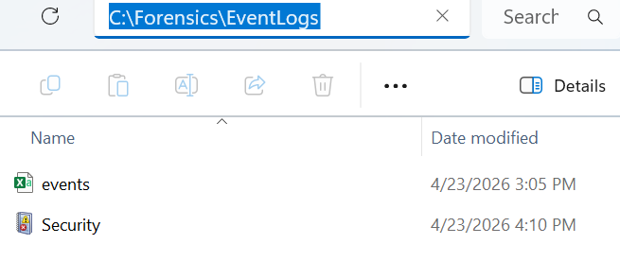

Part B: Prefetch Analysis (Program Execution Evidence)
This phase focused on analyzing Prefetch files to understand application execution behavior. The main objectives were:
- Identify frequently used programs
- Detect execution from suspicious locations (Temp, Downloads, etc.)
- Analyze execution timestamps
- Build an execution timeline
This helps in detecting potentially malicious or unusual program activity.
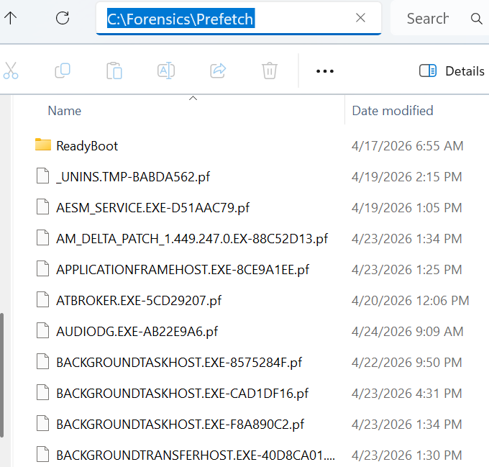

Part C: Cache & Deletion Artifact Analysis (User Activity Evidence)
This phase focused on analyzing:
- Thumbcache: To identify viewed images
- Browser Cache: To track web activity
- Recycle Bin: To identify deleted files
These artifacts provide insight into user behavior and help recover traces of deleted or accessed content.
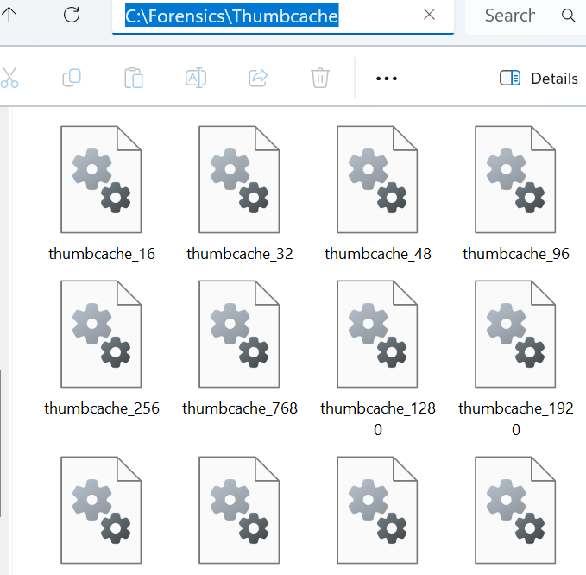

Use of Administrative Privileges
All tasks were performed using Administrator privileges because most forensic artifacts are stored in protected system directories, such as:
- C:\Windows\System32\winevt\Logs\Security.evtx
- C:\Windows\Prefetch
- C:\$Recycle.Bin
- AppData\Local\...
Without administrative access, the system may restrict access or return incomplete data.
Additionally, a proper forensic approach was followed by:
- Creating separate working directories
- Copying original files instead of modifying them
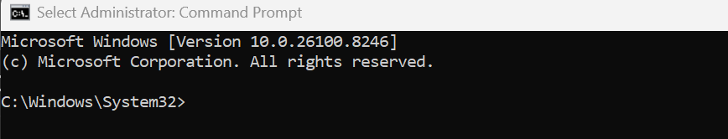

3. PART A — EVENT LOG ANALYSIS

Overview
Part A focused on analyzing the Windows Security Event Log, which is one of the most reliable sources of forensic evidence. These logs record authentication events, system activities, and privilege usage, making them essential for understanding what happened on a system.
The primary goal of this phase was to establish a baseline of normal activity and identify any unusual patterns.

1. Purpose of Event Log Analysis
The main purpose of this part was to establish a baseline of normal activity on the Windows machine.
A baseline means understanding what normal behavior looks like. Before an analyst can identify suspicious activity, they first need to understand normal activity.
For example, if a user normally uses the system between 10:00 AM and 8:00 PM, then logins during this time may be normal. However, if the logs show successful logins at 3:00 AM, that may require investigation.
Similarly, if there are a few failed password attempts, they may simply be caused by the user mistyping the password. But if there are many failed attempts within a short time, it could indicate a brute-force attack or unauthorized access attempt.
Therefore, the goal of Part A was not only to collect logs, but also to interpret them properly.

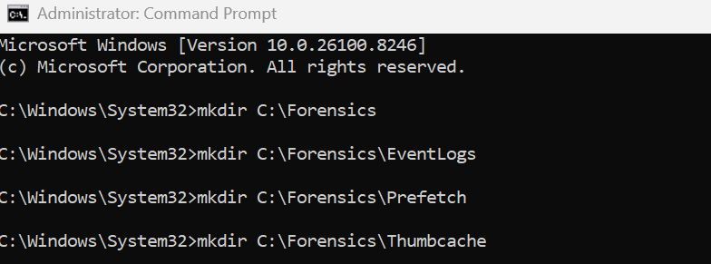
- Evidence Collection and Integrity
The Security Event Log was collected from the default Windows directory:
C:\Windows\System32\winevt\Logs\Security.evtx
Instead of working directly on the original file, it was copied into a dedicated forensic working folder:
C:\Forensics\EventLogs
This approach follows standard forensic procedures because:
- It prevents accidental modification of original evidence
- It allows safe analysis on a duplicate copy
- It maintains the integrity of the investigation

3. Why Windows Security Logs Are Important
Windows Security Logs contain records of authentication and account-related actions. These logs are stored in the file:
C:\Windows\System32\winevt\Logs\Security.evtx
The .evtx format is the standard Windows Event Log format.
Security logs are important because they can show:
Successful logins
Failed login attempts
Administrative privilege use
Account activity
Service logons
Possible signs of compromise
In a real incident response case, attackers often leave traces in the Security log. Even if they delete tools or files, authentication events may still remain in the logs unless the attacker clears them.If the Security log is manually cleared, Windows may record Event ID 1102, which is very important because it can indicate anti-forensic behavior.

4. Evidence Integrity and Hashing
After copying the Security log, a SHA256 hash was generated.
A hash is like a digital fingerprint of a file. If the file changes even slightly, the hash value also changes.
The purpose of hashing is to prove that the evidence was not modified after collection.
For example, if the hash value of the copied Security log is recorded before analysis, then later the same file can be hashed again. If both hash values match, it proves the file remained unchanged.
This is important in digital forensics because evidence must be reliable, repeatable, and defensible.
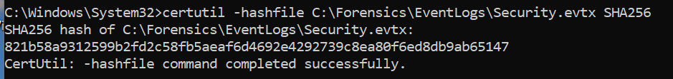

5. Log Parsing and Data Preparation
Since EVTX files are not easily readable in bulk, the tool EvtxECmd was used to convert the log file into CSV format.
This step made the analysis more efficient by allowing:
- Filtering specific Event IDs
- Sorting events based on timestamps
- Extracting relevant fields such as username, logon type, and status
Using Excel or spreadsheet tools, large volumes of log data can be quickly analyzed and organized into meaningful patterns.
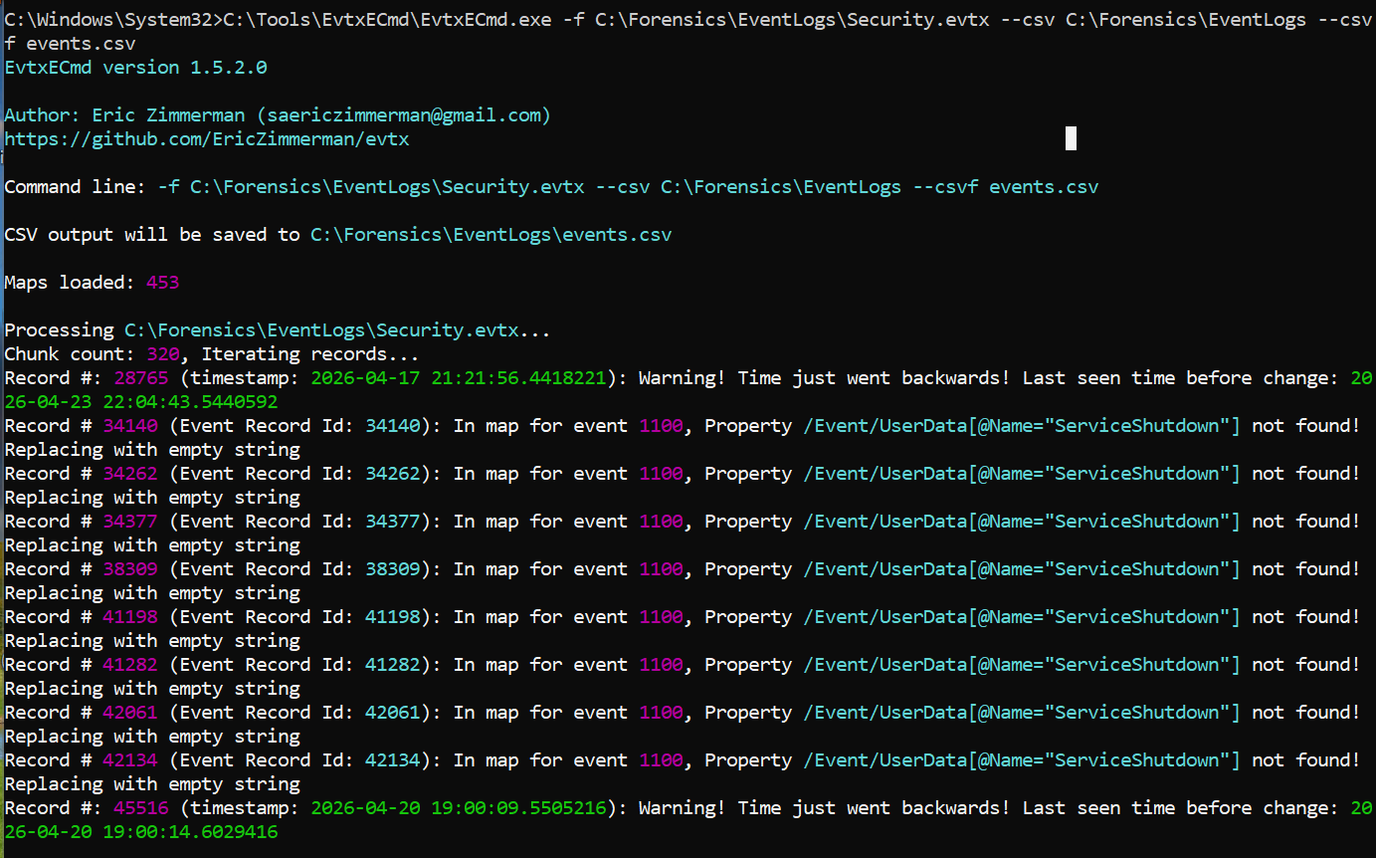
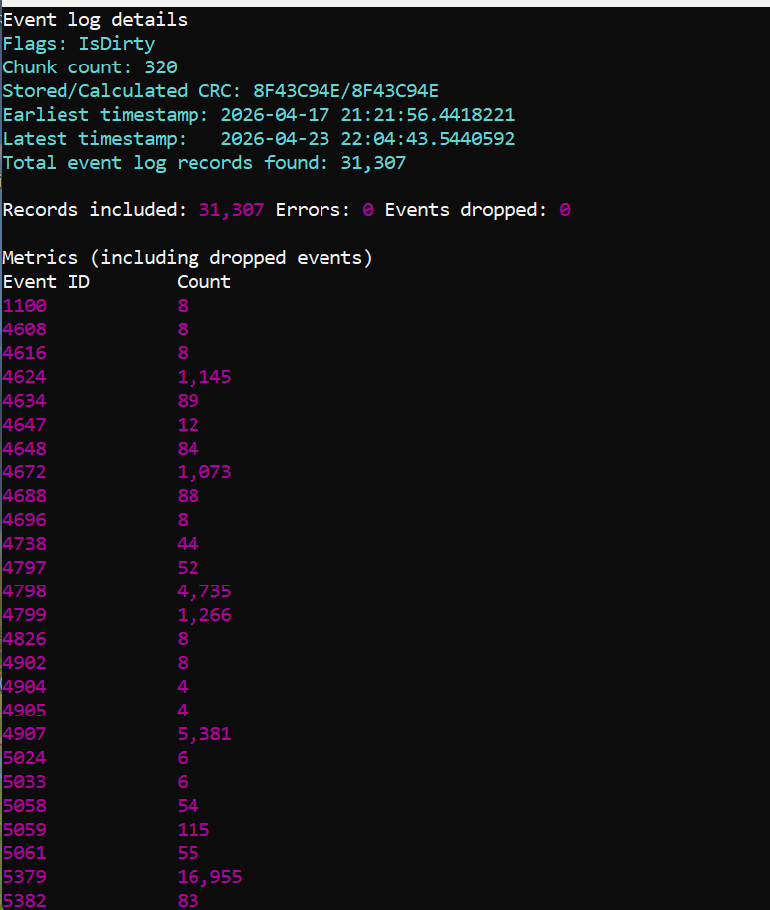

6. Key Event IDs and Their Significance
The analysis mainly focused on three important Event IDs:
- 4624 — Successful Logon
- 4625 — Failed Logon
- 4672 — Special Privileges Assigned
Each of these events provides different insights into system activity and user behavior.
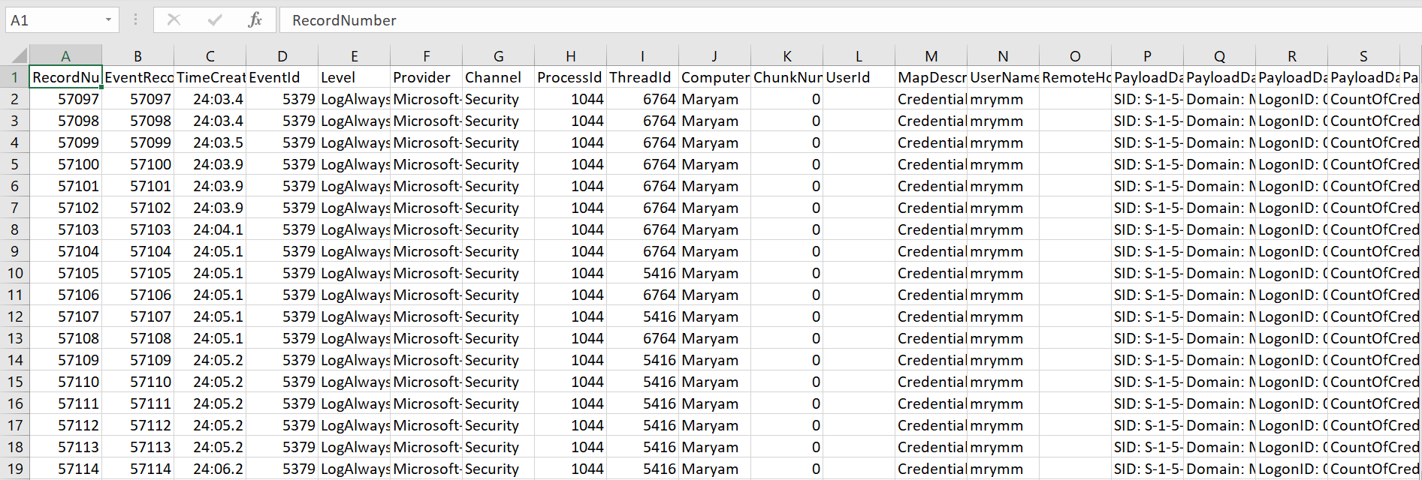
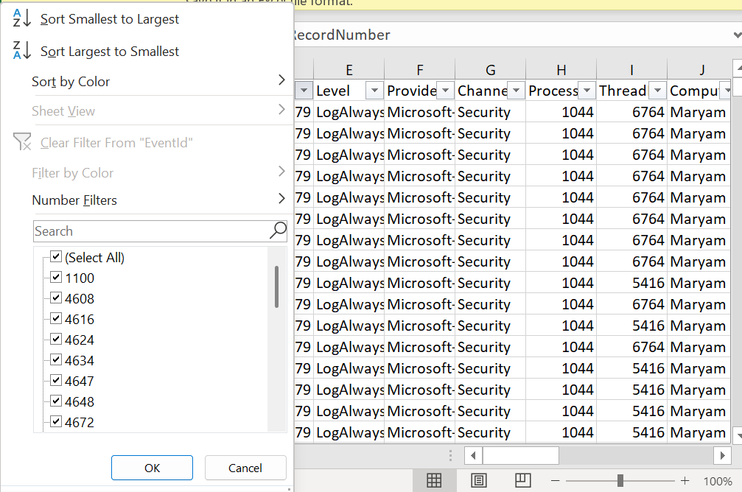
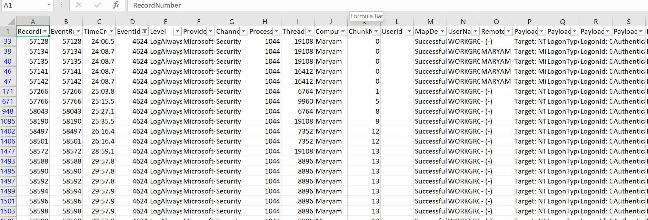

7. Human Activity Analysis (Event ID 4624)
Event ID 4624 indicates a successful login. However, not all successful logins represent human interaction. Windows generates many automated logins for services and background tasks.
To accurately identify real user activity, Logon Types were analyzed:
- Logon Type 2: Physical login at the system (keyboard login)
- Logon Type 7: Unlocking the system after it was locked
By focusing on these types, it was possible to create a user activity timeline.

What this helped identify:
- Start and end of user sessions
- Frequency of system usage
- Patterns in login behavior
- Any unusual login timings
For example, if logins consistently occur during daytime hours, that pattern becomes the baseline. Any deviation from this pattern could be flagged for further investigation.
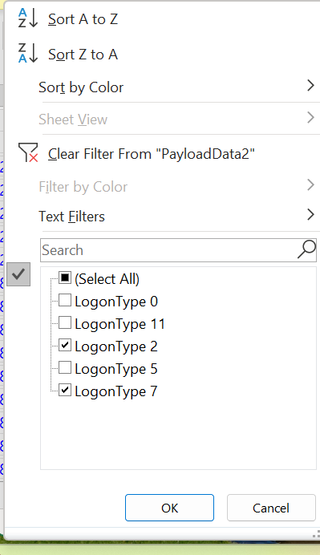
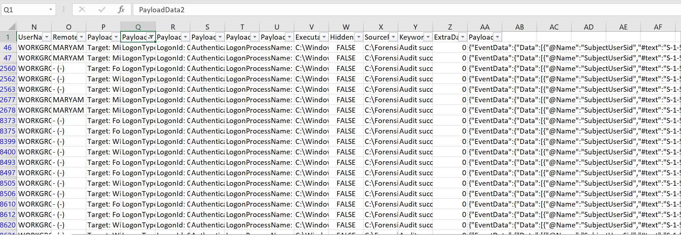
After filtering Event ID 4624 and focusing on Logon Type 2 (Interactive Logon) and Logon Type 7 (Screen Unlock), the following data was obtained:

Extracted Observations:
- Multiple Interactive Logon (Type 2) events were recorded at:
  - 4:20 AM
  - 4:56 AM
  - 9:10 PM
- Multiple Screen Unlock (Type 7) events were recorded at:
  - 4:12 AM
  - 4:27 AM
  - 8:24 PM
  - 9:47 PM

Interpretation
This data clearly shows real human interaction with the system:
- Logon Type 2 (Interactive Logon) indicates that the user logged into the system physically
- Logon Type 7 (Screen Unlock) indicates that the system was locked and later accessed again

Forensic Insight
- The sequence of login → unlock → unlock → login suggests multiple usage sessions
- Activity at early morning hours (around 4 AM) and evening hours (8–9 PM) indicates user usage pattern
- These timestamps help in building a timeline of user presence

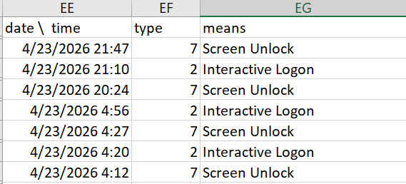

8. Privilege Escalation Analysis (Event ID 4672)
Event ID 4672 is triggered when a user or process is assigned special privileges, typically administrative rights.
This event is significant because privilege escalation is a common step in cyberattacks.

Common legitimate causes include:
- Running Command Prompt as Administrator
- Installing or updating software
- Approving User Account Control (UAC) prompts
During analysis, these events were correlated with actual user actions to determine whether they were legitimate or required further investigation.

Why this matter:
- Unauthorized privilege escalation can indicate compromise
- Helps track high-level system access
- Differentiates normal admin actions from suspicious ones
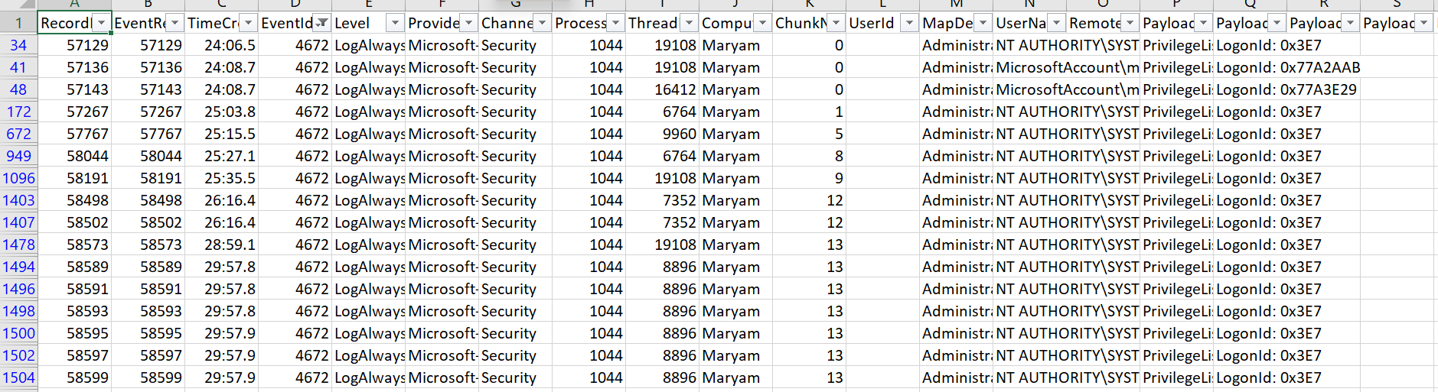
After filtering Event ID 4672, the following entries were observed:

Extracted Data:
- Account: mrymmughal001@gmail.com
- Privileges Assigned:
  - SeSecurityPrivilege
  - SeTakeOwnershipPrivilege
  - SeLoadDriverPrivilege
  - SeBackupPrivilege
  - SeRestorePrivilege
- System Accounts:
  - LOCAL SERVICE
  - NETWORK SERVICE
With privileges such as:
- SeAssignPrimaryTokenPrivilege
- SeImpersonatePrivilege
- SeAuditPrivilege

Interpretation
Event ID 4672 indicates that special administrative privileges were assigned.

Key observations:
- The user account received high-level privileges, which usually occur when:
  - Running programs as administrator
  - Performing system-level tasks
- System accounts (LOCAL SERVICE & NETWORK SERVICE) also received privileges, which is normal system behavior

Forensic Insight
- Privilege assignment to the main user account is expected during administrative actions
- Presence of system accounts confirms background system operations
- No abnormal or unknown accounts were observed

9. System Noise and Background Activity (Logon Type 5)
One of the key challenges in Event Log Analysis is distinguishing meaningful events from normal background activity, also known as system noise.
Logon Type 5 represents service logons, which are generated by Windows services running in the background.
Common accounts observed include:
- SYSTEM: Core operating system processes
- LOCAL SERVICE: Limited privilege services
- NETWORK SERVICE: Services requiring network access

Why this is important:
- These accounts generate frequent log entries
- They are part of normal system behavior
- They should not be misinterpreted as malicious activity
Understanding system noise helps reduce false positives and improves analysis accuracy.
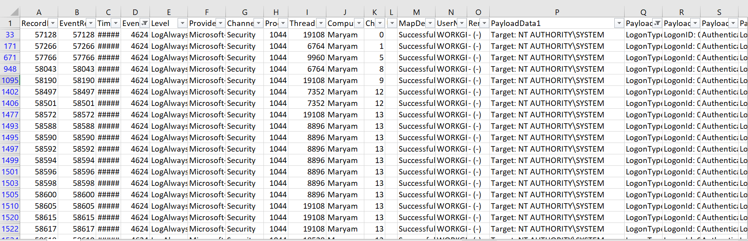
After filtering Event ID 4624 with Logon Type 5, the following entries were observed:

Extracted Data:
- Username: WORKGROUP\MARYAM$
- Logon Type: 5 (Service Logon)
- Target Accounts:
  - NT AUTHORITY\SYSTEM
  - NT AUTHORITY\LOCAL SERVICE
  - NT AUTHORITY\NETWORK SERVICE

Interpretation
These events represent background service activity, not human logins.

Key points:
- MARYAM$ represents a machine account
- Logon Type 5 confirms service-based authentication
- All target accounts are built-in Windows accounts

Forensic Insight
- These logs are part of normal Windows operations
- They occur automatically without user interaction
- They should not be flagged as malicious
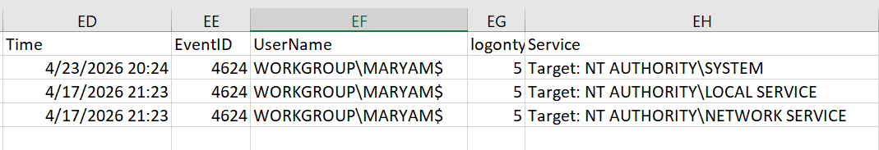

10. Additional Observations and Indicators
While analyzing the logs, certain indicators were considered important:
- Logins at unusual hours
- Multiple failed login attempts
- Unexpected administrative privilege assignments
- Unknown user accounts
- Event ID 1102 (Log Cleared) — potential anti-forensic activity
These indicators are commonly used in real-world investigations to detect suspicious behavior

4. PART B — PREFETCH ANALYSIS

Overview
Part B focused on the analysis of Windows Prefetch files, which provide detailed evidence of program execution on the system. Prefetch artifacts are important in digital forensics because they help identify which applications were executed, how frequently they were used, and from which locations they were launched.
The objective of this part was to:
- Identify commonly used programs
- Detect execution from suspicious locations
- Analyze execution frequency and timestamps
- Build an execution timeline
- Correlate findings with Event Log analysis
- Evidence Collection
The Prefetch directory was copied from:
C:\Windows\Prefetch
to:
C:\Forensics\Prefetch

Observation
- A large number of .pf files were successfully copied
- Examples observed:
  - CHROME.EXE-*.pf
  - CODE.EXE-*.pf
  - CMD.EXE-*.pf
  - BACKGROUNDTASKHOST.EXE
  - AUDIODG.EXE

Interpretation
Each .pf file represents an executed program.
Multiple entries of the same executable (e.g., Chrome, Code) indicate:
- Frequent usage
- Execution from different paths (due to different hash values)

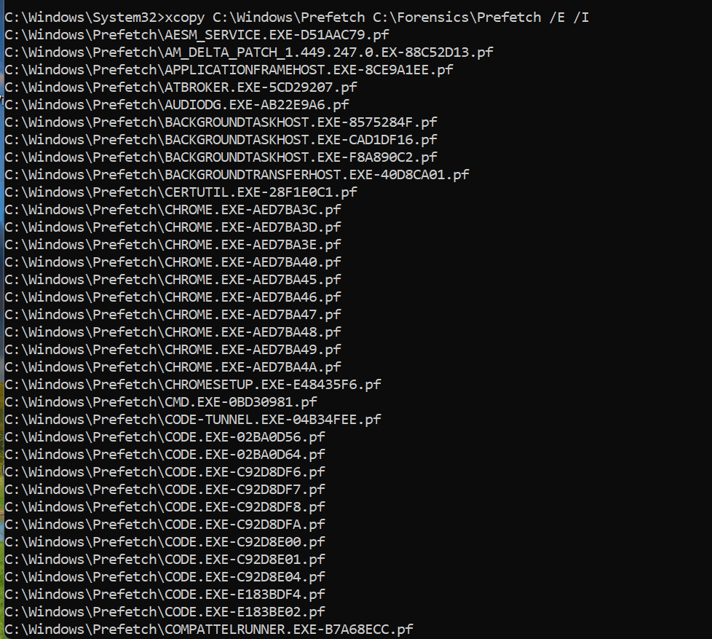
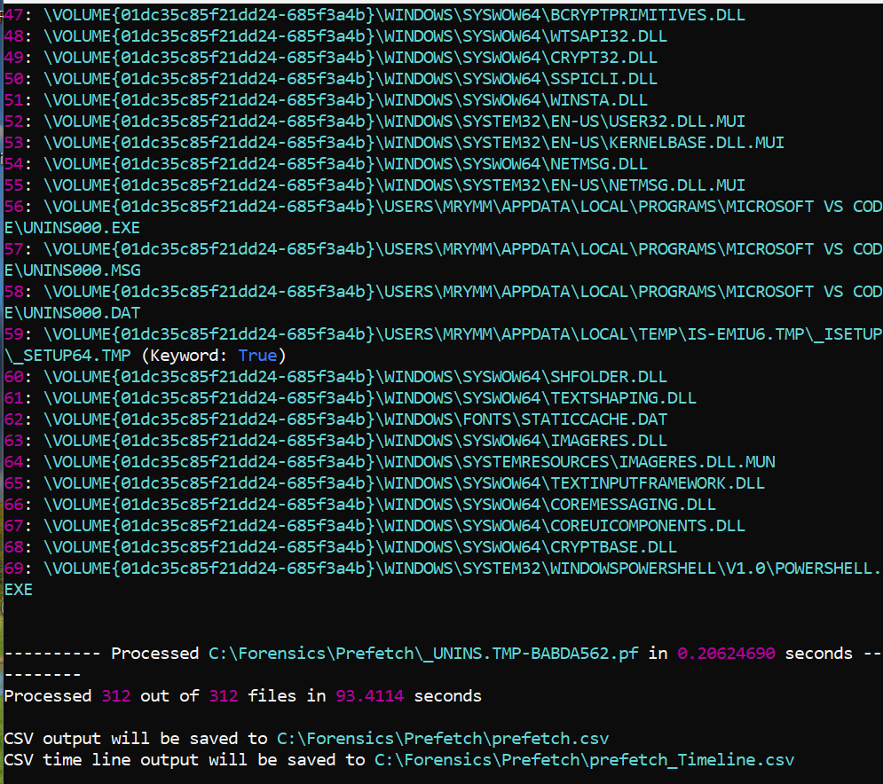
- Prefetch Parsing and Output
Prefetch files were parsed using PECmd, which produced:
- prefetch.csv
- prefetch_timeline.csv

Observation
- Total Prefetch files processed: 312 files
- CSV output successfully generated
- Timeline CSV created for execution tracking

Interpretation
- High number of Prefetch files indicates active system usage
- CSV structure allows efficient filtering and analysis
- Timeline data is useful for reconstructing user activity
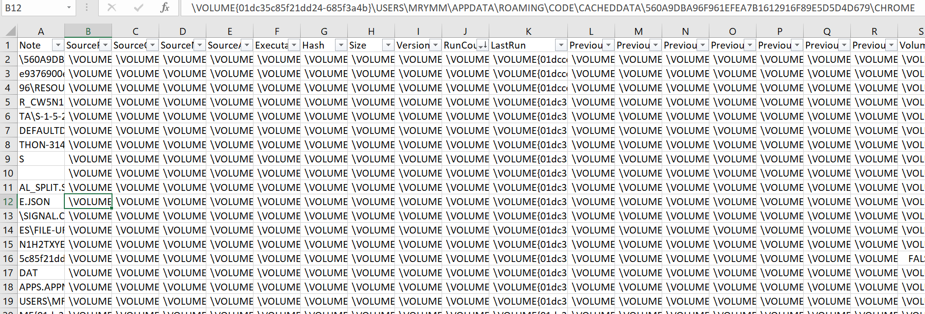

3. Analysis of Frequently Executed Programs
From the CSV output, the following programs were identified as frequently executed:
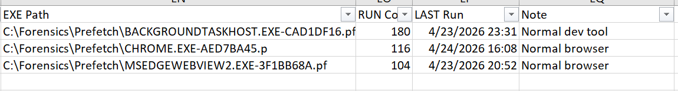

Interpretation
- Chrome and Edge WebView indicate regular browsing activity
- VS Code (CODE.EXE) indicates development or coding activity
- BackgroundTaskHost represents normal Windows background operations

Forensic Insight
- High run count = normal user behavior
- These programs form the baseline of expected execution activity
- No unknown or suspicious high-frequency program detected

4. Suspicious Path Analysis
From PECmd output, the following paths were observed:
C:\Users\...\AppData\Local\Temp\
C:\Users\...\AppData\Roaming\
C:\Users\...\Downloads\

Key Finding
Example path:
C:\Users\...\AppData\Local\Temp\IS-EMIU6.TMP\_SETUP64.TMP

Interpretation
- This path belongs to the Temp directory
- Temporary folders are often used by:
  - Software installers
  - Extracted files
  - Scripts and temporary executables

Forensic Insight
- Execution from Temp is considered potentially suspicious
- However, presence of:
  - UNINS000.EXE
  - Setup-related files
suggests this is likely legitimate installation activity
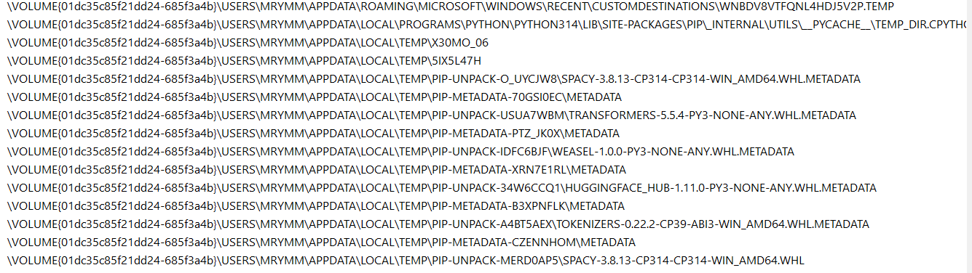

5. Download and Recent File Activity
The dataset included entries such as:
Downloads\desktop.ini
Recent\downloads.lnk

Interpretation
- Shows user interaction with downloaded files
- Indicates recent file access activity

Forensic Insight
- Helps track user file interaction
- Useful in identifying downloaded tools in investigations
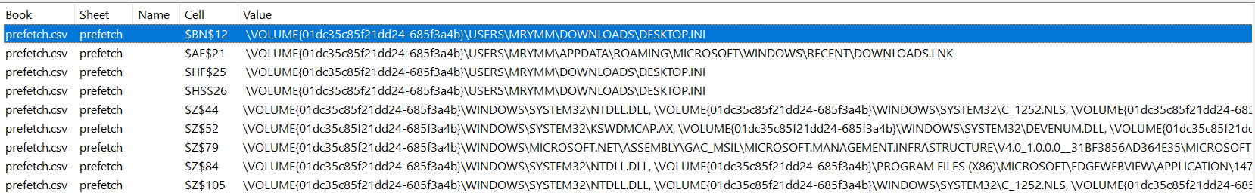

6. Application Data and File Access Analysis
The Prefetch CSV also revealed access to files in:
- AppData\Roaming\Code\Logs
- AppData\Local\Temp\pip-*
- Python-related directories

Interpretation
- Indicates use of:
  - Visual Studio Code
  - Python environment
  - Package installations (pip)

Forensic Insight
- Confirms development activity on the system
- Temp files related to Python packages are normal
- No malicious execution indicators observed

7. USB Device Analysis
A search for USB-related activity was performed.

Observation
- No evidence of USB drive execution found

Interpretation
- No external storage devices were used for executing programs
- Reduces likelihood of external malware introduction
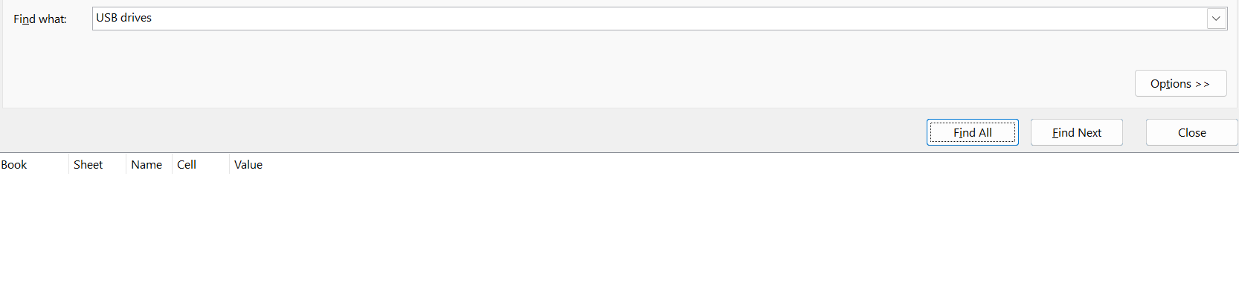

8. Execution Timeline Analysis
The timeline CSV provided timestamps for program execution.

Key Observations
- Programs executed during:
  - Evening hours
  - Active login sessions
- Execution aligns with:
  - Event Log login times

Forensic Insight
- Confirms consistency between:
  - User login activity (Part A)
  - Program execution activity (Part B)

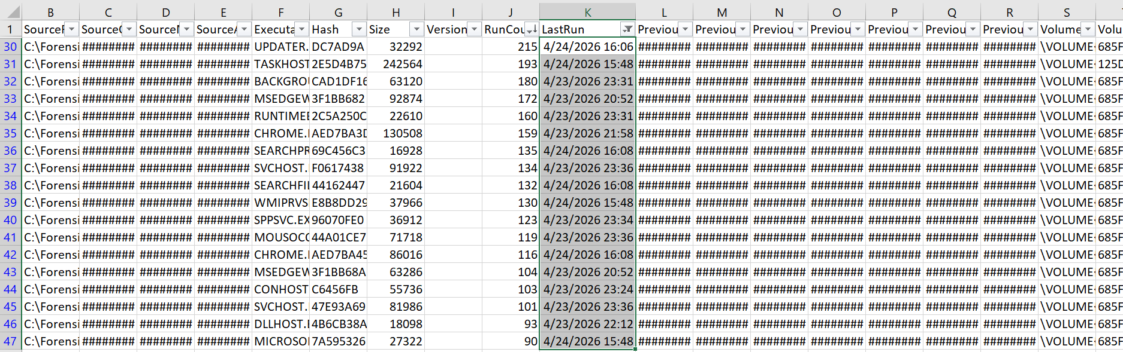

9. Correlation with Event Logs
Prefetch results were compared with Event Log data.

Example Correlation
- Login event → followed by Chrome/Code execution
- No execution without login detected

Interpretation
- Indicates legitimate user activity
- No signs of unauthorized execution

10. Key Findings from Part B
- 312 Prefetch files indicate heavy system usage
- Chrome and VS Code are primary user applications
- Temp directory execution observed (likely installer-related)
- No suspicious unknown executables detected
- No USB-based execution found
- Strong correlation with Event Log activity

5. PART C — CACHE, THUMBCACHE & RECYCLE BIN ANALYSIS

Overview
Part C focused on analyzing user activity artifacts, specifically Thumbcache, Browser Cache, and Recycle Bin data. These artifacts are important because they provide evidence of user interaction with files, images, and web content, even when the original data is deleted.
Unlike Prefetch (which shows program execution), these artifacts help reconstruct:
- What the user viewed
- What the user accessed online
- What the user deleted
These types of artifacts are especially valuable in investigations because they often persist independently of the original files.

Thumbcache Analysis

1. Evidence Collection
Thumbcache files were extracted from:
C:\Users\mrymm\AppData\Local\Microsoft\Windows\Explorer

Observation
- Total 15 thumbcache database files were identified
- Files included:
  - thumbcache_16.db
  - thumbcache_32.db
  - thumbcache_96.db
  - thumbcache_256.db
  - thumbcache_768.db
  - thumbcache_exif.db

Interpretation
- Each .db file stores thumbnails of different image sizes
- Larger files (e.g., thumbcache_256.db, thumbcache_768.db) contain more detailed thumbnails
- Presence of multiple databases indicates frequent browsing of image-based content

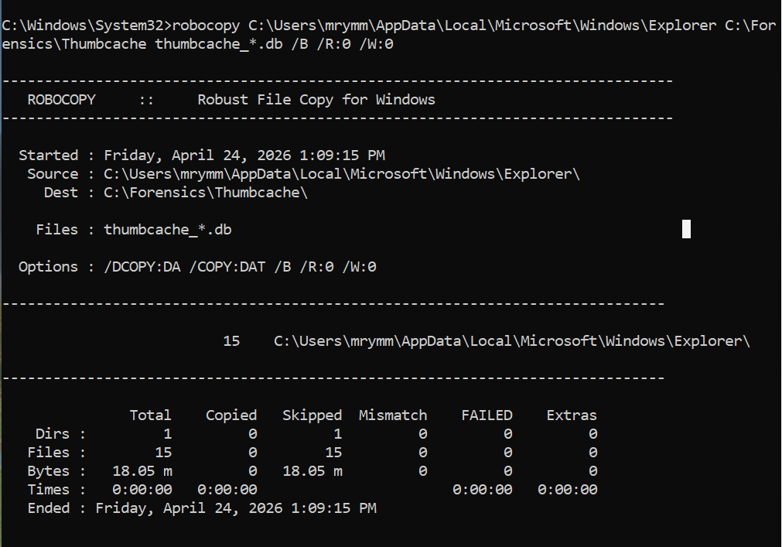
  - Thumbnail Extraction & Analysis
Using Thumbcache Viewer, thumbnail entries were successfully extracted.

Observed Data
- Multiple .jpg entries were found
- Example recovered image: Windows wallpaper preview
- Each entry contained:
  - File name
  - Cache size
  - Data offset

Forensic Insight
- Thumbcache proves that images/files were viewed by the user
- Even if the original file is deleted, thumbnails remain stored in cache
- This artifact provides visual evidence of user activity

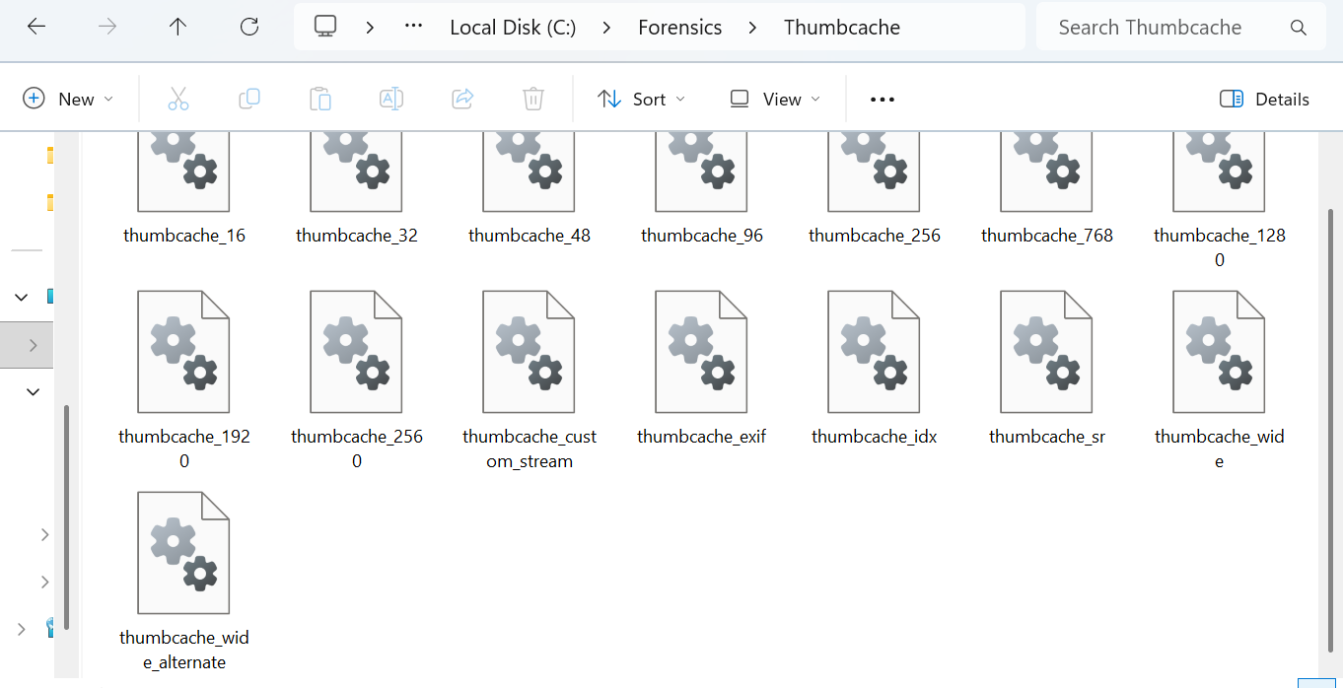
The thumbcache database files were successfully extracted from the system. Multiple thumbcache files of different sizes were identified, including thumbcache_256.db, which stores high-resolution thumbnails. Although the contents could not be visually parsed due to the absence of a dedicated tool, the presence of these files confirms that thumbnail data exists. This indicates that the user viewed images or folders on the system, as Windows automatically generates thumbnails for visual content.
File | Purpose
thumbcache_256.db | Stores large thumbnails
thumbcache_96.db | Stores medium thumbnails
thumbcache_32.db | Stores small thumbnails
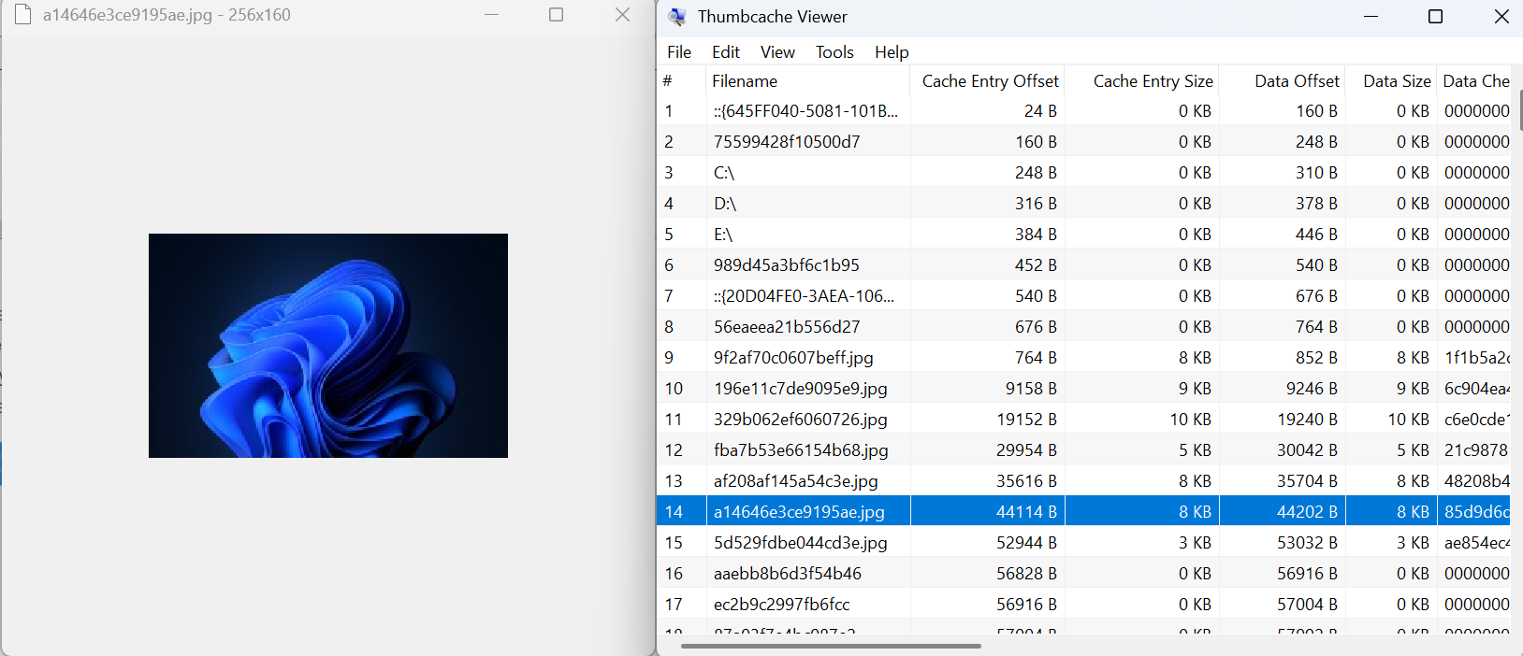
File Name | Source DB | Description
a14646e3ce9195ae.jpg | thumbcache_256.db | Windows system wallpaper thumbnail
196e11c7de9095e9.jpg | thumbcache_256.db | Image preview stored by system

B. Browser Cache Analysis

1. Evidence Location
Browser cache was located at:
C:\Users\mrymm\AppData\Local\Google\Chrome\User Data\Profile 2\Cache

Observation
- Cache folders present:
  - Cache_Data
  - No_Vary_Search
- Last modified timestamps indicate recent activity

Interpretation
- Cache stores locally downloaded web content such as:
  - Images
  - HTML pages
  - Scripts
  - Website resources
- Presence of these files confirms:
  - Active web browsing sessions
  - Interaction with online content

Forensic Insight
- Browser cache can reveal:
  - Websites accessed
  - Downloaded content
  - Time of access
- Even if browser history is cleared:
  - Cache files may still exist

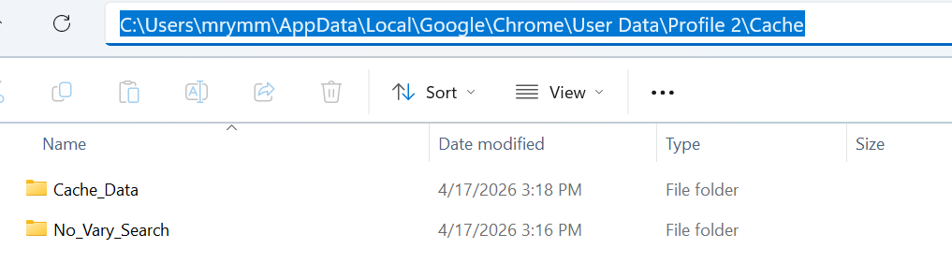

Additional Analysis Value
- Helps detect:
  - Suspicious websites
  - Downloaded malware
  - User online behavior
- Can be correlated with:
  - Prefetch (browser execution)
  - Event Logs (login times)

C. Recycle Bin Analysis

1. Evidence Collection
Recycle Bin was accessed using:
cd C:\$Recycle.Bin
dir /a

Observation
- Multiple directories identified:
  - S-1-5-21-...-1000
  - S-1-5-21-...-1001
- Each directory corresponds to a specific user account (SID)

Interpretation
- Windows stores deleted files separately for each user
- Recycle Bin structure confirms:
  - System contains multiple user profiles
  - Deletion activity is tracked per user

Expected Forensic Data
Normally, Recycle Bin contains:
- $I files → Metadata:
  - Original file path
  - File size
  - Deletion timestamp
- $R files → Actual file data

Current Finding
- No $I or $R files were observed

Forensic Insight
This may indicate:
- Recycle Bin is currently empty
- Files were permanently deleted
- Storage space was overwritten
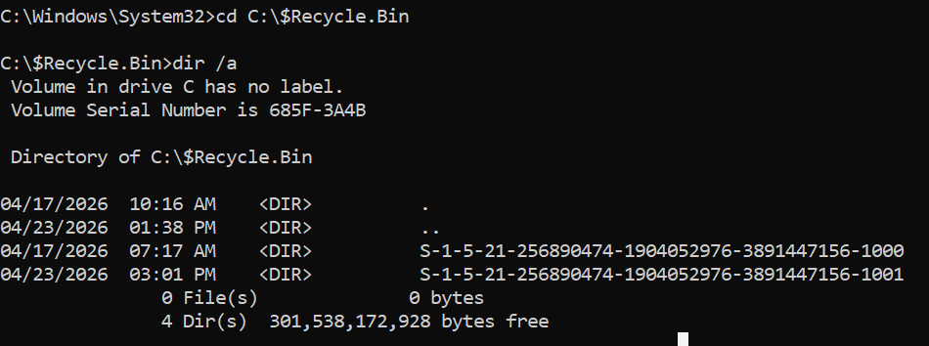
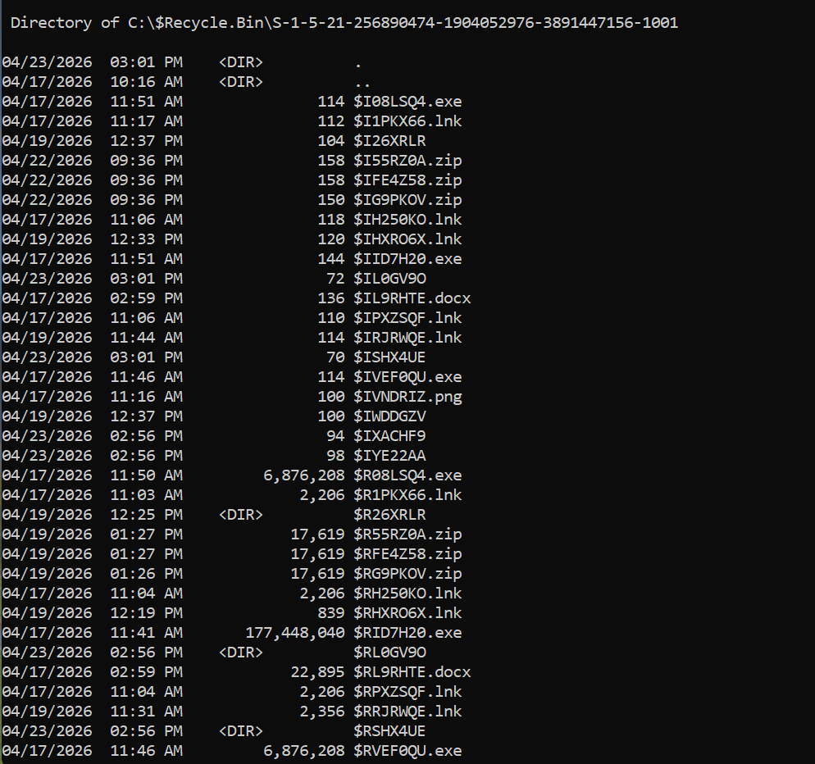

Investigative Importance
- Helps track deleted file activity
- Can reveal attempts to hide evidence
- Useful in timeline reconstruction
File Name | Type | Meaning
$IFE4Z58.zip | $I | Metadata of deleted ZIP file
$R0BLSQ4.exe | $R | Deleted executable file
$IL9RHTE.docx | $I | Deleted document file
$RVNDRIZ.png | $R | Deleted image file

The Recycle Bin directory was analyzed and multiple $I and $R files were identified. The $I files store metadata such as original file names and deletion timestamps, while the $R files contain the actual deleted file content. Various file types including ZIP, EXE, DOCX, and PNG were observed, indicating that different types of user files were deleted from the system. This confirms active file deletion activity on the system.

D. Cross-Artifact Correlation
This part connects findings from all three analyses:

Observed Pattern
- Event Logs → show user login activity
- Prefetch → shows programs executed
- Cache/Thumbcache → shows content viewed

Correlation Insight
- User logged in → executed browser or apps → viewed files/images
- Activity is consistent across all artifacts
- No conflicting or suspicious behavior observed

Key Findings from Part C
- 15 thumbcache databases confirm active file/image viewing
- Thumbnail images successfully recovered
- Browser cache confirms regular web browsing activity
- Recycle Bin structure identified, but no recoverable deleted files found
- No evidence of suspicious or hidden activity

