
CYBERSTER BLUE TEAM INTERNSHIP
WEEK 2 REPORT : Implementation of File Integrity Monitoring, Custom Wazuh Rules, Log Analysis, and Active Response using Wazuh SIEM
Submitted By: Maryam Mughal
ID: CSI-B1-293

Internship Program: Cyberster Blue Team Internship
Track: Blue Team – SOC Operations and SIEM Foundations

Week: Week 2 (Days 8 – 14)
Submission Date: 15-March-2026
Submitted To: Abdullah Zia

Table of Contents
- Introduction
- Lab Environment Setup
- Day 8–9: File Integrity Monitoring (FIM)
  - Configuration of FIM
  - Monitoring Critical Directories
  - Testing File Integrity Alerts
- Day 10–11: Custom Wazuh Rules
  - Rule for Linux User Creation Detection
  - Rule for SSH Brute Force Detection
  - Rule for USB Device Detection
- Day 12–13: Log Analysis
  - Linux Authentication Logs
  - Windows Security Event Analysis
  - Event Timeline Creation
- Day 14: Active Response Implementation
  - Firewall Drop Configuration
  - Blocking Attacker IP
- Results and Observations
- Challenges Encountered
- Conclusion
- References

1. Introduction
Security monitoring is an essential component of modern cybersecurity operations. Organizations must continuously monitor their systems to detect unauthorized activities, suspicious login attempts, and potential attacks. Security Information and Event Management (SIEM) platforms help achieve this by collecting logs from multiple sources, analyzing them, and generating alerts for security teams.
Wazuh is an open-source SIEM solution that provides capabilities such as file integrity monitoring, log analysis, intrusion detection, and automated incident response. It allows security teams to monitor endpoints, detect suspicious behavior, and respond quickly to potential threats.
In this lab, Wazuh was configured to monitor system activity, detect security threats, and automatically respond to malicious behavior. The tasks included implementing File Integrity Monitoring, creating custom detection rules, analyzing authentication logs, and configuring active response to block attackers.
The lab environment consisted of a Wazuh server and a Kali Linux machine used to simulate attacker activity. By generating security events and analyzing them in the Wazuh dashboard, the effectiveness of SIEM monitoring and threat detection was demonstrated.

2. Lab Environment Setup
The lab environment was created using Oracle VirtualBox virtualization software. Two virtual machines were used to simulate a monitored system and an attacker system.

Wazuh Server
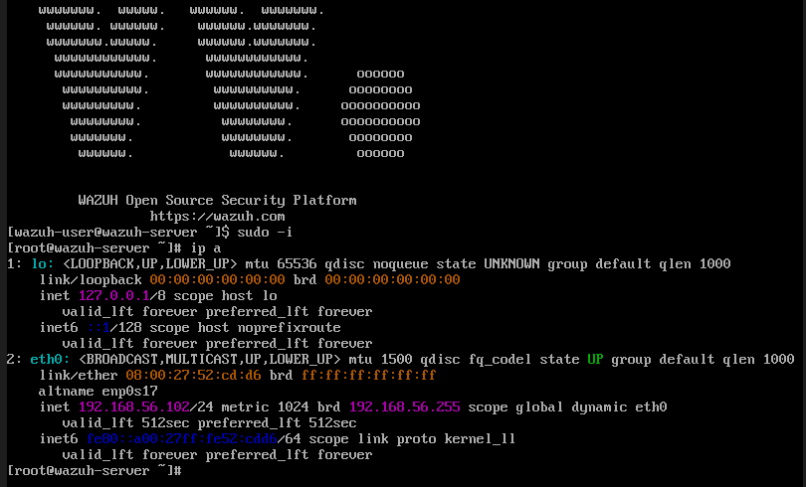
The Wazuh server was deployed using the official Wazuh OVA image. This server acted as the central SIEM platform responsible for collecting logs, analyzing security events, and generating alerts. The Wazuh dashboard provided a visual interface for monitoring detected threats and reviewing system activity.

Kali Linux Machine
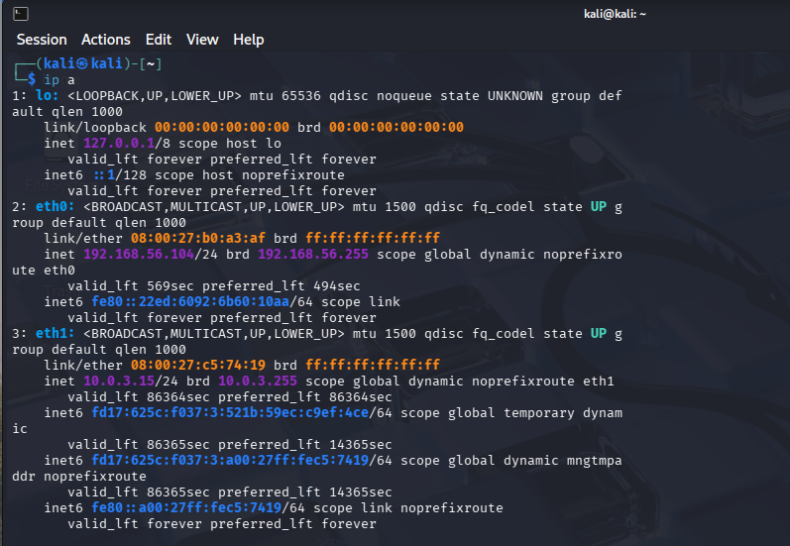
A Kali Linux virtual machine was used to simulate attacker activity. This system generated malicious events such as repeated SSH login attempts to test the detection capabilities of the Wazuh SIEM.

Network Configuration
Both virtual machines were connected using a host-only network adapter, allowing them to communicate with each other in an isolated environment.
Example network configuration:
System |  | Role
Wazuh Server |  | Monitoring Server
Kali Linux |  | Attacker Machine
This configuration allowed Kali Linux to perform simulated attacks while Wazuh monitored system activity and generated alerts.

3. Day 8–9: File Integrity Monitoring (FIM)

3.1 Overview of File Integrity Monitoring
File Integrity Monitoring (FIM) is a security mechanism used to detect changes in important system files and directories. It helps identify unauthorized modifications that may indicate malicious activity, system misconfiguration, or potential compromise.
In security operations centers (SOC), FIM is widely used to monitor critical operating system files, configuration files, and application directories. When a monitored file is created, modified, or deleted, the monitoring system generates an alert so that security analysts can investigate the event.
Wazuh implements file integrity monitoring using the syscheck module, which continuously checks monitored directories and compares file metadata such as permissions, ownership, timestamps, and cryptographic hashes.

3.2 Objective of the Task
The objective of the Day 8–9 task was to configure File Integrity Monitoring on selected directories and verify that Wazuh can detect file creation, modification, and deletion events.
Specifically, the task required:
- Monitoring critical directories
- Generating test file changes
- Observing alerts generated by Wazuh
- Analyzing the security significance of the detected events

3.3 Configuration of File Integrity Monitoring
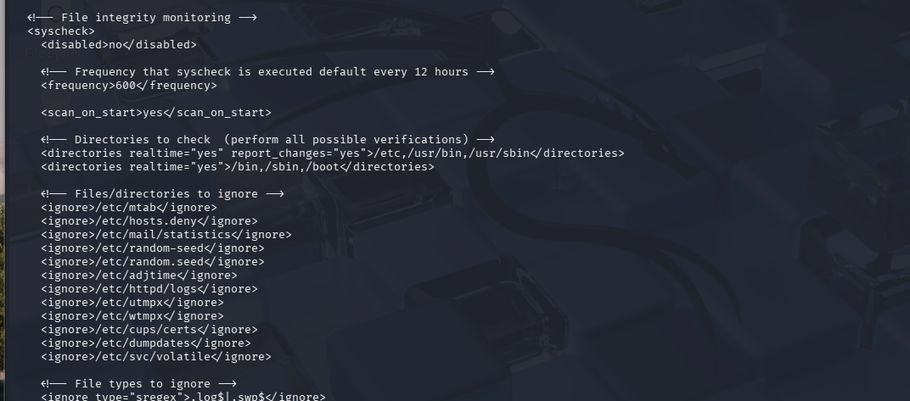
File integrity monitoring was configured in the Wazuh agent configuration file:
/var/ossec/etc/ossec.conf
Inside this configuration file, the syscheck module was enabled to monitor specific directories.

Parameter | Description
frequency | Determines how often the system scans files
realtime="yes" | Enables immediate detection of file changes
report_changes="yes" | Allows Wazuh to report file content changes
The /etc directory was monitored with report_changes enabled because it contains critical configuration files that are important for system security.
The /var/log directory was monitored without report_changes to avoid excessive alerts due to frequent log updates.

3.4 Directories Selected for Monitoring
The following directories were monitored during the lab:
- The /etc directory contains essential configuration files for the Linux operating system. Many important files related to authentication and system configuration are stored in this directory.
Examples include:
- /etc/passwd
- /etc/shadow
- /etc/gshadow
- /etc/sudoers
Monitoring this directory helps detect unauthorized configuration changes that could compromise system security.
- The /var/log directory contains system log files. Monitoring this directory helps detect potential log tampering or suspicious activity related to system operations.

3.5 Restarting the Wazuh Agent
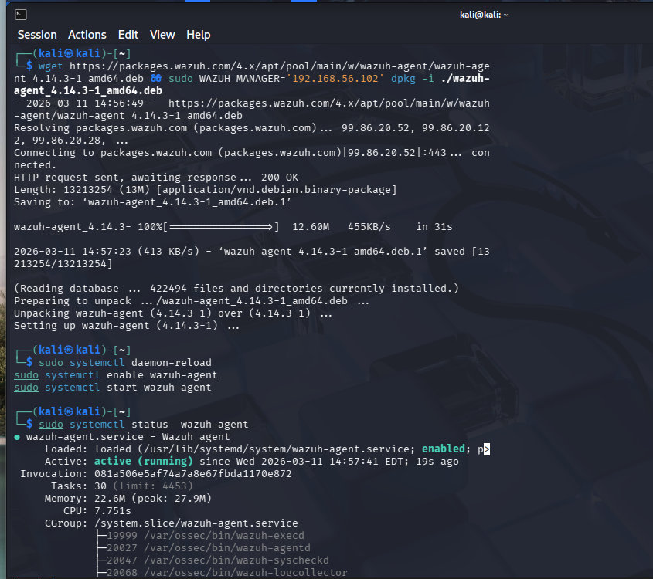
After modifying the configuration file, the Wazuh agent needed to be restarted to apply the changes.
Command used:
sudo systemctl restart wazuh-agent
The agent status was verified using:
sudo systemctl status wazuh-agent
The agent was confirmed to be active and successfully connected to the Wazuh manager.

3.6 Testing File Integrity Monitoring
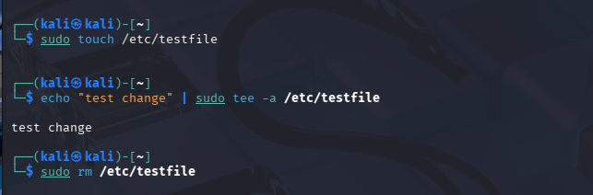
To verify that File Integrity Monitoring was working correctly, several test actions were performed.

File Creation Test
A test file was created in the monitored directory.

File Modification Test
The test file was modified using the following command:

File Deletion Test
Finally, the test file was removed:

3.7 Observed Alerts in Wazuh
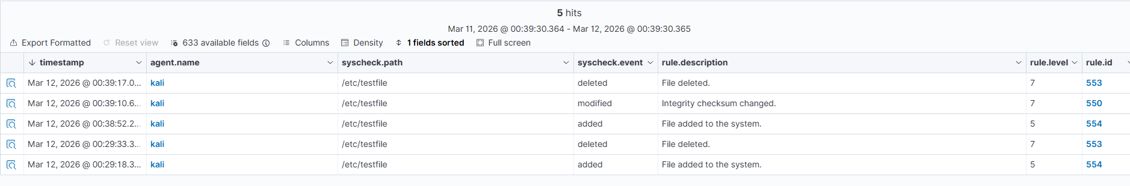
During testing, Wazuh successfully generated alerts for file changes.
The alert details included information such as:
- File path
- User ownership
- Group ownership
- File permissions
- MD5, SHA1, and SHA256 hashes
- Timestamp of the change
This confirmed that the File Integrity Monitoring system was functioning correctly.

3.8 Findings
The File Integrity Monitoring configuration was successfully implemented and tested. Wazuh detected file creation, modification, and deletion events within the monitored directories. Alerts generated by the system provided detailed information about file changes, demonstrating the effectiveness of the FIM module in identifying potentially suspicious activity.

4. Day 10–11: Custom Wazuh Rules

4.1 Introduction to Custom Rules
Wazuh provides a large number of built-in detection rules that identify common security events such as authentication failures, privilege escalation attempts, and suspicious system activity. However, in many real-world environments organizations require additional detection logic tailored to their specific systems and threat scenarios.
Custom Wazuh rules allow security analysts to define their own alert conditions. These rules analyze incoming log events and generate alerts when predefined patterns or conditions are matched. Custom rules are typically stored in the following configuration file:
/var/ossec/etc/rules/local_rules.xml
Rules defined in this file are processed by the Wazuh manager and can be used to detect specific behaviors such as account creation, repeated login failures, or unauthorized device activity.

4.2 Objective of the Task
The objective of the Day 10–11 task was to create and test three custom Wazuh rules:
- Detection of new Linux user account creation
- Detection of SSH brute-force login attempts
- Detection of USB device insertion events on Windows systems
Each rule required configuration, testing, and verification through the Wazuh dashboard.

4.3 Structure of a Wazuh Rule

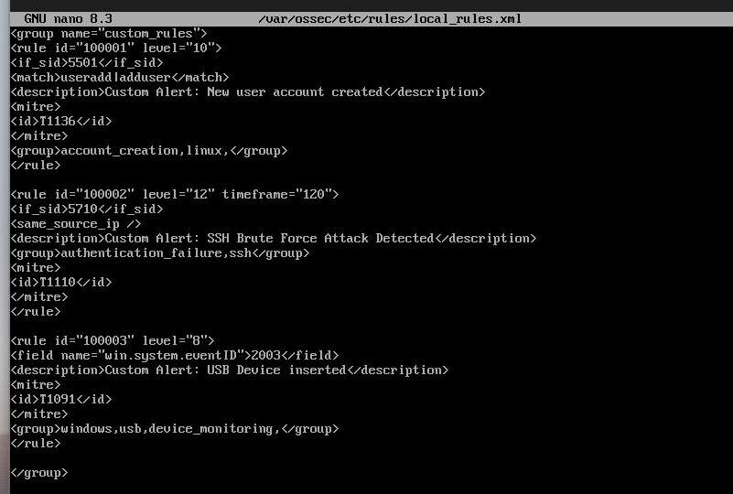
A typical Wazuh rule contains several key components:
Element | Purpose
rule id | Unique identifier for the rule
level | Alert severity level
if_sid | Links the rule to an existing base rule
match / field | Defines the event condition
description | Human-readable explanation of the alert
group | Categorizes the alert
mitre | Maps the rule to a MITRE ATT&CK technique
Rules are written in XML format and stored in the local_rules.xml file.

4.4 Rule 1: Detection of Linux User Account Creation
The first custom rule was designed to detect when a new Linux user account is created on the system.
User account creation events may indicate legitimate administrative activity or unauthorized account creation by an attacker attempting to gain persistence.

Explanation of the Rule

Parameter | Description
rule id | Unique rule identifier
level 10 | Medium-high severity alert
if_sid | Links the rule to an existing base rule
match | Detects user creation commands
MITRE ID | Maps the event to MITRE ATT&CK technique

4.5 Testing the User Creation Rule

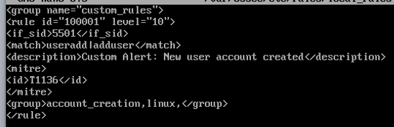
To test this rule, a new user account was created.
The Wazuh dashboard successfully generated an alert indicating that a new user account had been created.

4.7 Observed Alert

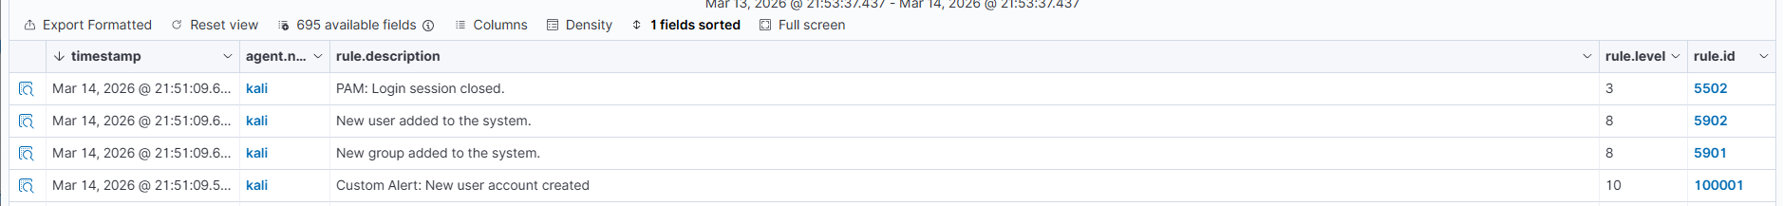
The alert generated in the Wazuh dashboard included the following information:
- Rule ID: 100001
- Alert Level: 10
- Description: Custom Alert: New user account created
- Event Source: Linux system logs
This confirmed that the custom rule was working correctly.

4.8 Rule 2: SSH Brute Force Detection
The second custom rule was designed to detect SSH brute-force attacks.
A brute-force attack occurs when an attacker repeatedly attempts different passwords in order to gain unauthorized access to a system.
Wazuh already generates alerts for failed SSH login attempts, but the goal of this task was to create a correlation rule that triggers when multiple failed login attempts occur within a short time period.

4.9 Explanation of the SSH Rule
Parameter | Description
rule id | Unique identifier for custom brute force detection
level 12 | High severity alert
frequency | Number of failed login attempts required
timeframe | Time window for the attempts
if_matched_sid | Base rule used for failed login detection
This rule triggers when three failed SSH login attempts occur within 120 seconds.

4.10 Problems Encountered During SSH Rule Development
During implementation, several issues were encountered:

Issue 1: Incorrect XML Syntax
An incorrect closing tag in the configuration file caused the Wazuh manager to fail during restart.
The problem was resolved by correcting the XML structure.

Issue 2: Difference Between if_sid and if_matched_sid
Initially, the rule used:
<if_sid>
However, correlation rules that use frequency and timeframe must use:
<if_matched_sid>
Using the correct element resolved the rule validation error.

Issue 3: SSH Session Password Limit
During testing it was observed that SSH allows only three password attempts per connection. Therefore, multiple SSH sessions were required to generate sufficient failed login attempts to trigger the rule.

4.11 Testing the SSH Brute Force Rule

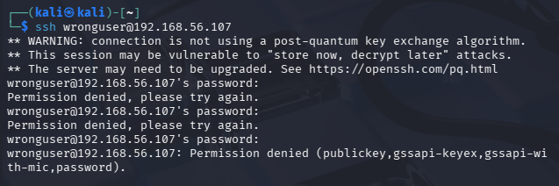
To simulate an attack, repeated failed SSH login attempts were performed from the Kali Linux machine.
Example command used:
ssh wronguser@192.168.56.107
Multiple login attempts with incorrect passwords were entered to simulate brute-force activity.

4.12 Observed SSH Alert

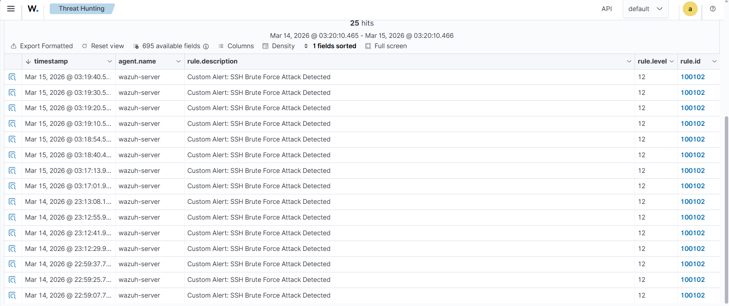

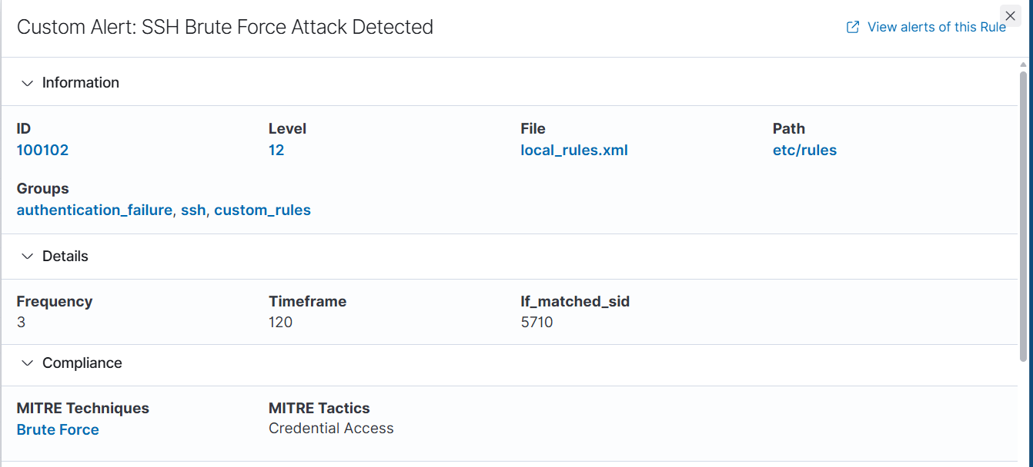
The Wazuh dashboard generated alerts showing:
- Rule ID: 100102
- Alert description: Custom Alert: SSH Brute Force Attack Detected
- Source IP: 192.168.56.104 (Kali machine)
This confirmed that the custom rule successfully detected repeated SSH login failures.

4.13 Understanding the Agent Name in Alerts
During testing it was observed that the alert showed the agent name as wazuh-server rather than kali.
This behavior is expected because the SSH service runs on the Wazuh server. Therefore, the authentication logs are generated on the server where the service exists, not on the attacker machine.

4.14 Rule 3: USB Device Detection

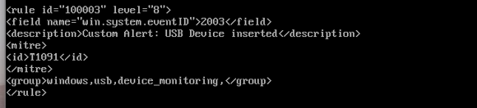
The third custom rule was intended to detect USB device insertion events on Windows systems.

4.15 Findings
The custom rules were successfully implemented and tested. The Linux user creation rule and SSH brute-force detection rule both generated alerts in the Wazuh dashboard. These rules demonstrated how Wazuh can be customized to detect specific security events and improve threat detection capabilities.

5. Day 12–13: Log Analysis

5.1 Introduction to Log Analysis
Log analysis is a critical activity in cybersecurity operations. Security logs provide detailed information about system events, user activity, authentication attempts, and system errors. By analyzing logs, security analysts can detect suspicious behavior, identify potential attacks, and investigate security incidents.
In a Security Operations Center (SOC), log analysis helps defenders understand what happened on a system, when it happened, and how it happened. SIEM platforms such as Wazuh collect logs from multiple systems and correlate them to detect malicious activity.
During this stage of the lab, log analysis was performed using the Wazuh dashboard and Linux system logs. The objective was to analyze authentication events, identify repeated failed login attempts, and construct a timeline of suspicious activity.

5.2 Objective of the Task
The objectives of Day 12–13 were:
- To analyze Linux authentication logs for failed login attempts
- To identify patterns indicating brute-force attacks
- To investigate security events detected by Wazuh
- To understand the significance of important Windows security event IDs
- To create a timeline of suspicious activity

5.3 Linux Authentication Log Analysis
Linux authentication activity is recorded in system logs. These logs contain information about login attempts, authentication failures, and privilege escalation events.
In this lab environment, the system used journald for log management instead of the traditional /var/log/auth.log file.

5.4 Observing Failed SSH Login Attempts

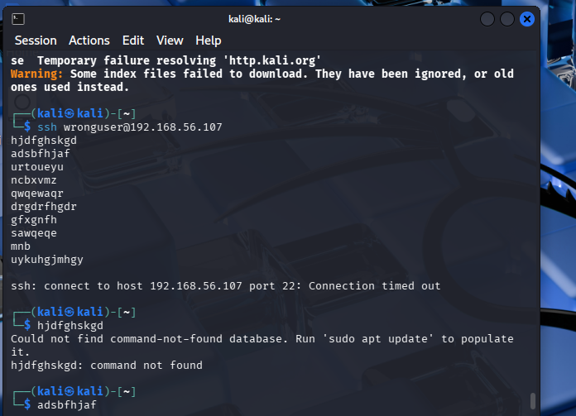
During the attack simulation from Kali Linux, repeated failed login attempts were recorded in the system logs.
Example log entry:
Failed password for invalid user wronguser from 192.168.56.104 port 51422 ssh2
Key information contained in this log entry includes:
Field | Description
invalid user | Username used during the attack
IP address | Source of the login attempt
ssh2 | Protocol used for the connection
These events indicate that an attacker attempted to log in using an invalid username.

5.5 PAM Authentication Failure Logs

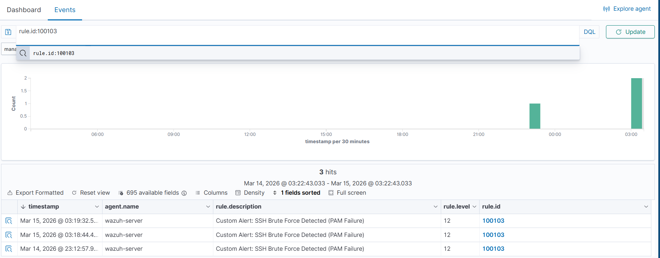
In addition to SSH daemon logs, Linux systems also record authentication failures using the PAM (Pluggable Authentication Module) framework.
Example log entry:
pam_unix(sshd:auth): authentication failure
This message indicates that the authentication process failed during login.
PAM logs are useful because they confirm that authentication was attempted but failed due to incorrect credentials.

5.6 Correlation of SSH and PAM Events
During the attack simulation, multiple events were recorded for each failed login attempt.
These included:
- SSH daemon logs (invalid user attempts)
- PAM authentication failure logs
Wazuh correlated these events and generated alerts using built-in detection rules.
Two important rule IDs were observed:
Rule ID | Description
5710 | Attempt to login using a non-existent user
5503 | PAM authentication failure
These events served as the base events used by the custom brute-force detection rule.

5.7 Identifying the Source of the Attack
The logs clearly showed that the login attempts originated from the Kali Linux machine.
The IP address corresponds to the Kali attacker system used during the lab.
The Wazuh dashboard also displayed this source IP in the event details.

5.8 Timeline of the SSH Attack

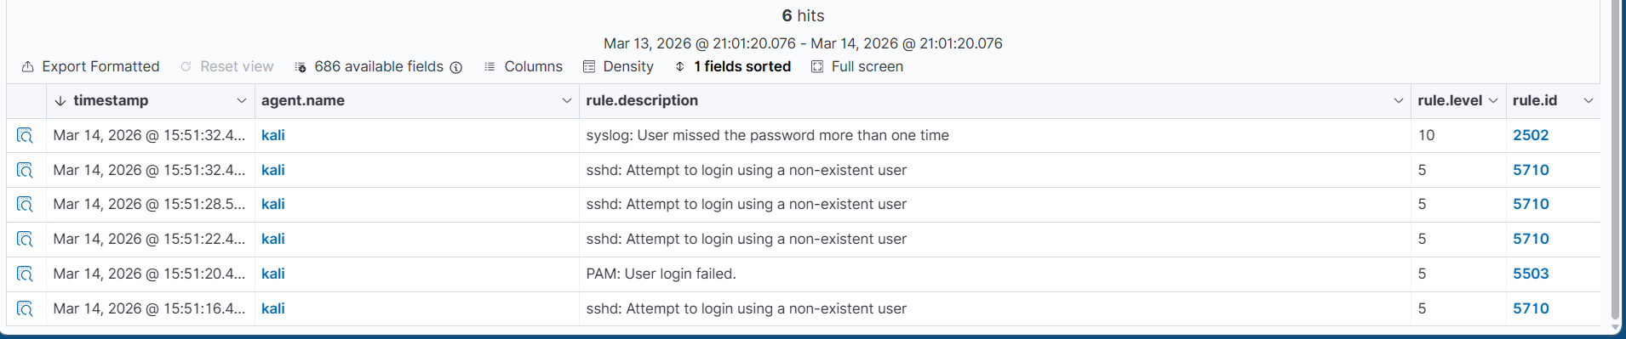
By analyzing the timestamps of the log entries, a timeline of the attack activity was created.
Example timeline:
Time | Event
15:51:16 | Failed SSH login attempt
15:51:22 | Another failed login attempt
15:51:28 | Authentication failure detected
15:51:32 | Additional login attempt
This pattern of repeated login attempts within a short time period indicates a brute-force attack attempt.

5.9 Detection of the Brute Force Pattern
Wazuh analyzed these events and identified the pattern of repeated failed login attempts.
Once the threshold defined in the custom rule was reached, Wazuh generated the following alert:
Custom Alert: SSH Brute Force Attack Detected
This alert confirmed that the correlation rule successfully detected the attack pattern.

6. Day 14: Active Response Implementation

6.1 Introduction to Active Response
Active Response is an automated security feature that allows a system to take immediate action when a suspicious event is detected. Instead of only generating alerts, the system can respond automatically to stop an attack in progress.
In Security Operations Centers (SOC), automated response mechanisms are used to reduce response time and minimize the impact of security incidents. For example, if repeated login attempts indicate a brute-force attack, the system can block the attacker's IP address automatically.
Wazuh provides built-in active response scripts that can perform defensive actions such as blocking IP addresses, terminating processes, or disabling compromised accounts.

6.2 Objective of the Task
The objective of the Day 14 task was to configure Wazuh Active Response to automatically block the attacker’s IP address after detecting a brute-force SSH attack.
Specifically, the task involved:
- Linking the brute-force detection rule to an automated response action
- Configuring the firewall-drop response
- Blocking the attacker’s IP address using the system firewall
- Verifying that the attacker machine could no longer connect

6.3 Active Response Mechanism in Wazuh
The Active Response process follows these steps:
- A security event is detected by Wazuh.
- A rule generates an alert when predefined conditions are met.
- The alert triggers an active response action.
- The response script performs a defensive action on the system.
In this lab, the active response action was triggered when the custom SSH brute-force rule (Rule ID 100102) detected repeated failed login attempts.

6.4 Firewall Drop Response

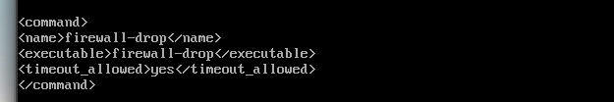
The firewall-drop script is a built-in Wazuh response script that blocks a specific IP address using the system firewall.
When triggered, the script adds a firewall rule that prevents further connections from the attacker.
This helps protect the system from continued brute-force attempts.

6.5 Configuration of Active Response

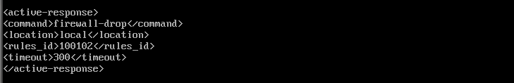
The active response configuration was added to the Wazuh manager configuration file:
/var/ossec/etc/ossec.conf

6.6 Explanation of the Configuration

Parameter | Description
command | Specifies the response script to execute
firewall-drop | Blocks the attacker IP using firewall rules
location | Defines where the response will execute
rules_id | Specifies the rule that triggers the response
timeout | Duration for which the attacker IP remains blocked
In this configuration, the system blocks the attacker IP for 300 seconds.

6.7 Restarting the Wazuh Manager
After modifying the configuration file, the Wazuh manager was restarted to apply the changes.
Command used:
sudo systemctl restart wazuh-manager
The manager status was verified using:
sudo systemctl status wazuh-manager
The service was confirmed to be active and running.

6.9 Simulating the Attack
To test the active response configuration, another brute-force attack simulation was performed from the Kali Linux machine.
The following command was used to initiate SSH login attempts:
ssh wronguser@192.168.56.107
Multiple incorrect passwords were entered to trigger the brute-force detection rule.

6.10 Detection and Automatic Blocking


Once the brute-force rule threshold was reached, Wazuh generated the alert:
Custom Alert: SSH Brute Force Attack Detected
Immediately after the alert, the active response script executed and blocked the attacker IP.

6.11 Verifying the Blocked IP Address

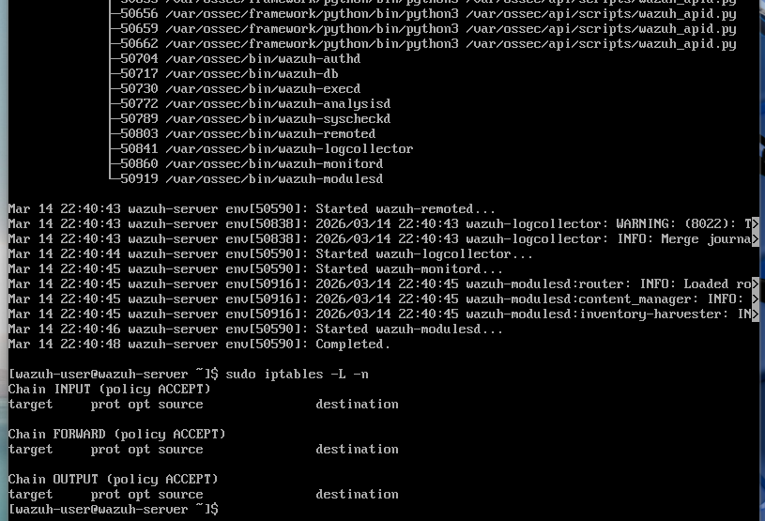
To verify that the attacker had been blocked, the firewall rules were checked using the command:
sudo iptables -L -n
The output displayed a rule similar to:
DROP all -- 192.168.56.104
This confirmed that the Kali attacker machine had been blocked by the firewall.

6.12 Testing the Block
After the active response was triggered, another SSH attempt was made from Kali.
The connection failed with the message:
Connection timed out
This confirmed that the attacker machine could no longer connect to the target system.

6.13 Security Importance of Active Response
Active Response significantly improves the defensive capabilities of a security monitoring system. Instead of only detecting attacks, the system can automatically mitigate threats before they escalate.
In real-world environments, automated response mechanisms help security teams reduce response time and limit damage caused by attackers.
However, active response mechanisms must be configured carefully to avoid blocking legitimate users due to false positives.

6.14 Findings
The active response configuration successfully blocked the attacker machine after detecting a brute-force SSH attack. The firewall-drop script executed automatically and prevented further connections from the attacker IP.
This demonstrated the ability of Wazuh to detect suspicious activity and immediately respond to mitigate the threat.

7. Results and Observations
The lab successfully demonstrated several key security monitoring capabilities using Wazuh SIEM.
File Integrity Monitoring was configured to monitor sensitive system directories and successfully detected changes in critical files such as /etc/gshadow. Custom detection rules were implemented to identify Linux user creation events and repeated SSH authentication failures.
Through attack simulation using Kali Linux, the system successfully generated security alerts and correlated multiple failed login attempts into a brute-force detection alert. Finally, the active response mechanism automatically blocked the attacker IP address using firewall rules.
These results demonstrate that Wazuh can effectively monitor system activity, detect suspicious behavior, and respond automatically to security threats.

8. Challenges Encountered
Several challenges were encountered during the lab:
- Incorrect XML syntax caused Wazuh manager restart failures.
- Understanding the difference between if_sid and if_matched_sid required troubleshooting.
- SSH allows only three password attempts per connection, requiring multiple sessions for testing.
- The absence of iptables in the default environment initially prevented active response execution.
- Some alerts displayed the Wazuh server as the agent instead of the attacker machine, which required understanding how log sources work.
These issues were resolved through troubleshooting and configuration adjustments.

9. Conclusion
This lab demonstrated the practical use of Wazuh SIEM for security monitoring and threat detection. Through the implementation of file integrity monitoring, custom detection rules, log analysis, and automated response mechanisms, the system was able to detect and mitigate simulated attacks.
The experiment showed how security monitoring platforms can help organizations detect suspicious activity in real time and automatically respond to potential threats. The ability to detect file modifications, identify repeated authentication failures, and block attackers demonstrates the effectiveness of SIEM solutions in modern cybersecurity operations.
Overall, the lab provided valuable experience in configuring and using Wazuh as a defensive security tool and highlighted the importance of proactive monitoring in protecting information systems.

10. References
- Wazuh Official Documentation
- Cyberster Blue Team Internship Lab Guide

