CyberSter

CYBERSTER BLUE TEAM INTERNSHIP
WEEK 3 REPORT
Suricata IDS Integration with Wazuh

Submitted By: Maryam Mughal
ID: CSI-B1-293

Internship Program: Cyberster Blue Team Internship
Track: Blue Team – SOC Operations and SIEM Foundations

Week: Week 3 (Days 15 – 21)
Submission Date: 21-March-2026

Submitted To: Abdullah Zia

Table of Contents
- Introduction
- Lab Environment
- Day 15 – Suricata Installation
- Day 16 – Suricata Configuration & Verification
- Day 17 – Custom Rule Writing in Suricata
- Day 18 – Integration of Suricata with Wazuh (Configuration)
- Day 19 – Integration Testing & Alert Verification
- Day 20 – GeoIP Blocking Setup (ipset & iptables)
- Day 21 – Firewall Rules Testing & Validation
- Challenges Faced & Troubleshooting
- Key Learnings
- Conclusion

1. INTRODUCTION
In modern cybersecurity environments, organizations are exposed to a wide range of threats that originate both from internal systems and external networks. Traditional monitoring solutions often focus on host-level activities such as login attempts, file modifications, and process execution. While this approach provides valuable insights into system behavior, it lacks visibility into network-level activities, which are often the initial stage of cyber attacks.
To address this limitation, organizations adopt a layered security approach that combines host-based and network-based monitoring tools. In this lab, two powerful tools were used: Suricata and Wazuh. Suricata is a network intrusion detection system that analyzes network traffic in real time, while Wazuh is a host-based security platform that collects and analyzes logs from endpoints.
The integration of these two tools provides a comprehensive monitoring environment. Suricata detects suspicious network behavior such as scanning and exploitation attempts, while Wazuh detects system-level changes such as privilege escalation and file modifications. When combined, these tools allow analysts to correlate events and understand the full lifecycle of an attack.
The objective of this week was to install and configure Suricata on the Kali Linux system, create custom detection rules, integrate Suricata logs into Wazuh running on Ubuntu, and implement firewall-based GeoIP blocking. This setup simulates a real-world Security Operations Center (SOC) environment where multiple layers of defense work together to detect and respond to threats.

2. LAB ENVIRONMENT
The lab environment consisted of multiple virtual machines, each serving a distinct role in the security architecture. This multi-machine setup is essential for simulating real-world scenarios where different systems interact over a network.
The primary system used was Kali Linux, which served as both an attacker machine and a monitoring node. On this system, Suricata was installed to monitor network traffic, and the Wazuh agent was configured to send logs to the central server. Kali Linux was used to generate various types of network traffic, including scans and requests, to test the detection capabilities of the system.
The second system was Ubuntu, which hosted the Wazuh Manager and dashboard. This system acted as the central monitoring platform, receiving logs from the Kali machine, processing them, and displaying alerts in a structured format. The Wazuh dashboard provided visibility into both network and host-based events.
A Windows machine was also used as a target system to simulate a victim environment. This allowed realistic testing of network scans and attack scenarios.
The interaction between these systems created a complete monitoring pipeline. Traffic generated from Kali Linux was analyzed by Suricata, and alerts were forwarded to the Wazuh Manager on Ubuntu. This centralized view allowed correlation of events and provided a better understanding of attack behavior.

3. DAY 15–16: SURICATA INSTALLATION & CONFIGURATION

3.1 Understanding Network Monitoring
Before installing Suricata, it was important to understand the concept of network monitoring. Unlike host-based tools that rely on logs generated by the operating system, network monitoring tools analyze raw packets traveling across the network. These packets contain valuable information about communication between systems, including source and destination addresses, protocols, and payload data.
Suricata operates by capturing these packets and analyzing them against a set of predefined rules. These rules define what constitutes suspicious or malicious behavior. If a packet matches a rule, Suricata generates an alert.

3.2 Installation Process
Suricata was installed on the Kali Linux system using the package manager. This process ensured that all necessary dependencies were automatically installed. After installation, the system was verified to confirm that Suricata was correctly set up.
The installation process is a critical step because any missing component can prevent the tool from functioning properly. Verifying the installation ensures that the system is ready for further configuration.
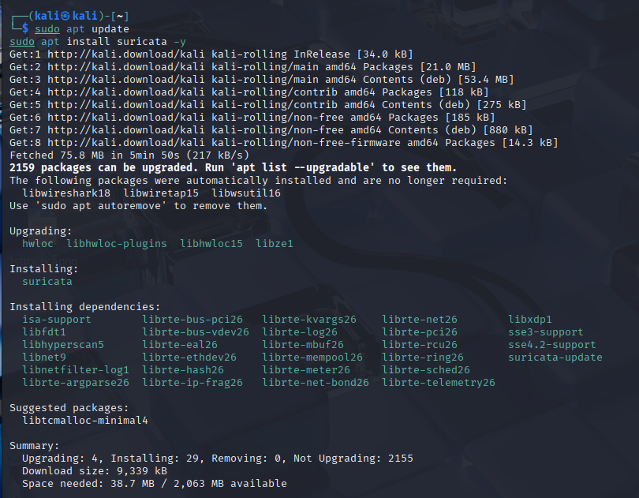

3.3 Verify Installation

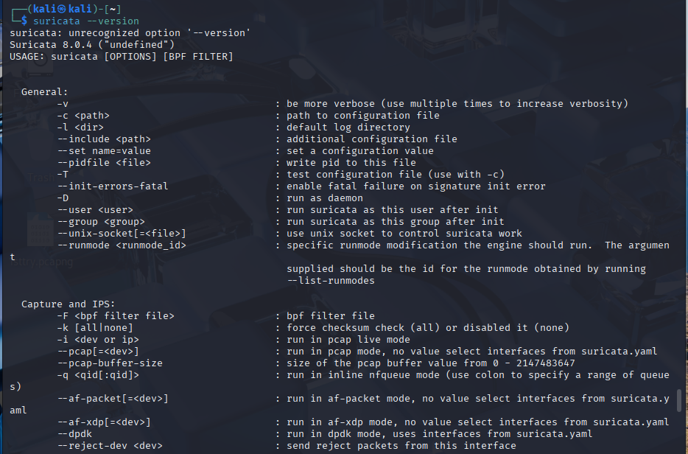

3.4 Start Suricata

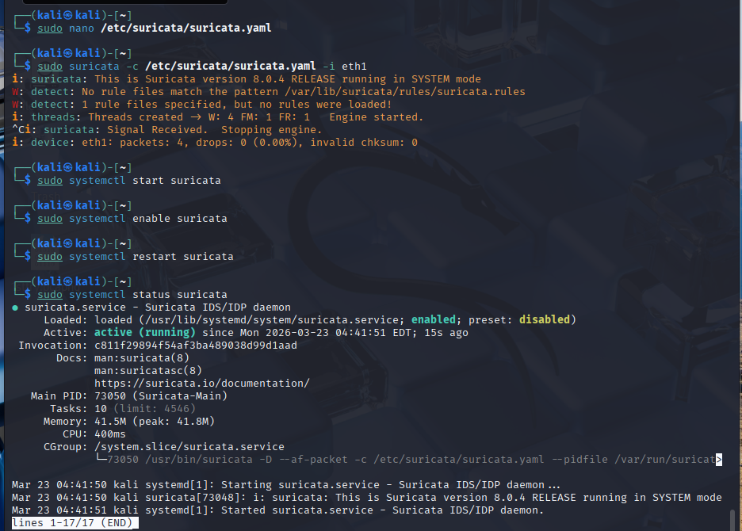

3.5 Configure Suricata
- Edit Config:
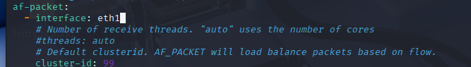

3.6 Generate Traffic

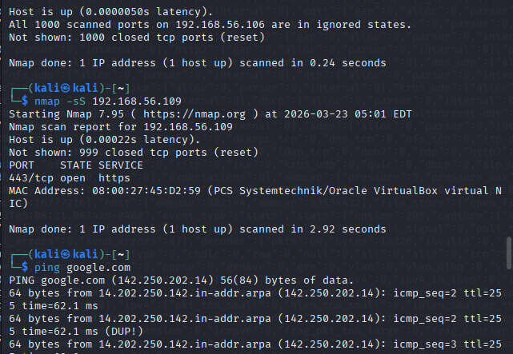

3.6 Generate Alert
Suricata uses advanced packet capture techniques to efficiently process network traffic. One such method is a high-performance interface that allows Suricata to capture packets directly from the network stack.
This mechanism ensures that Suricata can handle large volumes of traffic without missing packets. Efficient packet capture is essential for accurate detection, especially in high-traffic environments.

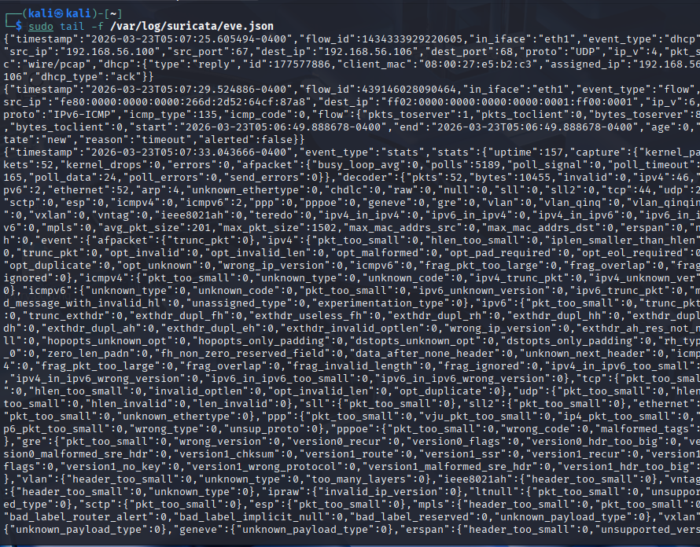

3.7 Log Files Analysis
Suricata generates multiple log files, each serving a specific purpose.
The fast log file provides a simplified view of alerts, making it easy to quickly verify whether rules are working. Each entry in this log contains basic information such as the timestamp, alert message, and source and destination addresses.
The eve.json file is more detailed and structured. It contains comprehensive information about each event, including protocol details, payload data, and metadata. This file is used for integration with Wazuh because it provides structured data that can be parsed and analyzed.
Understanding these logs is essential for both troubleshooting and analysis.

3.8 Traffic Generation and Testing
To verify that Suricata was functioning correctly, various types of traffic were generated. This included simple ping requests, web requests, and network scans.
These activities helped confirm that Suricata was capturing and analyzing traffic as expected. Alerts generated during this process demonstrated that the system was working correctly.

3.9 Observations and Challenges
During this phase, several challenges were encountered, particularly related to interface configuration. Initially, no alerts were generated because the wrong interface was selected. After correcting this, Suricata began capturing traffic successfully.
This highlights the importance of careful configuration and verification.

3.10 Learning Outcomes
This phase provided a deep understanding of how network monitoring works. It emphasized the importance of correct configuration and introduced key concepts such as packet analysis and log interpretation.

4. DAY 17 — CUSTOM RULE WRITING (DETAILED REPORT VERSION)

4.1 Introduction to Rule Writing
After successfully installing and configuring Suricata, the next step in this lab was to develop custom detection capabilities. While Suricata comes with a large set of prebuilt rules, relying only on default rules is not sufficient in real-world environments. Every organization has unique traffic patterns, systems, and potential threats. Therefore, security analysts must be able to write and customize rules according to specific requirements.
Rule writing is one of the most critical skills in network security because it directly determines what kind of activity will be detected and what will be ignored. A well-written rule can detect attacks accurately, while a poorly written rule may either miss attacks or generate excessive false alerts.

4.2 Understanding the Purpose of Custom Rules
The main purpose of writing custom rules in this lab was to simulate detection of three common attack scenarios:
- Network reconnaissance (Nmap scan)
- Web-based exploitation attempt (HTTP attack)
- Denial-of-Service behavior (ICMP flood)
Each of these represents a different phase of an attack lifecycle. By detecting them, a security analyst can identify suspicious activity at various stages of an intrusion.

4.3 Structure and Logic of Suricata Rules
A Suricata rule is essentially a logical condition that describes what kind of network traffic should trigger an alert. Every rule consists of two main parts:

Header Section
This defines:
- Type of traffic (TCP, HTTP, ICMP)
- Source and destination
- Direction of communication

Options Section
This defines:
- What pattern to look for
- What message to generate
- Identification of the rule
The rule engine continuously compares network packets against these conditions. If all conditions match, an alert is generated.

4.4 Update Rule

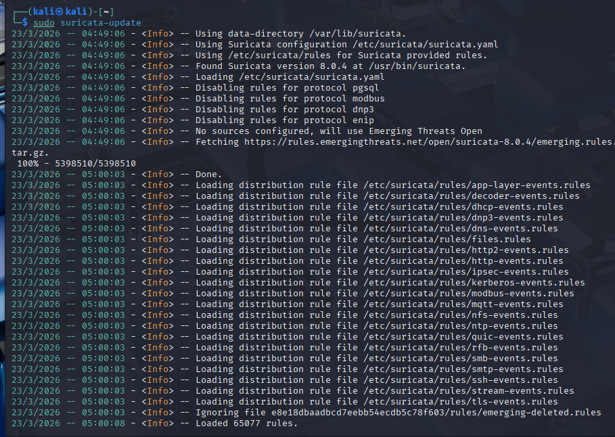

4.5 Importance of Precision in Rule Writing
Writing rules requires a balance between strictness and flexibility:
- If a rule is too broad → it generates many false positives
- If a rule is too strict → it may miss real attacks
This balance is what makes rule writing challenging and important. During this lab, careful consideration was required to ensure that rules were neither too loose nor too restrictive.
4.6 Create Custom Rules File

4.7 Nmap Scan Detection

Concept of Network Scanning
Network scanning is usually the first step an attacker performs. Tools like Nmap are used to identify open ports, services, and vulnerabilities. These scans generate unusual traffic patterns that differ from normal communication.
For example, during a SYN scan:
- The attacker sends a connection request but does not complete the full handshake
- This behavior is not typical of legitimate traffic

Detection Logic
The rule created for detecting Nmap scans focused on identifying packets with specific characteristics that indicate scanning behavior. Instead of looking at complete sessions, the rule looks for abnormal packet flags that are commonly used in scanning techniques.

Testing and Observation
During testing:
- A network scan was initiated from Kali Linux
- Suricata successfully generated alerts
- The alerts included source and destination details
This confirmed that the rule was functioning correctly.
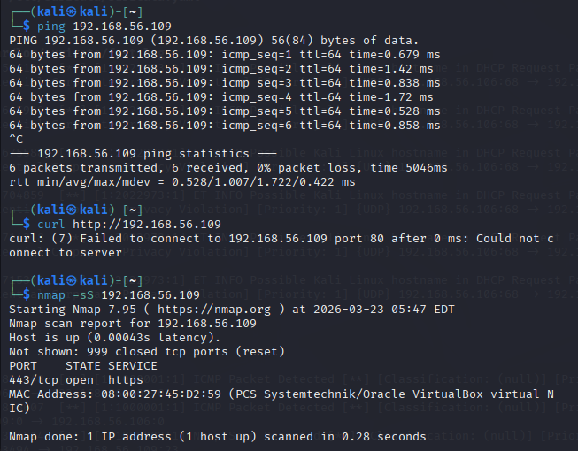

4.8 ICMP Flood Detection

Concept of ICMP Flood
ICMP is commonly used for network diagnostics. However, when a large number of ICMP packets are sent rapidly, it can overwhelm a system, resulting in a denial-of-service condition.

Detection Logic
Unlike the previous rules, this rule did not rely on a specific pattern. Instead, it used a threshold-based approach, where an alert is generated only if a certain number of packets are observed within a short time frame.

Testing and Observation
During testing:
- Rapid ping requests were generated
- Suricata detected the abnormal traffic volume
- Alerts were generated only after the threshold was exceeded

Importance of Threshold
Without thresholding:
- Every packet would generate an alert
- Logs would become flooded
With thresholding:
- Only meaningful alerts are generated
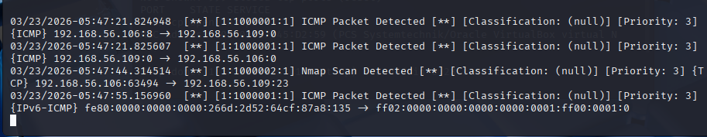

4.9 HTTP

Explanation
During Day 17, a custom HTTP rule was created to detect directory traversal attempts in web traffic. This type of attack occurs when an attacker tries to access restricted files by manipulating the URL structure. Such attacks are commonly used to retrieve sensitive system files from a server. The rule was designed to identify suspicious patterns within HTTP requests, allowing the system to detect potential exploitation attempts. This demonstrated how network intrusion detection systems can monitor and analyze web traffic for malicious behavior.

Testing
To test this rule, HTTP requests were generated from the Kali Linux machine using crafted URLs that simulate directory traversal attacks. The goal was to trigger alerts in Suricata logs. However, during testing, the external web server used for this purpose was not consistently reachable, which prevented successful execution of HTTP requests.

Issue
Due to connectivity issues, the HTTP rule could not be fully validated in the lab environment. The error related to the inability to connect to the server on port 80 indicated a network limitation rather than a problem with the rule itself. This is a common issue in virtual lab setups where external access may be restricted.

Conclusion
Although the HTTP alerts were not consistently generated, the rule was correctly configured and successfully demonstrated the concept of detecting web-based attacks. This highlights the importance of both proper rule design and a stable testing environment in intrusion detection systems.

4.10 Rule Testing and Validation
After creating the rules, each one was tested individually to ensure correct functionality. Testing is an essential part of rule development because it verifies whether the detection logic works in real scenarios.
Different types of traffic were generated, and logs were analyzed to confirm that alerts were being triggered correctly. Any inconsistencies observed during testing were used to refine the rules.

4.11 Challenges and Troubleshooting
Several common issues were encountered during this phase:
- Rules not loading due to configuration errors
- Incorrect rule placement
- Missing references in configuration files
- Alerts not appearing due to incorrect traffic generation
These issues were resolved through careful debugging and log analysis.

4.12 Overall Learning Outcomes
By the end of Day 17, the following key concepts were understood:
- How detection rules are structured
- How different types of attacks generate different traffic patterns
- Importance of testing and tuning rules
- Role of detection engineering in cybersecurity
This phase significantly improved practical understanding of how intrusion detection systems operate in real-world environments.

5. DAY 18–19 SURICATA + WAZUH INTEGRATION & CORRELATION

5.1 Introduction to SIEM Integration
In modern cybersecurity environments, monitoring a single source of data is not sufficient to detect complex attacks. Attackers typically operate across multiple layers, starting from network-level reconnaissance and moving towards system-level exploitation. To effectively detect such multi-stage attacks, it is necessary to integrate different security tools into a centralized system.
A Security Information and Event Management (SIEM) system plays a critical role in this process. It collects logs from multiple sources, processes them, and presents them in a unified dashboard. In this lab, Wazuh was used as the SIEM solution, while Suricata served as the network intrusion detection system.
The integration of Suricata with Wazuh enables the combination of network-level and host-level monitoring. This allows security analysts to observe events from multiple perspectives and understand the complete context of an attack.

5.2 Difference Between Network and Host Monitoring
Before performing the integration, it is important to clearly understand the difference between the two types of monitoring:

Network-Based Monitoring (Suricata)
Suricata analyzes packets traveling across the network. It detects:
- Scanning activity
- Suspicious HTTP requests
- Protocol anomalies
- Denial-of-service behavior
It provides visibility into what is happening between systems.

Host-Based Monitoring (Wazuh)
Wazuh collects logs from the operating system. It detects:
- File modifications
- Login attempts
- Privilege escalation
- System configuration changes
It provides visibility into what is happening inside a system.

Why Integration is Necessary
Individually:
- Suricata → cannot see internal system changes
- Wazuh → cannot see raw network traffic

5.3 Integration Architecture
The integration works through a pipeline where data flows from one component to another. Understanding this flow is critical for both implementation and troubleshooting.

Data Flow Explanation
- A network packet is generated (for example, during a scan or request)
- Suricata captures the packet and analyzes it
- If the packet matches a rule, Suricata generates an alert
- The alert is written into a structured log file (eve.json)
- The Wazuh agent monitors this log file
- The agent forwards the log to the Wazuh Manager (Ubuntu system)
- The Manager processes the log using decoders and rules
- The processed event is displayed in the Wazuh dashboard

Key Insight
This pipeline shows that Suricata and Wazuh do not communicate directly. Instead, they interact through log files and the agent mechanism. This modular design makes the system flexible and scalable.

5.4 Configuration Process
To enable integration, the Wazuh agent on the Kali machine was configured to monitor the Suricata log file. This configuration ensures that any alert generated by Suricata is automatically picked up and forwarded to the Wazuh Manager.
This step is critical because without it, Suricata and Wazuh operate independently, and no centralized visibility is achieved.
After updating the configuration, the agent service was restarted to apply the changes. Restarting services is an important step in system configuration because changes are not applied automatically.

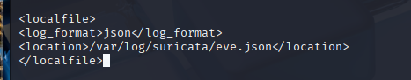
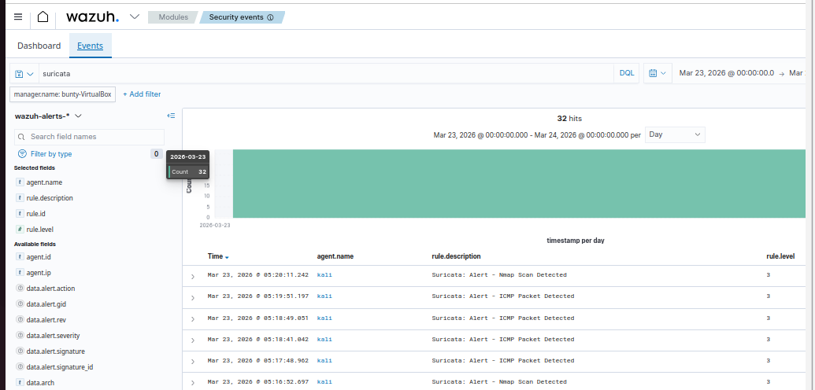

5.5 Verification of Integration
After completing the configuration, test traffic was generated to verify that the integration was working correctly.
Different types of activities were performed, including:
- Network scanning
- ICMP traffic
The Wazuh dashboard was then monitored to check whether Suricata alerts were appearing. Successful visibility of these alerts confirmed that the integration was functioning as expected.

5.6 Understanding Wazuh Dashboard Alerts
The Wazuh dashboard presents alerts in a structured format. Each alert contains detailed information, including:
- Timestamp of the event
- Source and destination IP addresses
- Type of activity detected
- Rule description
- Severity level
Suricata alerts appear with specific identifiers indicating that they originate from network monitoring. This distinction is important because it allows analysts to differentiate between network-based and host-based events.

5.7 Correlation
Correlation is the process of linking multiple events to identify a larger pattern. In cybersecurity, individual alerts may not provide sufficient information to determine whether an attack is occurring. However, when multiple related alerts are analyzed together, they can reveal a complete attack scenario.

Why Correlation is Important
Without correlation:
- Alerts appear isolated
- Difficult to understand intent
With correlation:
- Events form a timeline
- Attack patterns become clear

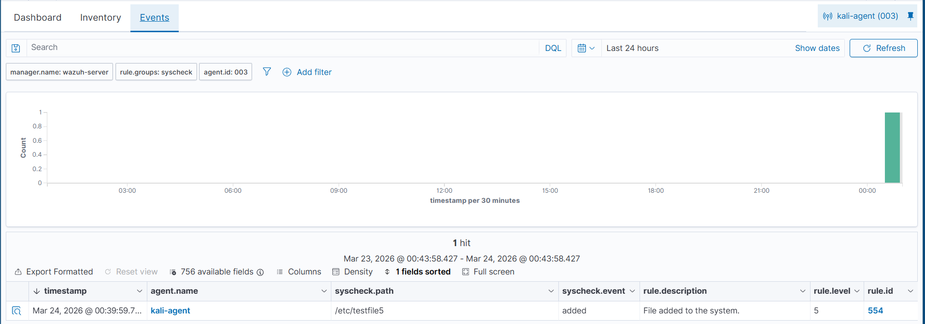

5.8 Correlation Analysis Performed
In this lab, correlation was performed using the following activities:
- A network scan was initiated from the Kali machine
- A system-level command was executed
The Wazuh dashboard displayed alerts corresponding to both activities. By analyzing the timestamps and source information, it was confirmed that both events originated from the same system within a short time frame.

Analysis
This demonstrated that:
- Suricata detected external behavior (network activity)
- Wazuh detected internal behavior (system activity)
The combination of these two perspectives provided a comprehensive view of the activity.

5.9 Challenges Faced During Integration
Several challenges were encountered during this phase:
- Incorrect configuration of log file monitoring
- Errors in configuration files
- Delays in alert generation
- Difficulty triggering specific types of alerts
These challenges were resolved through troubleshooting steps such as verifying configurations, restarting services, and analyzing logs.

5.10 Learning Outcomes
This phase provided critical insights into how modern security systems operate:
- Importance of centralized monitoring
- Role of SIEM in cybersecurity
- Value of combining multiple data sources
- Practical understanding of event correlation
It also highlighted that detection is not just about identifying individual events but about understanding the relationship between them.

6. DAY 20–21 FIREWALL IMPLEMENTATION & GEOIP BLOCKING

6.1 Introduction to Firewall-Based Security
After implementing detection using Suricata and centralized monitoring using Wazuh, the final phase of this lab focused on active defense mechanisms. While detection tools help identify malicious activity, they do not stop attacks. Therefore, it is necessary to implement controls that can actively block unwanted traffic.
A firewall is one of the most essential components of network security. It acts as a barrier between a trusted system and untrusted networks by filtering traffic based on defined rules. In this lab, a host-based firewall approach was implemented on the Kali Linux system.
The objective of this phase was to restrict traffic from specific geographical regions using GeoIP blocking and to demonstrate domain-level blocking using system configuration.

6.2 Understanding iptables and ipset
In Linux-based systems, firewall functionality is typically implemented using packet filtering frameworks. These frameworks analyze incoming and outgoing packets and decide whether to allow or block them.
Two important components used in this lab were:

Packet Filtering Mechanism
This mechanism evaluates each packet based on rules such as source address, protocol, and destination. Based on these conditions, the packet is either allowed or dropped.

Efficient IP Management
When dealing with large numbers of IP addresses, adding rules one by one becomes inefficient and slow. To solve this problem, IP sets are used. An IP set is a collection of IP addresses or ranges grouped together.
Instead of creating thousands of firewall rules, a single rule can reference an entire set. This significantly improves performance and simplifies management.

6.3 GeoIP Blocking Concept
GeoIP blocking is a technique that filters traffic based on the geographical origin of IP addresses. Each IP address is mapped to a specific country using publicly available databases.
In this lab, IP ranges belonging to specific countries were downloaded and used to create a blocklist. This blocklist was then applied to the firewall.

Why GeoIP Blocking is Important
- Reduces unnecessary exposure to global threats
- Blocks traffic from regions known for high attack activity
- Enhances overall system security posture

Real-World Use Case
Organizations often restrict access to their services based on geographical regions. For example, a company operating only in one country may block traffic from all other regions to reduce risk.

6.4 Implementation Explanation
The implementation involved several stages, each contributing to the final firewall setup.

Installing Required Tools
The necessary tools were installed to enable firewall configuration and IP set management. This step ensured that the system had all required components for implementing GeoIP blocking.
.

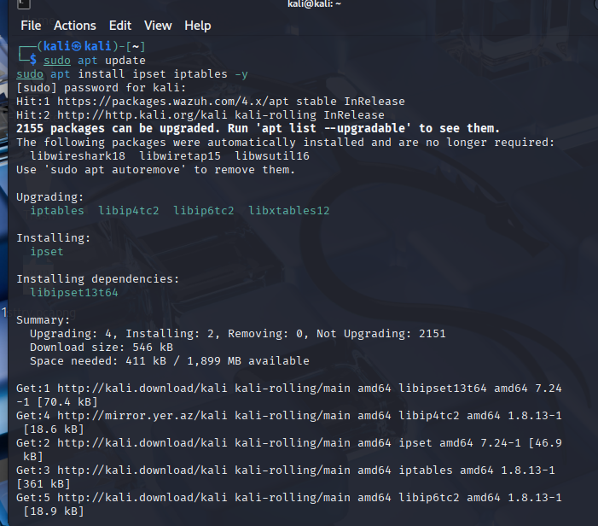

Downloading Country IP Ranges
A list of IP ranges belonging to a specific country was downloaded. These ranges represent all possible IP addresses assigned to that region.
This dataset forms the foundation of GeoIP blocking because it defines which traffic should be filtered
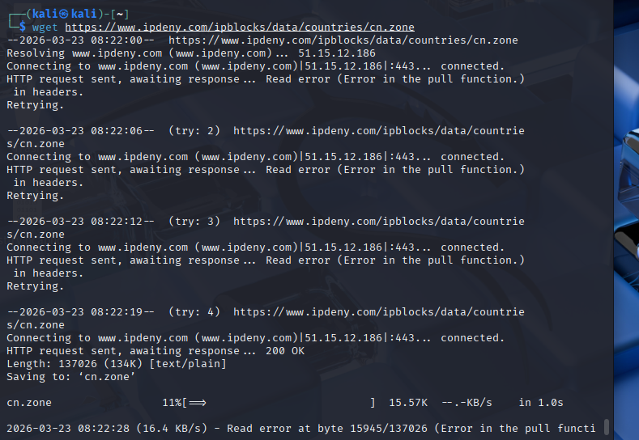
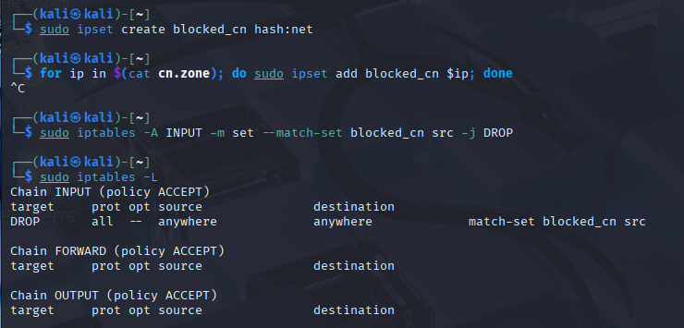

Creating an IP Set
An IP set was created to store all the downloaded IP ranges. This set acts as a container that can be referenced by firewall rules.

Populating the IP Set
The downloaded IP ranges were added into the set. This process effectively created a database of blocked IP addresses.

Applying Firewall Rule
A firewall rule was created to drop all incoming traffic originating from the IP addresses stored in the set.
This means that:
- Any packet coming from those IP ranges is automatically blocked
- The system does not process or respond to such traffic
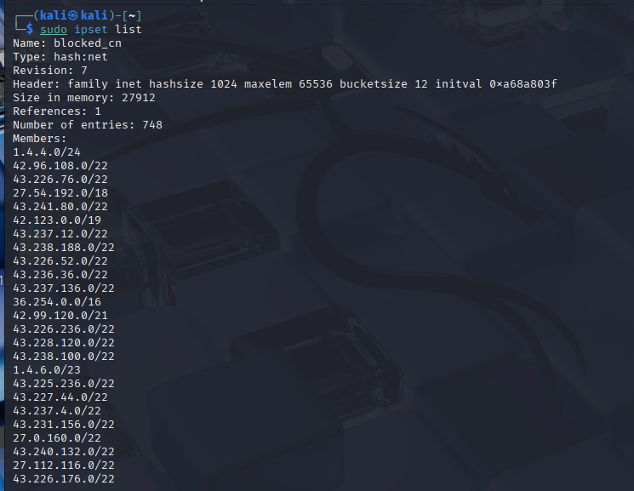

6.5 Observations During Implementation
During this phase, it was observed that:
- Firewall rules were successfully applied
- IP sets contained a large number of IP ranges
- The system was configured to silently block traffic from specified regions
Although it was not possible to fully simulate traffic from those regions in the lab, the configuration process demonstrated how such filtering works in real-world environments.
6.6 Domain Blocking Using Hosts File
In addition to GeoIP blocking, domain-level blocking was implemented using the system’s hosts file.

Concept of Hosts File
The hosts file is a local configuration file that maps domain names to IP addresses. When a system tries to access a domain, it first checks this file before querying external DNS servers.

Blocking Logic
By mapping a domain name to a local IP address, access to that domain can be effectively blocked. When the system attempts to connect, it is redirected locally instead of reaching the actual server.

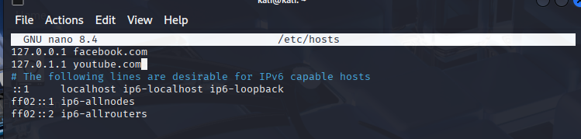

Testing and Observation
After adding entries to block popular websites, attempts to access those domains failed. This confirmed that the blocking mechanism was working correctly.
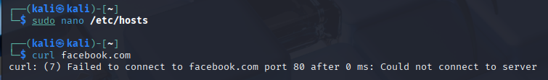

6.7 Firewall Logging and Wazuh Integration
During testing, it was observed that firewall-related alerts were not visible in the Wazuh dashboard. This is because logging for firewall events was not enabled by default.

