CyberSter

CYBERSTER BLUE TEAM INTERNSHIP
WEEK 4 REPORT
SOC Monitoring, Threat Intelligence & Vulnerability Analysis

Submitted By: Maryam Mughal
ID: CSI-B1-293

Internship Program: Cyberster Blue Team Internship
Track: Blue Team – SOC Operations and SIEM Foundations

Week: Week 4 (Days 22 – 28)
Submission Date: 29-March-2026

Submitted To: Abdullah Zia

Table of Contents
- Introduction
- Network Architecture
- pfSense Firewall Setup and Configuration
- Log Integration with Wazuh
- File Integrity Monitoring (FIM)
- Threat Intelligence Integration
- MITRE ATT&CK Mapping
- Vulnerability Detection and Analysis
- Dashboard Creation
- Security Analysis
- Results and Observations
- Conclusion

Executive Summary

This report presents the implementation of a SOC lab environment using Wazuh SIEM. It includes firewall integration using pfSense, log monitoring, threat intelligence integration, vulnerability analysis, and dashboard visualization. The objective was to simulate real-world SOC operations and analyze security events across multiple systems. The lab demonstrates how different security components work together to provide visibility, detection, and analysis in a monitored environment.

Day 22–23 — pfSense Firewall Setup & Log Integration

Introduction
In this phase, pfSense was deployed as a firewall to simulate a real-world network environment. The purpose was to control and monitor traffic between systems and generate network-level logs that could be analyzed using the Wazuh SIEM. Before this step, systems were communicating directly on the same network. After introducing pfSense, all communication was routed through a controlled point, making the environment more realistic and secure.
This stage is important because in real SOC environments, firewalls are used not only for blocking traffic but also for monitoring, logging, and providing visibility into network behavior.

Network Architecture
The lab consisted of three main components:
- Kali Linux (Agent/Attacker) → 192.168.56….
- Wazuh Server (SIEM) → 192.168.56….
- pfSense Firewall → 192.168.56…
pfSense was placed between all systems to act as:
- Gateway for network communication
- Firewall controlling inbound and outbound traffic
- Central logging point for network events
This setup ensured that all traffic passed through pfSense before reaching other machines.
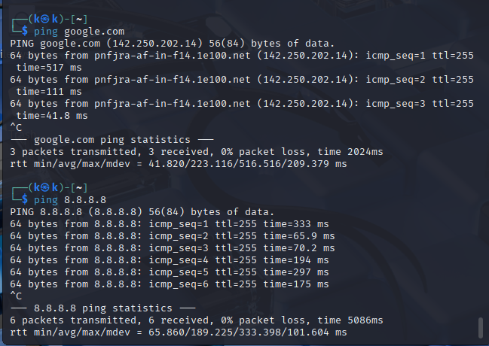
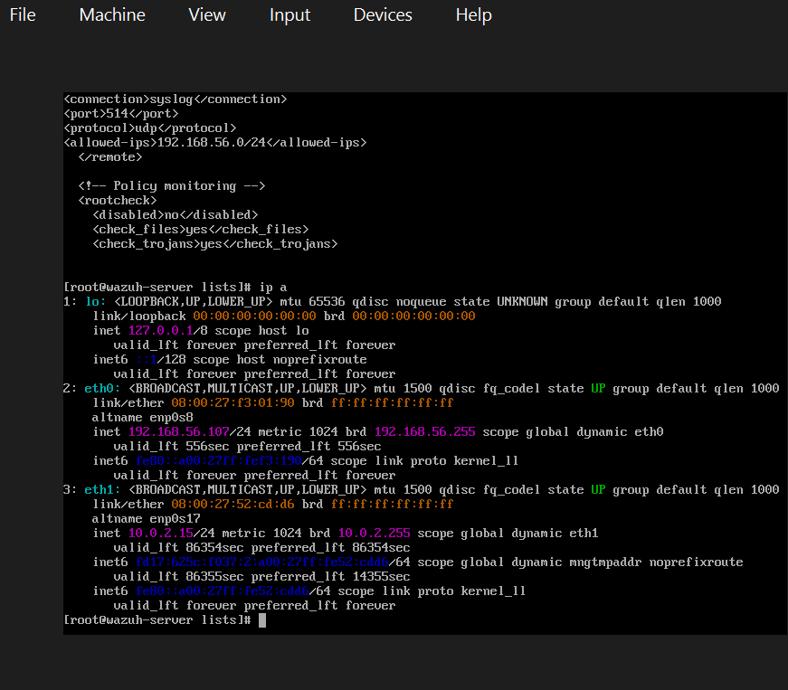
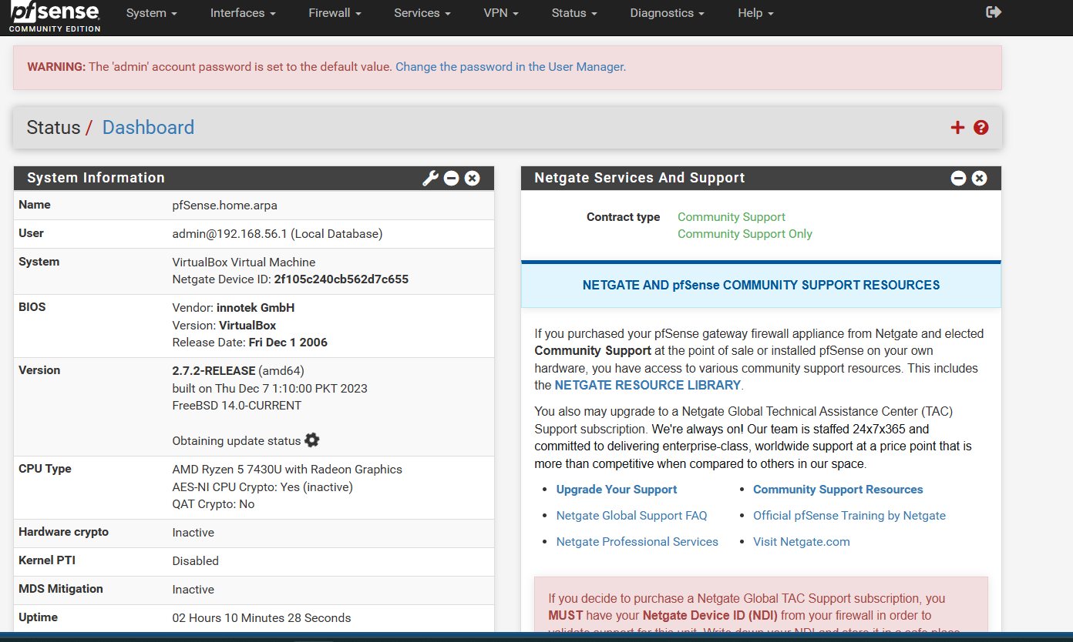

pfSense Configuration
pfSense was configured with two interfaces:

WAN Interface
- Connected to NAT network
- Provided external connectivity

LAN Interface
- Connected to Host-Only network
- Assigned IP: 192.168.56.101
This configuration allowed pfSense to separate internal and external traffic, similar to real enterprise networks.
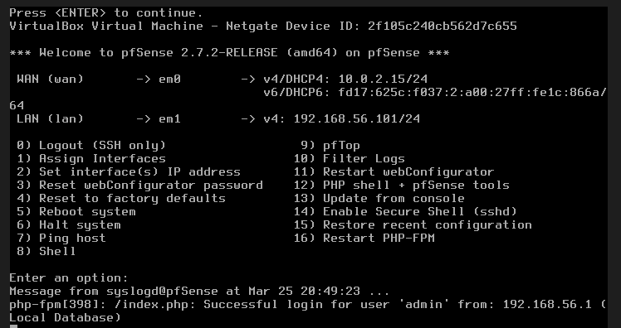

Routing Setup
All machines (Kali and Wazuh) were configured to use pfSense as their default gateway:
192.168.56….
This ensured:
- All outgoing traffic passed through pfSense
- pfSense could inspect, filter, and log all communications
- Connectivity Testing
Results showed:
- Successful communication
- 0% packet loss
This confirmed that the network configuration and routing were correctly implemented.
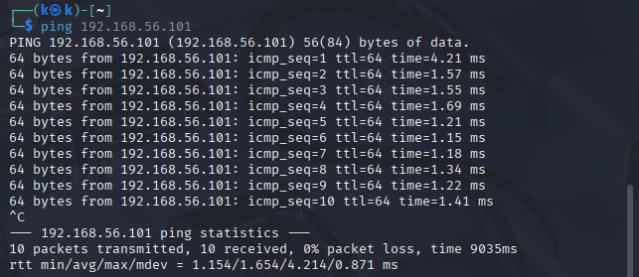

Firewall Rules & Logging
Firewall rules were configured on the LAN interface to:
- Allow traffic between systems
- Enable logging for all traffic
Logging is essential because:
- Without logging → no visibility of network activity
- With logging → full monitoring and analysis of traffic
This allowed pfSense to record events such as connections, requests, and communication between machines.

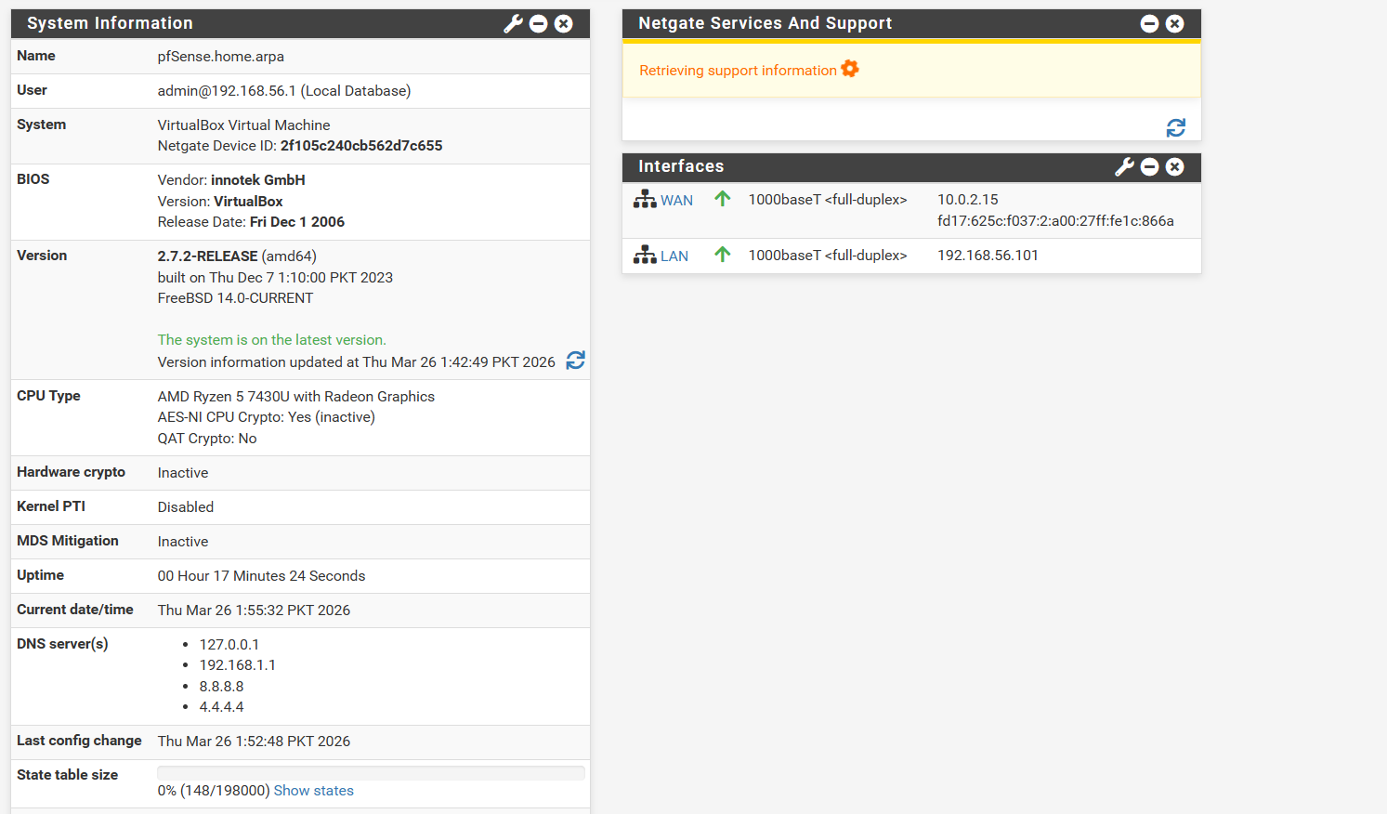
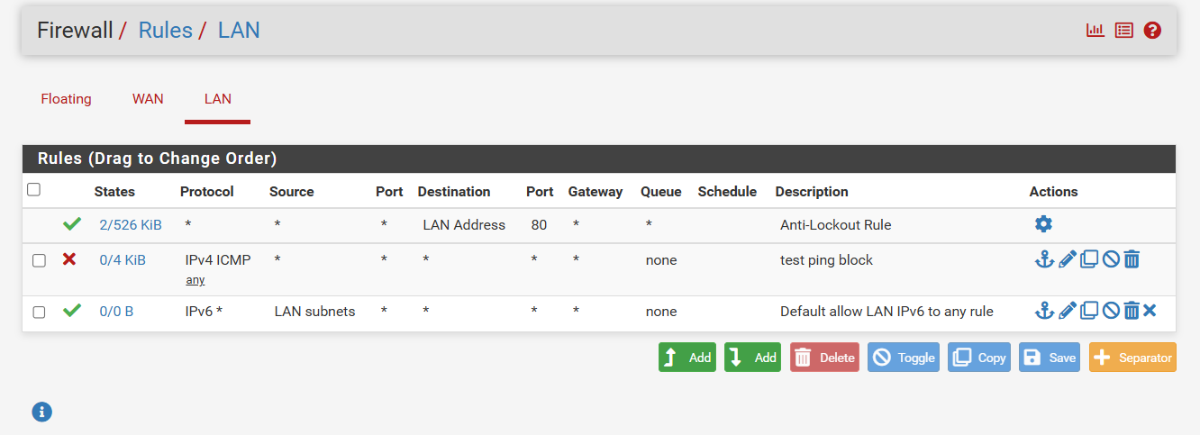

Log Forwarding to Wazuh
pfSense was configured to send logs to the Wazuh server using syslog.
Configuration:
- Protocol: UDP
- Port: 514
- Destination: 192.168.56….
This enabled pfSense to forward firewall and system logs to Wazuh for centralized monitoring.

Wazuh Configuration
Wazuh was configured to receive syslog data by adding the following configuration:
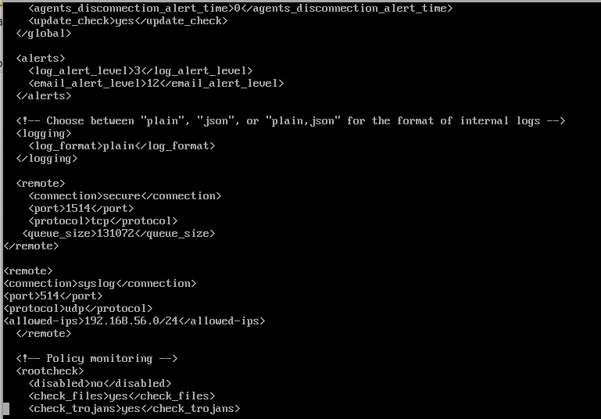

Custom Rule Configuration in Wazuh
In addition to collecting logs, custom rules were created in Wazuh to enhance detection capabilities. These rules were added in the local_rules.xml file, which allows analysts to define custom detection logic.

Purpose of Custom Rules
The purpose of adding rules in local_rules.xml is to:
- Detect specific activities not covered by default rules
- Customize alert behavior
- Improve visibility for targeted events

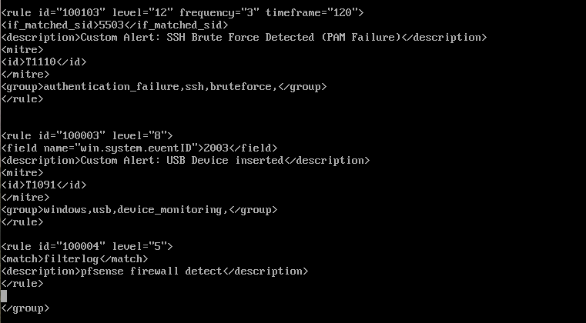

Results and Observations
- pfSense logs successfully appeared in the Wazuh dashboard
- Network activity was visible in real time
- Communication between systems was monitored through firewall logs
- Logs included information such as source, destination, and traffic behavior
This confirmed successful integration between pfSense and Wazuh.

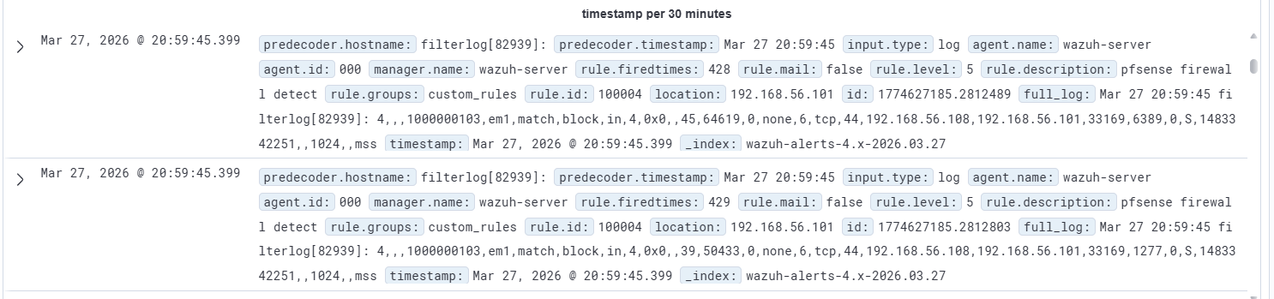
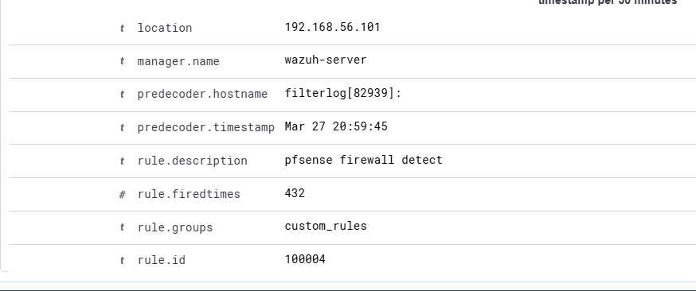

Conclusion
The integration of pfSense into the lab environment successfully transformed the network into a controlled and monitored setup. By routing all traffic through pfSense, visibility and control were achieved. The forwarding of logs to Wazuh enabled centralized analysis of both host-based and network-based events.
This setup closely resembles real-world SOC environments, where firewalls play a critical role in both security enforcement and monitoring.

Day 24–25 — Threat Intelligence Integration & Detection

Introduction
In this phase, the lab environment was enhanced by integrating threat intelligence and improving detection capabilities within Wazuh. While previous tasks focused on collecting logs and monitoring systems, this stage introduced external intelligence sources to provide additional context to alerts. This means that instead of only detecting events, the system can now help determine whether those events are associated with known malicious activity.
The main components implemented in this phase included:
- File Integrity Monitoring (FIM)
- VirusTotal integration
- URLhaus threat feed (CDB)
- MITRE ATT&CK mapping
This phase is critical in SOC operations because it connects raw alerts with real-world threat data, enabling better decision-making and prioritization.

File Integrity Monitoring (FIM)

Overview
File Integrity Monitoring is used to track changes in files such as creation, deletion, and modification. It is especially useful for detecting unauthorized changes that may indicate compromise or malicious activity.

Testing
To validate FIM functionality, test files were created.
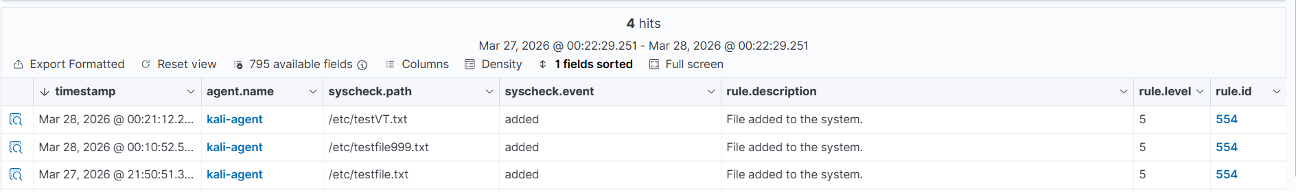
- Results
Wazuh generated alerts with the following details:
- Rule ID: 554
- Event Type: File added
- Severity: Medium
- File path correctly recorded
- Analysis
These results confirm that:
- Wazuh continuously monitors system directories
- File changes are detected immediately
- Relevant details such as file location and timestamp are captured
- Importance
FIM plays an important role in security by:
- Detecting unauthorized file changes
- Identifying potential malware installation
- Supporting forensic analysis

VirusTotal Integration

Overview
VirusTotal is a threat intelligence platform that analyzes files using multiple antivirus engines. Integrating it with Wazuh allows automatic validation of file hashes detected by FIM.

Configuration
The integration was configured in Wazuh so that whenever a file change occurs, its hash is automatically sent to VirusTotal for analysis.
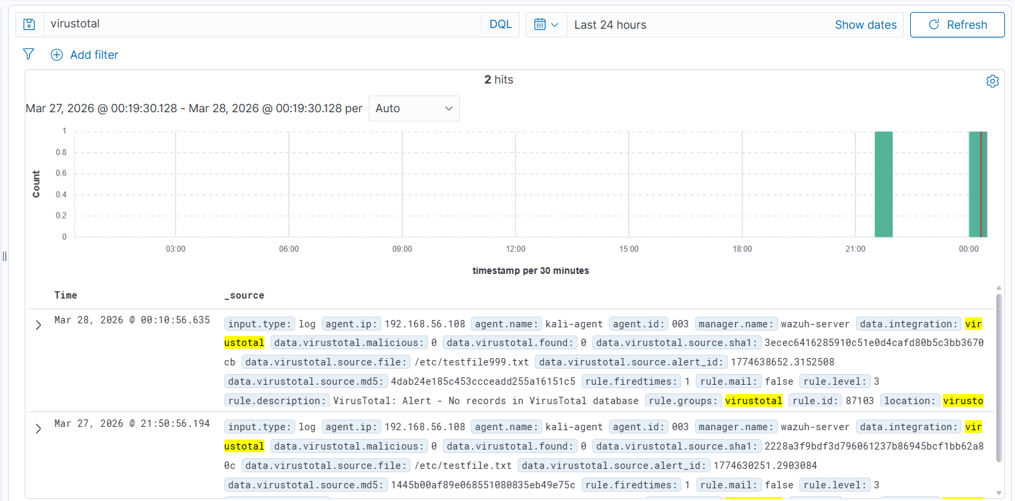
- Testing Process
- A file was created in the monitored directory
- Wazuh generated an alert
- The file hash was extracted
- The hash was sent to VirusTotal
From the Wazuh dashboard:
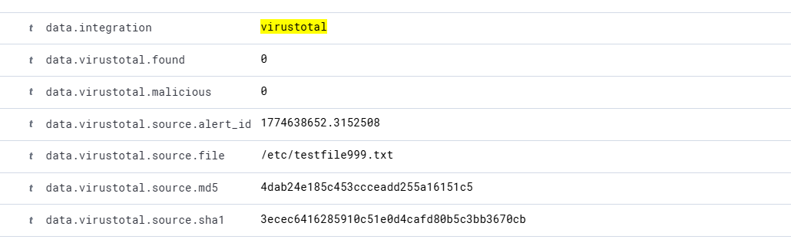
- Analysis
This indicates that:
- The integration is functioning correctly
- The file hash was successfully checked

URLhaus Threat Feed (CDB)

Overview
URLhaus is a public threat intelligence feed that provides lists of malicious URLs associated with malware distribution. In this lab, it was integrated using Wazuh’s CDB feature.
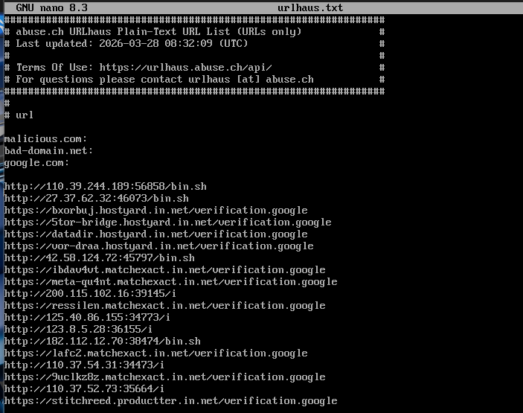
- Configuration
- URLhaus feed was downloaded
- Stored locally in the Wazuh system
- A custom rule was added in local_rules.xml to match URLs
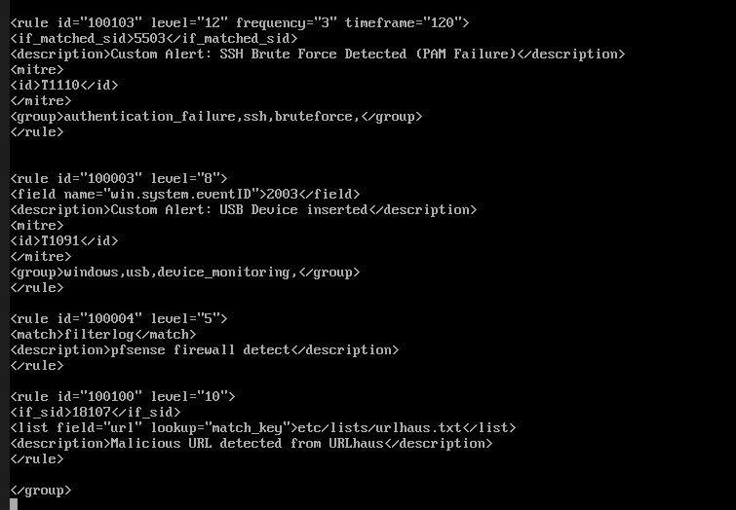

Testing
Malicious URLs were tested using:
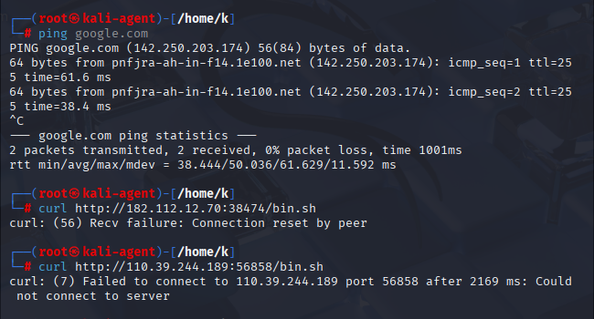
- Observed Results
- No alerts were generated
- Connections failed or were reset

Threat Intelligence (URLhaus CDB Feed)
A custom threat intelligence feed using URLhaus was configured in Wazuh to detect malicious URLs. The feed was successfully loaded and integrated into the system. During testing, multiple URLs from the feed were used; however, no alerts were generated because the URLs were unreachable or inactive. This behavior is expected, as many malicious URLs are taken down or become unavailable over time. Despite this, the configuration and integration of the threat feed were verified to be correctly implemented.

MITRE ATT&CK Mapping

Overview
MITRE ATT&CK is a framework that categorizes attacker techniques based on real-world behavior. Wazuh maps alerts to MITRE techniques to provide context.

Observed Techniques
Technique ID | Description
T1078 | Valid Accounts
T1548.003 | Privilege Escalation
T1562.001 | Defense Evasion

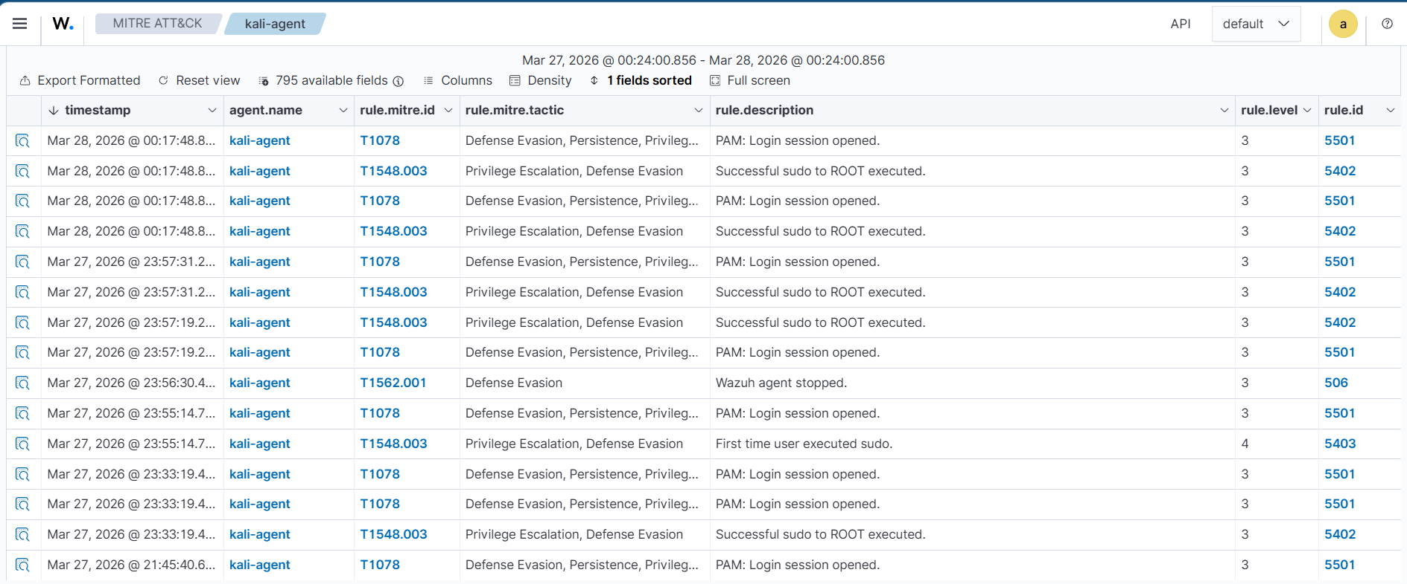
- Events Detected
- PAM login events
- Sudo commands
- User privilege changes
- Analysis
These mappings show:
- Use of valid credentials (possible misuse)
- Elevation of privileges
- Potential attacker activity
- Importance
MITRE mapping helps analysts:
- Understand attacker behavior
- Categorize alerts systematically
- Improve detection and response strategies

Results and Observations
After completing this phase:
- File changes were successfully detected
- VirusTotal integration worked correctly
- Threat intelligence enrichment was applied
- MITRE ATT&CK mapping provided behavioral context
- URLhaus feed was configured but did not generate alerts

Day 26–27 — Vulnerability Detection & Analysis

Introduction
In this phase, the focus shifted towards identifying system weaknesses using Wazuh’s vulnerability detection module. While previous stages focused on detecting activities and events, this phase aimed to analyze the security posture of the systems by identifying known vulnerabilities (CVEs) present in installed software.
Vulnerability management is a critical part of SOC operations because attackers often exploit outdated or vulnerable software to gain access. By identifying these weaknesses, organizations can prioritize patching and reduce risk.

System Inventory Collection

Overview
Before detecting vulnerabilities, Wazuh first collected a complete inventory of installed software using the syscollector module.
- Results
- Approximately 3000+ packages were detected on Kali Linux
- Information included:
  - Package name
  - Installed version
  - Architecture
  - Vendor details
- Analysis
This inventory is essential because:
- Vulnerability detection relies on comparing installed packages with known CVEs
- Accurate inventory ensures correct vulnerability mapping
- Provides full visibility of system components

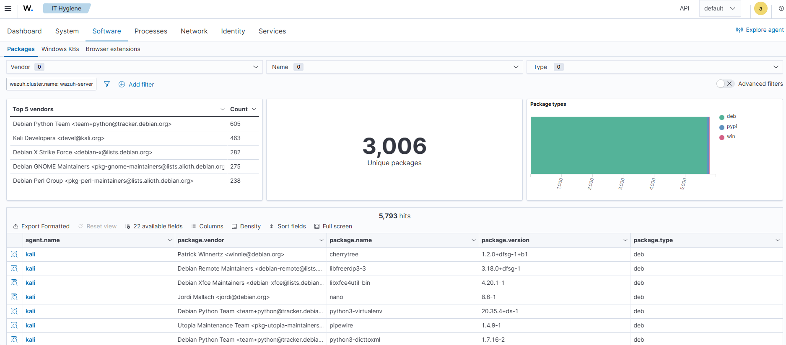

Vulnerability Detection Results
After inventory collection, Wazuh compared installed packages against vulnerability databases.
- Observed Results:
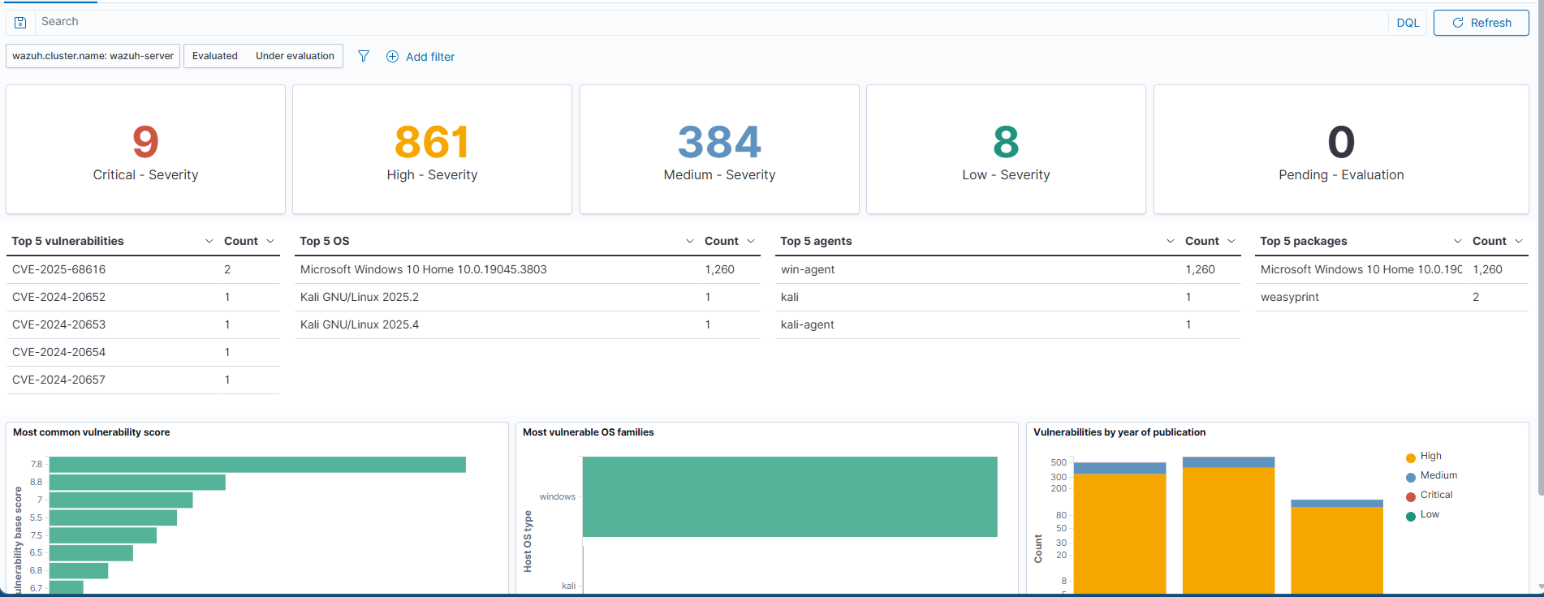
- Analysis
- A high number of vulnerabilities were detected, especially on the Windows system
- Kali Linux showed fewer vulnerabilities, indicating better patch status
- High and critical vulnerabilities represent the most serious risks

Example CVE Analysis

CVE-2025-68616
- Affects: weasyprint package
- Severity: High
- Risk: Potential exploitation due to improper input handling
- Impact
If exploited, this vulnerability could:
- Allow unauthorized actions
- Lead to system compromise
- Be used as part of a larger attack chain

Remediation Attempt
To fix the vulnerability, the affected package was updated.
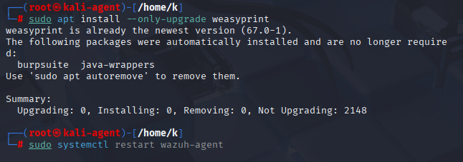
- Result
- Package version updated:
  - Old version: 62.3
  - New version: 67.0
- Verification
- System confirmed updated version
- Wazuh inventory reflected new package version
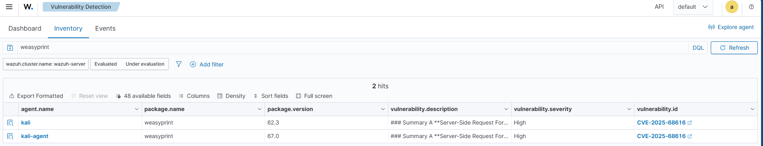

Issue: CVE Still Visible
After upgrading, the vulnerability still appeared in the Wazuh dashboard.
- Explanation
This behavior occurs because:
- Wazuh relies on external vulnerability databases
- Database updates may lag behind actual patches
- Detection is based on known CVE mappings, not real-time patch validation

Vulnerability Prioritization
Not all vulnerabilities have the same risk level. They must be prioritized based on severity and impact.
Priority | Severity | Reason
High | Critical | Immediate risk to system
Medium | High | Potential exploitation
Low | Medium/Low | Less urgent

Results and Observations
After completing this phase:
- System inventory was successfully collected
- Vulnerabilities were detected across systems
- Severity distribution was clearly visible
- A remediation attempt was performed
- CVE persistence issue was observed and analyzed
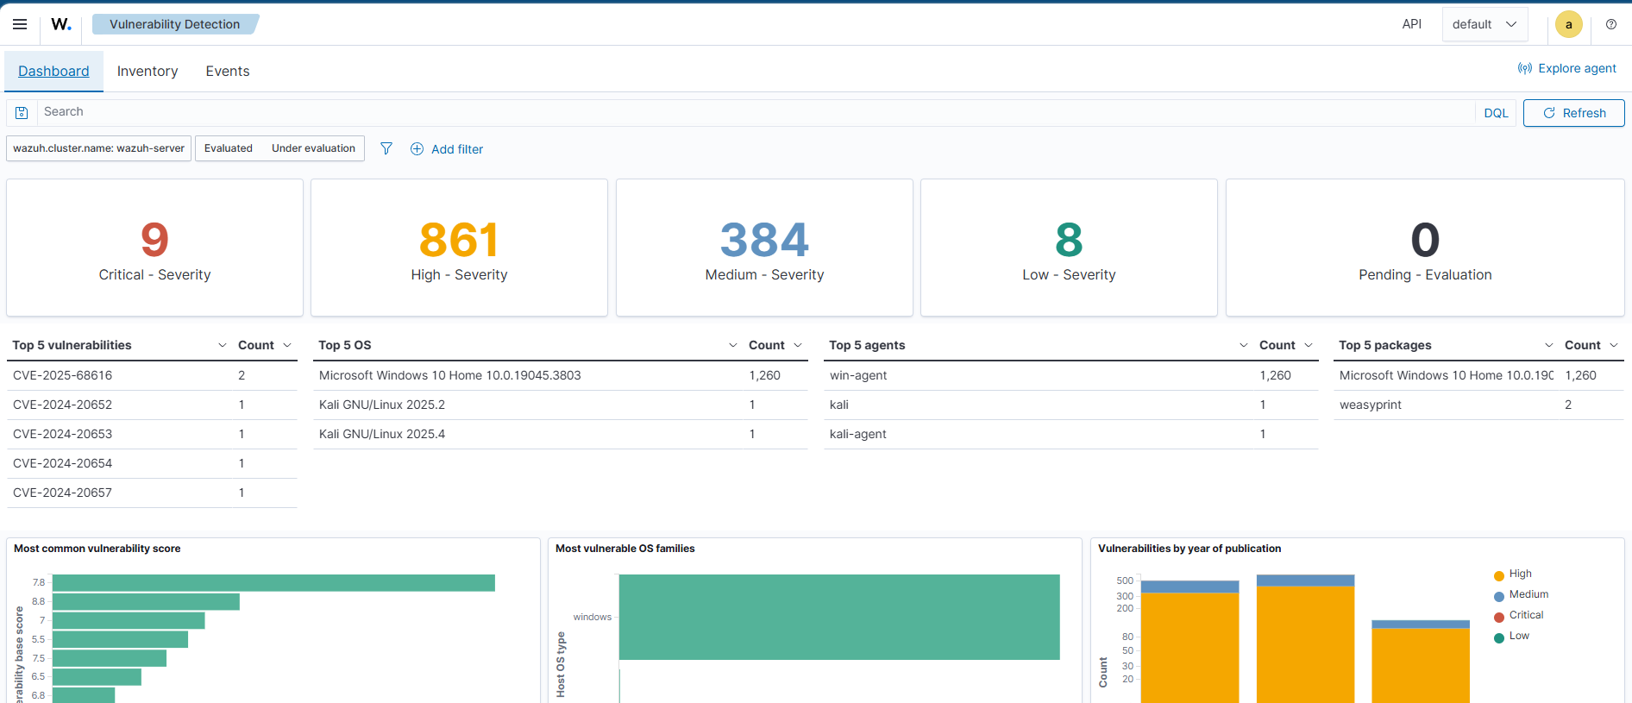
The vulnerability detection module successfully identified multiple vulnerabilities across the lab systems. The syscollector module provided a complete inventory, which enabled accurate vulnerability mapping. A remediation attempt was performed by updating the affected package, demonstrating the patching process.
Although the CVE remained visible after the update, this reflects real-world scenarios where vulnerability databases may not immediately reflect remediation. This highlights the importance of manual verification and continuous monitoring.
This behavior reflects real-world scenarios where vulnerability detection tools may not immediately reflect remediation due to delays in vulnerability databases.

Day 28 — Dashboard Creation & Reporting

Introduction
In this final phase, the focus was on visualizing security data and creating a structured report based on all previous activities. While earlier phases involved collecting logs, detecting events, and analyzing vulnerabilities, this stage aimed to present that data in a clear and understandable format using dashboards.
Dashboards are essential in SOC environments because they allow analysts to quickly understand system status, identify threats, and make informed decisions without manually reviewing raw logs.

Dashboard Creation

Overview
A custom dashboard was created in Wazuh to display important security information collected throughout the lab. The dashboard was designed to provide a high-level overview of system activity and highlight key security events.

Panels Created

Alerts by Severity
This panel displays the distribution of alerts based on severity levels.
- Low
- Medium
- High
- Critical

Analysis:
- Helps identify how serious the detected events are
- High and critical alerts indicate potential threats
- Allows prioritization of response

Top Rules Triggered
This panel shows the most frequently triggered rules.

Example events:
- Authentication logs
- Network activity
- System events

Analysis:
- Identifies common types of alerts
- Helps understand patterns in system behavior
- Highlights repeated or suspicious activities

Agent Activity / Status
This panel displays information about monitored systems (agents).

Analysis:
- Shows which systems are active
- Confirms agents are connected and reporting
- Helps ensure monitoring coverage

Source Analysis (IP / System)
This panel displays the origin of events, such as source IPs or systems.

Analysis:
- Helps identify where activity is coming from
- Useful for detecting suspicious sources
- Supports investigation of attacks

Dashboard Configuration Details
- Data source used: wazuh-alerts-*
- Visualization types:
  - Bar charts
  - Pie charts
  - Tables
- Data grouped using fields such as:
  - rule.level
  - rule.description
  - agent.name
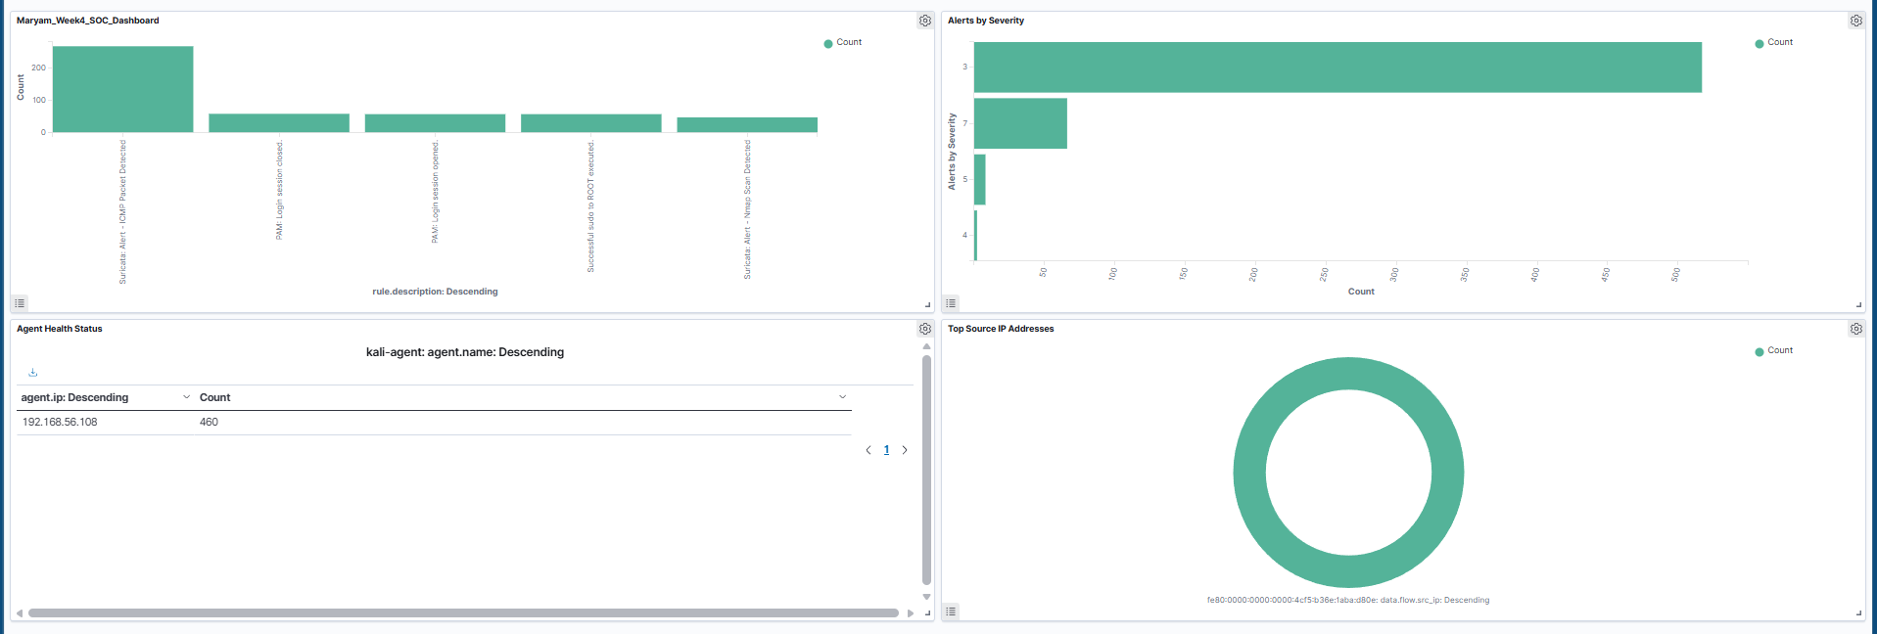

Observations
From the dashboard:
- Alerts were distributed across multiple severity levels
- High severity alerts were present, indicating potential risks
- Multiple rule types were triggered, including authentication and system events
- Agents were actively reporting data

Importance of Dashboard
Dashboards are important in SOC operations because they:
- Provide quick visibility of system activity
- Help analysts identify threats faster
- Reduce time required to analyze logs
- Support decision-making and incident response
Instead of manually checking logs, analysts can use dashboards to get a summarized view of the environment.

Reporting
Based on all lab activities technical report was created.

Key Areas Covered in Report

1. Authentication Events
- Login activity detected
- Sudo and privilege escalation events observed
- Indicates user behavior and potential misuse

2. File Integrity Monitoring
- File creation events detected
- Demonstrates monitoring of system changes

3. Network Monitoring
- pfSense logs captured network traffic
- Shows communication between systems

4. Threat Intelligence
- VirusTotal integration used for file analysis
- External validation of detected files

5. Vulnerability Detection
- Multiple CVEs detected
- Systems analyzed for weaknesses
- Patch attempt performed

Results and Observations
- Dashboard successfully displayed security data
- Events were clearly visualized
- Multiple data sources were combined in one view
- Report covered all aspects of monitoring and analysis

Conclusion
The dashboard creation and reporting phase successfully completed the SOC lab workflow. All collected data from previous stages was visualized and organized into meaningful panels, allowing easier analysis of security events.
The final report combined insights from authentication monitoring, file integrity, network logs, threat intelligence, and vulnerability analysis. This demonstrated how different security components work together in a SOC environment.
Overall, this phase highlighted the importance of data visualization and reporting in cybersecurity, as they enable analysts to interpret complex information efficiently and respond to potential threats effectively.

