CyberSter

CYBERSTER BLUE TEAM INTERNSHIP
WEEK 6 REPORT
Phase One Capstone: Insider Threat Simulation and Incident Response

Submitted By: Maryam Mughal
ID: CSI-B1-293
Internship Program: Cyberster Blue Team Internship
Track: Blue Team – SOC Operations and SIEM Foundations

Week: Week 6
Submission Date: 12-April-2026

Submitted To: Cyberster Blue Team Mentorship Team

Table of Contents

- Phase 0 — Pre-Engagement Setup

- Phase 1 — Red Team: Attack Execution

- Phase 2 — Blue Team: Detection and Investigation

- Phase 3 — Incident Response Report

PHASE 0 — PRE-ENGAGEMENT SETUP

Objective
The objective of this phase was to prepare a controlled and monitored lab environment capable of detecting file-based malicious activities in real time. This involved configuring a dedicated staging directory on the Windows endpoint and integrating it with the Wazuh File Integrity Monitoring (FIM) module. The purpose of this setup was to ensure that any unauthorized file creation, modification, or deletion performed during the simulated insider threat attack would be captured, logged, and forwarded to the Security Information and Event Management (SIEM) system for analysis.
This phase is critical because the effectiveness of the entire investigation depends on the visibility established before the attack. Without proper monitoring, malicious actions would leave little to no trace, making detection and forensic analysis impossible.

Environment Overview
The lab environment was composed of three primary systems, each performing a distinct role within the simulation:
- Windows Virtual Machine (Victim System):
Served as the endpoint where the insider threat activity was executed. This system had the Wazuh agent installed and was responsible for generating telemetry data based on file system changes.
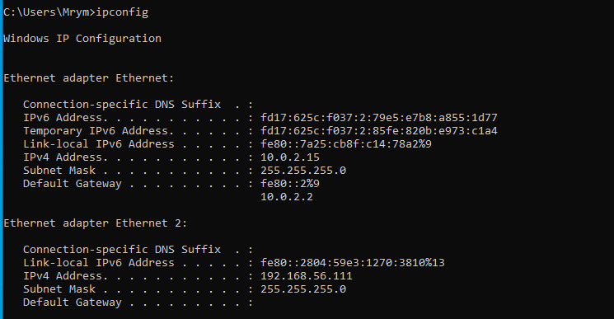
- Kali Linux Virtual Machine (Attacker System):
Functioned as the attacker-controlled machine used for receiving exfiltrated data. It also played a role in later forensic validation.
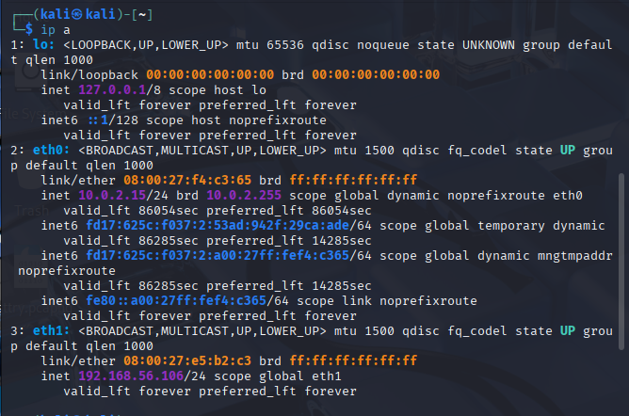
- Wazuh SIEM (Manager + Dashboard):
Deployed using a pre-configured OVA, this system acted as the centralized logging and monitoring platform. It collected, processed, and visualized security events generated by the Windows endpoint.
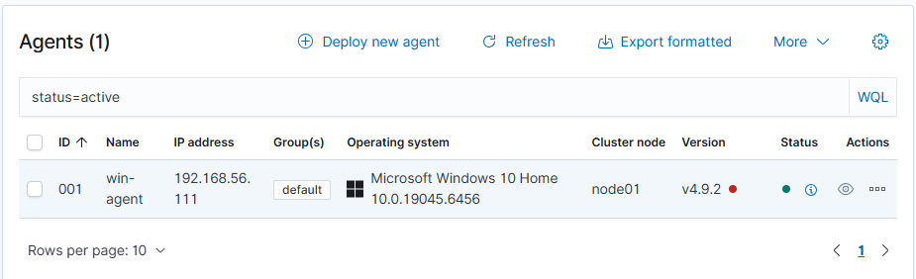
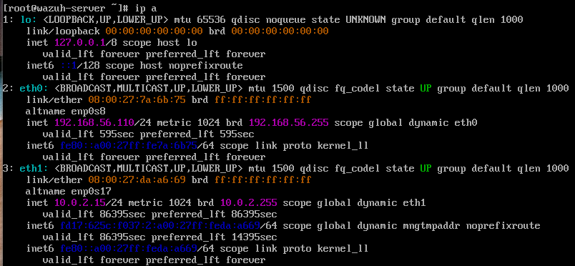
This architecture simulates a real-world Security Operations Center (SOC) environment where endpoints continuously report activity to a centralized SIEM for detection and analysis.

Step 1: Creation of Staging Directory
A dedicated directory was created on the Windows system to simulate a sensitive data staging location:
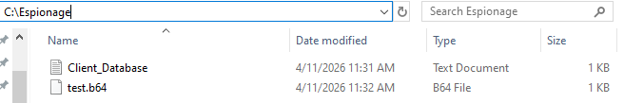
This directory was intentionally chosen to represent a non-standard folder where an insider might temporarily store confidential data before exfiltration.
The directory was created using administrative privileges to ensure full access and control. This step established the target location for all subsequent attacker actions, including file creation, encoding, and deletion.

Step 2: Wazuh Agent Configuration
To enable monitoring of the staging directory, the Wazuh agent configuration file was modified. The configuration file is located at:
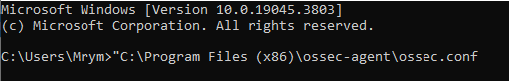
Within this file, the <syscheck> module is responsible for File Integrity Monitoring. The following configuration entry was added:
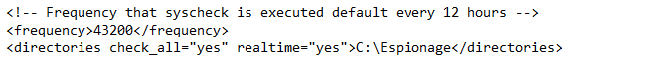

Explanation of Configuration Parameters
- check_all="yes"
This parameter ensures that all file attributes are monitored, including hashes, permissions, ownership, and timestamps. This provides comprehensive visibility into any changes occurring within the directory.
- realtime="yes"
Enables real-time monitoring using filesystem hooks. Without this setting, Wazuh would rely on periodic scans (default ~12 hours), which would delay detection significantly.
- Directory Path (C:\Espionage)
Specifies the exact folder to be monitored. Any mismatch in the path (including case sensitivity or syntax errors) would result in the directory being ignored silently.
This configuration ensures that every file-related event within the staging directory is immediately captured and forwarded to the SIEM.

Step 3: Agent Service Restart
After modifying the configuration file, the Wazuh agent service was restarted using the Windows Services Manager (services.msc).
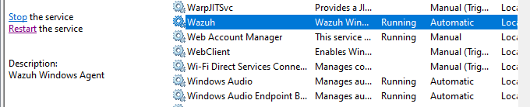
This step is mandatory because the Wazuh agent only loads its configuration during startup. If the service is not restarted, the new monitoring rules will not take effect.
Failure to perform this step is a common issue that results in missing FIM alerts during attack execution.

Step 4: Verification of Agent Connectivity
Following the configuration and restart, the Wazuh dashboard was accessed to verify that the Windows agent was actively communicating with the Wazuh manager.
The verification process included:
- Confirming the agent status as Active
- Ensuring recent heartbeat logs were being received
- Validating that the system appeared in the agent inventory list

This step confirmed that the endpoint was successfully integrated into the SIEM environment and ready to generate security events.

Result
The pre-engagement setup was successfully completed. The staging directory was created, and real-time File Integrity Monitoring was configured and validated. The Wazuh agent was actively reporting to the SIEM, ensuring full visibility into file system activity within the monitored directory.
This configuration enabled the capture of all relevant events during the attack phase, including file creation, encoding, and deletion, forming the foundation for the subsequent detection and investigation processes.

PHASE 1 — RED TEAM: ATTACK EXECUTION

Objective
The objective of this phase was to simulate a realistic insider threat scenario from the perspective of a malicious user with legitimate access to a corporate system. The attacker’s goal was to stage sensitive data, obscure it to avoid detection, exfiltrate it to an external system, and finally remove all traces of the activity.
This phase was designed to replicate real-world attack techniques where adversaries leverage trusted system tools rather than deploying external malware. Such techniques are commonly referred to as Living-off-the-Land (LotL) attacks, where built-in utilities are abused to bypass traditional security controls.
The execution of this phase provided the necessary artifacts and logs that would later be analyzed during the Blue Team investigation.

Attack Scenario Overview
The simulated attack followed a structured sequence of actions:
- Establish a listener on the attacker system
- Create a sensitive data file on the victim machine
- Encode the data to obscure its contents
- Exfiltrate the encoded data over HTTP
- Delete all evidence to evade detection
Each step corresponds to a specific tactic in the MITRE ATT&CK framework, allowing the attack to be mapped to standardized threat behaviors.

Tools and Techniques Used
- PowerShell (Windows): Used for file creation, data manipulation, and exfiltration
- certutil.exe: A legitimate Windows utility abused for Base64 encoding
- Netcat (Kali Linux): Used as a listener to receive exfiltrated data
- HTTP Protocol: Used for covert data transmission
- Wazuh FIM: Passively monitored all file-related activities

Step 1 — Attacker Listener Setup (Kali Linux)
The attack began by preparing the attacker machine to receive exfiltrated data. A Netcat listener was started on a specific port:

Explanation
Netcat is a lightweight networking utility capable of reading and writing data across network connections. In this scenario, it was used to simulate an attacker-controlled server waiting to receive stolen data.
- -l → Listen mode
- -v → Verbose output
- -n → No DNS resolution (faster execution)
- -p 8080 → Port number
Port 8080 was chosen because it is commonly used for HTTP traffic and is less likely to be blocked in internal networks compared to non-standard ports.

Security Insight
Using Netcat allows attackers to quickly establish a data exfiltration channel without deploying complex infrastructure. Because it does not require installation on most Linux systems, it is a preferred tool for quick and stealthy operations.

Step 2 — Data Staging on Windows Endpoint
The attacker created a file containing sensitive information within the monitored directory:

Explanation
The Set-Content cmdlet in PowerShell is used to create or overwrite files. In this case, it was used to simulate the creation of a confidential database file containing sensitive client information.
This step represents data staging, where attackers prepare information for extraction.

Step 3 — Data Obfuscation using certutil (Base64 Encoding)
The staged file was encoded using the Windows utility certutil.exe:

Explanation
certutil.exe is a legitimate Windows tool used for certificate management. However, it can also encode files into Base64 format.
Base64 encoding transforms binary or text data into an ASCII format, making it appear as unreadable text. This does not encrypt the data but makes it less obvious during casual inspection.

Why Attackers Use Base64
- Evades simple content inspection
- Makes data appear harmless (like system cache)
- Bypasses basic detection mechanisms

Security Insight
This step maps to MITRE ATT&CK T1027 — Obfuscated Files or Information.
Attackers frequently use encoding techniques to bypass detection systems that rely on keyword matching or plaintext inspection.

Step 4 — Data Exfiltration via HTTP POST
The encoded data was transmitted to the attacker machine using PowerShell:

Explanation
- Get-Content -Raw reads the entire file as a single string
- Invoke-WebRequest sends an HTTP request to a remote server
- The -Method Post option is used to send data in the request body
This simulates real-world data exfiltration over HTTP, which is one of the most common techniques used by attackers.

Step 5 — Anti-Forensics: Evidence Deletion
After successfully exfiltrating the data, the attacker removed all files:

Explanation
The Remove-Item cmdlet deletes files and directories. The -Force flag ensures that even hidden or protected files are removed without prompting.
This step attempts to eliminate any evidence of the attack from the system.

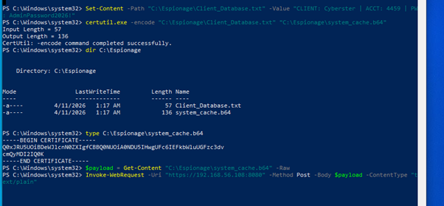
Step 6: Verify Data Reception on Kali
On the Kali VM, the netcat listener received the incoming HTTP POST request containing the Base64 encoded payload. The received data showed the full HTTP headers and the encoded certificate formatted Base64 content, confirming successful exfiltratio
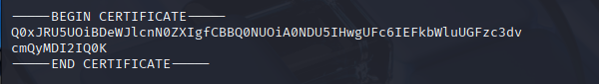
Phase 2 — Blue Team: Detection and Investigation

Task 1: Wazuh Rule Trigger Analysis

1 — File Creation Rule Trigger

Event
File created:
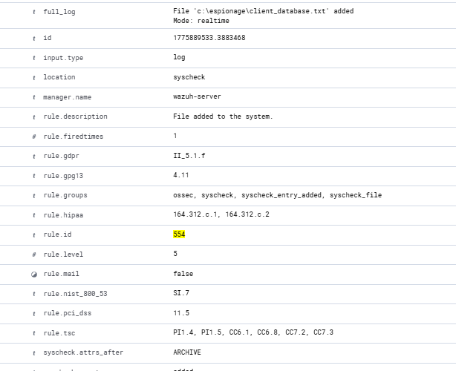
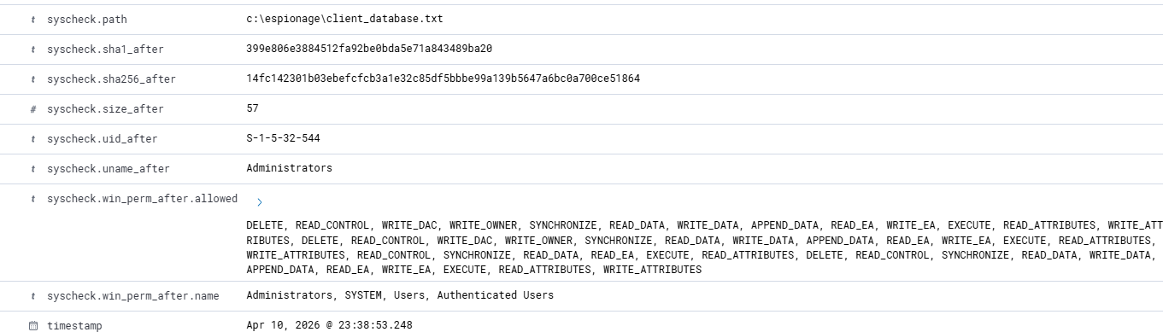

Why This Rule Triggered
Wazuh File Integrity Monitoring (FIM) detected a new file creation inside a monitored directory.
This rule alone is low-to-medium severity, but becomes important when:
- File name is sensitive
- Directory is unusual
- Followed by encoding or deletion

2 — File Modification / Encoding Rule Trigger

Event
Modified
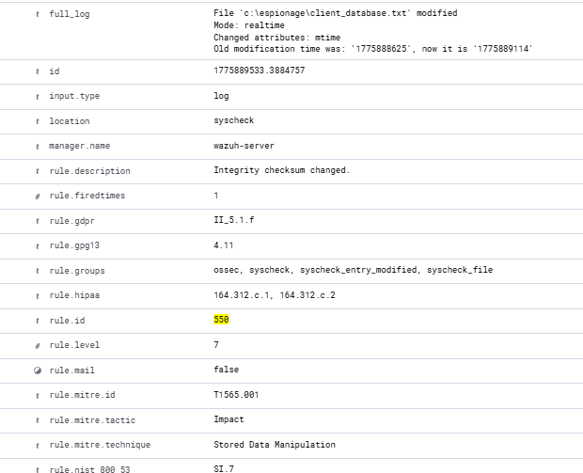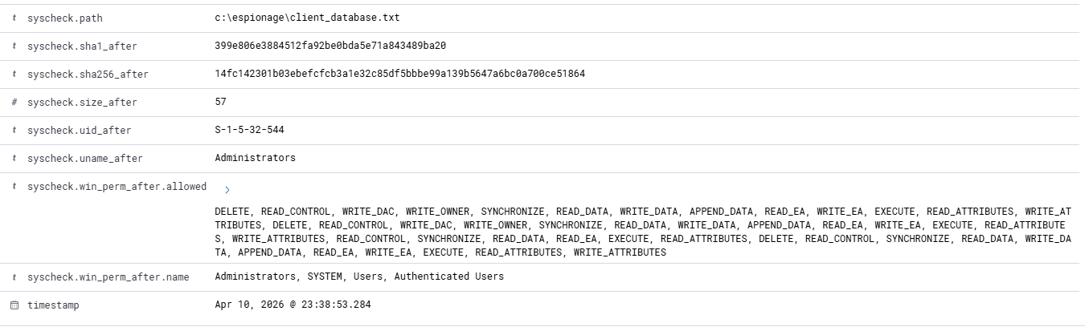

Why This Rule Triggered
- New .b64 file created
- File transformation occurred
- Directory contents changed
This is where real detection starts.
Indicators:
- Use of .b64 extension
- Presence of encoded data
- Possible obfuscation attempt

3 — File Deletion Rule Trigger (CRITICAL)

Event
Deletion
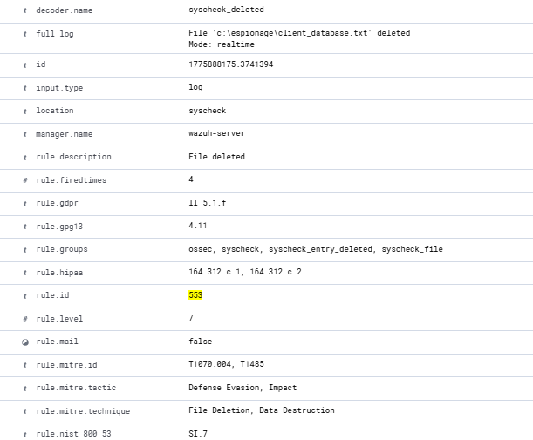
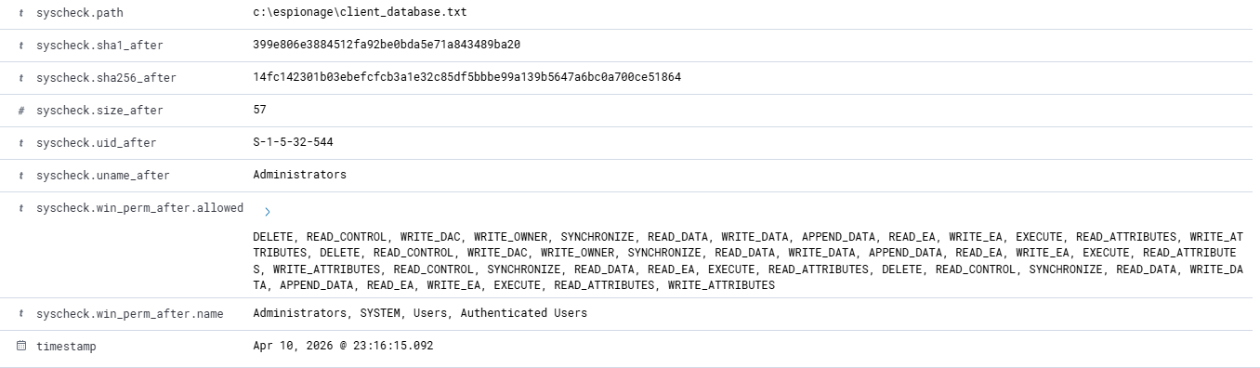

Why This Rule Triggered
Wazuh detected mass deletion of files in monitored directory.
The deletion of files immediately after encoding activity suggests intentional anti-forensic behavior aimed at removing evidence.

Rule | Meaning | Alone
554 | File Created | Normal
550 | File Modified | Normal
553 | File Deleted | Normal

Task 2: Evidence Decoding with CyberChef
The Base64-encoded data received by the attacker's listener was decoded using CyberChef (https://gchq.github.io/CyberChef/). The Base64 content was pasted into the input field after removing the certificate header (-----BEGIN CERTIFICATE-----) and footer (-----END CERTIFICATE-----) lines that certutil adds during encoding. The From Base64 recipe was applied, and the decoded output revealed the original plaintext content.
This confirmed that the exfiltrated data contained sensitive client credentials, validating the insider threat scenario and providing critical forensic evidence for the incident response report.
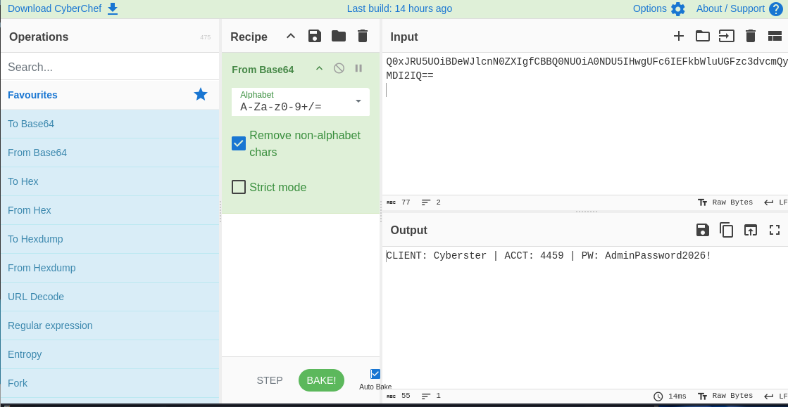

Task 3: Detection Engineering — Custom Wazuh Rule
The final investigative task was to engineer a custom Wazuh detection rule that would automatically alert on the specific attack pattern observed: the creation of Base64-encoded files within the Espionage directory. This rule would provide high-confidence detection of potential data exfiltration staging activity.
Initial Rule Development
The custom rule was developed in /var/ossec/etc/rules/local_rules.xml on the Wazuh Manager. The initial approach used a element to match the syscheck.path field against a regex pattern for .b64 files in the Espionage directory, chained to Rule 554 (File added) via .
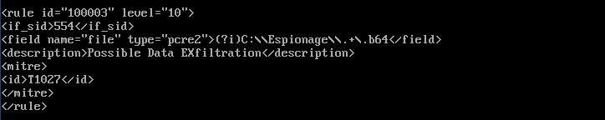
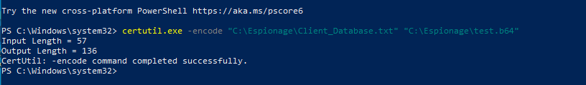

Phase 3 — Incident Response Report

Executive Summary
An authorized user with administrator privileges created a sensitive data file (Client_Database.txt) containing client credentials within a staging directory (C:\Espionage), encoded the file to Base64 format using the legitimate Windows utility certutil.exe, exfiltrated the encoded data to an external host (192.168.35.128:8080) via HTTP POST using PowerShell's Invoke-WebRequest, and subsequently deleted all evidence from the staging directory.
The incident was detected through Wazuh File Integrity Monitoring (FIM) alerts that captured file creation and deletion events in real-time. Evidence recovery confirmed the exfiltration of client credentials including account numbers and passwords. A custom detection rule (Rule ID 100500) was developed and deployed to provide automated alerting for this specific attack pattern in future incidents.

Detection and Analysis (MITRE ATT&CK Mapping)
The attack chain was mapped to the following MITRE ATT&CK techniques, providing a standardized framework for understanding the threat actor's behavior:
Technique | Tactic | Observed Behavior | Tool Used
T1074 — Data Staging | Collection | Creation of sensitive file in staging directory | PowerShell (Set-Content)
T1027 — Obfuscated Files or Information | Defense Evasion | Base64 encoding of data | certutil.exe
T1048 — Exfiltration Over Alternative Protocol | Exfiltration | Data transmitted via HTTP POST | PowerShell (Invoke-WebRequest)
T1070.004 — Indicator Removal (File Deletion) | Defense Evasion | Deletion of all staged files | PowerShell (Remove-Item)

Wazuh Rule Trigger Analysis
The detection of this incident relied on multiple Wazuh rules triggered during different stages of the attack.

Rule 554 — File Added
- Triggered when:
  - Client_Database.txt was created
  - system_cache.b64 was generated
Interpretation:
Indicates data staging and preparation activity. Individually low severity, but significant when correlated.

Rule 550 — File Modified
- Triggered during encoding process
Interpretation:
Represents transformation of data, consistent with obfuscation behavior.

Rule 553 — File Deleted
- Triggered when all files in C:\Espionage were removed
Interpretation:
Strong indicator of anti-forensic activity. High confidence of malicious intent when following encoding.

Custom Rule 100005— Suspicious Encoding Activity
- Triggered on .b64 file creation within monitored directory
Logic Summary:
- Detect Base64 file creation
- Identify suspicious naming patterns
- Increase alert severity
Interpretation:
Provides proactive detection of obfuscation attempts using legitimate tools.

Correlation Insight
While individual alerts appeared benign, their sequence revealed a complete attack chain:
File Creation → Encoding → Exfiltration → Deletion
This pattern confirms malicious activity consistent with insider data exfiltration.
Indicators of Compromise (IOCs)
Indicator Type | Value | Context
File Path | C:\Espionage\Client_Database.txt | Staging file
File Path | C:\Espionage\system_cache.b64 | Encoded file
File Extension | .b64 | Obfuscation indicator
Tool | certutil.exe | LOLBin abuse
Tool | PowerShell (Invoke-WebRequest) | Exfiltration
Network | HTTP POST (Port 8080) | Data transfer channel
Behavior | Bulk file deletion | Anti-forensics

Containment, Eradication, and Recovery

Containment
- Immediately disable the compromised user account
- Isolate the affected endpoint from the network
- Block outbound communication to suspicious IPs and ports
- Preserve all logs and forensic artifacts

Eradication
- Perform full system scan for persistence mechanisms
- Analyze PowerShell execution logs (if available)
- Investigate additional directories for hidden staging activity
- Remove unauthorized scripts or scheduled tasks

Recovery
- Reset all compromised credentials
- Restore system from a clean backup
- Validate system integrity post-recovery
- Reconnect system to network after verification

Post-Incident Recommendations and Lessons Learned

Detection Improvements
- Deploy custom Wazuh rule (ID 100500) in production
- Enable PowerShell Script Block Logging (Event ID 4104)
- Monitor certutil.exe usage via Sysmon
- Integrate network monitoring tools for HTTP inspection

Policy Improvements
- Enforce least privilege access control
- Restrict execution of LOLBins via AppLocker/WDAC
- Implement Data Loss Prevention (DLP) policies
- Conduct insider threat awareness training

Key Lessons Learned
- FIM provides visibility but not completeness
File monitoring alone cannot detect network-based exfiltration.
- Legitimate tools can be weaponized
Detection must focus on behavior, not just binaries.
- Correlation is critical
Individual alerts are weak; combined alerts reveal attacks.
- Anti-forensics is effective against local analysis
Centralized logging is essential for post-incident investigation.

Conclusion
This incident demonstrates a realistic insider threat scenario where an attacker successfully leveraged legitimate tools to perform data staging, obfuscation, exfiltration, and evidence removal. Although traditional detection mechanisms failed to identify the full attack in real time, Wazuh FIM provided sufficient visibility to reconstruct the attack through log correlation.
The development of a custom detection rule significantly enhances the organization's ability to detect similar threats in the future. However, the incident highlights the necessity of a layered security approach that includes endpoint monitoring, network analysis, and behavioral detection.
This exercise reflects real-world SOC operations, emphasizing the importance of detection engineering, incident response planning, and continuous security improvement.

