Oracle EBS R12.2.4
Practical Assessment Evidence
P2P Business Cycle + Oracle Workflow
Candidate | Maryam
EBS Username | MARYAM_TEST
Assessment Date | 15-Oct-2026
Environment | Oracle EBS R12.2.4

Evidence Summary
Reference | Value
Requisition No. | 16144
PO No. | 6796
Receipt No. | 9175
Invoice No. | MARYAMINV002
Accounting Event | 6276788
AE Header ID | 8190820
Transfer Request ID | 7580712
GL Journal No. | SYESTEM EROR
Workflow Item Type | MARYWF
Workflow Item Key | 1 /1

QUESTION 1 — Complete P2P Cycle
Scenario used: Laptop Computer | Quantity 3 | Unit Price 450 | Department IT | Need-by 20-Nov-2026 | Standard Purchase.

Q1.1 — Purchase Requisition
Action: Create requisition with required item, quantity, price, destination and supplier.
Expected evidence: Requisition No. 16144; Total 1,350; Status initially Incomplete before approval.
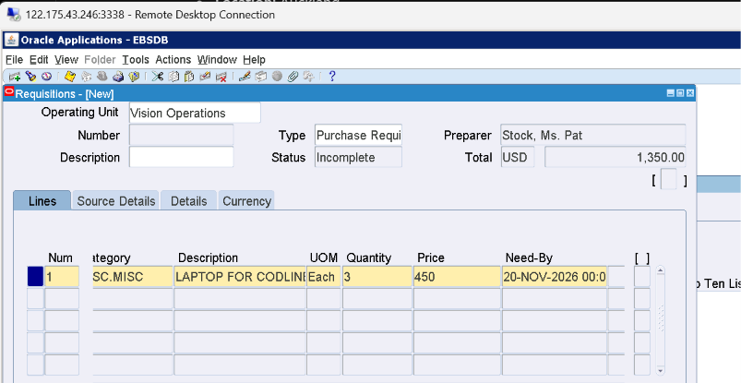
Requisition line entered for Laptop Computer, quantity 3, price 450, need-by date.
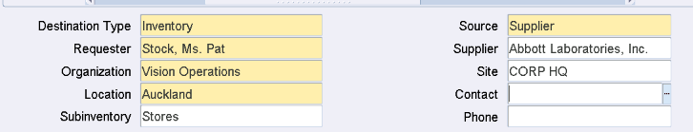
Source / destination details.
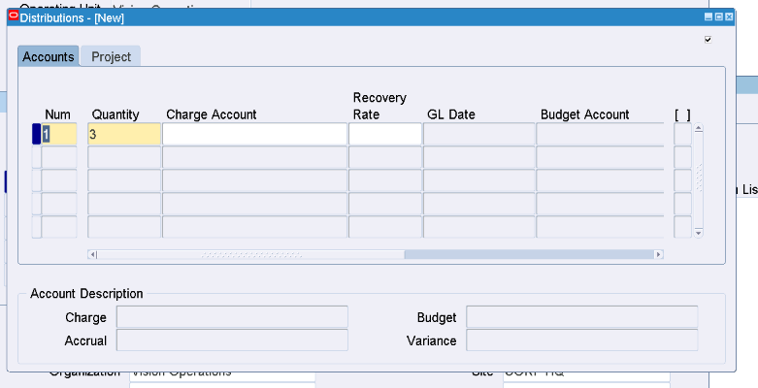
Requisition Distributions — quantity 3.
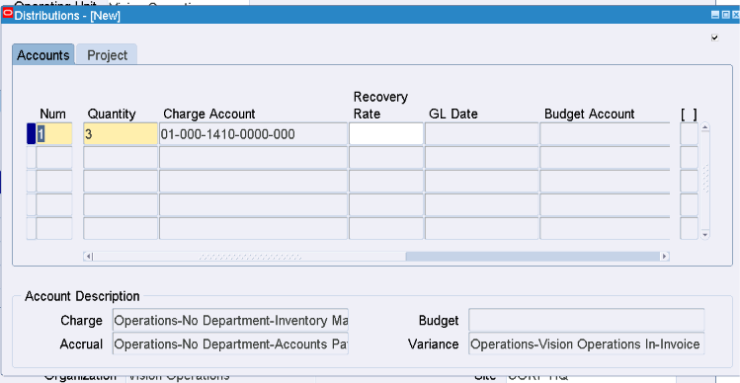
Distribution / charge account details.
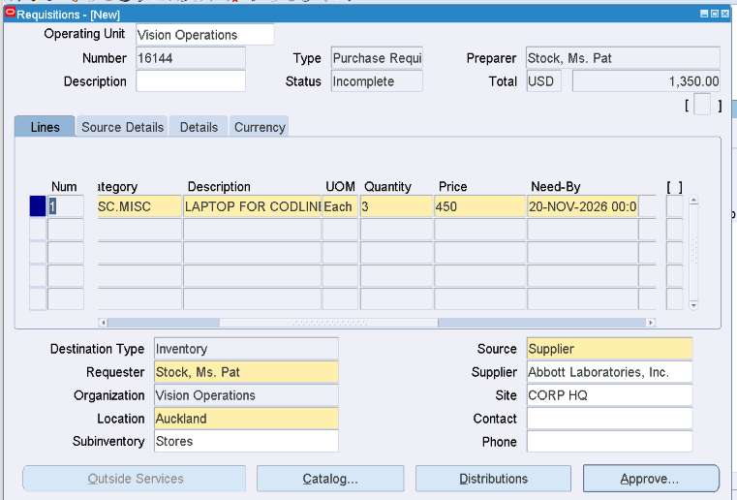
Completed requisition screen showing Requisition No. 16144 and total 1,350.

Q1.2 — Requisition Approval
Action: Submit requisition for approval and verify approval status.
Expected evidence: Requisition 16144 = Approved.
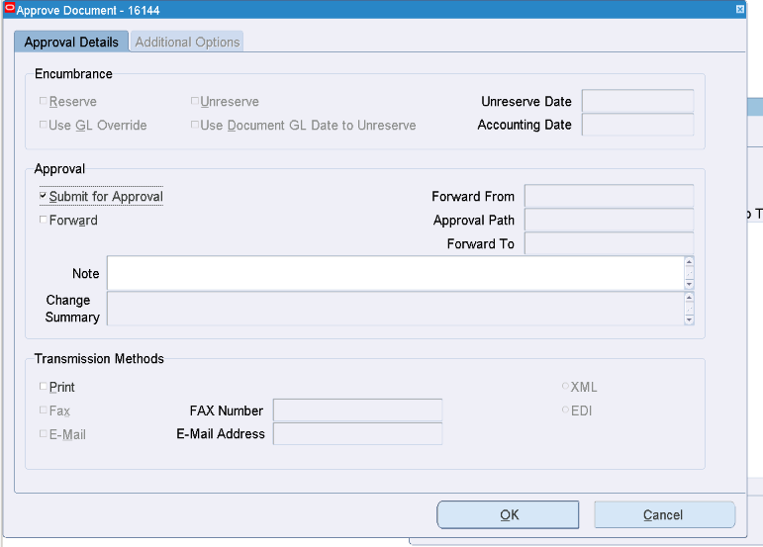
Submit / approval action.
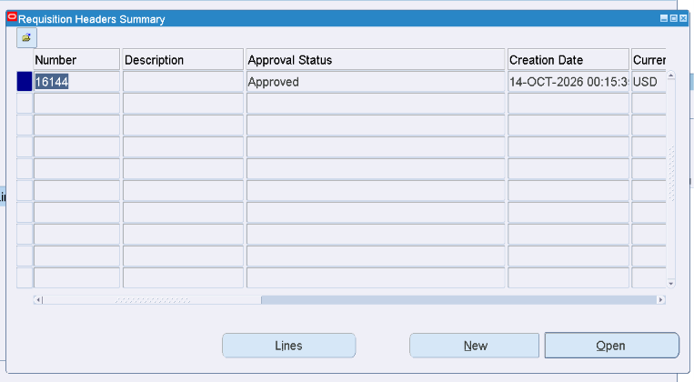
Requisition Summary / approval verification.
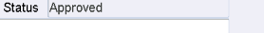
Approval status evidence: Approved.

Q1.3 — Purchase Order
Action: Create Standard Purchase Order from approved requisition; verify supplier, site, item, quantity, price, shipments and distributions.
Expected evidence: PO No. 6796; Status Approved; Total 1,350; Need-by 20-Nov-2026.
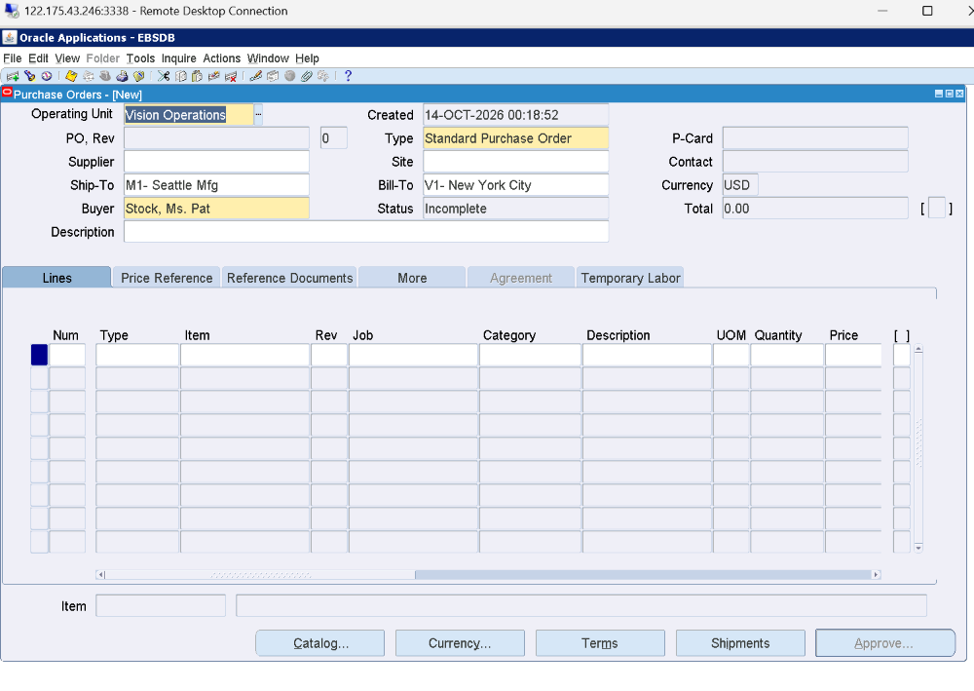
Purchase Order entry screen.
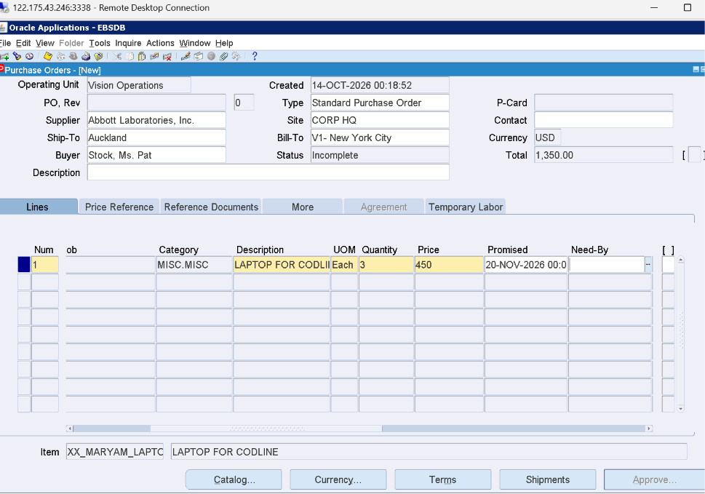
PO line details.
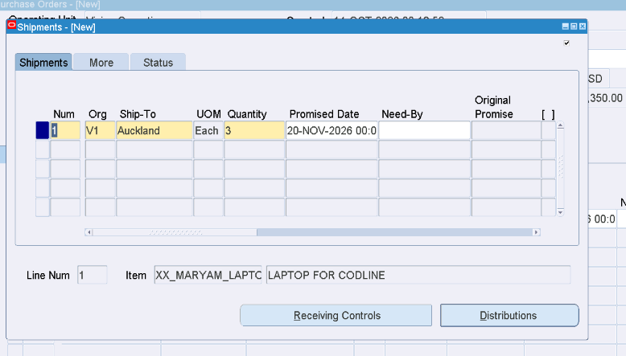
PO shipment details.
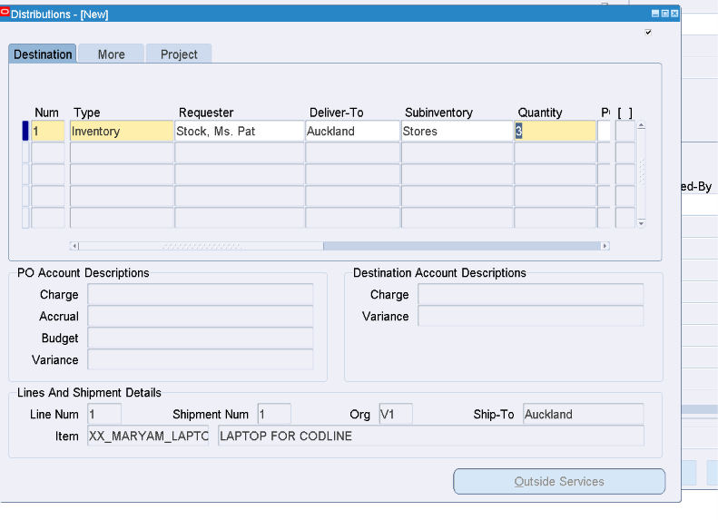
PO distribution details.
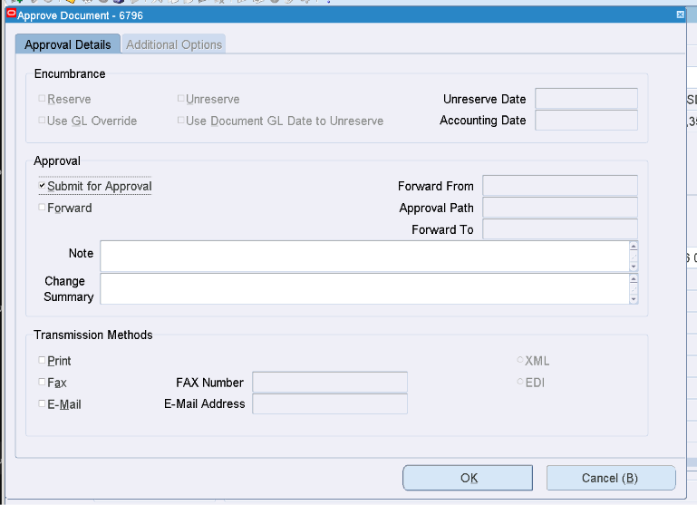
PO approval submission.
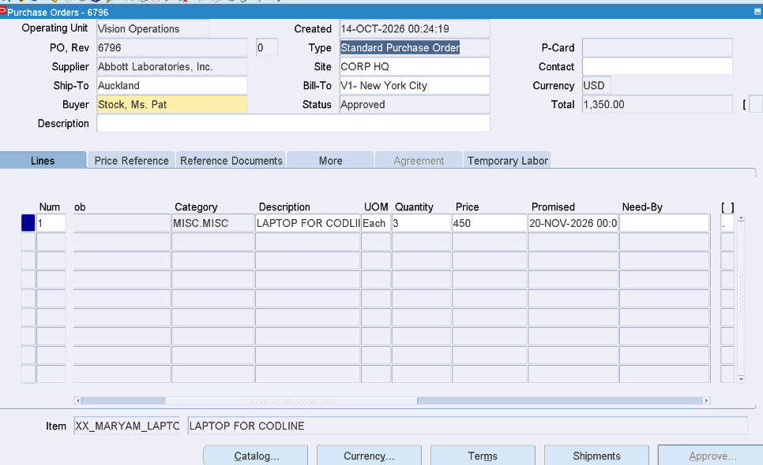
PO 6796 details / approval evidence.
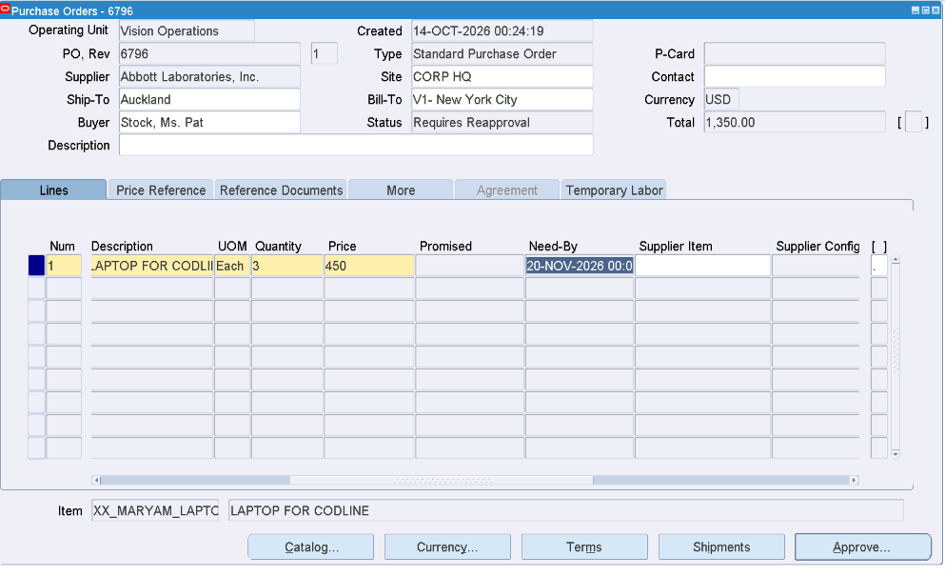
Need-by corrected to 20-Nov-2026; status Requires Reapproval after edit.
After correcting the Need-by date, the PO required reapproval. It was resubmitted and returned to Approved status.

Q1.4 — Receiving
Action: Receive the goods against PO 6796.
Expected evidence: Receipt No. 9175; Quantity 3; Destination Inventory; Routing Direct Delivery.
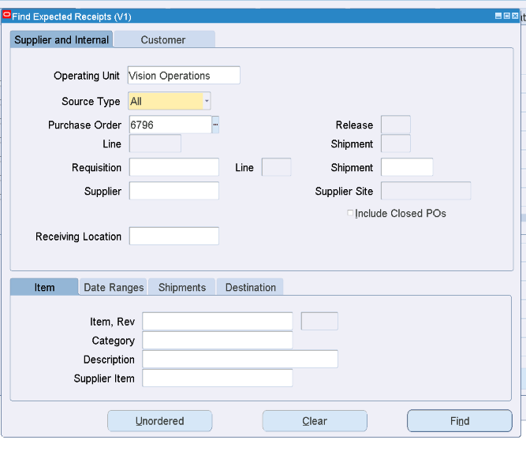
Find Receipts for PO 6796.
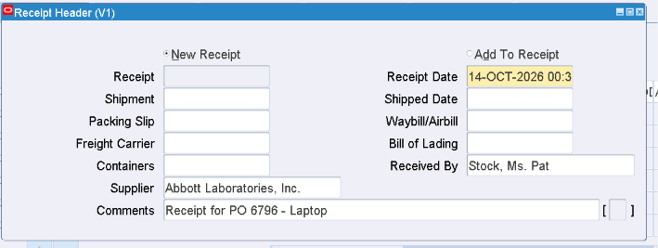
Receipt Header with supplier and comment.
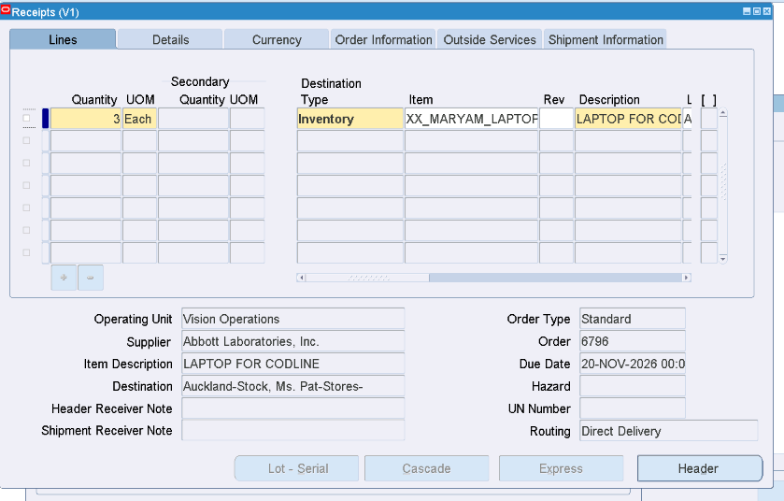
Receipt line: quantity 3, Inventory, Direct Delivery.
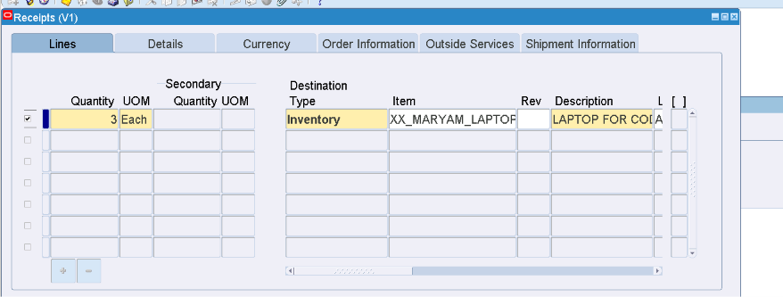
Receipt line selected for processing.
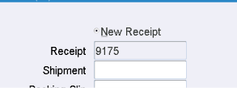
Receipt No. 9175 generated.
Saved successfully and generated Receipt No. 9175.

Q1.5 — AP Invoice
Action: Create and validate AP invoice against PO / receipt.
Expected evidence: Invoice MARYAMINV002; Amount 1,350; final validation status Validated.
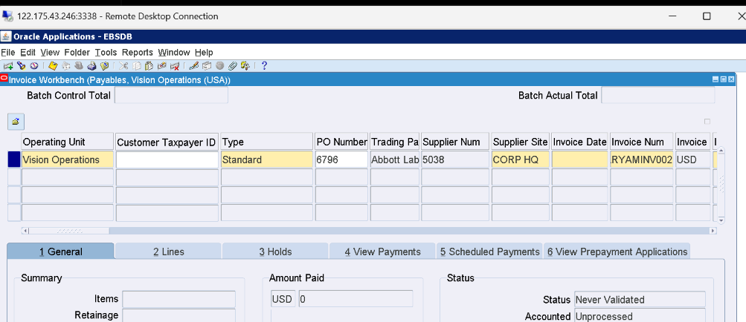
Invoice Workbench — invoice header.
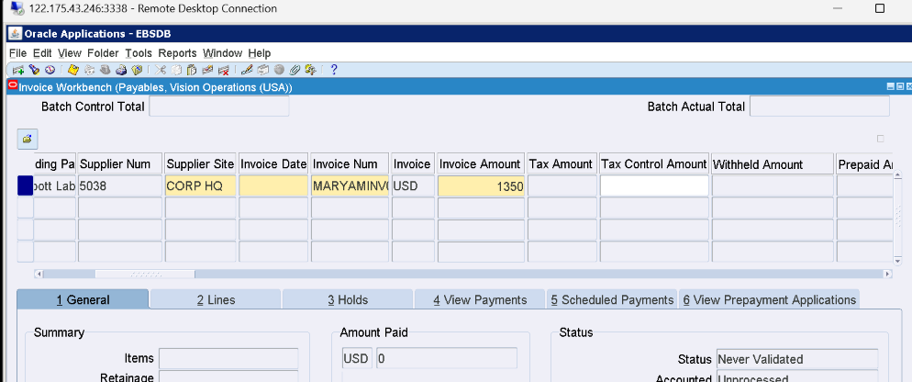
Invoice header / supplier / amount.
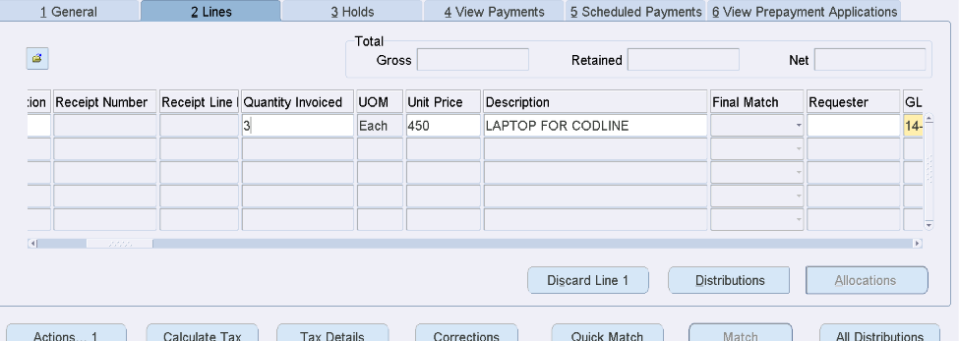
Invoice matching details.
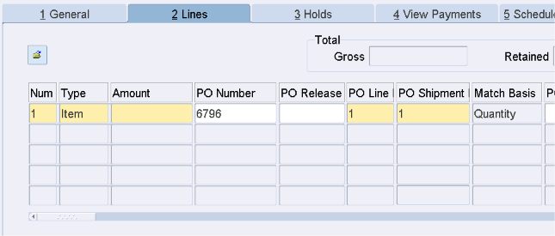
Invoice Lines — PO line / shipment / amount.
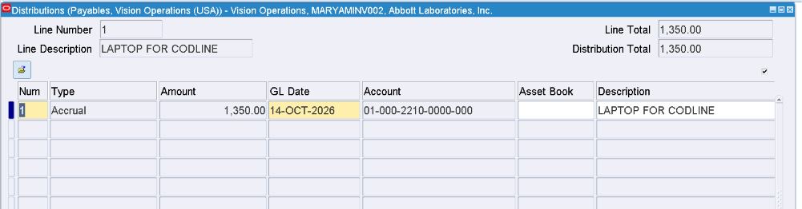
Invoice distributions.
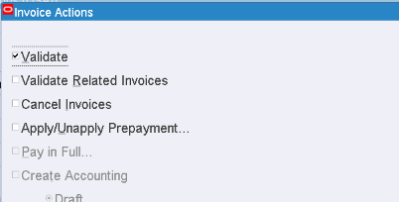
Invoice Actions — Validate.
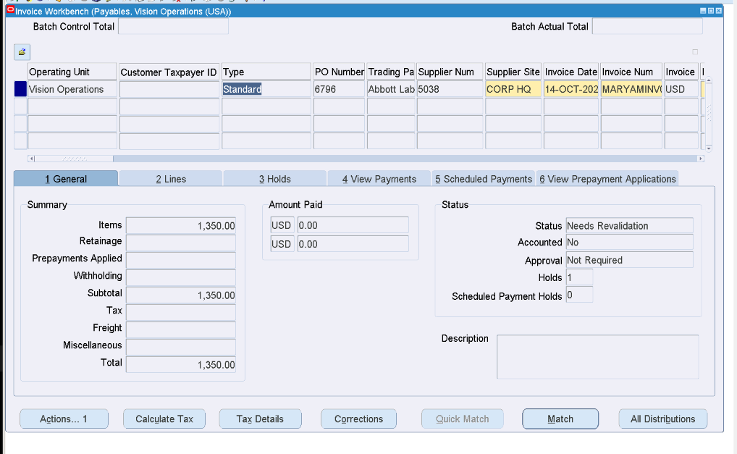
Invoice initially required revalidation.
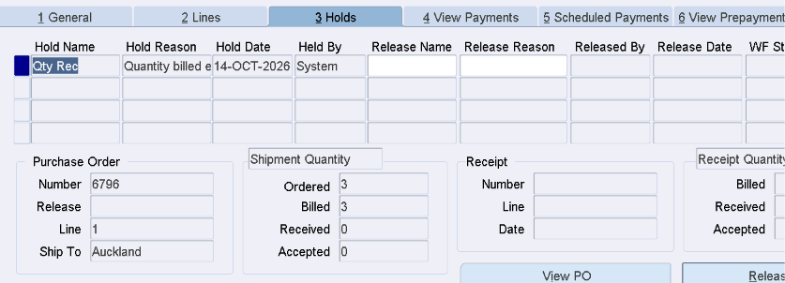
Hold Qty Rec shown.
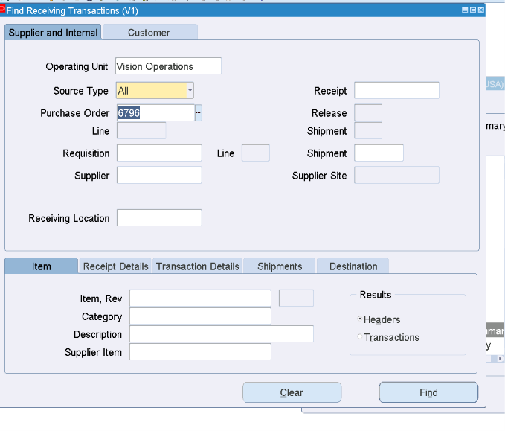
Receiving transaction check during hold troubleshooting.
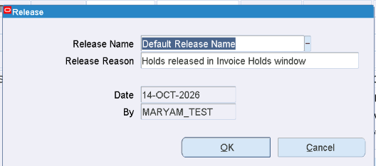
Hold Release — Default Release Name.
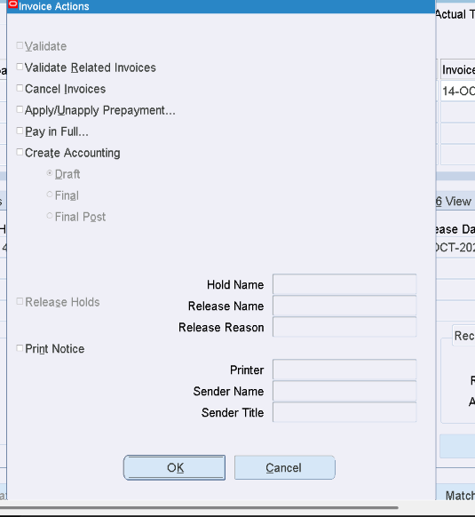
Invoice Actions after hold release.
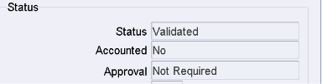
Validation status evidence: Validated.
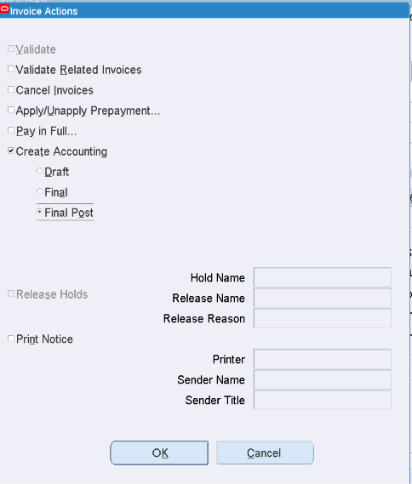
Create Accounting selection.
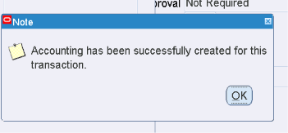
Accounting successfully created message.
Qty Rec hold was released using Default Release Name, then the invoice reached Validated status. Create Accounting completed successfully.

Q1.6 — Accounting Verification (SQL)
Action: Trace the exact invoice through AP and SLA to avoid using another user’s journal in the shared environment.
Expected evidence: Invoice ID 653184 → Event 6276788 → AE Header 8190820; accounting entry status Final.
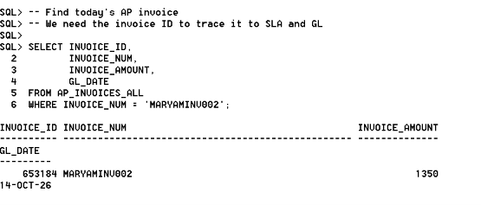
SQL: MARYAMINV002 → INVOICE_ID 653184; amount 1,350.
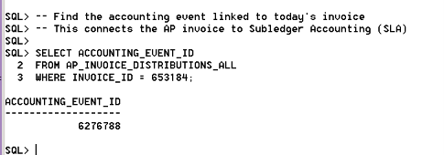
SQL: ACCOUNTING_EVENT_ID 6276788.
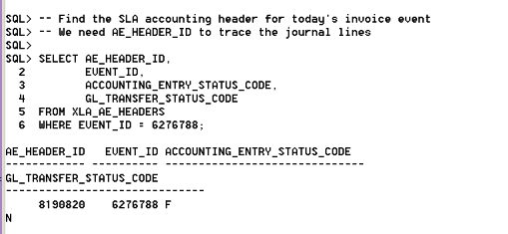
SQL: AE_HEADER_ID 8190820; accounting status F; GL transfer status N at this point.

Q1.7 — Transfer to GL
Action: Submit Transfer Journal Entries to GL and verify concurrent request completion.
Expected evidence: Request ID 7580712 was submitted, but remained Pending/Normal because the Standard Manager workers were occupied.
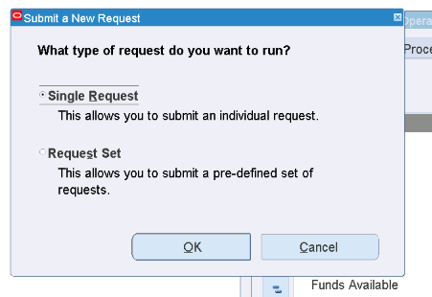
Submit a New Request — Single Request.
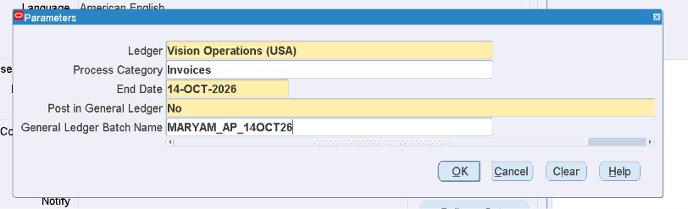
Transfer Journal Entries to GL parameters.
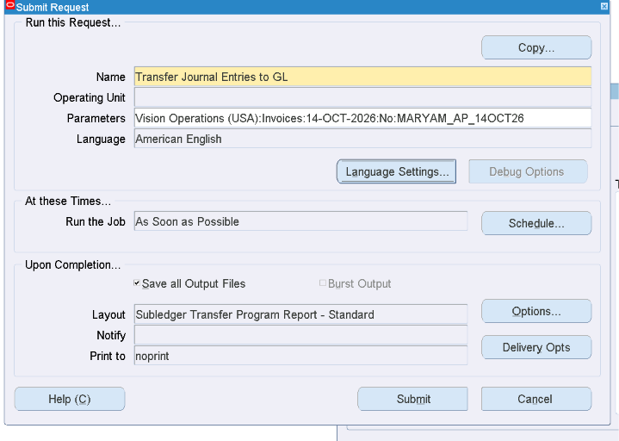
Transfer request setup / parameters.
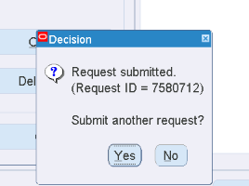
Request submitted — Request ID 7580712.
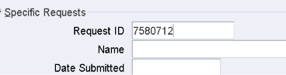
Find Request 7580712.
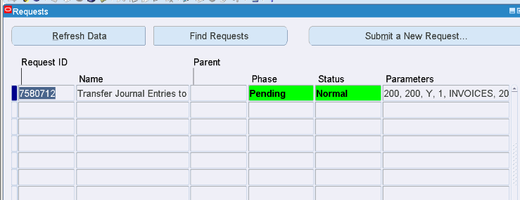
Request 7580712 = Pending / Normal.
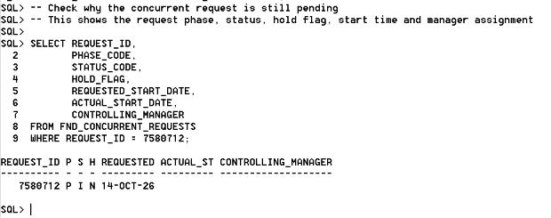
SQL diagnostic: request 7580712 pending; not on hold; no actual start / controlling manager.
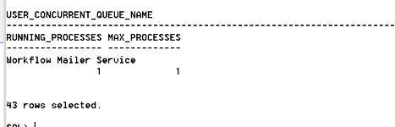
Concurrent manager status — Standard Manager 3 / 3 processes.
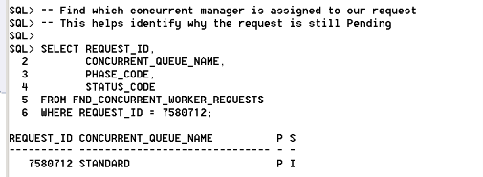
Worker request diagnostic — request assigned to STANDARD.
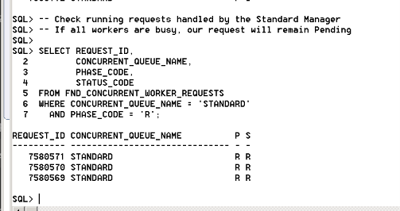
All three Standard Manager workers occupied by running requests.
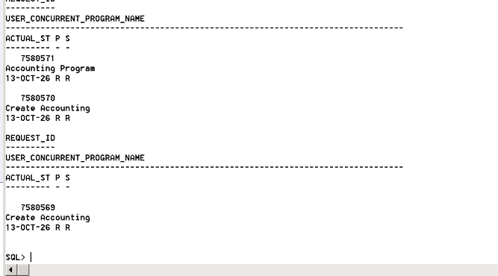
Running requests were long-running Create Accounting / Accounting programs.
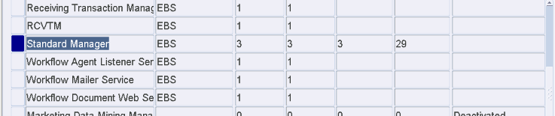
Administer Concurrent Managers — Standard Manager queue view.
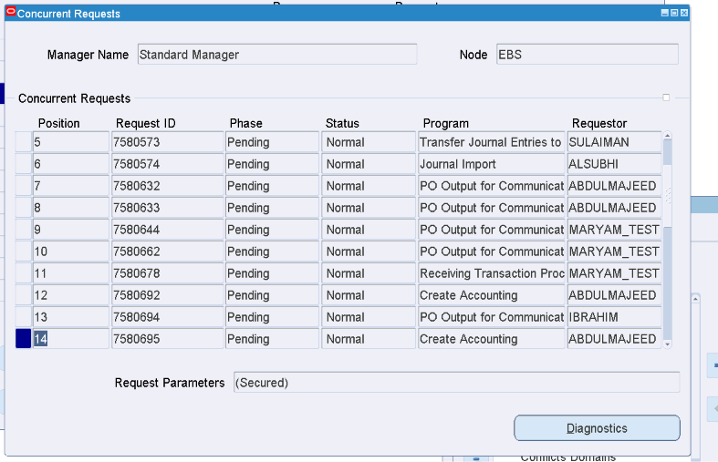
Standard Manager concurrent request queue with many pending requests.
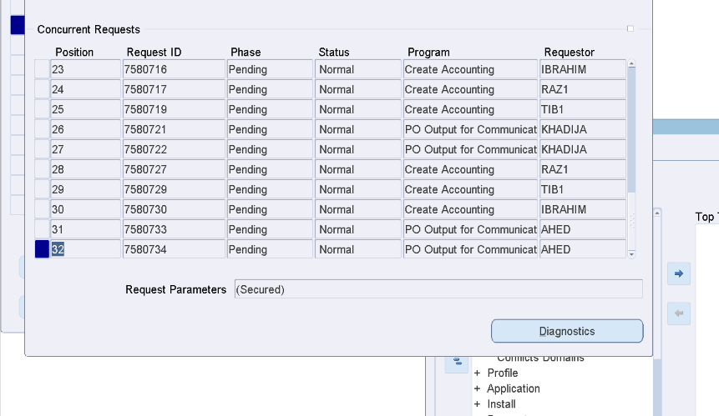
Additional pending queue evidence across multiple users.
Troubleshooting conclusion: the Transfer to GL request itself was submitted correctly. The shared lab Standard Manager had all 3 workers occupied and a backlog of pending requests. This is an environment/concurrent processing issue, not an invoice setup error.

Steps after: After the instructor restarts/clears the Standard Manager: (1) refresh Request 7580712 until Completed / Normal; (2) rerun the XLA header query and confirm GL_TRANSFER_STATUS_CODE changed from N; (3) locate the exact journal through GL_IMPORT_REFERENCES; (4) open General Ledger → Journals → Enter → Review Journal; (5) capture the journal name/number and Debit = 1,350 / Credit = 1,350. Fill the GL Journal No. in the document trail.

The SLA accounting entry was successfully created for invoice MARYAMINV002, showing a balanced Debit of 1,350 and Credit of 1,350
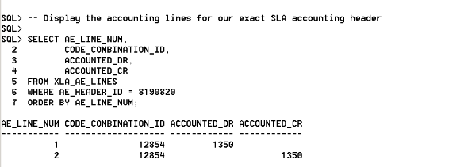
The Transfer Journal Entries to GL request remained in Pending / Normal status because the Concurrent Manager was still processing other requests; EBS confirmed this system condition
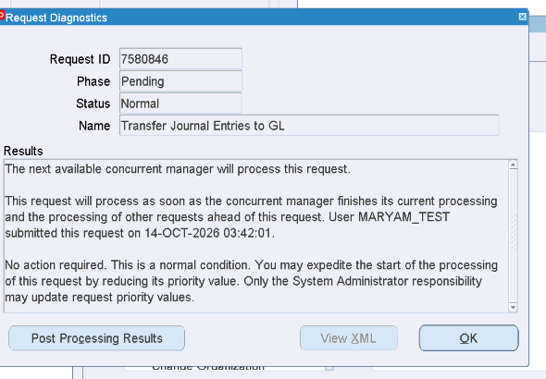
Example from the mock assessment showing the expected GL Journal screen and balanced Debit/Credit entries. (EBS)
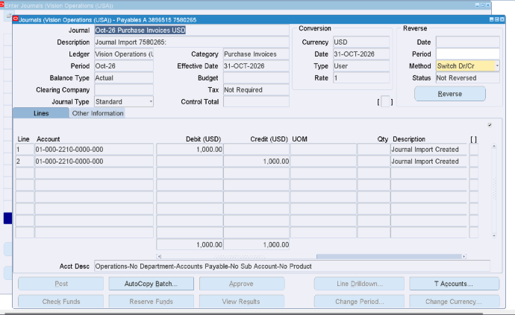

QUESTION 2 — Oracle Workflow
Business requirement implemented: “Maryam Welcome to the Company!!” notification workflow. Flow: Start → Submit → Monitor → Notify → END.

Q2.A — Create Workflow Definition
Action: Create Item Type, process, message, notification activities and transitions.
Expected evidence: Item Type MARYWF / Mary Welcome; process created; full flow visible in Workflow Builder.
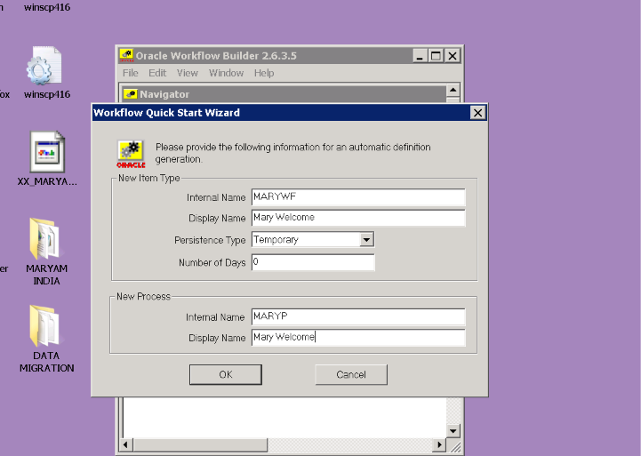
Quick Start Wizard — Mary Welcome item type / process.
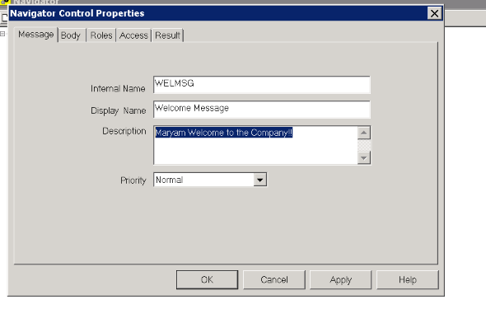
Welcome Message properties.
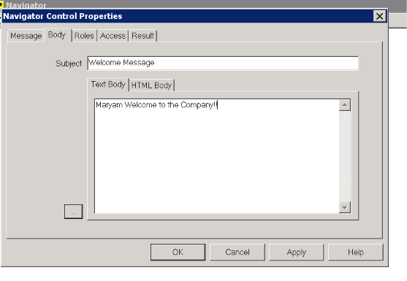
Message body: “Maryam Welcome to the Company!!”.
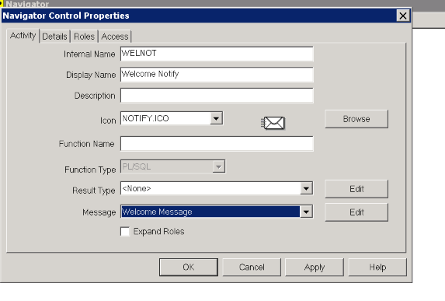
Welcome Notify activity linked to Welcome Message.
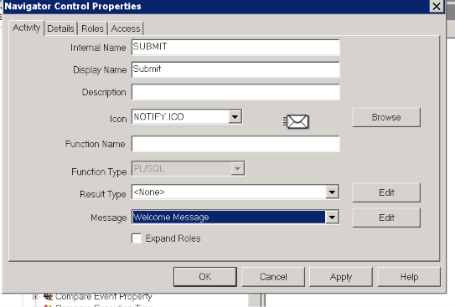
Submit activity.
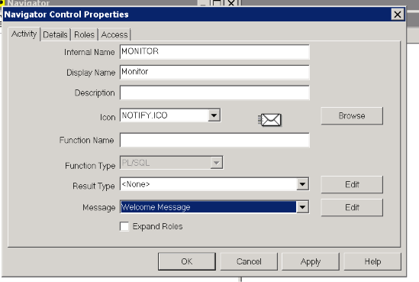
Monitor activity.

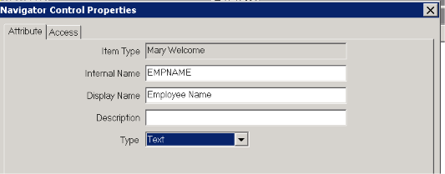
Attribute definition: EMPNAME / Employee Name / Type = Text. This satisfies the “Define appropriate attributes”

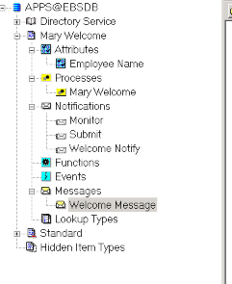
Workflow Builder Navigator showing process and activities.
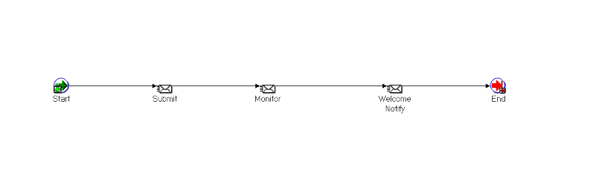
Workflow diagram: Start → Submit → Monitor → Welcome Notify → End.

Q2.B — Configure Notification
Action: Configure notification message, performer and response/result.
Expected evidence: Performer = MARYAM_TEST; informational notification uses Result Type <None> / no response required.
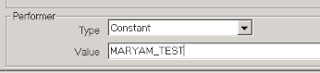
Performer configuration: Constant = MARYAM_TEST.
Response / result rationale: this is an informational welcome notification, so no user response is required; Result Type was left as <None>. The delivered notification confirms “This notification does not require a response.”

Q2.C — Deploy Workflow
Action: Save workflow definition to the EBS database and verify it is available in Developer Studio.
Expected evidence: MARYWF appears in Developer Studio as Mary Welcome.
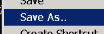
Workflow Builder Save As action.
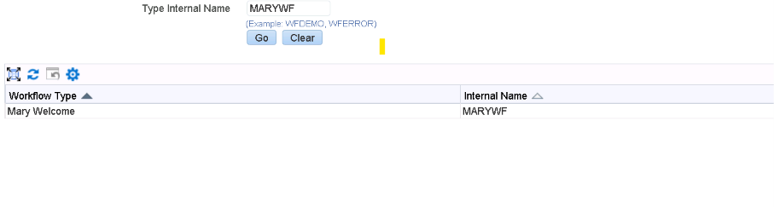
Developer Studio — MARYWF / Mary Welcome found.

Q2.D — Execute Workflow
Action: Run the workflow from Developer Studio / Workflow Administrator and verify Start → Submit → Monitor → Notify → END.
Expected evidence: Workflow item key 1 started successfully and completed.
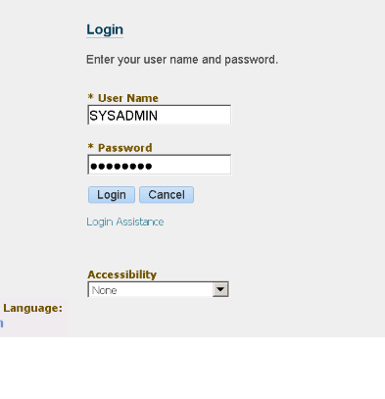
SYSADMIN login used to run the workflow.
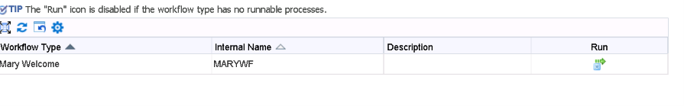
Developer Studio workflow record / Run action.
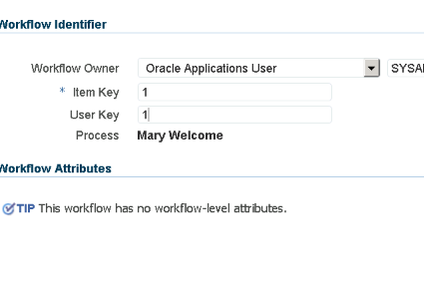
Run Workflow — Item Key 1 / Process Mary Welcome.
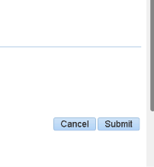
Submit action on Run Workflow page.
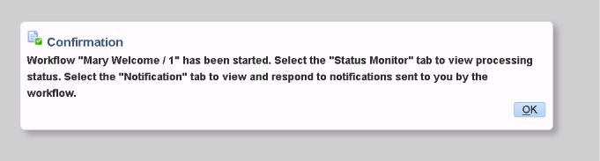
Confirmation: Mary Welcome / 1 started.
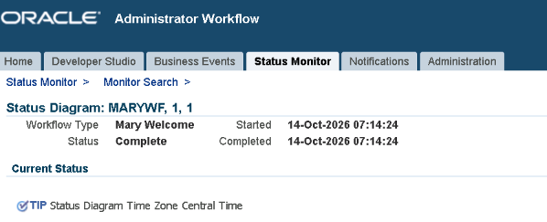
Status Monitor: MARYWF item 1 = Complete.

Q2 Notification Evidence
Action: Verify that MARYAM_TEST receives the notification and open the message.
Expected evidence: Worklist shows Mary Welcome notifications; detail shows “Maryam Welcome to the Company!!”.
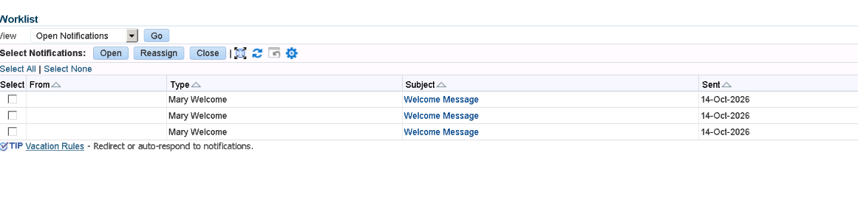
MARYAM_TEST Worklist — Mary Welcome / Welcome Message notifications.
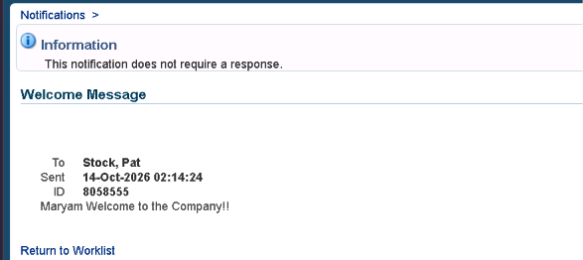
Notification detail — To Stock, Pat; message “Maryam Welcome to the Company!!”.

Q2.E — Troubleshooting (2 Marks)
- Incorrect performer / invalid user or role: verify the activity performer is a valid Workflow role (for example MARYAM_TEST) and check that the user exists in WF_ROLES.
- Workflow Mailer or notification configuration issue: verify the Workflow Mailer service is running, then confirm the Notification activity is linked to the correct Message and Performer.

