Create a Report Based on a Data Model
Task Summary
I completed the task in Oracle Fusion by following the steps below.

Steps Completed
- I opened Tools, selected Reports and Analytics, and opened Browse Catalog.
- I created a new Data Model or opened an existing one.
- I added a suitable data set, such as a SQL Query or Analysis, based on the available data source.
- I selected the required fields and saved the Data Model in the appropriate folder.
- I returned to the Catalog, selected Create, and chose Report.
- I selected the saved Data Model, arranged the required fields in the report layout, and saved the report.
- I ran the report and checked that the expected data appeared.

Screenshots
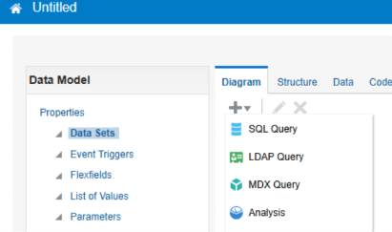
Screenshot 2026-11-02 201316.png
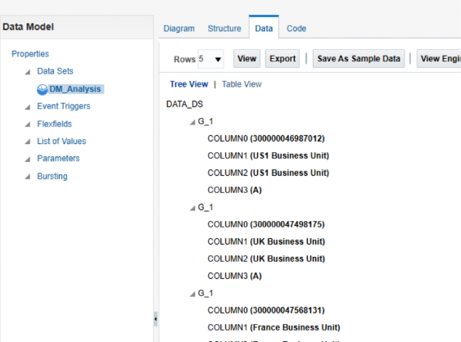
Screenshot 2026-11-02 201349.png
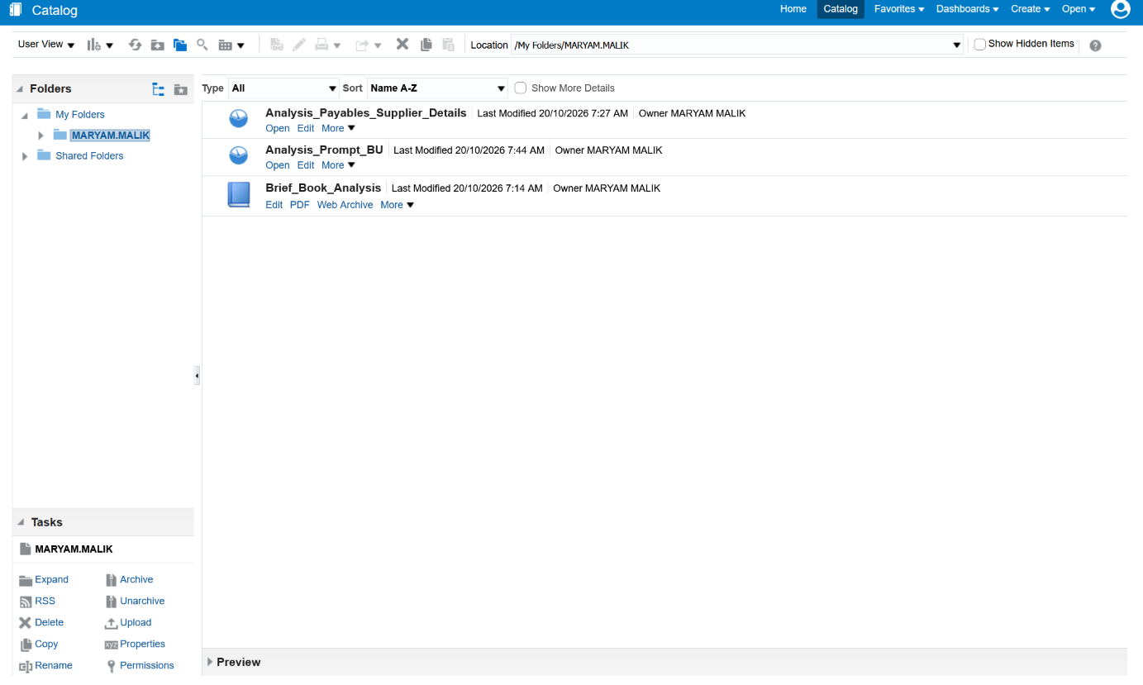
Screenshot 2026-10-20 114535.png
Note: Some menu names and available options may vary depending on the Oracle Fusion environment and assigned permissions.

