Create a Report Based on a Spreadsheet
Task Summary
I completed the task in Oracle Fusion by following the steps below.

Steps Completed
- I opened Reports and Analytics and selected Browse Catalog.
- I created a Data Model and added a spreadsheet or Excel data set where this option was available in the environment.
- I uploaded the spreadsheet and followed the import steps to identify the file and its columns.
- I checked the column names and data types, then saved the Data Model.
- I created a report based on the saved model and arranged the required fields in the layout.
- I saved and ran the report, then compared the output with the original spreadsheet.

Screenshots
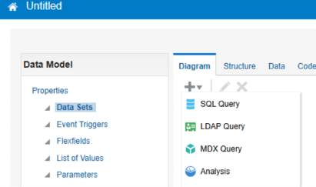
Screenshot 2026-11-02 201316.png
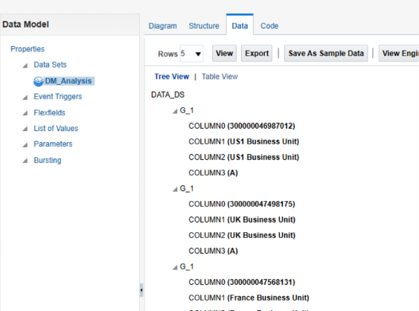
Screenshot 2026-11-02 201349.png
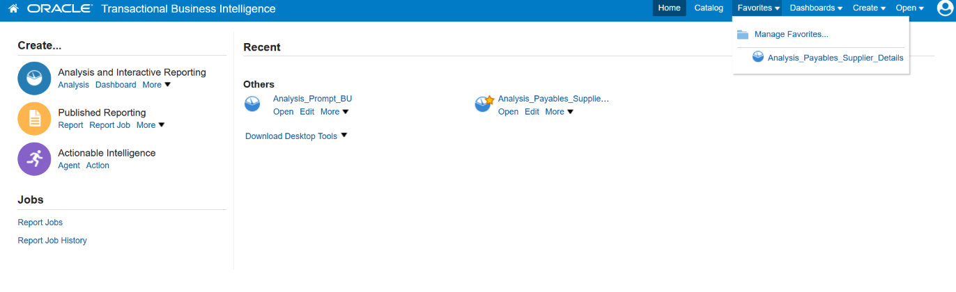
Screenshot 2026-10-20 115147.png
Note: Some menu names and available options may vary depending on the Oracle Fusion environment and assigned permissions.

