Create an Analysis for Payables Supplier Details
Task Summary
I completed the task in Oracle Fusion by following the steps below.

Steps Completed
- I opened Reports and Analytics and selected Analysis from the Create menu.
- I selected the appropriate Payables subject area, such as Payables Invoices - Transactions Real Time, depending on the available subject areas.
- I added the relevant columns, such as Supplier, Supplier Type, Supplier Number, Invoice Currency, Invoice Amount, and Invoice Name where available.
- I opened the Results tab and checked that the selected columns and data appeared correctly.
- I saved the analysis in the appropriate folder as Analysis_Payables_Supplier_Details.
- I ran the analysis again to confirm the output.

Screenshots
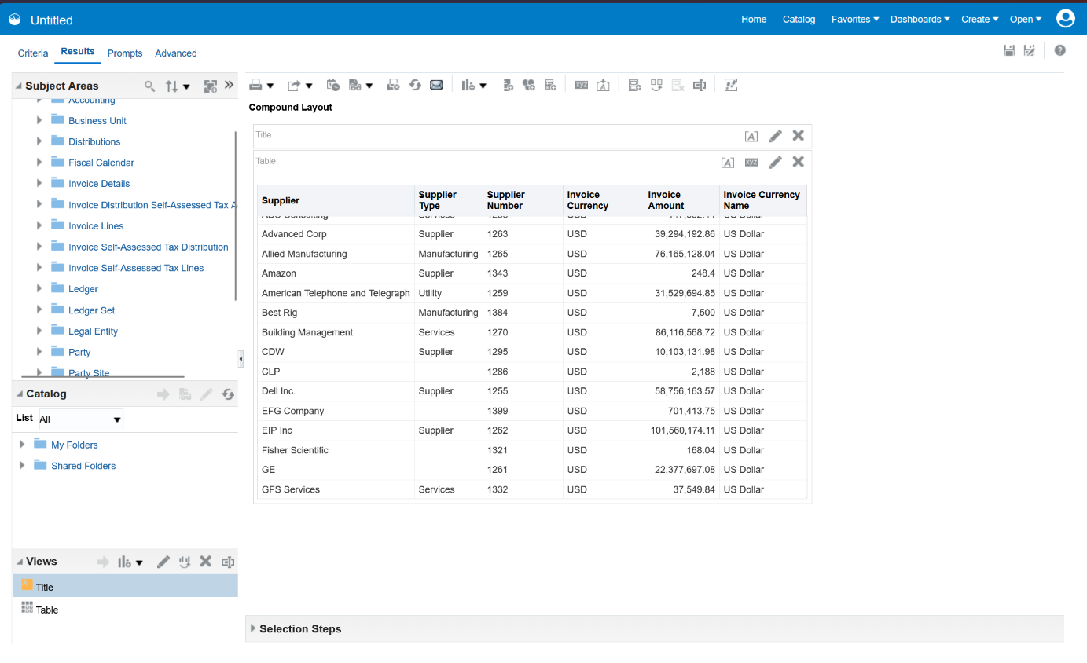
Screenshot 2026-10-20 103220.png
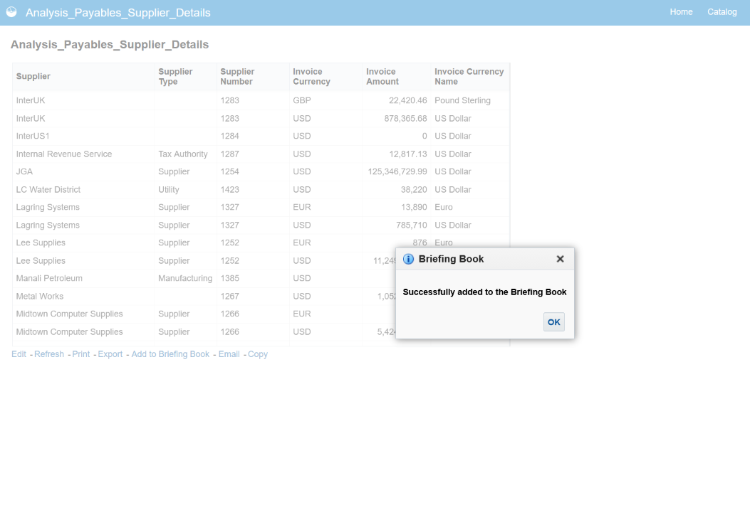
Screenshot 2026-10-20 111456.png
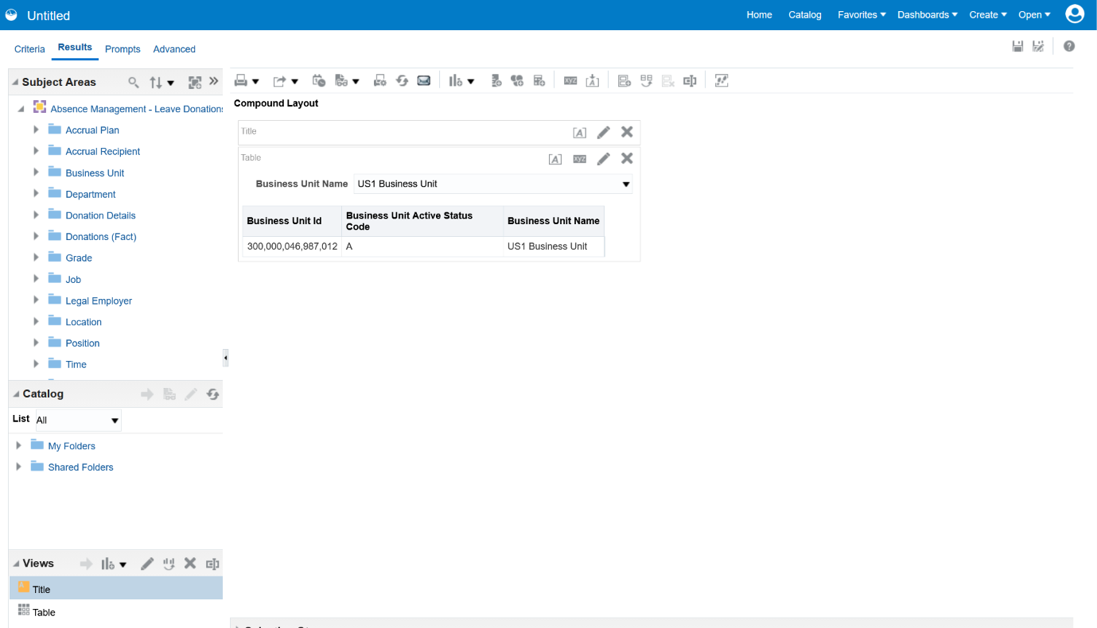
Screenshot 2026-10-20 114221.png
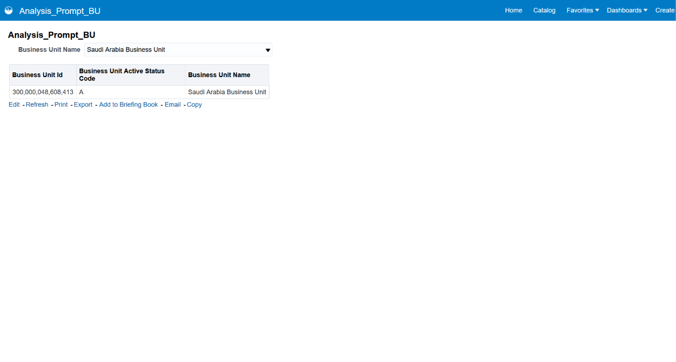
Screenshot 2026-10-20 114623.png
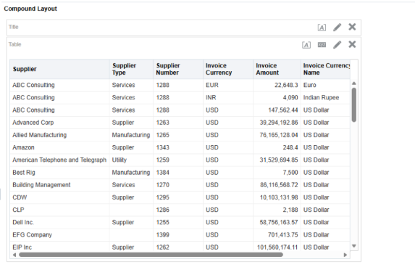
Screenshot 2026-11-02 201447.png
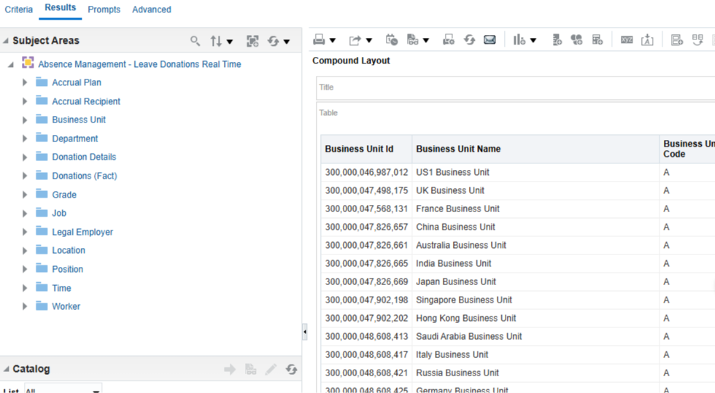
Screenshot 2026-11-02 201753.png
Note: Some menu names and available options may vary depending on the Oracle Fusion environment and assigned permissions.

