Create an Analysis with a Prompt
Task Summary
I completed the task in Oracle Fusion by following the steps below.

Steps Completed
- I opened Reports and Analytics and selected Create, then Analysis.
- I selected the appropriate subject area and added the required columns to Criteria.
- I created a prompt for the required column and configured how the available values would be selected.
- I connected the prompt to the relevant column or filter so that the selected value would affect the results.
- I opened the Results tab and checked that the analysis displayed the expected data.
- I saved the analysis with a clear name and tested the prompt by selecting different values.

Screenshots
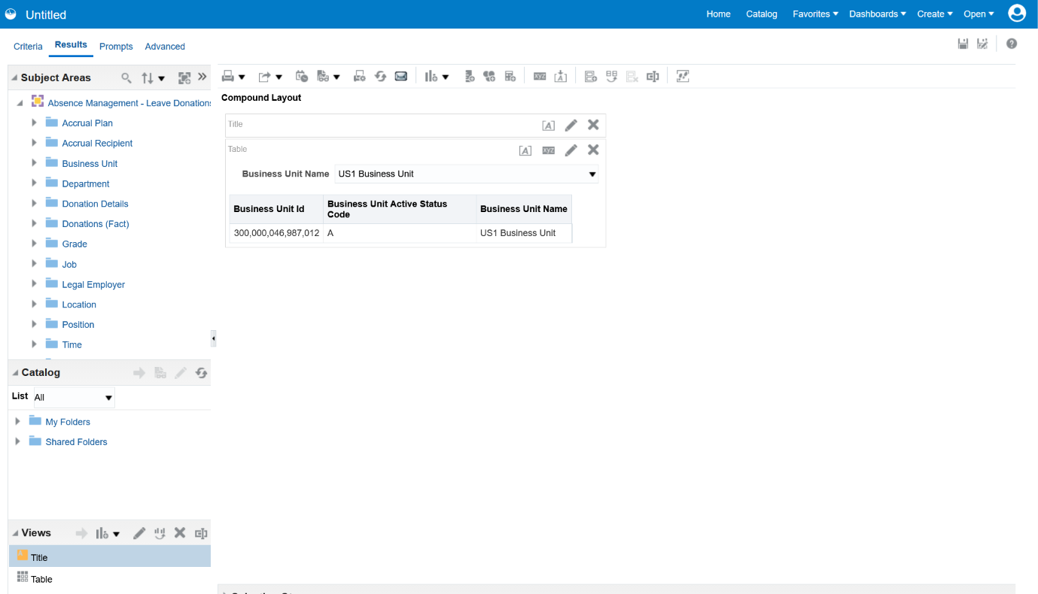
Screenshot 2026-10-20 114221.png
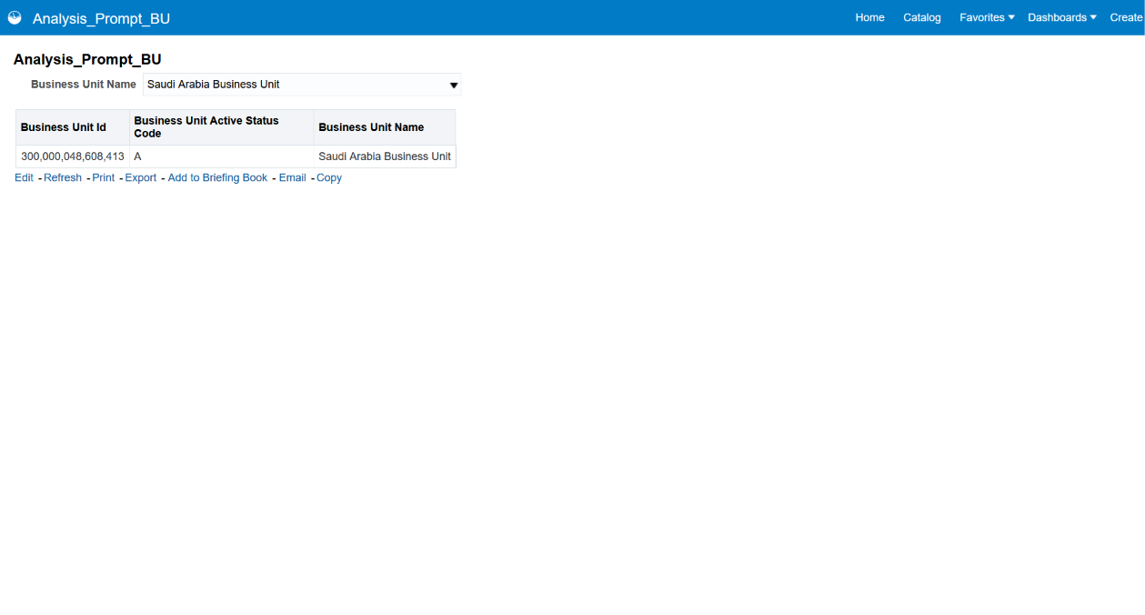
Screenshot 2026-10-20 114623.png
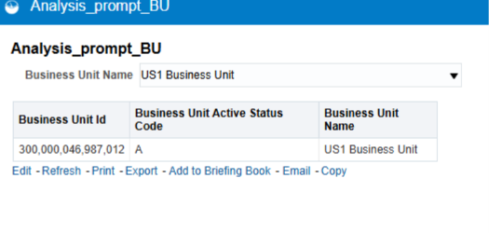
Screenshot 2026-11-02 201808.png
Note: Some menu names and available options may vary depending on the Oracle Fusion environment and assigned permissions.

