Create a Dashboard
Task Summary
I completed the task in Oracle Fusion by following the steps below.

Steps Completed
- I opened Tools and selected Reports and Analytics.
- I opened the Catalog, selected Create, and chose Dashboard.
- I entered a clear dashboard name and saved it in the appropriate folder.
- I added a dashboard page and placed the required reports or analyses on it from the Catalog.
- I arranged the items on the page and saved the changes.
- I opened the dashboard and checked that its contents displayed and ran correctly.

Screenshots
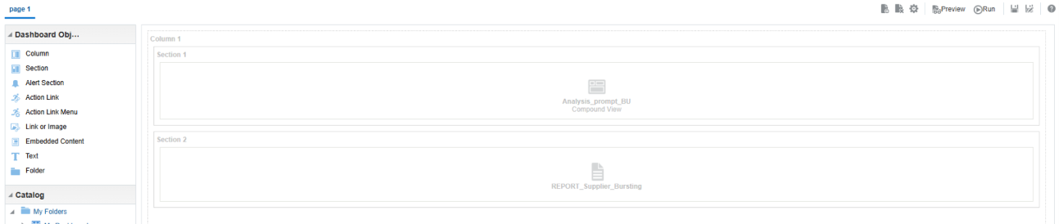
Screenshot 2026-11-02 201237.png
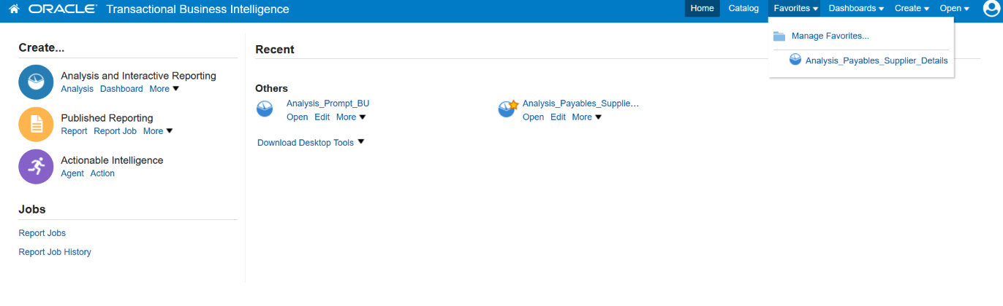
Screenshot 2026-10-20 115147.png
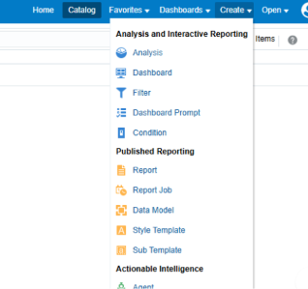
Screenshot 2026-11-02 201430.png
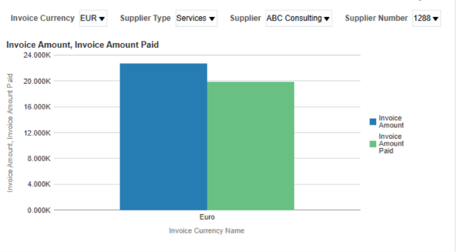
Screenshot 2026-11-02 201500.png
Note: Some menu names and available options may vary depending on the Oracle Fusion environment and assigned permissions.

