Create a Data Model Using an Analysis
Task Summary
I completed the task in Oracle Fusion by following the steps below.

Steps Completed
- I opened Reports and Analytics and checked that the required Analysis was available in the Catalog.
- I selected Create and then Data Model.
- I added a data set of type Analysis and selected the saved analysis from the Catalog.
- I reviewed the columns provided by the analysis and confirmed that they matched the report requirements.
- I previewed the data where the option was available and checked the results.
- I saved the Data Model with a clear name so it could be used to build a report.

Screenshots
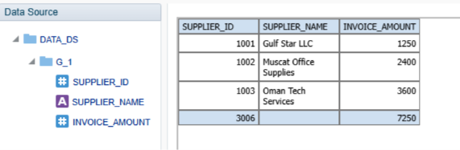
Screenshot 2026-11-02 201544.png
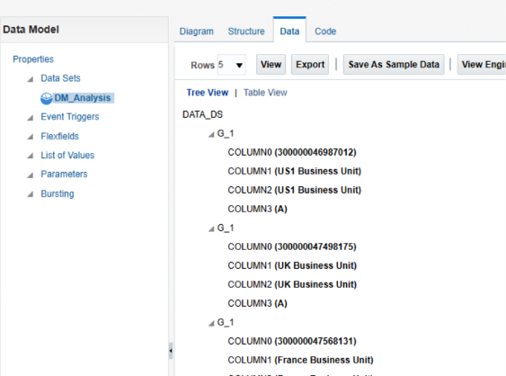
Screenshot 2026-11-02 201349.png
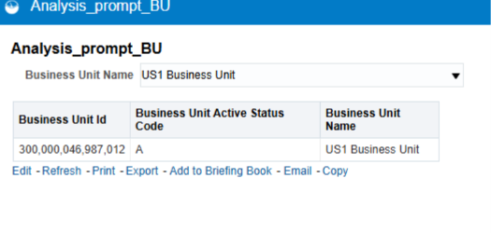
Screenshot 2026-11-02 201808.png
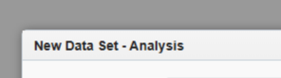
Screenshot 2026-11-02 201333.png
Note: Some menu names and available options may vary depending on the Oracle Fusion environment and assigned permissions.

