Give a User Access to Data or Catalog Content
Task Summary
I completed the task in Oracle Fusion by following the steps below.

Steps Completed
- I opened the Catalog and located the folder or item that needed to be shared.
- I opened the item's More menu or properties and selected Permissions.
- I added the required user or role and selected the appropriate permissions, such as View, Read, or Modify.
- Where required, I reviewed the related data-access or business-unit settings and selected the permitted data scope according to the task requirements.
- I saved the permission changes.
- I verified the access using the available testing method and checked that the user could access only the permitted content.

Screenshots
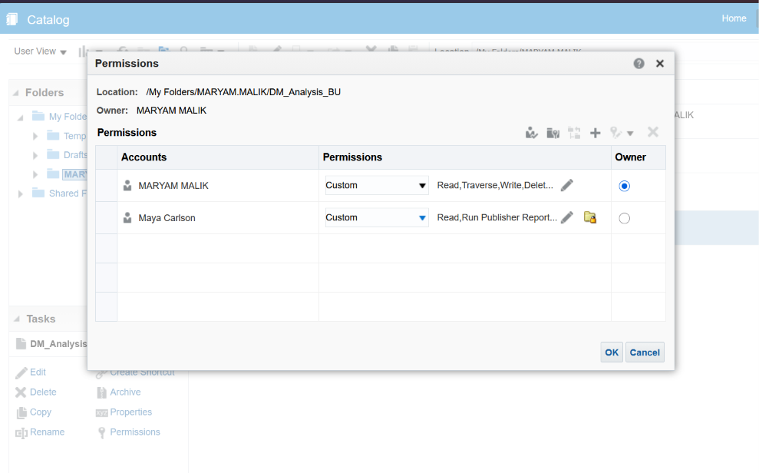
Screenshot 2026-10-20 141951.png
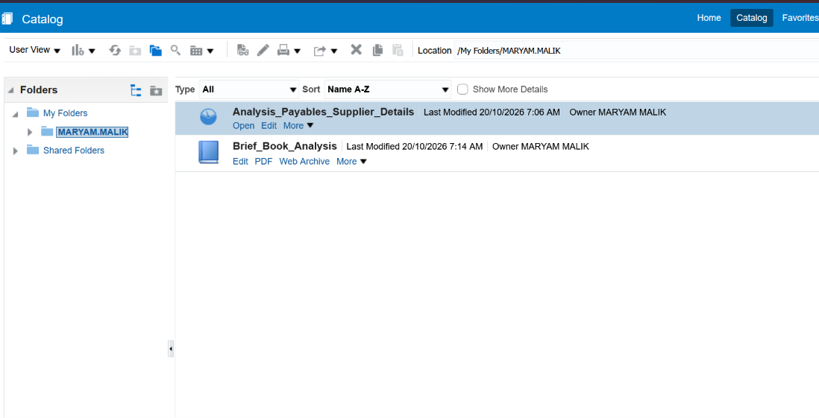
Screenshot 2026-10-20 111743.png
Note: Some menu names and available options may vary depending on the Oracle Fusion environment and assigned permissions.

