Implement Report Bursting
Task Summary
I completed the task in Oracle Fusion by following the steps below.

Steps Completed
- I prepared a Data Model and a report containing data that could be split into separate outputs, such as supplier records.
- I opened the Bursting section in the Data Model and added a bursting definition.
- I configured the split key, such as SUPPLIER_ID, and selected the delivery key or recipient field as required by the environment.
- I selected the output format, such as PDF, and configured the delivery method where it was available.
- I uploaded the report template where required and selected the template type and locale.
- I saved the bursting definition and ran the report to test the separate outputs.
- I reviewed the results and execution details to confirm that the output was split as expected.

Screenshots
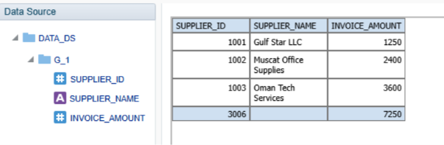
Screenshot 2026-11-02 201544.png
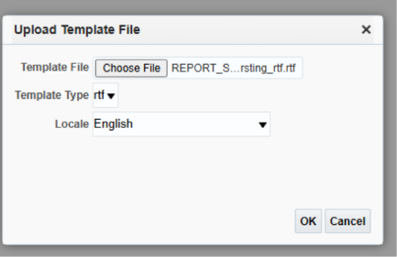
Screenshot 2026-11-02 201647.png
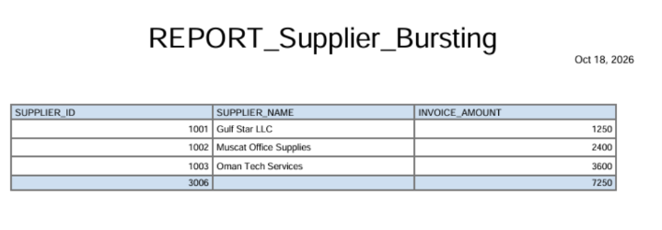
Screenshot 2026-11-02 201609.png
Note: Some menu names and available options may vary depending on the Oracle Fusion environment and assigned permissions.

