Create a Report with a Parameter
Task Summary
I completed the task in Oracle Fusion by following the steps below.

Steps Completed
- I opened the Data Model and created a suitable data set for the report.
- I added a parameter from the Parameters tab and configured its name, data type, and default value where needed.
- I used the parameter in the query condition so the report returned records matching the entered value.
- I saved the Data Model and created a report based on it.
- I ran the report, entered a parameter value, and selected Apply or Run.
- I checked that the output changed according to the value entered and saved the report.

Screenshots
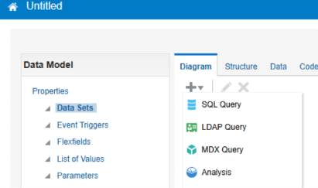
Screenshot 2026-11-02 201316.png
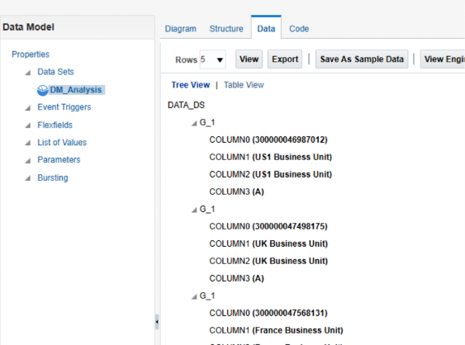
Screenshot 2026-11-02 201349.png
Note: Some menu names and available options may vary depending on the Oracle Fusion environment and assigned permissions.

