Create a Report with a Parameter and List of Values (LOV)
Task Summary
I completed the task in Oracle Fusion by following the steps below.

Steps Completed
- I opened the report's Data Model or created a new Data Model.
- I added a parameter from the Parameters tab, defined its name and data type, and set a default value where needed.
- I created a List of Values (LOV) and configured the data set or query that provided the available values.
- I linked the LOV to the parameter so the user could select a value from a list.
- I used the parameter in the data-set query or filter and saved the Data Model.
- I ran the report, selected a value from the LOV, and checked that the results matched the selected value.

Screenshots
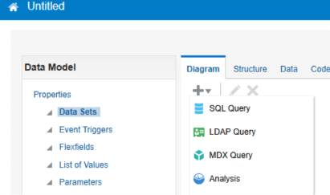
Screenshot 2026-11-02 201316.png
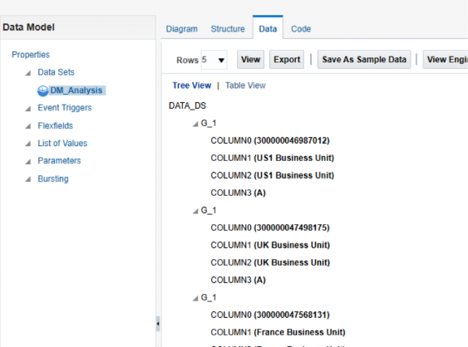
Screenshot 2026-11-02 201349.png
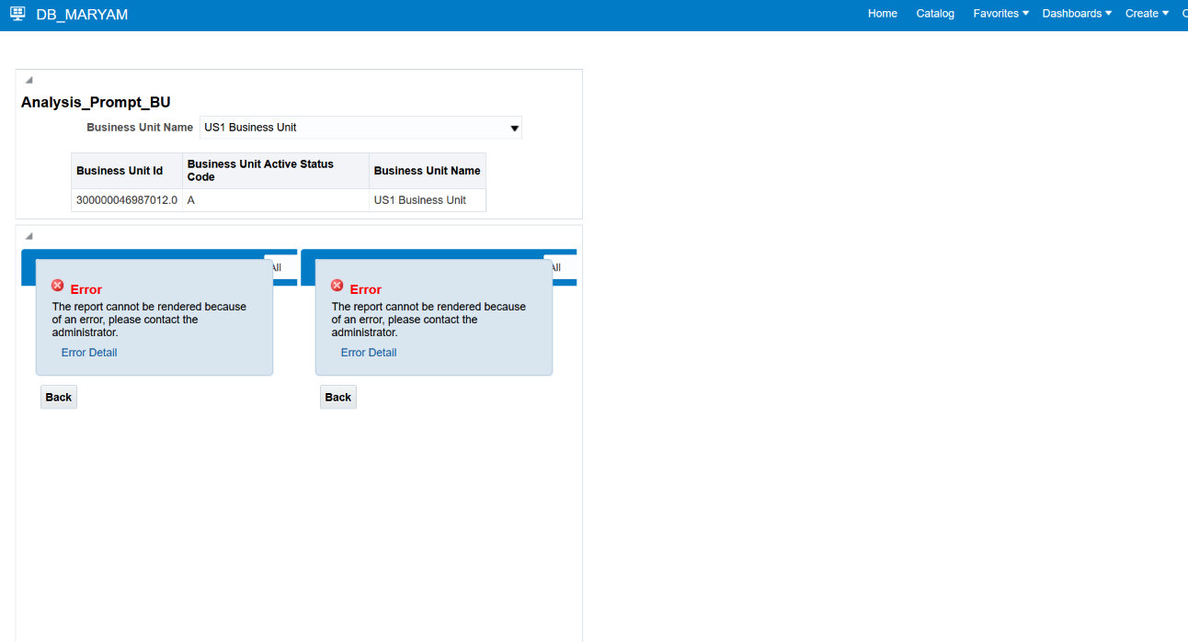
Screenshot 2026-10-20 145721.png
Note: Some menu names and available options may vary depending on the Oracle Fusion environment and assigned permissions.

