**Software Requirements Specification**

**For**

**<MedCo.pk -Online Medicines store >**

**Version 1.0 approved**

**Prepared by**

**<UMER FAROOQ-20K1625>**

**<SAMIA AZEEM-20K1685>**

**<MARYAM RAHEEM-20K1700>**

**< 5th of December 2022>**

# Table of Contents

Table of Contents ii

Revision History ii

1. **Introduction** [**1**](https://docs.google.com/document/d/1Dx1O9UEkluj4j0yEJDFzW6Vrd0UrhqRJRF9xnSiKJE4/edit#heading=h.32hioqz)
   1. Purpose[1](https://docs.google.com/document/d/1Dx1O9UEkluj4j0yEJDFzW6Vrd0UrhqRJRF9xnSiKJE4/edit#heading=h.1hmsyys)
   2. Document Conventions [1](https://docs.google.com/document/d/1Dx1O9UEkluj4j0yEJDFzW6Vrd0UrhqRJRF9xnSiKJE4/edit#heading=h.41mghml)
   3. Intended Audience and Reading Suggestions [1](https://docs.google.com/document/d/1Dx1O9UEkluj4j0yEJDFzW6Vrd0UrhqRJRF9xnSiKJE4/edit#heading=h.2grqrue)
   4. Product Scope [1](https://docs.google.com/document/d/1Dx1O9UEkluj4j0yEJDFzW6Vrd0UrhqRJRF9xnSiKJE4/edit#heading=h.vx1227)
   5. References [1](https://docs.google.com/document/d/1Dx1O9UEkluj4j0yEJDFzW6Vrd0UrhqRJRF9xnSiKJE4/edit#heading=h.3fwokq0)
2. **Overall Description** [**2**](https://docs.google.com/document/d/1Dx1O9UEkluj4j0yEJDFzW6Vrd0UrhqRJRF9xnSiKJE4/edit#heading=h.1v1yuxt)
   1. Product Perspective [2](https://docs.google.com/document/d/1Dx1O9UEkluj4j0yEJDFzW6Vrd0UrhqRJRF9xnSiKJE4/edit#heading=h.4f1mdlm)
   2. Product Functions [2](https://docs.google.com/document/d/1Dx1O9UEkluj4j0yEJDFzW6Vrd0UrhqRJRF9xnSiKJE4/edit#heading=h.2u6wntf)
   3. User Classes and Characteristics[2](https://docs.google.com/document/d/1Dx1O9UEkluj4j0yEJDFzW6Vrd0UrhqRJRF9xnSiKJE4/edit#heading=h.19c6y18)
   4. Operating Environment [2](https://docs.google.com/document/d/1Dx1O9UEkluj4j0yEJDFzW6Vrd0UrhqRJRF9xnSiKJE4/edit#heading=h.3tbugp1)
   5. Design and Implementation Constraints [2](https://docs.google.com/document/d/1Dx1O9UEkluj4j0yEJDFzW6Vrd0UrhqRJRF9xnSiKJE4/edit#heading=h.28h4qwu)
   6. User Documentation [2](https://docs.google.com/document/d/1Dx1O9UEkluj4j0yEJDFzW6Vrd0UrhqRJRF9xnSiKJE4/edit#heading=h.nmf14n)
   7. Assumptions and Dependencies [3](https://docs.google.com/document/d/1Dx1O9UEkluj4j0yEJDFzW6Vrd0UrhqRJRF9xnSiKJE4/edit#heading=h.37m2jsg)
3. **External Interface Requirements** [**3**](https://docs.google.com/document/d/1Dx1O9UEkluj4j0yEJDFzW6Vrd0UrhqRJRF9xnSiKJE4/edit#heading=h.1mrcu09)
   1. User Interfaces [3](https://docs.google.com/document/d/1Dx1O9UEkluj4j0yEJDFzW6Vrd0UrhqRJRF9xnSiKJE4/edit#heading=h.2jxsxqh)
   2. Hardware Interfaces [3](https://docs.google.com/document/d/1Dx1O9UEkluj4j0yEJDFzW6Vrd0UrhqRJRF9xnSiKJE4/edit#heading=h.46r0co2)
   3. Software Interfaces [3](https://docs.google.com/document/d/1Dx1O9UEkluj4j0yEJDFzW6Vrd0UrhqRJRF9xnSiKJE4/edit#heading=h.2lwamvv)
   4. Communications Interfaces [3](https://docs.google.com/document/d/1Dx1O9UEkluj4j0yEJDFzW6Vrd0UrhqRJRF9xnSiKJE4/edit#heading=h.111kx3o)
4. **System Features** [**4**](https://docs.google.com/document/d/1Dx1O9UEkluj4j0yEJDFzW6Vrd0UrhqRJRF9xnSiKJE4/edit#heading=h.3l18frh)
   1. System Feature 1 [4](https://docs.google.com/document/d/1Dx1O9UEkluj4j0yEJDFzW6Vrd0UrhqRJRF9xnSiKJE4/edit#heading=h.206ipza)
   2. System Feature 2 (and so on) [4](https://docs.google.com/document/d/1Dx1O9UEkluj4j0yEJDFzW6Vrd0UrhqRJRF9xnSiKJE4/edit#heading=h.4k668n3)
5. **Other Nonfunctional Requirements** [**4**](https://docs.google.com/document/d/1Dx1O9UEkluj4j0yEJDFzW6Vrd0UrhqRJRF9xnSiKJE4/edit#heading=h.2zbgiuw)
   1. Performance Requirements [4](https://docs.google.com/document/d/1Dx1O9UEkluj4j0yEJDFzW6Vrd0UrhqRJRF9xnSiKJE4/edit#heading=h.2bn6wsx)
   2. Safety Requirements [5](https://docs.google.com/document/d/1Dx1O9UEkluj4j0yEJDFzW6Vrd0UrhqRJRF9xnSiKJE4/edit#heading=h.1egqt2p)
   3. Security Requirements [5](https://docs.google.com/document/d/1Dx1O9UEkluj4j0yEJDFzW6Vrd0UrhqRJRF9xnSiKJE4/edit#heading=h.3ygebqi)
   4. Software Quality Attributes [5](https://docs.google.com/document/d/1Dx1O9UEkluj4j0yEJDFzW6Vrd0UrhqRJRF9xnSiKJE4/edit#heading=h.2dlolyb)
   5. Business Rules [5](https://docs.google.com/document/d/1Dx1O9UEkluj4j0yEJDFzW6Vrd0UrhqRJRF9xnSiKJE4/edit#heading=h.sqyw64)
6. **Other Requirements** [**5**](https://docs.google.com/document/d/1Dx1O9UEkluj4j0yEJDFzW6Vrd0UrhqRJRF9xnSiKJE4/edit#heading=h.3cqmetx)

**Appendix A: Glossary** [**5**](https://docs.google.com/document/d/1Dx1O9UEkluj4j0yEJDFzW6Vrd0UrhqRJRF9xnSiKJE4/edit#heading=h.1rvwp1q)

**Appendix B: Analysis Models** [**5**](https://docs.google.com/document/d/1Dx1O9UEkluj4j0yEJDFzW6Vrd0UrhqRJRF9xnSiKJE4/edit#heading=h.4bvk7pj)

# Revision History

|  |  |  |  |
| --- | --- | --- | --- |
| **Name** | **Date** | **Reason For Changes** | **Version** |
|  |  |  |  |
|  |  |  |  |

## 1. Introduction

### 1. Purpose

This is a project with the objective to develop an e-commerce website. The website will cater the needs of buying medical supplies. The main objective of this medical Booking Store system is to take the whole medical store online so that it is reachable to customers 24/7. It also aims at going towards cashless transactions. It will impart a wider visibility to the customers. Thus boosting the business to higher levels. The medical Booking Store will be a web based system with a very user friendly interface which indeed will make the whole management process easy to manage and operate with zero redundancies. Overall, an online medical booking store will become an efficient, highly responsive and extremely accurate system.

### Document Conventions

This Document was created based on the IEEE template for System Requirement Specification Documents

### 0. Intended Audience and Reading Suggestions

The audience for this documentation is course supervisor, developers, project managers, testers, users and documentation writers. All the parties that are interested in our product. The rest of the document describes external interface requirements, non-functional requirements etc. which are organized in the form of headings with subheadings under them.

The reader can first look at the table of contents to get an overall view of content in the document and then skim through the headings to find the intended topic thus it becomes easier for the reader to locate information just by looking at the headings in the first page of documentation.

### 0. Product Scope

Medical Booking Store System is an online website that caters to customer needs by helping them buy medicines from any Karachi based customer. It brings benefits to the user by helping users to buy different types of medicines with a click on screen while sitting at home. The goal of our website is to bring customer satisfaction through our product so that the gap between physical medical stores and humans can be bridged. This is fulfilled by our objectives such as increasing our stocks double by each year to release as much of stock as possible.

**In Scope:**

Medical Booking Store System works fine on browsers such as chrome, Firefox and operating systems such as windows, android (Browser-OS combinations) . Homepage to display the categories of different medications on the page with images of them displayed on the screen. Online payment to allow users to pay through cash,credit or debit with ease online through online bank transactions.

**Out of Scope:**

Medical Booking Store System website does not support iOS operating system thus safari search engine does not load this website.

### 0. References

https://dvago.pk/collections/devices-and-appliances?gclid=CjwKCAiAp7GcBhA0EiwA9U0mtrK4gApcif 0HrbDQ2AzNVf_VWZOVyVn5FB7XGosDJfhzRsVtH5Q_KhoCxZYQAvD_BwE

## 0. Overall Description

### 1. Product Perspective

The context of this product known as the Medical Booking Store System is an online retail business of different kinds of medicines and services from merchants who sell on the internet .It is an e-store. The origin of this product came from the demanding need of buying medicines through the limitations of house setting by different customers.

As many customers were reluctant to leave their households for many reasons, a faster way to get medicines in homes was needed.This is a new, self-contained product which integrates other components like databases to allow the software in keeping records of stock and the customers’ information*.*

**0. Product Functions**

**PAGE 1: LOGIN PAGE**

### Feature 1:UserName Field

A user is required to enter their username after they have signed up into the website and created their username and password.So that when they click on login page they would just have to enter their username.There can be two types of users one is admin and another client so accordingly both users will enter their usernames.

**Feature2: Password Field**

After entering the username the user irrespective of it's role would enter their password that is stored in the database.

**Feature3: Login Button**

When a user clicks on this button,the information he entered into the username and password fields would be checked against the information in the database . If they match then the user is given successful access to the website else he is asked to enter the fields correctly.

**(ADMINISTRATOR VIEW)**

**PAGE 1: HOME PAGE:**

Shows the administrator the list of products that the admin has added till now.The list includes the products with their images,description,actual and discounted prices.By clicking on the product shown in cart another window opens that shows the product details with a Buy Now button.Since the admin is not allowed to buy products if he/she clicks on the button then another window opens that pops up showing “You are not allowed to access the page”.Since the admin only manages the product and does not buy them.

### PAGE 3: ADD NEW PRODUCT PAGE

**Feature 1: PRODUCT NAME**

The admin inputs the product name he wants to add into the stock of medicines.

**Feature 2: PRODUCT DESCRIPTION**

This feature allows the admin to provide some description about the product he is adding into the products list.

**Feature 3: PRODUCT ACTUAL PRICE**

This feature allows the admin to add the amount of a particular product.

**Feature 4: PRODUCT DISCOUNTED PRICE**

This feature allows the admin to add a discounted amount of product.

**Feature 4: ADD PRODUCT IMAGE**

This feature allows the admin to upload images from his system for a particular product.

**Feature 4: ADD PRODUCT BUTTON**

This feature allows the admin to add products to the website.

**Feature 5: LOGOUT BUTTON**

This feature allows the user to logout of the website after buying products or even in between whether he buys the products or not.

### PAGE 4 : SHOW PRODUCT DETAILS

This particular page allows the admin to analyze the product's details by looking at the amount of products he has added through product id,product name,product description,product discounted price,product actual price and actions such as editing the product by changing it’s image or deleting the product.

**(USER VIEW)**

**PAGE 1: HOME PAGE:**

Shows the user the list of products that are available on the website.The list includes the products with their images,description,actual and discounted prices.By clicking on the product shown in cart another window opens that shows the product details with a Buy Now button.By clicking on the buy button the user is asked to input his Full Name, Full Address, Contact Number, Alternate Contact Number.

The user can also change the quantity number in the table on the right side of the screen that shows the price changes accordingly.After placing the order, the user can click on place order button to checkout.Another window pops up by showing “You order is placed successfully.It will get delivered to you within 4-5 business days”.This indicates that the the clients’s order has successfully been placed.

## 0. User Classes and Characteristics

* **Role Class:**

The role class includes attributes like roleName, roleDrescription with getters and setters for both attributes.

* **User Class:**

The User class will have attributes like

userName,userFirstName,userLastname,userPassword and Set<Role> role which stores the roles assigned to a particular user like admin or user.We’ll form association between user and role class since many users can have many roles.It will automatically form a third table called ‘user_role’ that stores attributes like user_id and role_id.

* **Product Class:**

The product class includes attributes like productId,productName,productDescription,productDiscountedPrice,product ActualPrice, Set<Image Model>(this attribute saves the number of different images associated with that product) as well as functions like getters and setters for these attributes.In this class we’ll form another table called ‘product_images’ by joining and forming a relationship between our product and ImageModel.This table will include two attributes of product_id and image_id.

## 0. Operating Environment

The technologies that we will be using are Angular, Spring boot and MySQL.The frontend is made up of Angular and Spring boot whereas the backend is formed by MySQL Workbench. The Web App will have role base Authentication using spring boot

JWT, and implementing tokens as well. We’ll be using POSTMAN for APIs, like Creating ,Uploading images, adding a product and deleting a product.A full internet connection is required for OSS and browsers like chrome, Internet explorer and Firefox. It also integrates with MySQL Workbench to allow web database management to keep data records of the pets in e-store. It also involves a 10,000 number of possible traffic on the e-store in the operating environment.

## 0. Design and Implementation Constraints

The expertise to implement the software is also important as the developer must know about languages such as Angular, Spring Boot etc. So specific technology skill is important for software implementation. As well as after deployment of software to tackle the issues arising in the working environment is an important job for the developer as some constraints like cross browser testing would be important for developer to take note on*.*

## 0. User Documentation

The user can be guided through video based online help where videos could be uploaded to help users give a demo on how to use the website and help the inexperienced users in the usability of software. FAQ’s could give the customer answer to their questions as it provides a list of questions with their answers.

### 0. Assumptions and Dependencies

It is assumed that the software will work on operating systems such as Android and wouldn’t support operating systems such as Ios.It is also assumed that the customer will have a browser and internet to order pets. And that the software will not work with 3rd party fulfillment sytem.It will have dependency on databases such as MySQL to keep product updates.

## 0. External Interface Requirements

### 1. User Interfaces

**MENU INTERFACE:**

This type of interface is so easy to describe that, basically the menu is the station of the options displayed on the screen, when the user wants to move into desired page then the user can select the option from the menu and can move into to new page. Like in the attached picture below.

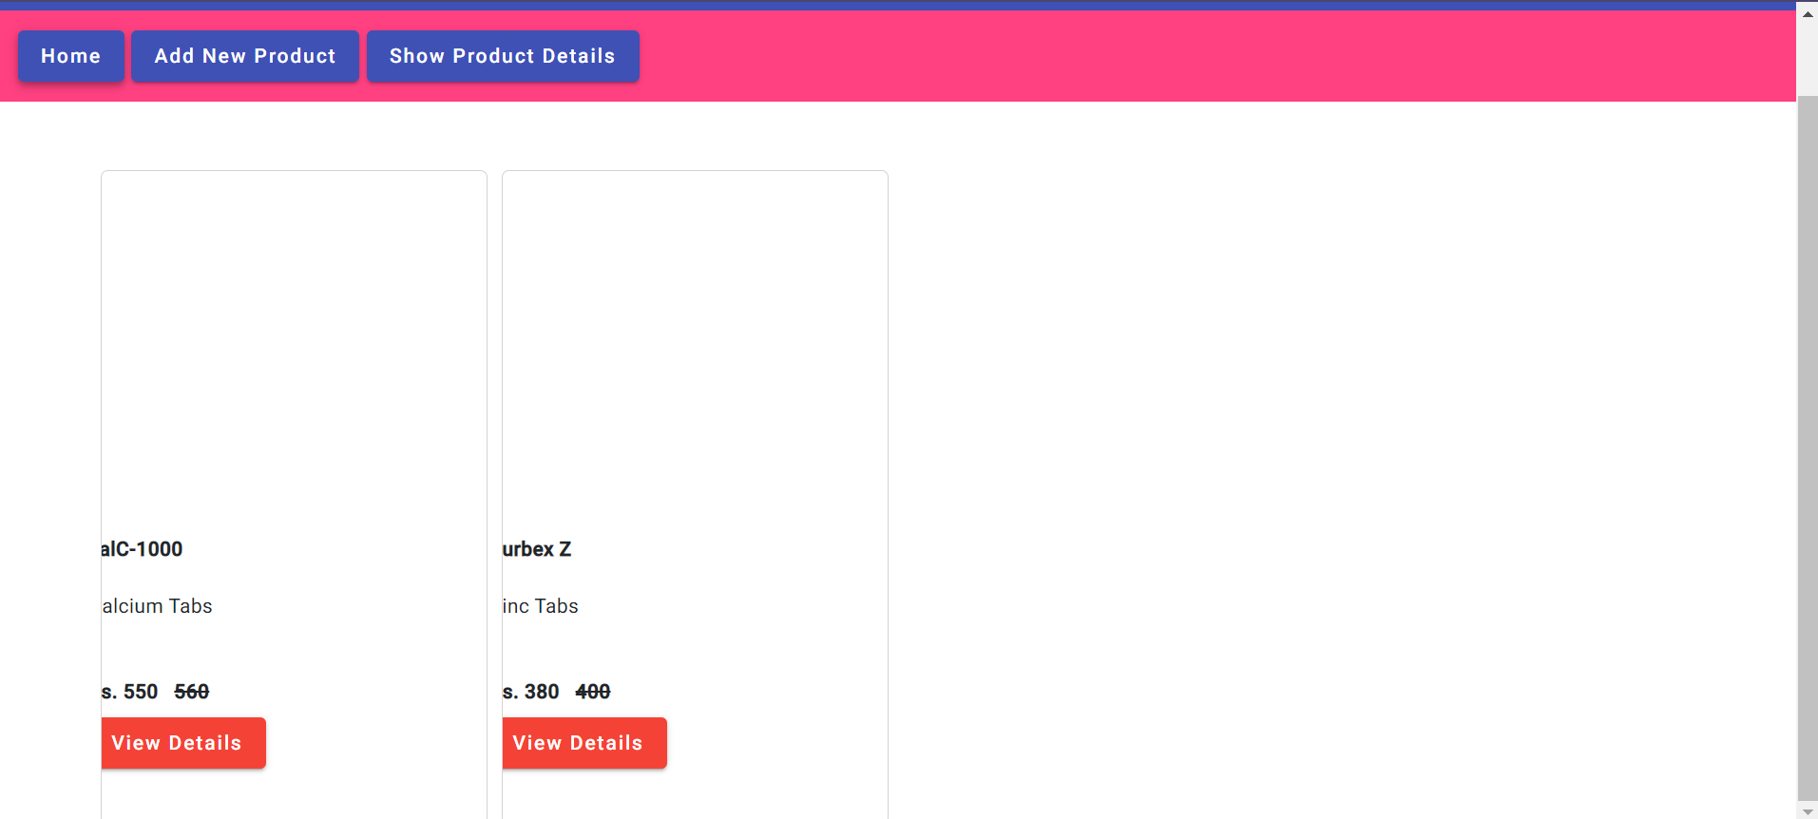

**POINT TO CLICK INTERFACE:**

In this window point to click interface, in which user selects the option after selecting it the user will move into the new page.

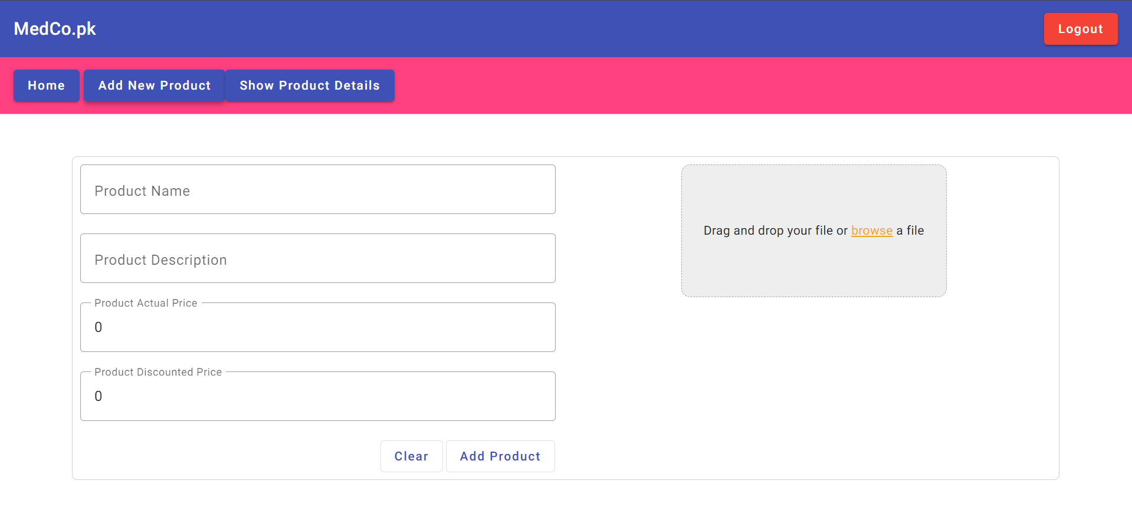

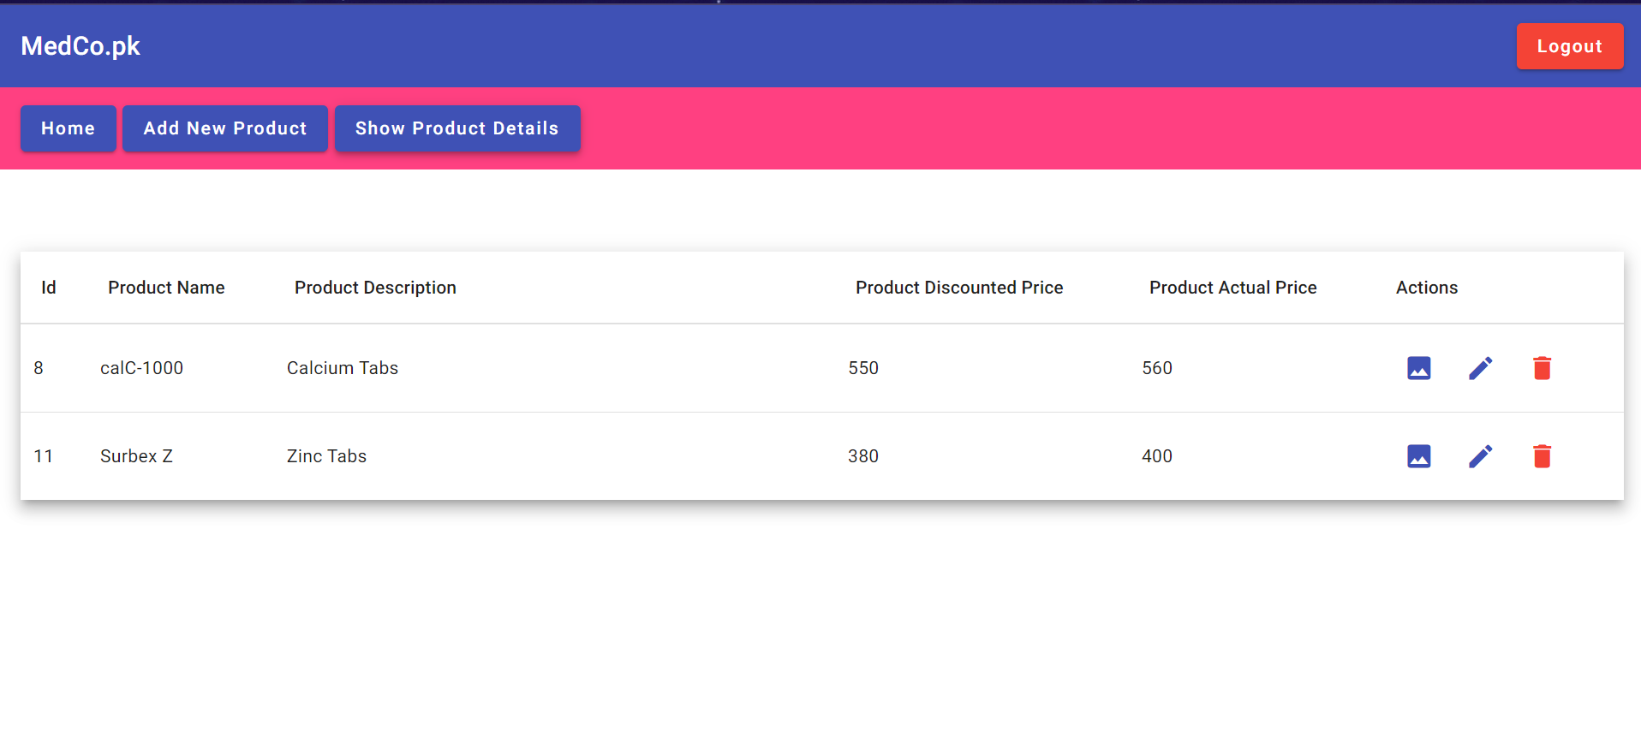

**FORM FILLING INTERFACE**:

In this interface, the user interacts with the website Form filling interface is implemented in this window.

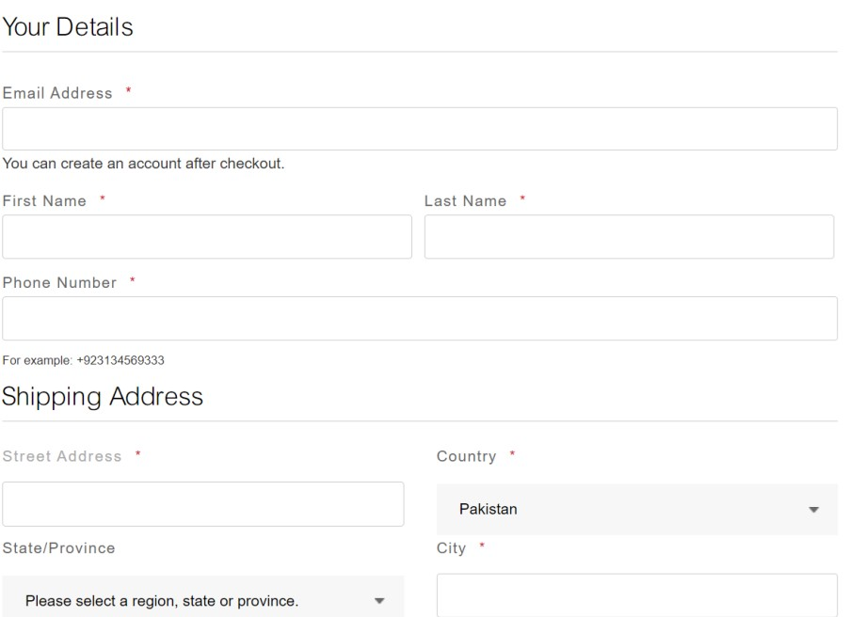

### 0. Hardware Interfaces

* processor: dual core/Pentium
* RAM: 3GB or higher
* The sender and receiver should be connected by LAN and WAN for the communication purpose.

### 0. Software Interfaces

* Browser and internet connection is required because the system is web-based.
* Operating system: Linux, windows etc. ● Database: MySQL Workbench.

### 0. Communications Interfaces

The user can confirm the order after selecting it, so that he/she can get their desirable medicines.

A confirmation email will be sent to the user after placing the order that the items they ordered will be delivered to the mentioned address and the estimated delivery time.

## 0. System Features

### 1. USE CASE

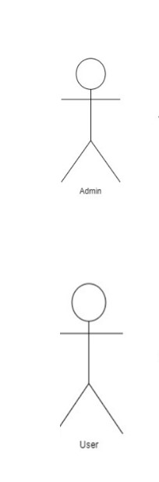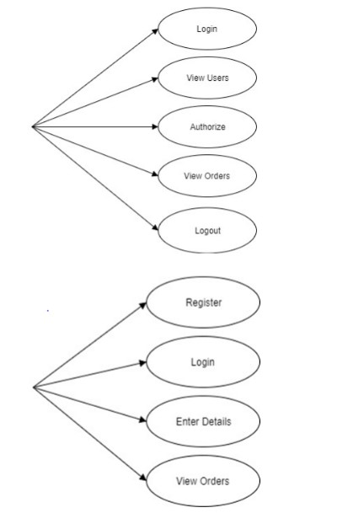

### 2. FUNCTIONAL REQUIREMENTS

**4.2.1. Buy Now**

On the homepage by clicking on a particular product another window opens that shows the details of products like its name,description,actual price and discounted price with a Buy Now button below. By clicking the Buy Now button the user is guided towards the checkout page.

**4.2.2. Place Order**

After buying the product the user is asked to enter his personal information like his fullName,lastName,Address etc .After he’s done with this,the user can place an order button to checkout.This is achieved by clicking on the Place Order button below.

Another window pops up by showing “You order is placed successfully.It will get delivered to you within 4-5 business days”.This indicates that the the clients’s order has successfully been placed.

**4.2.3. Confirm Order:**

After placing order,another window pops up by showing “You order is placed successfully.It will get delivered to you within 4-5 business days”.This indicates that the the clients’s order has successfully been placed.

**4.2.5. Categories:**

In our home screen of Medical Booking Store System we have used a list of different medicines shown in the cart that includes the products with their images,description,actual and discounted prices

## Other Nonfunctional Requirements

### 1. Performance Requirements

* System shall accommodate a large number of records of stocks in file without any fault or limitations.
* The connection depends on the attributes of the user, for example, his internet connection or location.
* The overall performance of the software will be reliable and enable the users to work efficiently.
* Responses to add, update, delete, view or execute any function for the admin shall not take longer than 2 seconds.

**0. Safety Requirements**

### 0. Security Requirements

Like privacy policy which includes a customer's personal identifiers such as name and address, demographic information such as age and date of birth and device identifiers such as telephone number and email address etc. however this data is not disclosed to other third parties and is kept safely for business records.A user can not access the add to cart page or product details page as it is visible to the admin similarly the admin can not access checkout page as he’s not allowed to access other pages beyond Buy Now button.

### 0. Software Quality Attributes

This is a testable property of the system that is used to indicate how well the system satisfies the need of the stockholders I.e. customer. The developer could check the robustness by seeing how quickly the software recovers from a malfunction. The interoperability of the system can be tested by modifying some its features and checking for any data loss between the web service and it’s database (other partner system).The user can compare the UI of pawsome with other online pet stores to judge better usability of the both systems. The performance measurement of the system can be checked by the user and developer both through the online website known as webpagetest.org.This helps both parties to analyze the quality attribute of performance more efficiently and easily, Here load testing is done by checking how the system behaves under an expected load whereas stress testing tests the stability and robustness of the system by using load beyond the expected range.

### 0. Business Rules

**Rule 1:** A customer can purchase one or more than one item at a time. An item can be purchased by more than one customer.

**Rule 2:** Customers can make one or many payments.

**Rule 3:** Having a secure website is one of the most mandatory business rules. It is really important to include the security sign in the website to make the customer feel more comfortable and secure in doing the transaction.

**Rule 4:** Make sure that the store is able to be navigated easily. It is preferable to categorize medicines with description and price range in such a way that it is more convenient for customers to find the products they need.

## 0. Other Requirements

* All data is stored in text-based flat files.
* Object oriented programming principles make sure confidential information is only accessed and modified by those in authority.

## Appendix A: Glossary

*RAM stands* for Random Access Memory. RAM stores files and data of programs that are currently being executed by CPU. It is a volatile memory as data loses when power is turned off.

*ROM,* Read-only memory (ROM) is a type of non-volatile memory used in computers and other electronic devices. Data stored in ROM cannot be electronically modified after the manufacture of the memory device.

*IEEE,* pronounced "Eye-triple-E," stands for the Institute of Electrical and Electronics Engineers. The association is chartered under this name and it is the full legal name.

*GB*, Gigabytes, are sometimes also abbreviated as “gigs,” and are often used to measure storage device's capacity. MB, Megabyte (MB) is a unit of digital information or computer storage.

*SQL***,** SQL stands for Structured Query Language. SQL lets you access and manipulate databases.

*OS*, The full form of OS is Operating System. The operating system (OS) is the most important type of system software in a computer system.

*LAN*, local area network (LAN) consists of a series of computers linked together to form a network in a circumscribed location.

*WAN*, A wide area network (also known as WAN), is a large network of information that is not tied to a single location. WANs can facilitate communication, the sharing of information and much more between devices from around the world through a WAN provider

**Appendix B: Analysis Models**

## ERD DIAGRAM