Main page/home page:

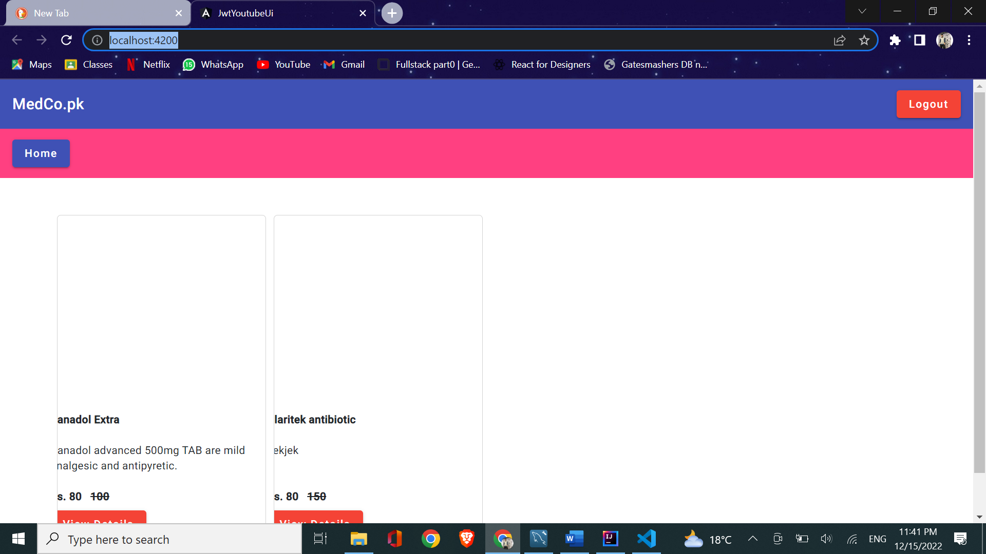

Login Page:

Admin Role:

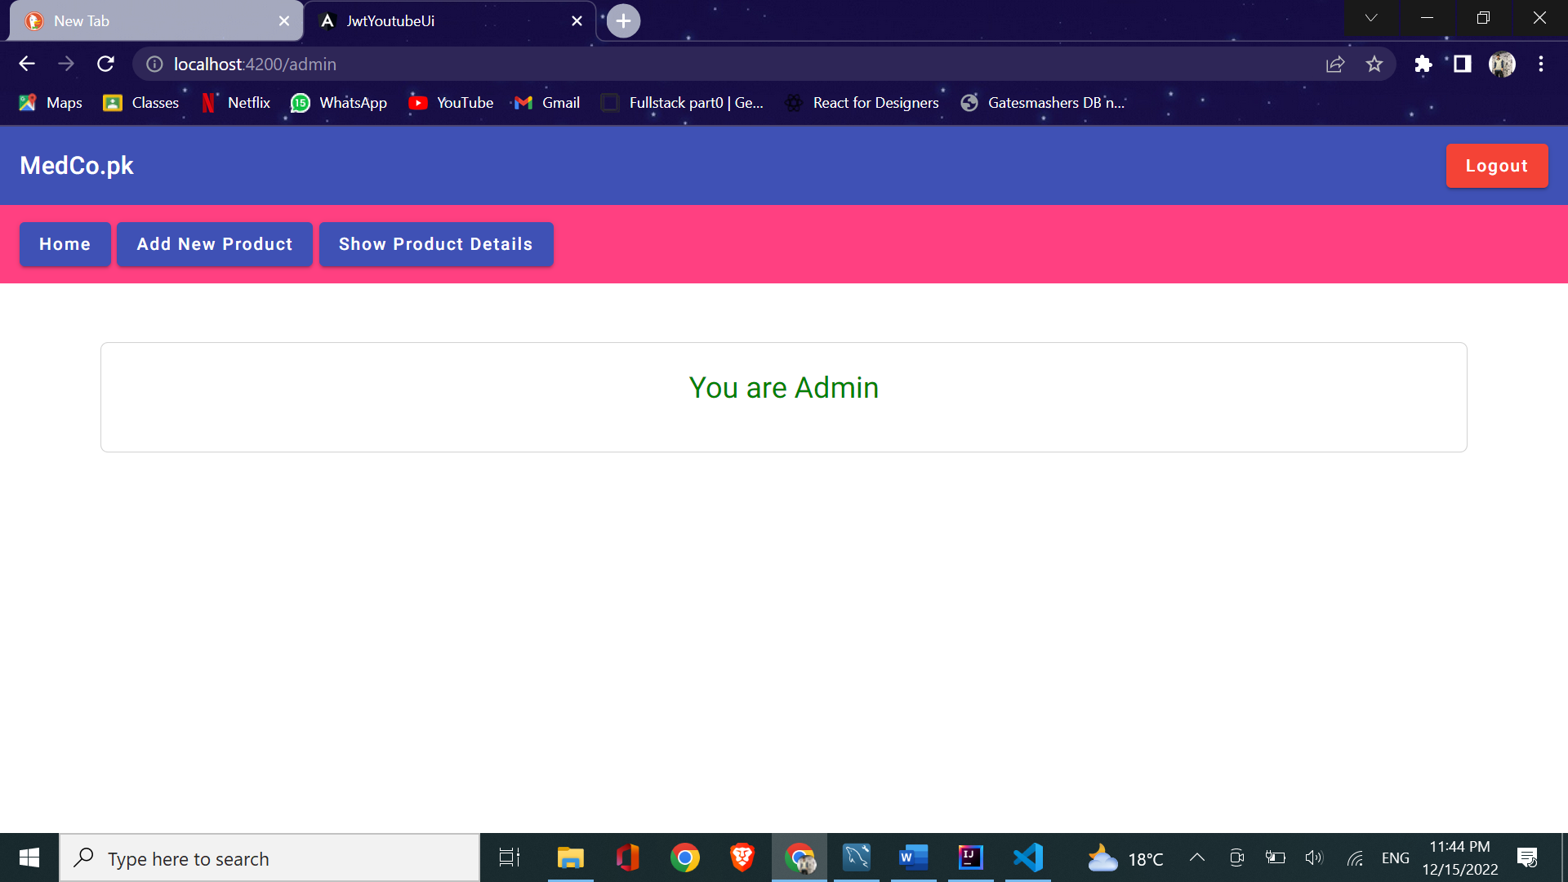

Add new product:

List all products:

User Dashboard:

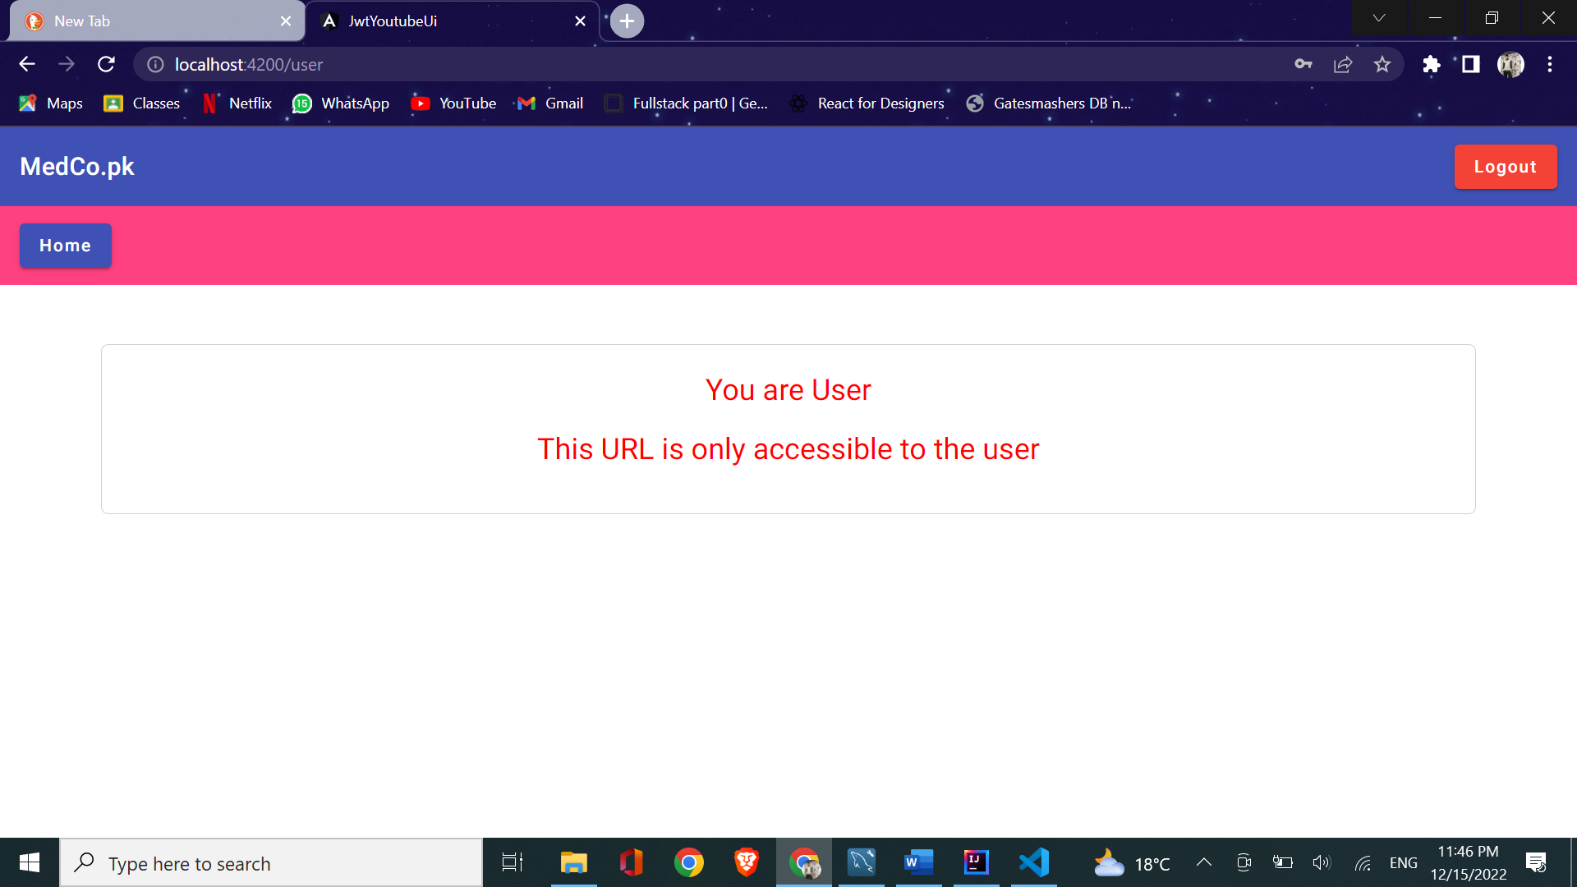

Buy Now

Order Place:

