Brazilian E-Commerce Sales Analysis
Based on the public Olist dataset: PostgreSQL & Power BI technical documentation

1. Executive Summary & Architecture

1.1 Objective
An end-to-end BI project that analyses the public Brazilian E-Commerce dataset released by Olist, a Brazilian online marketplace. The raw CSVs are loaded into PostgreSQL, validated, exposed through dimension and fact views, and served to Power BI via DirectQuery.

1.2 Pipeline
[Raw Olist CSVs]
|
v
[PostgreSQL base tables] (PK/FK constraints, validations, B-Tree indexes)
|
v
[BI views: bi_dim_product, bi_fact_review_latest, bi_fact_orders,
bi_fact_sales, bi_payments_order]
| DirectQuery
v
[Power BI data model] (DimDate, relationships, DAX measures)
|
v
[10-page Power BI report suite]

2. Database Design (PostgreSQL)

2.1 Tables
Nine tables are created, each preceded by DROP TABLE IF EXISTS ... CASCADE.
Table | Key columns
olist_customers_dataset | customer_id (PK), customer_unique_id, zip prefix, city, state
olist_geolocation_dataset | zip prefix, lat, lng, city, state (no PK)
olist_order_items_dataset | order_id, order_item_id, product_id, seller_id, shipping_limit_date, price, freight_value
olist_order_payments_dataset | order_id, payment_sequential, payment_type, payment_installments, payment_value
olist_order_reviews_dataset | review_id, order_id, review_score, comment title/message, creation and answer timestamps
olist_orders_dataset | order_id (PK), customer_id, order_status, purchase / approved / carrier / customer / estimated timestamps
olist_products_dataset | product_id (PK), category name, name/description length, photos, weight, L/H/W (cm)
olist_sellers_dataset | seller_id (PK), zip prefix, city, state
product_category_name_translation | product_category_name (PK), product_category_name_english

Example DDL (orders):
DROP TABLE IF EXISTS olist_orders_dataset CASCADE;
CREATE TABLE olist_orders_dataset (
order_id TEXT PRIMARY KEY,
customer_id TEXT,
order_status TEXT,
order_purchase_timestamp TIMESTAMP,
order_approved_at TIMESTAMP,
order_delivered_carrier_date TIMESTAMP,
order_delivered_customer_date TIMESTAMP,
order_estimated_delivery_date TIMESTAMP
);

2.2 Foreign Keys
ALTER TABLE olist_orders_dataset
ADD CONSTRAINT fk_orders_customers
FOREIGN KEY (customer_id) REFERENCES olist_customers_dataset (customer_id);

ALTER TABLE olist_order_items_dataset
ADD CONSTRAINT fk_items_orders FOREIGN KEY (order_id) REFERENCES olist_orders_dataset (order_id),
ADD CONSTRAINT fk_items_products FOREIGN KEY (product_id) REFERENCES olist_products_dataset (product_id),
ADD CONSTRAINT fk_items_sellers FOREIGN KEY (seller_id) REFERENCES olist_sellers_dataset (seller_id);

ALTER TABLE olist_order_payments_dataset
ADD CONSTRAINT fk_payments_orders FOREIGN KEY (order_id) REFERENCES olist_orders_dataset (order_id);

ALTER TABLE olist_order_reviews_dataset
ADD CONSTRAINT fk_reviews_orders FOREIGN KEY (order_id) REFERENCES olist_orders_dataset (order_id);

3. Data Validation
Three audit checks are run after ingestion:
- Row counts - UNION ALL of count(*) across all nine tables.
- Null counts - per table, rows where a required column IS NULL. Optional fields (review comment title/message, product attributes, delivery timestamps on undelivered orders) are excluded because they are legitimately empty.
- Duplicate keys - GROUP BY ... HAVING count(*) > 1 on customer_id, order_id, product_id, seller_id and product_category_name.
SELECT 'customers' AS table_name, count(*) FROM olist_customers_dataset
UNION ALL SELECT 'orders', count(*) FROM olist_orders_dataset
-- ... one line per table

SELECT order_id, count(*) FROM olist_orders_dataset GROUP BY order_id HAVING count(*) > 1;

-- required-column null check (orders)
SELECT count(*) FROM olist_orders_dataset
WHERE order_id IS NULL OR customer_id IS NULL OR order_status IS NULL
OR order_purchase_timestamp IS NULL OR order_estimated_delivery_date IS NULL;

4. Indexing Strategy
B-Tree indexes speed up joins and filters generated by DirectQuery:
Table | Indexed columns
Orders | customer_id, order_purchase_timestamp
Order items | order_id, product_id, seller_id
Customers | customer_state
Payments / Reviews | order_id

Primary-key columns (order_id, customer_id, etc.) are already indexed by their PRIMARY KEY constraints, so no separate index is created on them.
CREATE INDEX IF NOT EXISTS ix_orders_purchase_date ON olist_orders_dataset (order_purchase_timestamp);
CREATE INDEX IF NOT EXISTS ix_items_order_id ON olist_order_items_dataset (order_id);

5. Analytical BI Views

5.1 bi_dim_product
Adds English category names and package volume.
CREATE OR REPLACE VIEW bi_dim_product AS
SELECT
p.product_id,
COALESCE(t.product_category_name_english, p.product_category_name) AS category,
p.product_weight_g, p.product_length_cm, p.product_height_cm, p.product_width_cm,
(p.product_length_cm * p.product_height_cm * p.product_width_cm) AS volume_cm3
FROM olist_products_dataset p
LEFT JOIN product_category_name_translation t
ON t.product_category_name = p.product_category_name;

5.2 bi_fact_review_latest
One (latest) review per order.
CREATE OR REPLACE VIEW bi_fact_review_latest AS
SELECT DISTINCT ON (r.order_id)
r.order_id, r.review_score, r.review_creation_date, r.review_answer_timestamp
FROM olist_order_reviews_dataset r
ORDER BY r.order_id, r.review_creation_date DESC NULLS LAST;

5.3 bi_fact_orders
Delivery duration and the is_late SLA flag (delivered after the estimated date).
CREATE OR REPLACE VIEW bi_fact_orders AS
SELECT
o.order_id, o.customer_id, o.order_status,
o.order_purchase_timestamp::date AS purchase_date,
date_trunc('month', o.order_purchase_timestamp)::date AS purchase_month,
o.order_delivered_customer_date::date AS delivered_date,
o.order_estimated_delivery_date::date AS estimated_date,
CASE WHEN o.order_status = 'delivered' AND o.order_delivered_customer_date IS NOT NULL
THEN (o.order_delivered_customer_date::date - o.order_purchase_timestamp::date)
END AS delivery_days,
CASE WHEN o.order_status = 'delivered'
AND o.order_delivered_customer_date IS NOT NULL
AND o.order_estimated_delivery_date IS NOT NULL
AND o.order_delivered_customer_date::date > o.order_estimated_delivery_date::date
THEN 1 ELSE 0
END AS is_late,
c.customer_unique_id, c.customer_city, c.customer_state
FROM olist_orders_dataset o
JOIN olist_customers_dataset c ON c.customer_id = o.customer_id;

5.4 bi_fact_sales
Item-level fact imported into Power BI via DirectQuery. Payments are joined through bi_payments_order (one row per order) so item rows are not duplicated by multi-payment orders. Order-level payment values repeat on each item row, so the payment measures aggregate at order level (see 6.2).
CREATE OR REPLACE VIEW bi_fact_sales AS
SELECT
oi.order_id, oi.order_item_id, oi.product_id, oi.seller_id,
oi.shipping_limit_date::date AS shipping_limit_date,
oi.price, oi.freight_value,
fo.customer_id, fo.customer_unique_id, fo.order_status,
fo.purchase_date, fo.purchase_month, fo.delivered_date, fo.estimated_date,
fo.delivery_days, fo.is_late, fo.customer_city, fo.customer_state,
r.review_score, dp.category,
p.order_payment_type AS payment_type,
p.order_payment_installments AS payment_installments,
p.order_payment_value AS payment_value,
s.seller_city, s.seller_state
FROM olist_order_items_dataset oi
JOIN bi_fact_orders fo ON fo.order_id = oi.order_id
LEFT JOIN bi_dim_product dp ON dp.product_id = oi.product_id
LEFT JOIN bi_fact_review_latest r ON r.order_id = oi.order_id
LEFT JOIN bi_payments_order p ON p.order_id = oi.order_id
LEFT JOIN olist_sellers_dataset s ON s.seller_id = oi.seller_id;

5.5 bi_payments_order
Order-level payment total, max installments and dominant payment type. Joined into bi_fact_sales.
CREATE OR REPLACE VIEW bi_payments_order AS
SELECT
op.order_id,
SUM(op.payment_value) AS order_payment_value,
MAX(op.payment_installments) AS order_payment_installments,
(ARRAY_AGG(op.payment_type ORDER BY op.payment_value DESC NULLS LAST))[1] AS order_payment_type
FROM olist_order_payments_dataset op
GROUP BY op.order_id;

6. Power BI Semantic Model

6.1 Storage & Date Dimension
- Storage mode: DirectQuery on bi_fact_sales.
- Relationship: DimDate[Date] (1) to bi_fact_sales[purchase_date] (many).
DimDate =
ADDCOLUMNS(
CALENDAR(MIN('public bi_fact_sales'[purchase_date]), MAX('public bi_fact_sales'[purchase_date])),
"Year", YEAR([Date]),
"Month No", MONTH([Date]),
"Month", FORMAT([Date], "MMM"),
"Year-Month", FORMAT([Date], "YYYY-MM"),
"Quarter", "Q" & FORMAT([Date], "Q"),
"Weekday No", WEEKDAY([Date], 2),
"Weekday", FORMAT([Date], "DDD"),
"Month Start", DATE(YEAR([Date]), MONTH([Date]), 1)
)

6.2 DAX Measures
// Sales & orders
Revenue = SUM('public bi_fact_sales'[price])
Orders = DISTINCTCOUNT('public bi_fact_sales'[order_id])
AOV = DIVIDE([Revenue], [Orders])
Freight = SUM('public bi_fact_sales'[freight_value])
GMV = [Freight] + [Revenue]
Customers = DISTINCTCOUNT('public bi_fact_sales'[customer_unique_id])
Items Sold = COUNTROWS('public bi_fact_sales')
Items per Order = DIVIDE([Items Sold], [Orders])

// Logistics & SLA
Delivered Orders = CALCULATE([Orders], 'public bi_fact_sales'[order_status] = "delivered")
Late Orders = CALCULATE([Orders], 'public bi_fact_sales'[order_status] = "delivered",
'public bi_fact_sales'[is_late] = 1)
[ON-time %] = DIVIDE([Delivered Orders] - [Late Orders], [Delivered Orders])
[Late %] = DIVIDE([Late Orders], [Delivered Orders])
Avg Delivery Days = AVERAGE('public bi_fact_sales'[delivery_days])
On-time Target = 0.90

// Reviews
Avg_Rating = AVERAGE('public bi_fact_sales'[review_score])
Positive Review % =
DIVIDE(
CALCULATE(COUNTROWS('public bi_fact_sales'), 'public bi_fact_sales'[review_score] >= 4),
CALCULATE(COUNTROWS('public bi_fact_sales'), NOT ISBLANK('public bi_fact_sales'[review_score])))
Negative Reviews % =
DIVIDE(
CALCULATE(COUNTROWS('public bi_fact_sales'), 'public bi_fact_sales'[review_score] <= 2),
CALCULATE(COUNTROWS('public bi_fact_sales'), NOT ISBLANK('public bi_fact_sales'[review_score])))

// Payments
Payment Value = SUMX(VALUES('public bi_fact_sales'[order_id]),
CALCULATE(MAX('public bi_fact_sales'[payment_value])))
Average Installments = AVERAGEX(VALUES('public bi_fact_sales'[order_id]),
CALCULATE(MAX('public bi_fact_sales'[payment_installments])))
Payment % of Total = DIVIDE([Payment Value],
CALCULATE([Payment Value], ALL('public bi_fact_sales'[payment_type])))

// Time intelligence
Revenue LY = CALCULATE([Revenue], SAMEPERIODLASTYEAR(DimDate[Date]))
Revenue YTD = TOTALYTD([Revenue], DimDate[Date])
Rolling 30D Revenue = CALCULATE([Revenue], DATESINPERIOD(DimDate[Date], MAX(DimDate[Date]), -30, DAY))
YOY % = DIVIDE([Revenue] - [Revenue LY], [Revenue LY])

// Sellers & navigation
Sellers = DISTINCTCOUNT('public bi_fact_sales'[seller_id])
Revenue per Seller = DIVIDE([Revenue], [Sellers])
Drill Title = COALESCE(SELECTEDVALUE('public bi_fact_sales'[category]), "All")

6.3 Calculated Column
Review Bucket =
SWITCH(TRUE(),
ISBLANK('public bi_fact_sales'[review_score]), "No Review",
'public bi_fact_sales'[review_score] >= 4, "Positive (4-5)",
'public bi_fact_sales'[review_score] = 3, "Neutral (3)",
'public bi_fact_sales'[review_score] <= 2, "Negative (1-2)")

7. Report Suite
The Power BI report has ten pages. The values below match the finalized dashboards.

7.1 Executive Overview
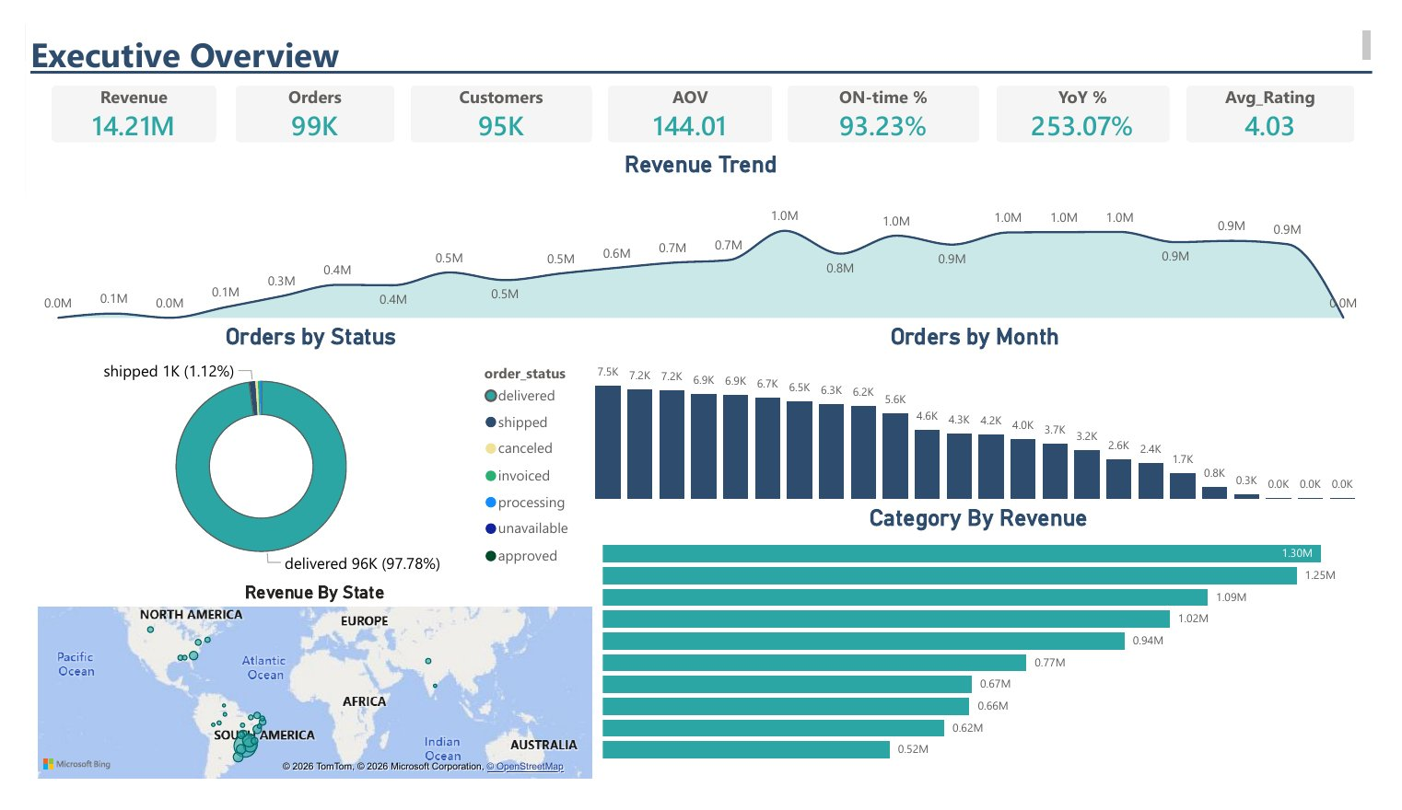
Figure 1: Executive Overview
- KPI cards: Revenue 14.21M, Orders 99K, Customers 95K, AOV 144.01, ON-time % 93.23%, YoY % 253.07%, Avg_Rating 4.03.
- Revenue Trend (area line): revenue by Year-Month (tooltips: AOV, Orders, YoY %). Peak of 1.05M in November 2017 (7,451 orders); lowest point 145 in September 2018 (1 order).
- Orders by Status (donut): delivered 96K (97.78%), shipped 1K (1.12%), plus canceled, invoiced, processing, unavailable and approved.
- Orders by Month (column): months sorted by volume, highest first (7.5K, 7.2K, 7.2K, 6.9K ... down to 0.0K).
- Category By Revenue (bar): ten categories led by health_beauty (1.30M revenue, 8,836 orders, 4.14 rating), then watches_gifts 1.25M, bed_bath_table 1.09M, sports_leisure 1.02M, computers_accessories 0.94M, furniture_decor 0.77M, housewares 0.67M, cool_stuff 0.66M, auto 0.62M and garden_tools 0.52M.
- Revenue By State (map): Bing bubble map with revenue concentrated in south-eastern Brazil, led by São Paulo (SP).

7.2 Sales Trend
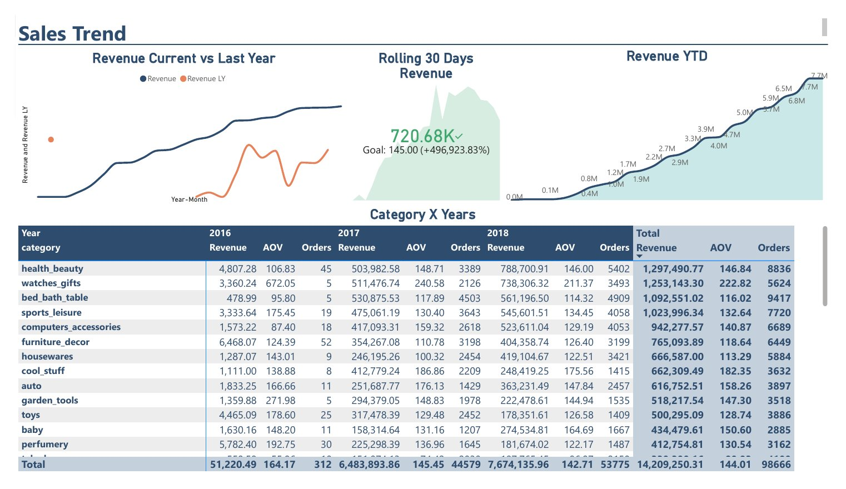
Figure 2: Sales Trend
- Revenue Current vs Last Year: line chart of Revenue and Revenue LY by Year-Month.
- Rolling 30 Days Revenue: KPI visual showing 720.68K against a goal of 145.00 (+496,923.83%).
- Revenue YTD: cumulative area chart by Year-Month, reaching 7.7M.
- Category X Years (matrix): Revenue, AOV and Orders for 2016, 2017 and 2018 with totals, sorted by total revenue. Leaders: health_beauty 1,297,490.77 (8,836 orders), watches_gifts 1,253,143.30 (5,624), bed_bath_table 1,092,551.02 (9,417), sports_leisure 1,023,996.34 (7,720), computers_accessories 942,277.57 (6,689). Lowest overall: security_and_services (283.29 revenue, 2 orders).
Year | Revenue | AOV | Orders
2016 | 51,220.49 | 164.17 | 312
2017 | 6,483,893.86 | 145.45 | 44,579
2018 | 7,674,135.96 | 142.71 | 53,775
Total | 14,209,250.31 | 144.01 | 98,666

7.3 Category & Product
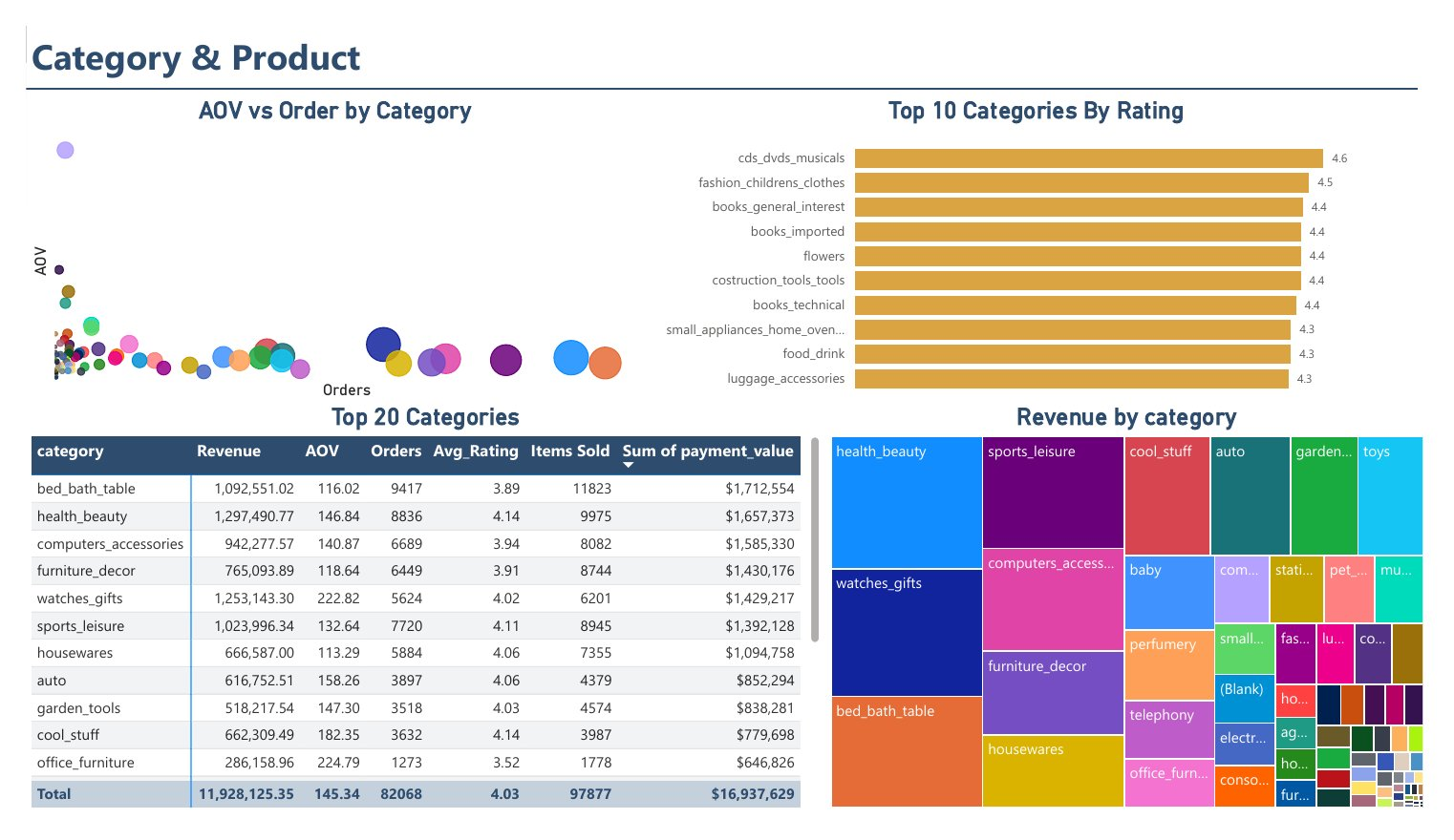
Figure 3: Category & Product
- AOV vs Order by Category (scatter): x = Orders, y = AOV, bubble size = Revenue. health_beauty has the largest sales impact; computers has the highest AOV (1,341.50 on 242,811.61 revenue and 181 orders).
- Top 10 Categories By Rating (bar): cds_dvds_musicals 4.6, fashion_childrens_clothes 4.5, books_general_interest, books_imported, flowers, costruction_tools_tools and books_technical at 4.4, then small_appliances_home_oven…, food_drink and luggage_accessories at 4.3.
- Revenue by category (treemap): block size shows revenue share, led by health_beauty, watches_gifts, bed_bath_table and sports_leisure.
- Top 20 Categories (table): sorted by Sum of payment_value; the first rows are shown below.
category | Revenue | AOV | Orders | Avg_Rating | Items Sold | Sum of payment_value
bed_bath_table | 1,092,551.02 | 116.02 | 9,417 | 3.89 | 11,823 | $1,712,554
health_beauty | 1,297,490.77 | 146.84 | 8,836 | 4.14 | 9,975 | $1,657,373
computers_accessories | 942,277.57 | 140.87 | 6,689 | 3.94 | 8,082 | $1,585,330
furniture_decor | 765,093.89 | 118.64 | 6,449 | 3.91 | 8,744 | $1,430,176
watches_gifts | 1,253,143.30 | 222.82 | 5,624 | 4.02 | 6,201 | $1,429,217
sports_leisure | 1,023,996.34 | 132.64 | 7,720 | 4.11 | 8,945 | $1,392,128
housewares | 666,587.00 | 113.29 | 5,884 | 4.06 | 7,355 | $1,094,758
auto | 616,752.51 | 158.26 | 3,897 | 4.06 | 4,379 | $852,294
garden_tools | 518,217.54 | 147.30 | 3,518 | 4.03 | 4,574 | $838,281
cool_stuff | 662,309.49 | 182.35 | 3,632 | 4.14 | 3,987 | $779,698
office_furniture | 286,158.96 | 224.79 | 1,273 | 3.52 | 1,778 | $646,826
Total | 11,928,125.35 | 145.34 | 82,068 | 4.03 | 97,877 | $16,937,629

7.4 Customer Geographics
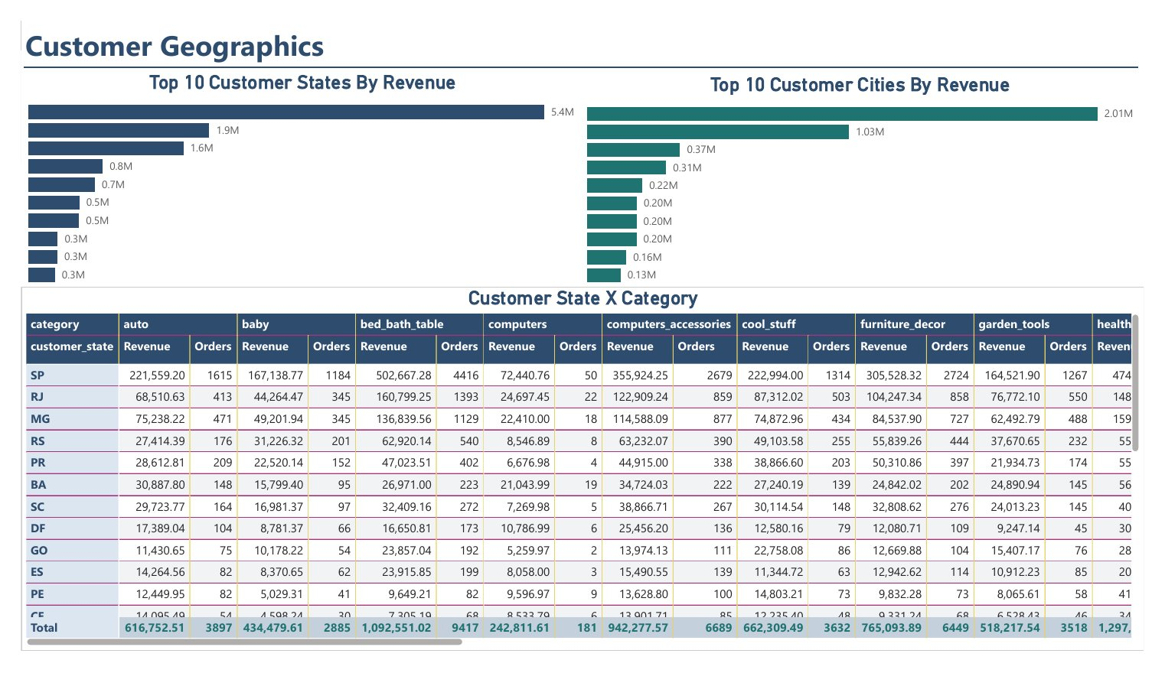
Figure 4: Customer Geographics
- Top 10 Customer States By Revenue (bar): 5.4M, 1.9M, 1.6M, 0.8M, 0.7M, 0.5M, 0.5M, 0.3M, 0.3M, 0.3M. SP leads with 5,448,301.72 revenue, 41,375 orders, AOV 131.68 and rating 4.13.
- Top 10 Customer Cities By Revenue (bar): 2.01M, 1.03M, 0.37M, 0.31M, 0.22M, 0.20M, 0.20M, 0.20M, 0.16M, 0.13M. sao paulo leads with 2,008,254.39 revenue, 15,402 orders and AOV 130.39.
- Customer State X Category (matrix): rows are customer states (SP, RJ, MG, RS, PR, BA, SC, DF, GO, ES, PE, CE...), columns are categories, each with Revenue and Orders. Example: SP / auto 221,559.20 (1,615 orders), SP / bed_bath_table 502,667.28 (4,416 orders).

7.5 Delivery & Logistics
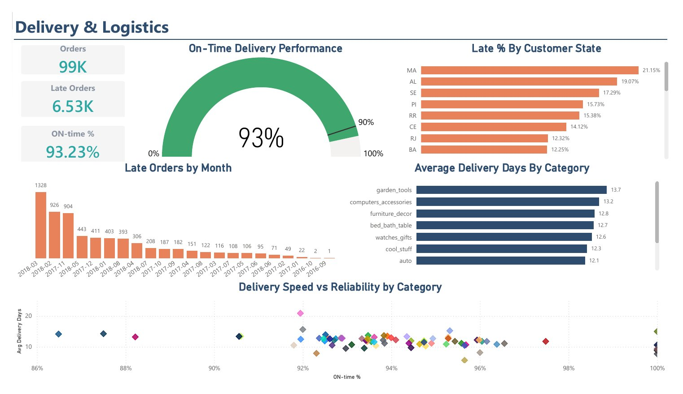
Figure 5: Delivery & Logistics
- Cards: Late Orders 6.53K, Orders 99K, ON-time % 93.23%.
- On-Time Delivery Performance (gauge): 93% against the 90% target (96,478 delivered orders, 6,534 late).
- Late % By Customer State (bar): highest rates first: MA 21.15%, AL 19.07%, SE 17.29%, PI 15.73%, RR 15.38%, CE 14.12%, RJ 12.32%, BA 12.25%. AC has the lowest rate (2.27%).
- Late Orders by Month (column): sorted by volume; peak in March 2018 with 1,328 late orders (of 7,188), followed by February 2018 (926) and November 2017 (904).
- Average Delivery Days By Category (bar): garden_tools 13.7, computers_accessories 13.2, furniture_decor 12.8, bed_bath_table 12.7, watches_gifts 12.6, cool_stuff 12.3, auto 12.1.
- Delivery Speed vs Reliability by Category (scatter): x = Avg Delivery Days, y = ON-time % (86% to 100%), one point per category.

7.6 Review Analysis
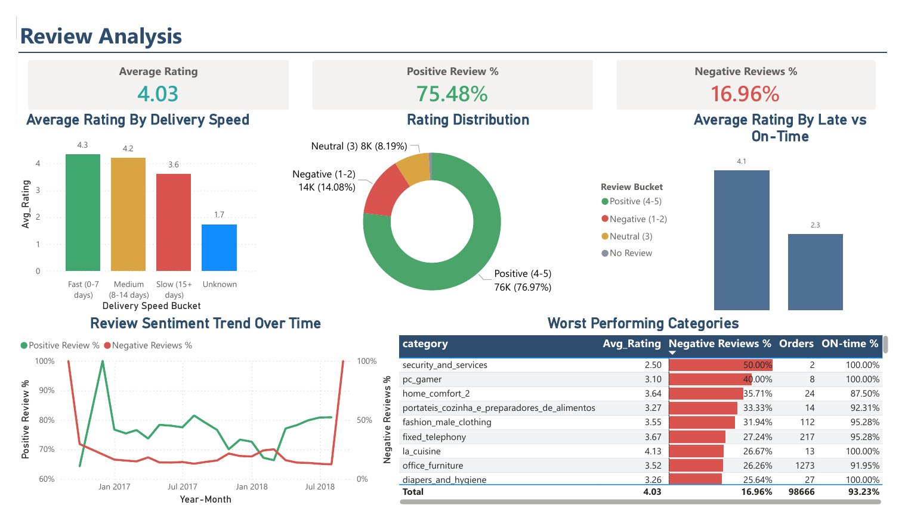
Figure 6: Review Analysis
- Cards: Average Rating 4.03, Positive Review % 75.48%, Negative Reviews % 16.96%.
- Average Rating By Delivery Speed (bar): Fast (0-7 days) 4.3, Medium (8-14 days) 4.2, Slow (15+ days) 3.6, Unknown 1.7.
- Rating Distribution (donut): Positive (4-5) 76K (76.97%), Negative (1-2) 14K (14.08%), Neutral (3) 8K (8.19%), plus No Review (about 0.76%).
- Average Rating By Late vs On-Time (bar): on-time orders 4.1, late orders 2.3.
- Review Sentiment Trend Over Time (dual line): Positive Review % and Negative Reviews % by Year-Month.
- Worst Performing Categories (table): sorted by Negative Reviews %.
category | Avg_Rating | Negative Reviews % | Orders | ON-time %
security_and_services | 2.50 | 50.00% | 2 | 100.00%
pc_gamer | 3.10 | 40.00% | 8 | 100.00%
home_comfort_2 | 3.64 | 35.71% | 24 | 87.50%
portateis_cozinha_e_preparadores_de_alimentos | 3.27 | 33.33% | 14 | 92.31%
fashion_male_clothing | 3.55 | 31.94% | 112 | 95.28%
fixed_telephony | 3.67 | 27.24% | 217 | 95.28%
la_cuisine | 4.13 | 26.67% | 13 | 100.00%
office_furniture | 3.52 | 26.26% | 1,273 | 91.95%
diapers_and_hygiene | 3.26 | 25.64% | 27 | 100.00%
Total | 4.03 | 16.96% | 98,666 | 93.23%

7.7 Payments
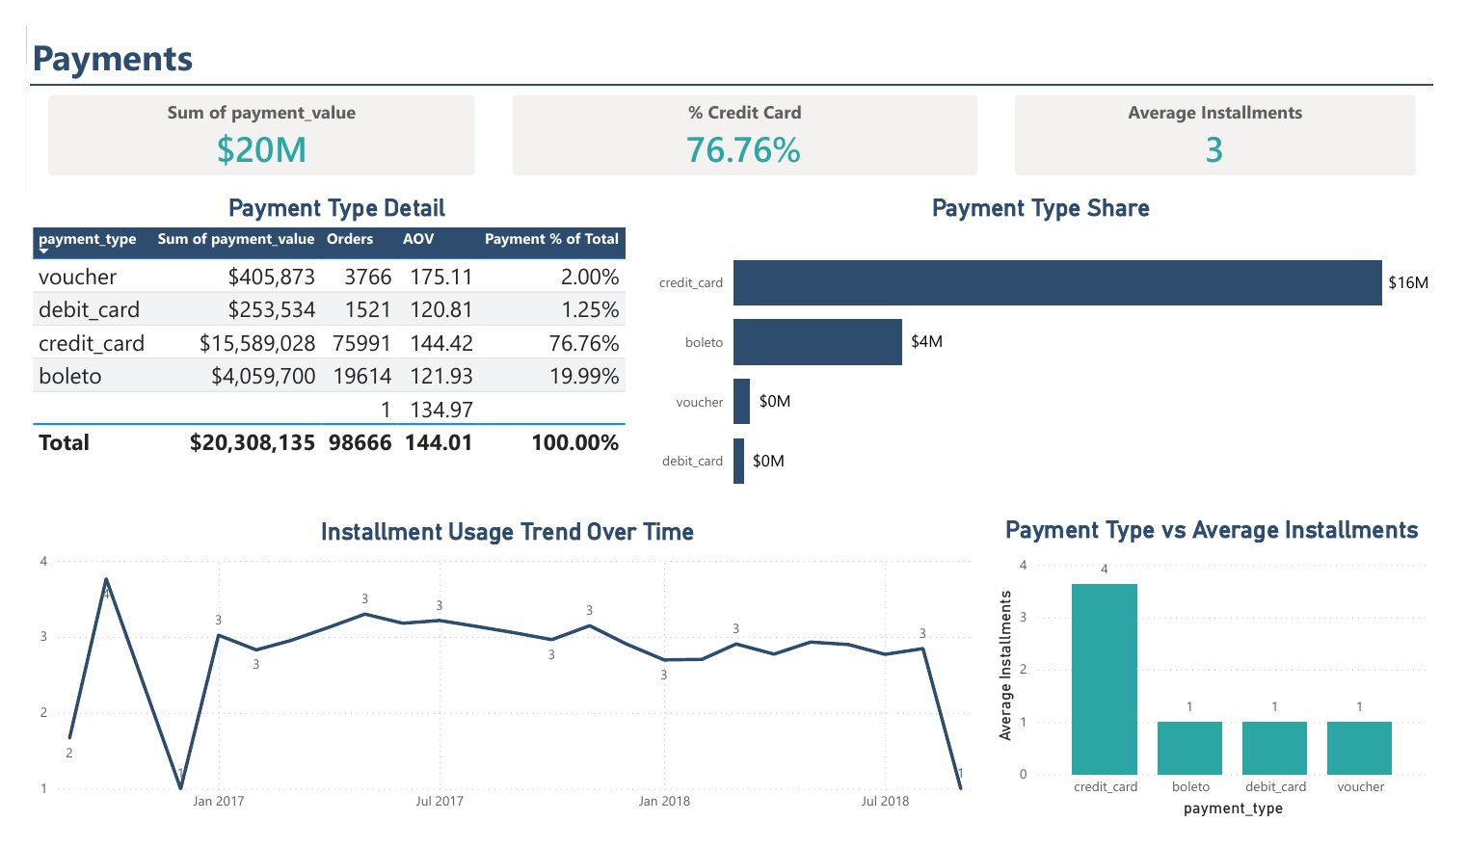
Figure 7: Payments
- Cards: Sum of payment_value $20M, Average Installments 3, % Credit Card 76.76%.
- Payment Type Share (bar): credit_card about $16M, boleto about $4M, voucher and debit_card under $1M.
- Payment Type vs Average Installments (bar): credit_card 4; boleto, debit_card and voucher 1.
- Installment Usage Trend Over Time (line): average installments by Year-Month from early 2017 to mid-2018, mostly around 3.
- Payment Type Detail (table):
payment_type | Sum of payment_value | Orders | AOV | Payment % of Total
credit_card | $15,589,028 | 75,991 | 144.42 | 76.76%
boleto | $4,059,700 | 19,614 | 121.93 | 19.99%
voucher | $405,873 | 3,766 | 175.11 | 2.00%
debit_card | $253,534 | 1,521 | 120.81 | 1.25%
(blank) | - | 1 | 134.97 | -
Total | $20,308,135 | 98,666 | 144.01 | 100.00%

7.8 Sellers
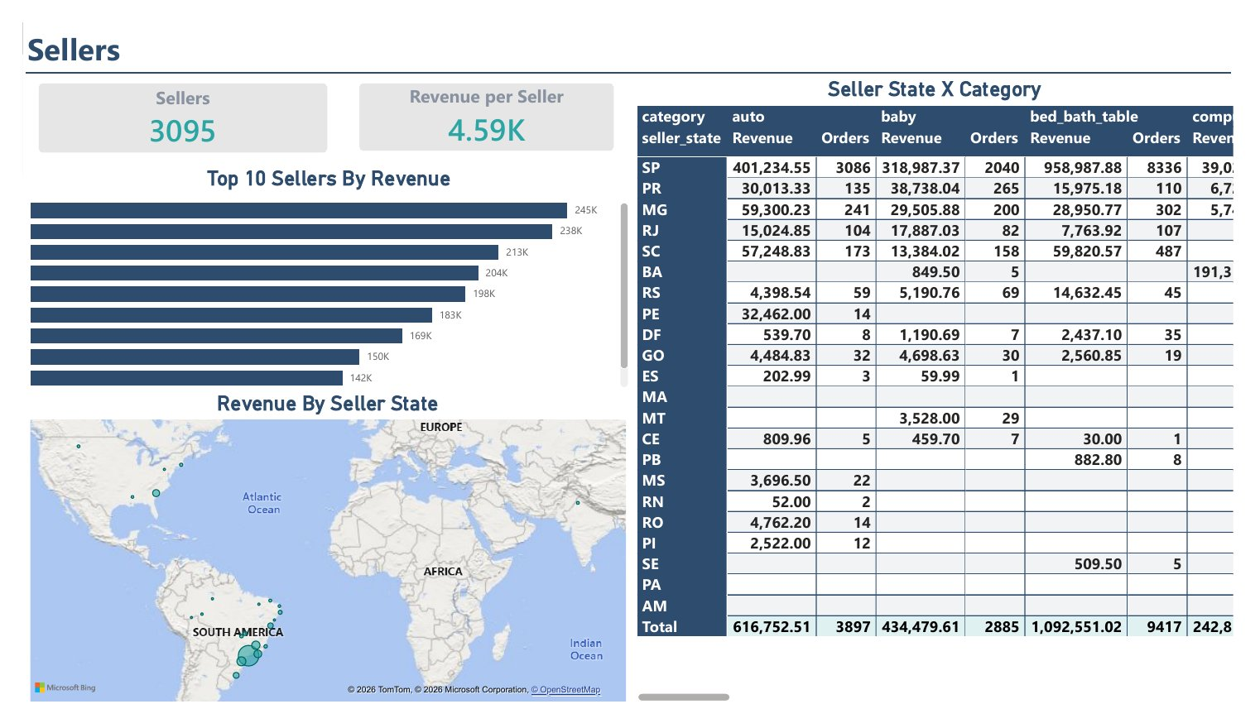
Figure 8: Sellers
- Cards: Sellers 3,095, Revenue per Seller 4.59K.
- Top 10 Sellers By Revenue (bar): 245K, 238K, 213K, 204K, 198K, 183K, 169K, 150K, 142K. The top seller is 53243585a1d6dc2643021fd1853d8905 (Lauro de Freitas, BA) with 244,627.55 revenue across 358 orders.
- Revenue By Seller State (map): Bing bubble map concentrated in south-eastern Brazil.
- Seller State X Category (matrix): rows are seller states (SP, PR, MG, RJ, SC, BA, RS, PE, DF, GO, ES, MA, MT, CE, PB, MS, RN, RO, PI, SE, PA, AM), columns are categories with Revenue and Orders. SP dominates, e.g. auto 401,234.55 (3,086 orders) and bed_bath_table 958,987.88 (8,336 orders).

7.9 Drillthrough Pages (Reports 9 & 10)
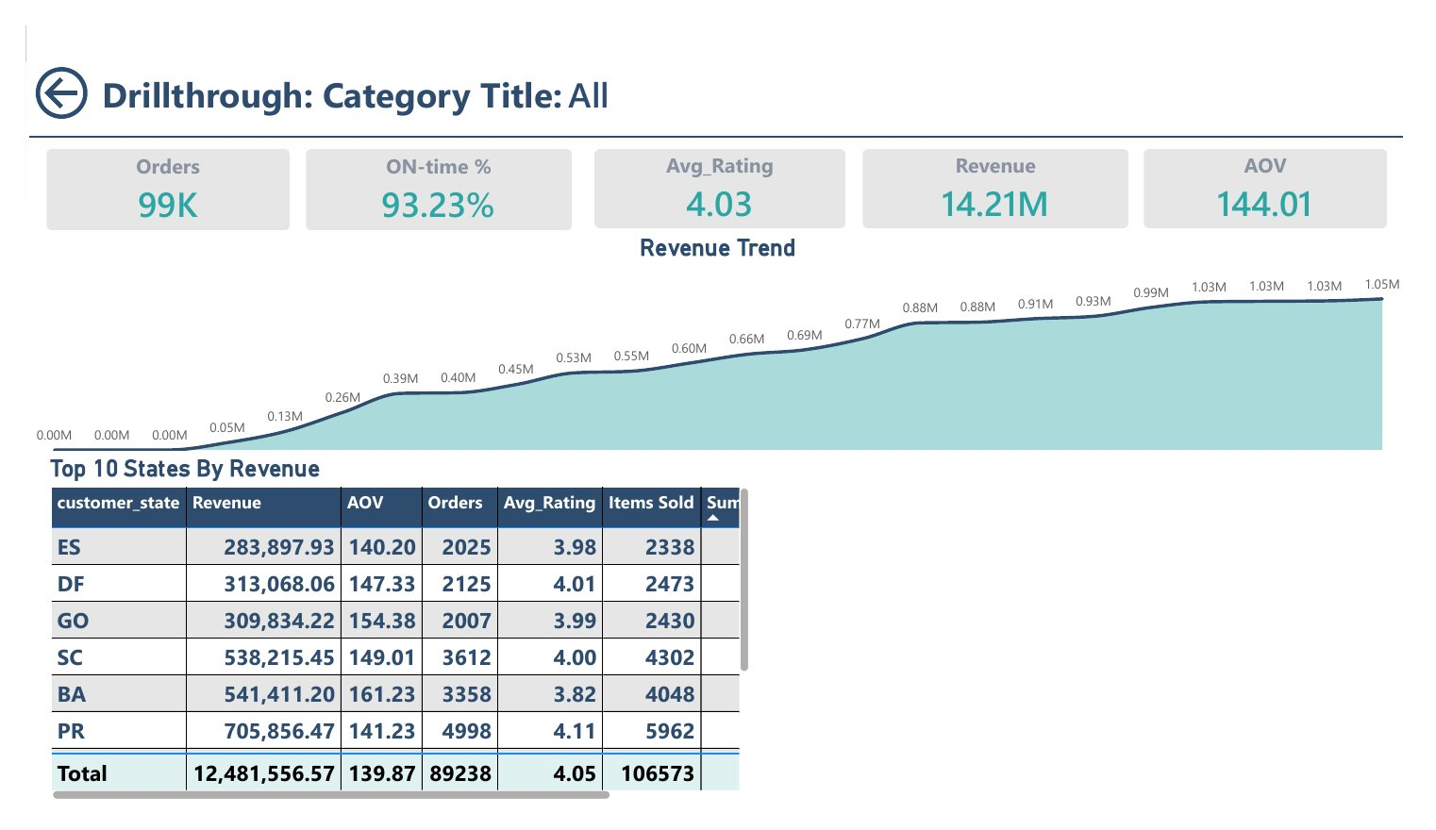
Figure 9: Drillthrough - Category Title
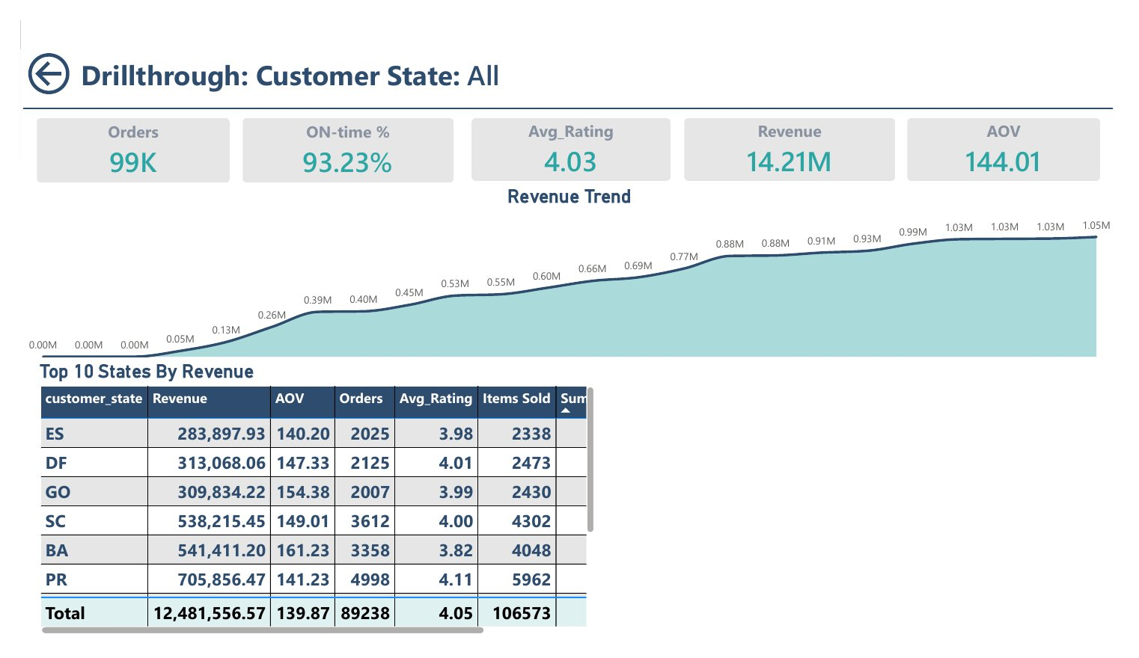
Figure 10: Drillthrough - Customer State
Both pages have a back button, a header driven by [Drill Title] ("All" when nothing is selected), five cards and a revenue trend. Report 9 is titled "Drillthrough: Category Title" and Report 10 "Drillthrough: Customer State".
- Cards: Orders 99K, ON-time % 93.23%, Avg_Rating 4.03, Revenue 14.21M, AOV 144.01.
- Revenue Trend (area): by Year-Month, reaching 1.05M.
- Top 10 States By Revenue (table): customer_state, Revenue, AOV, Orders, Avg_Rating, Items Sold and Sum of payment_value. Both pages currently show this same table; rows visible below.
customer_state | Revenue | AOV | Orders | Avg_Rating | Items Sold
ES | 283,897.93 | 140.20 | 2,025 | 3.98 | 2,338
DF | 313,068.06 | 147.33 | 2,125 | 4.01 | 2,473
GO | 309,834.22 | 154.38 | 2,007 | 3.99 | 2,430
SC | 538,215.45 | 149.01 | 3,612 | 4.00 | 4,302
BA | 541,411.20 | 161.23 | 3,358 | 3.82 | 4,048
PR | 705,856.47 | 141.23 | 4,998 | 4.11 | 5,962
Total | 12,481,556.57 | 139.87 | 89,238 | 4.05 | 106,573

