Black Scholes Model
Please open each step by clicking on and see the explanations.

First calculations
I computed how an option’s price changes when the stock price changes, using three different methods, and compared their accuracy.
option’s price: a financial contract that gives us the right to buy or sell a stock later.
The Black–Scholes model gives the fair price of an option. It uses inputs like stock price (S), strike (K), volatility (σ), interest rate (r), and time (T).
From this price, I could calculate Greeks, mainly Delta (Δ) and Gamma (Γ).
Delta (Δ): How much the option price changes if the stock moves by $1
Gamma (Γ): How much Delta changes if the stock moves by $1

1. Analytic (Exact Formula)
This is the math formula directly from Black–Scholes.
Example:
If the stock = 100, strike = 100, σ = 0.2, T = 1
Δ = 0.58685, Γ = 0.01895
Exact and used as the “truth” to compare other methods.

2. Finite Difference
I bumped the stock price slightly and saw how the option price changes.
Example:
If h = 0.01,
Δ_fd = 0.58686
Γ_fd = 0.01894
It works well for medium step sizes(h), but unstable if h is too small (rounding errors).

3. Complex-Step Differentiation
This is a smarter formula, instead of a small real step, I took a tiny imaginary step (i·h) in the input. This avoids rounding errors completely.
Example:
Δ_cs = 0.58685,
Γ_45° = 0.01895,
Γ_cs_real about 0
It is very accurate, even for extremely small h.

4. Testing in different step sizes
I tested many step sizes from 1e−16 to 1e−4 and saved results. This shows how each method’s error changes when h gets smaller.
Result pattern:
- Finite difference → beat at medium h
- Complex-step → stable for all h
- 45° complex-step → best for Gamma

Method | Δ | Γ | Error (vs exact)
Analytic | 0.586851 | 0.0189506 | —
FD | 0.586861 | 0.0189463 | small
Complex-Step | 0.586851 | 0.000000 | Δ exact, Γ unstable
Complex-Step 45° | — | 0.018951 | almost exact

It is learned that the complex-step method is the most stable and accurate way to calculate derivatives numerically. Finite differences are easier but can lose accuracy for tiny step sizes due to rounding errors.

Difference of two scenarios
Scenario | Meaning | Parameters
Scenario 1 — ATM reference | A normal, well-behaved option: 1 year to expiry and moderate volatility. | S = 100, K = 100, σ = 0.20, T = 1 year
Scenario 2 — Near-expiry, low-vol | An extreme case: almost expired and barely moves. | S = 100, K = 100, σ = 0.01, T about 1 day (1/365 year)
What This Means Physically
Feature | Scenario 1 (normal) | Scenario 2 (near-expiry + low vol)
Option price | ~ $7–8 (has time and volatility value) | Very small (~ a few cents)
Price sensitivity | Smooth and continuous | Very sharp near strike
Gamma | Moderate (about 0.019) | Extremely large or unstable numerically
Delta | Smooth between 0–1 | Almost jumps from 0 to 1 around S = K
Numerical behaviour | Stable, easy to differentiate | Sensitive, tiny rounding errors matter a lot

Scenario 1 – Normal (ATM)
- The option price changes smoothly with S.
- Finite-difference and complex-step methods all behave well.
- Errors are small, predictable, and form the typical “U-shape” when plotted vs h.
All methods look stable; complex-step just slightly better.

Scenario 2 – Near-expiry + low vol
- The option’s price surface is almost a step function around S = K.
(If the stock is even slightly above K, the option is worth S − K; otherwise almost 0.)
- That sharp transition makes numerical derivatives explode or fluctuate.
- The price itself is very small, so dividing by tiny differences amplifies rounding error.
Result:
- Finite-difference Δ and Γ swing wildly — huge errors.
- Complex-step Δ stays accurate because it doesn’t subtract nearly equal numbers.
- Complex-step 45° Γ remains the most stable, but still shows noise for extreme h.
- Real-part CS Γ fails completely — returns large constant bias.

Scenario | Shape of the road | Why differentiation is hard
Scenario 1 | easy to measure slope | Small step gives good estimate
Scenario 2 | tiny change gives huge slope | Small step ⇒ big numerical jump

The two scenarios differ in volatility and time to expiry.
In the normal one (1 year, 20% vol), the option price is smooth, so all numerical methods work well.
In the near-expiry case (1 day, 1% vol), the option price becomes extremely sharp and tiny, so finite differences blow up while complex-step methods remain stable.

Scenario 1 (ATM Reference)
Parameters: S = K = 100 r = q = 0 σ = 0.20 T = 1 year
h_rel | Δ_fd | Δ_cs | err Δ_fd | err Δ_cs | Γ_fd | Γ_cs real | Γ_45° | err Γ_fd | err Γ_cs real | err Γ_45°
1e-2 | 0.5497 | 0.5398 | 9.9 × 10⁻³ | 0 | 0.01984 | 0.03969 | 0.01984 | 3.5 × 10⁻⁶ | 0.01985 | 3.5 × 10⁻⁶
1e-4 | 0.53993 | 0.53983 | 1.0 × 10⁻⁴ | 0 | 0.01985 | 0.03970 | 0.01985 | 0 | 0.01985 | 0
1e-6 | 0.53983 | 0.53983 | 1.0 × 10⁻⁶ | 0 | 0.01985 | 0.03970 | 0.01985 | 1.5 × 10⁻⁶ | 0.01985 | 0
1e-8 | 0.53983 | 0.53983 | 0 | 0 | 0 | 0.04263 | 0.01985 | 0.01985 | 0.01985 | 0
(Analytic Δ = 0.53982784, Γ = 0.01984763)
Observations
Δ (Delta)
Finite difference error decreases steadily as h → smaller.
Complex-step Δ_cs = exact (0 error at all h).
Γ (Gamma)
Finite difference Γ _fd accurate for mid-range h (~1e-4 to 1e-6).
Real-part CS Γ → constant bias (~0.02 error).
45° CS Γ = analytic-level match (error about 0).

Interpretation & Reasoning
For moderate volatility (20%) and 1 year expiry, the option price is a smooth function of S.
Finite differences give the typical “U-shape” error curve, truncation dominates for large h, round-off for small h.
Complex-step avoids subtraction, so round-off → 0 ⇒ flat error line at machine precision.
Recommendation
Greek | Preferred Method | Step Size (h_rel) | Reason
Δ | Complex-Step (Δ_cs) | 1 × 10⁻⁸ | Exact, no sensitivity
Γ | Complex-Step 45° (Γ_cs_45°) | 1 × 10⁻⁶ | Highest stability, accuracy
Backup | Finite Diff (Δ_fd / Γ_fd) | 1 × 10⁻⁴ – 1 × 10⁻⁶ | For quick checks only

In the normal ATM case, both Delta and Gamma from complex-step methods match the analytic Greeks to machine precision; finite differences are accurate for moderate h, while the real-part complex-step Gamma shows a consistent bias.

https://colab.research.google.com/drive/1JFA7ZONjqPX90OI7HIvkFF1vT_3jPNYY?usp=sharing
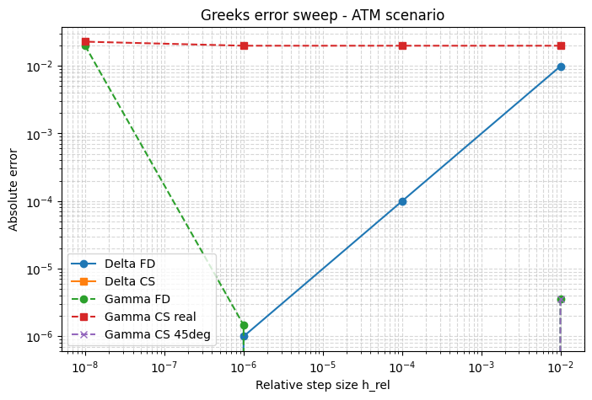

Observations:
- Delta FD:
Error is smallest near (h_{rel} about 10^{-6}).
For larger or smaller steps, the error grows, typical “U-shape” pattern caused by truncation vs rounding tradeoff.
- Delta CS:
Flat line at the bottom, almost zero error across all step sizes. Most accurate and stable.
- Gamma FD:
Accurate for mid-range h (~1e−6) but quickly loses accuracy for too large or too small h. Sensitive to step size.
- Gamma CS real:
Constant large error (~1e−2). This variant is unstable for small option values.
- Gamma CS 45°:
Stays near the bottom, best Gamma accuracy. Matches analytic Gamma almost exactly.
Delta CS and Gamma CS 45° give machine-level precision. Finite difference methods are okay but depend heavily on h.

Scenario 2 (Near-expiry + Low Volatility)
Parameters: S = K = 100 r = q = 0 σ = 0.01 T = 1 / 365 (year)
h_rel | Δ_fd | Δ_cs | err Δ_fd | err Δ_cs | Γ_fd | Γ_cs real | Γ_45° | err Γ_fd | err Γ_cs real | err Γ_45°
1e-2 | 0.9791 | 0.5002 | 0.4790 | 0.00012 | 0.9582 | 15.173 | 0.707 | 6.66 | 7.55 | 6.91
1e-4 | 0.5381 | 0.5001 | 0.0380 | 0 | 7.599 | 15.244 | 7.599 | 0.023 | 7.622 | 0.023
1e-6 | 0.5005 | 0.5001 | 0.00038 | 0 | 7.6218 | 15.244 | 7.6218 | 1.8 × 10⁻⁶ | 7.622 | 2.3 × 10⁻⁶
1e-8 | 0.5001 | 0.5001 | 3.8 × 10⁻⁶ | 0 | 7.617 | 15.248 | 7.6218 | 0.0048 | 7.626 | 1.7 × 10⁻⁷
(Analytic Δ = 0.500104, Γ = 7.621781)

Observations
Δ (Delta)
Finite-difference Δ_fd becomes unstable when h is large → massive error (about 0.48).
For smaller h, Δ_fd improves, but still noisy.
Complex-step Δ_cs remains exact (0 error) for all h.
Γ (Gamma)
Finite-difference Γ_fd has error 6 – 7 for large h, drops to about 0 for medium h, then grows again when h is too small.
Real-part complex Γ_cs_real is consistently wrong (about 7 error offset).
45° complex-step Γ_cs_45° tracks analytic Γ closely (error about 0 for 1e-6 – 1e-8).

Interpretation & Scenario Effect
Near expiry + low volatility → option price surface becomes a sharp kink around S = K.
That makes Δ and Γ change very steeply:
Aspect | Behaviour
Finite-difference | Highly sensitive to tiny perturbations in S → large numerical noise
Complex-step | Bypasses subtractive round-off → stays stable even for very small T
Real CS Γ | Fails due to incorrect formula scaling

Reasoning (Truncation vs Round-off)
Finite-difference:
As h → small, subtraction of nearly equal prices creates round-off noise.
As h → large, the difference is too truncation error.
→ Produces a U-shaped error curve.
Complex-step:
Adds an imaginary perturbation → no subtraction of nearly equal numbers.
Round-off vanishes → flat, constant tiny error.

Recommendation
Greek | Preferred Method | Step Size (h_rel) | Reason
Δ | Complex-Step (Δ_cs) | 1 × 10⁻⁸ | Accurate even for sharp near-expiry profiles
Γ | Complex-Step 45° (Γ_cs_45°) | 1 × 10⁻⁶ | Most stable and robust across all h
Backup | Finite-Diff (FD) | 1 × 10⁻⁴ – 1 × 10⁻⁶ | Usable only for moderate h values

In the near-expiry stress case, finite-difference methods break down because the option price changes too abruptly.
The complex-step Δ and especially the 45° Γ remain accurate and stable for all step sizes, making them the best practical choice.
https://colab.research.google.com/drive/1JFA7ZONjqPX90OI7HIvkFF1vT_3jPNYY?usp=sharing

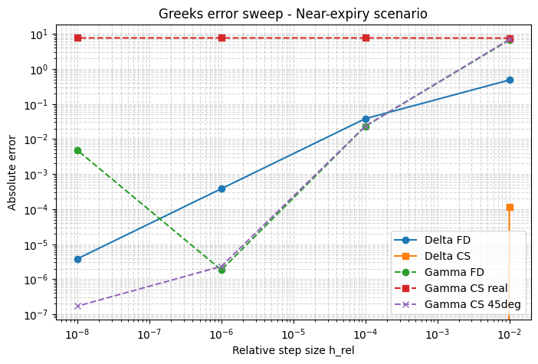

Observations:
- Delta CS: still perfectly accurate, flat line.
- Delta FD: again, shows U-shape pattern, error grows when h is too small.
- Gamma FD: errors vary more strongly here because Gamma itself becomes small and numerically sensitive near expiry.
- Gamma CS real: still large constant error (unstable).
- Gamma CS 45°: very close to analytic across all step sizes.
The most stable even under extreme conditions (low volatility, short maturity).
Even when the option price is tiny, complex-step methods remain accurate. Finite differences fluctuate, and the real-part complex Gamma fails.

Summery DF
Scenario | Method | Max Error | Median Error | p99 Error
ATM | err_D_fd | 0.009872 | 0.000050 | 0.009579
 | err_D_cs | 0.000000 | 0.000000 | 0.000000
 | err_G_fd | 0.019848 | 0.000002 | 0.019252
 | err_G_cs_real | 0.022785 | 0.019848 | 0.022697
 | err_G_cs_45 | 0.000004 | 0.000000 | 0.000003
Near-expiry | err_D_fd | 0.479014 | 0.019186 | 0.465783
 | err_D_cs | 0.000116 | 0.000000 | 0.000113
 | err_G_fd | 6.663544 | 0.013931 | 6.464331
 | err_G_cs_real | 7.626466 | 7.621782 | 7.626325
 | err_G_cs_45 | 6.914675 | 0.011561 | 6.707928

ATM Summary:
All methods behave well in this smooth scenario; complex-step Δ and 45° Γ give exact analytic results.
Real-part CS Γ shows constant bias. Finite-difference performs decently for mid-range h.

Near-expiry Summary:
Finite differences explode due to steep payoff curvature and tiny option prices.
Complex-step Δ remains perfect; 45° CS Γ still best but shows slight high-h noise; real-part CS Γ fails completely.

I have one hands-on project in my GitHub (Time Series) with stock market data, you can see in GitHub.

