**National Textile University, Faisalabad**

, Picture

**Department of Computer Science**

|  |  |
| --- | --- |
| **Name:** | Maryam Sameen |
| **Class:** | BSAI – 6h |
| **Registration No:** | 22-NTU-CS-1354 |
| **Lab Report:** | Lab 13 |
| **Course Name:** | Internet of Things |

# Task 1: ESP32 Arduino Publisher

The ESP32 reads temperature and humidity from a DHT11 sensor and publishes it over MQTT. Topics used are:  
- esp32/dht/temp  
- esp32/dht/hum

**Observations:**

The ESP32 was successfully connected to the WiFi network and communicated with the Mosquitto MQTT broker. Real-time temperature and humidity data from the DHT11 sensor were accurately published to designated MQTT topics. This confirms the reliable integration of IoT sensor data with MQTT-based communication.

Publishing from ESP32 to Mosquitto

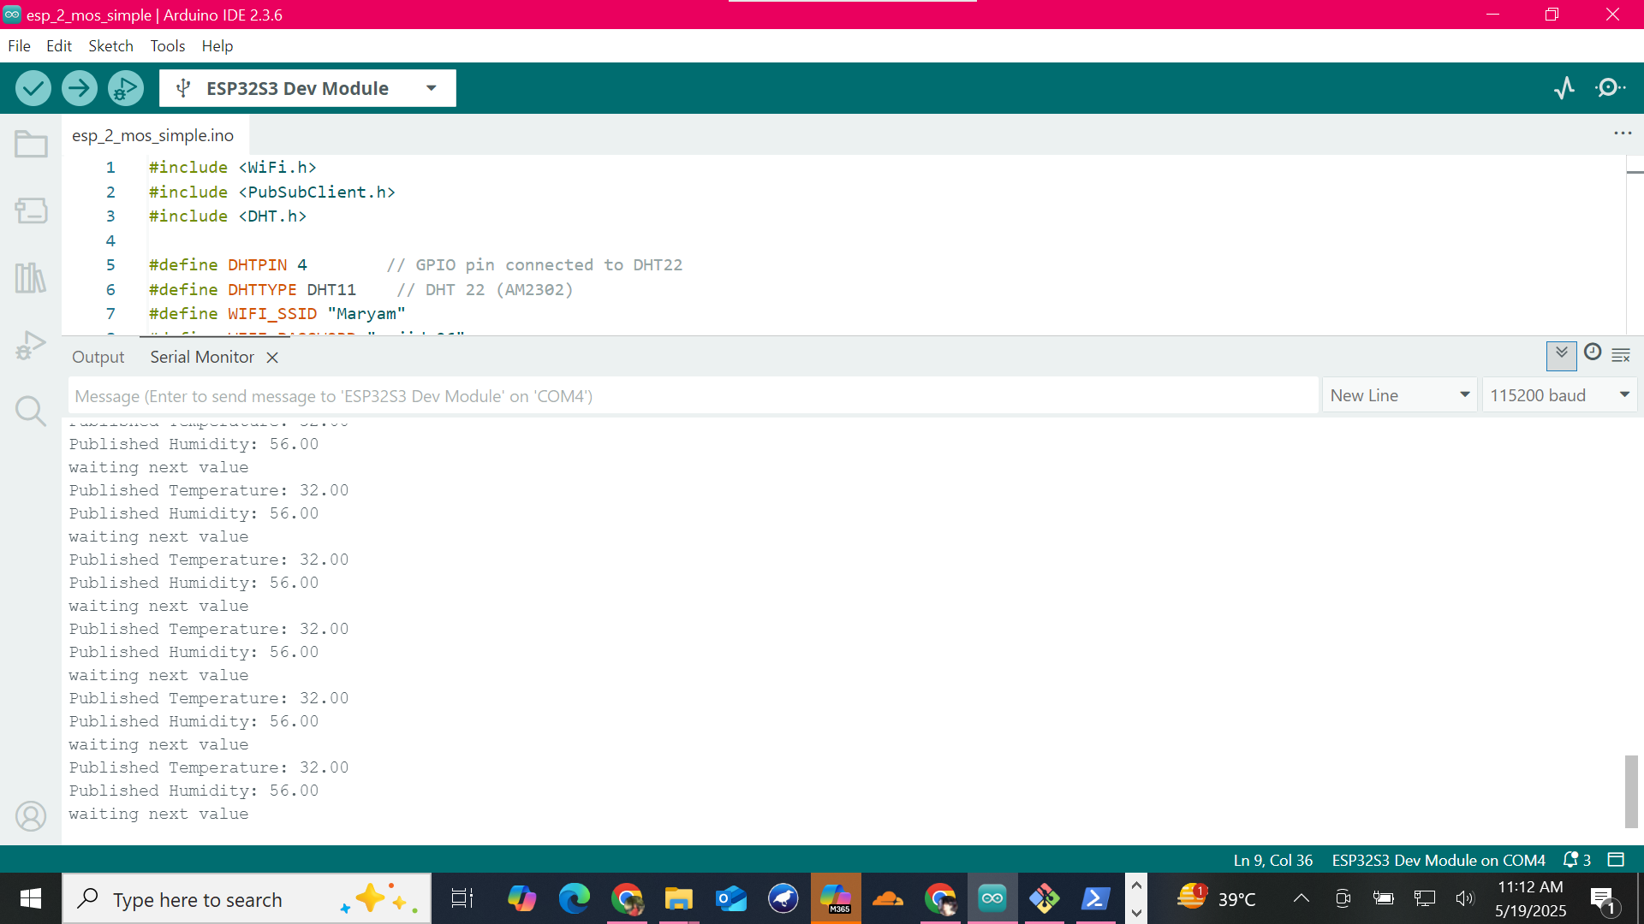

Data Published from ESP32 (Arduino Serial Monitor)

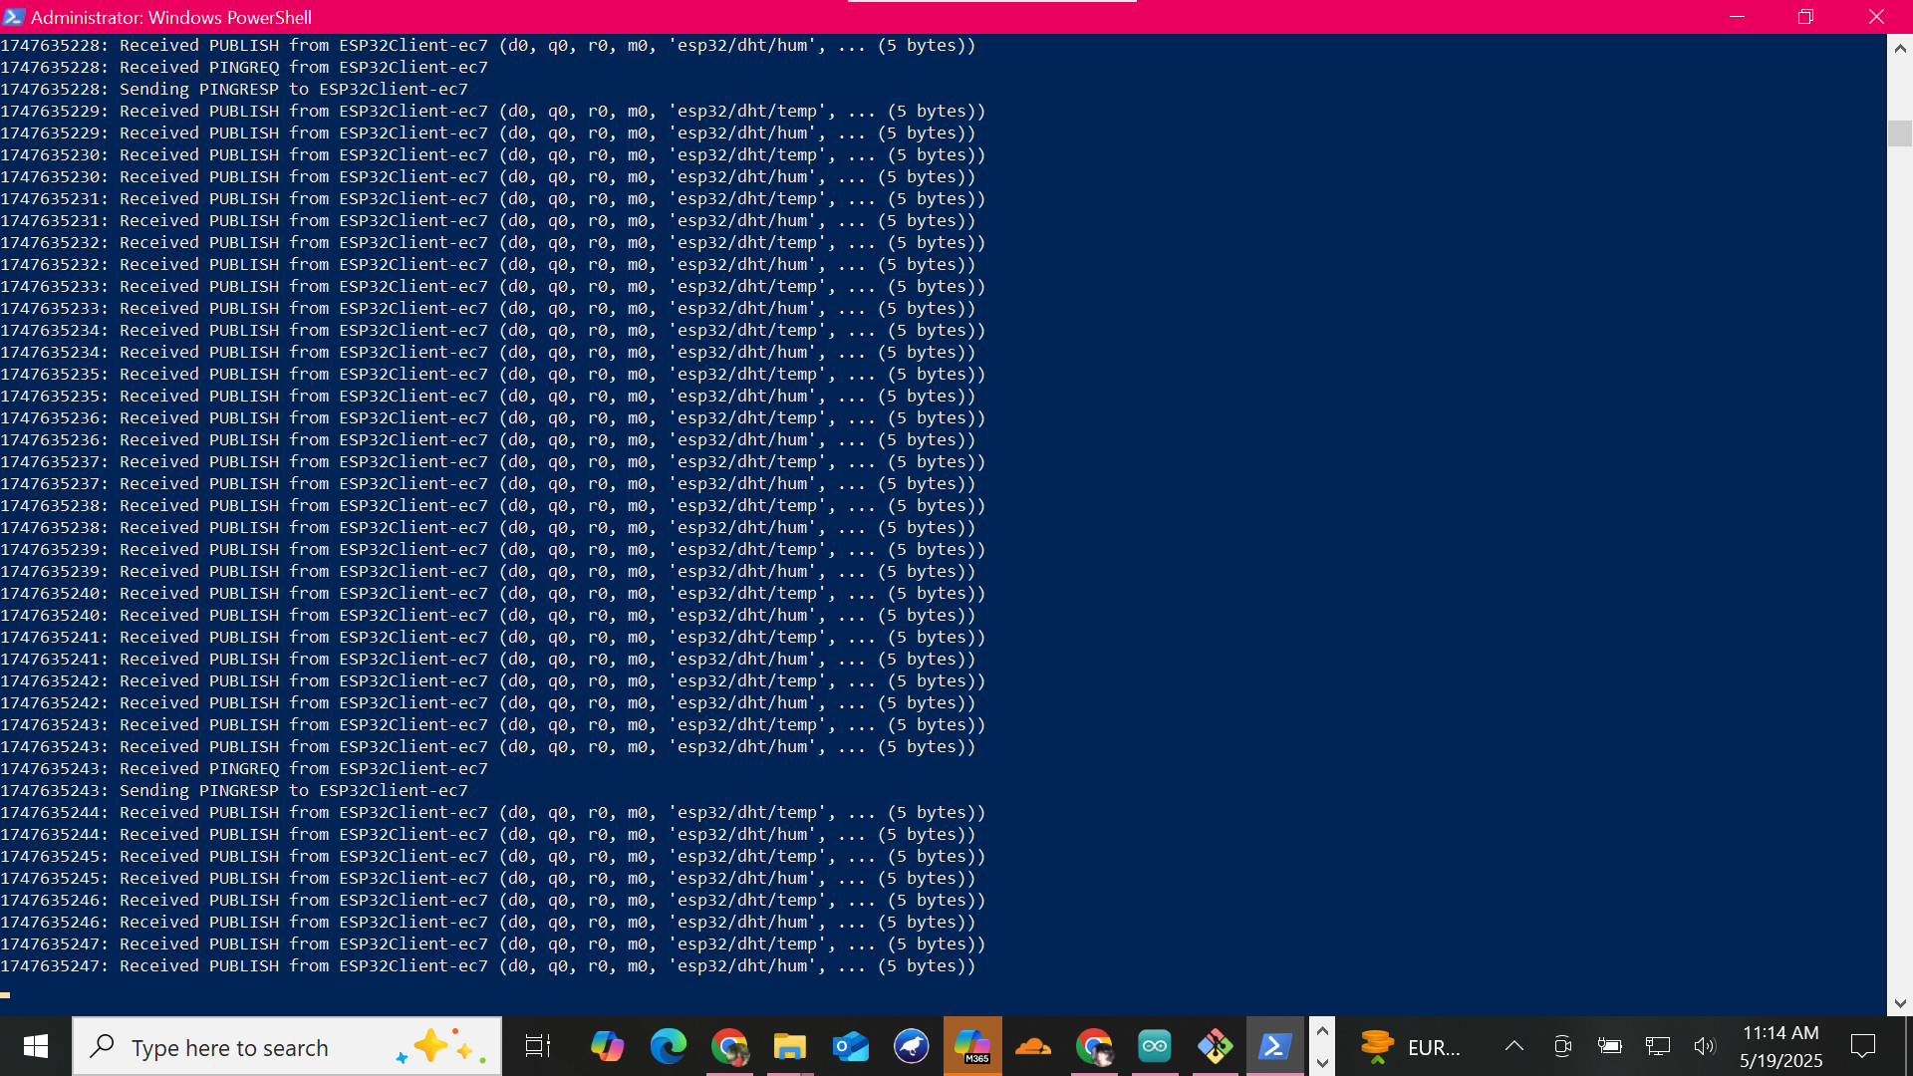

# Task 2: Python Listener for Raw DHT Data

A Python script subscribes to MQTT and logs the received temperature and humidity to InfluxDB under the 'dht_data' measurement.

**Observations:**

After providing the correct credentials for Influxdb i.e Influxdb token, influxdb organization, influxdb bucket and IPv4 address for MQTT Broker, the python script runs successfully and show real time temperature humidity data at the terminal and on for displaying it on influxdb interface, run “influxd” command on cmd and provide the username and password which will show the real time data.

Data Logged to InfluxDB (Python)

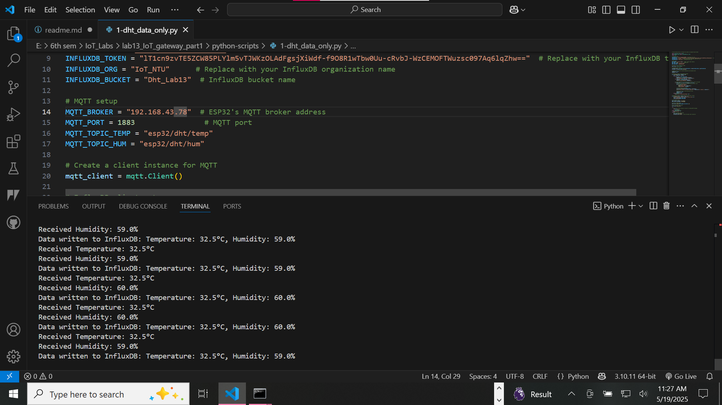

Raw Sensor Data in InfluxDB

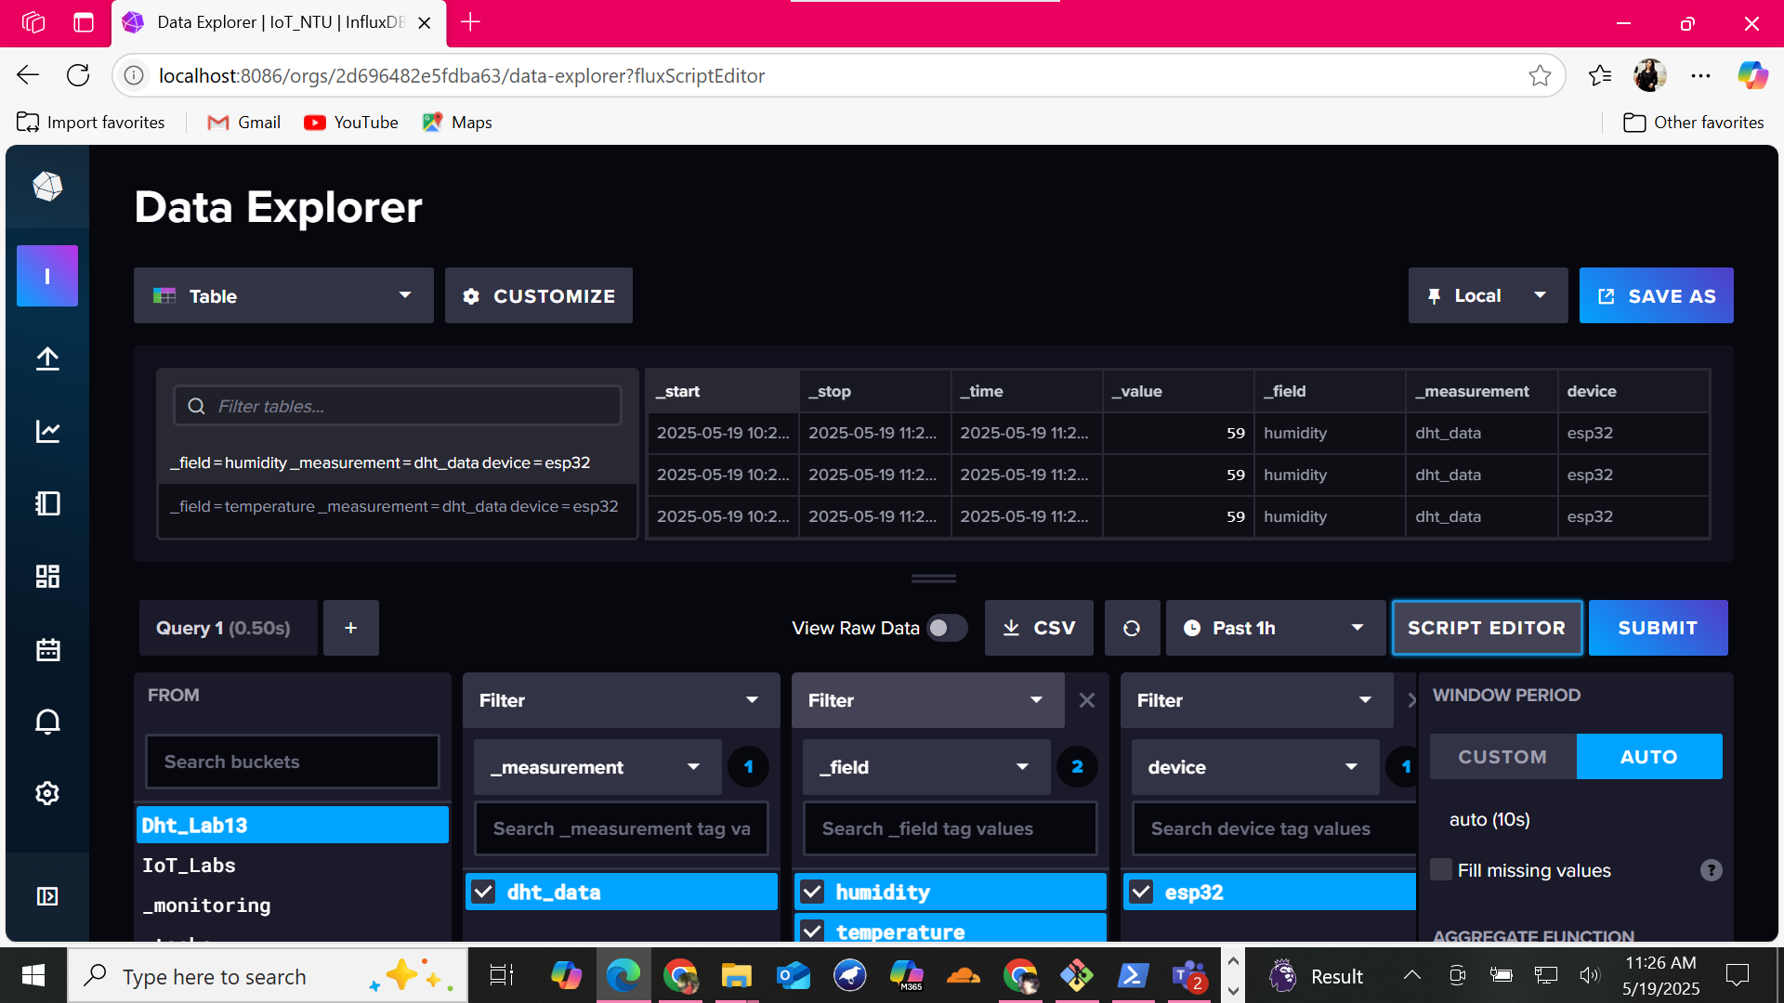

# Task 3: Train Classification Model with Noise

A neural network is trained using synthetically generated temperature and humidity data with added noise. The model classifies input into 5 categories:  
- Normal  
- Hot and Humid  
- Cold and Dry  
- Hot and Dry  
- Cold and Humid

**Observations:**

The neural network accurately classified DHT sensor readings into five environmental conditions using synthetic, noisy data. The model showed balanced performance, with a clear confusion matrix and strong classification report indicating reliable generalization.

Confusion Matrix Visualization

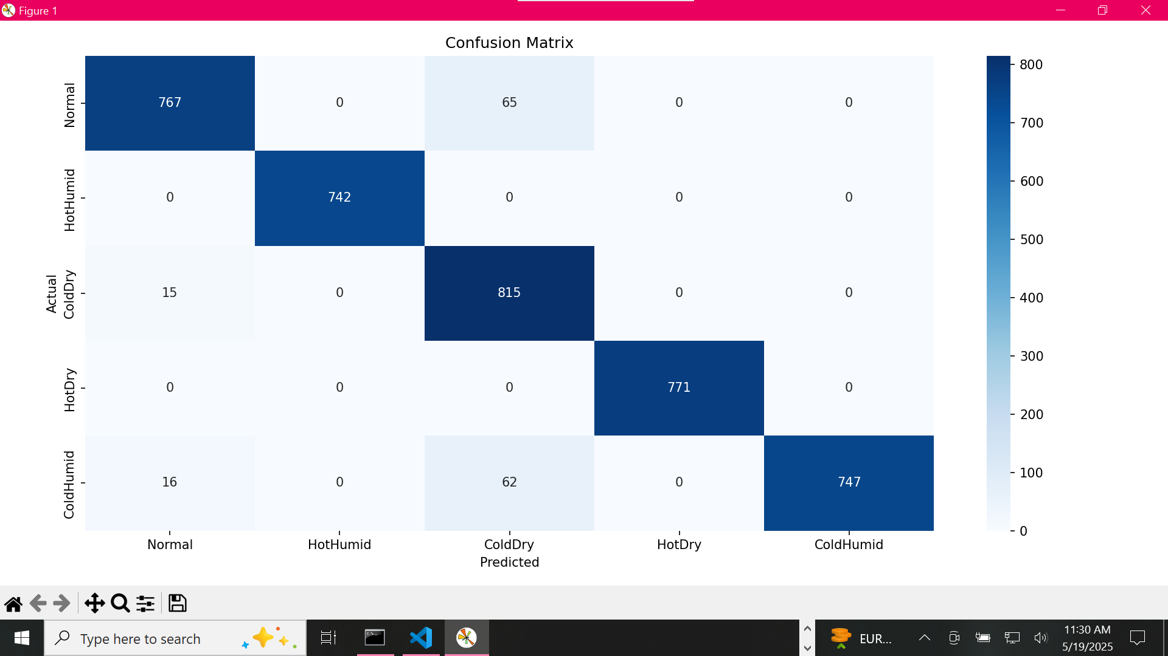

Classification Report Output

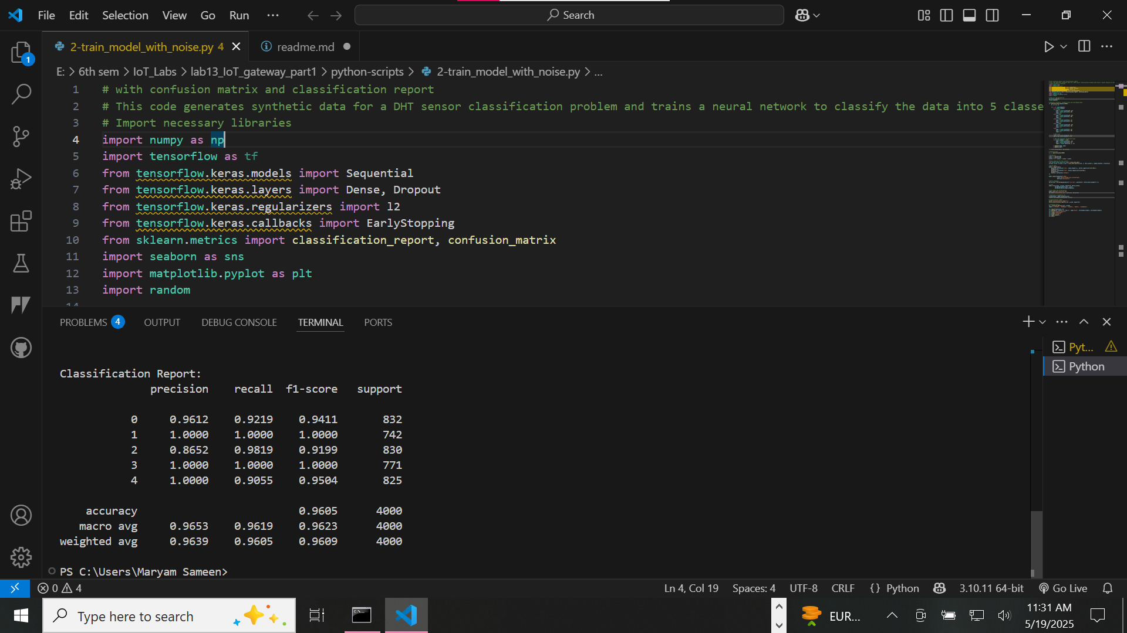

# Task 4: Real-Time Classification and Logging

This script receives real-time sensor values, classifies them using the trained model, and logs the class label along with temperature and humidity into InfluxDB.

**Observations:**

This script integrates MQTT, a trained DHT classifier model, and InfluxDB to predict environmental conditions in real-time based on temperature and humidity. Predicted class labels and sensor data are successfully stored in InfluxDB for monitoring and analysis.

Classified Sensor Data in InfluxDB

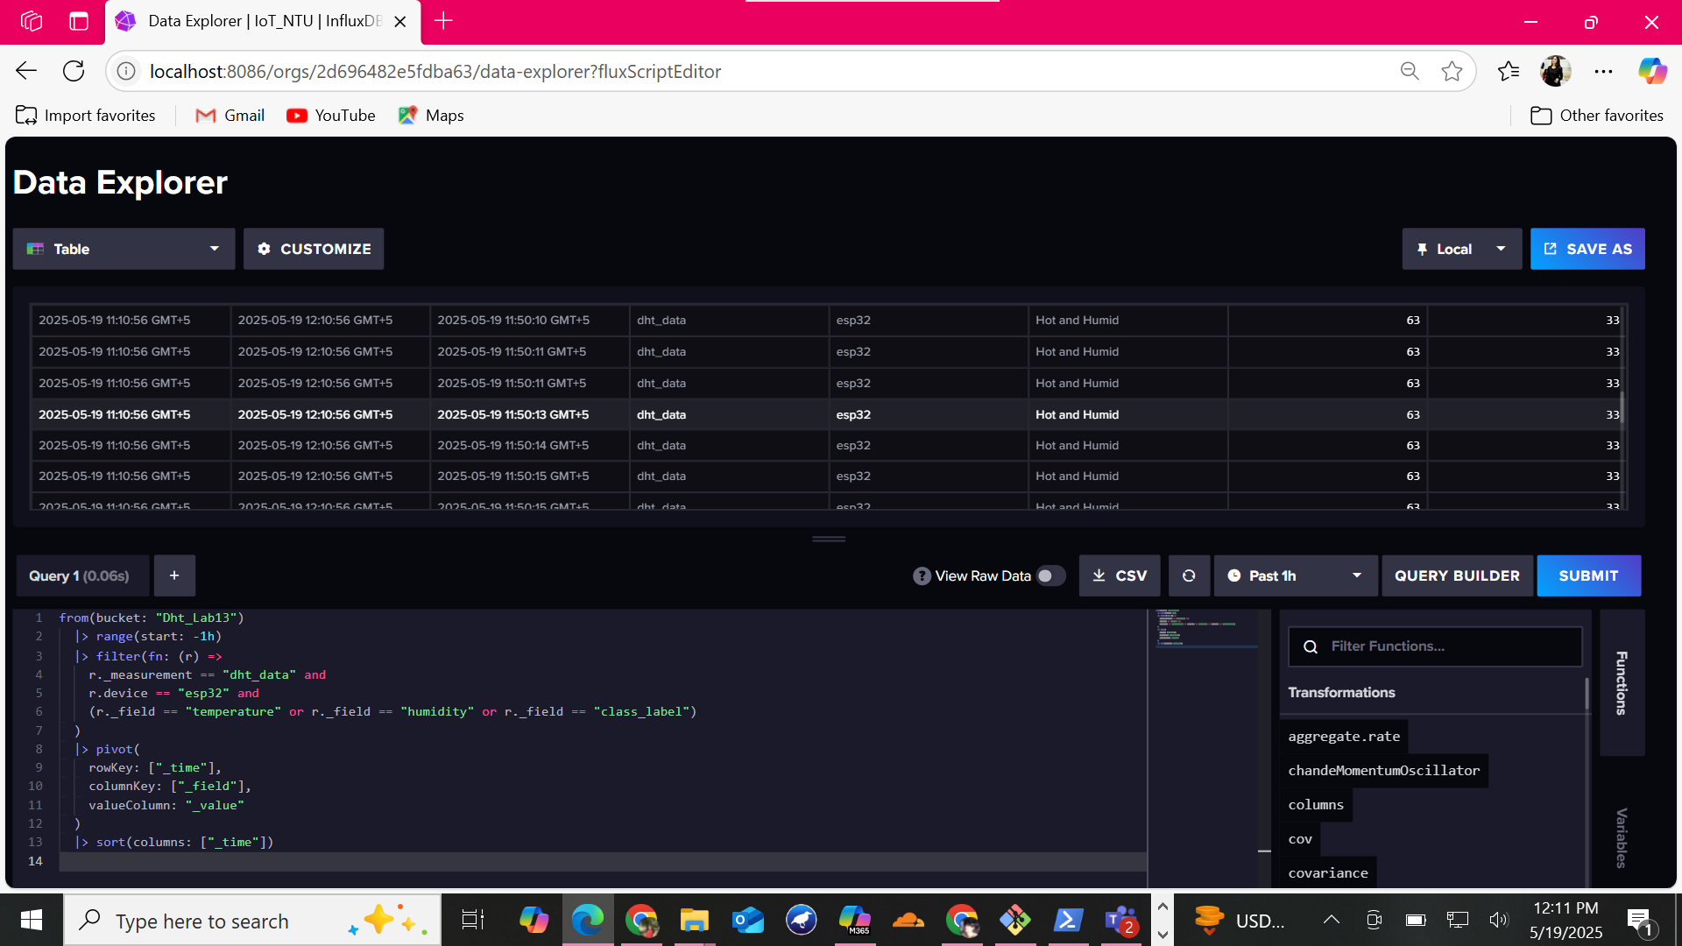

Classification Report in Terminal

